JOSH GREEN, M.D.  GOVERNOR  Ke Kiaʻāina | 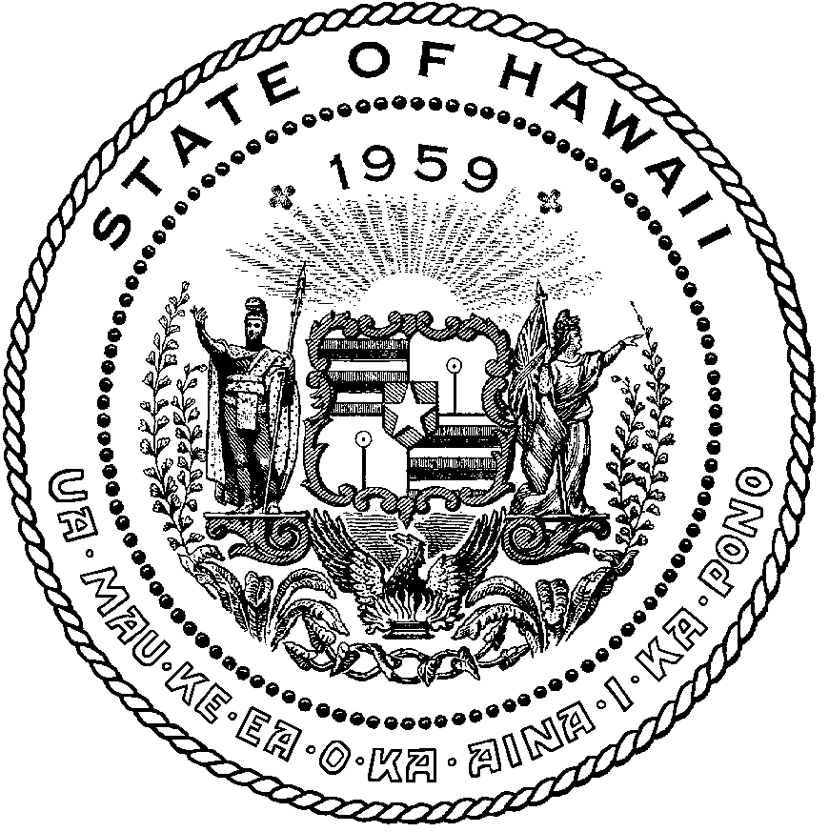 | KEITH A. REGAN  COMPTROLLER  Ka Luna Hoʻomalu Hana Laulā  MEOH-LENG SILLIMAN  DEPUTY COMPTROLLER  Ka Hope Luna Hoʻomalu Hana Laulā
STATE OF HAWAIʻI | KA Mokuʻāina o Hawaiʻi

DEPARTMENT OF ACCOUNTING AND GENERAL SERVICES | KA ʻOihana LOIHELU A LAWELAWE Laulā
P.O. BOX 119, HONOLULU, HAWAII 96810-0119

Communications, Technical, and Finance Meeting
(Combined Meeting)
Virtual Meeting – Microsoft Teams
Call-In: 808-829-4853; Phone Conf ID: 256 759 809#

Physical Location at
Kalanimoku Building Room 426, 1151 Punchbowl Street, Honolulu, Hawaii 96813 is available to the public and is guaranteed to be connected to the remote virtual meeting.

Join the meeting now
Meeting ID: 279 124 639 591 647
Passcode: v3mn6Mh7

Contact for Meeting Information/Testimony Submission; Benson Leung, State of Hawaii, 911 Board, VCC, 1151 Punchbowl Street, Honolulu, HI 96813
benson.c.leung@hawaii.gov

Please visit State of Hawaii 9-1-1 Board YouTube Channel for all Meeting Recordings

State of Hawaii 9-1-1 Board - YouTube

"In the event that audiovisual communication cannot be maintained by all participating board members and quorum is lost, the meeting will automatically be recessed for 30 minutes, during which time an attempt to restore audiovisual communication will be made. If such attempt to restore is unsuccessful within said 30 minutes, all board members, members of the public, staff and other interested individuals shall log on again to the Teams link on this Notice, whereby audio communication will be established for all participants and the meeting will continue. If reconvening the meeting is not possible because audio and visual communication cannot be re-established, the meeting will be terminated."

Thursday, May 7, 2026
9:00 am – 12:00 pm

Agenda

- Call to Order, Public Notice
- Public Testimony Will Be Taken on All Agenda Items as Those Items Occur During the Meeting
- Roll Call, Quorum
- Review and Approval of April Meeting Minutes
- Committee Updates by Committee Chairs
  - Communications Committee – Davlynn Racadio
    - Discussion Regarding 9-1-1 Goes to Washington (GTW) Newsletter and Support to Recognize Telecommunicators as First Responders
  - Technical Committee – Shawn Kuratani
    - RapidSOS Presentation Regarding Emergency Health Profiles
    - Update from Conference Attendees for CentralSquare ENGAGE, March 15-18, 2026, Washington, D.C.
    - Update from Conference Attendees for Summit Conference (Motorola Solutions), April 19-23, 2026, Orlando, Florida
      - Advisory Committee – Rebecca Lieberman
        - Updates on Legislative Session
        - Update Regarding SCR 62 SD 1 – Requesting the 911 Board to establish or utilize an appropriate working group to engage with the disability community to address continuing access issues in the State’s emergency and 911 response systems.
  - Finance Committee – Edward Fujioka
    - Review of Monthly Y-T-D (Year to Date) Cash Flow
    - Hawaii Fire Department Requesting $20,790.23 for Uninterruptible Power Supply (UPS) for Emergency Communications Center (ECC)
    - Honolulu Ocean Safety Department Requesting $1,092.55 for VIPER Positions
- Public Safety Answering Point Status Updates on Recruitment and other Personnel Issues
  - Kauai Police Department – Andrew Muraoka
    - Update on Recruitment Process/Strategies and Personnel Training
    - Update on Personnel Issues and Vacancies
  - Oahu Police Department – Bradon Ogata, Ah Lan Leong
    - Update on Recruitment Process/Strategies and Personnel Training
    - Update on Personnel Issues and Vacancies
  - Oahu Fire Department – Shawn Kuratani
    - Update on Recruitment Process/Strategies and Personnel Training
    - Update on Personnel Issues and Vacancies
  - Oahu Emergency Medical Services – Isaac Tejada, Frannie Chung, Sherryann Murphy
    - Update on Recruitment Process/Strategies and Personnel Training
    - Update on Personnel Issues and Vacancies
  - Maui Police Department – Davlynn Racadio, Melia Johnson
    - Update on Recruitment Process/Strategies and Personnel Training
    - Update on Personnel Issues and Vacancies
  - Molokai Police Department – Davlynn Racadio, Melia Johnson
    - Update on Recruitment Process/Strategies and Personnel Training
    - Update on Personnel Issues and Vacancies
  - Hawaii Police Department – Zachary Fernando
    - Update on Recruitment Process/Strategies and Personnel Training
    - Update on Personnel Issues and Vacancies
  - Hawaii Fire Department – Stacy Domingo
    - Update on Recruitment Process/Strategies and Personnel Training
    - Update on Personnel Issues and Vacancies
- Items for Discussion, Consideration, and Action
  - Additional Items Proposed by Meeting Attendees for Consideration and Possible Inclusion on Future Agendas
- Announcements
  - Future Virtual Meeting Dates/Times (9:00AM-12:00PM)
    - Thursday, June 4, 2026 (Combined Meeting)
    - Thursday, July 2, 2026 (Combined Meeting)
  - Future Conference Dates (3 Months of Advanced Approval Required)
    - NICE Conference & Expo (National Initiative for Cybersecurity Education), June 1-3, 2026, Philadelphia, PA
    - NENA Conference & Expo (National Emergency Number Association), June 27-July 2, 2026, Columbus, OH
    - APCO Conference & Expo (Association of Public-Safety Communications Officials), August 2-5, 2026, San Antonio, Texas
  - Additional Announcements from Meeting Attendees for Consideration and Possible Inclusion on Future Agendas
- Open Forum: Public Comment on Issues not on the Board Meeting Agenda; no Board action on matters not on the agenda
- Adjournment

