JOSH GREEN, M.D.  GOVERNOR  Ke Kiaʻāina |  | KEITH A. REGAN  COMPTROLLER  Ka Luna Hoʻomalu Hana Laulā  MEOH-LENG SILLIMAN  DEPUTY COMPTROLLER  Ka Hope Luna Hoʻomalu Hana Laulā
STATE OF HAWAIʻI | KA Mokuʻāina o Hawaiʻi

DEPARTMENT OF ACCOUNTING AND GENERAL SERVICES | KA ʻOihana LOIHELU A LAWELAWE Laulā
P.O. BOX 119, HONOLULU, HAWAII 96810-0119

Communications, Technical, and Finance Meeting
(Combined Meeting)

Thursday, April 9, 2026
9:00 am – 12:00 pm

Virtually Held Meeting with Physical Location at
Kalanimoku Building Room 426, 1151 Punchbowl Street, Honolulu, Hawaii 96813 is available to the public and is guaranteed to be connected to the remote virtual meeting.

MEETING MINUTES

April 9, 2026: Joint Committee and Board Meeting (youtube.com)

Communications Committee Members Present: Ah Lan Leong (HPD)

Communications Committee Members Not Present: Davlynn Racadio (MPD), Lavina Taovao (KPD)

Technical Committee Members Present: Stacy Domingo (HIFD), Kenison Tejada (FirstNet), Tony Velasco (DIT)

Technical Committee Members Not Present: Shawn Kuratani (HFD), Tony Ramirez (V2X)

Finance Committee Members Present: Edward Fujioka (EMS), Stephen Courtney (C&C of Honolulu), Liz Gregg (AT&T), Matthew Kurihara (HPD), Tony Velasco (DIT)

Finance Committee Members Not Present: Reed Mahuna (HIPD), Todd Omura (CIO Designee)

Staff: Royce Murakami (911 Board), Benson Leung (911 Board), Candace Park (AG)

Guests: Russell Andrus (Motorola), Daintry Bartoldus (DD Council), Darin Biamonte (Mission Critical), Brian Boezeman (Intrado), Christian Burns (HT), Eric Caddy (RapidSOS), Caroline Cadirao (EOA), Marc De Costa (HT), Carla Even (RapidSOS), Zachary Fernando (HIPD), Greg Florian (Spectrum), Barbara Geary (Spectrum), Buck Giles (OS), Roderick Green (KPD), Garrett Hall (EMS), Nicole Jackson (Motorola), Travis Jensen (Motorola), Melia Johnson (MPD), David Jones (Mission Critical), John Joseph (RapidSOS), Kevin Kaneshiro (HIFD), Elliott K. Ke (KPD), Ji Sook Kim (Consumer Advocate Designee), Michelle Kratel (HIPD), Amelia Kyewich-Kaneholani (DD Council), Robert Lau (DOH), Patrick Leddy (LCC), Adam Lerner (OS), Rebecca Lieberman (Spectrum), Karin Marquez (RapidSOS), Michael Matonis (Motorola), Angela Melody Young (Public), Bryan Mick (DOH), Angie Miller (Motorola), Meghan Miller (UHM), Tamera Neal (Intrado), Kristine Pagano (DCAB), Neil Pang (HPD), Candace Park (AG), Stacy Perreira (KPD), Megan Reilly (EagleView), Leona Sa McDermott (Public), Corey Shaffer (Verizon), Isaac Tejada (EMS), Justin Tokioka (DCAB), Keola Tom (MPD), Lesley Turner (Motorola), Lisa Wall (Kauai), Jason Wong (EOA)

- Call to Order, Public Notice
The meeting was called to order by the Board Chair. Public notice was given.

- Public Testimony Will Be Taken on All Agenda Items as Those Items Occur During the Meeting

- Roll Call, Quorum
A roll call was taken, quorum was present for all committees except the Communications Committee.

Board Chair announced Elliott K. Ke’s retirement and recognized his years of service as a 911 Board member. Elliott K. Ke thanked the Board Chair for his sentiments.

- Review and Approval of March Meeting Minutes
Board Chair requested a motion to approve March’s Meeting Minutes. Tony Velasco motioned to approve March’s Meeting Minutes. Rebecca Lieberman seconded the motion. A voice vote was taken, motion was unanimously approved.

- Committee Updates by Committee Chairs
  - Communications Committee – Davlynn Racadio
    - Update Regarding 9-1-1 Goes to Washington (GTW) Newsletter
Executive Director on behalf of Davlynn Racadio stated that this newsletter was created to provide information regarding two bills being promoted during 9-1-1 Goes to Washington and to highlight the efforts made during this conference. He added that this newsletter serves as a leave-behind for applicable/interested parties and during any events such as National Public Safety Telecommunicators Week. He mentioned that he will distribute this newsletter accordingly.

Edward Fujioka suggested that any future conference attendees document their work trips via a short video and/or photos as a way to report back and present to those who were unable to attend for edification purposes.

    - Discussion Regarding National Public Safety Telecommunicators Week, April 12-18, 2026
Executive Director on behalf of Davlynn Racadio asked each public safety answering point (PSAP) what they have planned for National Public Safety Telecommunicators Week.

Isaac Tejada responded stating that due to inclement weather conditions they will be postponing any activities but will host an event at a later date in the Joint Traffic Management Center (JTMC).

Roderick Green responded stating that they will be hosting a luncheon for their telecommunicators. He added that the telecommunicators by consensus decided not to have a large-scale event but rather there will be daily celebrations.

Melia Johnson responded stating that they will have daily activities and meals provided starting on Sunday until Friday, which is their Ohana night where they invite all of their telecommunicators and respective families for an evening that includes a luau, celebration, and bonding.

Stacy Domingo responded stating that she has been partnering with Zachary Fernando to work with county council to award their telecommunicators with an official certificate and are also planning to have a representative from the mayor’s office to announce a formal proclamation. She added that they will also host a luncheon and highlight their telecommunicators throughout the week via social media. Furthermore, this social media campaign will also educate the public about 911.

    - Follow-Up Regarding Spectrum Reach Multiscreen Campaign for Public Safety Answering Point (PSAP) Recruitment
Executive Director on behalf of Davlynn Racadio stated that Hawaii County will be pursuing this campaign mentioned above. He then stated that Honolulu County has shown interest, Kauai County has its own campaign, and Maui County is not interested at this point in time. He then requested Honolulu County to reach out to Spectrum and include him in the forthcoming conversations.

  - Technical Committee – Shawn Kuratani
    - Smart911 Presentation Regarding Safety Profiles

Travis Jensen stated that he is part of Motorola’s strategic team, which partners with state agencies to improve understanding of public safety ecosystems and integration of solutions to enhance overall public safety. He then mentioned that this presentation will cover the Smart911 tool, which would meet the intent of a bill being proposed during this current legislative session to address an access and functional needs registry in Hawaii. He added that Smart911 will redefine how public safety is delivered across Hawaii (changing from a reactive to proactive approach) by providing critical and complete caller information up front to telecommunicators and first responders ahead of an emergency. He commented that this will help identify any potential risks and improve response effectiveness. Furthermore, he mentioned that Smart911 is not a standalone product but rather a foundation to other fully integrated solutions such as the alert mass notification system, radius map solution, and link exchange to share information amongst agencies, which creates a statewide interoperable public safety platform altogether.


Travis Jensen stated that Smart911 will provide telecommunicators and first responders with caller information up front to improve emergency response.

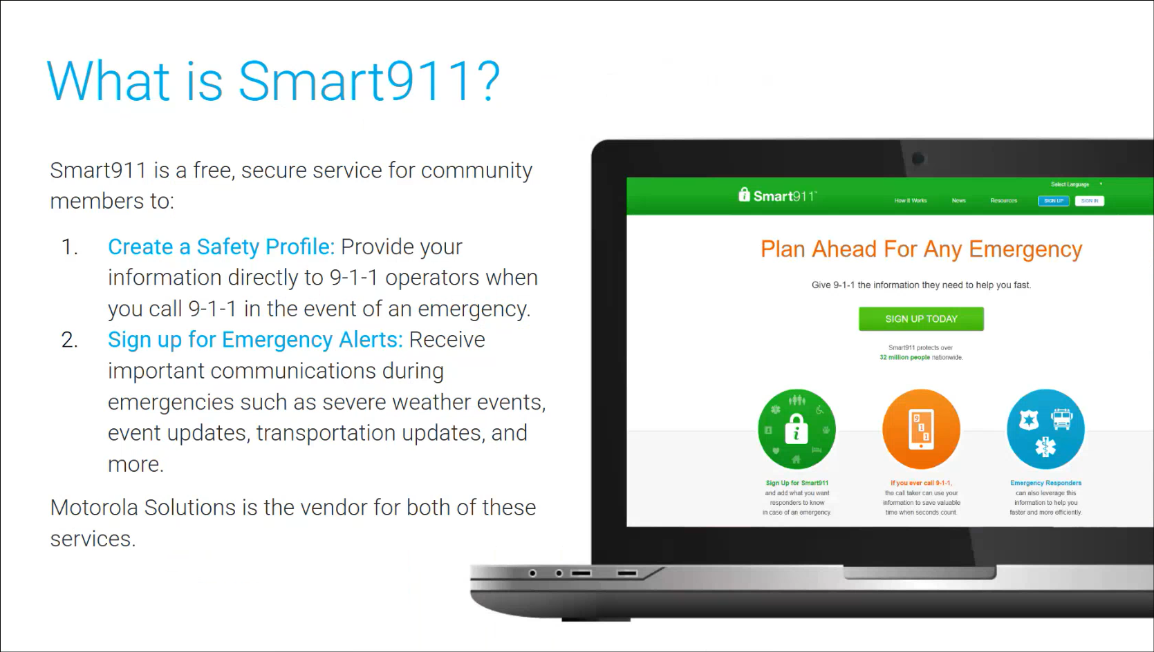
Travis Jensen stated that Smart911 is a free and secure service for the public to create safety profiles that are tied to their respective phone numbers, which includes mobile devices, landlines, smartwatches, etc. He added that this safety profile will be immediately available to a telecommunicator during a 911 call, which includes but not limited to medical conditions, family members, emergency contacts, etc. He mentioned that Smart911 is also able to send out alerts via Motorola’s mass notification platform. He then commented that Smart911 enables an agency to engage the public before, during, and after an emergency.

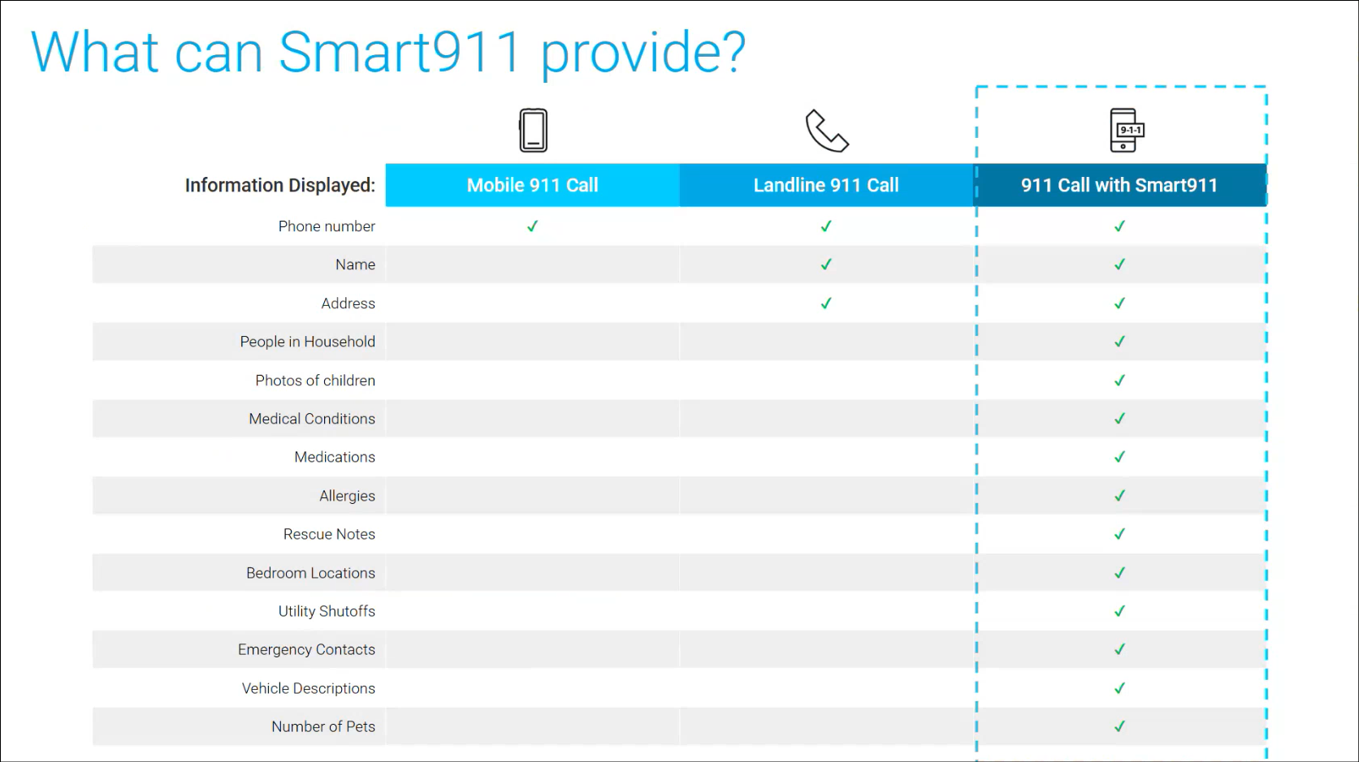
Travis Jensen referenced the slide above regarding information that Smart911 provides in comparison to mobile and landline 911 calls. He added that this should help prepare telecommunicators and first responders to improve response times and effectiveness instead of reacting to the unknown.

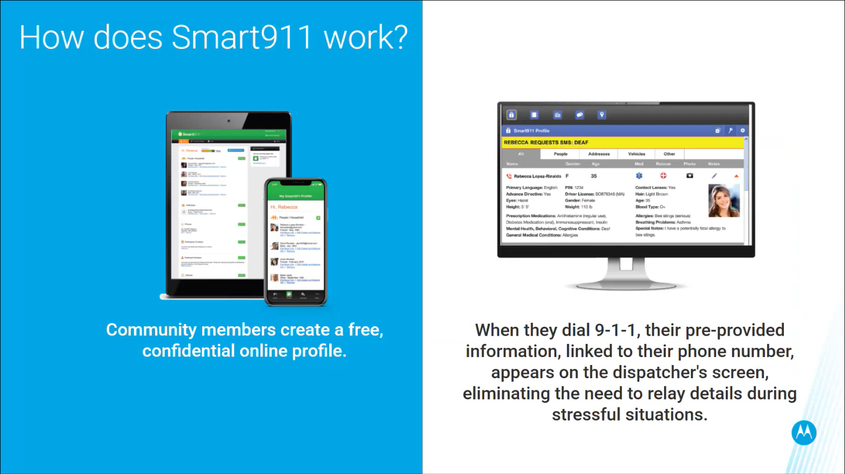
Travis Jensen referenced the slide above regarding Smart911 setup for the public and what appears on a telecommunicator’s screen during a 911 call. He added that this helps reduce the time required to gather information from the caller and the telecommunicator will utilize this saved time to manage the emergency situation instead.

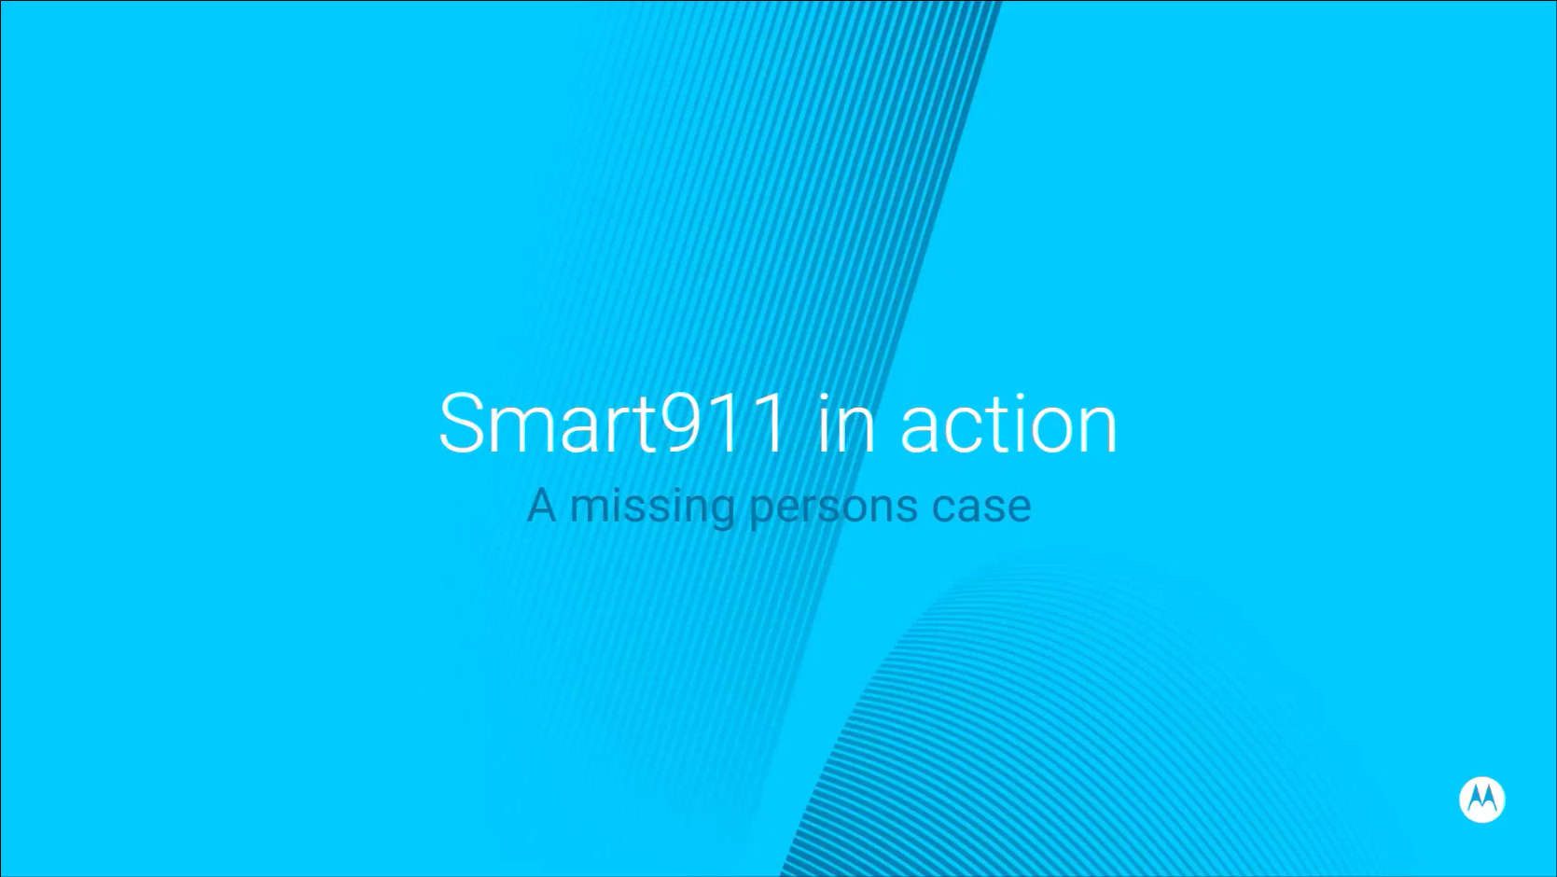
Travis Jensen stated that he will provide an example of a Smart911 use case involving a missing person who is an elderly individual.

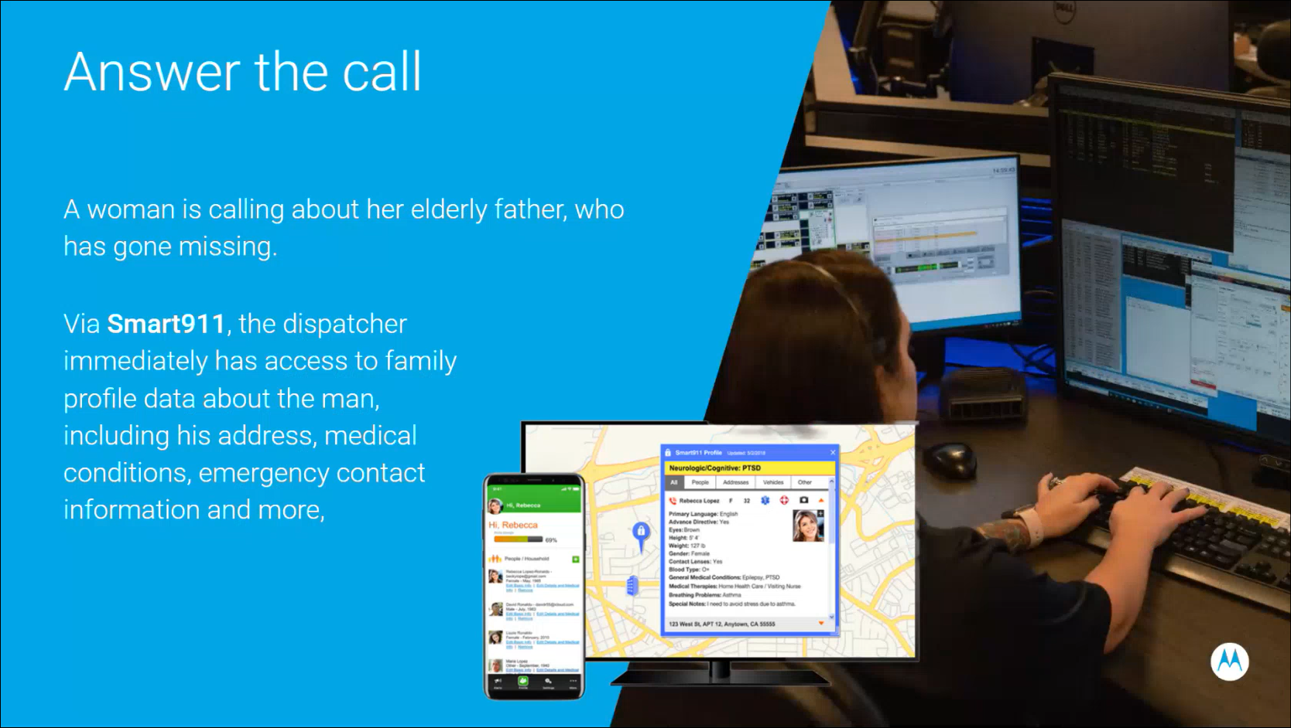
Travis Jensen referenced the slide above regarding the aforementioned missing person case. He highlighted that via Smart911 the telecommunicator has immediate access to critical information about the missing person.

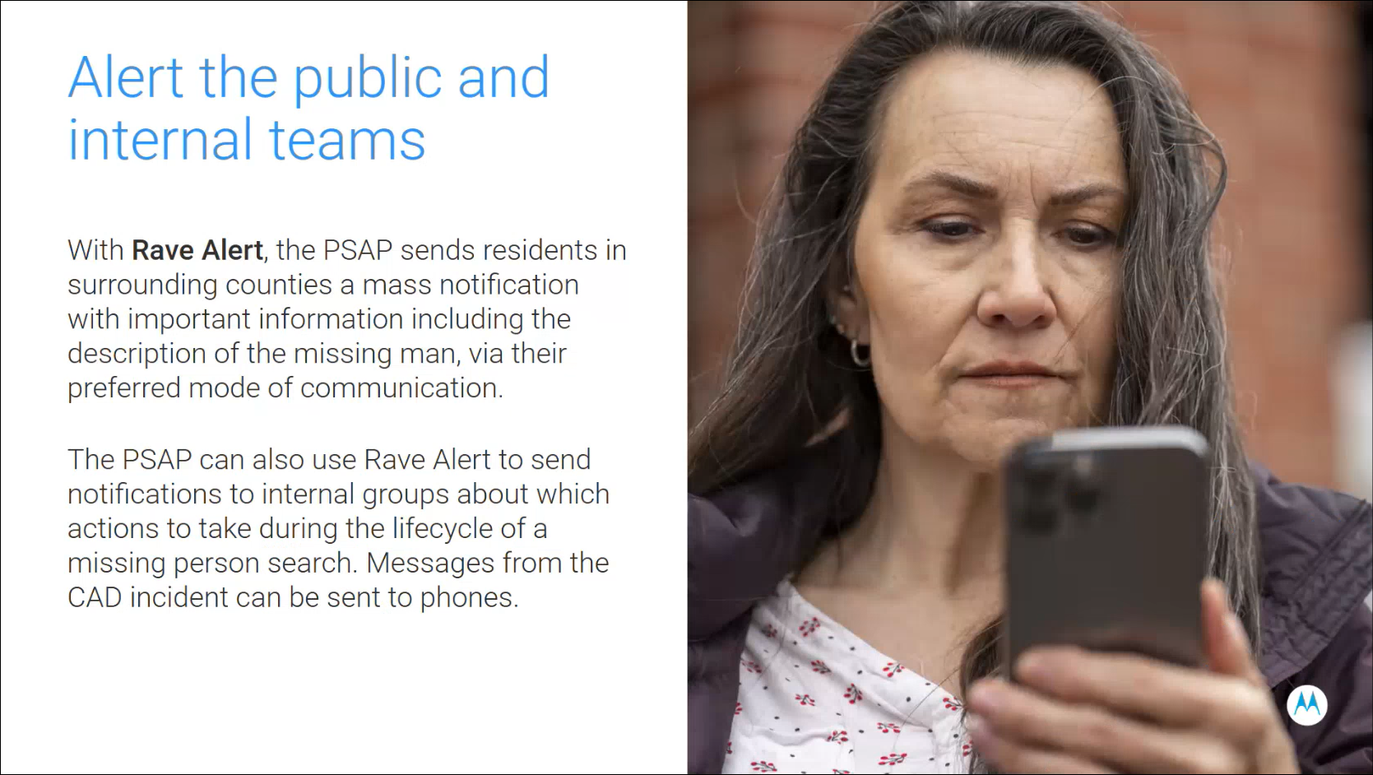
Travis Jensen referenced the slide above regarding Rave Alert, which allows the agency to send out mass notification about the missing person with pertinent information and physical description. He added that this becomes a force multiplier by increasing the efforts to locate the missing person. Additionally, he mentioned that Rave Alert has the capability to send notifications within internal groups to coordinate effectively.

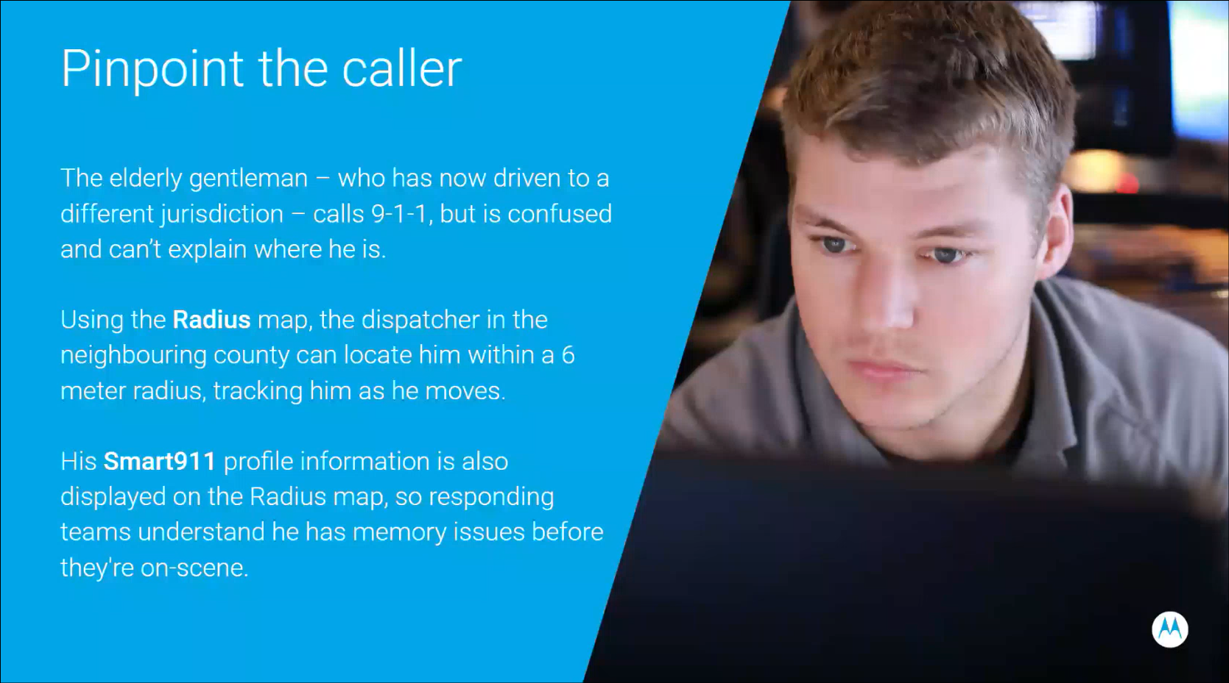
Travis Jensen referenced the slide above regarding the aforementioned missing person case and this individual has now crossed over into a different jurisdiction. He stated that the telecommunicator is able to locate the missing person by utilizing Motorola’s radius map, which has a 6-meter radius. He then mentioned radius plus (radius map enhancement), which enables Motorola’s assist artificial intelligence (AI) capabilities to provide the telecommunicator with real-time automatic call transcription, key details, and critical insights such as confusion, distress, medical indicators, etc.

In summary, Travis Jensen stated that this suite of solutions provides the telecommunicator and first responders with rich caller data via Smart911, precise location via radius map, and real-time AI assistance via radius plus. He added that this should support telecommunicators with faster decision making, reduced workloads, and improved emergency response.

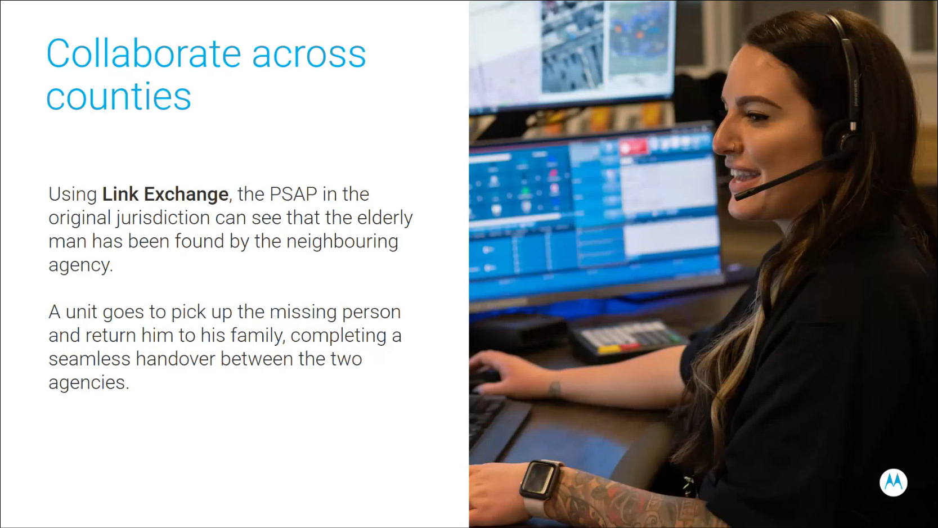
Travis Jensen referenced the slide above regarding link exchange, which enables agencies to share computer-aided dispatch (CAD) data with each other in real time. He mentioned that this could be used for a handover between jurisdictions such as the aforementioned missing person case after it has been resolved.


Travis Jensen stated that Motorola’s goal is to build a safer and more connected community across Hawaii utilizing the solutions mentioned throughout this presentation, which includes Smart911, alert mass notification system, radius map solution, radius plus, and link exchange. He added that this will enable the statewide public safety ecosystem to be proactive rather than reactive.

Corey Shaffer asked Travis Jensen what technology does Motorola’s radius map leverage. Travis Jensen responded stating that Motorola partners with both Apple and Google to retrieve location information directly from the global positioning system (GPS) of the user’s device. Corey Shaffer asked Travis Jensen a follow-up question inquiring what are the Smart911 adoption rates in their existing markets. Travis Jensen responded stating that he does not have that figure readily available and mentioned that adoption rates vary across the different states. He added that Motorola offers their marketing team to assist agencies with public relations (PR) campaigns and public information officer (PIO) information to educate the public about Smart911 to increase adoption rates. Corey Shaffer asked Travis Jensen a follow-up question regarding how are multiple safety profiles set up for a singular landline phone number. Travis Jensen responded stating that multiple safety profiles can be associated with a singular landline phone number or multiple phone numbers can be associated with a singular residence.

Edward Fujioka asked Travis Jensen if Smart911 supports voice over internet protocol (VoIP) and/or internet protocol (IP) phone systems or not. Travis Jensen responded stating that Smart911 supports landline, mobile, VoIP, and any another type of call as long as it has an attached phone number. Edward Fujioka asked Travis Jensen a follow-up question if Smart911 can integrate with RapidSOS data or not. Travis Jensen responded stating that Smart911 would be an overlay on Hawaii’s existing Intrado and VIPER system but does not integrate with RapidSOS data since they are a competitor. Edward Fujioka asked Travis Jensen a follow-up question inquiring what would happen to Smart911 during an outage. Travis Jensen responded stating that Smart911 would still be usable during a phone system outage but not during a 911 network outage.

Marc De Costa asked Travis Jensen how user information/data is migrated and/or input into Smart911. Travis Jensen responded stating that any agency can upload comma-separated values (CSV) files into Smart911 but otherwise it is at the discretion of each user to provide their consent and personal information to avoid any compliance issues. He added that Motorola can force opt-ins for their alert mass notification system.

Travis Jensen introduced Michael Matonis who will be providing a live demo of Smart911. Michael Matonis stated that he works on the technical side at Motorola.

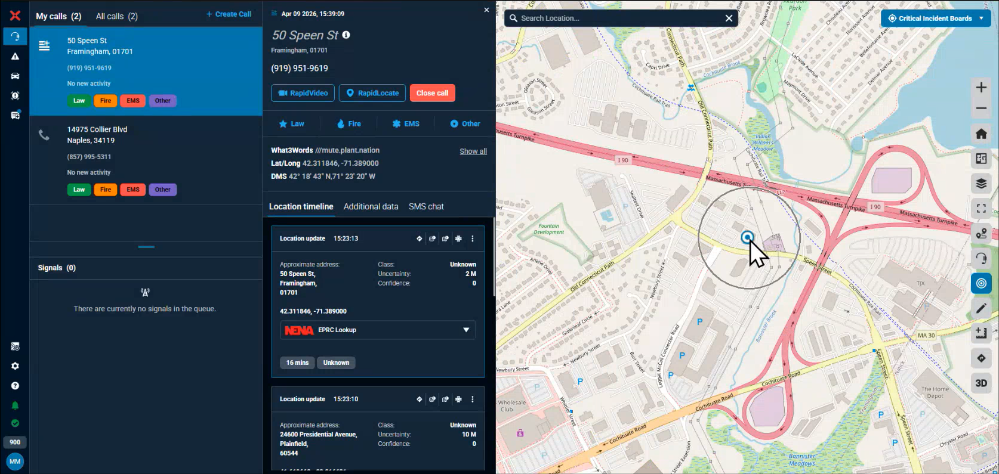
Michael Matonis referenced the slide above regarding a simulated 911 call and the radius map solution providing the caller’s location via GPS.

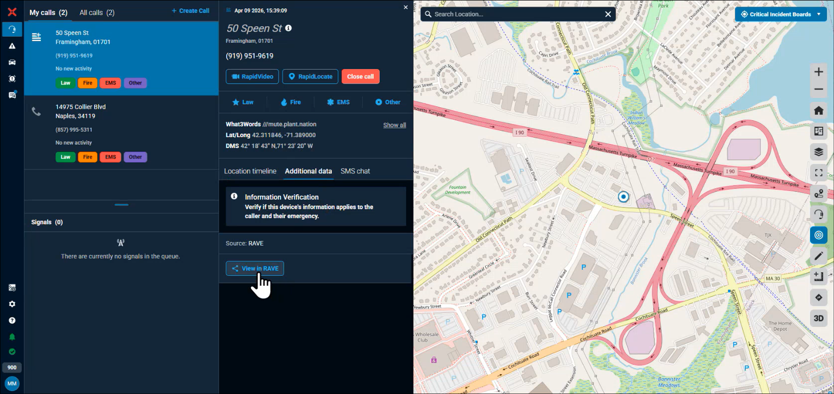
Michael Matonis stated that the Smart911 safety profiles are accessible through Motorola Rave.

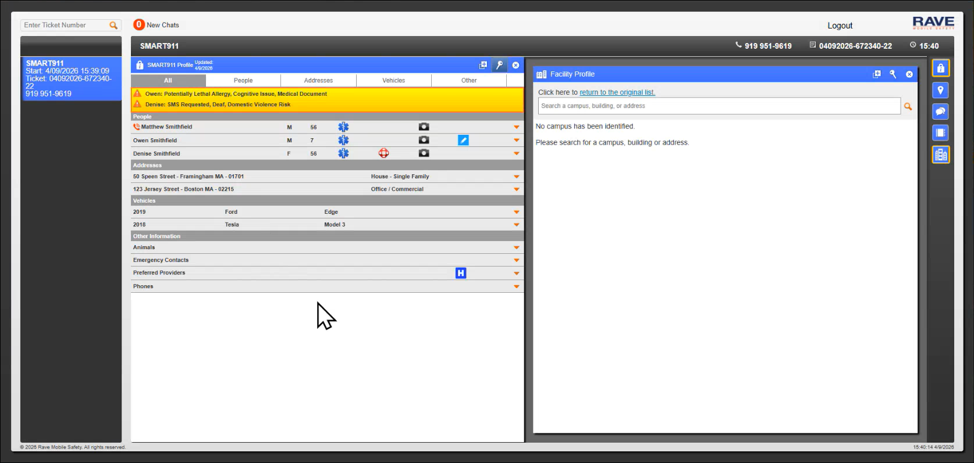
Michael Matonis referenced the slide above regarding a Smart911 safety profile example. He stated that the caller will have their respective name highlighted during a 911 call.

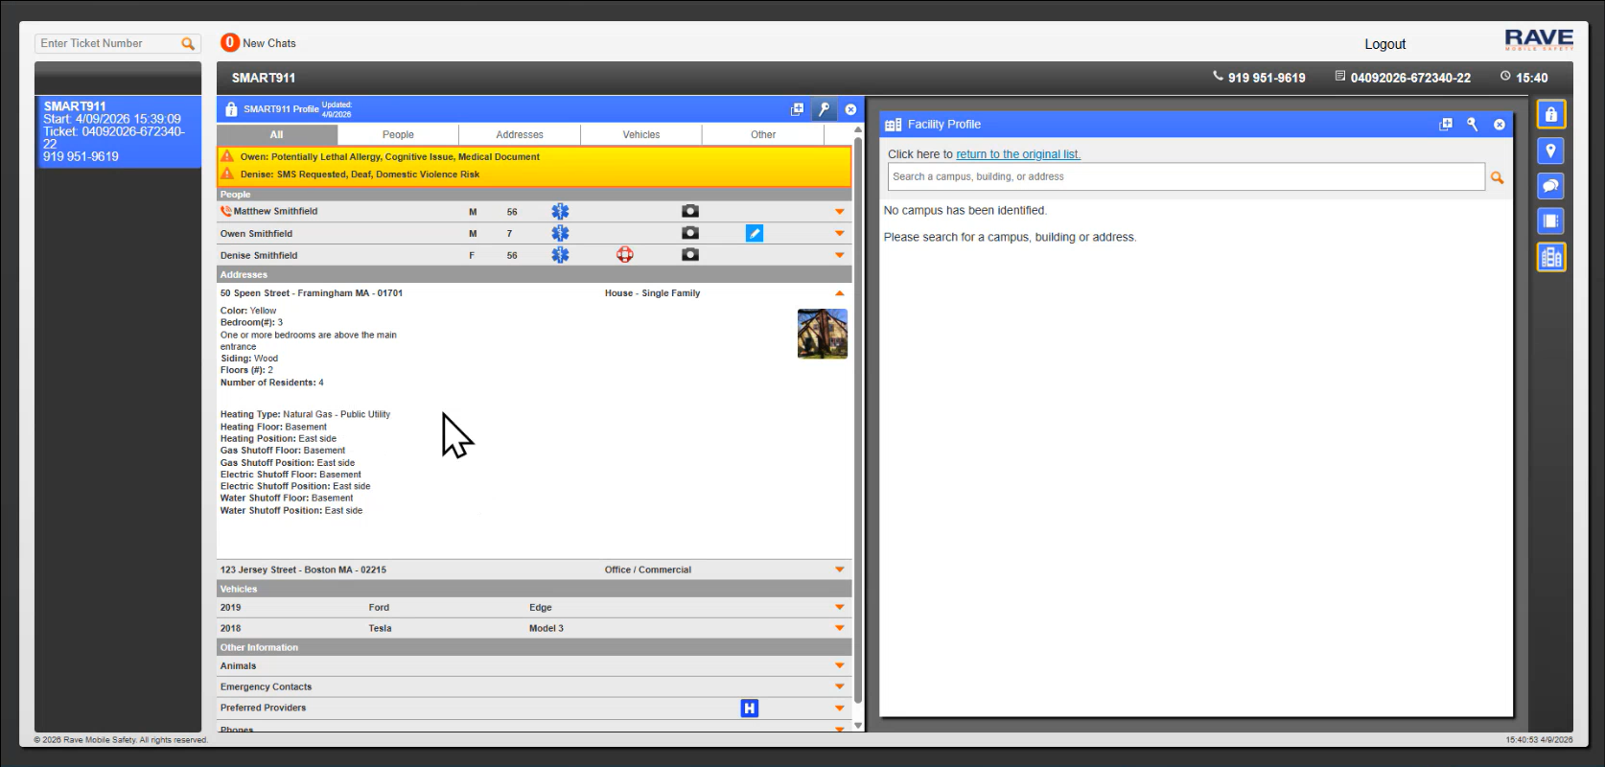
Michael Matonis referenced the slide above regarding the type of information captured in a Smart911 safety profile.

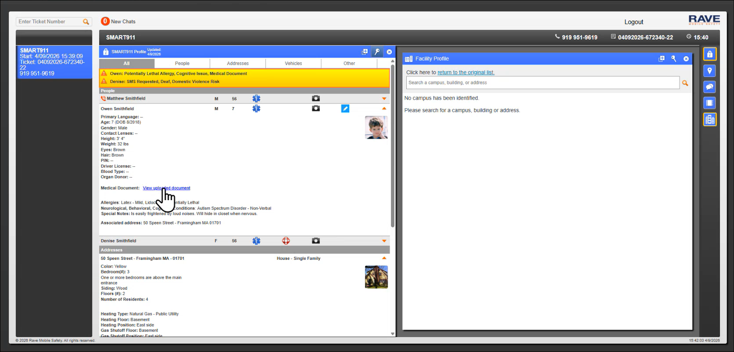
Michael Matonis stated that the Smart911 safety profile allows users to upload documents (e.g. medical information). He then referenced the slide above further showcasing the type of information captured in a Smart911 safety profile.

Corey Shaffer asked Michael Matonis if Smart911 is able to display only desired/selected safety profiles. Michael Matonis responded stating that it is the onus of the user during setup to determine how the safety profiles will be displayed in Smart911. He also mentioned that Smart911 is nationwide and operational as long as the respective jurisdiction is utilizing Smart911. Corey Shaffer asked Michael Matonis a follow-up question if the aforementioned jurisdiction needs to be set up with Motorola Rave or not. Michael Matonis responded stating that the applicable jurisdiction needs to have Motorola Rave to access the Smart911 safety profiles but the Smart911 database is shared nationwide.

Corey Shaffer asked Travis Jensen what percentage of the country is utilizing Smart911. Travis Jensen responded stating that they are currently adopting Smart911 as an automatic inclusion with their VESTA 9-1-1 call taking platform, which has ~80% market share in the country and makes it the largest 911 platform domestically.

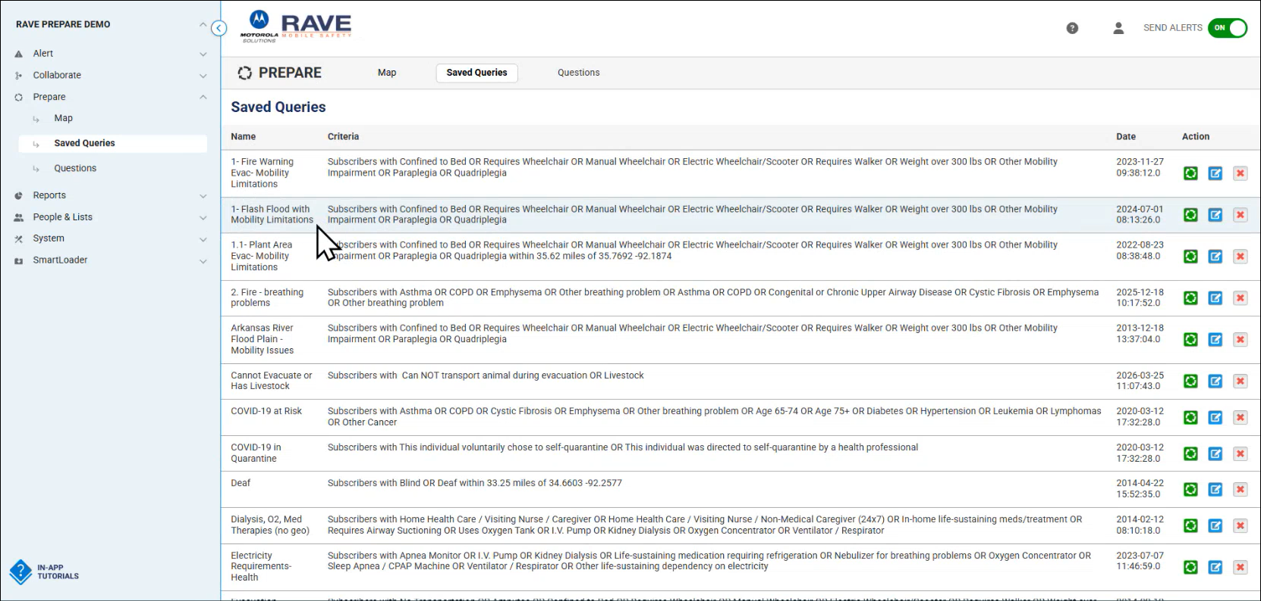
Michael Matonis referenced the slide above regarding creation of Smart911 queries for various emergency scenarios/situations.

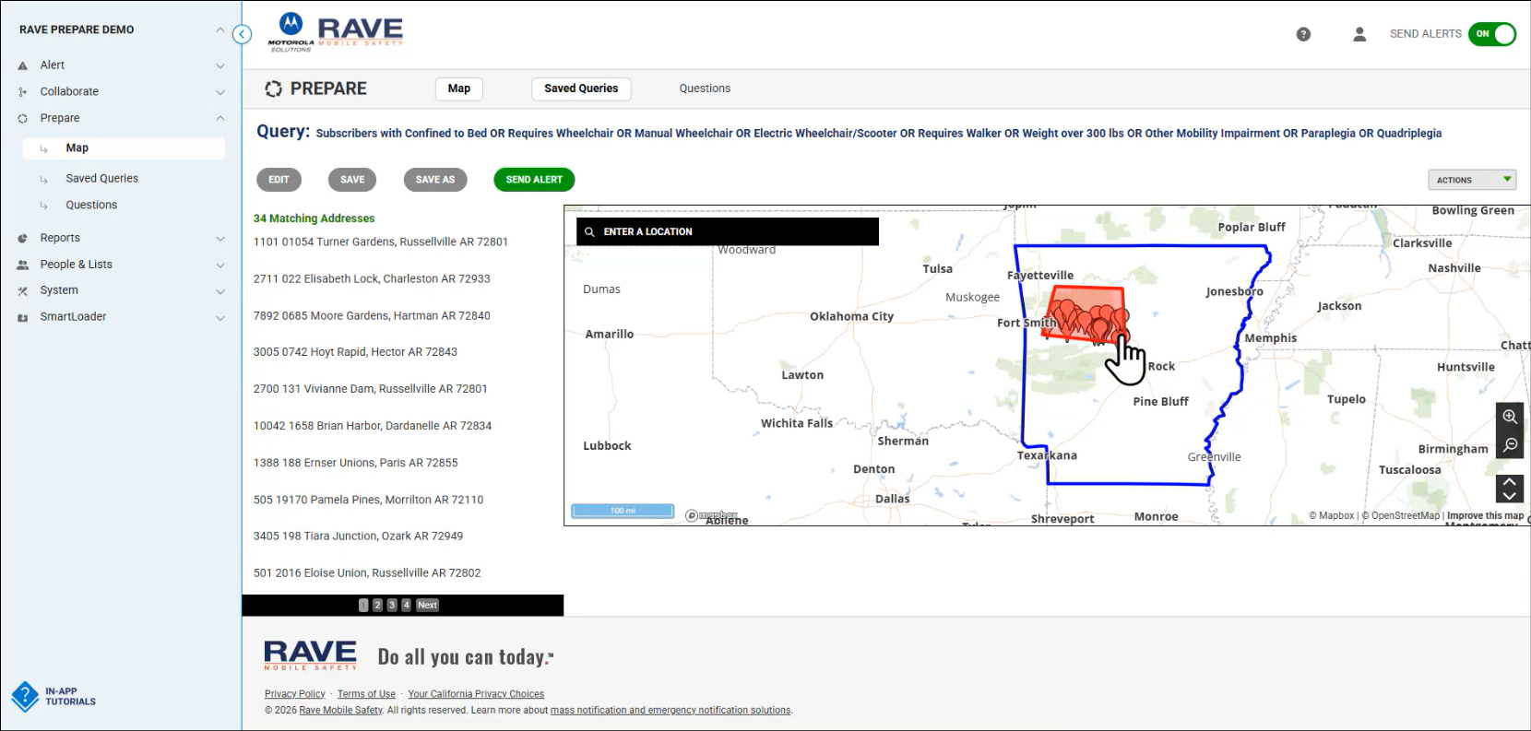
Michael Matonis referenced the slide above regarding an example of a Smart911 query result highlighted in red.

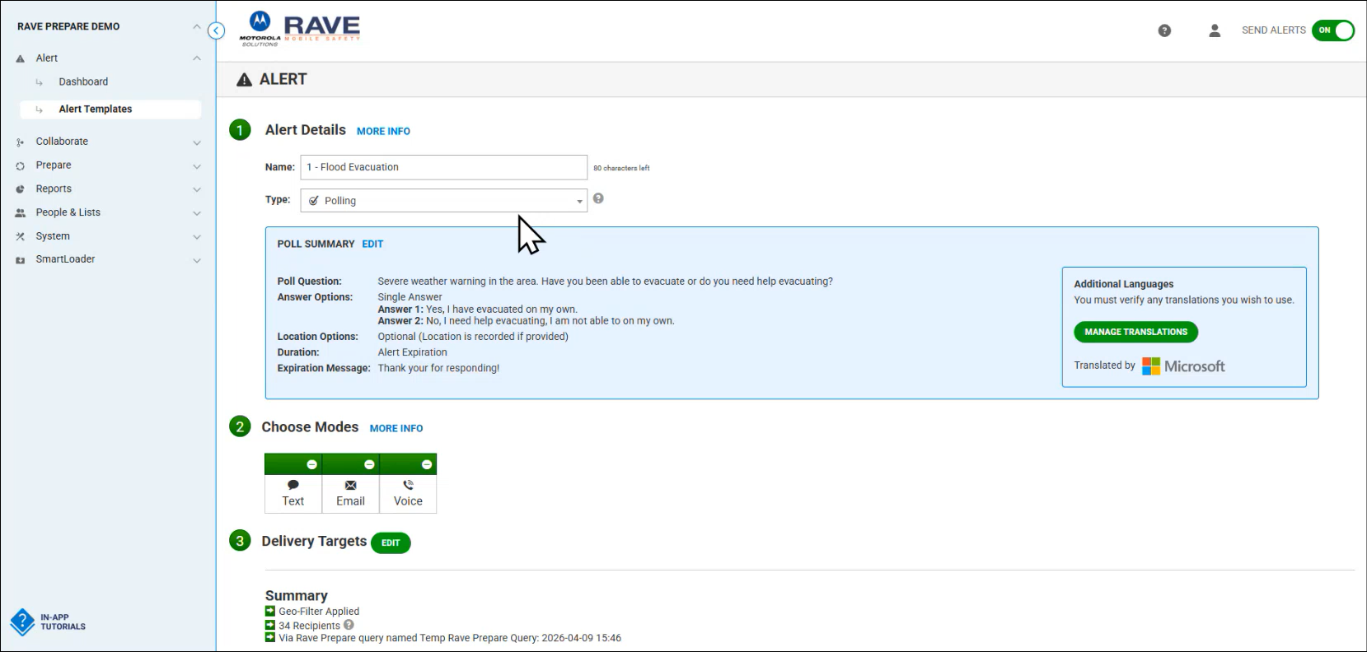
Michael Matonis referenced the slide above regarding an example of a message/alert that can be sent directly to the individuals within a Smart911 query result. Travis Jensen emphasized the importance of sending critical alerts promptly regarding natural disasters to aid evacuations and mitigate loss of life.

Edward Fujioka asked Michael Matonis if Honolulu’s emergency operations center (EOC) has a database/application similar to Smart911 for emergency alerts or not. Michael Matonis responded stating that Smart911’s emergency alert is a polling message that is sent via text message, email, and/or phone call. He added that in the example shown above the polling message inquires if the individual requires assistance evacuating or not. Travis Jensen added that Smart911 is capable of sending out mass polling messages. Edward Fujioka asked Michael Matonis a follow-up question if Rave Alert can be integrated into an EOC or Incident Management Team (IMT). Michael Matonis responded stating that Rave Alert is integrable for both EOC and IMT. He added that Rave Alert can be utilized amongst internal teams and external communication to the public.

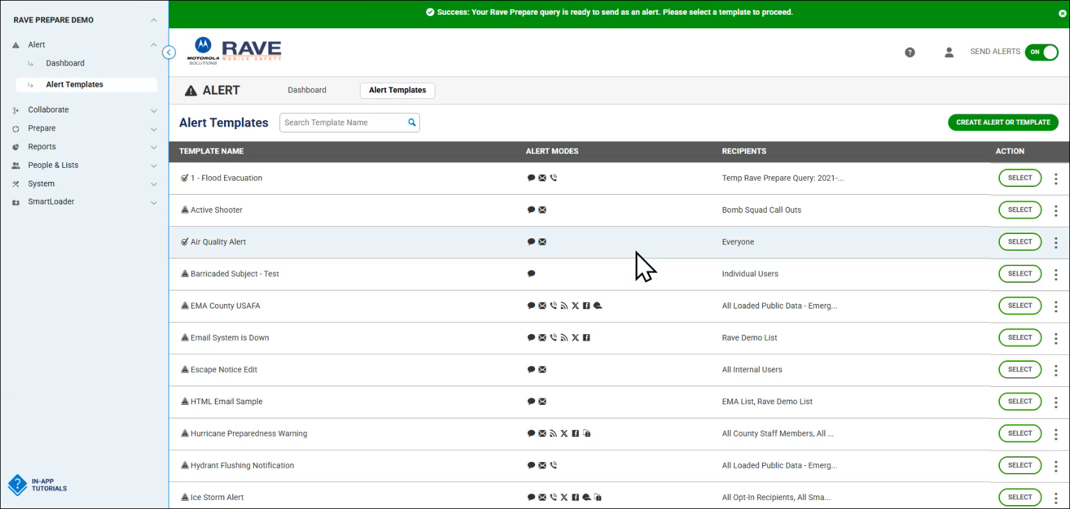
Michael Matonis referenced the slide above showcasing the various templates within Rave Alert. He added that these templates are provisioned via role-based access control.

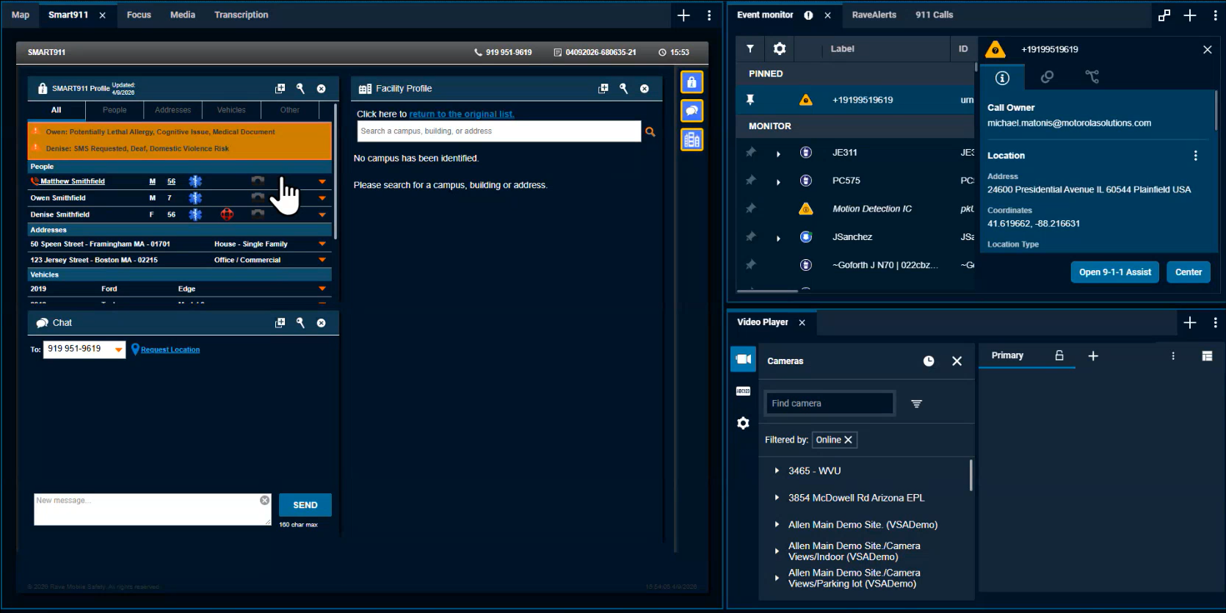
Michael Matonis referenced the slide above regarding Motorola’s CommandCentral Aware, which is an interface providing information such as the active 911 call details, caller location, Smart911 information, call transcription, pertinent media, Text-to-911, etc. for efficiency purposes and improved emergency response.

Travis Jensen expressed his appreciation on behalf of Motorola to the 911 Board for their time and attention. He added that they will work with Nicole Jackson and the Executive Director to draft a proposal and create demos if interested.

Ah Lan Leong asked Travis Jensen how would Smart911 be integrated since Intrado does not currently support it. Travis Jensen responded stating that Motorola is able to integrate with Intrado to support Smart911 if they are agreeable and willing. He added that Smart911 also has a web browser version. Michael Matonis stated that they strive to build Smart911 as platform agnostic as necessary.

Stephen Courtney asked Travis Jensen if Motorola provides application programming interfaces (API) to integrate third party applications. Travis Jensen responded stating that Motorola provides open application programming interfaces (API) across its technology portfolio and white papers. He added that they also offer a technical support team for assistance purposes.

Executive Director asked Travis Jensen if he could provide cost estimates. Travis Jensen responded stating that he will send a pricing portfolio for evaluation and consideration purposes. He added that nearly all of their offerings within the software portfolio are cloud-based subscriptions (Software as a Service - SaaS).

    - Discussion Regarding Emergency Profile Needs
Executive Director asked Daintry Bartoldus if there are any comments and/or concerns regarding Motorola’s Smart911 presentation. Daintry Bartoldus responded stating that she did not have any additional comments/concerns and asked Amelia Kyewich-Kaneholani if she had anything to bring up. Amelia Kyewich-Kaneholani responded stating that she had nothing further.

Executive Director asked Daintry Bartoldus what are the most important features and needs for an emergency profile system. Daintry Bartoldus responded stating that this includes accurately capturing access and functional needs information, alternate known locations, emergency contacts, confidentiality, security, understandable/translatable text, and Text-to-911 capabilities. Kristine Pagano added that video capabilities and braille accessibility are also vital.

Marc De Costa highlighted the importance of understanding how the future vendor’s emergency profile data architecture is stored, managed, secured, accessed, and transferred.

Garrett Hall clarified that Smart911 is currently not operational in Hawaii even though users are able to set up their Smart911 safety profiles. He then suggested that the 911 Board should reach out to the public regarding this misconception. Corey Shaffer asked Travis Jensen if Motorola is able to assist with notifying and/or alerting the public about this misconception. Travis Jensen responded stating that he will follow up on this matter and report back. Kristine Pagano stated that she will check the Disability and Communication Access Board’s (DCAB) archives to notify their known Smart911 users about the aforementioned misconception.

Corey Shaffer stated that the 911 Board will evaluate/compare emergency profile vendors and consider feedback from the public, other state agencies, and PSAPs before rendering a decision/selection. Corey Shaffer asked the Executive Director if presentations from other emergency profile vendors have been scheduled yet or not. Executive Director responded stating that RapidSOS will present during next month’s meeting.

    - Update from Conference Attendees for CentralSquare ENGAGE, March 15-18, 2026, Washington, D.C.
Executive Director on behalf of Shawn Kuratani stated that this agenda item mentioned above will be deferred to next month’s meeting given his absence.

      - Advisory Committee – Rebecca Lieberman
        - Updates on Legislative Session
Rebecca Lieberman stated that tomorrow is the last day for committee hearings, next week is crossover, and followed by two weeks of conference before the end of this current legislative session.

        - Update Regarding HB 1577 HD1 – Requires the 911 Board to establish a Statewide Emergency Safety Profile System Pilot Program and convene a working group. Requires report to the Legislature. Repeals on 6/30/2031. Effective 7/1/3000.
          - SCR 62 SD 1 – Requesting the 911 Board to establish or utilize an appropriate working group to engage with the disability community to address continuing access issues in the State’s emergency and 911 response systems.
Rebecca Lieberman stated that the legislative bill was deferred in committee hearing and became a concurrent resolution as noted above.

        - Update Regarding SB 2377 SD2 / HB 1798 HD1 – Establishes the offense of criminal property damage to critical infrastructure facilities as a class C felony. Expands the term "critical infrastructure" to include broadband, wireless, and cable networks. Effective 7/1/3000.
Rebecca Lieberman stated that this legislative bill did not get scheduled for another hearing and therefore will not be considered/passed.

  - Finance Committee – Edward Fujioka
    - Review of Monthly Y-T-D (Year to Date) Cash Flow
March 2026 Cashflow Statement:

Surcharge Collection: $1,016,806
Interest Income: $111,541
Total Receipts: $1,128,348
Total Disbursements: ($211,360)
Net Receipts/Disbursements: $916,987
Net Encumbrances Adds/(Paydown): $0
Net Cash Inflow/(Outflow): $916,987
Outstanding Encumbrances: $8,383,897
Net Bank Balance: $48,385,813
Unencumbered Cash Balance: $40,001,917

    - Hawaii Police Department Requesting $41,620.93 for Spectrum Reach Multiscreen Campaign
Edward Fujioka stated the item above and requested an explanation. Executive Director explained that this request includes the full amount with tax included and encompasses a 6-month period from May 2026 to October 2026. He added that Hawaii county will retain the intellectual property rights of the promotional video and can be used at their full discretion even upon campaign expiry. Furthermore, he mentioned that he is planning to have a progress update presented to the 911 Board during month 5 (September 2026) to assess effectiveness and if a renewal is warranted or not. Edward Fujioka asked the Executive Director if the requested amount above will impact the budget for FY2026 or FY2027. Executive Director responded stating that the funds will be expended from FY2026 reserves. Edward Fujioka asked the Executive Director a follow-up question if the budget for FY2027 will include the potential renewal costs. Executive Director responded stating that the Hawaii Police Department’s budget will include the potential renewal costs but is subject to board approval. Edward Fujioka asked for a motion to approve. Tony Velasco motioned to approve this request. Stephen Courtney seconded the motion. A voice vote was taken, motion was unanimously approved.

    - Executive Director Requesting $1,800.00 for Language Access Services
Edward Fujioka stated the item above and requested an explanation. Executive Director explained that this request covers language access services costs for the remainder of FY2026. He added that he is planning to include a full year’s amount of language access services costs in the proposed FY2027 budget. Edward Fujioka asked for a motion to approve. Stephen Courtney motioned to approve this request. Tony Velasco seconded the motion. A voice vote was taken, motion was unanimously approved.

- Next Generation 911 (NG911) Readiness Assessment Recommendations and Next Steps
  - Discussion of Governance Action Items
    - Update Regarding Permitted Interaction Group (PIG) to Develop Next Generation 911 (NG911) Strategic Plan
    - Update Regarding Permitted Interaction Group (PIG) to Develop State-Level Continuity of Operations Plan (COOP)
Corey Shaffer referenced the items above and requested an update from the Executive Director.

Executive Director stated that the PIG held a meeting on 4-2-2026 to discuss potential procurement of a project manager to assist with the NG911 strategic plan and implementation. He added that Mission Critical Partners (MCP) provided an estimate of $350,000.00 for a 2-year on-site plan and $320,000.00 for a 2-year remote plan with the difference being $30,000.00 for travel related expenses. He mentioned that based on the PIG’s discussions, they deemed it important to hire a project manager with NG911 transition experience. Furthermore, he commented that they would like to submit a request for proposal (RFP) to procure a project manager in FY2027 after each PSAP has completed their VIPER 7 upgrades, which is slated to be completed by the end of 2026. Marc De Costa stated that Honolulu County’s VIPER 7 upgrade is planned for next month. He added that after Honolulu County’s upgrade there will be three remaining PSAPs scheduled for VIPER 7 upgrades.

Corey Shaffer asked the Executive Director if MCP provided a scope of work for their project management duties and responsibilities. Executive Director responded stating that MCP provided a high-level scope of work and will distribute it accordingly for review and discussion. Corey Shaffer stated that he will review this scope of work and provide feedback if any.

Executive Director stated that the PIG has decided to postpone its meetings for the next two months to focus on completing the strategic budget for FY2027-2031. He added that they will discuss the project manager RFP when the PIG meetings reconvene. Furthermore, he commented that he plans to submit the aforementioned RFP before the end of 2026.

- Public Safety Answering Point Status Updates on Recruitment and other Personnel Issues
  - Kauai Police Department – Andrew Muraoka
    - Update on Recruitment Process/Strategies and Personnel Training
Roderick Green on behalf of Andrew Muraoka stated that they have 1 personnel starting next week. He added that they have 9 applicants currently in the background check phase. He mentioned that they will be interviewing 1 applicant in April 2026. He commented that they are seeking to hire 1 public safety communications manager starting in April 2026. Furthermore, he highlighted the recent success of their recruitment campaign, which increased the number of applicants.

    - Update on Personnel Issues and Vacancies
Roderick Green on behalf of Andrew Muraoka stated that they currently have 7 vacant positions. He added that they are planning to promote 3 personnel amongst the 5 internal candidates vying for promotion.

  - Oahu Police Department – Bradon Ogata, Ah Lan Leong
    - Update on Recruitment Process/Strategies and Personnel Training
Neil Pang on behalf of Ah Lan Leong stated that they are constantly working with their HR department for recruitment purposes. He added that they currently have 5 personnel in training. He mentioned that they recently had 1 contract hire.

    - Update on Personnel Issues and Vacancies
Neil Pang on behalf of Ah Lan Leong stated that they currently have a ~30% vacancy rate. He added that they are utilizing their cadet program to bolster personnel. He added that they currently have 7 personnel in training to become dispatchers.

  - Oahu Fire Department – Shawn Kuratani
    - Update on Recruitment Process/Strategies and Personnel Training
Shawn Kuratani not present to provide an update.

    - Update on Personnel Issues and Vacancies
Shawn Kuratani not present to provide an update.

  - Oahu Emergency Medical Services – Isaac Tejada, Frannie Chung, Sherryann Murphy
    - Update on Recruitment Process/Strategies and Personnel Training
Isaac Tejada stated that they recently hired 2 personnel who started in March 2026 from the 6 total applicants. He added that they currently have 10 applicants for their upcoming EMD academy in July 2026.

    - Update on Personnel Issues and Vacancies
Isaac Tejada stated that they currently have a ~22% vacancy rate with 6 total vacant positions.

  - Maui Police Department – Davlynn Racadio, Melia Johnson
    - Update on Recruitment Process/Strategies and Personnel Training
Melia Johnson stated that they currently have 3 personnel in training. She added that they have 2 personnel starting in April 2026. She mentioned that their next recruitment class will start in April 2026 with the following recruitment class slated to start in September 2026.

    - Update on Personnel Issues and Vacancies
Melia Johnson stated that they are planning to promote 2 personnel to supervisors. She added that they recently lost 1 personnel. She mentioned that they currently have a 50% vacancy rate.

  - Molokai Police Department – Davlynn Racadio, Melia Johnson
    - Update on Recruitment Process/Strategies and Personnel Training
Please see updates under Maui Police Department.

    - Update on Personnel Issues and Vacancies
Please see updates under Maui Police Department.

  - Hawaii Police Department – Zachary Fernando
    - Update on Recruitment Process/Strategies and Personnel Training
Zachary Fernando stated that they currently have 6 personnel in training. He added that they recently hired 4 personnel who will start training in May 2026.

    - Update on Personnel Issues and Vacancies
Zachary Fernando stated that they currently have 18 vacant positions. He added that they will be losing 1 personnel due to transfer in May 2026.

  - Hawaii Fire Department – Stacy Domingo
    - Update on Recruitment Process/Strategies and Personnel Training
Stacy Domingo stated that they currently have 2 personnel in training. She added that they are working with their HR department regarding recruitment and are hoping to hire in June 2026 or July 2026.

    - Update on Personnel Issues and Vacancies
Stacy Domingo stated that they currently have a ~54% vacancy rate, which is 11 out of 24 total positions filled.

- Items for Discussion, Consideration, and Action
  - Additional Items Proposed by Meeting Attendees for Consideration and Possible Inclusion on Future Agendas

- Announcements
  - Future Virtual Meeting Dates/Times (9:00AM-12:00PM)
    - Thursday, May 7, 2026 (Combined Meeting)
    - Thursday, June 4, 2026 (Combined Meeting)

  - Future Conference Dates (3 Months of Advanced Approval Required)
    - Summit Conference (Motorola Solutions), April 19-23, 2026, Orlando, FL
    - Navigator Conference, April 21-24, 2026, Las Vegas, NV
    - NICE Conference & Expo (National Initiative for Cybersecurity Education), June 1-3, 2026, Philadelphia, PA
    - NENA Conference & Expo (National Emergency Number Association), June 27-July 2, 2026, Columbus, OH
    - APCO Conference & Expo (Association of Public-Safety Communications Officials), August 2-5, 2026, San Antonio, Texas

  - Additional Announcements from Meeting Attendees for Consideration and Possible Inclusion on Future Agendas

- Open Forum: Public Comment on Issues not on the Board Meeting Agenda; no Board action on matters not on the agenda
There was no public comment on issues not on the agenda.

- Adjournment
Board Chair requested a motion to adjourn the meeting. Tony Velasco motioned to adjourn the meeting. Stephen Courtney seconded the motion. A voice vote was taken, adjournment was unanimously approved. The meeting was adjourned.

