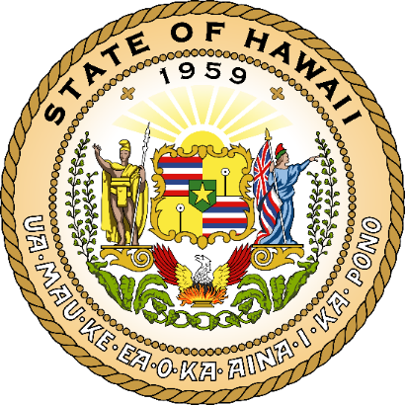
STATE OF HAWAIʻI | KA Mokuʻāina o Hawaiʻi

DEPARTMENT OF ACCOUNTING AND GENERAL SERVICES | KA ʻOihana LOIHELU A LAWELAWE Laulā

Workplace EV Charging
Lower Emissions, Lower Costs
- DAGS is helping the State reduce carbon emissions and save on energy costs long-term.
Workplace Charging Made Easy
- Employees can charge EVs at work; no home charger needed.
- Convenient, accessible, and supportive of sustainable commuting.
Benefits for Employees
- Easier transition to electric vehicles.
- Reduced dependence on fossil fuels.
- Supportive infrastructure right at work.
Benefits for the State
- Contributes to environmental goals.
- Reduces fleet and energy costs.
- Promotes sustainable workplace practices.

