JOSH GREEN, M.D.  GOVERNOR  Ke Kiaʻāina |  | KEITH A. REGAN  COMPTROLLER  Ka Luna Hoʻomalu Hana Laulā  MEOH-LENG SILLIMAN  DEPUTY COMPTROLLER  Ka Hope Luna Hoʻomalu Hana Laulā
STATE OF HAWAIʻI | KA Mokuʻāina o Hawaiʻi

DEPARTMENT OF ACCOUNTING AND GENERAL SERVICES | KA ʻOihana LOIHELU A LAWELAWE Laulā
P.O. BOX 119, HONOLULU, HAWAII 96810-0119

Communications, Technical, and Finance Meeting
(Combined Meeting)

Thursday, March 12, 2026
9:00 am – 12:00 pm

Virtually Held Meeting with Physical Location at
Kalanimoku Building Room 426, 1151 Punchbowl Street, Honolulu, Hawaii 96813 is available to the public and is guaranteed to be connected to the remote virtual meeting.

MEETING MINUTES

March 12, 2026: Joint Committee and Board Meeting (youtube.com)

Communications Committee Members Present: Davlynn Racadio (MPD), Lavina Taovao (KPD)

Communications Committee Members Not Present: Ah Lan Leong (HPD)

Technical Committee Members Present: Stacy Domingo (HIFD), Tony Ramirez (V2X), Kenison Tejada (FirstNet), Tony Velasco (DIT)

Technical Committee Members Not Present: Shawn Kuratani (HFD)

Finance Committee Members Present: Matthew Kurihara (HPD), Todd Omura (CIO Designee), Tony Velasco (DIT)

Finance Committee Members Not Present: Edward Fujioka (EMS), Stephen Courtney (C&C of Honolulu), Liz Gregg (AT&T), Reed Mahuna (HIPD)

Staff: Royce Murakami (911 Board), Benson Leung (911 Board), Candace Park (AG)

Guests: Darin Biamonte (Mission Critical), Brian Boezeman (Intrado), Christian Burns (HT), Sean Chun (HFD), Frannie Chung (EMS), Ruth Cruz (Intrado), Marc De Costa (HT), Savannah Heckman (EagleView), Robert Horne (Mission Critical), Melia Johnson (MPD), David Jones (Mission Critical), Elliott K. Ke (KPD), Kurt Lager (OS), Rebecca Lieberman (Spectrum), Crystal McDonald (Mission Critical), Brian McKee (DIT), Andrew Muraoka (KPD), Sherryann Murphy (EMS), Neil Pang (HPD), Candace Park (AG), Stacy Perreira (KPD), Kapu Ping (OS), Megan Reilly (EagleView), Corey Shaffer (Verizon), Isaac Tejada (EMS), Justin Tokioka (DCAB), Keola Tom (MPD), Jason Wong (EOA)

- Call to Order, Public Notice
The meeting was called to order by the Board Chair. Public notice was given.

- Public Testimony Will Be Taken on All Agenda Items as Those Items Occur During the Meeting

- Roll Call, Quorum
A roll call was taken, quorum was present for all committees except the Finance Committee.

- Review and Approval of February Meeting Minutes on 2-12-2026
Board Chair requested a motion to approve February’s Meeting Minutes. Tony Velasco motioned to approve February’s Meeting Minutes. Todd Omura seconded the motion. A voice vote was taken, motion was unanimously approved.

- Committee Updates by Committee Chairs
  - Communications Committee – Davlynn Racadio
    - Update from Conference Attendees for 9-1-1 Goes to Washington (GTW), February 22-25, 2026, Arlington, VA
Davlynn Racadio referenced the item above and requested updates from conference attendees.

Executive Director stated that the 9-1-1 Goes to Washington conference went well overall and highlighted the teamwork amongst attendees. He added that congressman Ed Case seemed receptive to supporting the two bills being S. 725 (reclassifying telecommunicators) and H.R. 6505 (NG911 funding).

Administrative Services Assistant stated that the 9-1-1 Goes to Washington conference and meetings with legislators went well overall.

Matthew Kurihara concurred with the Executive Director and Administrative Services Assistant. He mentioned that it is very likely that S. 725 (reclassifying telecommunicators) will be passed. He added that the 911 Board should monitor H.R. 6505 (NG911 funding) since it is a relatively new bill.

Keola Tom thanked Davlynn Racadio for scheduling and coordinating the meetings with legislators. He stated that these meetings were beneficial for the attendees and legislators to bolster mutual support.

Melia Johnson commented that the Hawaii contingent featured diverse representation from the 911 Board, which allowed specific subject matter experts to answer questions thoroughly and accurately. She added that the 9-1-1 Goes to Washington conference went well overall and was successful.

Marc De Costa stated that he was impressed with the professionalism and expertise of the various members from the Hawaii contingent during meetings and discussions with legislators and their respective teams/staffers when providing responses and/or explanations.

Davlynn Racadio expressed her appreciation for this year’s Hawaii contingent that attended the 9-1-1 Goes to Washington conference. She concurred with Melia Johnson and Marc De Costa regarding the contingent’s depth of knowledge/experience and teamwork. She thanked the 911 Board for supporting this conference. She added that the Executive Director is creating publicity/promotional material to showcase the efforts made during the 9-1-1 Goes to Washington conference. Executive Director stated that he will seek comments and revisions before finalizing the aforementioned material.

  - Technical Committee – Shawn Kuratani
    - Mission Critical Partners Presentation Regarding Automated Secure Alarm Protocol (ASAP)
Executive Director requested an update from David Jones regarding the item above.

David Jones introduced Crystal McDonald who is an account executive with Mission Critical Partners (MCP) on the Automated Secure Alarm Protocol (ASAP) team.


Crystal McDonald stated that she has been with MCP for over a year now and previously had ~20 years of experience through various roles within an Arkansas police department.

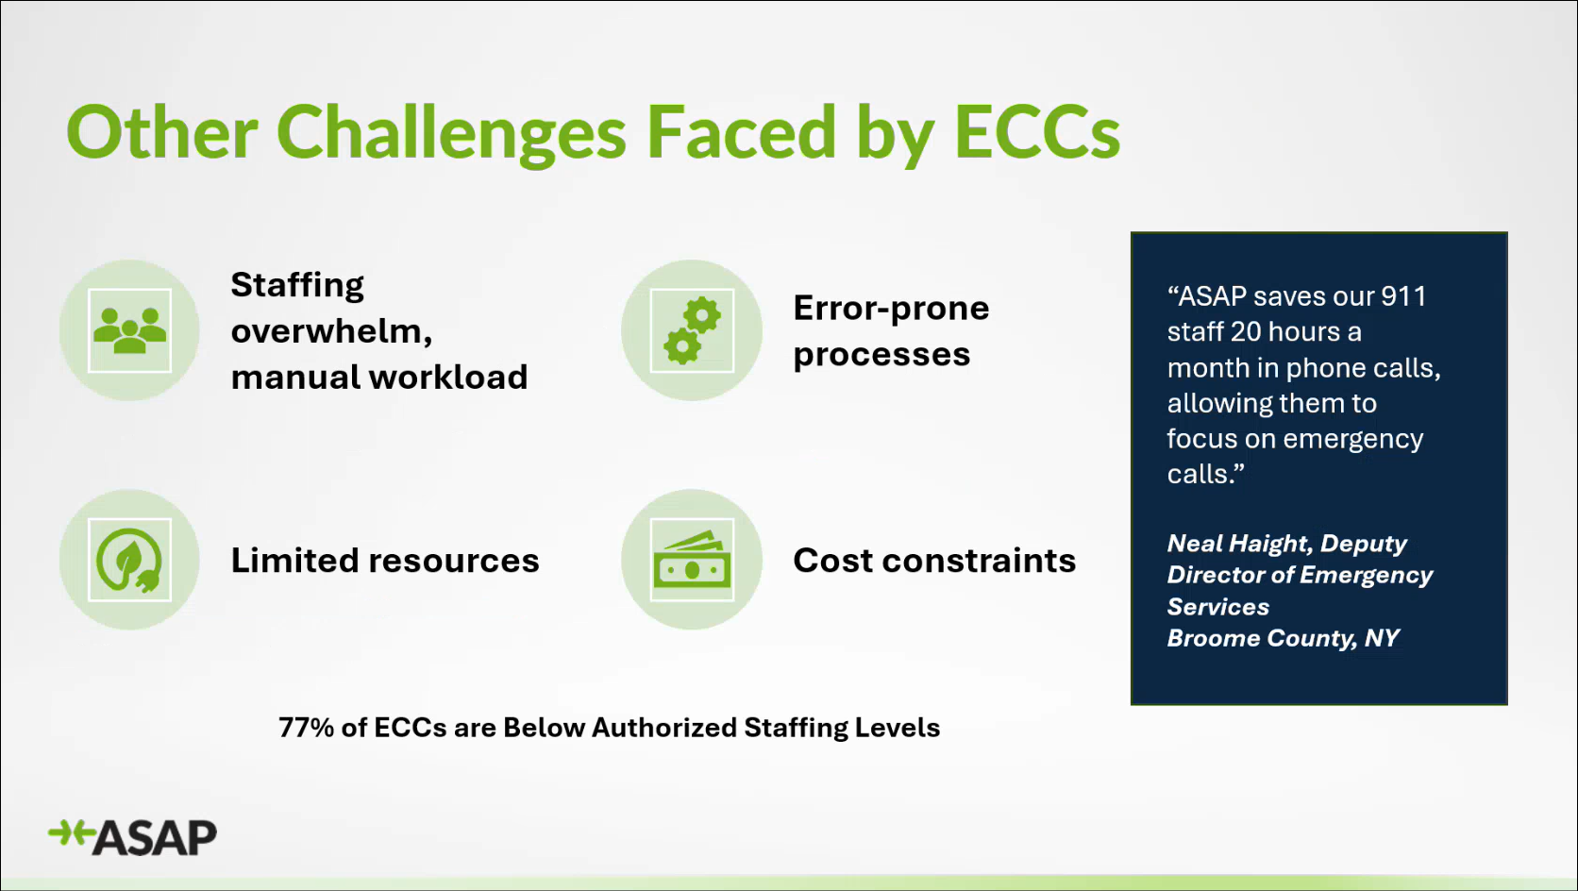
Crystal McDonald referenced the slide above regarding challenges that affect Emergency Communications Centers (ECC) nationwide. She stated that these aforementioned challenges were an issue when she started her career in dispatch ~20 years ago. She highlighted the most prominent issue being staffing shortages causing increased workloads for the existing telecommunicators/dispatchers. She added that 77% of all ECCs are reporting below authorized staffing levels.

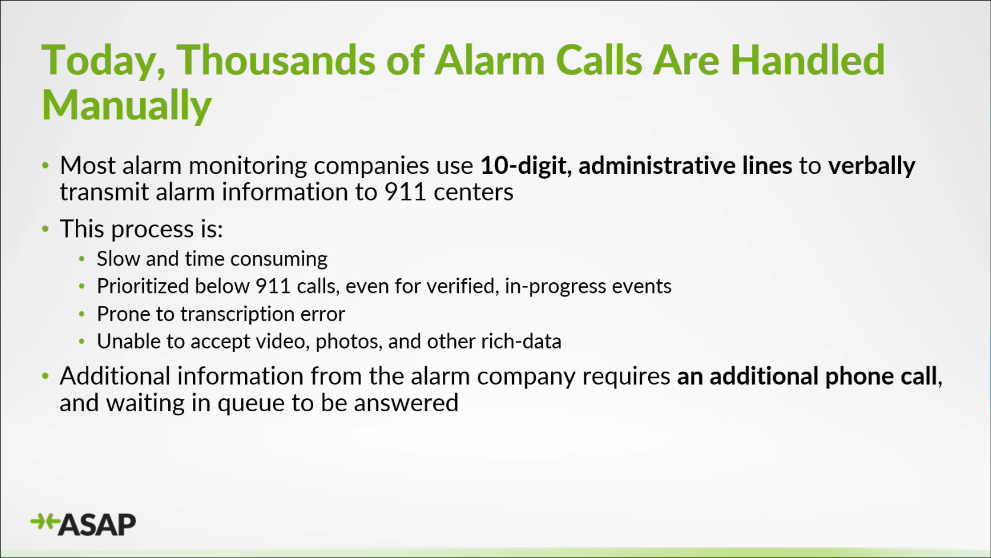
Crystal McDonald stated that ASAP is a program to help ECCs handle alarm calls. She then referenced the slide above regarding what an alarm call is and the issues involved that hinder proper and timely processing of these alarm calls.

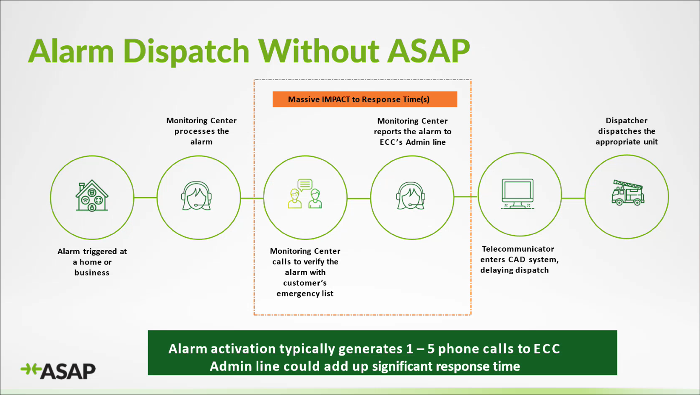
Crystal McDonald referenced the slide above regarding the general process to handle an alarm call without the ASAP program, which is manual and cumbersome.

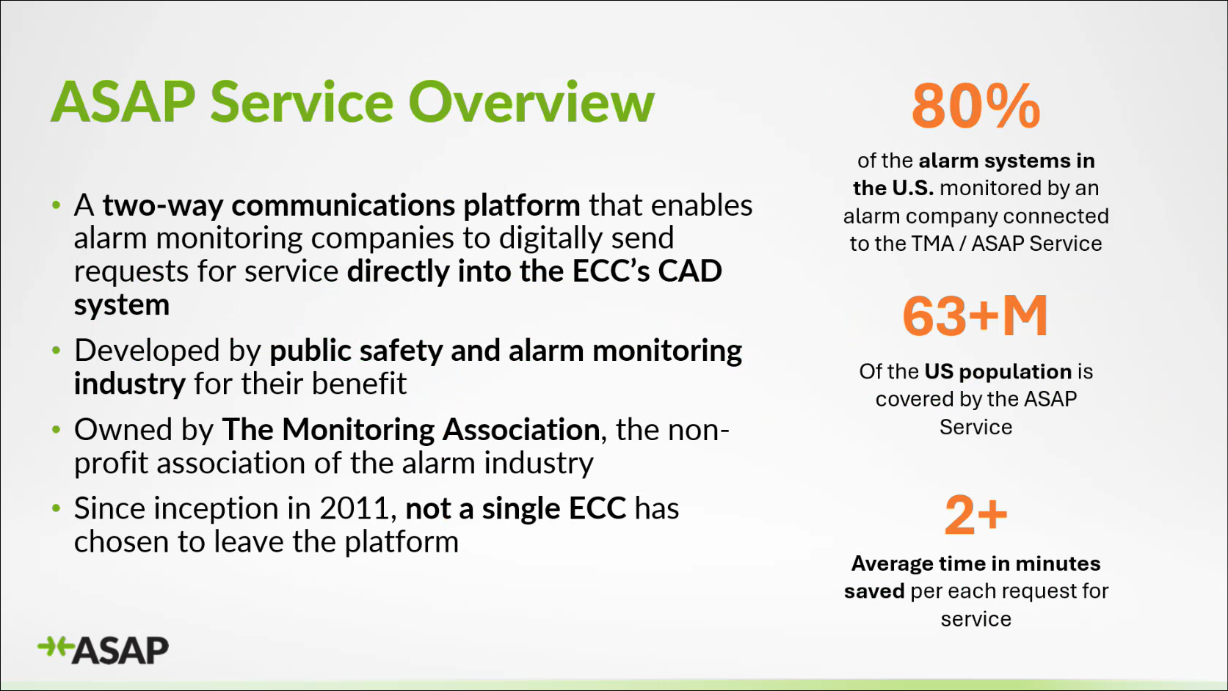
Crystal McDonald referenced the slide above regarding information about the ASAP program. She highlighted that the ASAP program has direct integration into an ECC’s Computer-Aided Dispatch (CAD) system, which streamlines the process to create a CAD incident/call. She stated that the average time of 2+ minutes saved shown in the slide above refers to the initial alarm call only and does not include the back-and-forth calls mentioned previously.

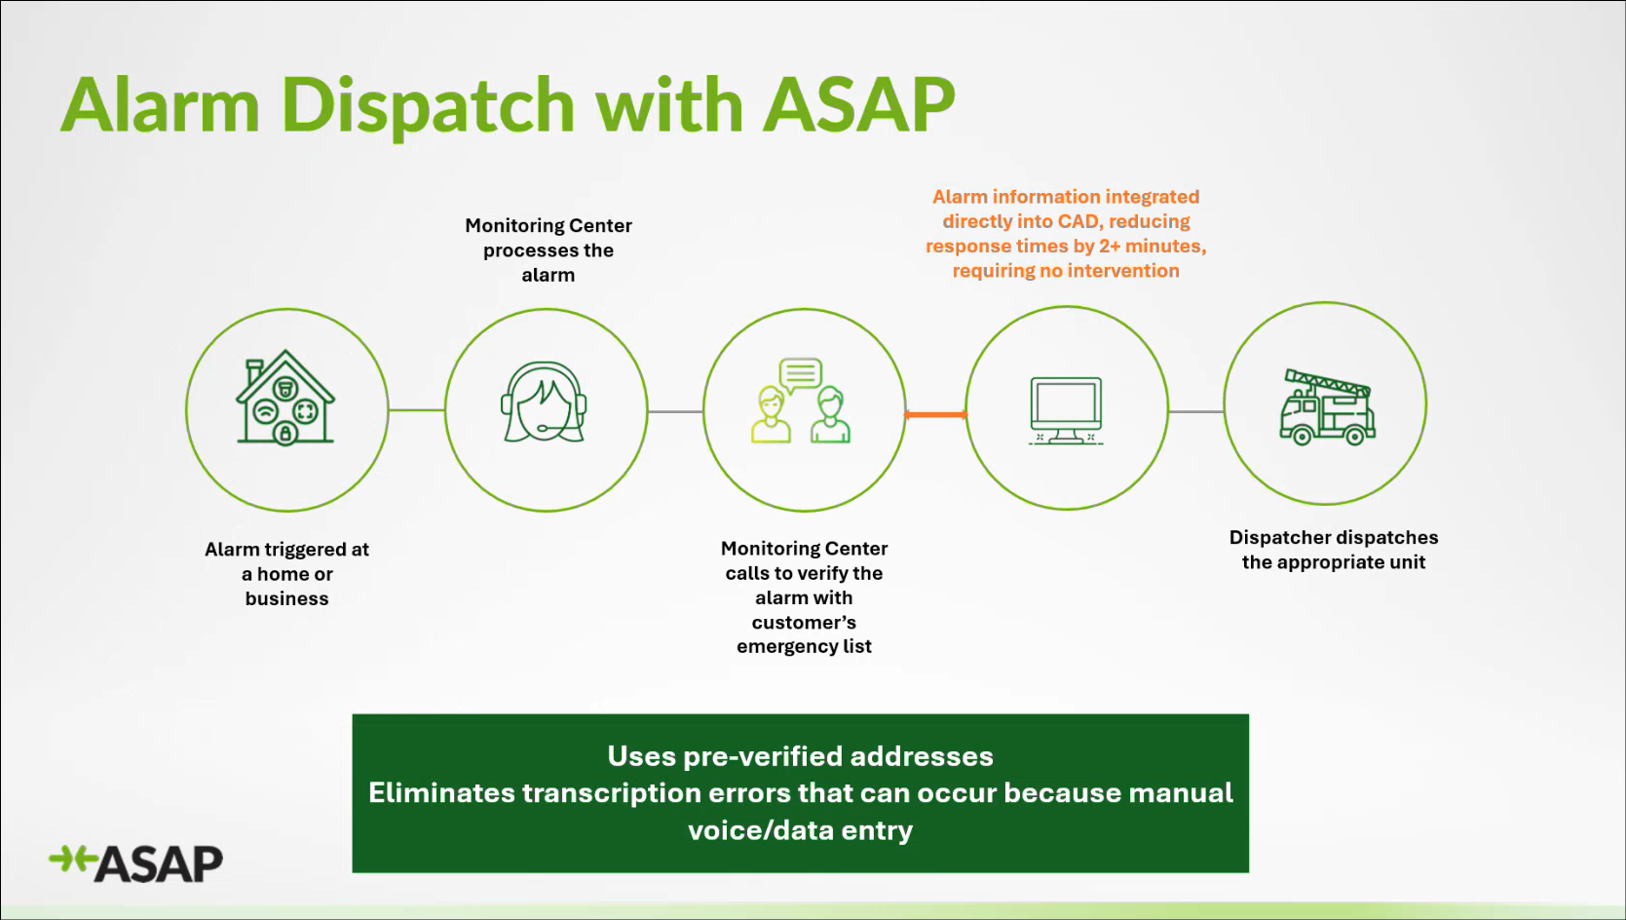
Crystal McDonald referenced the slide above regarding the general process to handle an alarm call with the ASAP program. She stated that the key feature/difference is direct CAD integration, which is highlighted in orange text above. She added that ASAP program implementation and integration requires front end work to compare and verify addresses between the ECC and monitoring center for pre-verification purposes to ensure accuracy and seamless transition.

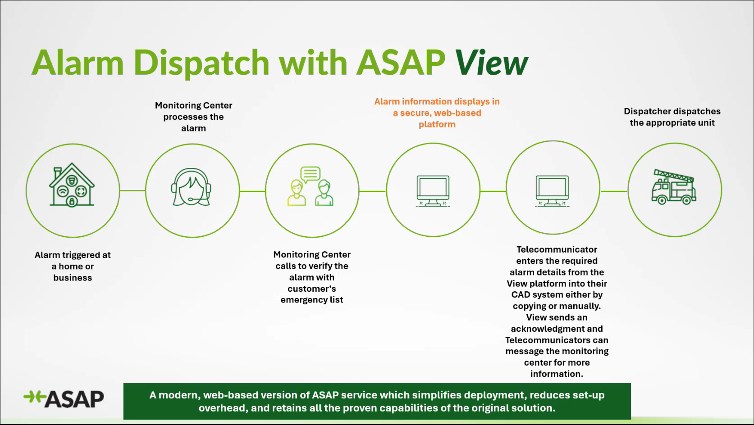
Crystal McDonald referenced the slide above regarding ASAP View, which is a web-based platform acting as a temporary solution while full CAD integration is being worked on. She added that phase one is ASAP View implementation, which takes about 4-6 weeks.

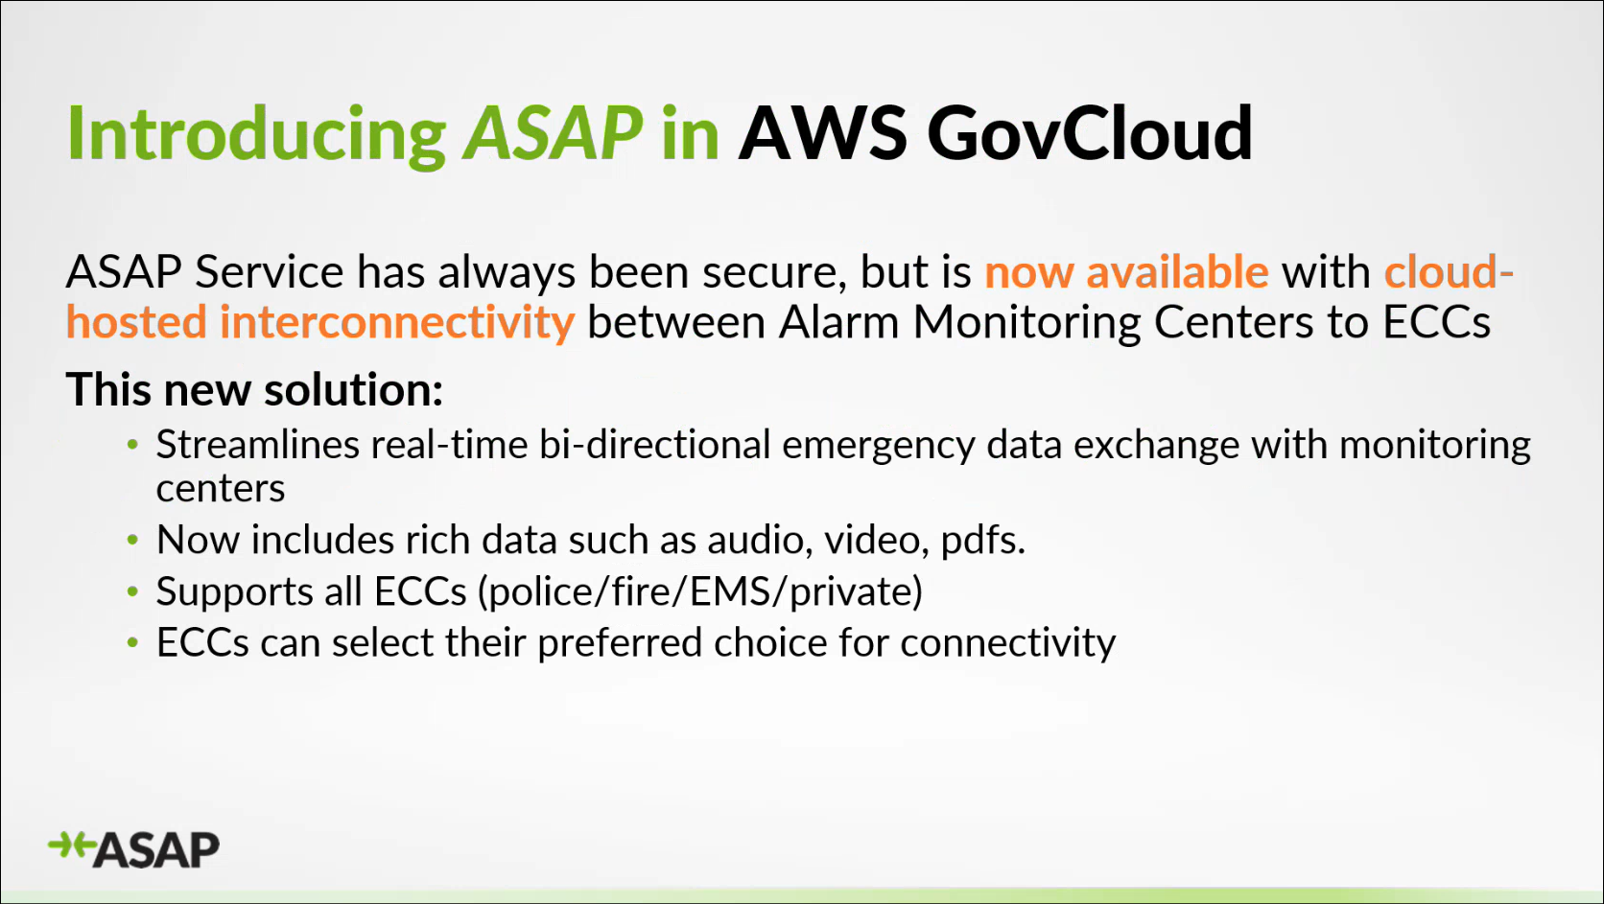
Crystal McDonald referenced the slide above regarding the ASAP program features. She stated that the ASAP interface is built through Amazon Web Services (AWS) GovCloud. She highlighted that the ASAP program allows for two-way communication between the ECC and monitoring center, which eliminates any back-and-forth calls.

David Jones stated that ASAP was created ~15 years ago and is a standard adopted by the Association of Public-Safety Communications Officials (APCO) and The Monitoring Association (TMA). He added that previously ASAP was built to operate on a state switch but has changed to AWS GovCloud, which provides significant technical flexibility.

Marc De Costa asked Crystal McDonald how does the ASAP program handle alarm calls via toll free numbers. Crystal McDonald responded stating that the ASAP program replaces toll free numbers with its digital interface.


Crystal McDonald referenced the slide above highlighting a few of the ASAP program’s participating alarm companies and CAD vendors. She stated that they are actively pursuing other alarm monitoring centers to participate.

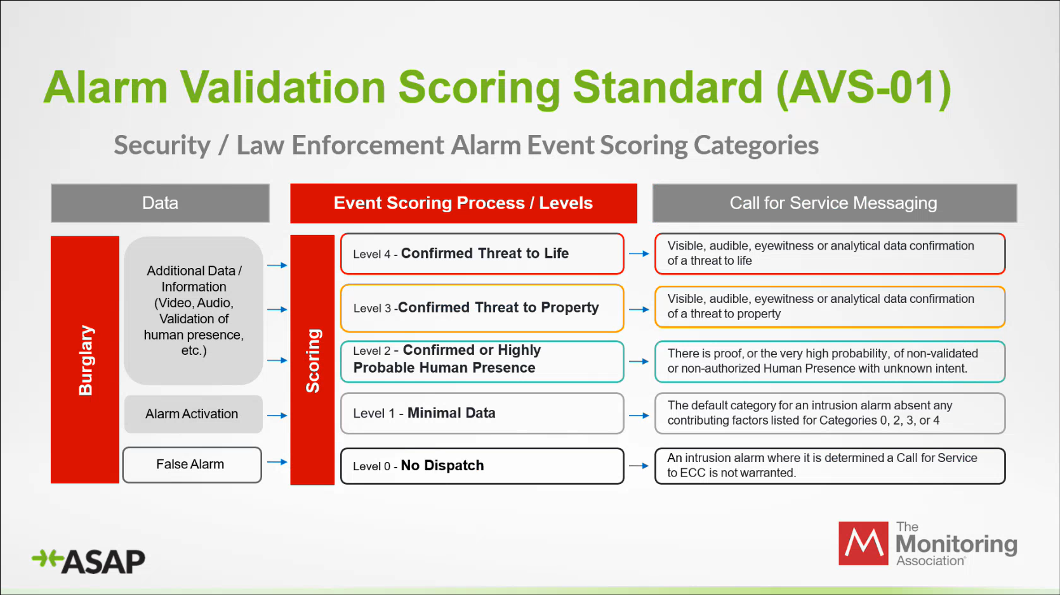
Crystal McDonald referenced the slide above regarding an example of the alarm validation scoring standard developed by TMA in partnership with APCO. She added that the ASAP program is the only standards-based solution for automation of alarms. She mentioned that this scoring standard is currently only for security and law enforcement alarms but TMA is in the process of expanding it to cover fire and EMS.

David Jones stated that he is an advocate for this aforementioned scoring standard given the sheer volume of false alarm incidents. In addition, he commented that this scoring standard provides information regarding the severity of the alarm.

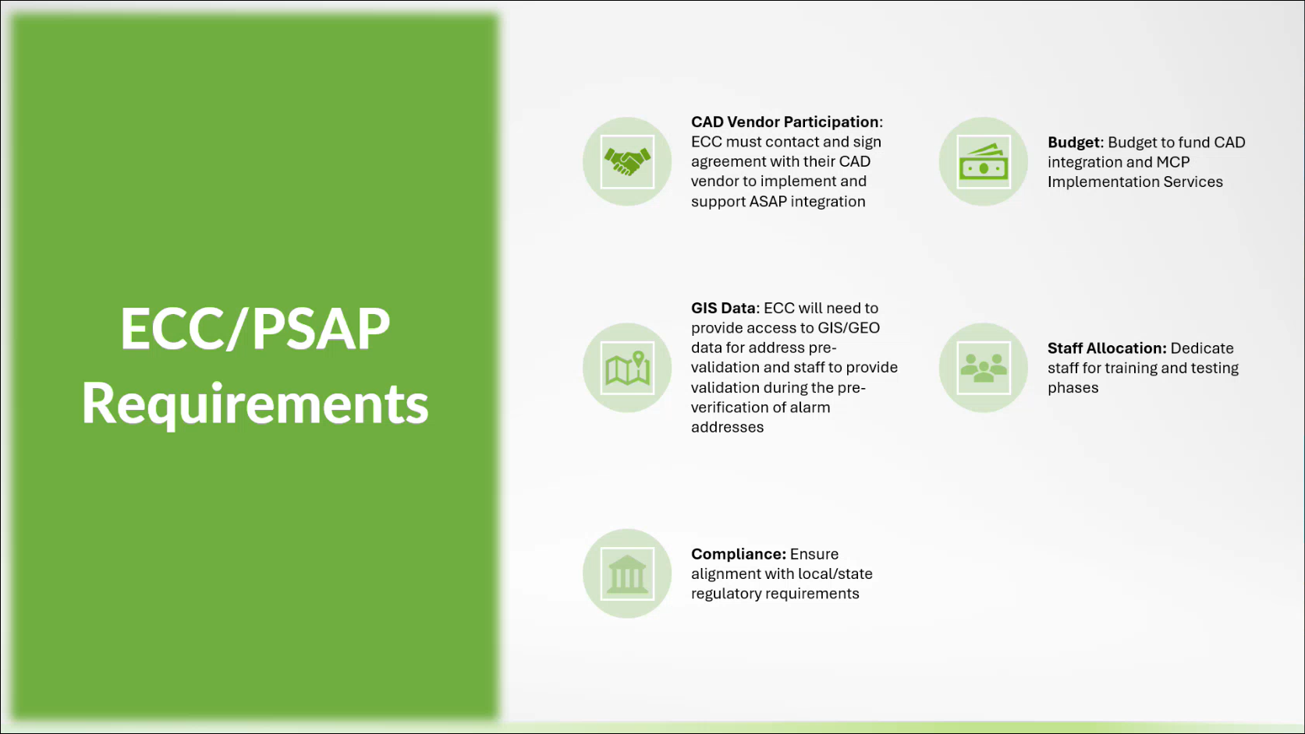
Crystal McDonald referenced the slide above regarding ECC requirements for the ASAP program. She stated that MCP charges the ECC a one-time fee for implementation services. She added that the ECC will also need to inquire with their respective CAD vendor regarding ASAP integration costs.


Crystal McDonald referenced the slide above regarding benefits of the ASAP program.

      - Advisory Committee – Rebecca Lieberman
        - Updates on Legislative Session
        - Discussion Regarding HB 1577 HD1 – Requires the 911 Board to establish a Statewide Emergency Safety Profile System Pilot Program and convene a working group. Requires report to the Legislature. Repeals on 6/30/2031. Effective 7/1/3000.
        - Discussion Regarding SB 2921 – Transfers to the general fund the excess balances of various non-general funds and programs.
        - Discussion Regarding SB 2377 SD1 / HB 1798 HD1 – Establishes the offense of criminal property damage to critical infrastructure facilities as a class C felony. Expands the term "critical infrastructure" to include broadband and cable networks. Effective 9/1/2050.
Please see Board Meeting Minutes on 3-12-2026.

  - Finance Committee – Edward Fujioka
    - Review of Monthly Y-T-D (Year to Date) Cash Flow
February 2026 Cashflow Statement:

Surcharge Collection: $1,038,859
Interest Income: $99,742
Total Receipts: $1,138,601
Total Disbursements: ($664,459)
Net Receipts/Disbursements: $474,142
Net Encumbrances Adds/(Paydown): ($363,402)
Net Cash Inflow/(Outflow): $110,740
Outstanding Encumbrances: $8,383,897
Net Bank Balance: $47,468,826
Unencumbered Cash Balance: $39,084,929

- Next Generation 911 (NG911) Readiness Assessment Recommendations and Next Steps
  - Discussion of Governance Action Items
    - Update Regarding Permitted Interaction Group (PIG) to Develop Next Generation (NG911) Strategic Plan
    - Update Regarding Permitted Interaction Group (PIG) to Develop State-Level Continuity of Operations Plan (COOP)
Corey Shaffer referenced the items above and requested an update from the Executive Director.

Executive Director stated that MCP presented high level documents regarding NG911 implementation, project management support, and strategic planning support during the most recent PIG meeting. He added that MCP would assist with drafting service level agreements (SLA). He mentioned that the PIG is currently awaiting a cost estimate from MCP for the aforementioned services. Tony Ramirez stated that they inquired with MCP regarding standard expectations of a Next Generation Core Services (NGCS) provider. Corey Shaffer added that the 911 Board should also clarify the ownership and location of any NG911 equipment.

- Public Safety Answering Point Status Updates on Recruitment and other Personnel Issues
  - Kauai Police Department – Andrew Muraoka
    - Update on Recruitment Process/Strategies and Personnel Training
Andrew Muraoka stated that they currently have 3 applicants in the background check stage. He added that they also have 1 applicant who will be interviewed next month.

    - Update on Personnel Issues and Vacancies
Andrew Muraoka stated that they currently have a ~50% vacancy rate.

  - Oahu Police Department – Bradon Ogata, Ah Lan Leong
    - Update on Recruitment Process/Strategies and Personnel Training
Ah Lan Leong not present to provide an update.

    - Update on Personnel Issues and Vacancies
Ah Lan Leong not present to provide an update.

  - Oahu Fire Department – Shawn Kuratani
    - Update on Recruitment Process/Strategies and Personnel Training
Sean Chun on behalf of Shawn Kuratani stated no updates.

    - Update on Personnel Issues and Vacancies
Sean Chun on behalf of Shawn Kuratani stated that they are currently fully staffed.

  - Oahu Emergency Medical Services – Isaac Tejada, Frannie Chung, Sherryann Murphy
    - Update on Recruitment Process/Strategies and Personnel Training
Isaac Tejada stated that they recently completed 6 interviews yesterday and are planning to hire 3 of those applicants. He added that they are planning to start their EMD academy in July 2026 with 8 potential applicants who are currently in the background check stage.

    - Update on Personnel Issues and Vacancies
Isaac Tejada stated that they currently have a ~29% vacancy rate with 8 total vacant positions.

  - Maui Police Department – Davlynn Racadio, Melia Johnson
    - Update on Recruitment Process/Strategies and Personnel Training
Davlynn Racadio stated that they currently have 4 personnel in training. She added that they completed interviews last week and are planning to start a training class in April 2026.

    - Update on Personnel Issues and Vacancies
Davlynn Racadio stated no updates.

  - Molokai Police Department – Davlynn Racadio, Melia Johnson
    - Update on Recruitment Process/Strategies and Personnel Training
Please see updates under Maui Police Department.

    - Update on Personnel Issues and Vacancies
Please see updates under Maui Police Department.

  - Hawaii Police Department – Zachary Fernando
    - Update on Recruitment Process/Strategies and Personnel Training
Executive Director on behalf of Zachary Fernando stated no updates.

    - Update on Personnel Issues and Vacancies
Executive Director on behalf of Zachary Fernando stated no updates.

  - Hawaii Fire Department – Stacy Domingo
    - Update on Recruitment Process/Strategies and Personnel Training
Stacy Domingo stated that they currently have 2 personnel in training.

    - Update on Personnel Issues and Vacancies
Stacy Domingo stated that they currently have a ~54% vacancy rate due to 1 personnel resigning earlier this week, which is 11 out of 24 total positions filled. She added that they have 1 personnel on extended leave.

- Items for Discussion, Consideration, and Action
  - Additional Items Proposed by Meeting Attendees for Consideration and Possible Inclusion on Future Agendas

- Announcements
  - Future Virtual Meeting Dates/Times (9:00AM-12:00PM)
    - Thursday, April 9, 2026 (Combined Meeting)
    - Thursday, May 7, 2026 (Combined Meeting)

  - Future Conference Dates (3 Months of Advanced Approval Required)
    - CentralSquare ENGAGE, March 15-18, 2026, Washington, D.C.
    - International Wireless Communications Expo (IWCE), March 16-19, 2026, Las Vegas, NV
    - Summit Conference (Motorola Solutions), April 19-23, 2026, Orlando, FL
    - Navigator Conference, April 21-24, 2026, Las Vegas, NV
    - NICE Conference & Expo (National Initiative for Cybersecurity Education), June 1-3, 2026, Philadelphia, PA
    - NENA Conference & Expo (National Emergency Number Association), June 27-July 2, 2026, Columbus, OH
    - APCO Conference & Expo (Association of Public-Safety Communications Officials), August 2-5, 2026, San Antonio, Texas

  - Additional Announcements from Meeting Attendees for Consideration and Possible Inclusion on Future Agendas

- Open Forum: Public Comment on Issues not on the Board Meeting Agenda; no Board action on matters not on the agenda
There was no public comment on issues not on the agenda.

- Adjournment
Board Chair requested a motion to adjourn the meeting. Tony Ramirez motioned to adjourn the meeting. Tony Velasco seconded the motion. A voice vote was taken, adjournment was unanimously approved. The meeting was adjourned.

