JOSH GREEN, M.D.  GOVERNOR  Ke Kiaʻāina |  | KEITH A. REGAN  COMPTROLLER  Ka Luna Hoʻomalu Hana Laulā  MEOH-LENG SILLIMAN  DEPUTY COMPTROLLER  Ka Hope Luna Hoʻomalu Hana Laulā
STATE OF HAWAIʻI | KA Mokuʻāina o Hawaiʻi

DEPARTMENT OF ACCOUNTING AND GENERAL SERVICES | KA ʻOihana LOIHELU A LAWELAWE Laulā
P.O. BOX 119, HONOLULU, HAWAII 96810-0119

Communications, Technical, and Finance Meeting
(Combined Meeting)

Thursday, February 12, 2026
9:00 am – 12:00 pm

Virtually Held Meeting with Physical Location at
Kalanimoku Building Room 426, 1151 Punchbowl Street, Honolulu, Hawaii 96813 is available to the public and is guaranteed to be connected to the remote virtual meeting.

MEETING MINUTES

February 12, 2026: Joint Committee and Board Meeting (youtube.com)

Communications Committee Members Present: Davlynn Racadio (MPD), Ah Lan Leong (HPD)

Communications Committee Members Not Present: Lavina Taovao (KPD)

Technical Committee Members Present: Shawn Kuratani (HFD), Stacy Domingo (HIFD), Tony Ramirez (V2X), Kenison Tejada (FirstNet), Tony Velasco (DIT)

Technical Committee Members Not Present: None

Finance Committee Members Present: Edward Fujioka (EMS), Stephen Courtney (C&C of Honolulu), Liz Gregg (AT&T), Matthew Kurihara (HPD), Todd Omura (CIO Designee), Tony Velasco (DIT)

Finance Committee Members Not Present: Reed Mahuna (HIPD)

Staff: Royce Murakami (911 Board), Benson Leung (911 Board), Charles Lee (AG)

Guests: Francis Alueta (HT), Darin Biamonte (Mission Critical), Brian Boezeman (Intrado), Christian Burns (HT), Sean Chun (HFD), Ruth Cruz (Intrado), Marc De Costa (HT), Zachary Fernando (HIPD), Buck Giles (OS), Sherri Griffith Powell (Mission Critical), Wayne Hirasa (Alakaina), David Jones (Mission Critical), Ji Sook Kim (Consumer Advocate Designee), Michelle Kratel (HIPD), Kurt Lager (OS), Charles Lee (AG), Rebecca Lieberman (Spectrum), Andrew Muraoka (KPD), Sherryann Murphy (EMS), Tamera Neal (Intrado), Bradon Ogata (HPD), Neil Pang (HPD), Kyle Penna (GovWorx), Stacy Perreira (KPD), Jeff Reeve (AT&T), Ernest Robello (DLE), Corey Shaffer (Verizon), Isaac Tejada (EMS), Keola Tom (MPD)

- Call to Order, Public Notice
The meeting was called to order by the Board Chair. Public notice was given.

- Public Testimony Will Be Taken on All Agenda Items as Those Items Occur During the Meeting

- Roll Call, Quorum
A roll call was taken, quorum was present for all committees.

Board Chair observed a moment of silence to honor the life of deceased Fire Chief Kazuo Todd.

- Review and Approval of January Meeting Minutes
Board Chair requested a motion to approve January’s Meeting Minutes. Tony Velasco motioned to approve January’s Meeting Minutes. Rebecca Lieberman seconded the motion. A voice vote was taken, motion was unanimously approved.

- Committee Updates by Committee Chairs
  - Communications Committee – Davlynn Racadio
    - Discussion Regarding 9-1-1 Goes to Washington (GTW)
Davlynn Racadio referenced the item above and requested additional information from attendees such as NENA member or not, first timers or not, official job titles, work email addresses, and resident zip codes. She added that she is in the midst of scheduling meetings with one confirmed thus far and will follow up on the rest. Furthermore, she mentioned that there should be a contingent of 19 total people representing Hawaii for 9-1-1 Goes to Washington, which may require breakout groups for meetings due to the large number of attendees. She stated that this is to support recognizing telecommunicators as first responders and funding NG911. Lastly, she highlighted that the conference hosts a congressional breakfast to garner support for the aforementioned bills.

  - Technical Committee – Shawn Kuratani
    - Intrado Updated Roadmap Presentation
Shawn Kuratani requested an update from Brian Boezeman regarding the item above.

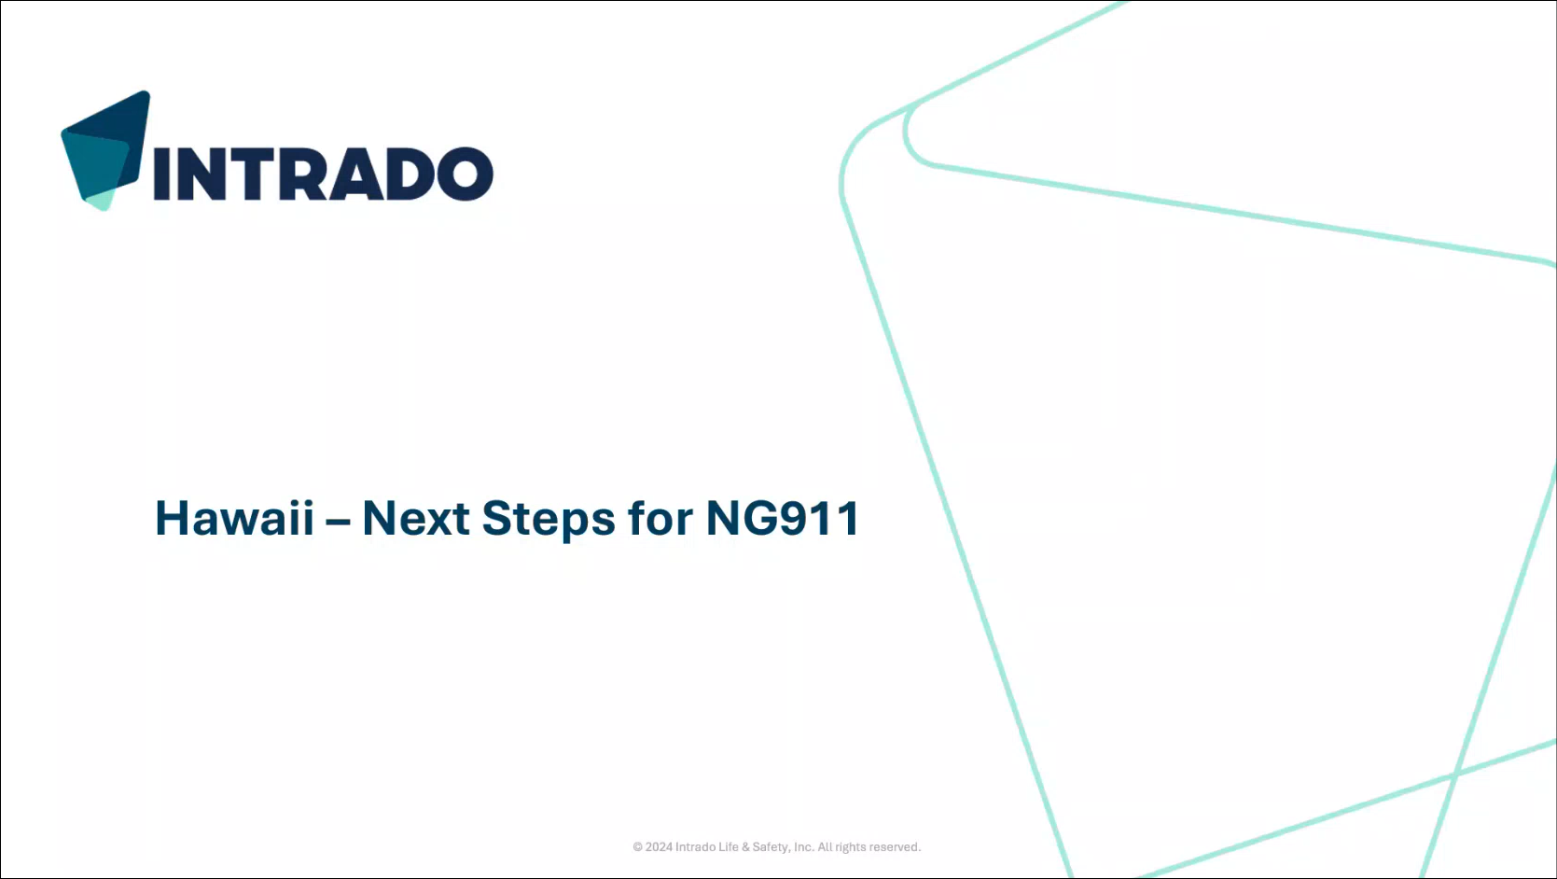
Brian Boezeman stated that this presentation will be covered at a high level mostly regarding the Next Generation 911 (NG911) transition for Hawaii, which will include discussion of the past efforts, future next steps, and estimated timelines.

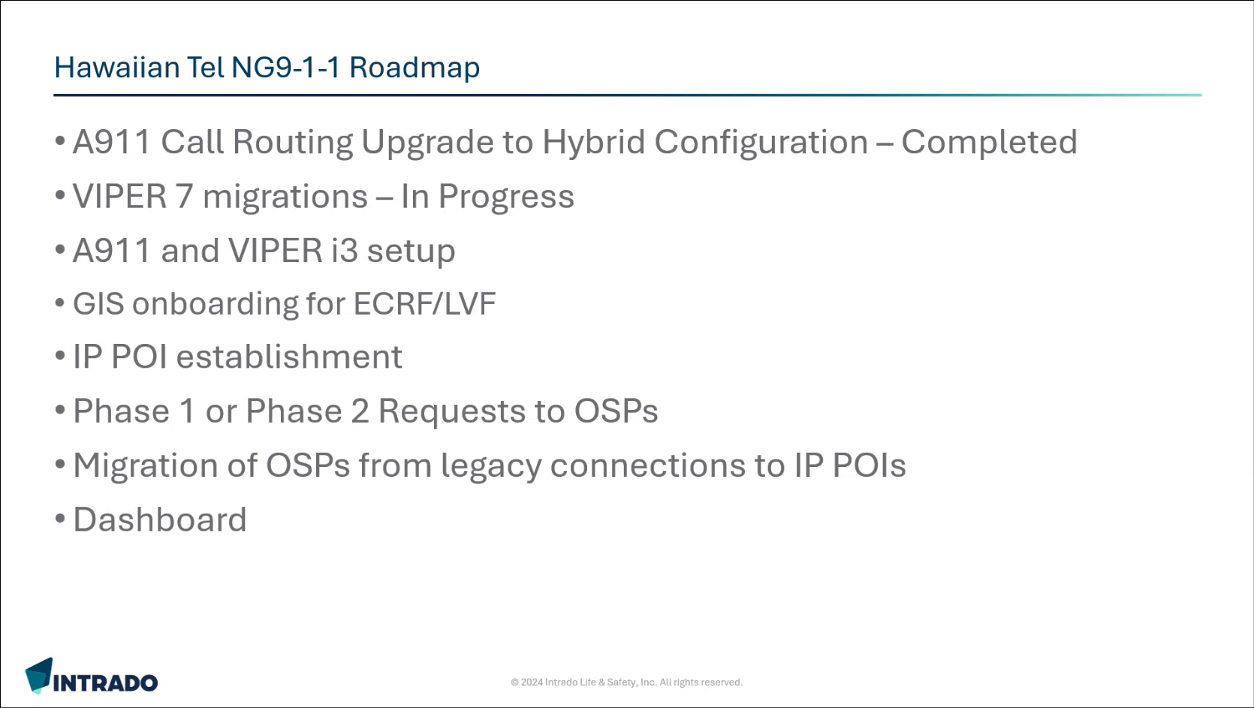
Brian Boezeman stated the topics that will be covered in the presentation.

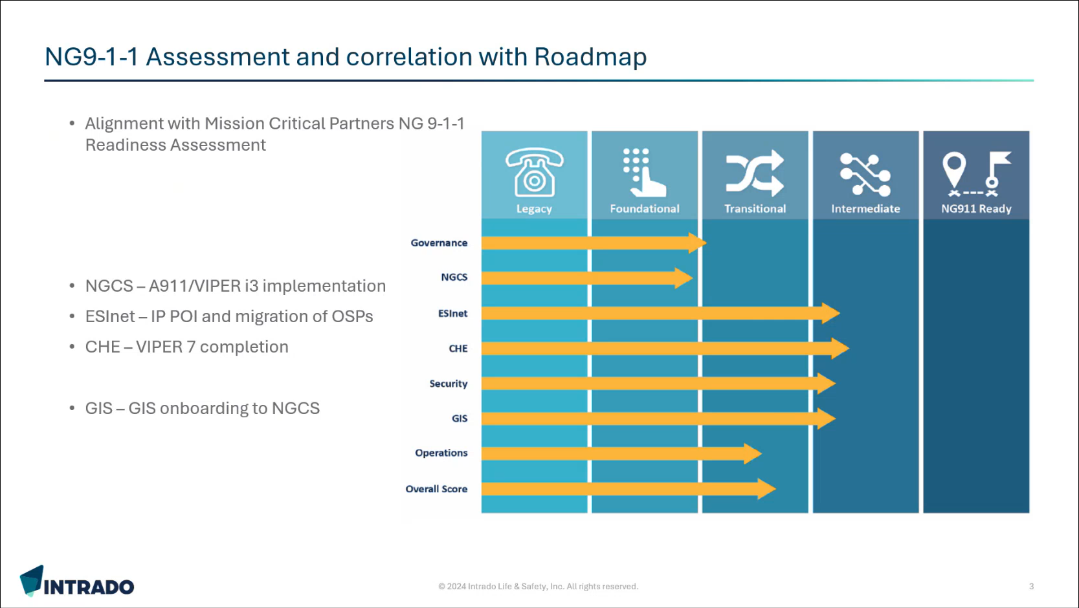
Brian Boezeman stated that Intrado’s NG911 roadmap took Mission Critical Partners’ (MCP) NG911 Readiness Assessment Report (completed in September 2025) into consideration for alignment purposes. He mentioned key focal points such as Next Generation Core Services (NGCS), Emergency Services IP Network (ESInet), Call Handling Equipment (CHE), and Geographic Information Systems (GIS). Furthermore, he stated that there are required upgrades for the A911/VIPER systems for full i3 implementation, ESInet for Internet Protocol (IP) Point of Interface (POI) to meet mandates, CHE for VIPER 7, and GIS for onboarding to NGCS.

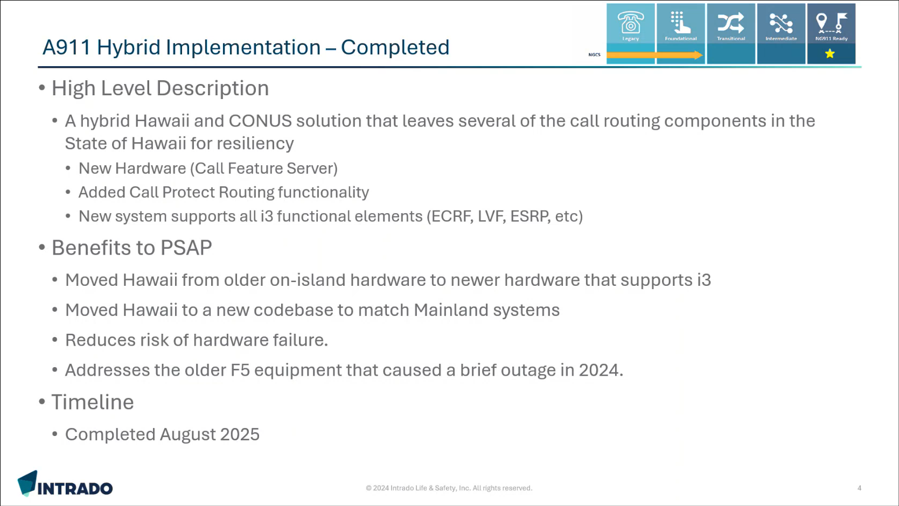
Brian Boezeman mentioned that the upper right-hand corner of the slide features a key that references a category stated in MCP’s NG911 readiness assessment report. He commented that Hawaii was utilizing an A911 system, which was unique to the state and lagged in terms of upgrades being hardware/software releases. He then stated that the on-site A911 Hybrid Implementation was completed in August 2025, which incorporates both Hawaii and Continental United States (CONUS) elements allowing the functionality of voice calls to remain within the state even if connectivity is lost to CONUS. He added that they may not have access to location data during connectivity loss to CONUS, which is due to carrier equipment being based in CONUS. Furthermore, he stated that they are using CONUS equipment for call routing and database lookups. Lastly, he highlighted that they transitioned to new hardware supporting i3, which provides access to the latest code base, reduces risk of hardware failures, and addresses F5 component issues.

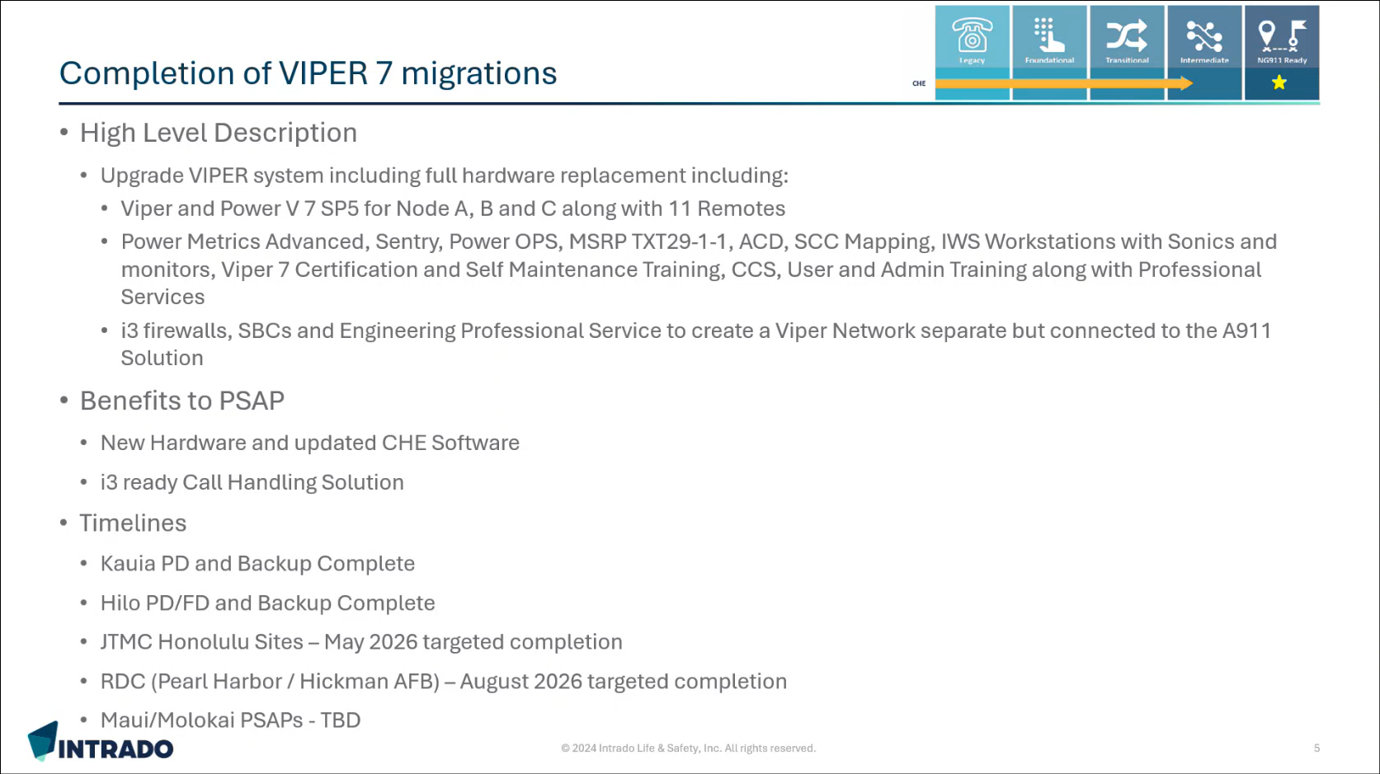
Brian Boezeman stated that they are in the midst of the VIPER 7 migrations utilizing Spatial Command & Control (SCC) mapping, which is i3 capable/ready and replaces the previous mapping system. He added that VIPER 7 migrations must be completed for all Public Safety Answering Points (PSAP) to enable full i3 implementation.

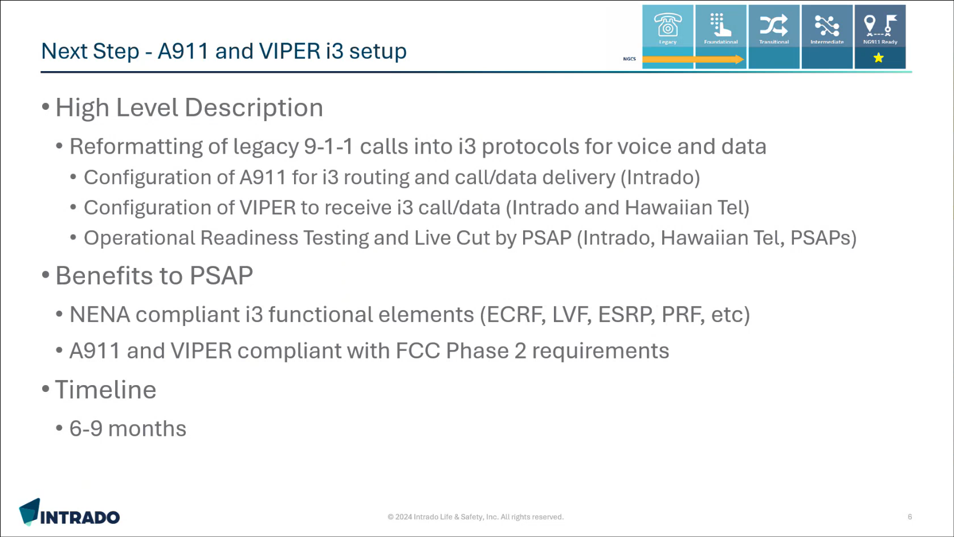
Brian Boezeman stated that current 911 calls from the A911 system to VIPER are delivered via Request for Assistance Interface (RFAI), which is a Session Initiation Protocol (SIP). He added that they need to reformat the in-place legacy protocols into i3 formats for full i3 implementation. He mentioned that the PSAPs will experience little to no change in their systems since the call data will remain mostly the same despite the call delivery method changing. He stated that they will conduct operational readiness testing for non-live calls to avoid any impact on the PSAPs’ operations. Furthermore, he highlighted that live cuts will only be implemented after successful test cases for each individual PSAP. Lastly, he commented that they will need the PSAPs to assist with testing calls and the live cutover process.

Brian Boezeman stated that the National Emergency Number Association (NENA) compliant i3 functional elements being Emergency Call Routing Function (ECRF), Location Validation Function (LVF), Emergency Service Routing Proxy (ESRP), and Policy Routing Function (PRF) are all currently in-place but not actively utilized because Hawaii has not fully transitioned to i3. He added that these aforementioned NENA elements help meet the Federal Communications Commission’s (FCC) Phase 2 requirements for NG911. He highlighted that LVF is a major component, which requires carriers to validate addresses using GIS data instead of Master Street Address Guide (MSAG) data for full NG911 transition. He commented that the completion timeline of the items mentioned in this slide will be around 6-9 months.

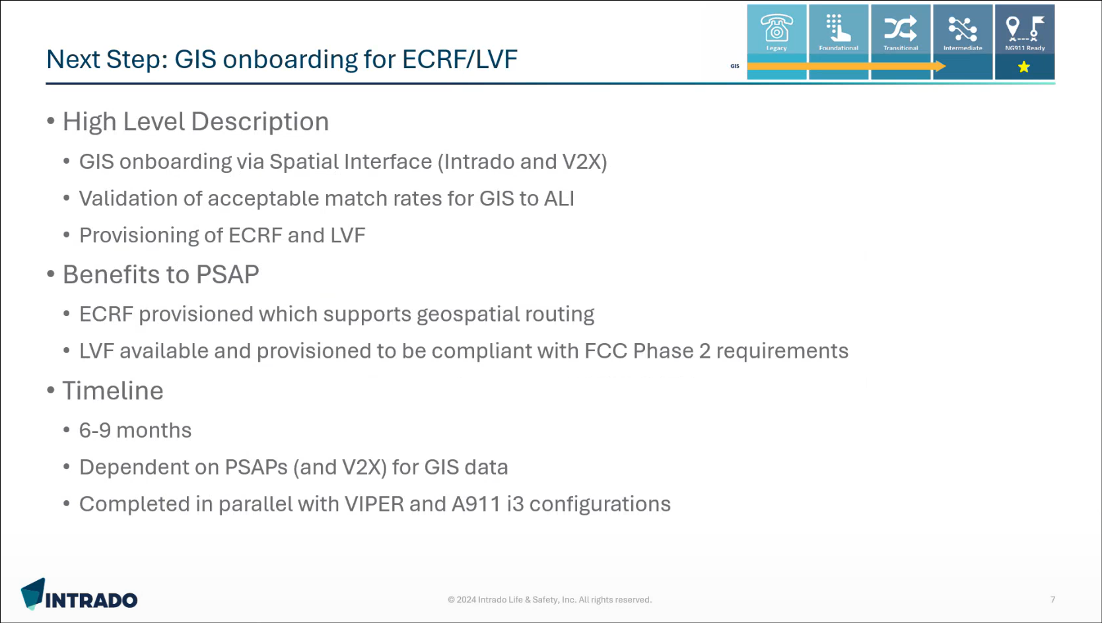
Brian Boezeman commented that the current routing of 911 calls is tabular, which utilizes a phone number, Emergency Service Number (ESN), and the corresponding PSAP. He stated that NG911 with full i3 implementation requires calls to be routed using the caller’s actual location. He added that they will be incorporating GIS data into the ECRF and LVF for carrier validation purposes. Furthermore, he mentioned that they will be working with V2X for acceptable match rates between GIS to Automatic Location Identification (ALI). He then highlighted V2X’s longstanding relationship with Hawaii regarding management of its GIS and MSAG data, which enables a smoother onboarding process. Lastly, he stated that this aforementioned GIS onboarding will be completed in parallel with the VIPER and A911 configurations so that it will be ready when the i3 call routing and protocols are initiated in order to route calls via GIS data.

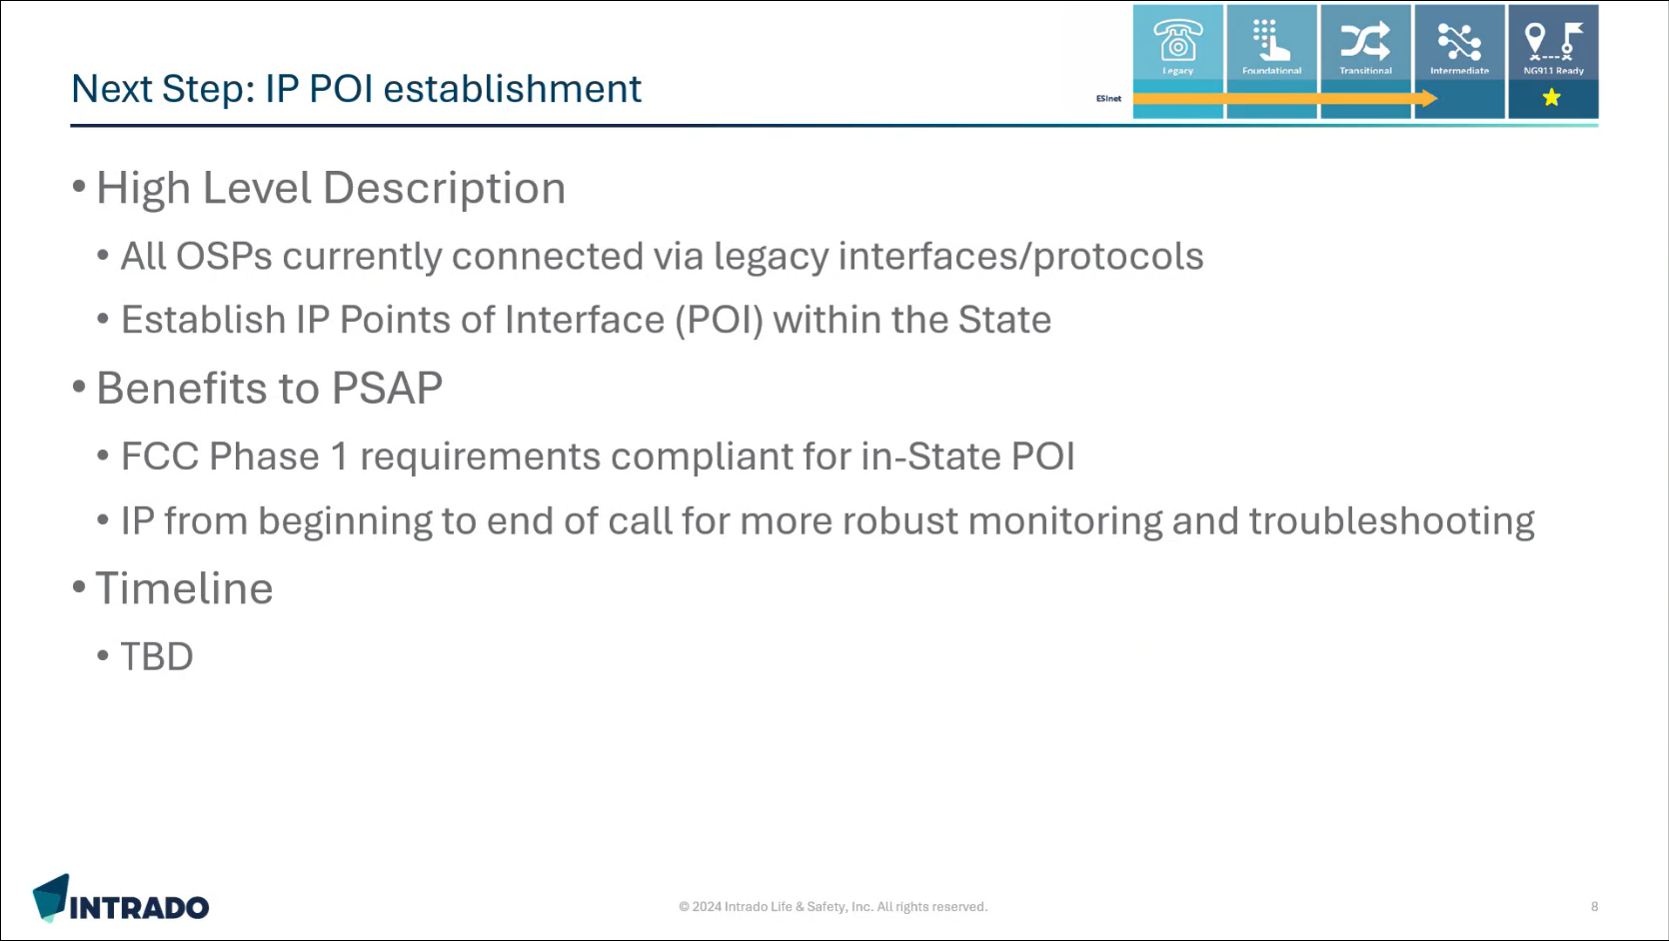
Brian Boezeman stated that currently all the carriers (wireless, wireline, and VoIP) are connected into Hawaii’s 911 system through legacy protocols such as time-division multiplexing (TDM) trunks/circuits, Primary Rate Interface (PRI), and NF trunks. He added that the FCC Phase 1 requirements include an in-state POI, which will be established in coordination with Hawaiian Telcom (HT). Furthermore, this would enable IP format connections for the carriers to send IP and i3 calls. Francis Alueta stated that they are working on the overall voice network to transform it from the legacy TDM switch to a soft switch. He added that currently this is the tandem switch based on the existing tariff. Furthermore, he mentioned that there are ongoing discussions whether the aforementioned tandem switch should transition to Intrado’s in-state selective router or not.

Corey Shaffer asked Brian Boezeman if an in-state POI is a mandatory requirement from the FCC or not. Brian Boezeman responded stating that the FCC requirements allow for negotiations of other POIs if warranted. He added that at least 1 in-state POI is required to encourage the aforementioned carriers to transition. Furthermore, he mentioned that there are other options available. Corey Shaffer commented that an in-state POI could potentially be more reliable.

Corey Shaffer asked Francis Alueta what is the estimated timeline for the in-state POI establishment. Francis Alueta responded stating that they need to determine where the in-state POI should exist and conduct resiliency discussions regarding whether additional mainland POIs are necessary or not.

Tony Ramirez asked Brian Boezeman who will be responsible for the IP routing and addressing plan for this hybrid configuration. Brian Boezeman responded stating that they will match the data received from a carrier to the GIS data consisting of street center line data, address point data, PSAP polygons, and first responder shapes for PSAP routing purposes. Tony Ramirez suggested discussing this further offline to develop the IP addressing plan. Brian Boezeman mentioned that the PRF is capable of volume distribution and alternate call routing to multiple areas.

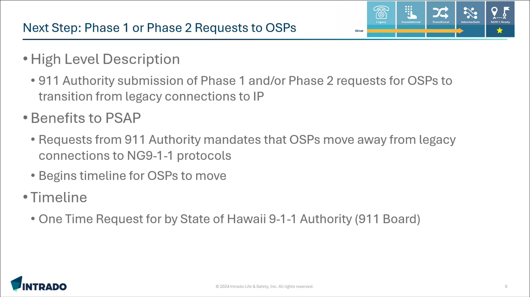
Brian Boezeman stated that the FCC requires the 911 authority to submit requests for the Originating Service Providers (OSP) to mandate transition from legacy connections to IP, which will start the completion timeline for the respective carriers. He mentioned that he believes this will be a one-time request to the carriers for Hawaii. He added that Intrado or HT could submit these aforementioned requests if permissible. Furthermore, he stated that they will work with the carriers to validate if Phase 1 and Phase 2 requirements are met or not.

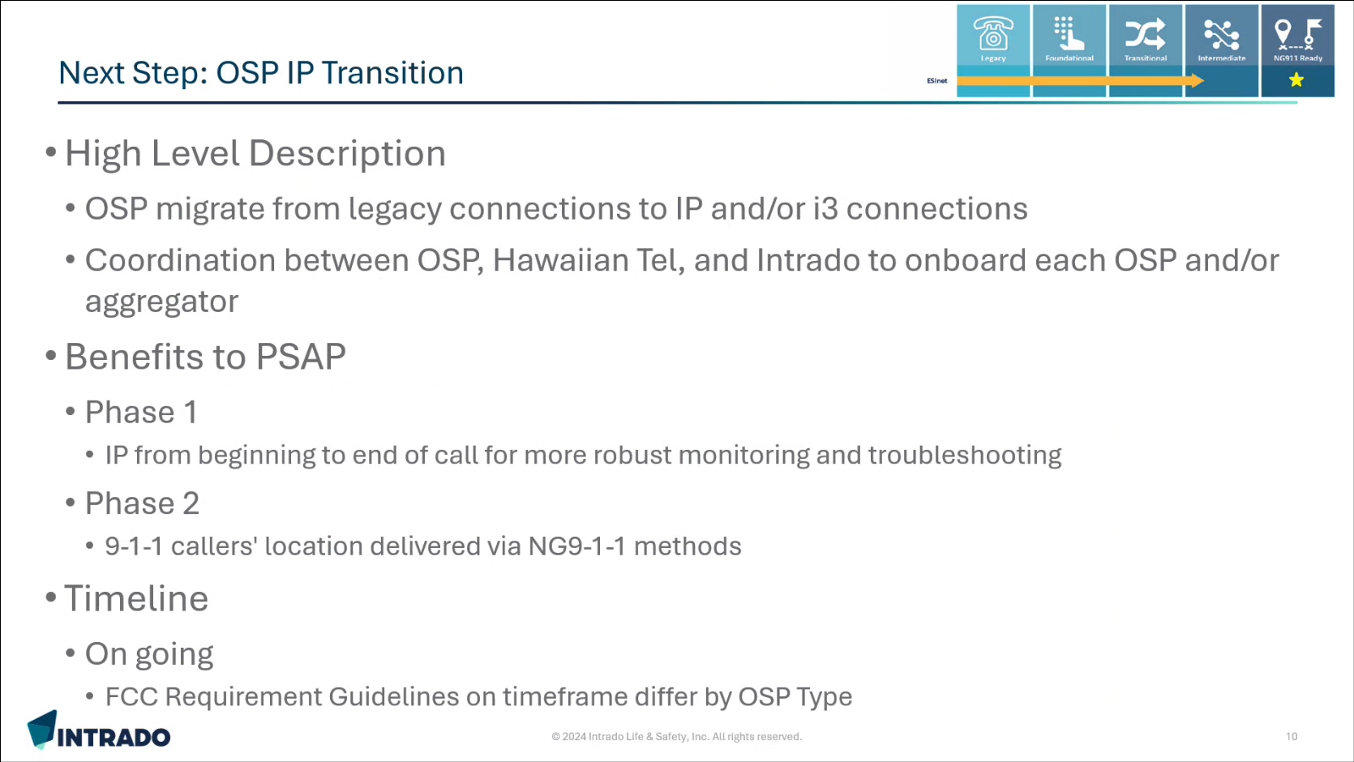
Brian Boezeman stated that Intrado and HT will work with each carrier to ensure a successful cutover from legacy connections to IP. He added that the OSP type will determine the completion timeline length. Furthermore, he mentioned that successful cutovers will enable i3. Corey Shaffer commented that some carriers are eager for this aforementioned cutover to improve reliability for the 911 system since it is the only service still utilizing copper. Brian Boezeman added that it is much easier to maintain and troubleshoot an IP network compared to a copper network.

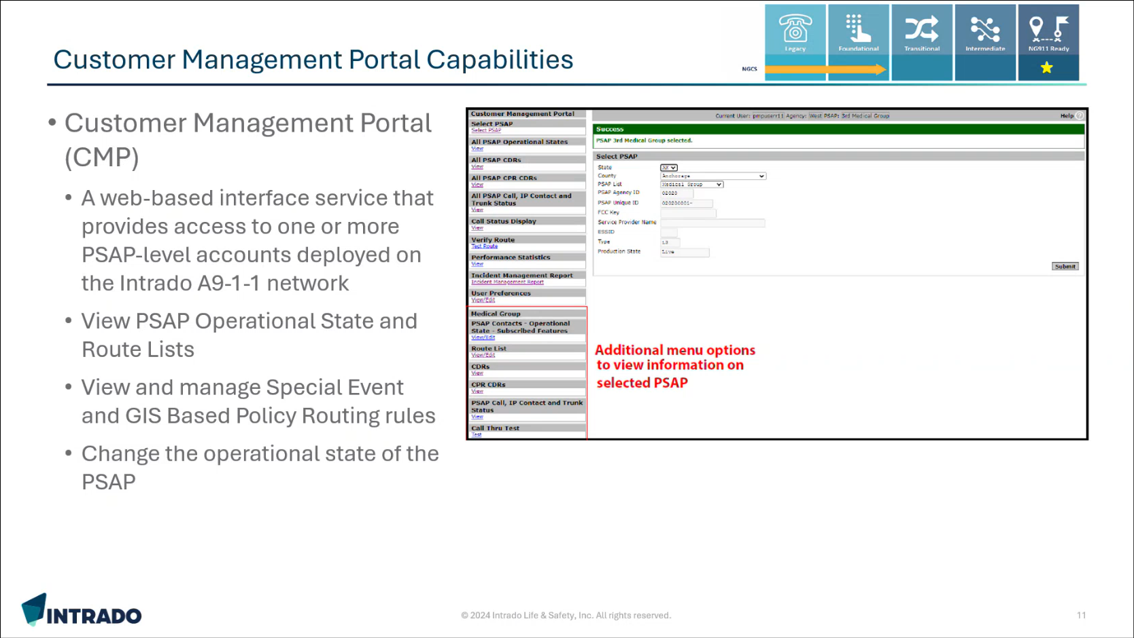
Brian Boezeman stated that the new A911 system features a customer management portal and mentioned that he is willing to provide a demo upon request. He added that this portal provides the capability to view specific A911 call data such as route lists, call record details, etc. Furthermore, he commented that this portal also provides visibility of the A911 system. He stated that they can set this up for any PSAP if desired and it will not incur any additional costs since it is included with the service. Lastly, he highlighted that the individual user provisioning is role based and customizable.

Edward Fujioka asked Brian Boezeman if the upgrade involves firmware or hardware. Brian Boezeman responded stating that the A911 upgrade consists of remote system configuration changes. He added that the VIPER upgrade requires configuration changes to be completed at the host sites coupled with remote test calls.

Edward Fujioka asked Brian Boezeman if secondary PSAPs will be upgraded before the primaries. Brian Boezeman responded stating that the upgrade sequence can be dictated by the respective county based on preference. Francis Alueta stated that Hawaiian Telcom’s standard operating procedure is to upgrade alternate sites first.

Sherri Griffith Powell asked Brian Boezeman how would they transition a secondary PSAP to i3 first if the primary routes the initial call. Brian Boezeman responded stating that they would reformat the initial RFAI call format into i3 for the secondary PSAP. Sherri Griffith Powell suggested discussing this further offline regarding this matter.

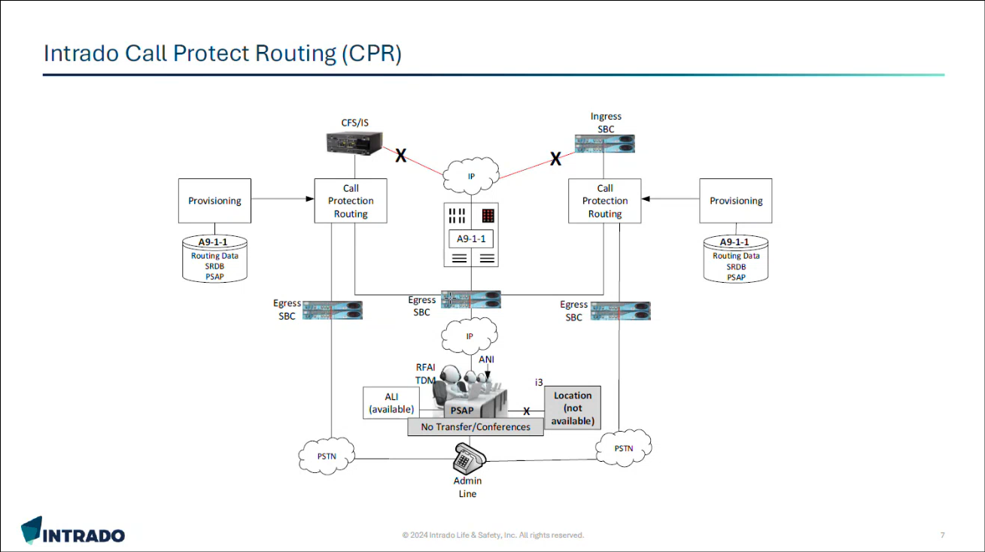
Stephen Courtney asked Brian Boezeman if it is possible or not to separate services in the hybrid configuration based on location (on-site versus mainland). Brian Boezeman responded stating that the A911 components for ECRF, LVF, and PRF such as servers for Session Border Controllers (SBC), media, call feature, and call protect routing are all located in Hawaii. He added that essentially any portion handling a voice call is based in Hawaii while location information is hosted on the mainland. Furthermore, he mentioned that the diagram above showcases a scenario if mainland connectivity is lost, which still allows the functionality of voice calls to remain within the state.

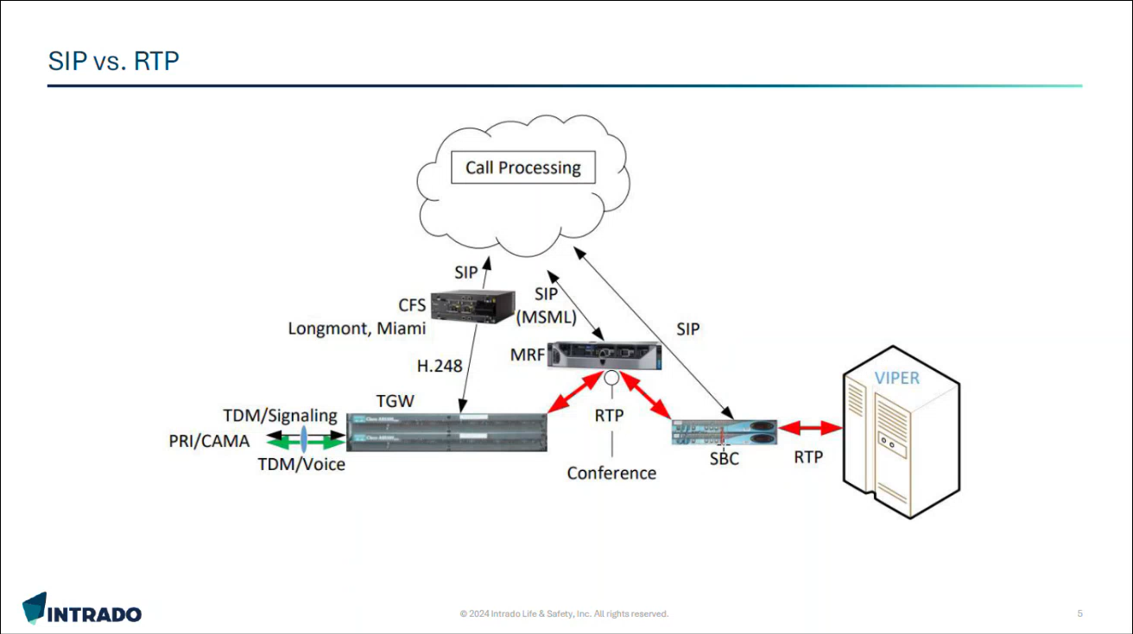
Brian Boezeman stated that their call processing elements are cloud-based while the other components depicted above are all located in Hawaii. He added that call processing is responsible for location data and i3 while the other components are necessary for the voice call.

      - Advisory Committee – Rebecca Lieberman
        - Updates on Legislative Session
Rebecca Lieberman stated that next week is the first lateral deadline for any proposed bills with multiple committee referrals.

        - Discussion Regarding SB 2267 / HB 1577 – Relating to 911 Services, Requires the 911 Board to establish, implement, and maintain a statewide emergency safety profile system that allows residents to voluntary create and manage secure personal profiles containing information relevant to emergency responses
Rebecca Lieberman requested an update from the Executive Director regarding the item above.

Executive Director stated that a board meeting was held on 2-4-2026 to discuss the 911 Board’s official position on this bill. He added that written testimony was not formally accepted for the hearing that took place on 2-6-2026 since it was a decision-making meeting only. He mentioned that he sent the 911 Board’s agreed upon written testimony to the bill’s committee chair and other involved state agencies for information purposes only. Furthermore, he stated that the decision made during the hearing requires the 911 Board to establish a 5-year statewide emergency safety profile system pilot program, convene a working group, and provide a report to the legislature. Lastly, he commented that he will schedule meetings with the applicable parties after the house draft of the bill is posted to better understand the intent of the revisions. Rebecca Lieberman commented that the aforementioned bill requires a hearing by the finance committee before it crosses over to the senate, which is expected to take place before the end of this month. She also mentioned that they are tracking Senate Bill 2921, which is anticipated to have a hearing near the end of this month or early next month.

  - Finance Committee – Edward Fujioka
    - Review of Monthly Y-T-D (Year to Date) Cash Flow
January 2026 Cashflow Statement:

Surcharge Collection: $1,054,905
Interest Income: $110,932
Total Receipts: $1,165,837
Total Disbursements: ($963,959)
Net Receipts/Disbursements: $201,878
Net Encumbrances Adds/(Paydown): ($331,627)
Net Cash Inflow/(Outflow): ($129,749)
Outstanding Encumbrances: $8,747,299
Net Bank Balance: $47,358,086
Unencumbered Cash Balance: $38,610,787

    - Honolulu Emergency Medical Services Department Requesting $4,960.32 for Computer-Aided Dispatch (CAD) Server Upgrade
Edward Fujioka stated the item above and requested an explanation. Isaac Tejada explained that this request is a necessary server upgrade to increase capacity for updates to fix issues. Edward Fujioka asked for a motion to approve. Stephen Courtney motioned to approve this request. Liz Gregg seconded the motion. A voice vote was taken, motion was unanimously approved.

- Next Generation 911 (NG911) Readiness Assessment Recommendations and Next Steps
  - Discussion of Governance Action Items
    - Update Regarding Permitted Interaction Group (PIG) to Develop Next Generation (NG911) Strategic Plan
    - Update Regarding Permitted Interaction Group (PIG) to Develop State-Level Continuity of Operations Plan (COOP)
Corey Shaffer referenced the items above and requested an update from the Executive Director.

Executive Director stated that they held a PIG meeting on 2-5-2026, which included a request for MCP to provide a high-level document regarding NG911 implementation, project management support, and strategic planning support. He mentioned that this aforementioned document was received last week, the PIG is planning to review/discuss it early next month, and will report back to the 911 Board thereafter. He added that the PIG raised various questions for HT during this meeting. Furthermore, he highlighted that the most prominent question was regarding costs if the 911 Board and PSAPs select HT and Intrado for its NGCS. Francis Alueta stated that currently there are no foreseeable additional costs if selected as the NGCS provider other than standard year-over-year increases.

Corey Shaffer asked Francis Alueta if the infrastructure upgrades for HT will be dedicated to 911 or used for other services. Francis Alueta responded stating that last mile costs will be dedicated and the Multiprotocol Label Switching (MPLS) is shared. Corey Shaffer asked Francis Alueta a follow-up question if larger purchases such as the SBCs are 911 dedicated or shared. Francis Alueta responded stating that they are currently shared but require further discussion as they continue to assess their overall voice network. He added that the selective router is 911 dedicated. Corey Shaffer asked Brian Boezeman if this selective router needs to be upgraded or not. Brian Boezeman responded stating that this upgrade was completed in August 2025.

Executive Director provided the following additional highlights below from the PIG meeting held on 2-5-2026:
- Requesting HT to align VIPER contracts for budgetary purposes and to prepare for NG911
- Inquired with HT if they could assemble a network monitoring team for the 911 system and NG911
  - Alternatively, the 911 Board could increase its staff beyond the Executive Director and Administrative Services Assistant

Tony Ramirez added that the PIG asked HT to explain the need for the selective router since it would be replaced in NG911. Francis Alueta stated that he will prepare documentation to explain this. Tony Ramirez commented that this would help prepare the NG911 strategic plan, COOP, etc.

- Public Safety Answering Point Status Updates on Recruitment and other Personnel Issues
  - Kauai Police Department – Andrew Muraoka
    - Update on Recruitment Process/Strategies and Personnel Training
Andrew Muraoka stated that they currently have 1 applicant undergoing the advanced background check stage and 3 applicants being interviewed.

    - Update on Personnel Issues and Vacancies
Andrew Muraoka stated that there were little to no changes from the previous month regarding staffing.

  - Oahu Police Department – Bradon Ogata, Ah Lan Leong
    - Update on Recruitment Process/Strategies and Personnel Training
Ah Lan Leong not present to provide an update.

    - Update on Personnel Issues and Vacancies
Ah Lan Leong not present to provide an update.

  - Oahu Fire Department – Shawn Kuratani
    - Update on Recruitment Process/Strategies and Personnel Training
Shawn Kuratani stated no updates.

    - Update on Personnel Issues and Vacancies
Shawn Kuratani stated that they are currently fully staffed.

  - Oahu Emergency Medical Services – Isaac Tejada, Frannie Chung, Sherryann Murphy
    - Update on Recruitment Process/Strategies and Personnel Training
Isaac Tejada stated that they will be conducting EMD academy interviews next month for approximately 11 applicants. He added that if the EMT academy has excess applicants then they will refer them to the EMD academy.

    - Update on Personnel Issues and Vacancies
Isaac Tejada stated that they currently have 7 total vacant positions.

  - Maui Police Department – Davlynn Racadio
    - Update on Recruitment Process/Strategies and Personnel Training
Davlynn Racadio stated that they currently have 4 personnel in training. She added that they are seeking to interview new applicants starting next month with the hopes of hiring 4 additional personnel.

    - Update on Personnel Issues and Vacancies
Davlynn Racadio stated no updates.

  - Molokai Police Department – Davlynn Racadio
    - Update on Recruitment Process/Strategies and Personnel Training
Please see updates under Maui Police Department.

    - Update on Personnel Issues and Vacancies
Please see updates under Maui Police Department.

  - Hawaii Police Department – Zachary Fernando
    - Update on Recruitment Process/Strategies and Personnel Training
Zachary Fernando stated that they have 2 personnel that recently went solo. He added that they currently have 5 personnel who started classroom training in February 2026.

    - Update on Personnel Issues and Vacancies
Zachary Fernando stated that they currently have a ~46% vacancy rate with 18 total vacant positions due to 1 personnel resigning last month.

  - Hawaii Fire Department – Stacy Domingo
    - Update on Recruitment Process/Strategies and Personnel Training
Stacy Domingo stated that they recently lost 1 trainee and currently have 3 personnel in training.

    - Update on Personnel Issues and Vacancies
Stacy Domingo stated that they currently have a 50% vacancy rate, which is 12 out of 24 total positions filled.

- Items for Discussion, Consideration, and Action
  - Additional Items Proposed by Meeting Attendees for Consideration and Possible Inclusion on Future Agendas

- Announcements
  - Future Virtual Meeting Dates/Times (9:00AM-12:00PM)
    - Thursday, March 12, 2026 (Combined Meeting)
    - Thursday, April 9, 2026 (Combined Meeting)

  - Future Conference Dates (3 Months of Advanced Approval Required)
    - 9-1-1 Goes to Washington (GTW), February 22-25, 2026, Arlington, VA
    - CentralSquare ENGAGE, March 15-18, 2026, Washington, D.C.
    - International Wireless Communications Expo (IWCE), March 16-19, 2026, Las Vegas, NV
    - Summit Conference (Motorola Solutions), April 19-23, 2026, Orlando, FL
    - Navigator Conference, April 21-24, 2026, Las Vegas, NV
    - NICE Conference & Expo (National Initiative for Cybersecurity Education), June 1-3, 2026, Philadelphia, PA
    - NENA Conference & Expo (National Emergency Number Association), June 27-July 2, Columbus, OH

  - Additional Announcements from Meeting Attendees for Consideration and Possible Inclusion on Future Agendas

- Open Forum: Public Comment on Issues not on the Board Meeting Agenda; no Board action on matters not on the agenda
There was no public comment on issues not on the agenda.

- Adjournment
Board Chair requested a motion to adjourn the meeting. Tony Velasco motioned to adjourn the meeting. Tony Ramirez seconded the motion. A voice vote was taken, adjournment was unanimously approved. The meeting was adjourned.

