JOSH GREEN, M.D.  GOVERNOR  Ke Kiaʻāina |  | KEITH A. REGAN  COMPTROLLER  Ka Luna Hoʻomalu Hana Laulā  MEOH-LENG SILLIMAN  DEPUTY COMPTROLLER  Ka Hope Luna Hoʻomalu Hana Laulā
STATE OF HAWAIʻI | KA Mokuʻāina o Hawaiʻi

DEPARTMENT OF ACCOUNTING AND GENERAL SERVICES | KA ʻOihana LOIHELU A LAWELAWE Laulā
P.O. BOX 119, HONOLULU, HAWAII 96810-0119

State of Hawaii 911 Board Meeting

Thursday, February 12, 2026
9:00 am – 12:00 pm

Virtually Held Meeting with Physical Location at
Kalanimoku Building Room 426, 1151 Punchbowl Street, Honolulu, Hawaii 96813 is available to the public and is guaranteed to be connected to the remote virtual meeting.

MEETING MINUTES

February 12, 2026: Joint Committee and Board Meeting (youtube.com)
Board Members Present: Corey Shaffer (Verizon), Keola Tom (MPD), Francis Alueta (HT), Stephen Courtney (C&C of Honolulu), Liz Gregg (AT&T), Ji Sook Kim (Consumer Advocate Designee), Matthew Kurihara (HPD), Rebecca Lieberman (Spectrum), Todd Omura (CIO Designee)
Board Members Not Present: Elliott K. Ke (KPD), Reed Mahuna (HIPD), Scott Winecoff (T-Mobile)
Staff: Royce Murakami (911 Board), Benson Leung (911 Board), Charles Lee (AG)
Guests: Darin Biamonte (Mission Critical), Brian Boezeman (Intrado), Sean Chun (HFD), Ruth Cruz (Intrado), Marc De Costa (HT), Stacy Domingo (HIFD), Zachary Fernando (HIPD), Edward Fujioka (EMS), Buck Giles (OS), Sherri Griffith Powell (Mission Critical), David Jones (Mission Critical), Shawn Kuratani (HFD), Charles Lee (AG), Ah Lan Leong (HPD), Andrew Muraoka (KPD), Sherryann Murphy (EMS), Tamera Neal (Intrado), Neil Pang (HPD), Kyle Penna (GovWorx), Stacy Perreira (KPD), Davlynn Racadio (MPD), Tony Ramirez (V2X), Ernest Robello (DLE), Isaac Tejada (EMS), Kenison Tejada (FirstNet), Tony Velasco (DIT)

- Call to Order, Public Notice
The meeting was called to order by the Board Chair. Public notice was given.

- Public Testimony Will Be Taken on All Agenda Items as Those Items Occur During the Meeting

- Roll Call, Quorum
A roll call was taken, quorum was present for the Board.

- Review and Approval of January Meeting Minutes
Board Chair requested a motion to approve January’s Meeting Minutes. Rebecca Lieberman motioned to approve January’s Meeting Minutes. Liz Gregg seconded the motion. A voice vote was taken, motion was unanimously approved.

- Committee Updates by Committee Chairs
  - Communications Committee – Davlynn Racadio
    - Discussion Regarding 9-1-1 Goes to Washington (GTW)
Davlynn Racadio stated no further updates.

    - Update from Hawaiian Telcom Regarding V2X Report Call Volume Discrepancy
Davlynn Racadio requested an update from Marc De Costa regarding the item above.

Marc De Costa recapped that this is in relation to the no value calls. He stated that ~70% of these aforementioned calls originated from alarm companies. He added that there is no Automatic Number Identification (ANI)/Automatic Location Identification (ALI) because these alarm companies have call centers based in the mainland. He mentioned that there was more alarm company calls on VIPER 7 as compared to VIPER 5. Furthermore, he highlighted two solutions being: 1) forwarding these alarm company calls to the admin lines or 2) utilizing Text-to-911 to handle the alarm company calls, with the latter being considered by Hawaiian Telcom (HT). He commented that the alarm companies have an application using Text-to-911 to send inquiries via text instead of call and this is available from Intrado with no additional costs to the Public Safety Answering Points (PSAP). Lastly, he requested an update from Tamera Neal regarding this potential solution. Tamera Neal stated that this presentation will provide a high-level overview of the aforementioned solution. Brian Boezeman commented that there is another option being the Automated Secure Alarm Protocol (ASAP), which sends the alarm company incidents directly to the respective PSAPs’ Computer-Aided Dispatch (CAD) system instead of the call taker.

Marc De Costa asked Brian Boezeman if the PSAPs would incur any additional costs for ASAP or not. Brian Boezeman responded stating that historically there have been additional costs associated with ASAP for the PSAPs. David Jones stated that The Monitoring Association (TMA) would assess a nominal one-time fee for ASAP setup. He added that there could be additional costs for CAD integration purposes.

Francis Alueta asked Brian Boezeman why the alarm companies do not possess the ANI/ALI information. Brian Boezeman responded stating that the Federal Communications Commission (FCC) does not classify alarm companies as Originating Service Providers (OSP).

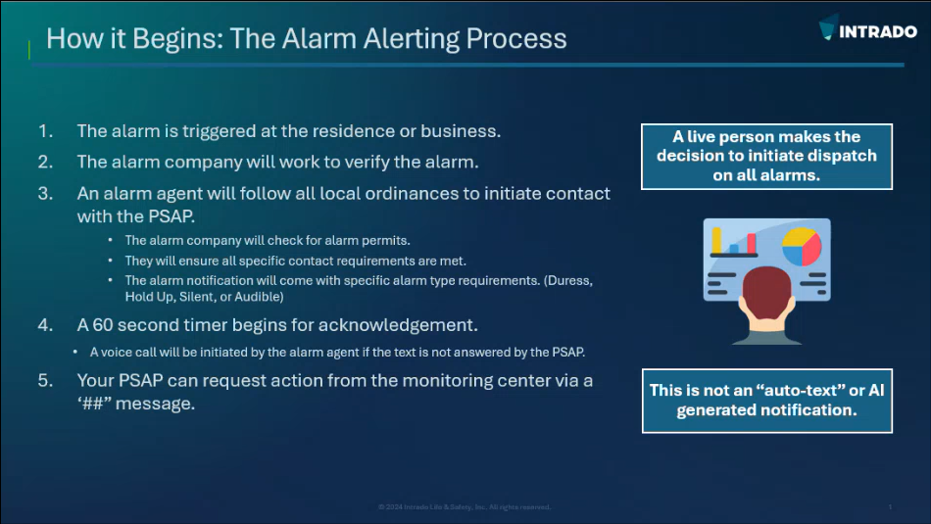
Brian Boezeman referenced the slide above regarding Intrado’s solution for alarm company calls using Text-to-911, which would also eliminate a large volume of the aforementioned no value calls.

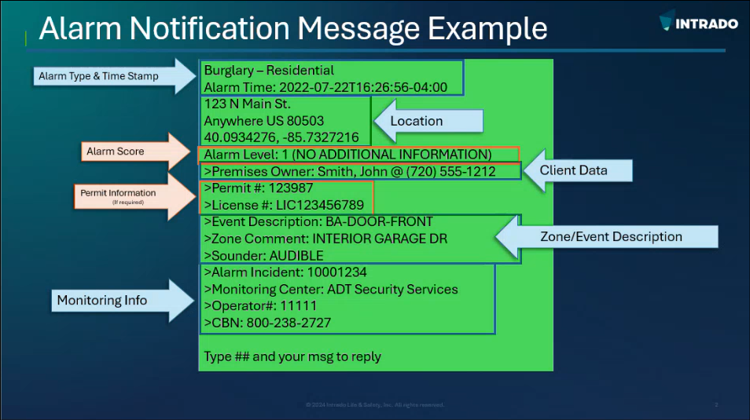
Tamera Neal referenced the slide above regarding example information that would be sent via text message to a PSAP for an alarm call. She added that this text message will provide the alarm company with a confirmation receipt if it is answered by the PSAP. Brian Boezeman stated that this service allows for two-way communication between the PSAPs and alarm companies to gather additional information if necessary.

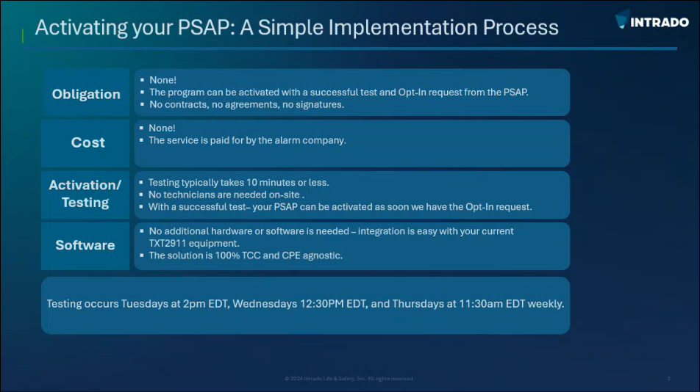
Tamera Neal referenced the slide above regarding the implementation process for this solution. She mentioned that in addition to the steps mentioned above, the respective PSAP would have to fill out a form requesting this service from Intrado. She added that they will schedule testing and activation after this form has been processed. Furthermore, she stated that there is no cost to the PSAPs and no additional hardware or software.

Corey Shaffer asked Brian Boezeman if there are any process changes for the alarm companies. Brian Boezeman responded stating that the alarm companies are not mandated to change their procedures to accommodate this solution. He added that he believes the alarm companies would be willing to adopt these changes.

Francis Alueta asked Brian Boezeman if the 911 authority for other states are sending this request letter to the alarm companies. Brian Boezeman responded stating that the 911 authority for the respective state or county will send the request letter.

Corey Shaffer asked Marc De Costa if HT is able to provide the 911 Board with a list of the applicable alarm companies. Marc De Costa responded stating that this requested data is not easily accessible. He recommended sending out mass notifications to the alarm companies, which will encourage them to be a part of this solution. Alternatively, he mentioned that they could remove the ability for alarm companies to initiate calls with 911.

Tony Ramirez commented that the Text-to-911 solution or ASAP both meet the requirements for dispatchable locations as identified by the FCC, which would provide location data and reduce the volume of no value calls.

Davlynn Racadio mentioned that she was able to identify the alarm companies for her PSAP by using their internal system and records (e.g. CAD and recorder). She then offered her assistance to HT if needed. Brian Boezeman commented that the sheer quantity of alarm company calls presents a challenge.

Edward Fujioka commented that a portion of these alarm company calls are false alarms, which consume first responder resources and availability. He added that the alarm company calls do not provide information such as the type of request and callback number. He mentioned that there were previous considerations to charge the alarm companies for every incident that first responders are dispatched to. Davlynn Racadio stated that Maui enforces a $25.00 fee for excessive false alarms. She commented that she needs to weigh the pros and cons of each solution before making a final decision.

Corey Shaffer on behalf of the 911 Board expressed the willingness to send request letters to the alarm companies if any PSAPs are interested in this Text-to-911 solution. He added that there is an opportunity for the PSAPs to aid in this effort by identifying the applicable alarm companies using their respective systems and records.

Corey Shaffer asked David Jones if ASAP utilizes Text-to-911 or not. David Jones responded stating that ASAP digitizes the alarm process, which eliminates any voice calls and/or text messages to 911. He added that ASAP is directly integrated into a respective PSAP’s CAD. Furthermore, he mentioned that ASAP is an Association of Public-Safety Communications Officials (APCO) standard. Corey Shaffer asked David Jones a follow-up question if ASAP requires request letters to the alarm companies for setup purposes or not. David Jones responded stating that request letters are needed but the TMA will handle this since they represent the alarm companies. He added that the TMA currently represents approximately 80%-85% of all alarm companies in the United States. He mentioned that ASAP previously was not an option for Hawaii because it had to operate on the state law enforcement switch but it has since transitioned to Amazon Web Services (AWS) GovCloud, which provided flexibility. Additionally, he confirmed with his team that ASAP is an available option for Hawaii. Furthermore, he offered to provide a presentation regarding ASAP if interested. Corey Shaffer on behalf of the 911 Board expressed interest in this presentation and asked the Executive Director if he could coordinate and schedule this. Executive Director responded stating that he will work with David Jones on this matter.

Davlynn Racadio thanked meeting participants for the engaged discussion and HT, Intrado, and Mission Critical Partners (MCP) for providing the solutions offered.

  - Technical Committee – Shawn Kuratani
    - Intrado Updated Roadmap Presentation
Shawn Kuratani stated no further updates.

      - Advisory Committee – Rebecca Lieberman
        - Updates on Legislative Session
        - Discussion Regarding SB 2267 / HB 1577 – Relating to 911 Services, Requires the 911 Board to establish, implement, and maintain a statewide emergency safety profile system that allows residents to voluntary create and manage secure personal profiles containing information relevant to emergency responses
Executive Director asked the 911 Board if they have any comments and/or concerns before he reaches out to RapidSOS regarding a verification bot for landline and VoIP users to create medical IDs. Corey Shaffer responded stating that he is interested in technical feasibility and estimated costs.

  - Finance Committee – Edward Fujioka
    - Review of Monthly Y-T-D (Year to Date) Cash Flow
    - Honolulu Emergency Medical Services Department Requesting $4,960.32 for Computer-Aided Dispatch (CAD) Server Upgrade
Edward Fujioka stated no further updates.

- Next Generation 911 (NG911) Readiness Assessment Recommendations and Next Steps
  - Discussion of Governance Action Items
    - Update Regarding Permitted Interaction Group (PIG) to Develop Next Generation (NG911) Strategic Plan
    - Update Regarding Permitted Interaction Group (PIG) to Develop State-Level Continuity of Operations Plan (COOP)
Stephen Courtney asked Francis Alueta to confirm if there will be any additional costs from HT and/or Intrado regarding Next Generation 911 (NG911) services that they will provide. Francis Alueta responded stating that currently there are no foreseeable additional costs. David Jones recommended that the 911 Board should validate HT/Intrado’s guidance that they will provide NG911 services without any additional costs. He added that this is not consistent based on his past experience with other states and their respective NG911 deployments. Corey Shaffer mentioned that Intrado’s updated roadmap presentation regarding NG911 focused heavily on the technical aspects and that there are other areas of NG911 that could incur additional costs such as governance, cybersecurity, etc.

Stephen Courtney asked Corey Shaffer how much of the 911 Board’s unencumbered cash balance will be earmarked for NG911 transition. Corey Shaffer responded stating that it is too early at this point in time to specify a total amount. He added that discussions will need to be held if there is a significant cash reserve after NG911 is fully implemented. He suggested a potential option could be to adjust the surcharge rate prudently.

- Public Safety Answering Point Status Updates on Recruitment and other Personnel Issues
  - Kauai Police Department – Andrew Muraoka
    - Update on Recruitment Process/Strategies and Personnel Training
    - Update on Personnel Issues and Vacancies
Andrew Muraoka stated no further updates.

  - Oahu Police Department – Bradon Ogata, Ah Lan Leong
    - Update on Recruitment Process/Strategies and Personnel Training
Neil Pang on behalf of Ah Lan Leong stated that they currently have 4 personnel in training. He added that they had 6 personnel recently complete training. Furthermore, he anticipates that they may have 3 additional personnel in training around April or May 2026. Lastly, he commented that they are currently working with their HR department regarding recruitment.

    - Update on Personnel Issues and Vacancies
Neil Pang on behalf of Ah Lan Leong stated that they currently have a ~29% vacancy rate.

  - Oahu Fire Department – Shawn Kuratani
    - Update on Recruitment Process/Strategies and Personnel Training
    - Update on Personnel Issues and Vacancies
Shawn Kuratani stated no further updates.

  - Oahu Emergency Medical Services – Isaac Tejada, Frannie Chung, Sherryann Murphy
    - Update on Recruitment Process/Strategies and Personnel Training
    - Update on Personnel Issues and Vacancies
Isaac Tejada stated no further updates.

  - Maui Police Department – Davlynn Racadio
    - Update on Recruitment Process/Strategies and Personnel Training
    - Update on Personnel Issues and Vacancies
Davlynn Racadio stated no further updates.

  - Molokai Police Department – Davlynn Racadio
    - Update on Recruitment Process/Strategies and Personnel Training
    - Update on Personnel Issues and Vacancies
Davlynn Racadio stated no further updates.

  - Hawaii Police Department – Zachary Fernando
    - Update on Recruitment Process/Strategies and Personnel Training
    - Update on Personnel Issues and Vacancies
Zachary Fernando stated no further updates.

  - Hawaii Fire Department – Stacy Domingo
    - Update on Recruitment Process/Strategies and Personnel Training
    - Update on Personnel Issues and Vacancies
Stacy Domingo stated no further updates.

- Executive Director’s Report
  - Spectrum Reach Multiscreen Campaign Follow-Up Regarding Public Safety Answering Point (PSAP) Interest
Executive Director stated that the City and County of Honolulu and Hawaii County both expressed interest regarding Spectrum Reach’s recruitment campaign. He requested the aforementioned counties to follow their respective procurement procedures and provide him the finalized quotes upon receipt for the 911 Board’s consideration, discussion, and approval. Furthermore, he recommended both counties to select the 6-month contract option with a 7-1-2026 start date. Lastly, he mentioned that it would be ideal to review the post recruitment campaign statistics before engaging in subsequent contracts.

Corey Shaffer asked the PSAPs if they had any feedback and/or comments. Davlynn Racadio responded stating that she may be interested in the future when she has adequate staffing to support larger training classes. Executive Director stated that he will follow up with Kauai County offline regarding this matter since Elliott K. Ke is not present at today’s meeting.

  - Update Regarding Auditor Procurement for FY 2026-2028 Independent Audit Reports
Executive Director stated that the auditor contract for the FY 2026-2028 independent audit reports has been awarded to KMH LLP.

  - Discussion Regarding Community Outreach and Public Education
Executive Director stated that community outreach is a measure of effectiveness for the 911 Board. He requested that each county should complete at least 1 community outreach event per year to educate and inform the public about 911. Furthermore, he offered to help the counties with completing community outreach events. Lastly, he asked the counties to provide recommendations regarding potential community outreach events. Corey Shaffer stated that specific initiatives such as medical ID should be promoted as well as general community outreach. Stacy Domingo asked the Executive Director if there is a target demographic for these community outreach events and what should be covered. Executive Director responded stating that currently the target demographics would be the elderly/youth and the disability community. He added that the promotion of Text-to-911 and medical IDs could be initial topics. Corey Shaffer added that best practices regarding 911 calls would be a useful topic to inform the public, which could improve emergency response and increase PSAP efficiency.

Stacy Domingo asked Ah Lan Leong if they maintain a social media presence or not. Ah Lan Leong responded stating that their department has a social media presence but police dispatch was denied access to social media due to various concerns. She added that they will work with the handler of their department’s social media presence to promote police dispatch events. Stacy Domingo asked Corey Shaffer a follow-up question if a statewide social media campaign for the upcoming National Public Safety Telecommunicators Week is feasible or not. Corey Shaffer responded stating that it seems feasible as long as the PSAPs coordinate with each other. He asked the Executive Director if he could prepare draft social media content for the PSAPs to review. Executive Director responded stating that he will work on this with his Administrative Services Assistant and the PSAPs.

  - Volunteers Request for Department of Commerce and Consumer Affairs (DCCA) National Consumer Protection Week Fair on March 5, 2026
Executive Director stated that the primary focus for this DCCA fair will be to promote education about medical ID setup. He added that he created 2 flyers (for iOS and Android) explaining how to set up a medical ID. He then requested for any volunteers who are willing to participate. Lastly, he mentioned that these flyers could be shared on social media and with other agencies.

- Items for Discussion, Consideration, and Action
  - Honolulu Emergency Medical Services Department Requesting $4,960.32 for Computer-Aided Dispatch (CAD) Server Upgrade
Board Chair stated the item above and asked for a motion to approve. Ji Sook Kim motioned to approve this request. Francis Alueta seconded the motion. A voice vote was taken, motion was unanimously approved.

  - Additional Items Proposed by Meeting Attendees for Consideration and Possible Inclusion on Future Agendas

- Announcements
  - Future Virtual Meeting Dates/Times (9:00AM-12:00PM)
    - Thursday, March 12, 2026 (Combined Meeting)
    - Thursday, April 9, 2026 (Combined Meeting)

  - Future Conference Dates (3 Months of Advanced Approval Required)
    - 9-1-1 Goes to Washington (GTW), February 22-25, 2026, Arlington, VA
    - CentralSquare ENGAGE, March 15-18, 2026, Washington, D.C.
    - International Wireless Communications Expo (IWCE), March 16-19, 2026, Las Vegas, NV
    - Summit Conference (Motorola Solutions), April 19-23, 2026, Orlando, FL
    - Navigator Conference, April 21-24, 2026, Las Vegas, NV
    - NICE Conference & Expo (National Initiative for Cybersecurity Education), June 1-3, 2026, Philadelphia, PA
    - NENA Conference & Expo (National Emergency Number Association), June 27-July 2, Columbus, OH

  - Additional Announcements from Meeting Attendees for Consideration and Possible Inclusion on Future Agendas
Stephen Courtney stated that he was recently approached by a vendor regarding artificial intelligence (AI) handling of non-emergency calls to reduce a PSAP’s workload. He asked Corey Shaffer if the 911 Board would be interested in a presentation regarding this or not. Corey Shaffer responded stating that he is interested in this presentation and advised him to schedule and coordinate with the Executive Director.

- Open Forum: Public Comment on Issues not on the Board Meeting Agenda; no Board action on matters not on the agenda
There was no public comment on issues not on the agenda.

- Adjournment
Board Chair requested a motion to adjourn the meeting. Ji Sook Kim motioned to adjourn the meeting. Rebecca Lieberman seconded the motion. A voice vote was taken, adjournment was unanimously approved. The meeting was adjourned.

