JOSH GREEN, M.D.  GOVERNOR  Ke Kiaʻāina |  | KEITH A. REGAN  COMPTROLLER  Ka Luna Hoʻomalu Hana Laulā  MEOH-LENG SILLIMAN  DEPUTY COMPTROLLER  Ka Hope Luna Hoʻomalu Hana Laulā
STATE OF HAWAIʻI | KA Mokuʻāina o Hawaiʻi

DEPARTMENT OF ACCOUNTING AND GENERAL SERVICES | KA ʻOihana LOIHELU A LAWELAWE Laulā
P.O. BOX 119, HONOLULU, HAWAII 96810-0119

Communications, Technical, and Finance Meeting
(Combined Meeting)

Thursday, January 15, 2026
9:00 am – 12:00 pm

Virtually Held Meeting with Physical Location at
Kalanimoku Building Room 426, 1151 Punchbowl Street, Honolulu, Hawaii 96813 is available to the public and is guaranteed to be connected to the remote virtual meeting.

MEETING MINUTES

January 15, 2026: Joint Committee and Board Meeting (youtube.com)

Communications Committee Members Present: Davlynn Racadio (MPD), Ah Lan Leong (HPD)

Communications Committee Members Not Present: Lavina Taovao (KPD)

Technical Committee Members Present: Shawn Kuratani (HFD), Stacy Domingo (HIFD), Tony Ramirez (V2X), Kenison Tejada (FirstNet), Tony Velasco (DIT)

Technical Committee Members Not Present: None

Finance Committee Members Present: Stephen Courtney (C&C of Honolulu), Liz Gregg (AT&T), Matthew Kurihara (HPD), Reed Mahuna (HIPD), Tony Velasco (DIT)

Finance Committee Members Not Present: Edward Fujioka (EMS), Todd Omura (CIO Designee)

Staff: Royce Murakami (911 Board), Benson Leung (911 Board), Charles Lee (AG)

Guests: Ian Atkins (Carbyne), Jeremy Bell (AT&T), Darin Biamonte (Mission Critical), Brian Boezeman (Intrado), Joshua Brantley (ETS), Christian Burns (HT), Frannie Chung (EMS), Ruth Cruz (Intrado), Marc De Costa (HT), Zachary Fernando (HIPD), Greg Florian (Spectrum), Marisa Fujimoto (HT), Barbara Geary (Spectrum), Buck Giles (OS), Roderick Green (KPD), Tim Hansen (NAMI), Bertie Johnson (HPD), Melia Johnson (MPD), David Jones (Mission Critical), Ji Sook Kim (Consumer Advocate Designee), Michelle Kratel (HIPD), Robert Lau (DOH), Charles Lee (AG), Rebecca Lieberman (Spectrum), Brian McKee (DIT), Sherryann Murphy (EMS), Tamera Neal (Intrado), Neil Pang (HPD), Stacy Perreira (KPD), Corey Shaffer (Verizon), Nietzche Tolan (AG), Keola Tom (MPD), Scott Winecoff (T-Mobile)

- Call to Order, Public Notice
The meeting was called to order by the Board Chair. Public notice was given.

- Public Testimony Will Be Taken on All Agenda Items as Those Items Occur During the Meeting

- Roll Call, Quorum
A roll call was taken, quorum was present for all committees.

- Review and Approval of December Meeting Minutes
Board Chair requested a motion to approve December’s Meeting Minutes. Tony Velasco motioned to approve December’s Meeting Minutes. Liz Gregg seconded the motion. A voice vote was taken, motion was unanimously approved.

- Committee Updates by Committee Chairs
  - Communications Committee – Davlynn Racadio
    - Spectrum Reach Multiscreen Campaign Follow-Up Presentation Regarding Public Safety Answering Point (PSAP) Recruitment
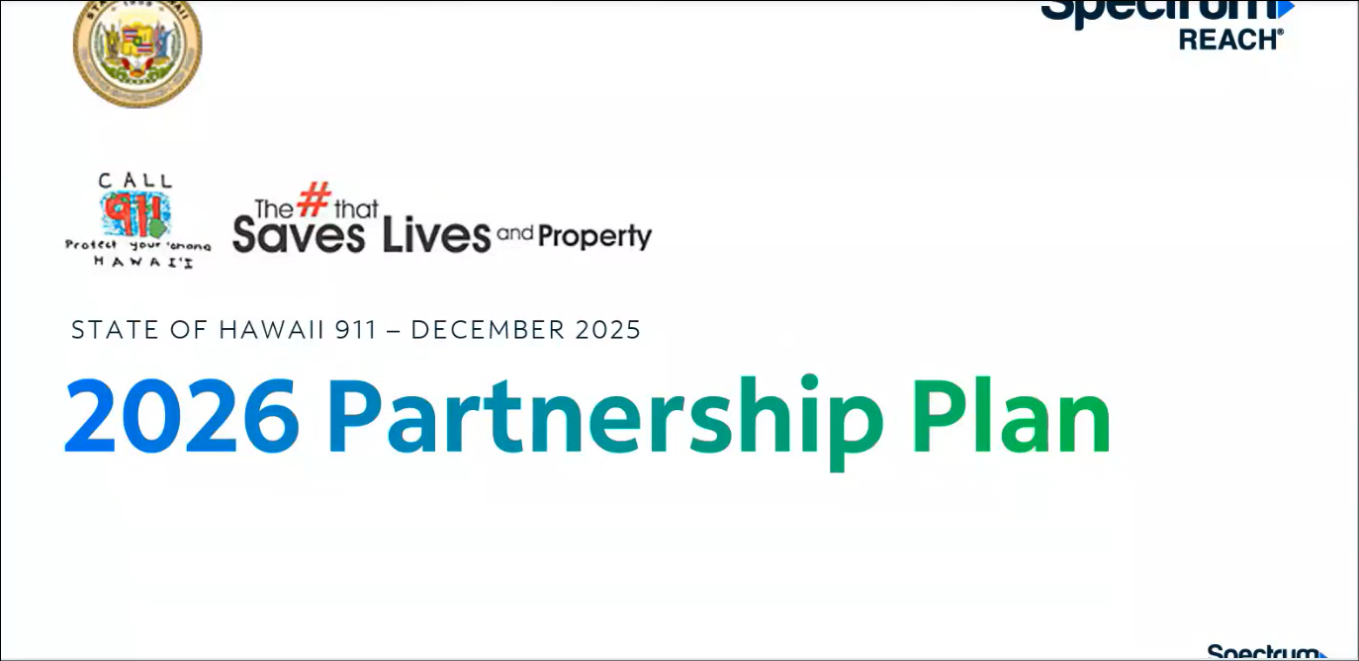
Davlynn Racadio requested an update from Barbara Geary regarding the agenda item mentioned above.

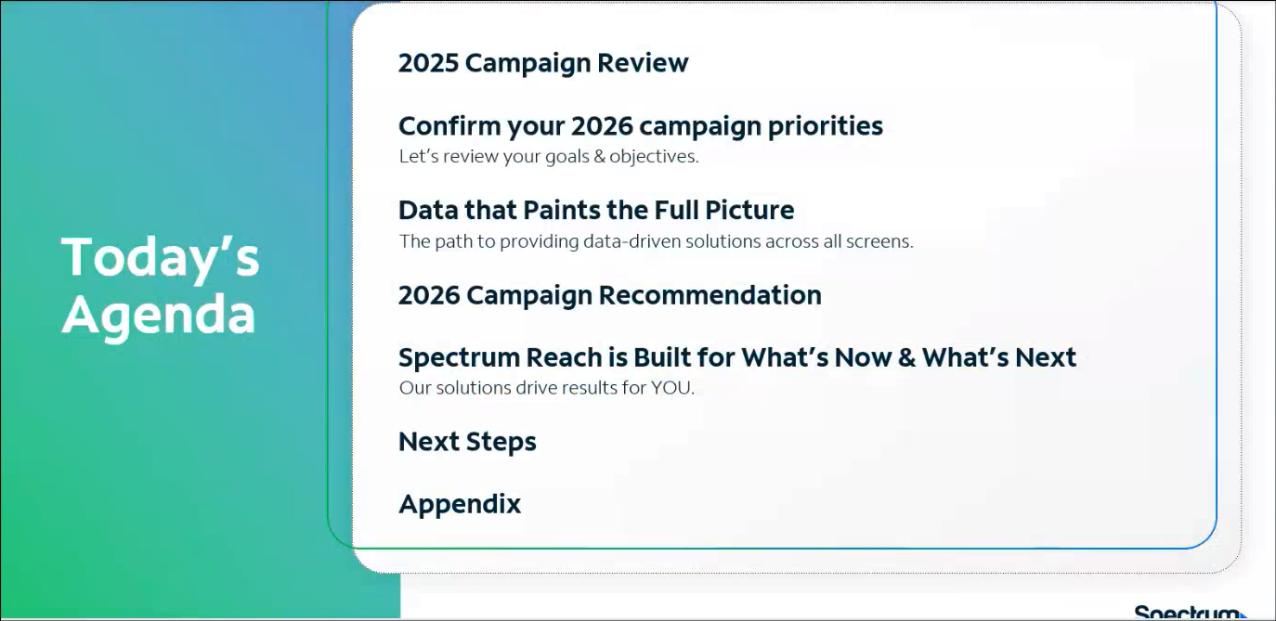
Barbara Geary stated the topics that will be covered in the follow-up presentation.

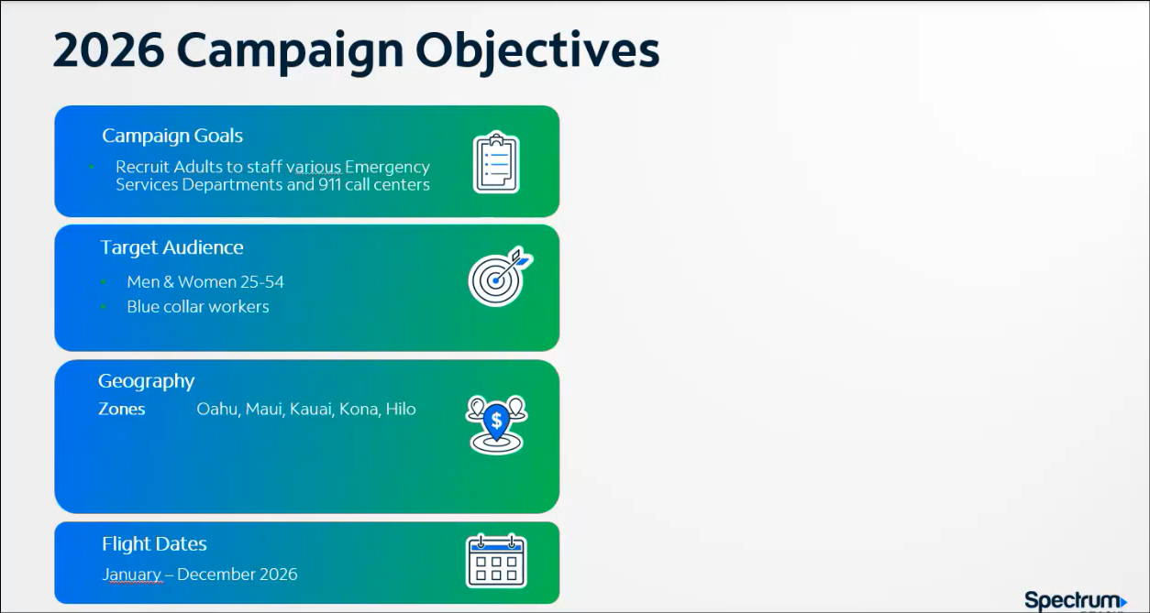
Barbara Geary confirmed the recruitment campaign’s primary objective. Stacy Domingo asked Barbara Geary if they could change the geography zone from Kona and Hilo to Hawaii (Island). Barbara Geary responded stating that she will make the revision. Stephen Courtney asked Barbara Geary if there is a minimum age requirement or not. Barbara Geary responded stating that non-sworn positions typically do not have an age requirement as compared to sworn positions where officers usually start around 21 years old. Corey Shaffer stated that the target audience age range mentioned above is for campaign purposes only and does not correlate to the PSAPs’ recruitment criteria and requirements.


Barbara Geary referenced Spectrum Reach’s mantra “Built for What’s Now and What’s Next”, which highlights their advertising solutions and credentials.


Barbara Geary stated that the recruitment campaign consists of three main phases, which are finding the key target audience, reaching the intended audience through multiple platforms, and measuring the results thereafter. She added that the recruitment campaign is accompanied by a reporting dashboard, which is accessible 24/7. Furthermore, she mentioned that they are available to assist with generating and reviewing reports to determine if pivoting is necessary or not.

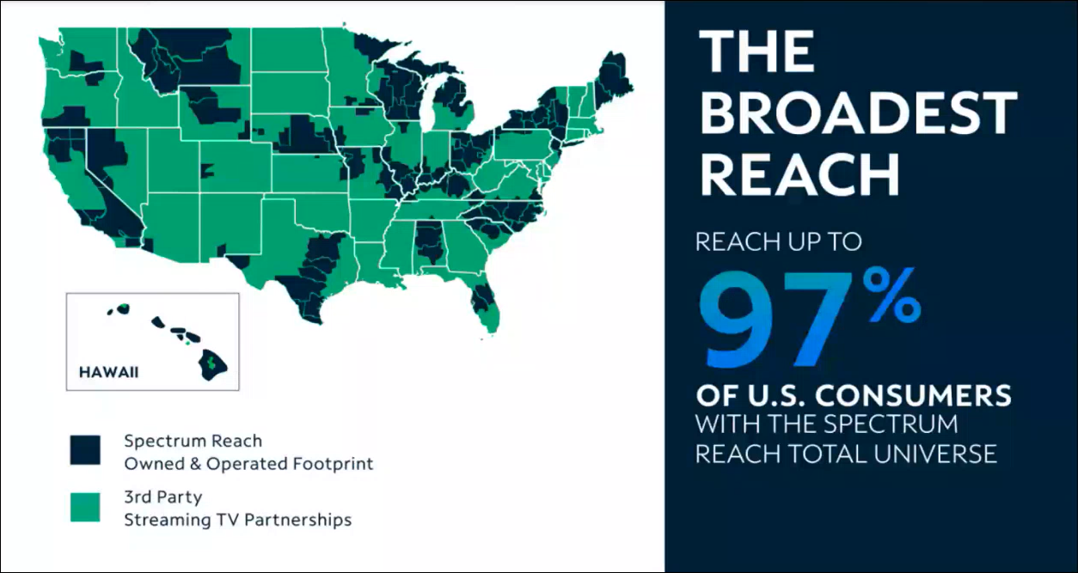
Barbara Geary stated that Spectrum has local operations in Hawaii and the ability to reach up to 97% of U.S. consumers.


Barbara Geary stated that consumers have broad viewing preferences and emphasized the importance of quality data.

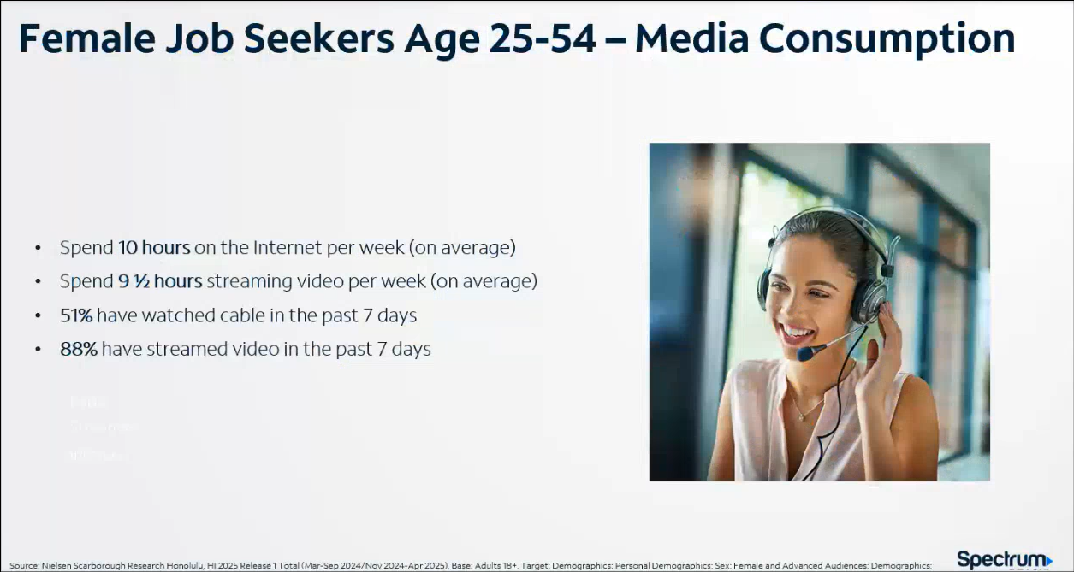
Barbara Geary showcased an example of Spectrum’s research on the media consumption of female job seekers between the ages of 25 and 54. She added that both content and timing are key to reach the desired target audience.

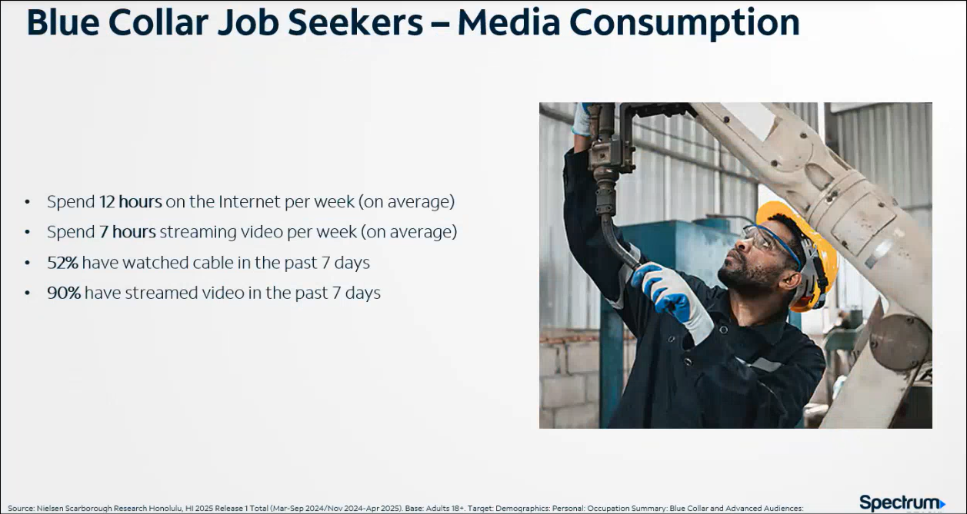
Barbara Geary showcased an example of Spectrum’s research on the media consumption of blue-collar job seekers.

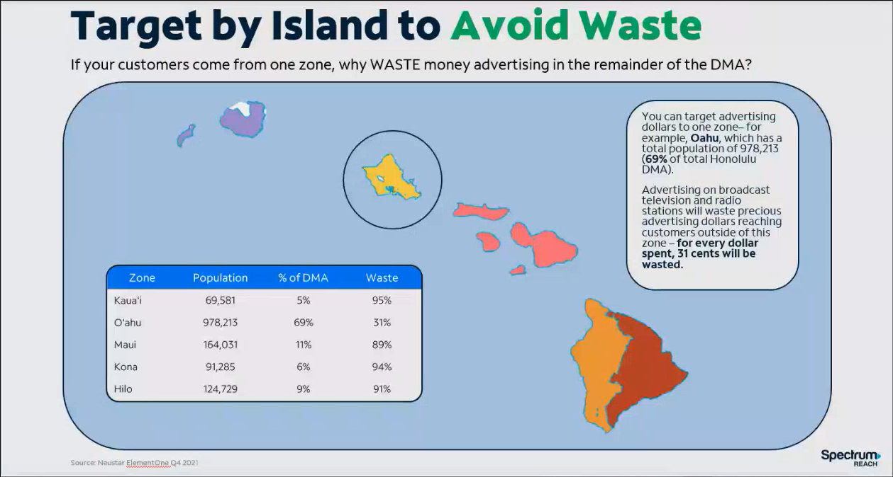
Barbara Geary stated that Spectrum has the capability to target specific zones to avoid any wasted marketing efforts as well as curate zone specific messaging.

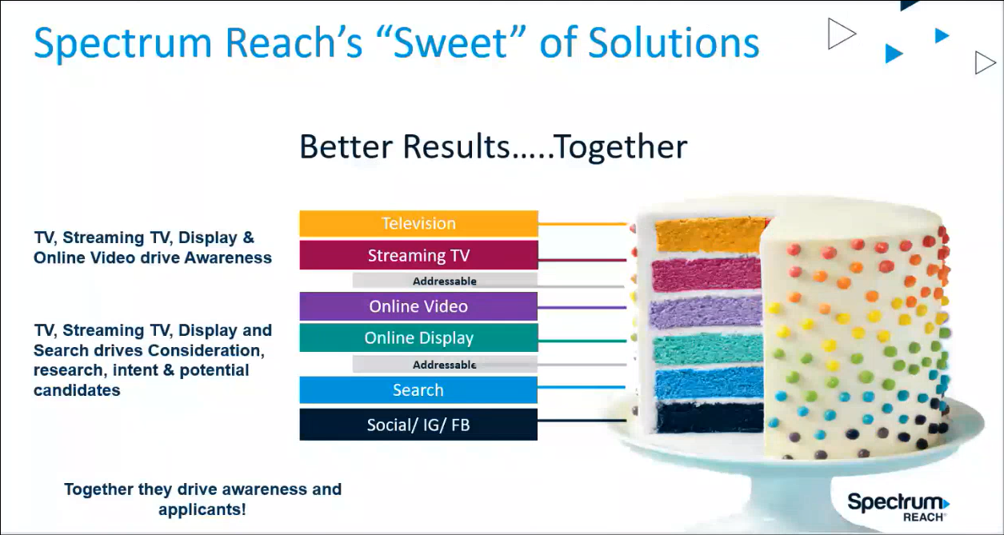
Barbara Geary stated that Spectrum has a suite of solutions in order to reach the target audience across multiple platforms to raise awareness about the recruitment campaign. She added that there are multiple layers/platforms regarding consumer viewing options.

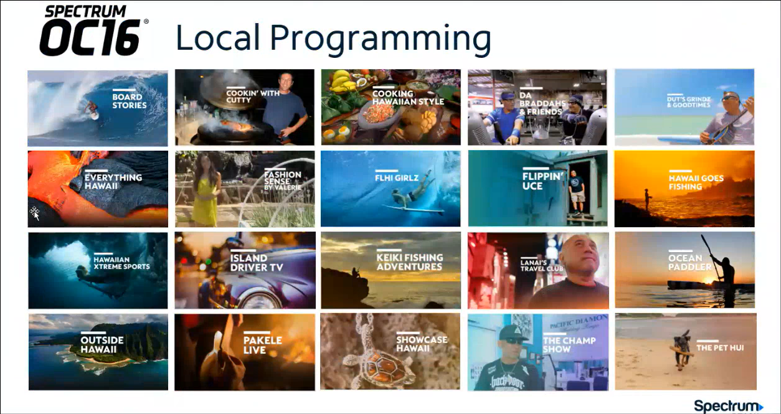
Barbara Geary stated that Spectrum OC16 offers a wide variety of local programming topics, which provides advertising reach into the local market.

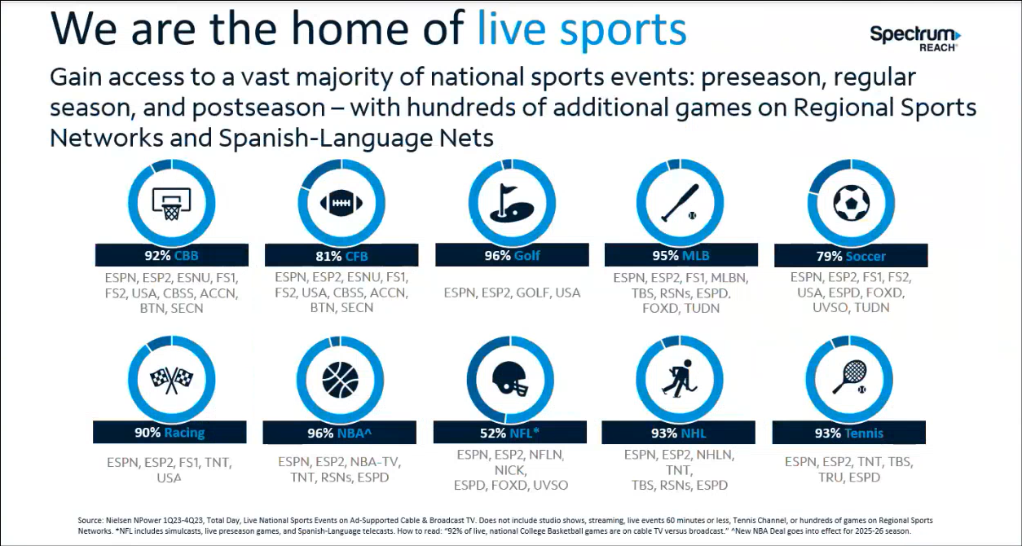
Barbara Geary stated that Spectrum offers live sports, which is popular amongst viewers/subscribers.


Barbara Geary stated that the recruitment campaign only consists of digital advertising. She added that the targeted audience demographics, age, and behaviors are customizable.

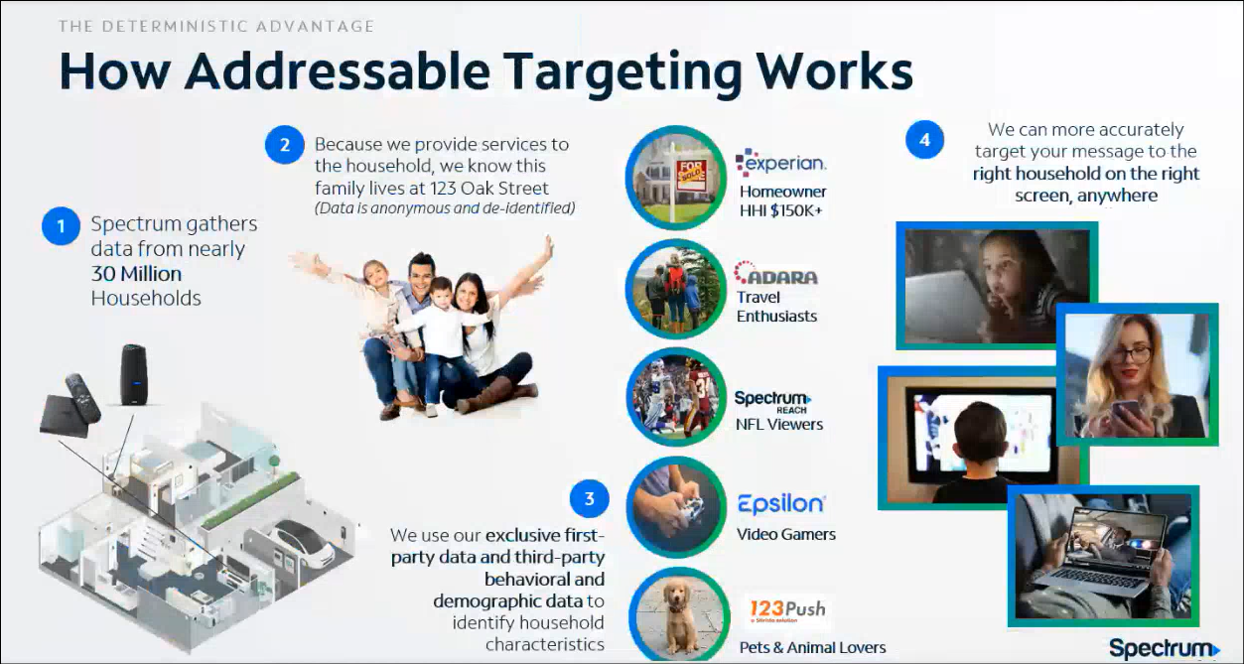
Barbara Geary stated that Spectrum offers an addressable campaign, which hyper targets job seekers. She added that the broader overall campaign has the ability to reach the influencers of potential job seekers such as spouses, family, and/or friends.


Barbara Geary stated that Spectrum offers site retargeting, which redisplays the recruitment campaign’s ad to a previously interested job seeker on any Spectrum vetted website that they visit for up to 30 days. She added that this is for persistence purposes and to reinforce the recruitment campaign’s message.


Barbara Geary stated that Spectrum’s streaming campaigns maintain over 450 networks and publishers. She added that the Spectrum streaming app has been the most streamed in Hawaii for the past 13 months and running.


Barbara Geary stated that Spectrum’s streaming campaign encompasses Spectrum’s Xumo Box, Amazon, Roku, Pluto, Hulu, cable networks, etc.

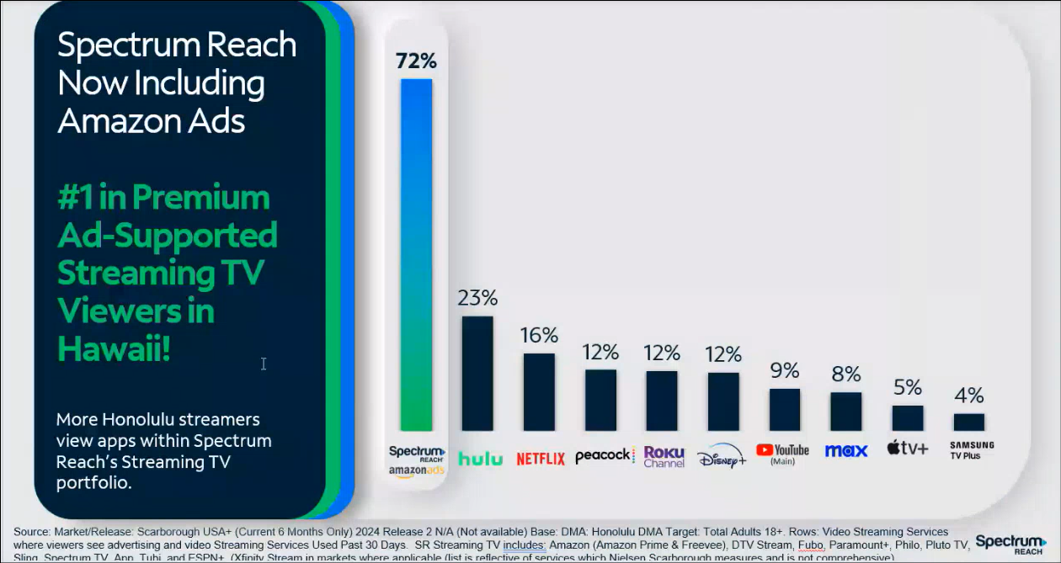
Barbara Geary stated that Spectrum Reach, which includes both Amazon Ads and Hulu, comprises the majority of premium ad-supported streaming viewership in Hawaii.


Barbara Geary stated that Spectrum has partnered with Google, Bing, and Yahoo regarding search ads, which comprises 97% of the total monthly searches. She added that Spectrum offers an hourly bid optimization, which calculates the cost/price per click. Furthermore, she mentioned that reporting is included.

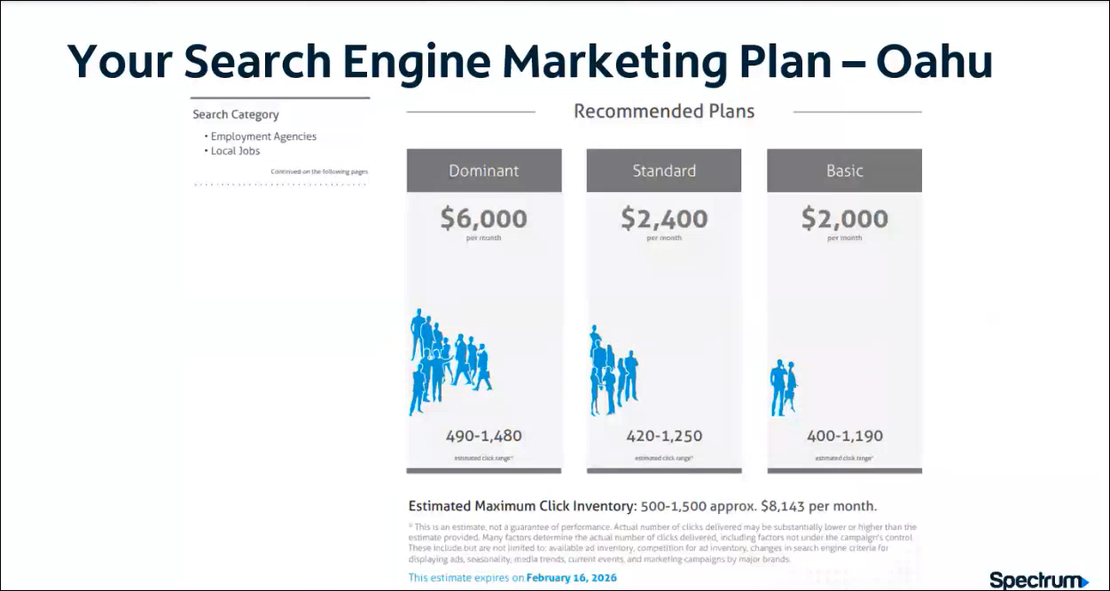
Barbara Geary referenced the slide above regarding a proposal example for Oahu zip codes, which is a current 90-day lookback of individuals searching for either employment agencies and/or local jobs.

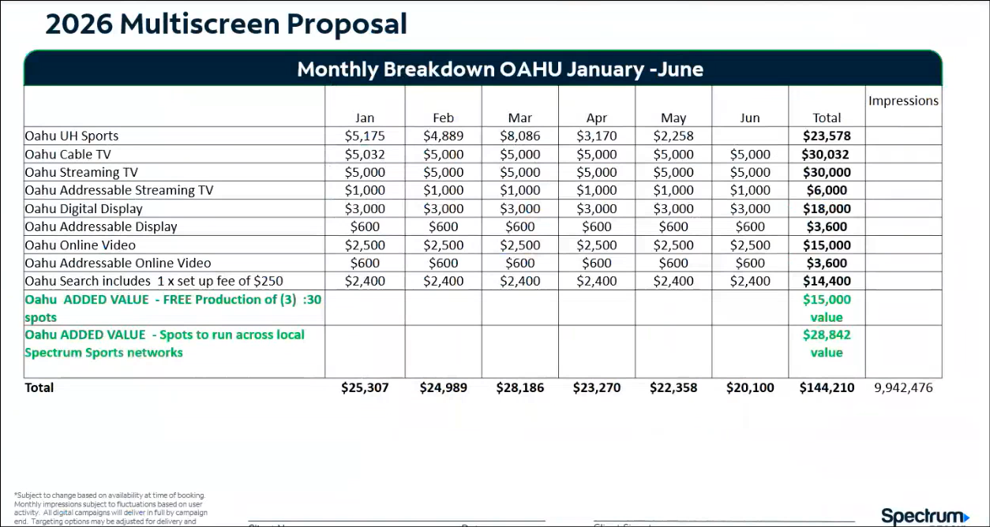
Barbara Geary referenced the slide above regarding Spectrum’s proposal for Oahu. She added that they determined and included the relevant platforms to reach the recruitment campaign’s key individuals. She stated that this proposal includes the free production of three 30-second commercials, which is an added value. She added that the production of three unique commercials is being offered to accommodate the potential need for different departments and/or messaging. She mentioned that this proposal includes free additional commercial spots.

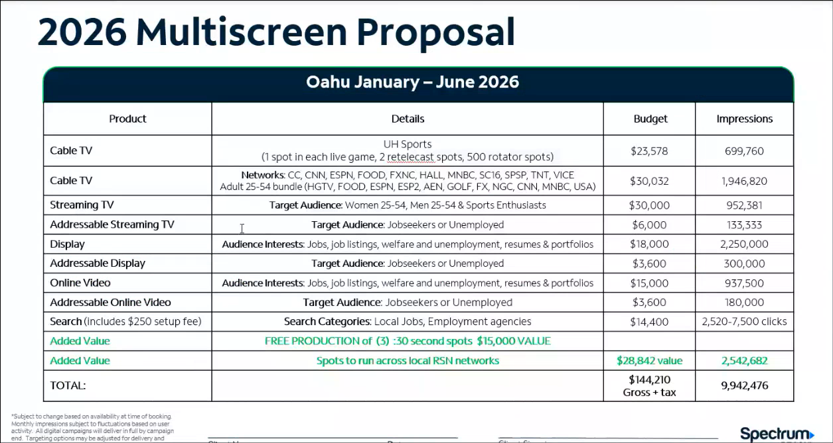
Barbara Geary referenced the slide above regarding additional details of Spectrum’s proposal for Oahu’s recruitment campaign. She added that the cable TV networks mentioned above are targeted towards job seekers that possess certain demographics for the recruitment campaign.

Barbara Geary commented that the proposals are negotiable since they are not final regarding services, price, etc. Greg Florian and Barbara Geary thanked the 911 Board for the opportunity to present their proposal. Greg Florian then highlighted his past experience working with a State of Hawaii agency regarding successful recruitment and program advocacy. He added that Hawaii’s proposal incorporates successful elements from another state’s recruitment campaign for 911 call center staff. Barbara Geary stated that the current proposals do not include U.S. mainland exposure but have the capability to, if desired.

Corey Shaffer asked the Executive Director to obtain the proposals from Spectrum and distribute them to the appropriate parties upon receipt. He added that each PSAP should provide thoughts/decisions during next month’s 911 Board meeting after reviewing their respective proposal. The Executive Director responded stating that he will assist with distribution of the proposals. He highlighted that the proposals are customizable regarding selection of services.

    - Discussion Regarding Confirmation of 9-1-1 Goes to Washington (GTW) Attendees
Davlynn Racadio referenced the item above and requested an attendee list from each agency by 1-20-2026 to accurately schedule meetings and events. She stated that any last-minute add-ons will be difficult to include. She mentioned that she has a state captain meeting next week on 1-21-2026 in preparation for this year’s 911 GTW.

  - Technical Committee – Shawn Kuratani
    - No Updates

      - Advisory Committee – Rebecca Lieberman
        - Updates on Legislative Session
Rebecca Lieberman stated that the 2026 legislative session will convene next week on 1-21-2026 and will provide further updates thereafter.

  - Finance Committee – Edward Fujioka
    - Review of Monthly Y-T-D (Year to Date) Cash Flow
December 2025 Cashflow Statement:

Surcharge Collection: $1,394,826
Interest Income: $113,557
Total Receipts: $1,508,382
Total Disbursements: ($274,258)
Net Receipts/Disbursements: $1,234,124
Net Encumbrances Adds/(Paydown): ($1,011,000)
Net Cash Inflow/(Outflow): $223,124
Outstanding Encumbrances: $9,078,926
Net Bank Balance: $47,487,835
Unencumbered Cash Balance: $38,408,909

    - Hawaii Police Department Requesting $10,000.00 for 2 Additional Personnel to Attend 9-1-1 Goes to Washington (GTW) 2026
Executive Director on behalf of Edward Fujioka stated the item above and requested an explanation. Zachary Fernando explained that this request will be only for 1 additional personnel since their total headcount has changed. Executive Director on behalf of Edward Fujioka asked for a motion to amend this agenda item from $10,000.00 (2 Additional Personnel) to $5,000.00 (1 Additional Personnel). Tony Velasco motioned to approve this request. Matthew Kurihara seconded the motion. A voice vote was taken, motion was unanimously approved. Executive Director on behalf of Edward Fujioka asked for a motion to approve this amended request. Stephen Courtney motioned to approve this request. Matthew Kurihara seconded the motion. A voice vote was taken, motion was unanimously approved.

    - Hawaii Fire Department Requesting to Transfer $5,000.00 from 9-1-1 Goes to Washington (GTW) 2026 to Navigator Conference 2026
Executive Director on behalf of Edward Fujioka referenced the item above, stated approval is not required, and commented that this is for information purposes only.

    - Honolulu Fire Department Requesting to Transfer $10,000.00 from NENA Conference & Expo (National Emergency Number Association) 2026 and $5,000.00 from 9-1-1 Goes to Washington (GTW) 2026 to Summit Conference (Motorola Solutions) 2026
Executive Director on behalf of Edward Fujioka referenced the item above, stated approval is not required, and commented that this is for information purposes only. Shawn Kuratani added that this transfer request will better align with their staff schedules and departmental interests.

- Next Generation 911 (NG911) Readiness Assessment Recommendations and Next Steps
  - Discussion of Governance Action Items
    - Update Regarding Permitted Interaction Group (PIG) to Develop Next Generation (NG911) Strategic Plan
    - Update Regarding Permitted Interaction Group (PIG) to Develop State-Level Continuity of Operations Plan (COOP)
Corey Shaffer referenced the items above and thanked the Executive Director for preparing the PIGs’ meeting minutes. Shawn Kuratani provided a brief overview of the PIG meetings held on 1-5-2026 and 1-8-2026 below:
- Requested for an updated roadmap timeline and presentation regarding NG911 transition from Hawaiian Telcom and Intrado
- Current internal discussions are being held regarding pricing for both tariff and non-tariff positions
- Termination point will change from the existing Hawaiian Telcom tandem to Intrado’s selective router
  - A selective router is not viable for an NG911 environment due to the IP-based infrastructure
  - RDC intends to maintain its selective router and will be transitioning its military switch to a national system
- NG911 core components are not covered under the existing tariff and would be regulated by the FCC not PUC
- Mission Critical Partners (MCP) posed two distinct paths being: 1) continued relationship with Hawaiian Telcom and Intrado for NG911 transition with increased vendor accountability or 2) the PSAPs would create their own RFPs to procure vendors for NG911 services at the county level
  - MCP will provide a high-level document regarding these aforementioned pathways, which is based on the existing assessment report
- Considering potential expansion of 911 Board’s organizational chart to include network monitoring staff and if they should be procured/contracted or created via permanent positions
  - Ongoing discussion is being held to determine if the State of Hawaii’s IT department has the capacity and capability to handle this aforementioned networking monitoring or not
- Discussion whether creating an RFP for a project manager to oversee the entire NG911 transition and implementation process is necessary or not

Corey Shaffer stated that Hawaiian Telcom provides the physical network (e.g. fiber cables) for the 911 system regarding telecommunications connectivity and Intrado is a service provider for 911 software and equipment. He added that currently we do not work with Intrado directly but rather through Hawaiian Telcom. Furthermore, he mentioned that we have the ability to procure the physical network and 911 software/equipment separately.

Tony Ramirez emphasized the upcoming regulatory environment change from the PUC to FCC as a result of NG911 transition and implementation. He thanked Shawn Kuratani for acknowledging this forthcoming change.

Corey Shaffer asked the Executive Director when will MCP provide the aforementioned high-level document. Executive Director responded stating that he will follow up with them on this matter.

Executive Director asked Corey Shaffer if it is necessary or not to procure a project manager to oversee the entire NG911 transition and implementation process. He added that this project manager would assist with the creation of the strategic plan as well. Corey Shaffer responded stating that an NG911 project manager would most likely be warranted. He added that the scope and duration of this project manager require further discussion and decision making prior to procurement.

Tony Ramirez emphasized the importance of using service level agreements (SLA) for future NG911 services. Corey Shaffer concurred with Tony Ramirez and mentioned that SLAs need to clearly define expectations and enforce penalties if they are not met.

Executive Director stated that these PIG meetings will most likely occur on a monthly basis with updates to follow during the 911 Board’s monthly meeting. He added that they will adjust the frequency as necessary.

- Public Safety Answering Point Status Updates on Recruitment and other Personnel Issues
  - Kauai Police Department – Andrew Muraoka
    - Update on Recruitment Process/Strategies and Personnel Training
Roderick Green on behalf of Andrew Muraoka stated that they were referred 12 potential applicants from their HR department. He added that they have until 1-21-2026 to complete their personal history packages. He mentioned that a sworn personnel member who was recently assigned to light duty will assist with their PSAP for the next few months.

    - Update on Personnel Issues and Vacancies
Roderick Green on behalf of Andrew Muraoka stated that they currently have 11 vacant positions.

  - Oahu Police Department – Matthew Kurihara
    - Update on Recruitment Process/Strategies and Personnel Training
Ah Lan Leong on behalf of Matthew Kurihara stated that they have 6 personnel in training who have passed classroom training and are onto the next training phase. She added that they have 4 personnel in training, which started in January 2026. Furthermore, she mentioned that they have 6 existing personnel who are interested in the upcoming radio training class in March 2026.

    - Update on Personnel Issues and Vacancies
Ah Lan Leong on behalf of Matthew Kurihara stated that they currently have a ~32% vacancy rate. She added that 3 personnel retired at the end of last year.

  - Oahu Fire Department – Shawn Kuratani
    - Update on Recruitment Process/Strategies and Personnel Training
Shawn Kuratani stated no updates.

    - Update on Personnel Issues and Vacancies
Shawn Kuratani stated no updates.

  - Oahu Emergency Medical Services – Isaac Tejada, Frannie Chung, Sherryann Murphy
    - Update on Recruitment Process/Strategies and Personnel Training
Frannie Chung stated that they have 4 personnel in training. She added that they will be conducting interviews this month.

    - Update on Personnel Issues and Vacancies
Frannie Chung stated that they currently have 8 vacant positions.

  - Maui Police Department – Davlynn Racadio
    - Update on Recruitment Process/Strategies and Personnel Training
Melia Johnson on behalf of Davlynn Racadio stated that they currently have 4 personnel in training, who are anticipated to go solo in June 2026. She added that they have 1 ride-along scheduled today in their PSAP. Furthermore, she mentioned that their next training class will start in June 2026 and they hope to have 4-6 trainees. Corey Shaffer asked Melia Johnson how long they have been using PSAP ride-alongs for recruitment purposes. Melia Johnson responded stating that PSAP ride-alongs are not new but it is a tool their recruitment team is trying to utilize more.

    - Update on Personnel Issues and Vacancies
Keola Tom stated that Gregg Okamoto retired at the end of December 2025 and they are currently seeking to fill his vacant position. Melia Johnson on behalf of Davlynn Racadio stated that they currently have a ~40% vacancy rate.

  - Molokai Police Department – Davlynn Racadio
    - Update on Recruitment Process/Strategies and Personnel Training
Please see updates under Maui Police Department.

    - Update on Personnel Issues and Vacancies
Please see updates under Maui Police Department.

  - Hawaii Police Department – Zachary Fernando
    - Update on Recruitment Process/Strategies and Personnel Training
Zachary Fernando stated that they have 2 personnel in training. He added that they have 5 personnel who will start a training class in February 2026. Furthermore, he mentioned that they have 10-12 potential applicants completing their background checks.

    - Update on Personnel Issues and Vacancies
Zachary Fernando stated that they currently have 17 vacant positions.

  - Hawaii Fire Department – Stacy Domingo
    - Update on Recruitment Process/Strategies and Personnel Training
Stacy Domingo stated that they have 4 personnel in training who started in December 2025. She added that they hosted 2 externships in December 2025 with local high school teachers to inform them how to prepare their students for a future career in the PSAP.

    - Update on Personnel Issues and Vacancies
Stacy Domingo stated that they currently have a ~45% vacancy rate. She added that they have 1 personnel currently on maternity leave.

- Items for Discussion, Consideration, and Action
  - Additional Items Proposed by Meeting Attendees for Consideration and Possible Inclusion on Future Agendas

- Announcements
  - Future Virtual Meeting Dates/Times (9:00AM-12:00PM)
    - Thursday, February 12, 2026 (Combined Meeting)
    - Thursday, March 12, 2026 (Combined Meeting)

  - Future Conference Dates (3 Months of Advanced Approval Required)
    - 9-1-1 Goes to Washington (GTW), February 22-25, 2026, Arlington, VA
    - CentralSquare ENGAGE, March 15-18, 2026, Washington, D.C.
    - International Wireless Communications Expo (IWCE), March 16-19, 2026, Las Vegas, NV
    - Summit Conference (Motorola Solutions), April 19-23, 2026, Orlando, FL
    - Navigator Conference, April 21-24, 2026, Las Vegas, NV
    - NICE Conference & Expo (National Initiative for Cybersecurity Education), June 1-3, 2026, Philadelphia, PA

  - Additional Announcements from Meeting Attendees for Consideration and Possible Inclusion on Future Agendas

- Open Forum: Public Comment on Issues not on the Board Meeting Agenda
Tony Ramirez congratulated the Maui PSAP for a recent successful search and rescue effort where they were able to locate the distressed individual through their watch’s location system.

- Adjournment
Board Chair requested a motion to adjourn the meeting. Tony Ramirez motioned to adjourn the meeting. Tony Velasco seconded the motion. A voice vote was taken, adjournment was unanimously approved. The meeting was adjourned.

