JOSH GREEN, M.D.  GOVERNOR  Ke Kiaʻāina | 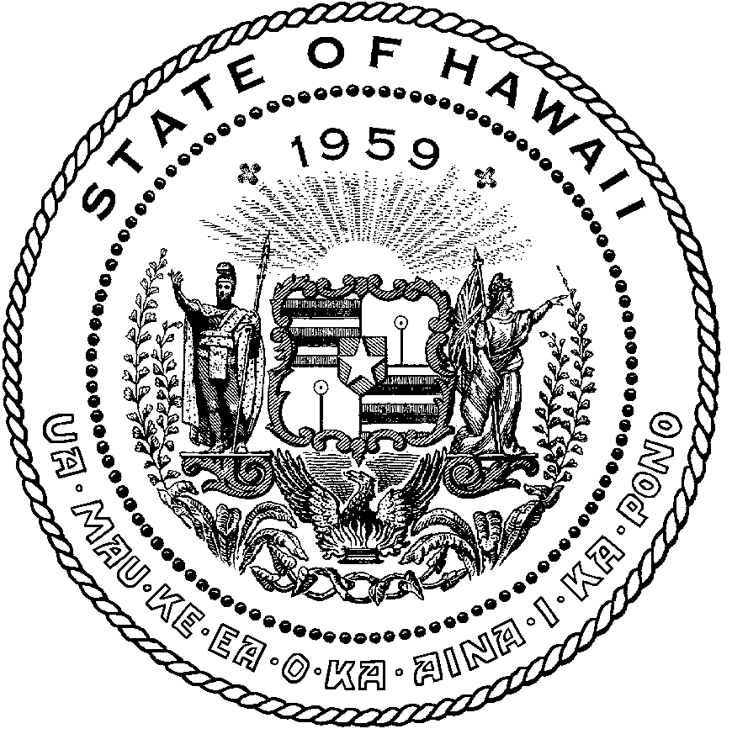 | KEITH A. REGAN  COMPTROLLER  Ka Luna Hoʻomalu Hana Laulā  MEOH-LENG SILLIMAN  DEPUTY COMPTROLLER  Ka Hope Luna Hoʻomalu Hana Laulā
STATE OF HAWAIʻI | KA Mokuʻāina o Hawaiʻi

DEPARTMENT OF ACCOUNTING AND GENERAL SERVICES | KA ʻOihana LOIHELU A LAWELAWE Laulā
P.O. BOX 119, HONOLULU, HAWAII 96810-0119

State of Hawaii 911 Board Meeting

Thursday, January 15, 2026
9:00 am – 12:00 pm

Virtually Held Meeting with Physical Location at
Kalanimoku Building Room 426, 1151 Punchbowl Street, Honolulu, Hawaii 96813 is available to the public and is guaranteed to be connected to the remote virtual meeting.

MEETING MINUTES

January 15, 2026: Joint Committee and Board Meeting (youtube.com)
Board Members Present: Corey Shaffer (Verizon), Keola Tom (MPD), Stephen Courtney (C&C of Honolulu), Liz Gregg (AT&T), Ji Sook Kim (Consumer Advocate Designee), Matthew Kurihara (HPD), Rebecca Lieberman (Spectrum), Reed Mahuna (HIPD), Scott Winecoff (T-Mobile)
Board Members Not Present: Francis Alueta (HT), Elliott K. Ke (KPD), Todd Omura (CIO Designee)
Staff: Royce Murakami (911 Board), Benson Leung (911 Board), Charles Lee (AG)
Guests: Christian Burns (HT), Frannie Chung (EMS), Marc De Costa (HT), Stacy Domingo (HIFD), Zachary Fernando (HIPD), Buck Giles (OS), Roderick Green (KPD), Tim Hansen (NAMI), Bertie Johnson (HPD), Melia Johnson (MPD), David Jones (Mission Critical), Michelle Kratel (HIPD), Shawn Kuratani (HFD), Robert Lau (DOH), Charles Lee (AG), Ah Lan Leong (HPD), Brian McKee (DIT), Sherryann Murphy (EMS), Tamera Neal (Intrado), Neil Pang (HPD), Stacy Perreira (KPD), Davlynn Racadio (MPD), Tony Ramirez (V2X), Kenison Tejada (FirstNet), Nietzche Tolan (AG), Tony Velasco (DIT)

- Call to Order, Public Notice
The meeting was called to order by the Board Chair. Public notice was given.

- Public Testimony Will Be Taken on All Agenda Items as Those Items Occur During the Meeting

- Roll Call, Quorum
A roll call was taken, quorum was present for the Board.

- Review and Approval of December Meeting Minutes
Board Chair requested a motion to approve December’s Meeting Minutes. Rebecca Lieberman motioned to approve December’s Meeting Minutes. Liz Gregg seconded the motion. A voice vote was taken, motion was unanimously approved.

- Committee Updates by Committee Chairs
  - Communications Committee – Davlynn Racadio
    - Spectrum Reach Multiscreen Campaign Follow-Up Presentation Regarding Public Safety Answering Point (PSAP) Recruitment
    - Discussion Regarding Confirmation of 9-1-1 Goes to Washington (GTW) Attendees
Davlynn Racadio stated no further updates.

  - Technical Committee – Shawn Kuratani
    - No Updates

      - Advisory Committee – Rebecca Lieberman
        - Updates on Legislative Session
Rebecca Lieberman stated no further updates.

  - Finance Committee – Edward Fujioka
    - Review of Monthly Y-T-D (Year to Date) Cash Flow
    - Hawaii Police Department Requesting $10,000.00 for 2 Additional Personnel to Attend 9-1-1 Goes to Washington (GTW) 2026
    - Hawaii Fire Department Requesting to Transfer $5,000.00 from 9-1-1 Goes to Washington (GTW) 2026 to Navigator Conference 2026
    - Honolulu Fire Department Requesting to Transfer $10,000.00 from NENA Conference & Expo (National Emergency Number Association) 2026 and $5,000.00 from 9-1-1 Goes to Washington (GTW) 2026 to Summit Conference (Motorola Solutions) 2026
Executive Director on behalf of Edward Fujioka stated no further updates.

- Next Generation 911 (NG911) Readiness Assessment Recommendations and Next Steps
  - Discussion of Governance Action Items
    - Update Regarding Permitted Interaction Group (PIG) to Develop Next Generation (NG911) Strategic Plan
    - Update Regarding Permitted Interaction Group (PIG) to Develop State-Level Continuity of Operations Plan (COOP)
PIG members stated no further updates.

- Public Safety Answering Point Status Updates on Recruitment and other Personnel Issues
  - Kauai Police Department – Andrew Muraoka
    - Update on Recruitment Process/Strategies and Personnel Training
    - Update on Personnel Issues and Vacancies
Roderick Green on behalf of Andrew Muraoka stated no further updates.

  - Oahu Police Department – Matthew Kurihara
    - Update on Recruitment Process/Strategies and Personnel Training
Ah Lan Leong on behalf of Matthew Kurihara stated that they are currently working with SHOPO to reinstate their sworn personnel call taker program. She added that their HR department is working with DOE on externships.

    - Update on Personnel Issues and Vacancies
Matthew Kurihara stated that he was recently promoted and is no longer with the communications division. He added that he has joined the HR division.

  - Oahu Fire Department – Shawn Kuratani
    - Update on Recruitment Process/Strategies and Personnel Training
    - Update on Personnel Issues and Vacancies
Shawn Kuratani stated no further updates.

  - Oahu Emergency Medical Services – Isaac Tejada, Frannie Chung, Sherryann Murphy
    - Update on Recruitment Process/Strategies and Personnel Training
    - Update on Personnel Issues and Vacancies
Frannie Chung stated no further updates.

  - Maui Police Department – Davlynn Racadio
    - Update on Recruitment Process/Strategies and Personnel Training
    - Update on Personnel Issues and Vacancies
Melia Johnson on behalf of Davlynn Racadio stated no further updates.

  - Molokai Police Department – Davlynn Racadio
    - Update on Recruitment Process/Strategies and Personnel Training
    - Update on Personnel Issues and Vacancies
Melia Johnson on behalf of Davlynn Racadio stated no further updates.

  - Hawaii Police Department – Zachary Fernando
    - Update on Recruitment Process/Strategies and Personnel Training
    - Update on Personnel Issues and Vacancies
Zachary Fernando stated no further updates.

  - Hawaii Fire Department – Stacy Domingo
    - Update on Recruitment Process/Strategies and Personnel Training
    - Update on Personnel Issues and Vacancies
Stacy Domingo stated no further updates.

- Executive Director’s Report
  - Fiscal Year 2027-2031 Strategic Budget Plan Update
Executive Director stated that he is planning to provide each agency with their respective budget excel sheets by the end of February 2026. He added that there will be first and second rounds of review before the final review takes place in June 2026. He mentioned that each agency should inform him of any substantial requests as early as possible.

  - Introduction of Deputy Attorney General Assigned to State of Hawaii 911 Board
Executive Director introduced Charles Lee as the new deputy attorney general who is assigned to the State of Hawaii 911 Board. Charles Lee greeted everyone and stated that he is Stella Kam’s replacement.

- Items for Discussion, Consideration, and Action
  - Hawaii Police Department Requesting $10,000.00 for 2 Additional Personnel to Attend 9-1-1 Goes to Washington (GTW) 2026
Board Chair stated the item above and asked for a motion to amend this agenda item from $10,000.00 (2 Additional Personnel) to $5,000.00 (1 Additional Personnel). Liz Gregg motioned to approve this request. Rebecca Lieberman seconded the motion. A voice vote was taken, motion was unanimously approved.

Board Chair stated the amended item above and asked for a motion to approve. Liz Gregg motioned to approve this request. Stephen Courtney seconded the motion. A voice vote was taken, motion was unanimously approved.

  - Hawaii Fire Department Requesting to Transfer $5,000.00 from 9-1-1 Goes to Washington (GTW) 2026 to Navigator Conference 2026
Board Chair referenced the item above, stated approval is not required, and commented that this is for information purposes only.

  - Honolulu Fire Department Requesting to Transfer $10,000.00 from NENA Conference & Expo (National Emergency Number Association) 2026 and $5,000.00 from 9-1-1 Goes to Washington (GTW) 2026 to Summit Conference (Motorola Solutions) 2026
Board Chair referenced the item above, stated approval is not required, and commented that this is for information purposes only.

  - Additional Items Proposed by Meeting Attendees for Consideration and Possible Inclusion on Future Agendas

- Announcements
  - Future Virtual Meeting Dates/Times (9:00AM-12:00PM)
    - Thursday, February 12, 2026 (Combined Meeting)
    - Thursday, March 12, 2026 (Combined Meeting)

  - Future Conference Dates (3 Months of Advanced Approval Required)
    - 9-1-1 Goes to Washington (GTW), February 22-25, 2026, Arlington, VA
    - CentralSquare ENGAGE, March 15-18, 2026, Washington, D.C.
    - International Wireless Communications Expo (IWCE), March 16-19, 2026, Las Vegas, NV
    - Summit Conference (Motorola Solutions), April 19-23, 2026, Orlando, FL
    - Navigator Conference, April 21-24, 2026, Las Vegas, NV
    - NICE Conference & Expo (National Initiative for Cybersecurity Education), June 1-3, 2026, Philadelphia, PA

  - Additional Announcements from Meeting Attendees for Consideration and Possible Inclusion on Future Agendas

- Open Forum: Public comment on Issues not on the Board Meeting Agenda
There was no public comment on issues not on the agenda.

- Adjournment
Board Chair requested a motion to adjourn the meeting. Ji Sook Kim motioned to adjourn the meeting. Liz Gregg seconded the motion. A voice vote was taken, adjournment was unanimously approved. The meeting was adjourned.

