JOSH GREEN, M.D.  GOVERNOR  Ke Kiaʻāina |  | KEITH A. REGAN  COMPTROLLER  Ka Luna Hoʻomalu Hana Laulā  MEOH-LENG SILLIMAN  DEPUTY COMPTROLLER  Ka Hope Luna Hoʻomalu Hana Laulā
STATE OF HAWAIʻI | KA Mokuʻāina o Hawaiʻi

DEPARTMENT OF ACCOUNTING AND GENERAL SERVICES | KA ʻOihana LOIHELU A LAWELAWE Laulā
P.O. BOX 119, HONOLULU, HAWAII 96810-0119

Communications, Technical, and Finance Meeting
(Combined Meeting)

Thursday, December 11, 2025
9:00 am – 12:00 pm

Virtually Held Meeting with Physical Location at
Kalanimoku Building Room 426, 1151 Punchbowl Street, Honolulu, Hawaii 96813 is available to the public and is guaranteed to be connected to the remote virtual meeting.

MEETING MINUTES

December 11, 2025: Joint Committee and Board Meeting (youtube.com)

Communications Committee Members Present: Davlynn Racadio (MPD), Ah Lan Leong (HPD)

Communications Committee Members Not Present: Lavina Taovao (KPD)

Technical Committee Members Present: Shawn Kuratani (HFD), Tony Ramirez (V2X), Tony Velasco (DIT)

Technical Committee Members Not Present: Stacy Domingo (HIFD), Kenison Tejada (FirstNet)

Finance Committee Members Present: Edward Fujioka (EMS), Stephen Courtney (C&C of Honolulu), Liz Gregg (AT&T), Matthew Kurihara (HPD), Todd Omura (CIO Designee), Tony Velasco (DIT)

Finance Committee Members Not Present: Reed Mahuna (HIPD)

Staff: Royce Murakami (911 Board), Benson Leung (911 Board), Nietzche Tolan (AG)

Guests: Ian Atkins (Carbyne), Jeremy Bell (AT&T), Darin Biamonte (Mission Critical), Christian Burns (HT), Frannie Chung (EMS), Marc De Costa (HT), Carla Even (RapidSOS), Zachary Fernando (HIPD), Greg Florian (Spectrum), Marisa Fujimoto (HT), Barbara Geary (Spectrum), Roderick Green (KPD), Sherri Griffith Powell (Mission Critical), Wayne Hirasa (Alakaina), Bertie Johnson (HPD), Melia Johnson (MPD), Kevin Kaneshiro (HIFD), Wesley Kawachi (AOK), Elliott K. Ke (KPD), Michelle Kratel (HIPD), Robert Lau (DOH), Patrick Leddy (LCC), Rebecca Lieberman (Spectrum), Andrew Muraoka (KPD), Sherryann Murphy (EMS), Tamera Neal (Intrado), Gregg Okamoto (MPD), Lorrin Okumura (EMS), Frank Pace (DOD), Neil Pang (HPD), Stacy Perreira (KPD), Kapu Ping (OS), Ernest Robello (DLE), Christine Sakuda (ETS), Corey Shaffer (Verizon), Chas Taketa (HIFD), Nietzche Tolan (AG), Keola Tom (MPD), Nathan Wilson (HIFD)

- Call to Order, Public Notice
The meeting was called to order by the Board Chair. Public notice was given.

- Public Testimony Will Be Taken on All Agenda Items as Those Items Occur During the Meeting

- Roll Call, Quorum
A roll call was taken, quorum was present for all committees.

- Review and Approval of November Meeting Minutes
Board Chair requested a motion to approve November’s Meeting Minutes. Tony Velasco motioned to approve November’s Meeting Minutes. Keola Tom seconded the motion. A voice vote was taken, motion was unanimously approved.

- Presentation Regarding FY 2024-2025 Independent Audit Report
Wesley Kawachi from Akamine, Oyadomari & Kosaki CPA’s, Inc. (AOK) introduced himself as the auditor who conducted the FY 2024-2025 independent audit report for the State of Hawaii 911 Board. He then provided an overview of his presentation consisting of financial statements review, discussion of the governance letter, and a Q&A session.

Wesley Kawachi mentioned that the report states the audit objectives. He added that the management’s discussion and analysis (MD&A) section is not formally audited but provides useful information, summaries, and explanations. He stated that the financial information and figures were fully audited. Furthermore, the auditor stated that the audit report is considered unmodified (i.e. clean) resulting in an opinion that the financial statements present fairly, in all material respects, the financial position of the State of Hawaii 911 Board. Lastly, he stated that there are no auditor findings this fiscal year and mentioned that the prior year’s finding was satisfactorily resolved.

Wesley Kawachi stated that the governance letter accompanies the audit report, which is from the auditors to the board members directly and determines if there are any problems/issues during the audit process. He mentioned that there were no problems/issues and expressed his satisfaction whilst working with the Executive Director and Administrative Services Assistant to complete the audit report.

Board Chair expressed his appreciation to Wesley Kawachi, the Executive Director, and the Administrative Services Assistant for producing this clean audit report. Executive Director expressed his gratitude to Wesley Kawachi for his efforts and due diligence throughout this audit process.

- Committee Updates by Committee Chairs
  - Communications Committee – Davlynn Racadio
    - Spectrum Reach Multiscreen Campaign Presentation Regarding Public Safety Answering Point (PSAP) Recruitment
Greg Florian introduced himself as the local sales manager for Spectrum in Honolulu, Hawaii. He then introduced his colleague Barbara Geary who has public safety experience.

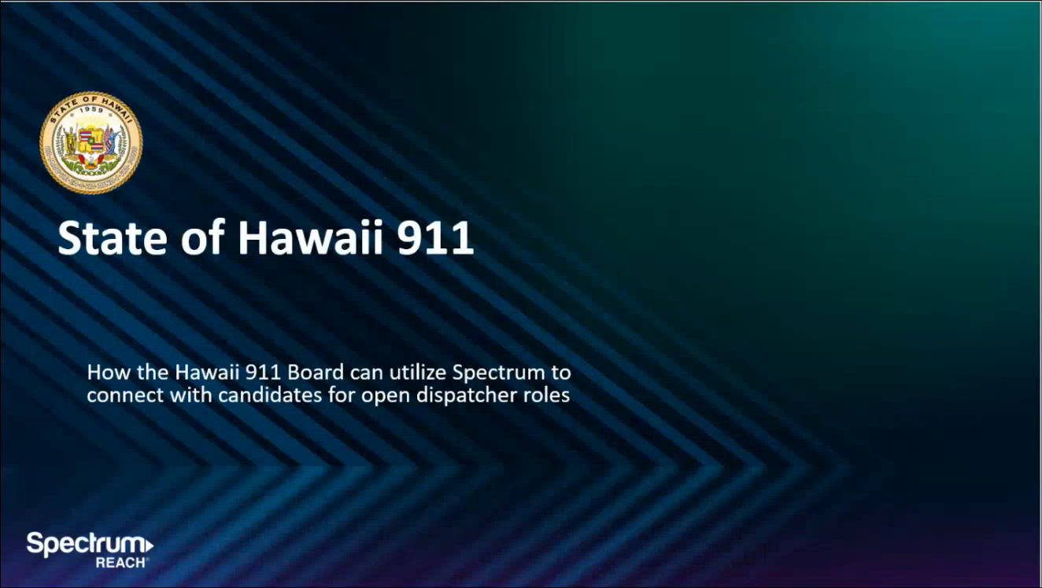
Greg Florian referenced the slide above regarding Spectrum’s proposal to aid the PSAPs with recruitment. He added that they worked with the North Carolina 911 Board to provide this recruitment campaign in the past.

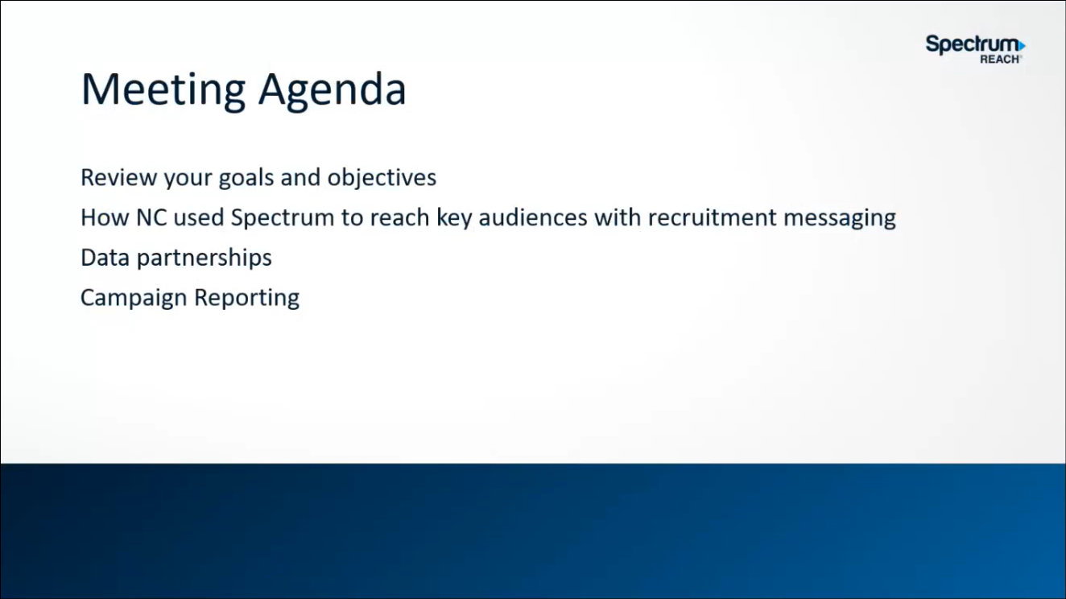
Greg Florian asked Corey Shaffer what are the 911 Board’s goals/objectives in terms of PSAP recruitment. Corey Shaffer responded stating that previous recruitment campaigns have been relatively limited and were conducted on a county basis rather than a statewide campaign. He added that the goals/objectives would be to increase recruitment to reduce vacancies and advocate the importance of these public safety roles/positions. Matthew Kurihara concurred with Corey Shaffer and cautioned potential headwinds regarding ethics and compliance.

Corey Shaffer asked the Executive Director if Spectrum’s proposed recruitment campaign is a reimbursable expenditure for the PSAPs or not. Executive Director responded stating that it is a reimbursable expenditure after discussing with the 911 Board’s attorney general. He added that a caveat is that each county would need to procure their own contract.

Corey Shaffer asked Greg Florian how would the various county recruitment videos be differentiated from each other. Greg Florian responded stating that Spectrum’s proposal offers flexibility ranging from recruitment videos sharing similar elements or individualized by county. He added that each county would be able to promote their own unique web addresses to direct the appropriate applicants. In addition, he mentioned that Spectrum is able to track the recruitment stats for each county.

Edward Fujioka asked Greg Florian if the North Carolina 911 Board conducted a statewide recruitment campaign or through each county. Greg Florian responded stating that the North Carolina 911 Board opted for a statewide recruitment campaign with additional county specific levels. He added that Spectrum is able to provide recruitment data based on zip codes and the multimedia source used to view the aforementioned video. Edward Fujioka asked Greg Florian a follow-up question if the recruitment campaign videos will be broadcast based on zip codes. Greg Florian responded stating that Spectrum is able to set up and broadcast each recruitment campaign video to the desired county. He added that Spectrum is capable of targeting specific demographics based on age, gender, etc. Edward Fujioka asked Greg Florian a follow-up question if this recruitment campaign includes social media presence or not. Greg Florian responded stating that the recruitment campaign videos can be posted on Facebook and/or Instagram.


Greg Florian referenced the slide above regarding the positive impacts of Spectrum’s recruitment campaign in North Carolina.

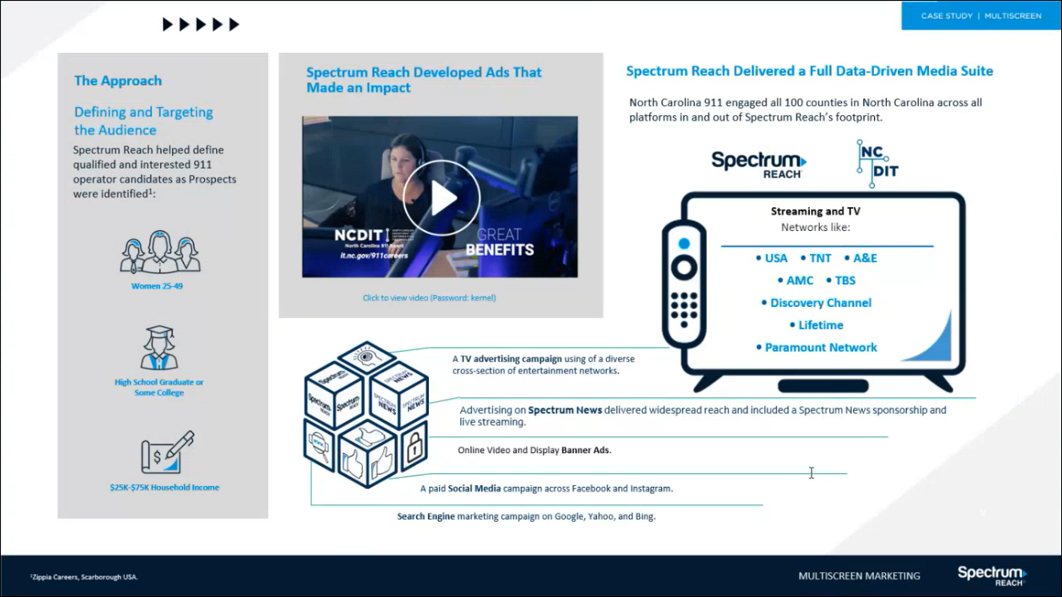
Greg Florian referenced the slide above regarding the tactics utilized to promote the recruitment campaign video for North Carolina. He added that he recommends broadcasting Hawaii’s recruitment campaign video during sports games at the local high school and collegiate levels given its popularity amongst viewers.


Greg Florian referenced the slide above regarding the successful results of Spectrum’s recruitment campaign in North Carolina.

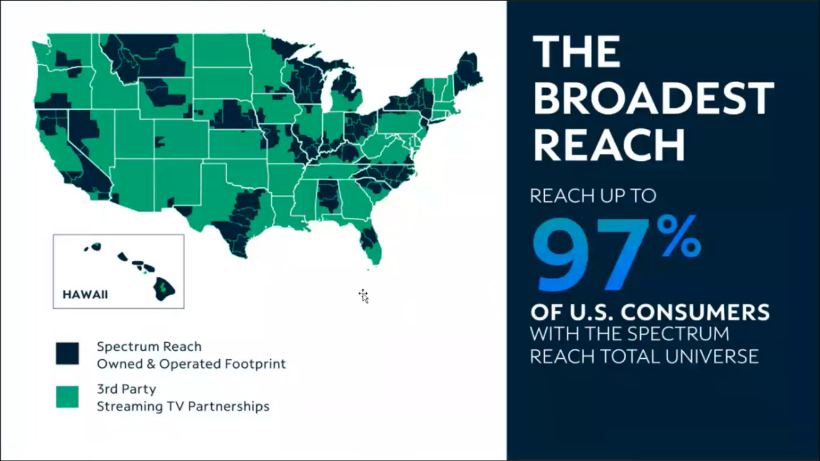
Greg Florian referenced the slide above regarding Spectrum’s coverage in the U.S. He added that Spectrum has an expansive network covering 41 states total if Hawaii opts to promote and broadcast in the continental U.S.


Greg Florian referenced the slide above regarding Spectrum’s access to data and trends based on consumer usage via their home’s connection point.

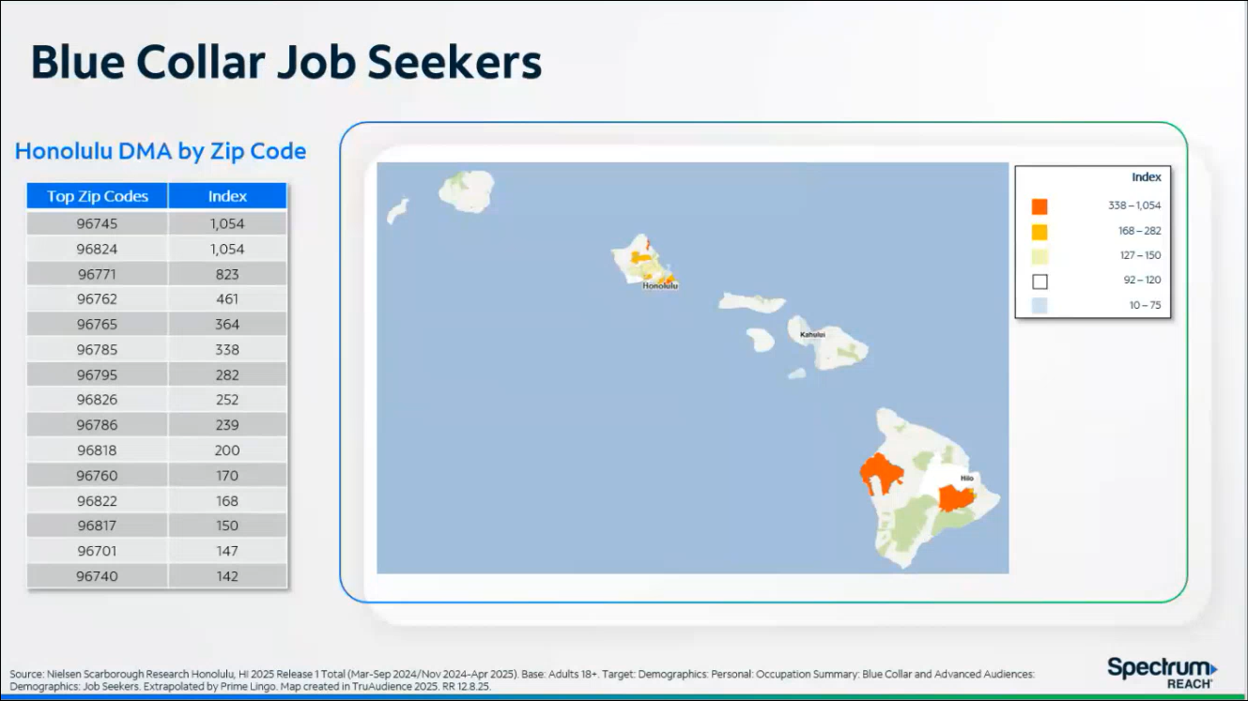
Greg Florian referenced the slide above regarding Spectrum’s ability to generate heatmaps identifying concentrations of job seekers for additional precision with targeted ads and messaging.

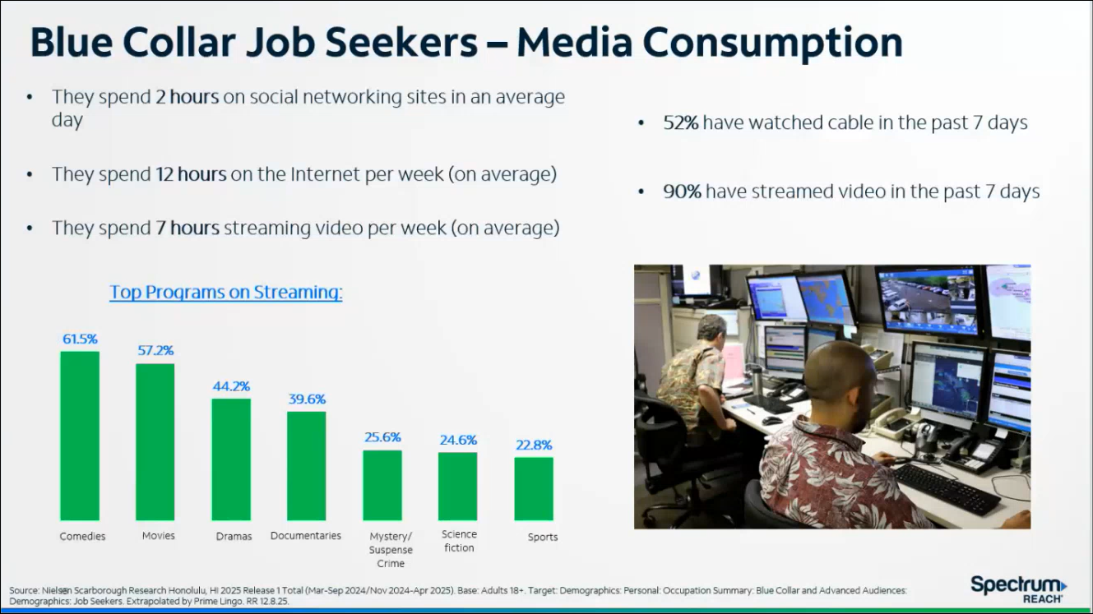
Greg Florian referenced the slide above regarding Spectrum’s ability to track consumer usage trends and patterns.

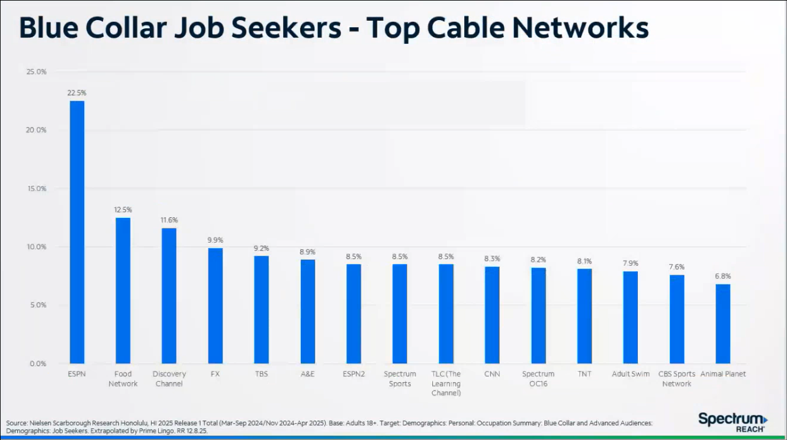
Greg Florian referenced the slide above regarding viewer preferences for specific cable networks.

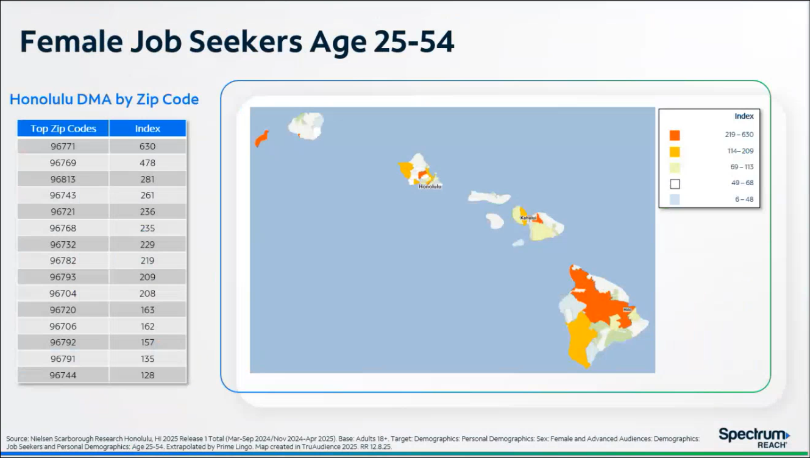
Greg Florian referenced the slide above regarding Spectrum’s capability to pinpoint certain demographics and parameters, which was a tactic utilized in North Carolina’s recruitment campaign.

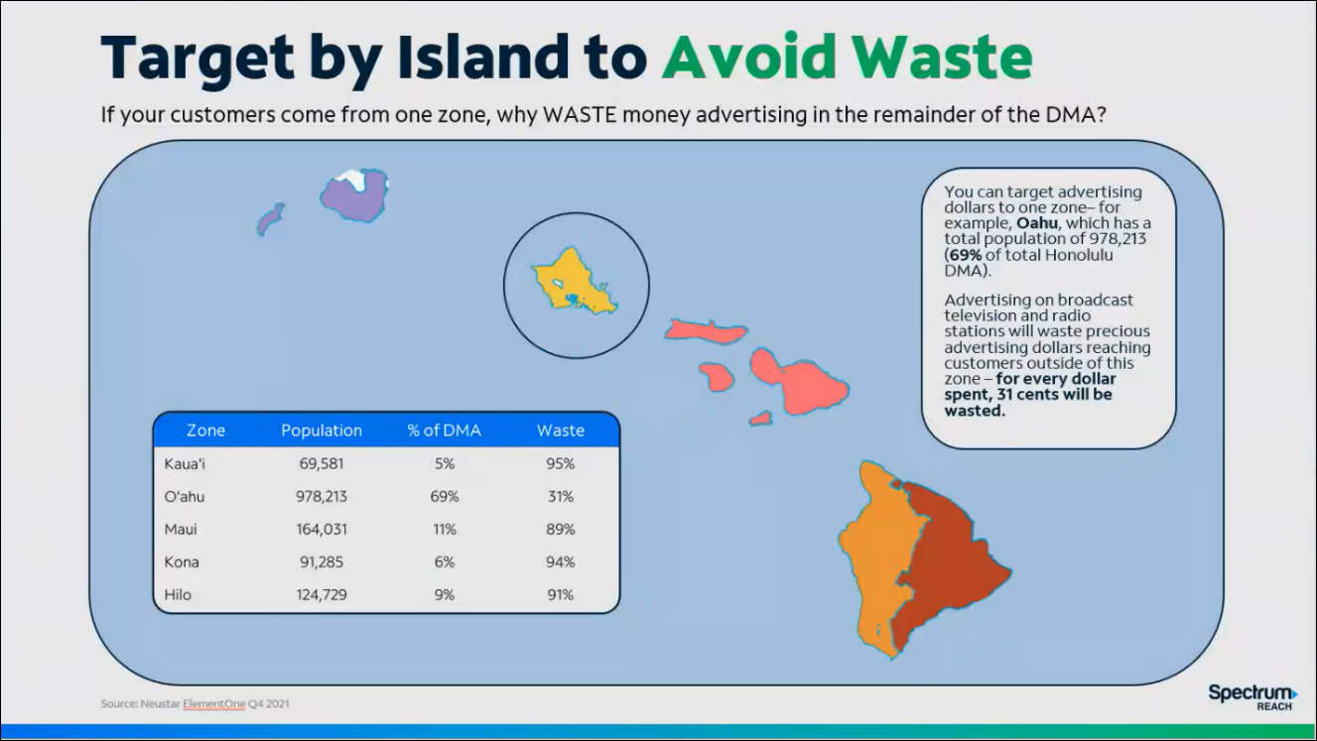
Greg Florian referenced the slide above reiterating Spectrum’s flexibility to create individualized recruitment campaigns, videos, etc. based on each county’s needs.

Matthew Kurihara asked Greg Florian if Spectrum would be open to conducting a joint recruitment campaign for both the PSAP and police officers since HPD has a separate HR division that oversees recruitment for both the PSAP and police officers. Greg Florian responded stating that this is possible. Barbara Geary added that she has been actively working with HPD’s recruitment department and is currently awaiting a follow-up meeting. She mentioned that HPD’s recruitment department is discussing both budget and procurement matters as it relates to Spectrum’s recruitment campaign proposal. Corey Shaffer mentioned that the 911 Board is only able to reimburse the PSAP associated recruitment campaign costs and expenditures. Matthew Kurihara commented that there is a great likelihood of HPD funding the entire joint recruitment campaign for the PSAP and police officers without any financial assistance from the 911 Board.

Edward Fujioka asked Greg Florian if each respective county will own their recruit campaign video rights postproduction or not. Greg Florian responded stating that each county will maintain the rights and has the ability to utilize their recruitment campaign video at their discretion with no additional licensing or copyright fees.


Greg Florian referenced the slide above regarding advanced reporting metrics for the recruitment campaign to track effectiveness. He added that Spectrum provides this dashboard, which is accessible 24/7.

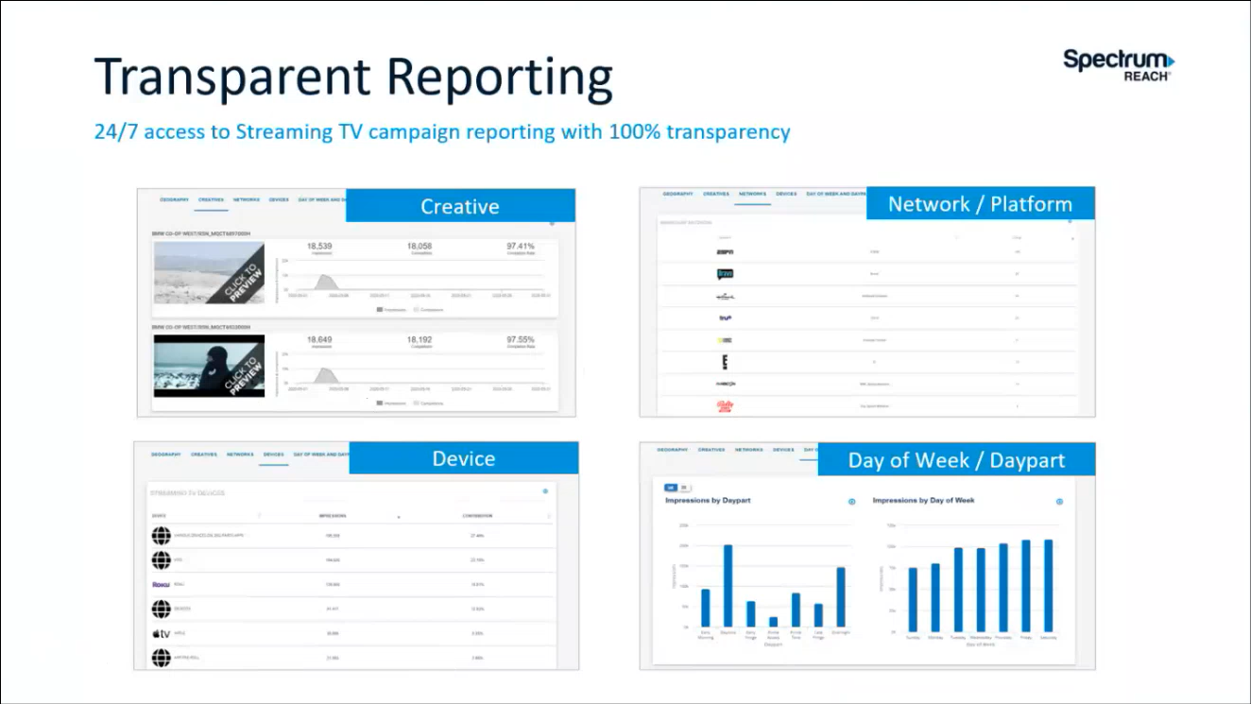
Greg Florian referenced the slide above regarding Spectrum’s ability to provide custom reports generated from the aforementioned dashboard including but not limited to click rates, times viewed, type of user devices, report frequency, etc.

Corey Shaffer asked Greg Florian what are the next steps to inquire further about Spectrum’s recruitment campaign. Greg Florian responded stating that the PSAPs could reach out to him and Barbara Geary directly or have the Executive Director facilitate. Corey Shaffer added that any quotes and/or proposals received by the PSAPs from Spectrum should be discussed during a future 911 Board monthly meeting before it is finalized. Tony Ramirez mentioned that there have been past media campaigns in Hawaii regarding Text-to-911 and HPD’s database services.

Barbara Geary asked Matthew Kurihara if they are interested in recruitment from the continental U.S. or not. Matthew Kurihara responded stating that his PSAP would be interested and recently there has been a significant influx of recruits from the continental U.S.

Elliott K. Ke mentioned that KPD recently entered into a contract with Spectrum Reach in October 2025 for a police officer recruitment campaign. He stated his support of Spectrum’s offering due to their professionalism, attention to detail, and customization. He added that they are currently pending the job application volume data from their HR department.

Davlynn Racadio advocated her support for Spectrum’s recruitment campaign proposal but stated that this may not work for MPD at this point in time due to their existing applicant backlog and the shortage of trainers. She mentioned that she will keep this aforementioned recruitment campaign in mind for potential future usage if warranted.

    - Discussion Regarding 9-1-1 Goes to Washington (GTW) Attendees
Davlynn Racadio referenced the item above and requested an attendance check so that she is able to coordinate and plan meetings with the correct headcount. She mentioned to contact her if there are any questions regarding this conference.

  - Technical Committee – Shawn Kuratani
    - Follow-Up Discussion Regarding SCC (Spatial Command and Control) Mapping Icons
Shawn Kuratani referenced the item above and stated that the PSAPs determined they will not move forward to pursue the new SCC mapping icons. He mentioned that during a previous meeting, Hawaiian Telcom stated that they are unable to add any new mapping icons since it would adversely affect existing map functionalities. Furthermore, an email from the PSAPs was sent to Hawaiian Telcom on 11-18-2025 to formally confirm this decision.

    - Follow-Up Discussion Regarding PUC (Public Utilities Commission) Re-Evaluation Regarding Number of Tariff Positions Allotted
Shawn Kuratani referenced the item above and stated that the PSAPs will not be initiating this re-evaluation at this point in time.

      - Advisory Committee – Rebecca Lieberman
        - 2026 Legislative Session Opening Day on January 21, 2026
Rebecca Lieberman referenced the item above and stated that she will review the proposed bills when the legislative session begins and will bring forth relevant bills to the 911 Board if any.

  - Finance Committee – Edward Fujioka
    - Review of Monthly Y-T-D (Year to Date) Cash Flow
November 2025 Cashflow Statement:

Surcharge Collection: $728,068
Interest Income: $116,953
Total Receipts: $845,021
Total Disbursements: ($419,779)
Net Receipts/Disbursements: $425,242
Net Encumbrances Adds/(Paydown): ($771,706)
Net Cash Inflow/(Outflow): ($346,464)
Outstanding Encumbrances: $10,089,926
Net Bank Balance: $47,264,711
Unencumbered Cash Balance: $37,174,785

Executive Director mentioned that on average the 911 Board receives ~$1,000,000.00 in monthly surcharge collections. He stated that a provider who typically remits ~$300,000.00 did not send a submittal in November 2025. Furthermore, this aforementioned provider’s submittal was received in December 2025.

    - Executive Director Requesting $104,380.38 for Honolulu Police Department Public Safety Answering Point (PSAP) 9-1-1 Provisioning Database
Edward Fujioka stated the item above and requested an explanation. Executive Director explained that this request was caused by a clerical bookkeeping error due to a physical check being voided and reissued during the 911 Board’s bank transition from FHB to CPB. He added that the aforementioned check was erroneously accounted for twice when assessing the contract’s remaining balance. Edward Fujioka asked the Executive Director if this request will provide additional funds or not. Executive Director responded stating that this request will not provide additional funds nor deduct existing funds. Edward Fujioka asked for a motion to approve. Tony Velasco motioned to approve this request. Liz Gregg seconded the motion. A voice vote was taken, motion was unanimously approved.

    - Kauai Police Department Requesting $36,720.00 for HigherGround Capture911 Logging Recorder Upgrade
Edward Fujioka stated the item above and requested an explanation. Andrew Muraoka explained that this request is to upgrade their existing HigherGround Capture911 logging recorder, which has reached its end of life and the current version will no longer be supported if they do not upgrade. Edward Fujioka asked for a motion to approve. Matthew Kurihara motioned to approve this request. Stephen Courtney seconded the motion. A voice vote was taken, motion was unanimously approved.

- Next Generation 911 (NG911) Readiness Assessment Recommendations and Next Steps
  - Discussion of Governance Action Items
    - Discussion Regarding Creation of Permitted Interaction Group (PIG) to Develop Next Generation (NG911) Strategic Plan
Corey Shaffer referenced the item above and stated that the strategic plan should include the following: vision statement, mission statement, goals/objectives, actionable steps, available resources, performance metrics, project milestones, etc.

    - Discussion Regarding Creation of Permitted Interaction Group (PIG) to Develop State-Level Continuity of Operations Plan (COOP)
Corey Shaffer asked the Executive Director if both PIGs will have identical members or not. Executive Director responded stating that they will be the same. Corey Shaffer asked the Executive Director a follow-up question regarding when these PIG meetings will take place. Executive Director responded stating that the PIGs will meet offline and provide pertinent updates as they become available during the 911 Board’s monthly meetings.

Executive Director stated that the following individuals listed below are proposed for both PIGs:
- Hawaii County
  - Zachary Fernando
  - Pedro Cacho Jr.
  - Stacy Domingo
- Maui County
  - Davlynn Racadio
  - Melia Johnson
- Kauai County
  - Stacy Perreira
  - Andrew Muraoka
- Oahu County
  - Shawn Kuratani
  - Sean Chun
  - Sherryann Murphy
  - Diana Chun
  - Matthew Kurihara
  - Ah Lan Leong
  - Buck Giles
  - Kapu Ping
- V2X
  - Tony Ramirez
- Hawaiian Telcom
  - Francis Alueta
- DIT
  - Stephen Courtney
  - Tony Velasco
- 911 Board
  - Royce Murakami
  - Edward Fujioka

- Public Safety Answering Point Status Updates on Recruitment and other Personnel Issues
  - Kauai Police Department – Andrew Muraoka
    - Update on Recruitment Process/Strategies and Personnel Training
Andrew Muraoka stated that they have an interviewee advancing to the next phase of their hiring process. He added that they are setting up an interview for 1 referred candidate.

    - Update on Personnel Issues and Vacancies
Andrew Muraoka stated that they have 1 personnel resigning and 1 personnel going on leave. He added that they still have several vacant positions.

  - Oahu Police Department – Matthew Kurihara
    - Update on Recruitment Process/Strategies and Personnel Training
Matthew Kurihara stated that they currently have 6 personnel in training and are planning to start their next class in January 2026, which only consists of 2 trainees at this point in time but they are hoping to increase the class size. He added that background checks for potential hires have been delaying their hiring process due to the shortage of polygraph examiners. Corey Shaffer asked Matthew Kurihara if it is feasible to remove polygraph testing from their hiring process or not. Matthew Kurihara responded stating that it has been considered with no final decision rendered yet. He mentioned that only ~175 applicants out of ~600 total passed the initial CritiCall test.

    - Update on Personnel Issues and Vacancies
Matthew Kurihara stated no updates.

  - Oahu Fire Department – Shawn Kuratani
    - Update on Recruitment Process/Strategies and Personnel Training
Shawn Kuratani stated that they will begin a training class in January 2026 and are anticipating 16 personnel total to be fully trained at the end of the same year.

    - Update on Personnel Issues and Vacancies
Shawn Kuratani stated that they are currently fully staffed but 15 out of 24 total positions will be eligible for retirement at the end of 2026. Corey Shaffer asked Shawn Kuratani if the significant amount of eligible retirees was intentional or not. Shawn Kuratani responded stating that this was not intentional but was caused by coincidence due to historically large recruitment classes.

  - Oahu Emergency Medical Services – Lorrin Okumura, Diana Chun, Frannie Chung
    - Update on Recruitment Process/Strategies and Personnel Training
Lorrin Okumura stated that they might plan another EMD academy class next year given the success from this past year. He added that there could be potential incoming personnel transfers in January 2026, which will improve their vacancy rate.

    - Update on Personnel Issues and Vacancies
Lorrin Okumura stated that they currently have a ~21% vacancy rate, which is 22 out of 28 total positions filled. He announced that he will be retiring on 12-30-2025 with Frannie Chung and Sherryann Murphy as his replacements during the 911 Board’s monthly meetings. He added that his interim replacement is Isaac Tejada. He expressed his gratitude to the 911 Board for all the support provided to him.

  - Maui Police Department – Davlynn Racadio
    - Update on Recruitment Process/Strategies and Personnel Training
Melia Johnson on behalf of Davlynn Racadio stated that they recently started a recruitment class in December 2025 with 4 trainees total.

    - Update on Personnel Issues and Vacancies
Melia Johnson on behalf of Davlynn Racadio stated that they currently have a ~46% vacancy rate.

  - Molokai Police Department – Davlynn Racadio
    - Update on Recruitment Process/Strategies and Personnel Training
Please see updates under Maui Police Department.

    - Update on Personnel Issues and Vacancies
Please see updates under Maui Police Department.

  - Hawaii Police Department – Zachary Fernando
    - Update on Recruitment Process/Strategies and Personnel Training
Zachary Fernando stated that they added 1 personnel recently and currently have 2 personnel in training. He mentioned that they are planning to hire 4 applicants in February 2026.

    - Update on Personnel Issues and Vacancies
Zachary Fernando stated that they currently have a ~40% vacancy rate.

  - Hawaii Fire Department – Stacy Domingo
    - Update on Recruitment Process/Strategies and Personnel Training
Kevin Kaneshiro on behalf of Stacy Domingo stated that they recently started 4 new hires in December 2025.

    - Update on Personnel Issues and Vacancies
Kevin Kaneshiro on behalf of Stacy Domingo stated that they currently have a ~50% vacancy rate. He added that they have 1 personnel currently on maternity leave.

- Items for Discussion, Consideration, and Action
  - Additional Items Proposed by Meeting Attendees for Consideration and Possible Inclusion on Future Agendas

- Announcements
  - Future Virtual Meeting Dates/Times (9:00AM-12:00PM)
    - Thursday, January 15, 2026 (Combined Meeting)
    - Thursday, February 12, 2026 (Combined Meeting)

  - Future Conference Dates (3 Months of Advanced Approval Required)
    - 9-1-1 Goes to Washington (GTW) February 22-25, 2026, Arlington, VA
    - CentralSquare ENGAGE March 15-18, 2026, Washington, D.C.
    - International Wireless Communications Expo (IWCE) March 16-19, 2026, Las Vegas, NV
    - Summit Conference (Motorola Solutions), April 19-23, 2026, Orlando, Florida
    - Navigator Conference, April 21-24, 2026, Las Vegas, Nevada

  - Additional Announcements from Meeting Attendees for Consideration and Possible Inclusion on Future Agendas

- Open Forum: Public Comment on Issues not on the Board Meeting Agenda
There was no public comment on issues not on the agenda.

- Adjournment
Board Chair requested a motion to adjourn the meeting. Matthew Kurihara motioned to adjourn the meeting. Tony Ramirez seconded the motion. A voice vote was taken, adjournment was unanimously approved. The meeting was adjourned.

