JOSH GREEN, M.D.  GOVERNOR  Ke Kiaʻāina |  | KEITH A. REGAN  COMPTROLLER  Ka Luna Hoʻomalu Hana Laulā  MEOH-LENG SILLIMAN  DEPUTY COMPTROLLER  Ka Hope Luna Hoʻomalu Hana Laulā
STATE OF HAWAIʻI | KA Mokuʻāina o Hawaiʻi

DEPARTMENT OF ACCOUNTING AND GENERAL SERVICES | KA ʻOihana LOIHELU A LAWELAWE Laulā
P.O. BOX 119, HONOLULU, HAWAII 96810-0119

Communications, Technical, and Finance Meeting
(Combined Meeting)

Thursday, November 13, 2025
9:00 am – 12:00 pm

Virtually Held Meeting with Physical Location at
Kalanimoku Building Room 426, 1151 Punchbowl Street, Honolulu, Hawaii 96813 is available to the public and is guaranteed to be connected to the remote virtual meeting.

MEETING MINUTES

November 13, 2025: Joint Committee and Board Meeting (youtube.com)

Communications Committee Members Present: Davlynn Racadio (MPD), Ah Lan Leong (HPD)

Communications Committee Members Not Present: Lavina Taovao (KPD)

Technical Committee Members Present: Shawn Kuratani (HFD), Stacy Domingo (HIFD), Kenison Tejada (FirstNet), Tony Velasco (DIT)

Technical Committee Members Not Present: Thalia Burns (APCO/NENA), David Miyasaki (KPD), Tony Ramirez (V2X)

Finance Committee Members Present: Edward Fujioka (EMS), Stephen Courtney (C&C of Honolulu), Matthew Kurihara (HPD), Tony Velasco (DIT)

Finance Committee Members Not Present: Liz Gregg (AT&T), Reed Mahuna (HIPD), Todd Omura (CIO Designee)

Staff: Royce Murakami (911 Board), Benson Leung (911 Board), Nietzche Tolan (AG)

Guests: Diane Ako (DAGS), Francis Alueta (HT), Christian Burns (HT), Michael Chambrella (AG), Frannie Chung (EMS), Ruth Cruz (Intrado), Marc De Costa (HT), Carla Even (RapidSOS), Kristen Falco (NC 911 Board), Scott Faust (Sanborn), Zachary Fernando (HIPD), Marisa Fujimoto (HT), Roderick Green (KPD), Pokey Harris (NC 911 Board), Wayne Hirasa (Alakaina), Melia Johnson (MPD), David Jones (Mission Critical), Ji Sook Kim (Consumer Advocate Designee), Michelle Kratel (HIPD), Rebecca Lieberman (Spectrum), Sherryann Murphy (EMS), Tamera Neal (Intrado), Gregg Okamoto (MPD), Lorrin Okumura (EMS), Megan Reilly (EagleView), Thomas Rogers (NC 911 Board), Corey Shaffer (Verizon), Keola Tom (MPD), Scott Winecoff (T-Mobile)

- Call to Order, Public Notice
The meeting was called to order by the Board Chair. Public notice was given.

- Public Testimony Will Be Taken on All Agenda Items as Those Items Occur During the Meeting

- Roll Call, Quorum
A roll call was taken, quorum was present for all committees.

- Review and Approval of October Meeting Minutes
Board Chair requested a motion to approve October’s Meeting Minutes. Tony Velasco motioned to approve October’s Meeting Minutes. Keola Tom seconded the motion. A voice vote was taken, motion was unanimously approved.

- Presentation, 2024 Hurricane Helene: Validating North Carolina Next Generation 911 (NG911)
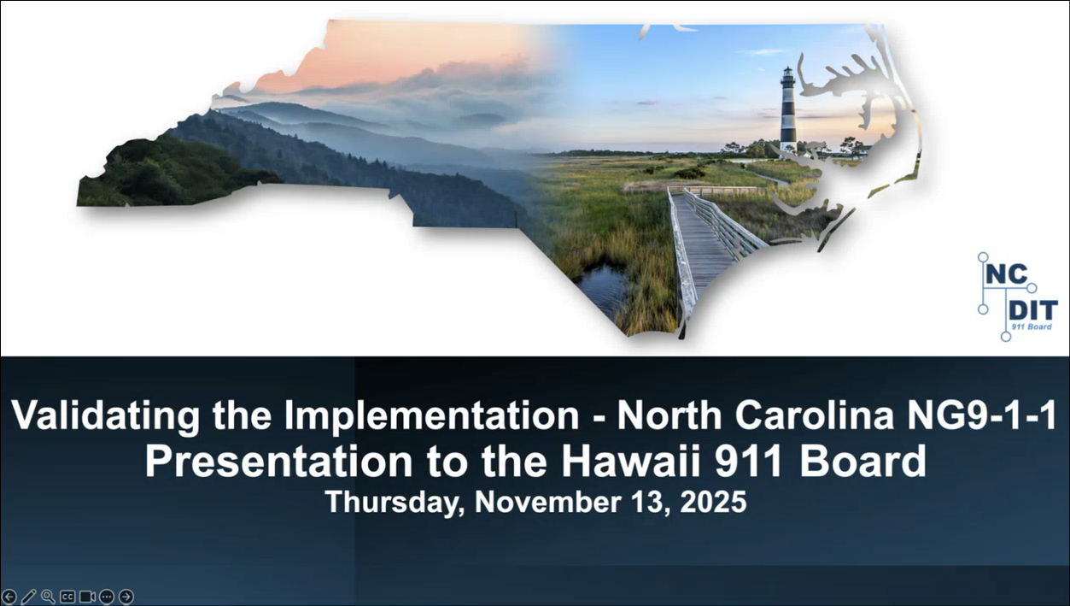
Pokey Harris introduced herself as the executive director for the North Carolina 911 Board and the current president of the National Association of State 911 Administrators (NASNA). She then introduced her colleagues from the North Carolina 911 Board, Kristen Falco who is currently the education and training coordinator and previously the regional 911 coordinator and financial review specialist. Additionally, Thomas Rogers is their Next Generation 911 (NG911) network engineer and program manager.

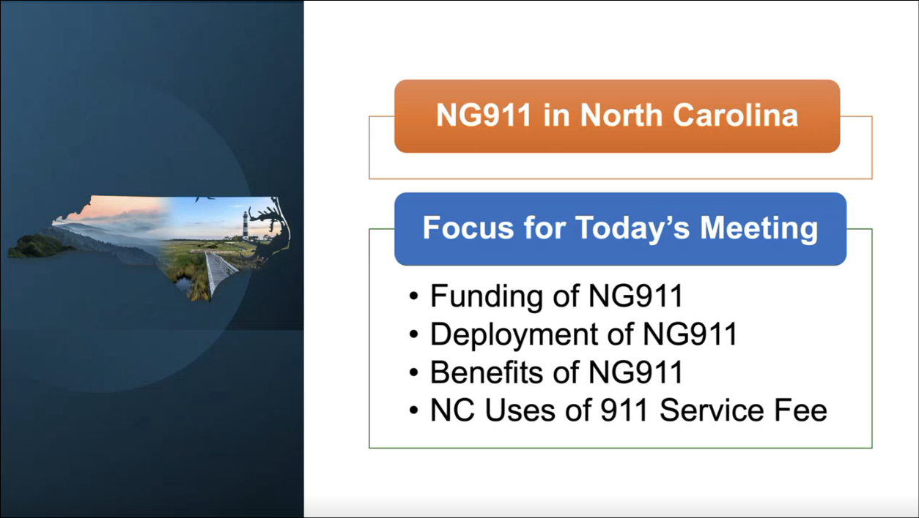
Pokey Harris referenced the slide above regarding the topics that will be covered in the presentation. She added that the presentation will discuss governance and authority as well.


Pokey Harris referenced the slide above regarding a quote from Pablo Picasso, which has become the mantra for the North Carolina 911 Board. She highlighted the keywords being vehicle, route, and success.

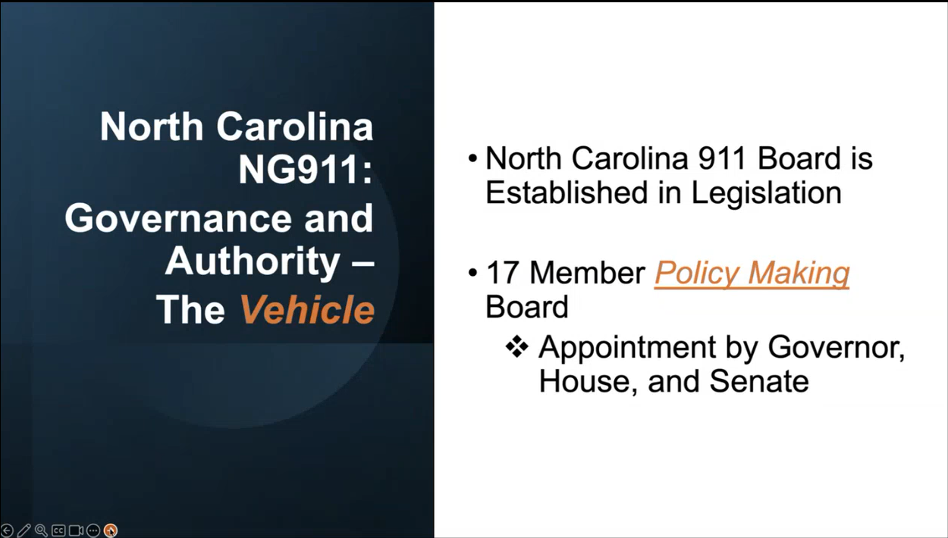
Pokey Harris referenced the slide above regarding the North Carolina 911 Board’s governance and authority. She added that this board is not advisory but rather creates policies, procedures, and standards that have authority.

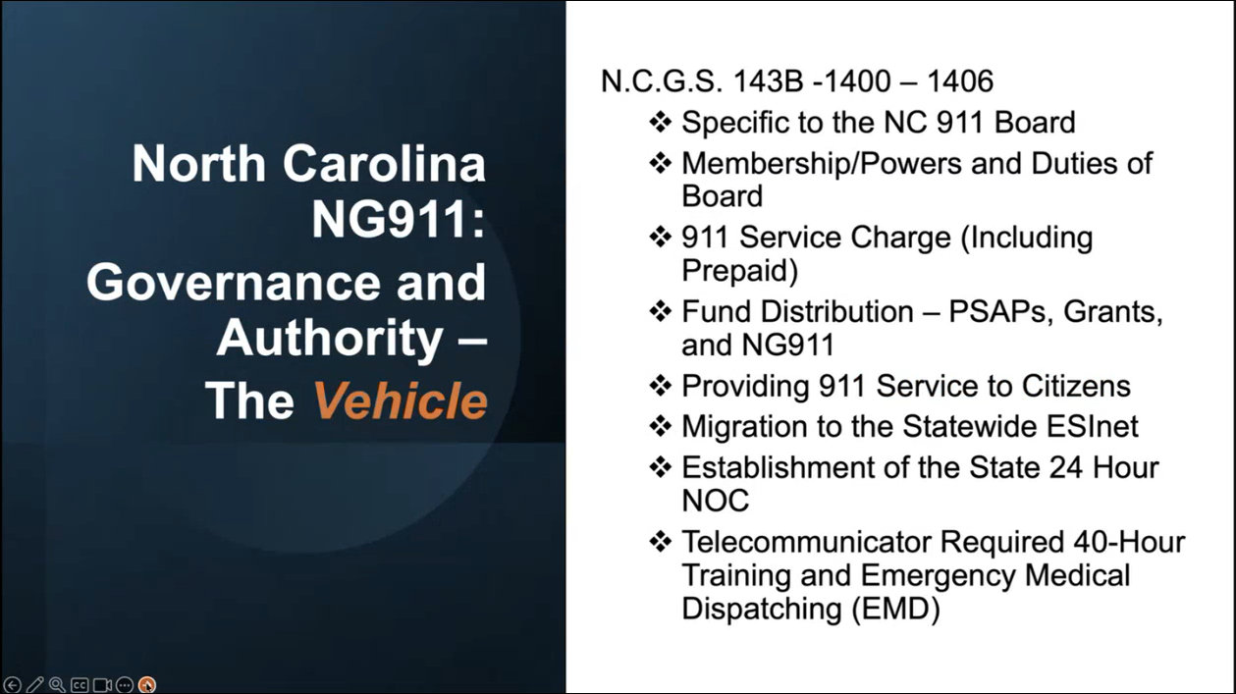
Pokey Harris referenced the slide above regarding the general statute of the North Carolina 911 Board. She added that they are not allowed to own a telecommunications emergency network. She also stated that they have a 24-hour network operations center (NOC) or network monitoring and assistance center (NMAC), which provides visibility into the function of their statewide ESInet.

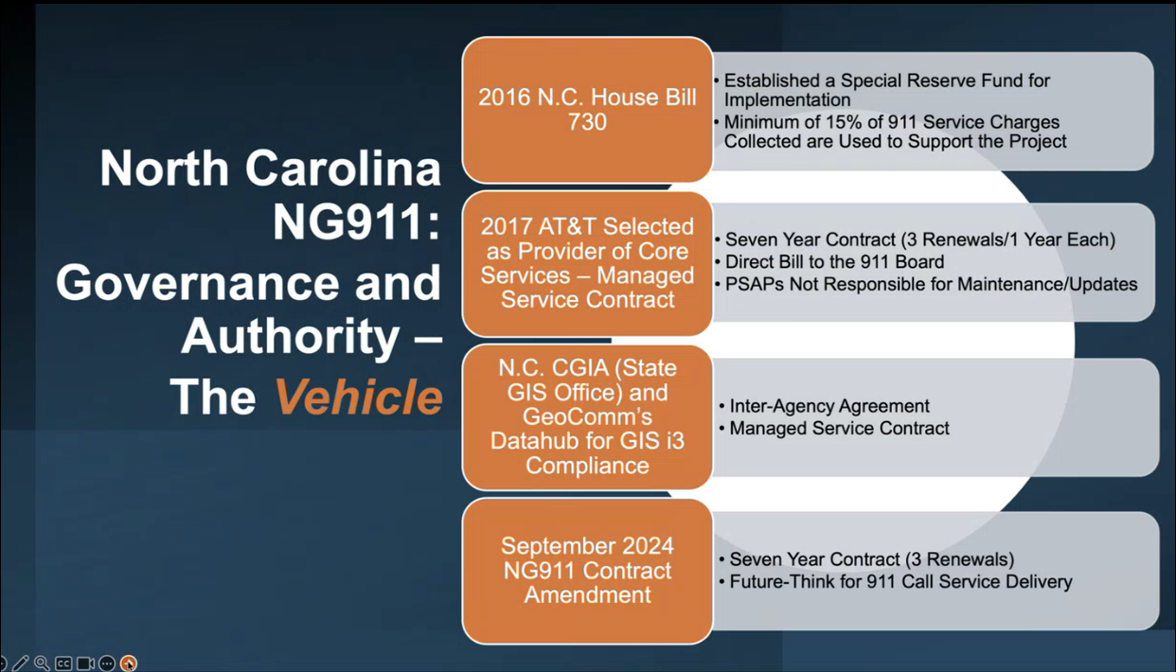
Pokey Harris referenced the slide above regarding a NG911 timeline for the North Carolina 911 Board. She added that AT&T was selected via a managed service contract as the vendor for both Next Generation Core Services (NGCS) and hosted call handling. Furthermore, she mentioned that every 30 months they discuss with their vendor about emerging technologies and how those could be incorporated into the current managed service contract.

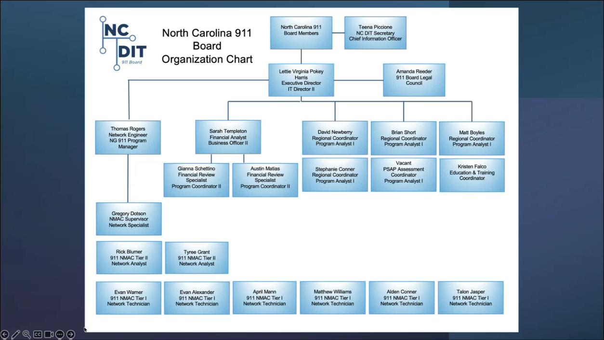
Pokey Harris referenced the slide above regarding the organization chart of the North Carolina 911 Board. She added that they have 22 total members including full time legal counsel, which she emphasized the latter being a vital component to aid the project magnitude of NG911. Furthermore, she mentioned that by legislation the secretary of the chief information officer for their department of information technology serves as the chair in the North Carolina 911 Board.

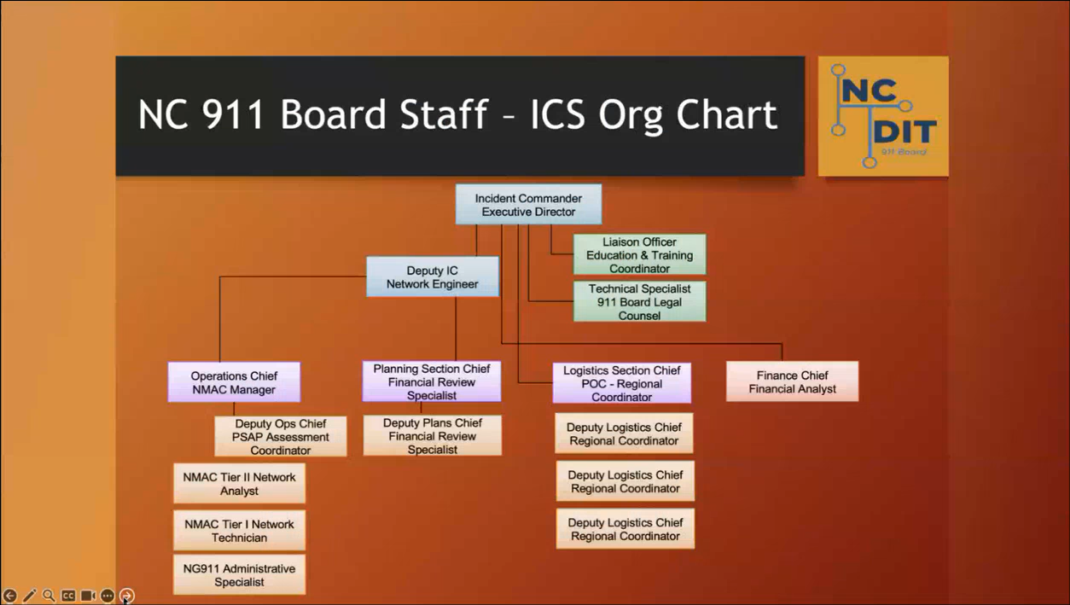
Pokey Harris referenced the slide above regarding the organization chart of the Incident Command System (ICS) team for the North Carolina 911 Board during management of incidents involving 911 call delivery degradation, which could be caused by weather, network, telecommunications, etc.

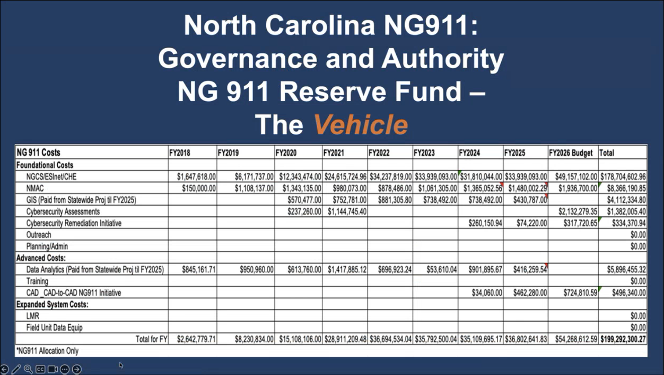
Pokey Harris referenced the slide above regarding the costs of NG911, which are comprised of categories provided by NASNA that include foundational costs, advanced costs, and expanded system costs for consistency purposes when utilized amongst the various states. She then highlighted a few line items such as core services, GIS, cybersecurity, etc. and the total NG911 costs amounting to ~$200 million over the past 9 years.

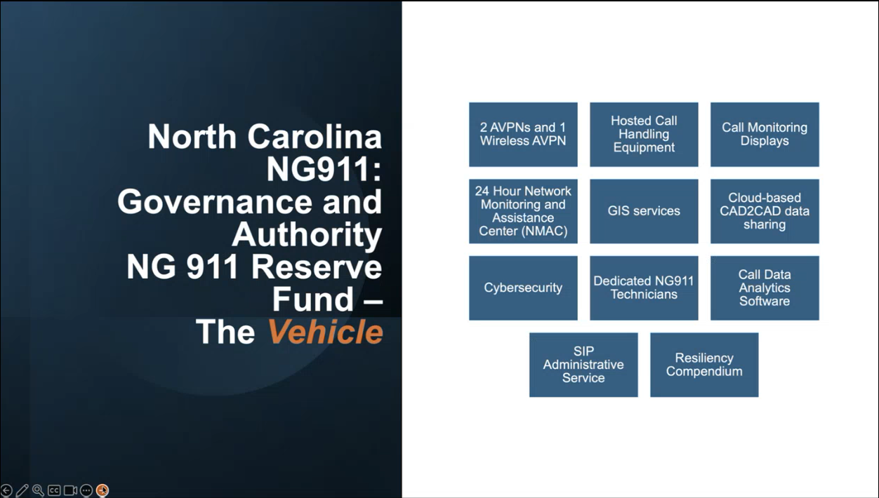
Pokey Harris referenced the slide above regarding the different categories of NG911 deployment costs, which include the following:
- AT&T virtual private network (VPN) and the FirstNet wireless connection
  - AT&T provides core services and hosted call handling
- Public safety answering points (PSAP) are not required to utilize the hosted call handling
  - However, she mentioned that ~96% of their PSAPs opted to use the hosted call handling with only 5 PSAPs opting out
- Call monitoring displays include both hardware and software
- Cybersecurity includes cybersecurity assessments as well as a cybersecurity initiative for the PSAPs to provide information to request reimbursements of cybersecurity related costs
- Resiliency compendium to provide services such as:
  - Low earth orbit services
  - 911 call data sharing
  - Additional cybersecurity assessments
  - Push-to-talk radio initiative for a percentage of 911 center consoles allowing PSAPs to communicate with each other

Pokey Harris stated that the objective of the initiative for the statewide ESInet is to enable interoperability, which enables the routing of 911 calls from any PSAP to one another. She added that the push-to-talk radio initiative mentioned above allows for the PSAPs to share information with each other regarding the aforementioned routed calls. Furthermore, the low earth orbit services mentioned above provide the PSAPs with internet capability to share information with each other via email, cellphones, etc. for routed calls.

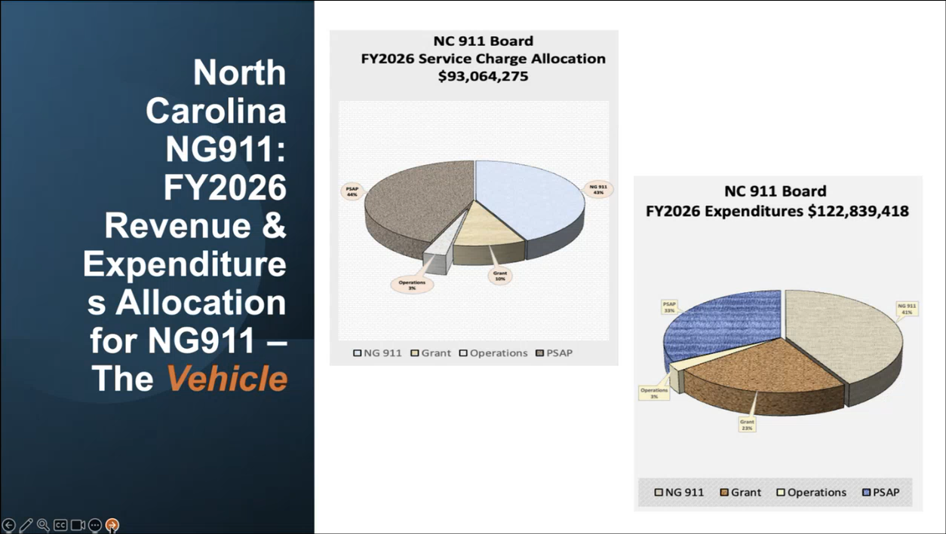
Pokey Harris referenced the slide above regarding the revenues and expenditures of the North Carolina 911 Board. She highlighted that 41% of the total expenditures are earmarked for NG911. She added that other expenditures are associated with items not tied to NG911 known as emergency telephone service fund expenditures including furniture, headsets, chairs, recorders, other radio components, etc. Furthermore, she mentioned that 2% of the total expenditure is allocated for administrative services.

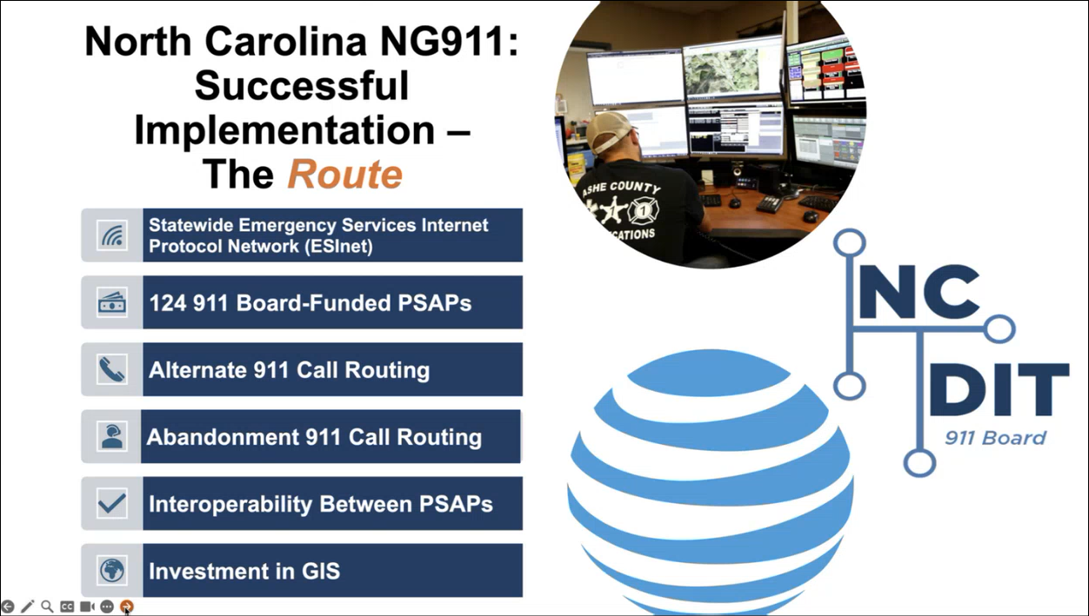
Pokey Harris referenced the slide above regarding the implementation of NG911 and mentioned that they have existing partnerships with AT&T and GeoComm. She added that the managed service contract with AT&T provides both the statewide ESInet and core services. She stated that the PSAPs in North Carolina have partnerships with each other for alternate and abandonment 911 call routing, which are dependent on interoperability. She emphasized the importance of GIS investment for a successful NG911 implementation.

Corey Shaffer asked Pokey Harris if the NMAC staff members are paid through the budgeted administrative services or DIT. Pokey Harris responded stating that they are covered under the budgeted NG911 costs. She added that the service fee collected has various allocations for NG911, administrative services, and grants. Corey Shaffer asked Pokey Harris a follow-up question if the allocation for NG911 pertaining to service fee collection is for ongoing NG911 costs and not only for transition. Pokey Harris responded stating that it is for ongoing NG911 costs. She added that it was advantageous for them during their procurement process to conduct the project based on operational expenditure instead of capital expenditures outright, which delayed vendor payments until the first 911 center went live with NG911.

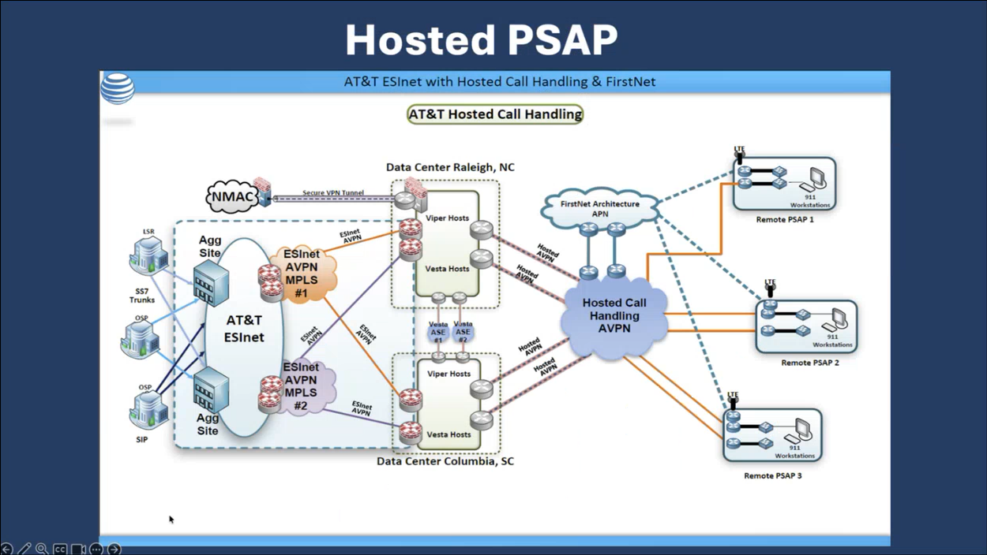
Thomas Rogers referenced the slide above regarding AT&T’s hosted call handling solution, which is utilized by 96% of their PSAPs. Corey Shaffer asked Thomas Rogers if the hosted data centers, workstations, full VPN, ESInet, and aggregation sites are owned and operated by AT&T or not. Thomas Rogers responded stating that AT&T owns and operates all of the aforementioned items since the North Carolina 911 Board by statute is not allowed to own a telecommunications emergency network. He added that AT&T is in the process of building two in-state aggregation sites in adherence to phase one of the new FCC requirements, which will result in both external and internal.

Edward Fujioka asked Thomas Rogers if their FirstNet architecture maintains a core or satellite connection for call taking in the event the local network experiences an outage. Thomas Rogers responded stating that they currently do not possess this feature but will deploy mobile units from FirstNet during outages, which provides a separate and dedicated network to complement the North Carolina statewide ESInet.

Pokey Harris offered their continued assistance via future discussions, meetings, etc. to aid Hawaii’s NG911 deployment and implementation.

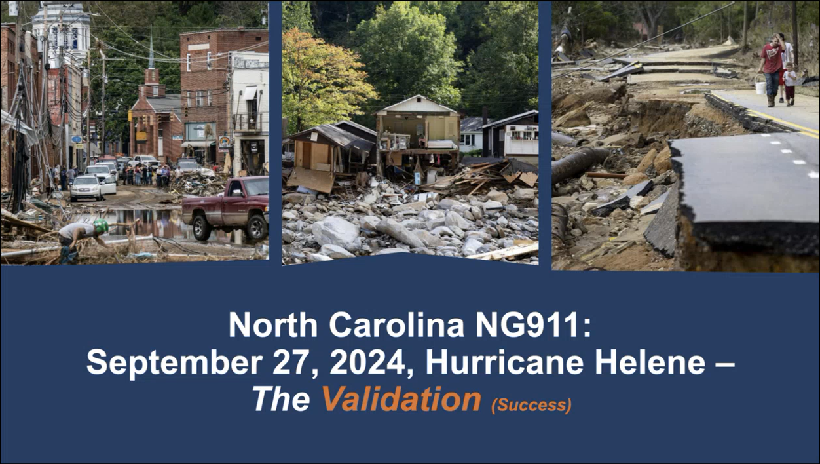
Pokey Harris stated that Hurricane Helene validated NG911 and its functionality of the statewide ESInet.

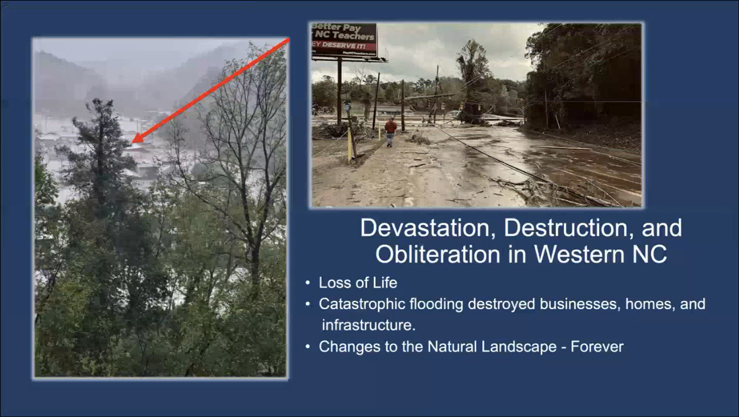
Pokey Harris referenced the slide above regarding the detrimental impact of Hurricane Helene. She highlighted the photo on the left, which points to a former PSAP.

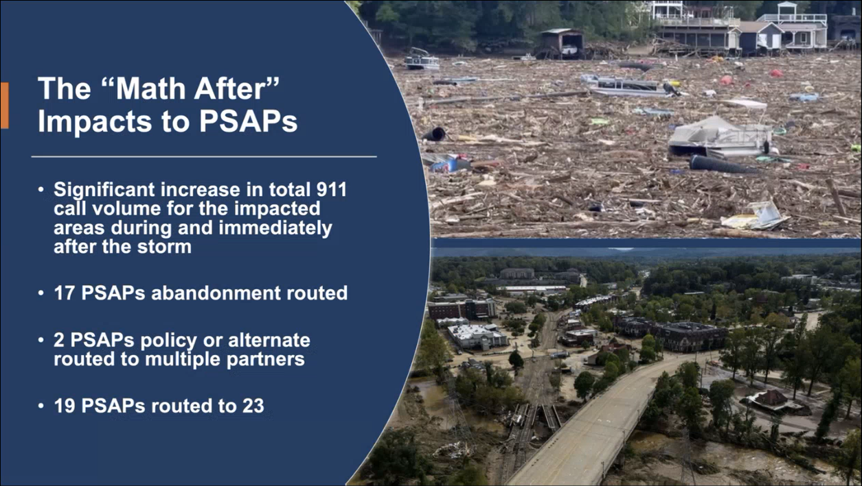
Pokey Harris referenced the slide above regarding the significant impact to PSAPs, call routing usage, and aftermath photos from Hurricane Helene. She added that there was a tremendous effort after Hurricane Helene to collect statistics such as call volume, call routing durations, etc.

Thomas Rogers stated that 17 PSAPs had all of their calls manually routed to a pre-defined partner PSAP within North Carolina. He added that 2 PSAPs severely inundated with large call volumes received assistance from other North Carolina PSAPs.

Pokey Harris stated that their current policy for alternate and abandonment 911 call routing will automatically take place at a pre-defined partner PSAP if the 911 call is not answered within a reasonable timeframe. She added that this call routing policy could also be used for instances of coverage if a PSAP is unavailable for various reasons such as funeral, outage, etc. Thomas Rogers added that the aforementioned call routing policy alleviates the stress of handling disconnected calls since they are automatically routed to a pre-defined partner PSAP.

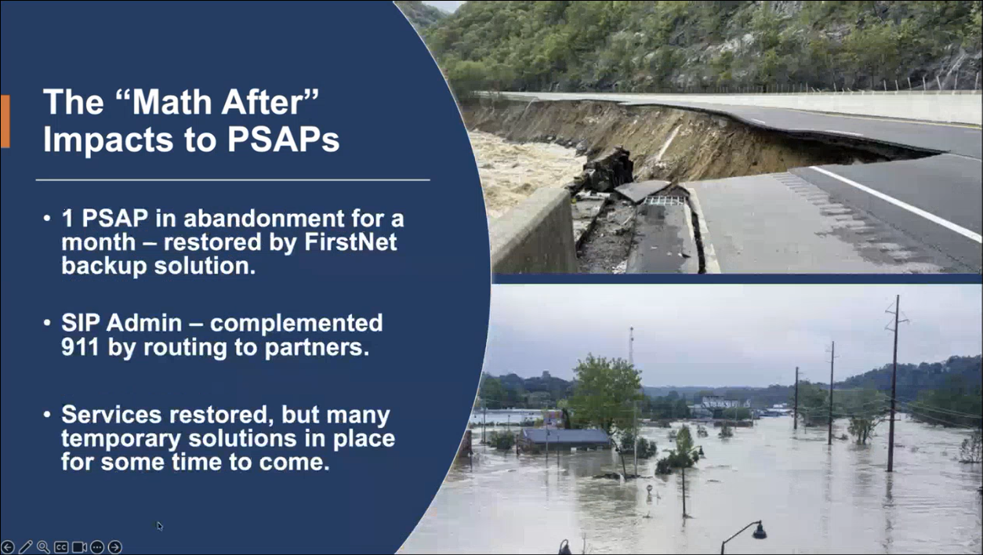
Pokey Harris referenced the slide above regarding call routing duration, backup/temporary solutions, and additional aftermath photos from Hurricane Helene. She added that a PSAP utilized abandonment routing for 30 days with their calls being routed to a pre-defined partner PSAP approximately 220 miles away. She mentioned that the PSAPs with routed calls used creative solutions to relay 911 call information to each other via CAD-to-CAD, DCI capabilities, statewide LMR, cellphones, excel sheets, and/or email. She referenced the importance of the resiliency compendium mentioned previously regarding the ability to share 911 call data and information through interoperability amongst PSAPs.

Pokey Harris stated that the SIP administrative service allows the PSAPs to route administrative phone calls accordingly as necessary.

Pokey Harris mentioned that they anticipate 911 call delivery degradation in western North Carolina as services continue to be restored due to the catastrophic damage of telecommunications infrastructure caused by Hurricane Helene. She added that the statewide ESInet was not impacted and continued to deliver 911 calls.

Pokey Harris stated that a PSAP in Madison County re-routed their calls for a month before switching to a single thread provided through the FirstNet wireless redundant solution as their last mile connectivity, which lasted 370 days. She added that they were single threaded due to the sheer damage to their telecommunications infrastructure in the area. Furthermore, the two AT&T VPNs provided by the North Carolina 911 Board and the aforementioned FirstNet wireless redundant solution aided the recovery of their 911 call delivery and processing after a month.

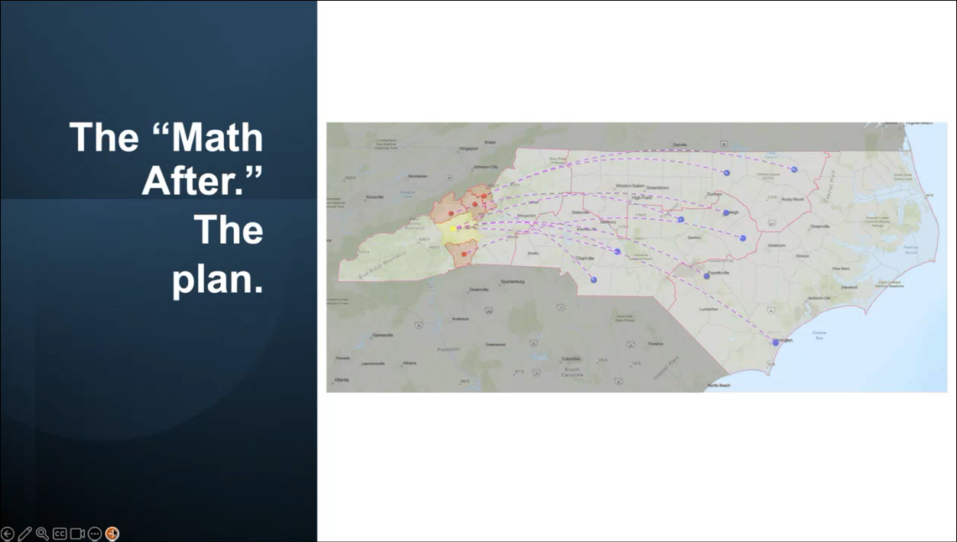
Thomas Rogers stated that the trajectory of Hurricane Helene was unusual, which made landfall on the state from the west in the mountains. He added that given this situation they worked with the PSAPs, regional coordinators, and NMAC to ensure a plan was in place to have pre-defined partner PSAPs for 911 call re-routing purposes, which is referenced in the slide above.

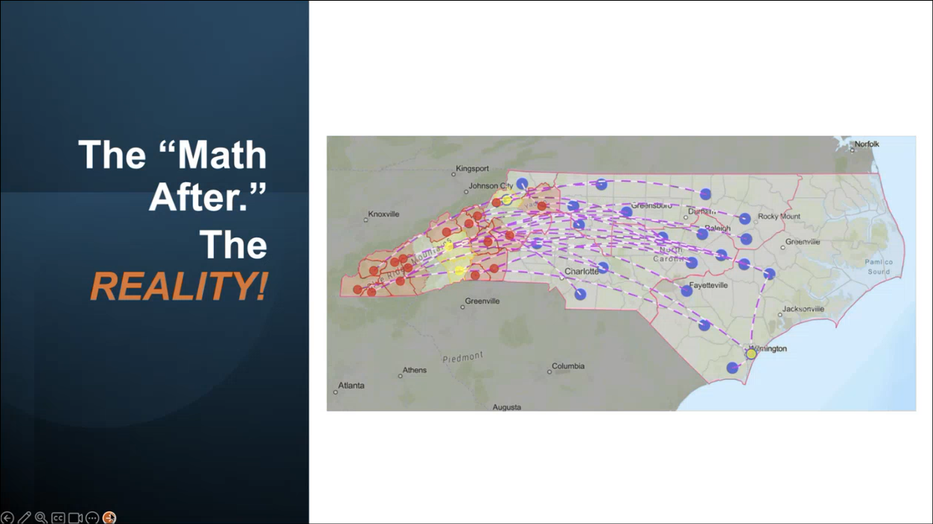
Thomas Rogers referenced the slide above regarding the actual 911 call re-routing that took place during Hurricane Helene, which was worse than they had anticipated. He added that 17 PSAPs experienced abandonment call routing while 2 PSAPs utilized alternate call routing. He highlighted a PSAP in Wilmington (southeast) that used alternate call routing even though they were not directly affected by Hurricane Helene due to the tremendous volume of 911 calls.

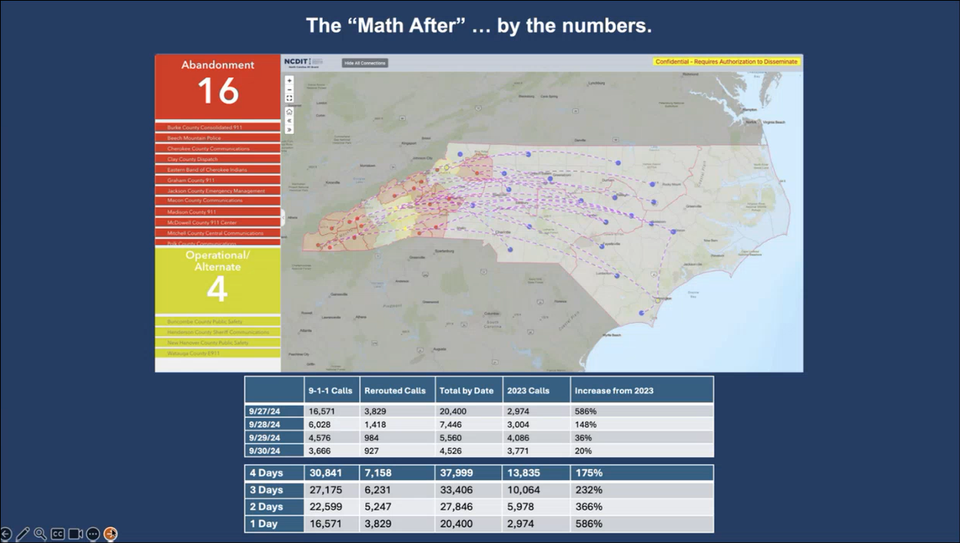
Thomas Rogers referenced the slide above regarding the aftermath of Hurricane Helene pertaining to the number of PSAPs using abandonment and alternate call routing. He added that they experienced 911 call delivery degradation and interruption during their post recovery efforts due to accidental fiber cuts from heavy machinery. He highlighted the significant call volume increase on 9-27-2024 of 586%. Pokey Harris mentioned that a smaller PSAP experienced a 13,000 or 100% call volume increase. Furthermore, she stated that the ability of the statewide ESInet to use alternate call routing helped the PSAPs manage the large volumes of calls.

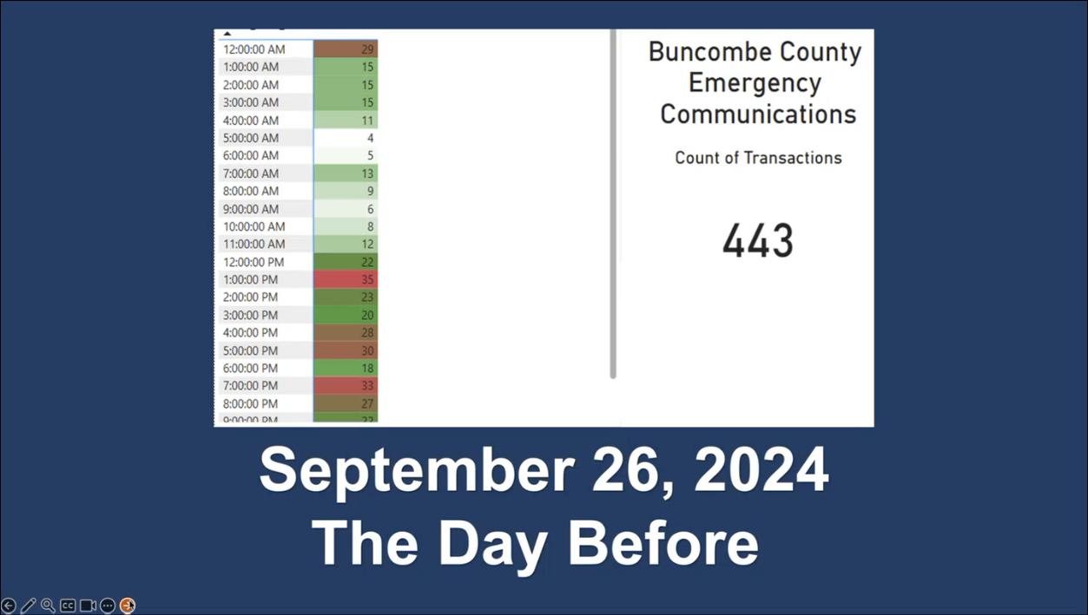
Thomas Rogers referenced the slide above regarding the number of 911 calls Buncombe County received the day prior to Hurricane Helene, which does not include their administrative calls.

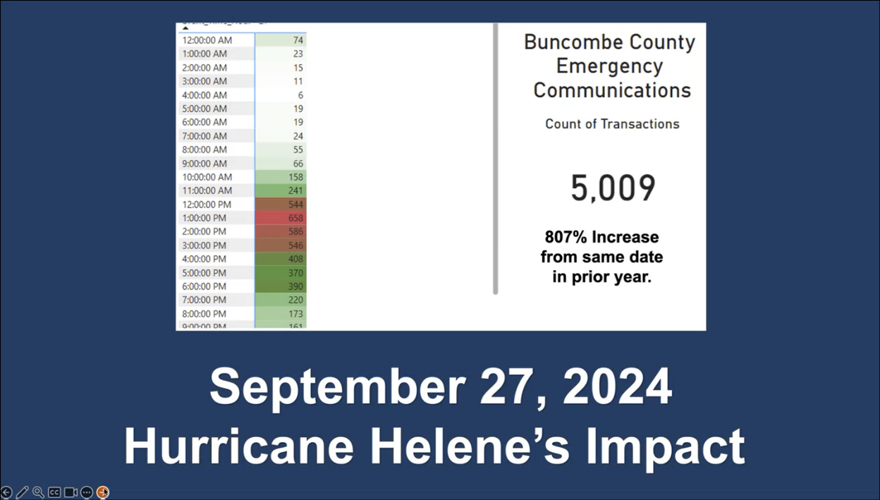
Thomas Rogers referenced the slide above regarding the significant increase in call volume experienced in Buncombe County as compared to the previous slide, which was an 807% increase of 5,009 total calls. He added that they never lost connectivity but utilized alternate call routing to handle the large increase in calls. Pokey Harris mentioned that they were able to route calls from 19 PSAPs to the other 23 PSAPs some of which were ~200 miles away. She added that although the 911 calls were answered and handled by a trained telecommunicator, a significant portion of these calls were unable to render aid from first responders given the untraversable landscape caused by Hurricane Helene or the first responders were already handling another distress call.

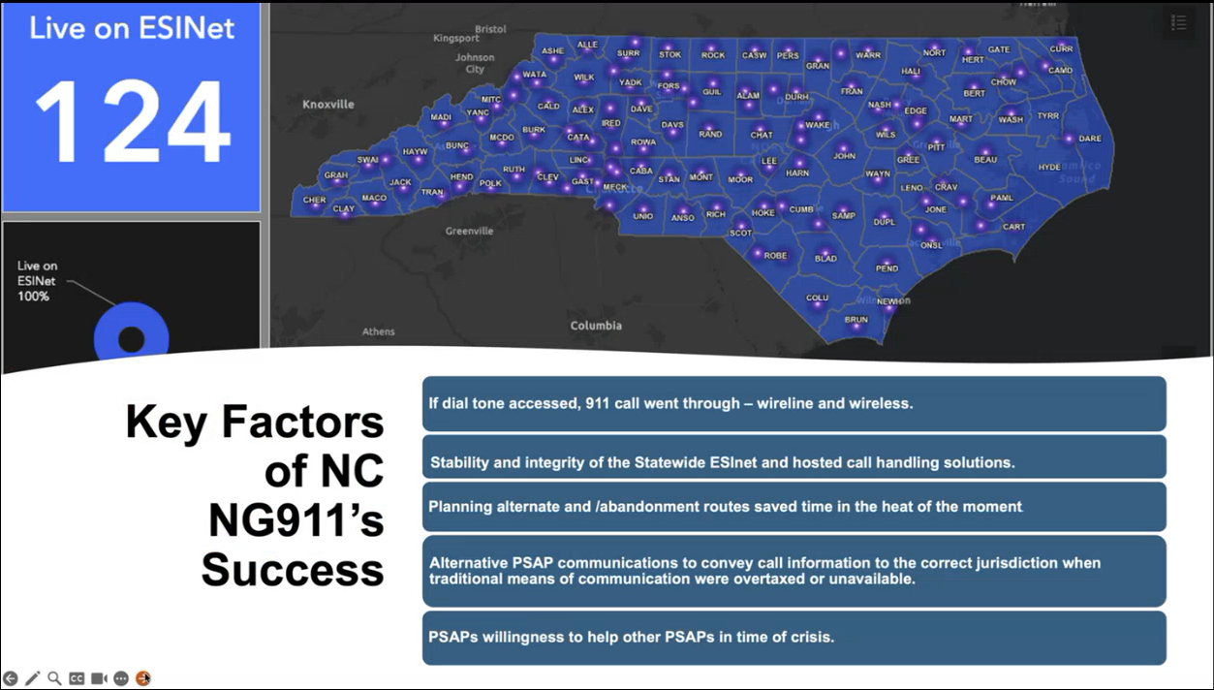
Pokey Harris referenced the slide above regarding the validation of NG911 during Hurricane Helene. She added that the statewide ESInet worked as intended and designed.

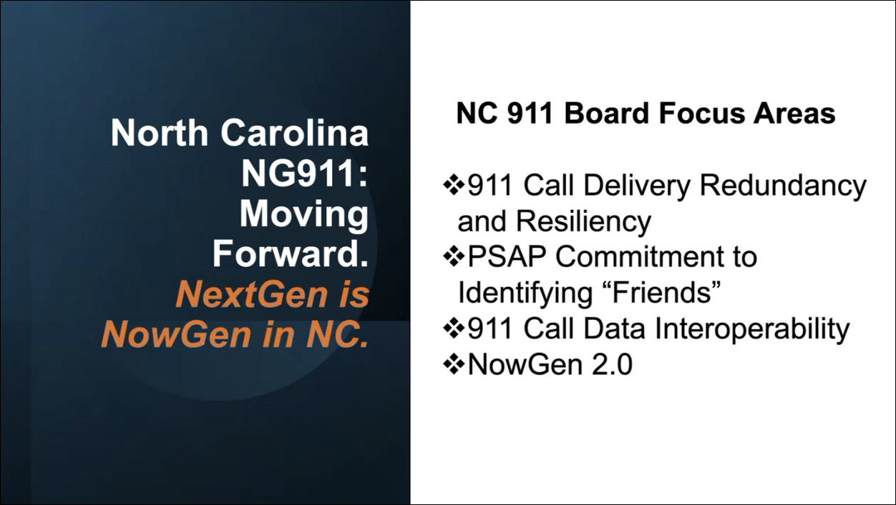
Pokey Harris referenced the slide above regarding focus areas for NG911 moving forward. She added that by statute each PSAP must identify at least one partner PSAP within their region and another partner PSAP in one of the other three regions. She mentioned that two PSAPs will be piloting an over-the-top data sharing application to relay 911 call information with each other.

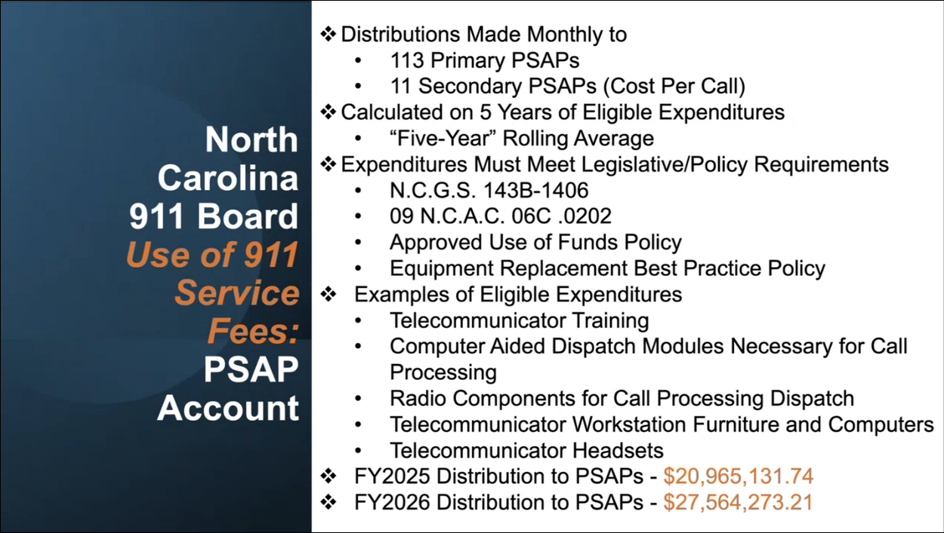
Kristen Falco referenced the slide above regarding uses of the collected 911 service fees. She added that the current monthly service charge is $0.55 per device with the ability to call 911. She mentioned that the general rule for approved expenditures are items required to answer a 911 call within the physical PSAP. Furthermore, RMS and JMS modules are not approved expenditures.

Edward Fujioka asked Kristen Falco if they are using P25 radios statewide. Kristen Falco responded stating that the majority of PSAPs use P25 radios statewide.

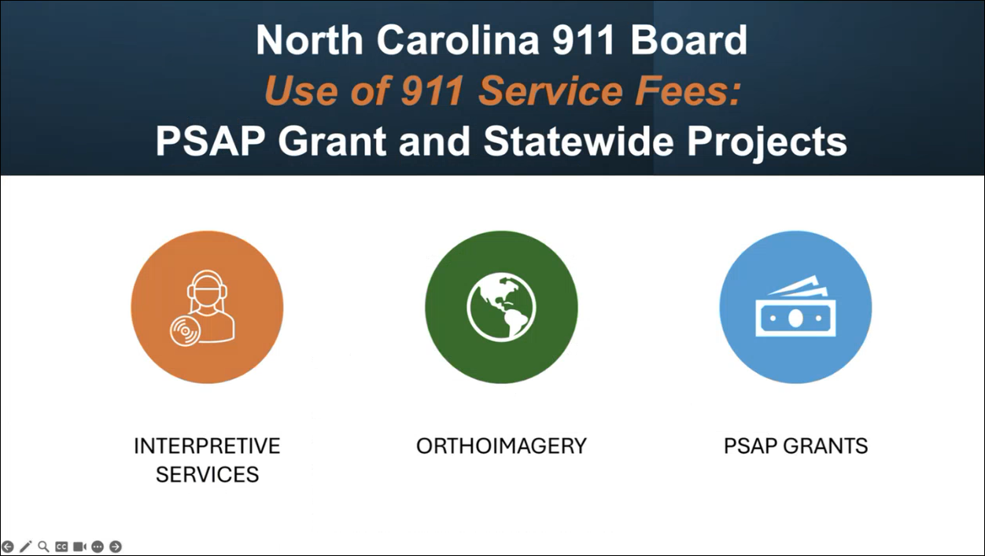
Kristen Falco referenced the slide above regarding additional uses of the collected 911 service fees. She stated that a portion of the funds are for projects that benefit all PSAPs such as interpretive services and orthoimagery. She added that ~75% of these funds are for PSAP grants and the remainder are used for statewide projects such as interpretive services and orthoimagery.

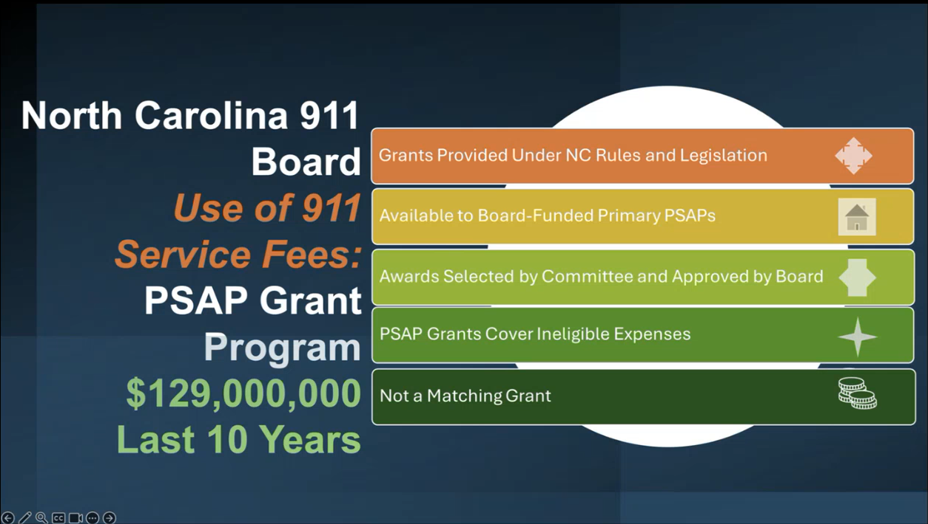
Kristen Falco stated that they have a separate grant program for their primary PSAPs with the rules outlined in North Carolina’s legislation. She added that they have a grant committee to administer the lengthy grant program process, which typically starts in March with the application process being open for a couple months. Furthermore, they host a mandatory grant program workshop if the PSAPs wish to apply for grants. She then provided an example that these grants could be used for ineligible expenditures. She highlighted that their grant program does not require the PSAP to match the received funds. Additionally, she stated that the grant program’s current priority is consolidation projects, which will take precedence over other requests. Lastly, she mentioned that they have funded ~$129 million in grant projects over the past 10 years.

Corey Shaffer asked Pokey Harris how they determined the correct amount to appropriate to the grant funding pool, which typically funds ineligible expenditures. Pokey Harris responded stating that they started off with a modest amount to fill the gap of ineligible expenditures from the PSAPs and adjusted accordingly as necessary. Kristen Falco added that they have funding reconsiderations twice a year for the PSAPs to request additional funding to cover eligible expenditures, which are reviewed and approved by their funding committee and board members. She also mentioned that they currently have running statewide public service announcements through Spectrum Reach for a telecommunicator recruitment campaign and a hold the line campaign regarding how to handle accidental 911 calls. Pokey Harris concurred with Kristen Falco and stated that the aforementioned campaigns are to assist the PSAPs with staffing shortages with the former yielding an increase of applications for job positions in the PSAPs.

Edward Fujioka asked Kristen Falco if the PSAP grants can fund staffing retention or not. Kristen Falco responded stating that their legislation does not allow the payment of PSAP salaries. Pokey Harris concurred with Kristen Falco. Kristen Falco added that they have funded building, mental health initiatives, and end-of-life equipment through the PSAP grant program.

Corey Shaffer asked Kristen Falco if the PSAPs in North Carolina experience staffing issues or not. Kristen Falco responded stating that inadequate PSAP staffing is a nationwide issue. She added PSAP staffing levels seem to be correlated with the overall U.S. economy with higher staffing levels during recessions due to the stability of government employment as compared to lower staffing levels when the economy is stronger given the better employment opportunities offered through the private sector. Furthermore, she emphasized the marketability of PSAP jobs by highlighting that it is a technology driven role with meaningful and impactful implications to provide public safety.

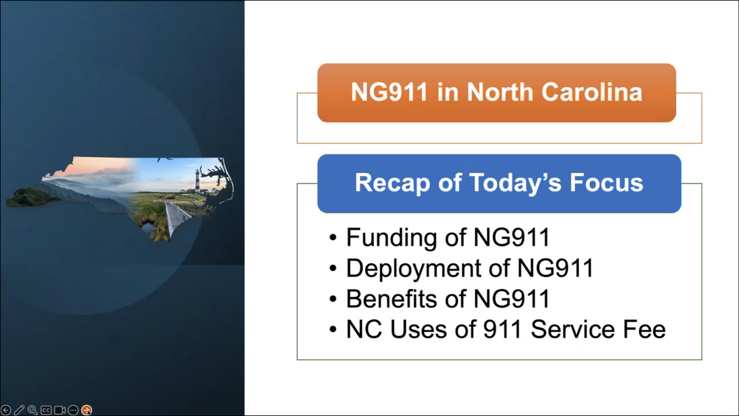
Pokey Harris referenced the slide above regarding a recap summary of this presentation.

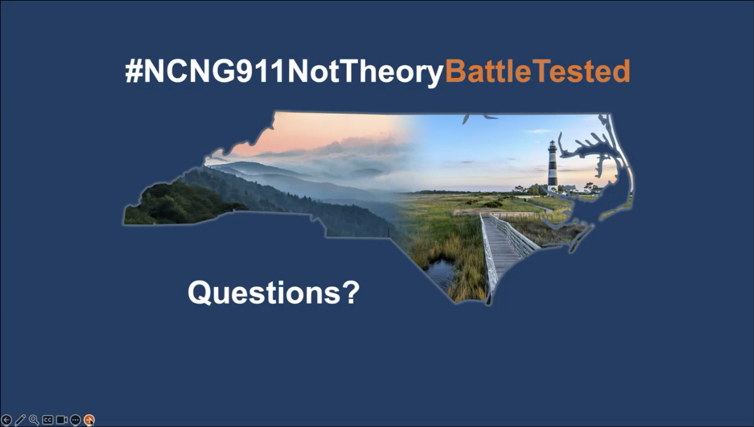
Pokey Harris referenced the slide above regarding the unofficial hashtag, which denotes that NG911 in North Carolina has been validated through its usage before, during, and after Hurricane Helene. She then expressed her gratitude for allowing them to share this presentation with Hawaii.

Kenison Tejada asked Pokey Harris if they used a consultant or had hired staff members on the North Carolina 911 Board for their NG911 deployment and implementation. Pokey Harris responded stating that they had a combination of both and commissioned a NG911 concept paper from a consulting firm that is about 11 years old now. Kenison Tejada asked Pokey Harris a follow-up question if the North Carolina 911 Board led the NG911 deployment and implementation with minimal effort from the PSAPs themselves. Pokey Harris responded stating that the North Carolina 911 Board championed the majority of the effort to deploy and implement NG911 with roadshows for the PSAPs to increase the adoption rate before it was required by legislation.

Edward Fujioka asked Pokey Harris if training and/or travel conferences are accounted for in their budget. Pokey Harris responded stating that they have budgeted for both training and travel conferences under NG911 and administrative services for the pertinent personnel. Edward Fujioka asked Pokey Harris a follow-up question if PSAP personnel are able to utilize funds for travel conferences or not. Pokey Harris responded stating that those requests are covered under the general fund expenditure. Kristen Falco added that there is an approved training list detailing the allowable classes, courses, and conferences.

Edward Fujioka asked Thomas Rogers if their NG911 dashboard has the ability to run detailed call analytics or not. Thomas Rogers responded stating that the NG911 dashboard is capable of running both detailed call analytics via a customer management portal as well as network diagnostics. Pokey Harris concurred with Thomas Rogers.
Board Chair expressed his gratitude on behalf of the State of Hawaii 911 Board to the North Carolina 911 Board for their presentation and discussion regarding NG911. Pokey Harris reiterated that they are open to furthering any topics of discussion that Hawaii wishes to pursue with North Carolina.

- Next Generation 911 (NG911) Readiness Assessment Recommendations and Next Steps
  - Discussion of Governance Action Items
    - Legislation Update to Remove Cost Recovery Language
    - Consideration to Incorporate Prepaid Surcharge Collection
    - Assessment of Current Surcharge Rate
Board Chair stated the three items above and mentioned that the Executive Director will lead the discussion and draft any potential legislation regarding these matters. Executive Director stated that legislative draft proposals are typically due around the end of August each year preceding the legislative session and mentioned that no legislative requests will be submitted this upcoming legislative session. He added that it would be ideal to submit all three legislative proposals in a single package but will gauge it based on the forthcoming feedback and discussion. He mentioned that other states collect prepaid surcharge fees at the point of sale rather than a monthly basis.

Executive Director noted that other states will implement a range for their monthly surcharge rate, which is normally dictated by their respective PUC with annual evaluations to determine the appropriate monthly surcharge rate for the year. Board Chair stated that this idea needs to be vetted given the pros and cons being ease of monthly surcharge rate changes and relinquishing control, respectively. Rebecca Lieberman stated that any ideas for legislative changes require thoughtful and prudent discussion amongst the attorney general and 911 Board committees and members given the past experience with state legislators. She added that further discussion needs to take place regarding the PUC if they possess the expertise and/or time to dictate a monthly surcharge rate scale since there is no current relationship between the PUC and the 911 Board. Ji Sook Kim stated that as a DCA representative she would most likely have to recuse herself from any vote regarding PUC matters. She cautioned that any legislative changes involving the monthly surcharge rate need to be carefully considered given the 911 Board’s considerable unencumbered cash balance. She added that Mission Critical Partners assessment report did not address the aforementioned unencumbered balance. She also mentioned that Hawaii’s monthly surcharge rate is not the lowest in the nation but noted that the differences in population size could be a determining factor. Furthermore, she questioned whether having the PUC dictate the monthly surcharge rate range is viable or not due to their current lack of involvement with the 911 Board. Board Chair stated that any proposed legislative changes will be discussed in great detail prior to submission.

Ji Sook Kim asked the Board Chair if the Executive Director needs more employees or not to assist with the NG911 transition. Board Chair responded stating that this could be discussed in a future meeting. Davlynn Racadio commented that these are constructive discussions, which should occur more frequently and are necessary to strategize future decisions appropriately.

    - Potential Technical Committee Assignment or Creation of Permitted Interaction Group (PIG) to Develop Next Generation (NG911) Strategic Plan
    - Potential Technical Committee Assignment or Creation of Permitted Interaction Group (PIG) to Develop State-Level Continuity of Operations Plan (COOP)
Board Chair stated the two items above and requested feedback/thoughts. Shawn Kuratani responded stating that he recommends the creation of PIGs to ensure that all the primary PSAPs are represented. Davlynn Racadio concurred with Shawn Kuratani. Edward Fujioka asked the Board Chair if one of these PIGs will have project management for NG911 or not. Board Chair responded stating that project management for NG911 should be included. Francis Alueta asked the Executive Director what are the rules regarding board member participation in a PIG. Executive Director responded stating that he will research this offline and provide an answer thereafter. He added that he will work with Shawn Kuratani to identify potential members for both of the PIGs mentioned above. Board Chair stated that follow-up discussions will be held during next month’s meeting regarding these PIGs.

  - Discussion of Security Action Items
    - Potential Creation of Permitted Interaction Group (PIG) to Develop Statewide Cybersecurity Policies and Procedures
Board Chair stated the item above and requested feedback/thoughts. Francis Alueta responded stating that each county should have their own cybersecurity policies/procedures and a statewide version as well. He added that these aforementioned cybersecurity policies and procedures should be reviewed if they are applicable to the PSAPs or not. Board Chair asked the Executive Director to reach out to each county’s DIT for their respective cybersecurity policies and procedures. Executive Director responded stating that he will conduct the inquiries regarding this matter. He added that the Mission Critical Partners assessment report recommended developing best practices regarding cybersecurity policies and procedures that all the PSAPs can agree and adhere to.

Edward Fujioka asked the Board Chair if a statewide interoperability plan would be developed or not. Board Chair responded stating that this will be created if the PSAPs are agreeable to utilization of a statewide ESInet.

- Committee Updates by Committee Chairs
  - Communications Committee – Davlynn Racadio
    - Discussion of Responses to Support Letters regarding S. 725 – The Enhancing First Response Act, 119th Congress (2025-2026), To direct the Federal Communications Commission to issue reports after activation of the Disaster Information Reporting System and to make improvements to network outage reporting, to categorize public safety telecommunicators as a protective service occupation under the Standard Occupational Classification system, and for other purposes.
Davlynn Racadio requested an update from the Executive Director regarding the item above. Executive Director asked Davlynn Racadio if any action needs to be taken regarding the response letters received from representative Ed Case. Davlynn Racadio responded stating that they did not receive any response letters from representative Jill Tokuda. Executive Director recommended that follow-up letters could be sent if the aforementioned bill stalls.

  - Technical Committee – Shawn Kuratani
    - Follow-Up Discussion regarding SCC (Spatial Command and Control) Mapping Icons and Feedback from Public Safety Answering Points
Shawn Kuratani stated the item above and cited a recent update following a meeting held between Hawaiian Telcom, Intrado, and the PSAPs on 11-10-2025. He mentioned that Hawaiian Telcom stated they are unable to accommodate the PSAPs' request to add tower icons onto the new SCC mapping system since it would adversely affect other map functionalities. He added that they have a follow-up meeting tomorrow with the PSAPs to further discuss this matter. Additionally, he stated that the PSAPs will render a decision early next week regarding whether or not they will pursue the aforementioned icons implementation. Furthermore, he mentioned that Intrado will modify the sector shape for Phase 1 calls from a circle to a cone, which aligns with the visual format that call takers are currently accustomed to distinguishing quickly between Phase 1 and Phase 2 calls. Lastly, he recommended deferring this topic until next month’s meeting to provide the PSAPs adequate time to review and finalize their recommendation.

Marisa Fujimoto stated that the class of service icon is displayed via two areas in the new SCC mapping system being the details panel on the left and the audio call panel on the bottom right of the screen but is not displayed on the map itself. She added that the addition of the PSAP requested mapping icons is software enhancement and not a software bug.

    - Discussion of PUC (Public Utilities Commission) Re-Evaluation Regarding Number of Tariff Positions Allotted
Shawn Kuratani requested an update from Francis Alueta regarding the item above. Francis Alueta stated that the 911 Board would need to send an official letter to Hawaiian Telcom’s regulatory affairs to open and review the existing wireline and wireless tariff. Stacy Domingo added that the purpose of this would be to re-evaluate the number of tariff positions allotted across the state given the population increase. Ji Sook Kim expressed her concern regarding this re-evaluation process since the majority of PSAPs are experiencing staffing issues. Francis Alueta added that this legacy tariff was previously assessed when wireline calls were more prevalent compared to now with wireless comprising the larger portion of calls, which could impact this reassessment by decreasing wireline and increasing wireless costs. Ji Sook Kim mentioned that this could impact consumer costs. Executive Director stated that he will follow up on this matter.

Edward Fujioka asked Francis Alueta if the state’s Department of Law Enforcement has requested for tariff positions or not. Francis Alueta responded stating that this has not occurred since they are not a designated primary or secondary PSAP.

      - Advisory Committee – Rebecca Lieberman
        - No Updates
Rebecca Lieberman stated that the 2026 legislative session starts on 1-21-2026 and she will monitor the upcoming bills to determine whether or not they would impact the 911 Board. She added that the 911 Board does not have any proposed bills this legislative session.

  - Finance Committee – Edward Fujioka
    - Review of Monthly Y-T-D (Year to Date) Cash Flow
October 2025 Cashflow Statement:

Surcharge Collection: $1,055,125
Interest Income: $133,366
Total Receipts: $1,188,491
Total Disbursements: ($589,534)
Net Receipts/Disbursements: $598,956
Net Encumbrances Adds/(Paydown): ($1,921,792)
Net Cash Inflow/(Outflow): ($1,322,832)
Outstanding Encumbrances: $10,861,633
Net Bank Balance: $47,611,176
Unencumbered Cash Balance: $36,749,543

    - Hawaii Police Department Requesting $12,200.00 for Additional Text-to-911 Charges Attributed to New Facility Transition
Edward Fujioka stated the item above and requested an explanation. Executive Director explained that this request was inadvertently omitted by HIPD from the budget. He added that this request will cover costs for both HIPD and HIFD. Edward Fujioka asked for a motion to approve. Tony Velasco motioned to approve this request. Matthew Kurihara seconded the motion. A voice vote was taken, motion was unanimously approved.

    - Hawaii Police Department Requesting $250.00 for Additional Text-to-911 Charges Attributed to Backup Center
Edward Fujioka stated the item above and requested an explanation. Executive Director explained that this request was due to a miscalculation by HIPD. He added that this request will cover costs for both HIPD and HIFD. Edward Fujioka asked for a motion to approve. Tony Velasco motioned to approve this request. Matthew Kurihara seconded the motion. A voice vote was taken, motion was unanimously approved.

- Public Safety Answering Point Status Updates on Recruitment and other Personnel Issues
  - Kauai Police Department – Andrew Muraoka
    - Update on Recruitment Process/Strategies and Personnel Training
Roderick Green on behalf of Andrew Muraoka stated that they will be interviewing 1 potential applicant next week. He added that they recently announced the opening of their public safety communications manager position, which closes on 11-19-2025 and is a non-sworn role.

    - Update on Personnel Issues and Vacancies
Roderick Green on behalf of Andrew Muraoka stated that they currently have a ~50% vacancy rate. He mentioned that they have 2 personnel that will be resigning soon. He added that 1 of these aforementioned personnel would like to return on an 89-day contract basis.

  - Oahu Police Department – Matthew Kurihara
    - Update on Recruitment Process/Strategies and Personnel Training
Matthew Kurihara stated that they have 6 personnel who started last week. He added that it will be about 5-6 months before the aforementioned personnel are ready to take on positions. He mentioned that SHOPO no longer allows them to utilize sworn personnel to assist with vacancies and staffing shortages.

    - Update on Personnel Issues and Vacancies
Matthew Kurihara stated that they currently have a ~32% vacancy rate.

  - Oahu Fire Department – Shawn Kuratani
    - Update on Recruitment Process/Strategies and Personnel Training
Shawn Kuratani stated no updates.

    - Update on Personnel Issues and Vacancies
Shawn Kuratani stated that they are currently fully staffed.

  - Oahu Emergency Medical Services – Lorrin Okumura, Diana Chun, Frannie Chung
    - Update on Recruitment Process/Strategies and Personnel Training
Frannie Chung on behalf of Lorrin Okumura stated that they have 5 EMD academy students that are anticipated to graduate on 11-21-2025.

    - Update on Personnel Issues and Vacancies
Frannie Chung on behalf of Lorrin Okumura stated that they currently have a ~40% vacancy rate, which is 17 out of 28 total positions filled.

  - Maui Police Department – Davlynn Racadio
    - Update on Recruitment Process/Strategies and Personnel Training
Melia Johnson on behalf of Davlynn Racadio stated that they have a recruitment class starting on 12-1-2025 with 5 potential new hires. She added that 3 out of the 5 have passed the background check stage. She mentioned that the previous recruitment class yielded 4 out of 12 new hires who recently completed their first year. She commented that these aforementioned 4 personnel have made significant contributions already regarding overall PSAP morale and scheduling.

    - Update on Personnel Issues and Vacancies
Melia Johnson on behalf of Davlynn Racadio stated that they currently have a ~51% vacancy rate, which is 19 out of 39 total positions filled. She added that they have been allowing the Molokai team to create their own schedules in an effort to boost both morale and work-life balance.

  - Molokai Police Department – Davlynn Racadio
    - Update on Recruitment Process/Strategies and Personnel Training
Please see updates under Maui Police Department.

    - Update on Personnel Issues and Vacancies
Please see updates under Maui Police Department.

  - Hawaii Police Department – Zachary Fernando
    - Update on Recruitment Process/Strategies and Personnel Training
Zachary Fernando stated that they have 1 personnel graduating to solo assignment on 11-17-2025. He added that they have 2 trainees who began call taker training on 11-1-2025. He mentioned that they have 5 potential hires scheduled for interviews next week with an anticipated start date in January 2026 if they are hired.

    - Update on Personnel Issues and Vacancies
Zachary Fernando stated that they currently have a ~43% vacancy rate, which is 17 total vacant positions.

  - Hawaii Fire Department – Stacy Domingo
    - Update on Recruitment Process/Strategies and Personnel Training
Stacy Domingo stated that they have 4 new hires starting on 12-1-2025.

    - Update on Personnel Issues and Vacancies
Stacy Domingo stated that they currently have a ~62% vacancy rate, which is 9 out of 24 total positions filled. She added that they will have 1 personnel on maternity leave in early December 2025.

- Items for Discussion, Consideration, and Action
  - Additional Items Proposed by Meeting Attendees for Consideration and Possible Inclusion on Future Agendas

- Announcements
  - Future Virtual Meeting Dates/Times (9:00AM-12:00PM)
    - Thursday, December 11, 2025 (Combined Meeting)
    - Thursday, January 8, 2026 (Combined Meeting)

  - Future Conference Dates (3 Months of Advanced Approval Required)
    - 9-1-1 Goes to Washington (GTW) February 22-25, 2026, Arlington, VA
    - International Wireless Communications Expo (IWCE) March 16-19, 2026, Las Vegas, NV

  - Additional Announcements from Meeting Attendees for Consideration and Possible Inclusion on Future Agendas

- Open Forum: Public Comment on Issues not on the Board Meeting Agenda
There was no public comment on issues not on the agenda.

- Adjournment
Board Chair requested a motion to adjourn the meeting. Tony Velasco motioned to adjourn the meeting. Stephen Courtney seconded the motion. A voice vote was taken, adjournment was unanimously approved. The meeting was adjourned.

