JOSH GREEN, M.D.  GOVERNOR  Ke Kiaʻāina |  | KEITH A. REGAN  COMPTROLLER  Ka Luna Hoʻomalu Hana Laulā  MEOH-LENG SILLIMAN  DEPUTY COMPTROLLER  Ka Hope Luna Hoʻomalu Hana Laulā
STATE OF HAWAIʻI | KA Mokuʻāina o Hawaiʻi

DEPARTMENT OF ACCOUNTING AND GENERAL SERVICES | KA ʻOihana LOIHELU A LAWELAWE Laulā
P.O. BOX 119, HONOLULU, HAWAII 96810-0119

Communications, Technical, and Finance Meeting
(Combined Meeting)

Thursday, October 9, 2025
9:00 am – 12:00 pm

Virtually Held Meeting with Physical Location at
Kalanimoku Building Room 426, 1151 Punchbowl Street, Honolulu, Hawaii 96813 is available to the public and is guaranteed to be connected to the remote virtual meeting.

MEETING MINUTES

October 9, 2025: Joint Committee and Board Meeting (youtube.com)

Communications Committee Members Present: Davlynn Racadio (MPD), Ah Lan Leong (HPD), Lavina Taovao (KPD)

Communications Committee Members Not Present: None

Technical Committee Members Present: Shawn Kuratani (HFD), Stacy Domingo (HIFD), Tony Ramirez (V2X), Kenison Tejada (FirstNet), Tony Velasco (DIT)

Technical Committee Members Not Present: Thalia Burns (APCO/NENA), David Miyasaki (KPD)

Finance Committee Members Present: Stephen Courtney (C&C of Honolulu), Liz Gregg (AT&T), Matthew Kurihara (HPD), Tony Velasco (DIT)

Finance Committee Members Not Present: Edward Fujioka (EMS), Reed Mahuna (HIPD), Todd Omura (CIO Designee)

Staff: Royce Murakami (911 Board), Benson Leung (911 Board), Nietzche Tolan (AG)

Guests: Francis Alueta (HT), Darin Biamonte (Mission Critical), Brian Boezeman (Intrado), Joshua Brantley (ETS), Christian Burns (HT), Frannie Chung (EMS), Ruth Cruz (Intrado), Marc De Costa (HT), Carla Even (RapidSOS), Zachary Fernando (HIPD), Marisa Fujimoto (HT), Buck Giles (OS), Roderick Green (KPD), Sherri Griffith Powell (Mission Critical), Savannah Heckman (EagleView), Wayne Hirasa (Alakaina), Bertie Johnson (HPD), David Jones (Mission Critical), Elliott K. Ke (KPD), Ji Sook Kim (Consumer Advocate Designee), Rebecca Lieberman (Spectrum), Brian McKee (DIT), Andrew Muraoka (KPD), Tamera Neal (Intrado), Lorrin Okumura (EMS), Stacy Perreira (KPD), Jeff Reeve (AT&T), Megan Reilly (EagleView), Corey Shaffer (Verizon), Geoffrey Shon (GS Consulting), Calvin Sung (HPD), Nietzche Tolan (AG), Douglas Tom (SWIC), Keola Tom (MPD), Scott Winecoff (T-Mobile)

- Call to Order, Public Notice
The meeting was called to order by the Board Chair. Public notice was given.

- Public Testimony Will Be Taken on All Agenda Items as Those Items Occur During the Meeting

- Roll Call, Quorum
A roll call was taken, quorum was present for all committees.

- Review and Approval of September Meeting Minutes
Board Chair requested a motion to approve September’s Meeting Minutes. Tony Ramirez motioned to approve September’s Meeting Minutes. Francis Alueta seconded the motion. A voice vote was taken, motion was unanimously approved.

- Committee Updates by Committee Chairs
  - Communications Committee – Davlynn Racadio
    - Discussion of S. 725 – The Enhancing First Response Act regarding Support Letters
Davlynn Racadio asked the meeting attendees if they have sent their respective support letters to representatives Ed Case and Jill Tokuda regarding S. 725 – The Enhancing First Response Act yet or not. She added that support letters have been sent from her individually, the Maui Police Department, and 911 Board.

Corey Shaffer responded stating that he has sent out his support letter and confirmed the 911 Board’s support letter submission.

Elliott K. Ke stated that support letters have been sent from him individually and the Kauai Police Department. He added that they have requested support letters from both the Kauai mayor’s office and the county council.

Matthew Kurihara stated that he will prepare a support letter and inquire with the Honolulu Police Department chief for signature.

Stacy Domingo stated that she will prepare a support letter and inquire with the Hawaii Fire Department chief for signature.

Zachary Fernando stated that he will follow up on the status of Hawaii Police Department’s support letter.

Shawn Kuratani voiced his individual support and stated that he will inquire with the fire council regarding the support letter.

Davlynn Racadio stated that she requested a support letter from the county council in Maui. She added that she sent Mazie Hirono and Brian Schatz letters to express gratitude and request for their continued support. Furthermore, she emphasized the importance of recognizing public safety telecommunicators as first responders.

Corey Shaffer asked the Executive Director to notify the board if a response is received regarding the support letters mentioned above. The Executive Director responded stating that the 911 Board’s support letters were mailed out last week Friday and he will provide notification of any response upon receipt.

    - Update from Conference Attendees for APCO Conference (Association of Public-Safety Communications Officials) July 27-30, 2025, Baltimore, MD
Davlynn Racadio requested updates from conference attendees regarding the event mentioned above.

Ah Lan Leong stated that their trainer who attended the conference acquired meaningful takeaways and provided excellent feedback, which resulted in ideas currently under consideration for implementation in terms of training for call takers and dispatchers.

Zachary Fernando stated that their major said it was beneficial to explore various equipment purchases in-person to assess efficiency such as ergonomic headsets.

Andrew Muraoka stated that their captain and two dispatchers attended with notable takeaways being the usage of artificial intelligence in the call center to handle non-emergency calls and the implementation of new headsets. Roderick Green added that the artificial intelligence offerings from Hyper were particularly impressive. Furthermore, he stated that he attended a learning session regarding next generation dispatchers that utilized a high school program to aid in recruitment efforts, which they are considering. Lastly, he mentioned that it was enlightening to garner insights from the call taker and dispatcher perspectives.

Shawn Kuratani stated that there were no attendees from the Honolulu Fire Department.

Lorrin Okumura stated that there were no attendees from the Honolulu Emergency Services Department.

Executive Director mentioned he and the Administrative Services Assistant attended the conference and stated that the learning sessions were useful and interaction with vendors was meaningful. He added that Pokey Harris, the executive director of the North Carolina 911 Board, will give a presentation during next month’s meeting about their response to Hurricane Helene, which includes the integration of Next Generation 911.

Davlynn Racadio thanked those who shared their thoughts and takeaways. She then asked Andrew Muraoka to provide feedback regarding the headsets mentioned above when available and inquired if these are the Clear Choice SHG (Secure Headset Group) headsets. Andrew Muraoka agreed to provide feedback and confirmed the headset models. He added that he will send her the current information in his possession.

  - Technical Committee – Shawn Kuratani
    - Discussion of Recent Hawaiian Telcom Meeting regarding PSAP Migration to Viper 7
Shawn Kuratani introduced Marisa Fujimoto from Hawaiian Telcom to provide information regarding the upgrade from Viper 5 to Viper 7, which includes the transition from MapFlex to SCC mapping.

Marisa Fujimoto stated that they completed the Viper 7 upgrade for Kauai last year and for Big Island this past April/May 2025. She added that they began phase one of the Viper 7 upgrade for Oahu but is currently on hold due to functionality differences between MapFlex and SCC mapping. Furthermore, she mentioned that SCC mapping was designed by Intrado to meet Next Generation 911 requirements. After using Viper 7 for a few months, Kauai identified that SCC mapping does not have the functionality for wireless Phase 1 calls, which the PSAPs deem as a critical component due to the significant volume. She then stated that they are currently working with Intrado to resolve this aforementioned issue and discuss the PSAP request for icons before proceeding with any further Viper 7 related upgrades. Lastly, she stated that Intrado has committed to develop the requested functionality/features by the end of calendar year Q1 2026, Hawaiian Telcom will start phase two of the Viper 7 upgrade for Oahu in calendar year Q2 2026, and Viper 7 upgrades for Maui and the Regional Dispatcher Center have not been scheduled yet.

Shawn Kuratani stated that the PSAPs deem the aforementioned icons vital for operations since it provides insight to the dispatcher regarding the incoming call type and how to properly handle it. He added that the estimated cost for these icons is ~$50,000.00, which would require 911 Board discussion and voting for funding purposes. He then introduced Tony Ramirez from V2X who will discuss this proposed cost.


Tony Ramirez stated that this presentation will cover the discussion of GIS regarding the differences in location displays between wireless plus VoIP and wireline. He added that there are differences between Hawaii and the mainland.

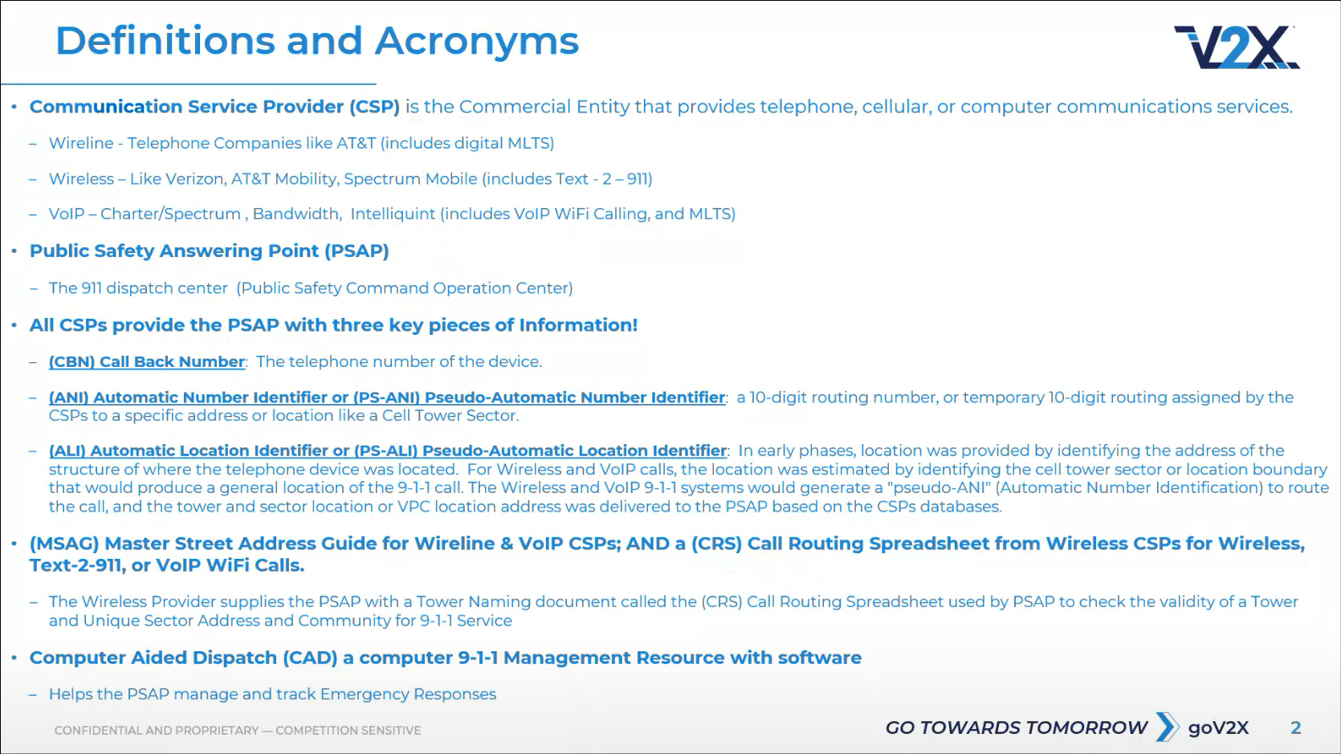
Tony Ramirez referenced the slide above regarding definitions and acronyms that will be used during this presentation.

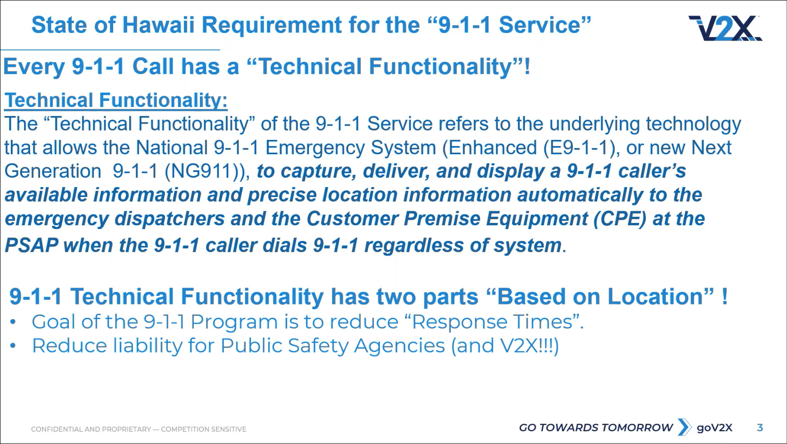
Tony Ramirez referenced the slide above regarding the State of Hawaii’s requirement for 911 call technical functionality. He mentioned that the communication service provider is required to provide the CBN, ANI/PS-ANI, and ALI/PS-ALI, which were defined in the previous slide. He added that the 911 Board provides funding for costs related to technical functionality.

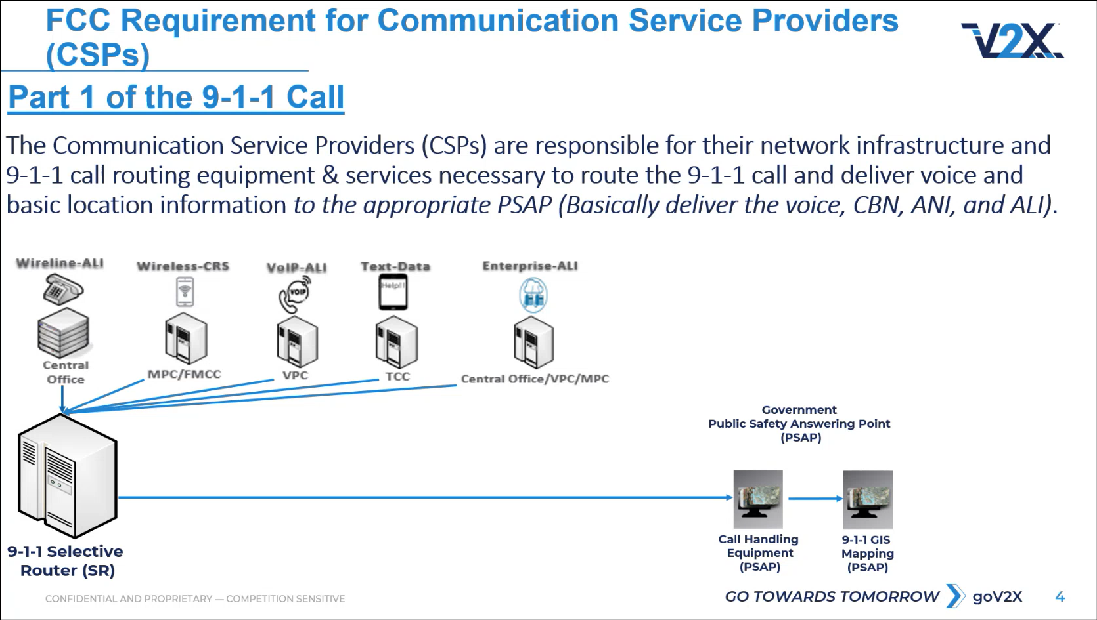
Tony Ramirez referenced the slide above regarding part 1 of the 911 call, which is the responsibility of the communication service provider. He added that this enables the selective router to function properly by routing the 911 call to the correct PSAP based on the caller’s location.

Tony Ramirez stated that the basic system utilized wireline with a selective router that sent information to the call handling equipment at the respective PSAP.

Tony Ramirez stated that the FCC determined the selective router is the demarcation point when wireless was deployed. He added that this resulted in the wireless providers being responsible for the routing equipment into the selective router and the PSAPs are responsible for any cost associated with the selective router inclusive of mapping. Additionally, the CAD system at this time did not allow for Phase 1 mapping but instead used PowerMap and the GeoComm system. Furthermore, Intrado offered to provide MapFlex when TXT2911 was implemented.

Tony Ramirez stated that when VoIP was introduced it used the same routing information and/or systems as wireless being PS-ANI and PS-ALI, which were sent to the respective PSAP.

Tony Ramirez stated that TXT2911 utilized the same technology as wireless and VoIP. He added that TXT2911 uses the E2 steering mechanism, which is the same software tool being PS-ALI and/or an equivalent to PS-ALI. He mentioned that the communication service providers and carriers are responsible for their own networks and delivery systems.

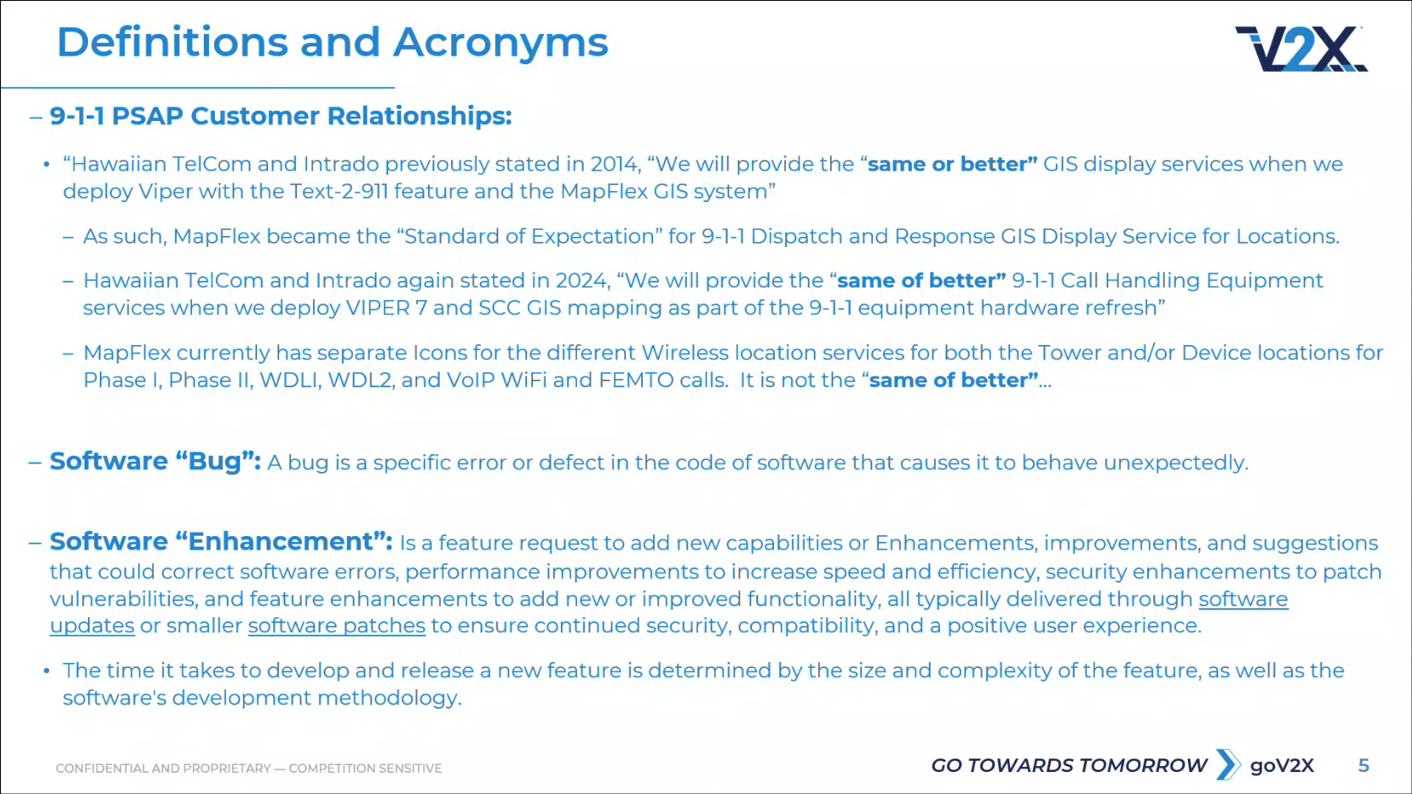
Tony Ramirez stated that Hawaiian Telcom would provide the same or better service when they replaced PowerMap with MapFlex, which then became the standard of expectation regarding GIS mapping display since the existing CAD systems were unable to display wireless Phase 1 mapping. He added that in 2024, Hawaiian Telcom’s equipment refresh would provide the same or better call handling equipment and mapping system, which would maintain the same level of service and functionality or better. He mentioned that MapFlex currently has separate icons for the different wireless and VoIP services to determine towers, device locations, and class of services. Furthermore, the new SCC mapping system does not have these aforementioned icons, which is not the same or better comparatively.

Tony Ramirez defined a software bug as an error within the specific software that causes the system to behave unexpectedly, which Hawaiian Telcom and Intrado have been attempting to explain regarding the functionality of the aforementioned mapping icons. He added that a former Esri solution engineer would have described the omission of mapping icons as a bug. He then defined software enhancement as a feature request to add new capabilities that do not require any coding changes, which should be paid for by the respective PSAP. In contrast, he mentioned that a software bug should be covered under the development of the software itself.

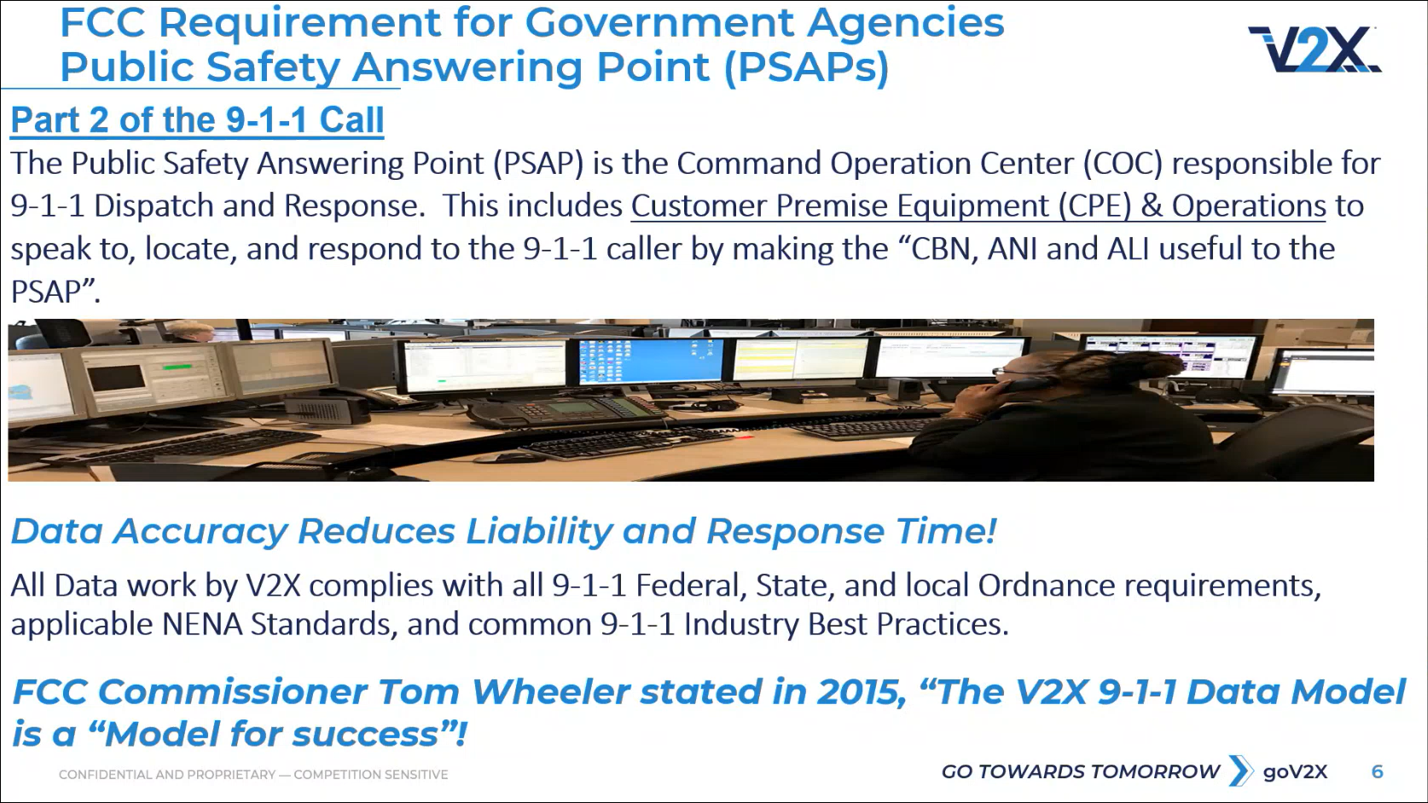
Tony Ramirez referenced the slide above regarding part 2 of the 911 call, which is the responsibility of the PSAP. He added that it is vital to aid the PSAPs in reducing their dispatch and response times. Additionally, all the ordinances, industry standards, and best practices must be compliant.

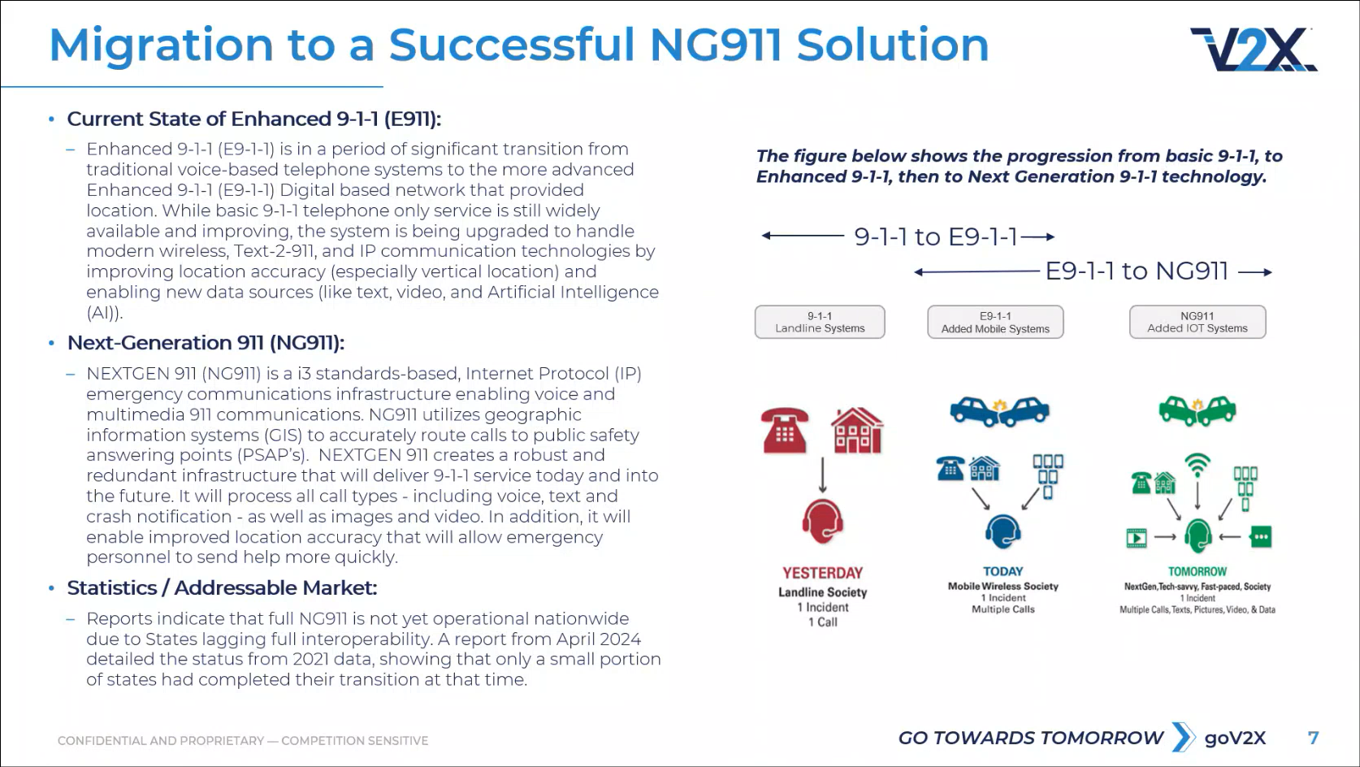
Tony Ramirez stated that we have to cite the history of 911 in Hawaii and what transpired in the past in order to have a successful migration to an NG911 solution. He added that the current state of Enhanced 911 in Hawaii includes the routing of all systems such as wireline, wireless, MLTS, TXT2911, and VoIP, which are all working in accordance with the federal laws under NENA standards.

Tony Ramirez stated that the aforementioned systems will not be changing for the NG911 transition. He then asked Corey Shaffer if Verizon will be changing their wireless delivery system for the NG911 transition. Corey Shaffer responded stating that the protocols will change for the delivery of information from TDM to SIP, which is IP based. Tony Ramirez asked Brian Boezeman a follow-up question if the class of service will be removed or if it is going to be included in a different part of the SIP message such as the header or footer. Brian Boezeman responded stating that NENA i3 does not support class of service being delivered but rather it is subscriber and/or service information. Tony Ramirez asked Brian Boezeman a follow-up question if it is not a required data element for the location information then why is it being used for ECaTS. Brian Boezeman responded stating that the Viper call handling system is capable of translating a portion of the NENA i3 information into the legacy class of service but NENA i3 itself does not have a class of service or method of delivery. Tony Ramirez asked Brian Boezeman a follow-up question if the aforementioned information appears in the header or footer. Brian Boezeman responded stating that the current NENA i3 does not provide a place for this information to be displayed but translation via the Viper system is used instead as a current workaround solution. Tony Ramirez asked Brian Boezeman a follow-up question if class of service is necessary until the deployment of NG911. Brian Boezeman responded stating that class of service will be used until then.

Tony Ramirez stated that the difference between Enhanced 911 and NG911 is that the latter will be delivered over an IP network. He added that NG911 will allow the delivery of calls from additional sources beyond the current Enhanced 911 system. He mentioned that full NG911 deployment is not yet operational nationwide due to individual states lacking the proper development of respective data. Furthermore, he stated that various reports acknowledge the success of isolated state deployments regarding data but run into issues with data integration involving multiple regions/states.

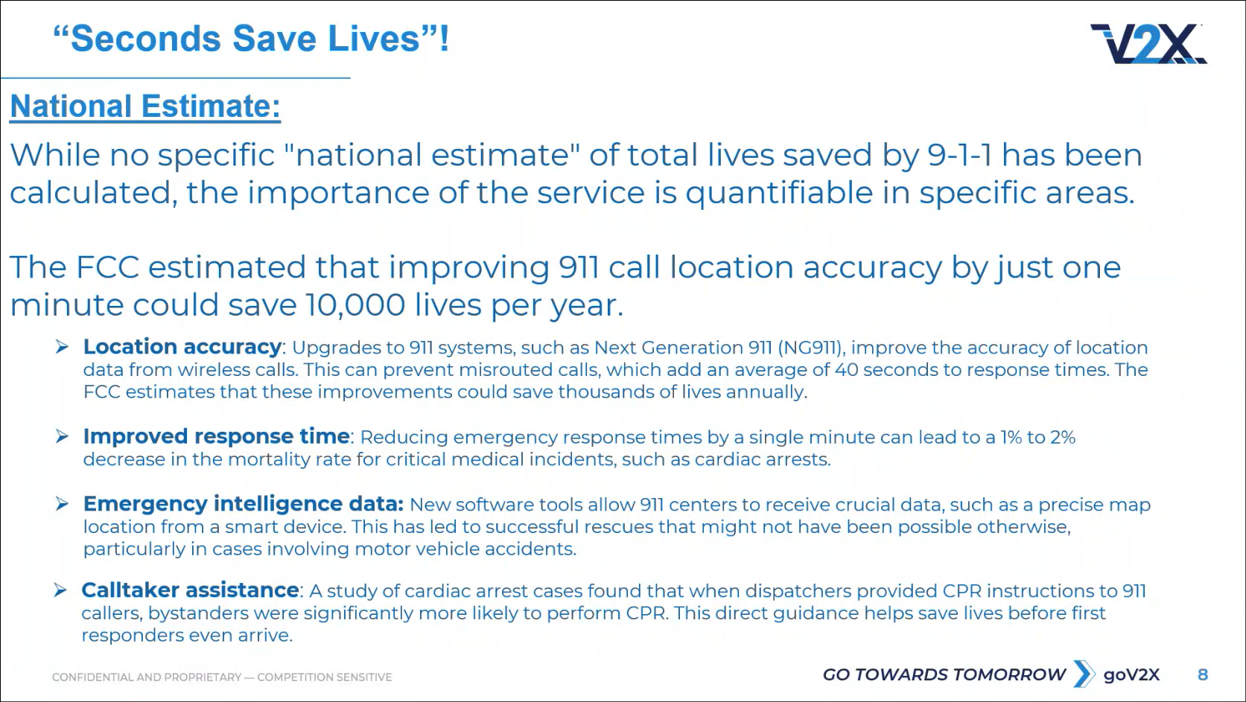
Tony Ramirez referenced the slide above regarding the sub bullets that will be considered for Hawaii’s NG911 transition, which is expected to increase the responsibilities of 911 call center personnel.

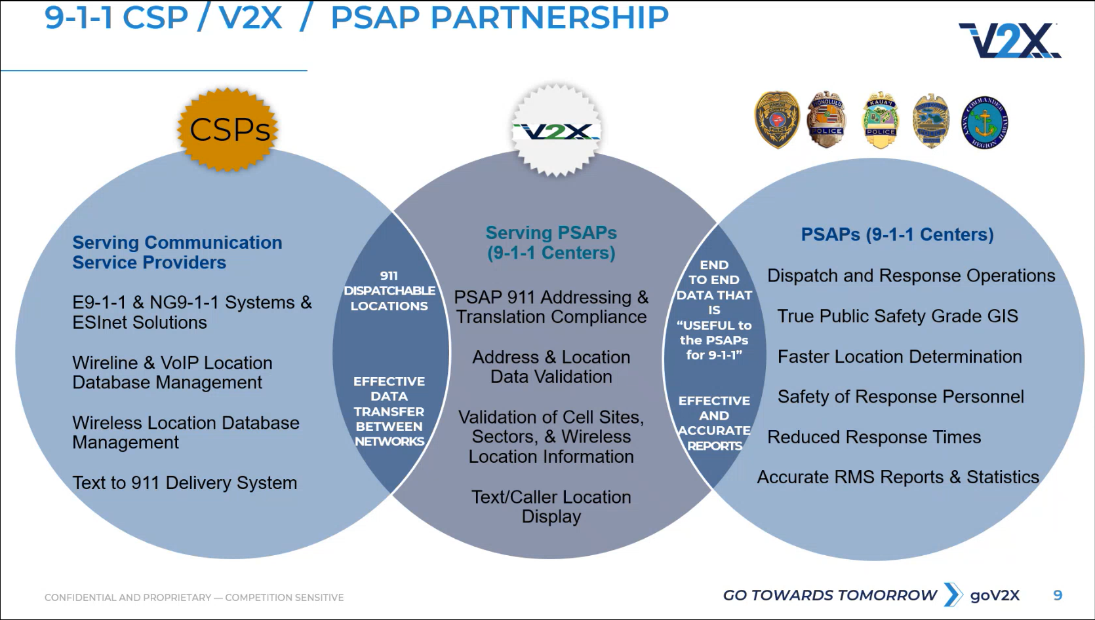
Tony Ramirez stated that V2X helps to enhance the data between the communication service providers and PSAPs to ensure that the system functions as intended. He added that Hawaii operates its wireless and VoIP systems differently when compared to the mainland U.S. since the majority of them do not use wireless Phase 1. Furthermore, he mentioned that Hawaii is able to maintain its numerous cell sector sites successfully and utilize them efficiently.

Francis Alueta asked Tony Ramirez to recap the substantial differences between the PSAPs in Hawaii versus the mainland U.S. in terms of Phase 1 mapping. Tony Ramirez responded stating that wireless systems utilize the E2 steering mechanism using a 10-digit number known as a PS-ANI to register in the database and pinpoints which cell sector did the call originate from. He added that the aforementioned database will then provide data from that sector such as the street name and send it to the respective PSAP in the ALI information. Furthermore, he mentioned that the cell sectors will match V2X’s layers and provide theoretical coverage areas. He then stated that the VoIP system operates similarly other than the usage of boundaries. He added that an ESQK is received instead of an ESRK, which then searches the VPC database of maps to provide an address. He explained that when either a telephone or VoIP call has a hyphen in the middle then it is not a valid MSAG and displays as an NRF since V2X does not use special characters in their addresses. Additionally, he mentioned that special characters will cause the VoIP providers to claim that there are invalid addresses.

Francis Alueta asked Tony Ramirez if V2X developed maps with cell sectors to be displayed in the CAD. Tony Ramirez responded stating that it will not display in the CAD without a separate mapping system such as MapFlex or SCC mapping. He added that V2X created layers for mapping, theoretical coverage areas, and boundaries for VoIP services. Francis Alueta asked Tony Ramirez a follow-up question how this differs from PSAPs in the mainland U.S. Tony Ramirez responded stating that wireline is regulated by the PUC while wireless and VoIP are regulated by the FCC since they are delivered over digital or IP networks. He added that V2X had to configure the maps and layers to be compatible with MapFlex so that the icons are displayed correctly. Furthermore, he stated that SCC mapping does not have the proper coding to display the aforementioned icons, which delays the 911 call center personnel in identifying the type of call being received. Corey Shaffer asked Tony Ramirez what information these icons provide such as sectors, sector mapping, and/or class of service. Tony Ramirez responded stating that the incoming call’s class of service will trigger the mapping system to display an icon whether it is a Phase 1 or Phase 2 call, which will prompt the appropriate response from 911 call center personnel. He added that these icons promote efficiency for 911 call center personnel. Corey Shaffer stated that it would be beneficial to gather feedback from 911 call center personnel regarding the differences between MapFlex and SCC mapping. Corey Shaffer asked Tony Ramirez if the potential costs to implement this feature will be requested from the 911 Board. Tony Ramirez responded stating that if it is deemed a software enhancement instead of a software bug then the funds will be requested from the 911 Board. He added that this concern regarding the accurate plotting and displaying of Phase 1 calls was raised early on to both Hawaiian Telcom and Intrado due to the significant amount received in Hawaii given the numerous ocean and mountain rescues. Shawn Kuratani stated that the Phase 1 call icons are an essential component before upgrading to Viper 7 and SCC mapping. He added that Hawaiian Telcom and Intrado agreed to have this matter sorted and working properly before the cutover at no additional cost. Furthermore, he mentioned that the omission of these aforementioned icons is a loss of capability and is not the same or better when comparing MapFlex to SCC mapping. He then suggested to table this discussion to provide Hawaiian Telcom time to determine whether or not this is a software enhancement or software bug in regard to who is responsible for the proposed costs. Marisa Fujimoto asked Tony Ramirez where did this statement of same or better derive from. Tony Ramirez responded stating that this aforementioned statement can be traced back to 2014 when Hawaii deployed TXT2911 and at that time Intrado offered to provide an improved mapping system, which would be the same or better. He added that in a 2024 discussion with Intrado, they stated that it would be the same or better regarding the switch from MapFlex to SCC mapping. Marisa Fujimoto asked Tony Ramirez a follow-up question if he recalls who made this statement of same or better. Tony Ramirez responded stating that it was the group who gave an SCC mapping demonstration to the Honolulu Police Department in 2024. Corey Shaffer asked Tony Ramirez if there are any records of this aforementioned meeting. Tony Ramirez responded stating that he will check his files. Corey Shaffer stated that feedback from the PSAPs about this matter and discussion regarding whether this is a software enhancement or software bug will be heard during next month’s meeting under the technical committee. Corey Shaffer asked Tony Ramirez which PSAPs are currently using SCC mapping. Tony Ramirez responded stating that Big Island and Kauai have migrated to SCC mapping. Corey Shaffer asked Stacy Domingo and Andrew Muraoka if they could gather intel and/or bring personnel to attend next month’s meeting for this discussion. Stacy Domingo and Andrew Muraoka responded stating that they were both agreeable. Corey Shaffer asked Francis Alueta and Marisa Fujimoto if they can prepare for this discussion during next month’s meeting. Francis Alueta and Marisa Fujimoto responded stating that they were both agreeable.

      - Advisory Committee – Rebecca Lieberman
        - No Updates

  - Finance Committee – Edward Fujioka
    - Review of Monthly Y-T-D (Year to Date) Cash Flow
September 2025 Cashflow Statement:

Surcharge Collection: $1,063,526
Interest Income: $118,636
Total Receipts: $1,182,162
Total Disbursements: ($301,100)
Net Receipts/Disbursements: $881,063
Net Encumbrances Adds/(Paydown): ($1,999,682)
Net Cash Inflow/(Outflow): ($977,780)
Outstanding Encumbrances: $12,783,425
Net Bank Balance: $48,934,008
Unencumbered Cash Balance: $36,150,583

    - Kauai Police Department Requesting $2,500.00 for Dispatch Console Upgrades
Executive Director on behalf of Edward Fujioka stated the item above and requested an explanation. Andrew Muraoka explained that this request is to convert obsolete jacks for existing consoles at both the primary and backup PSAP locations to enable six wire conversion from the current four wires. Executive Director on behalf of Edward Fujioka asked for a motion to approve. Tony Velasco motioned to approve this request. Matthew Kurihara seconded the motion. A voice vote was taken, motion was unanimously approved.

    - Maui Police Department Requesting $934.12 for FY 2023 HW710 Headsets
Executive Director on behalf of Edward Fujioka stated the item above and explained that this request was an inadvertently returned prior encumbrance. Executive Director on behalf of Edward Fujioka asked for a motion to approve. Tony Velasco motioned to approve this request. Matthew Kurihara seconded the motion. A voice vote was taken, motion was unanimously approved.

- Public Service Answering Point Status Updates on Recruitment and other Personnel Issues
  - Kauai Police Department – Andrew Muraoka
    - Update on Recruitment Process/Strategies and Personnel Training
Andrew Muraoka stated that they have an upcoming call taker class to assist with vacancies and staffing shortages.

    - Update on Personnel Issues and Vacancies
Andrew Muraoka stated that they currently have a ~50% vacancy rate.

  - Oahu Police Department – Matthew Kurihara
    - Update on Recruitment Process/Strategies and Personnel Training
Matthew Kurihara stated that they have been exploring alternative solutions such as the usage of sworn personnel. He added that they are conducting another training class next week with 5 sworn personnel. Furthermore, he mentioned that they have 3 new personnel starting soon.

    - Update on Personnel Issues and Vacancies
Matthew Kurihara stated that they currently have a ~34% vacancy rate, which is approximately 50 PCO positions. He added that they have 3 personnel retiring later this year.

  - Oahu Fire Department – Shawn Kuratani
    - Update on Recruitment Process/Strategies and Personnel Training
Shawn Kuratani stated no updates.

    - Update on Personnel Issues and Vacancies
Shawn Kuratani stated that they are currently fully staffed.

  - Oahu Emergency Medical Services – Lorrin Okumura, Diana Chun, Frannie Chung
    - Update on Recruitment Process/Strategies and Personnel Training
Frannie Chung on behalf of Lorrin Okumura stated that 4 out of 5 trainees in their EMD academy have completed both the skills and written tests. She added that the remaining trainee will take the written test tomorrow who is anticipated to pass.

    - Update on Personnel Issues and Vacancies
Frannie Chung on behalf of Lorrin Okumura stated that they still have vacancies.

  - Maui Police Department – Davlynn Racadio
    - Update on Recruitment Process/Strategies and Personnel Training
Davlynn Racadio stated that they have 1 returning personnel from the mainland. She added that they sent out 7 conditional offers recently. Furthermore, she mentioned that they are planning to start another training class in December 2025.

    - Update on Personnel Issues and Vacancies
Davlynn Racadio stated no updates.

  - Molokai Police Department – Davlynn Racadio
    - Update on Recruitment Process/Strategies and Personnel Training
Please see updates under Maui Police Department.

    - Update on Personnel Issues and Vacancies
Please see updates under Maui Police Department.

  - Hawaii Police Department – Zachary Fernando
    - Update on Recruitment Process/Strategies and Personnel Training
Zachary Fernando stated that they currently have 2 trainees and approximately 16 potential hires in the background check stage. He added that all 7 recruits resigned from the past 3 training classes this year. Corey Shaffer asked Zachary Fernando why did these aforementioned recruits resign. Zachary Fernando responded stating that the recruits said the training is too difficult.

    - Update on Personnel Issues and Vacancies
Zachary Fernando stated that they currently have a ~43% vacancy rate, which is approximately 17 positions. He added that 1 personnel recently resigned.

  - Hawaii Fire Department – Stacy Domingo
    - Update on Recruitment Process/Strategies and Personnel Training
Stacy Domingo stated that they sent out 4 conditional offers recently. She added that they are planning to start a training class in December 2025.

    - Update on Personnel Issues and Vacancies
Stacy Domingo stated that they currently have a ~62% vacancy rate, which is 9 out of 24 total positions filled.

- Items for Discussion, Consideration, and Action
  - Additional Items Proposed by Meeting Attendees

- Announcements
  - Future Virtual Meeting Dates/Times (9:00AM-12:00PM)
    - Thursday, November 13, 2025 (Combined Meeting)
    - Thursday, December 11, 2025 (Combined Meeting)

  - Future Conference Dates (3 Months of Advanced Approval Required)
    - 9-1-1 Goes to Washington (GTW) February 22-25, 2026, Arlington, VA

  - Additional Announcements from Meeting Attendees
Francis Alueta stated that Hawaiian Telcom underwent organizational changes last month to combine their voice architecture and support teams together, which affects 911. He added that Marc De Costa will slowly replace Marisa Fujimoto’s role in 911 as lead while Christian Burns and the technicians will remain as-is. Furthermore, Marisa Fujimoto will still be involved during the interim for transition purposes. Additionally, Marisa Fujimoto is not leaving Hawaiian Telcom and will continue her role to support the overall data network, which is a part of 911 call delivery. He mentioned that one of Marc De Costa’s focus areas will be UPS upgrades throughout the PSAPs. Lastly, he stated that Marc De Costa is experienced with Hawaiian Telcom’s operations, familiar with the local market/environment, and is based in Oahu.

- Open Forum: Public comment on issues not on the Board Meeting Agenda
There was no public comment on issues not on the agenda.

- Adjournment
Board Chair requested a motion to adjourn the meeting. Tony Velasco motioned to adjourn the meeting. Stephen Courtney seconded the motion. A voice vote was taken, adjournment was unanimously approved. The meeting was adjourned.

