JOSH GREEN, M.D.  GOVERNOR  Ke Kiaʻāina |  | KEITH A. REGAN  COMPTROLLER  Ka Luna Hoʻomalu Hana Laulā  MEOH-LENG SILLIMAN  DEPUTY COMPTROLLER  Ka Hope Luna Hoʻomalu Hana Laulā
STATE OF HAWAIʻI | KA Mokuʻāina o Hawaiʻi

DEPARTMENT OF ACCOUNTING AND GENERAL SERVICES | KA ʻOihana LOIHELU A LAWELAWE Laulā
P.O. BOX 119, HONOLULU, HAWAII 96810-0119

Communications, Technical, and Finance Meeting
(Combined Meeting)

Thursday, September 11, 2025
9:00 am – 12:00 pm

Virtually Held Meeting with Physical Location at
Kalanimoku Building Room 426, 1151 Punchbowl Street, Honolulu, Hawaii 96813 is available to the public and is guaranteed to be connected to the remote virtual meeting.

MEETING MINUTES

September 11, 2025: Joint Committee and Board Meeting (youtube.com)

Communications Committee Members Present: Davlynn Racadio (MPD), Ah Lan Leong (HPD)

Communications Committee Members Not Present: Lavina Taovao (KPD)

Technical Committee Members Present: Shawn Kuratani (HFD), Stacy Domingo (HIFD), Tony Ramirez (V2X), Kenison Tejada (FirstNet), Tony Velasco (DIT)

Technical Committee Members Not Present: Thalia Burns (APCO/NENA), David Miyasaki (KPD)

Finance Committee Members Present: Edward Fujioka (EMS), Stephen Courtney (C&C of Honolulu), Liz Gregg (AT&T), Matthew Kurihara (HPD), Tony Velasco (DIT)

Finance Committee Members Not Present: Reed Mahuna (HIPD), Todd Omura (CIO Designee)

Staff: Royce Murakami (911 Board), Benson Leung (911 Board), Stella Kam (AG)

Guests: Francis Alueta (HT), Brian Boezeman (Intrado), Joshua Brantley (ETS), Ruth Cruz (Intrado), Roderick Green (KPD), Sherri Griffith Powell (Mission Critical), Wayne Hirasa (Alakaina), Bertie Johnson (HPD), Melia Johnson (MPD), David Jones (Mission Critical), Stella Kam (AG), Elliott K. Ke (KPD), Ji Sook Kim (Consumer Advocate Designee), Michelle Kratel (HIPD), Patrick Leddy (LCC), Brian McKee (DIT), Robert Mohr (Exacom), Andrew Muraoka (KPD), Tamera Neal (Intrado), Gregg Okamoto (MPD), Lorrin Okumura (EMS), Stacy Perreira (KPD), Kapu Ping (OS), Megan Reilly (EagleView), Christine Sakuda (ETS), Corey Shaffer (Verizon), Calvin Sung (HPD), Keola Tom (MPD), Gordon Vanauken (Mission Critical), Scott Winecoff (T-Mobile)

- Call to Order, Public Notice
The meeting was called to order by the Board Chair. Public notice was given.

- Public Testimony Will Be Taken on All Agenda Items as Those Items Occur During the Meeting

- Roll Call, Quorum
A roll call was taken, quorum was present for all committees.

Board Chair observed a moment of silence to honor the life of fallen police officer Suzanne O.

- Review and Approval of August Meeting Minutes
Board Chair requested a motion to approve August’s Meeting Minutes. Tony Velasco motioned to approve August’s Meeting Minutes. Stephen Courtney seconded the motion. A voice vote was taken, motion was unanimously approved.

- Review of Mission Critical Partners Report & Cost Analysis
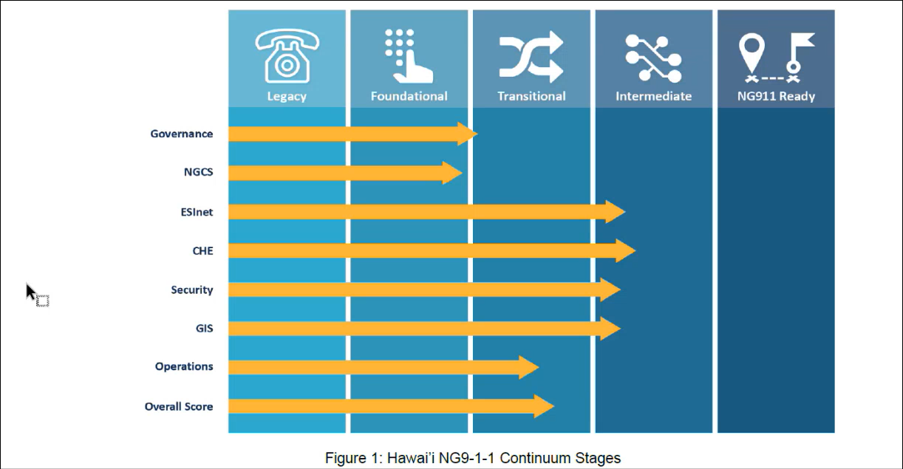
Sherri Griffith Powell stated that the slide above represents Mission Critical Partners’ (“MCP”) assessment of Hawaii’s NG911 transition for each listed category. She added that Hawaii overall is in the transitional phase.

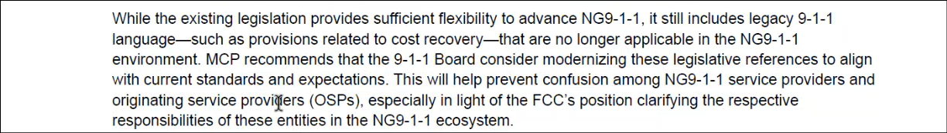
Sherri Griffith Powell stated that Hawaii’s 911 legislation should be amended to remove any language regarding legacy terminology. She added that this should be replaced by references to the usage of current and future technologies.

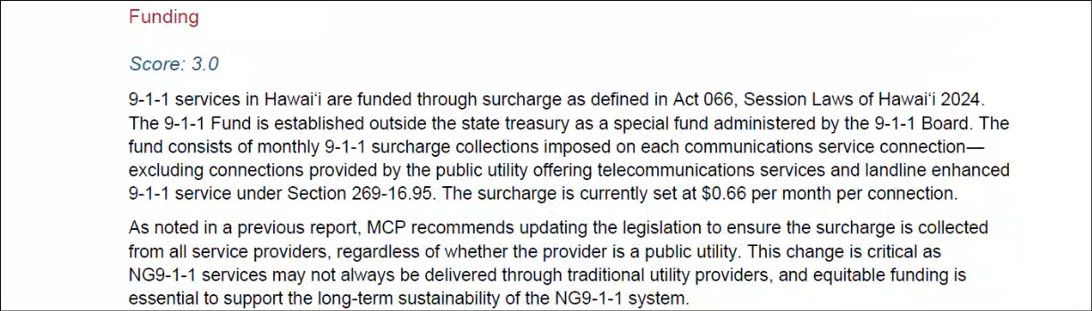
Sherri Griffith Powell stated that MCP gave Hawaii a lower score in terms of funding. She added that they will review the cost analysis after the readiness assessment.

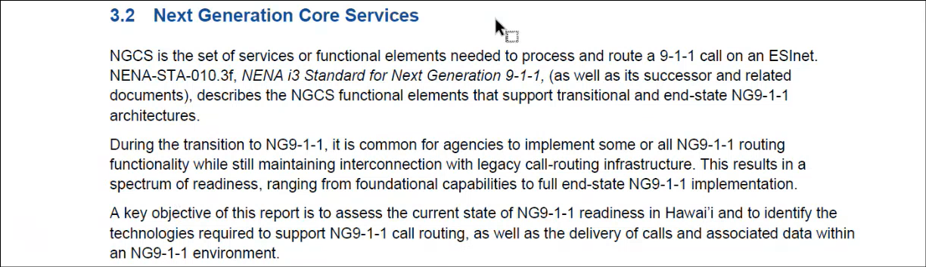
Sherri Griffith Powell stated that Hawaii received a lower NGCS score from MCP since it has not been implemented yet. She added that Hawaiian Telcom and Intrado have an existing plan in-place regarding this and the score will improve after transition to Intrado’s i3 version, which requires Hawaii’s originating service provider to connect via IP.

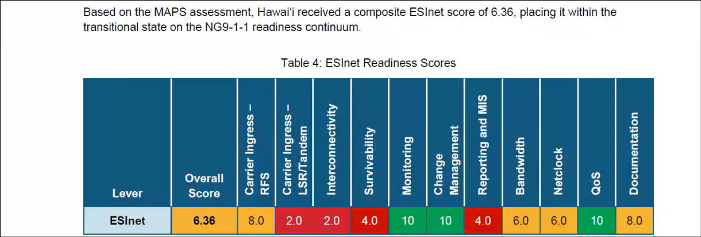
Sherri Griffith Powell stated that Hawaii has sufficient bandwidth for its current needs, which yielded the adequate score in the slide above. She added that the amount of bandwidth will need to increase upon NG911 transition due to the addition of multimedia such as videos/photos and/or the inclusion of a cloud-based call handling system.

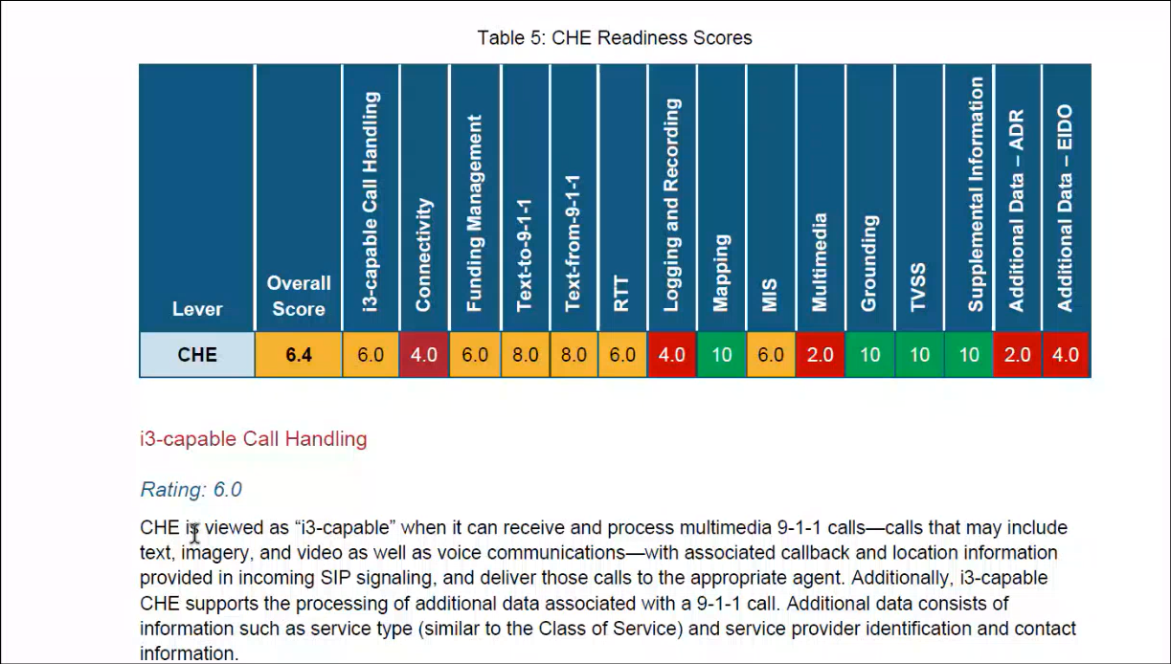
Sherri Griffith Powell stated that the majority of Hawaii’s call handling equipment is i3 capable but requires the Viper 7 upgrade to complete i3 readiness, which is currently underway. She reiterated that Hawaii should evaluate its last mile connectivity regarding the acceptance of videos and/or photos.

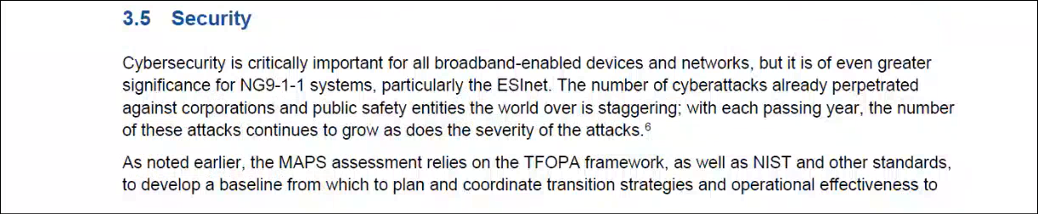
Sherri Griffith Powell recommended the 911 Board to create mutually agreeable statewide minimum guidelines and/or best practices regarding cybersecurity for the PSAPs. She stated that this will be an addition to the existing policies and procedures that each PSAP already has in-place. She mentioned that Hawaiian Telcom maintains strong network security. She added that the 911 Board should consider proactively monitoring the system/network. Furthermore, she mentioned that the National Institute of Standards and Technology’s (“NIST”) recommendation is to conduct a third-party cybersecurity assessment for each PSAP.

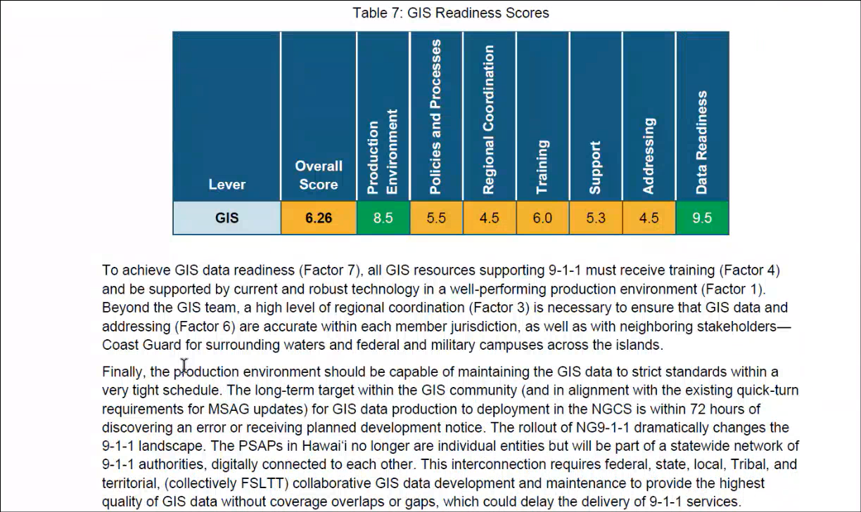
Sherri Griffith Powell stated that Hawaii’s overall GIS score is proficient. She added that the relationship with V2X is excellent. She recommended ensuring that each PSAP maintains its respective contract with V2X.

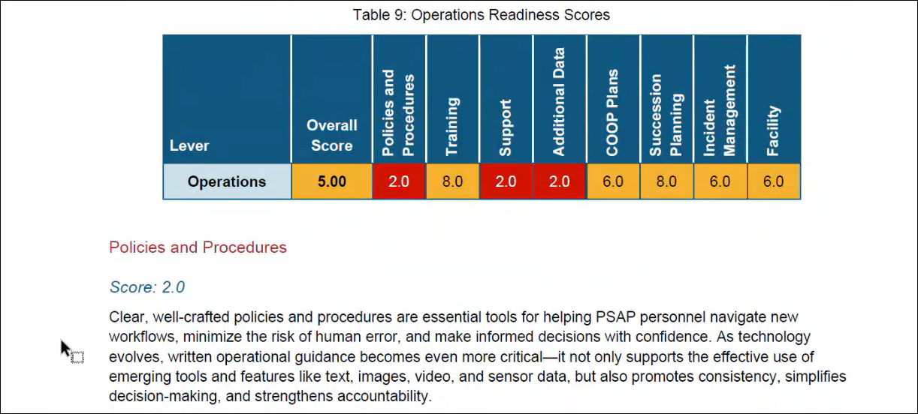
Sherri Griffith Powell recommended that the 911 Board could help develop policies and procedures regarding operations for best practices to be shared amongst the PSAPs. She stated a consensus from the PSAPs that there is a lack of uniform technical and/or IT support. She suggested that the 911 Board may consider options such as identifying and earmarking funds to provide dedicated support to remedy the aforementioned issue.

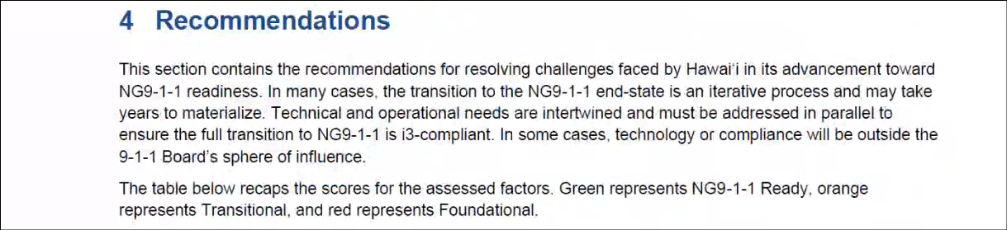
Sherri Griffith Powell stated that MCP summarized their recommendations for each category towards the end of the readiness assessment. She added that the cumulative scores and breakdowns are also re-stated in this section.

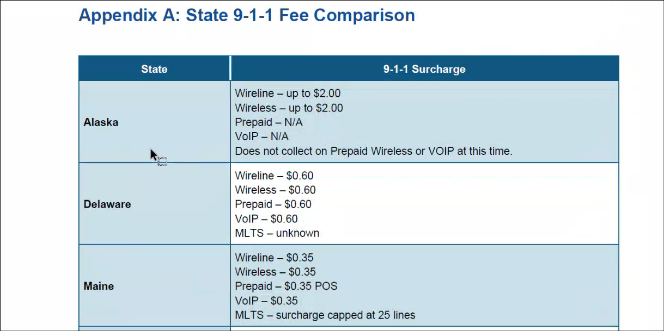
Sherri Griffith Powell stated that the slide above provides fee comparisons from other states that are similar to Hawaii in terms of either geographical challenges or population size.

Edward Fujioka asked Sherri Griffith Powell which service providers are missing regarding surcharge collection under the funding section. Sherri Griffith Powell responded stating that Hawaii should be collecting surcharge from prepaid phones and Hawaiian Telcom. She added that the current legislation excludes the service provider if they are a public utility. She mentioned that there are observed past trends of consumers switching to prepaid phones during economic downturns. Edward Fujioka asked Sherri Griffith Powell a follow-up question if other states encountered resistance from legislators when attempting to include surcharge collection from prepaid phones. Sherri Griffith Powell responded stating that other states have experienced pushbacks regarding this and they addressed legislative concerns by either matching the flat surcharge collection fee with existing wireline/wireless/VoIP fees or utilizing a point-of-sale fee collection to alleviate the financial burden on consumers. She added that the surcharge collection from prepaid phones is to mitigate fluctuation risks in funding.

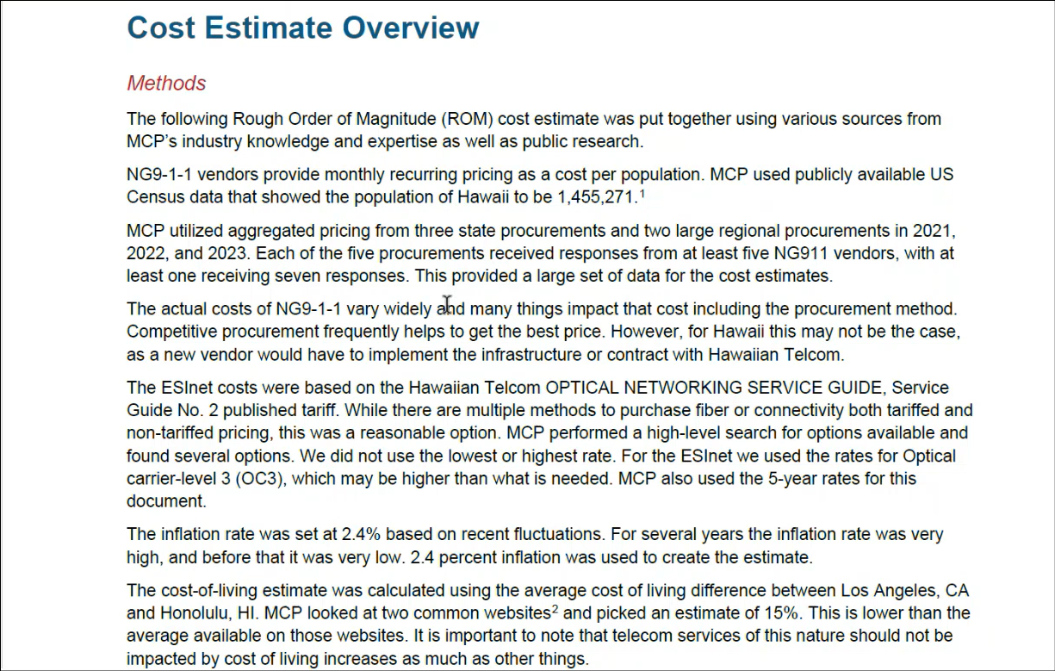
Sherri Griffith Powell stated that the cost estimate overview is a supplemental document shown in the slide above that provides information and methodology for the cost analysis. She added that this includes data from NG911 vendors, the monthly recurring charge for NGCS based on population size per census data, low and high range estimates, and factors affecting the costs of NGCS and ESInet. She mentioned that typically the usage of competitive procurement is the ideal way to secure the best pricing. However, she stated that Hawaii’s situation differs since Hawaiian Telcom is the sole local exchange carrier (“LEC”) that maintains the infrastructure for 911 services. Additionally, if Hawaii decided to conduct competitive procurement to seek out another vendor for NGCS and ESInet then that awardee would either have to build out their own infrastructure or pay Hawaiian Telcom for usage of the existing infrastructure with markup costs. Gordon Vanauken stated that the cost analysis consists of 4 total tabs: low, high, current, and the working copy. He added that low and high estimates were created using relevant examples and procurements. Furthermore, the cost analysis has the ability to take into consideration both rates for inflation and cost of living.

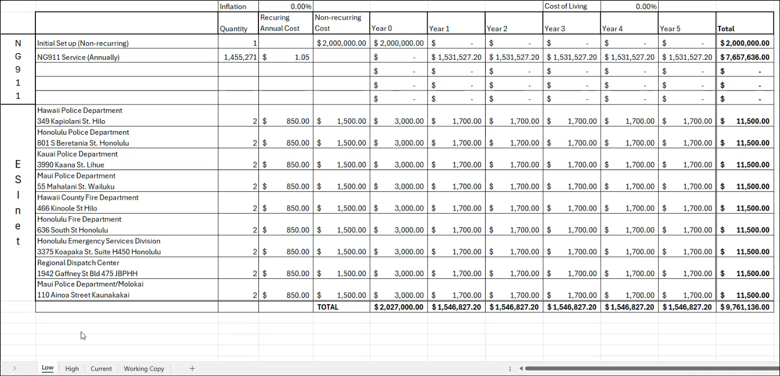
Gordon Vanauken referenced the slide above regarding the low estimate:
- The low estimate did not utilize the absolute lowest figures
- Both rates for inflation and cost of living were kept at 0.00%
- Initial set up (non-recurring) costs for a NG911 system includes equipment plus its associated programming, software setup, and PSAP delivery fees
- Low estimate for NG911 service is based on a monthly charge of $0.0877 per population (recurring annual cost of $1.05 per population)
- No recurring charge for NGCS in year 0 due to set up period
- 2 required IP circuits for each PSAP priced at $850.00 for recurring costs and $1,500.00 non-recurring setup fees based on OC3 level per Hawaiian Telcom’s optical tariffs

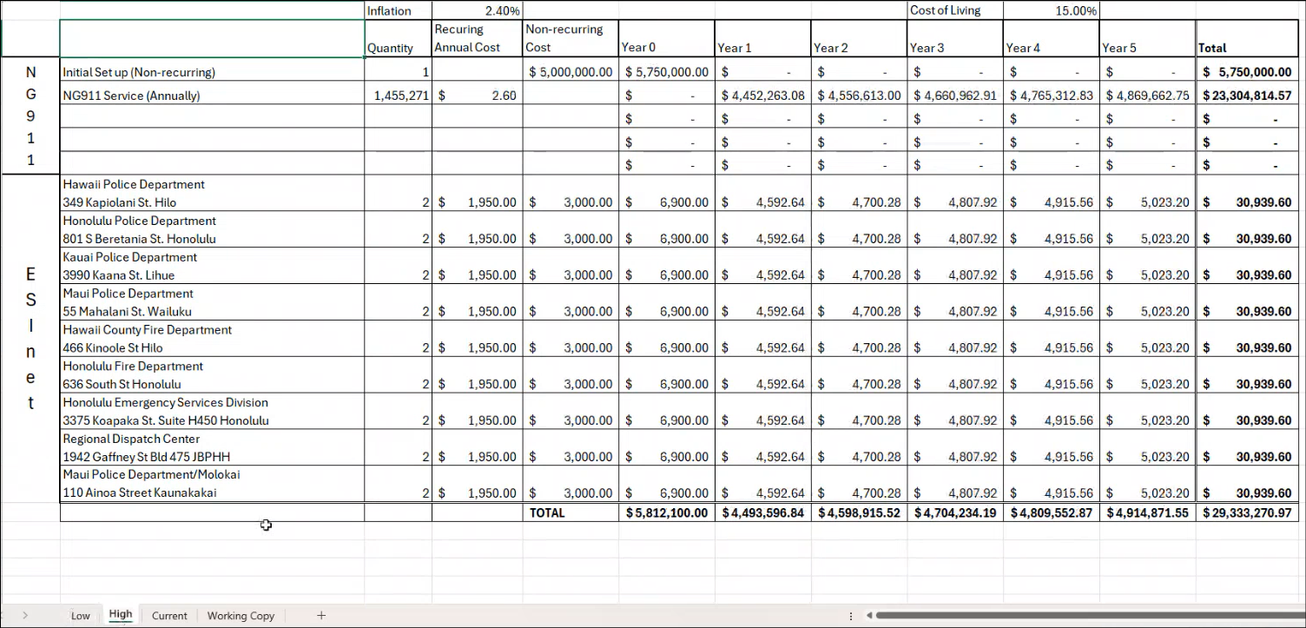
Gordon Vanauken referenced the slide above regarding the high estimate:
- Applied rates for inflation of 2.40% and cost of living at 15.00% regarding NG911 costs
- High estimate for NG911 service is based on a monthly charge of $0.2165 per population (recurring annual cost of $2.60 per population)
- Both rates for inflation and cost of living were not applied to ESInet costs since they are based on the existing tariff
- 2 required IP circuits for each PSAP priced at $850.00 for recurring costs and $1,500.00 non-recurring setup fees based on OC3 level per Hawaiian Telcom’s optical tariffs
- IP circuits are not controlled by the tariff and may change year-over-year
- Majority of the equipment and systems will be located in the mainland U.S. and the remaining to be stationed in Hawaii
- Total costs of ~$29 million based on this 5-year estimate

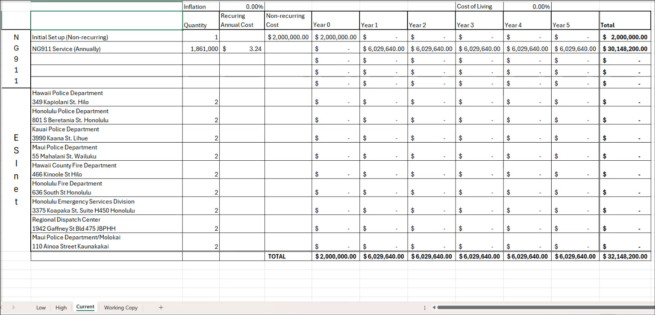
Gordon Vanauken referenced the slide above regarding the current tab:
- Assuming no changes to the existing tariff, the current estimate for NG911 service is based on a monthly charge of $0.27 per access line (recurring annual cost of $3.24 per access line)
- Total access lines of 1,861,000 stated via the FCC competition report
- Total costs of ~$32 million based on this 5-year estimate
- ESInet costs based on the existing tariff were assumed to be included in the monthly charge of $0.27 per access line

Corey Shaffer asked Gordon Vanauken if this current tab factors in wireless surcharge revenue or not. Gordon Vanauken responded stating that only costs were taken into consideration and no revenue was accounted for.

Tony Ramirez mentioned that Hawaiian Telcom charges the PSAPs monthly for their tariff and non-tariff positions with the latter maintaining varying price points amongst the PSAPs and being slightly higher in cost. He added that both of these costs should be included in this current tab. Francis Alueta commented that he will research and provide the actual figures. Corey Shaffer asked Gordon Vanauken if these aforementioned costs could be added. Gordon Vanauken responded stating that this is possible if the 911 Board is able to provide these figures. The Executive Director stated that he will provide MCP the requested figures.

Stacy Domingo asked Gordon Vanauken how could the PSAPs initiate a re-evaluation of the number of tariff positions allotted given the increases in population and call volume. Gordon Vanauken responded stating that for most other states it would be a PUC action that accompanies the tariff. He recommended reviewing Hawaii’s legislation regarding this matter. Tony Ramirez stated that the PUC prefers it to be a 911 Board sponsored request for re-evaluation of the existing tariff positions. He added that in the past they worked with Intrado through Hawaiian Telcom to re-evaluate the number of tariff positions but those efforts yielded no results. Corey Shaffer asked Francis Alueta what the best route is to conduct this re-evaluation of tariff positions. Francis Alueta responded stating that he believes the 911 Board will most likely have to send a formal request to Hawaiian Telcom’s regulatory affairs team in order to open up the tariff for review/discussion and any amendments/changes. He added that he will follow up with the Hawaiian Telcom team regarding this question.

Tony Ramirez asked Sherri Griffith Powell if they can add a statement in the readiness assessment to clarify that the 911 surcharge is a fee for service rather than a tax. Sherri Griffith Powell responded stating that they will make the addition.

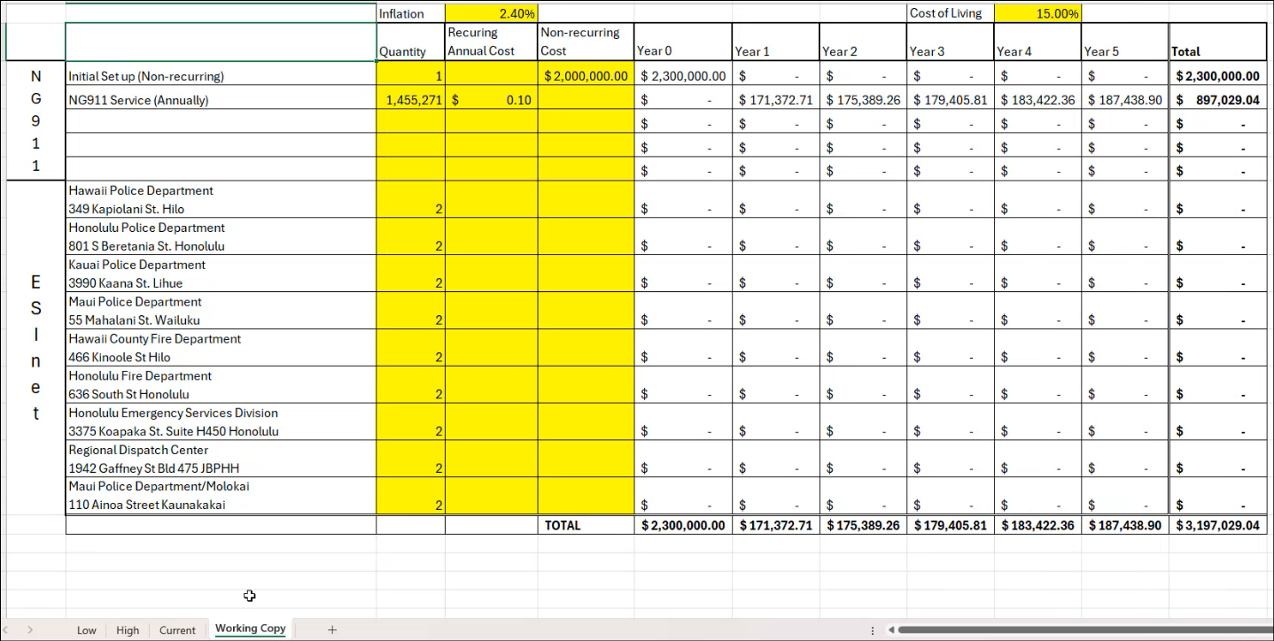
Gordon Vanauken referenced the slide above regarding the working copy tab that provides the user with the ability to adjust any of the figures in the highlighted sections to assess different financial outcomes.

Tony Ramirez expressed his gratitude to MCP for their efforts and work on the readiness assessment. Sherri Griffith Powell echoed the same sentiment and mentioned on behalf of the MCP team that it was a pleasure working with Hawaii.

- Committee Updates by Committee Chairs
  - Communications Committee – Davlynn Racadio
    - No Updates
Davlynn Racadio stated that she received an update this morning regarding senate bill 725 (The Enhancing First Response Act) sponsored by Amy Klobuchar and Marsha Blackburn, which has been passed by the senate and now moves to the house for consideration and action. She added that this bill reclassifies public safety telecommunicators as a protective service occupation from the current classification of office and administrative support. Furthermore, congress does not maintain a strict legislative calendar and there is no hearing deadline for the aforementioned bill. Corey Shaffer asked the Executive Director if he could prepare and send support letters on behalf of the 911 Board to Hawaii’s U.S. house representatives: Ed Case and Jill Tokuda. The Executive Director responded stating that he will assist with this request.

  - Technical Committee – Shawn Kuratani
    - Hawaii Interisland Undersea Cable Systems
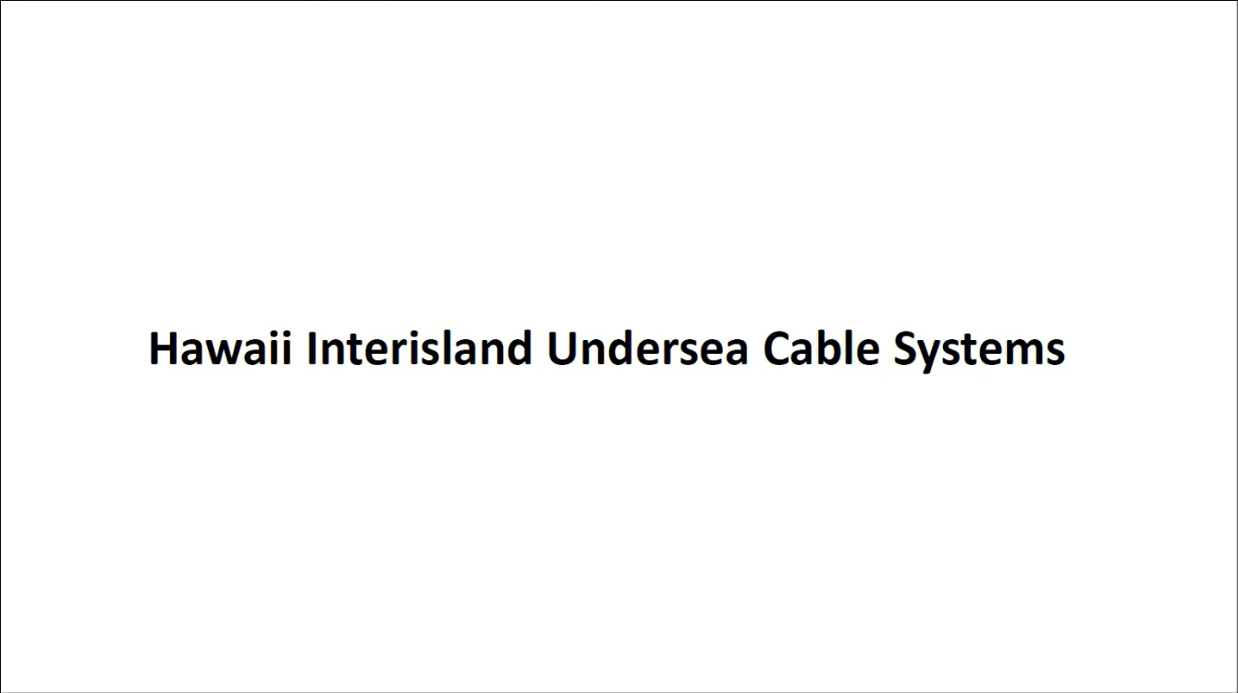
Shawn Kuratani introduced Wayne Hirasa as the presenter who has over 30 years of experience at Hawaiian Telcom and 16 years at Sandwich Isles Communications. He added that the presentation will cover how the Hawaii interisland undersea cable systems project may affect the PSAPs.

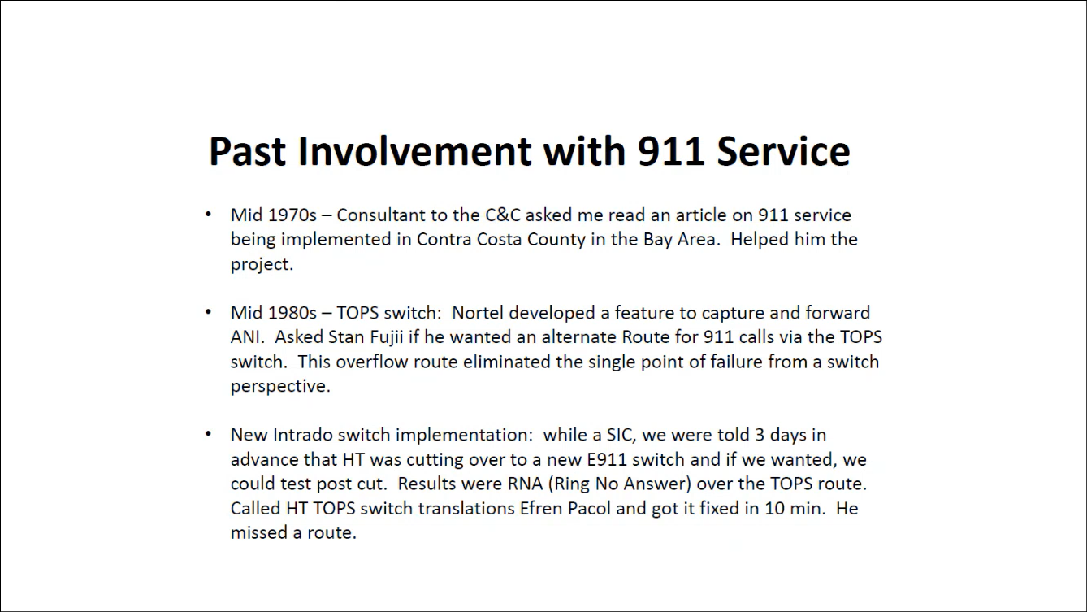
Wayne Hirasa stated each bullet point from the slide above regarding his past involvement with 911 services.

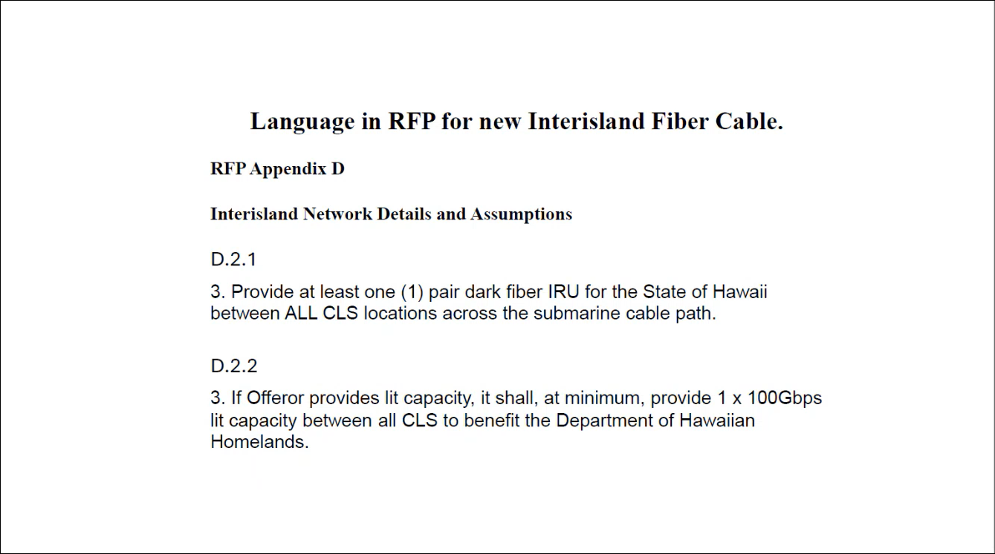
Wayne Hirasa stated that the slide above highlights his involvement with the Broadband Hui. He referenced item D.2.1 from the slide above and stated that this language appears in both RFPs for 2 new interisland fiber cable systems.

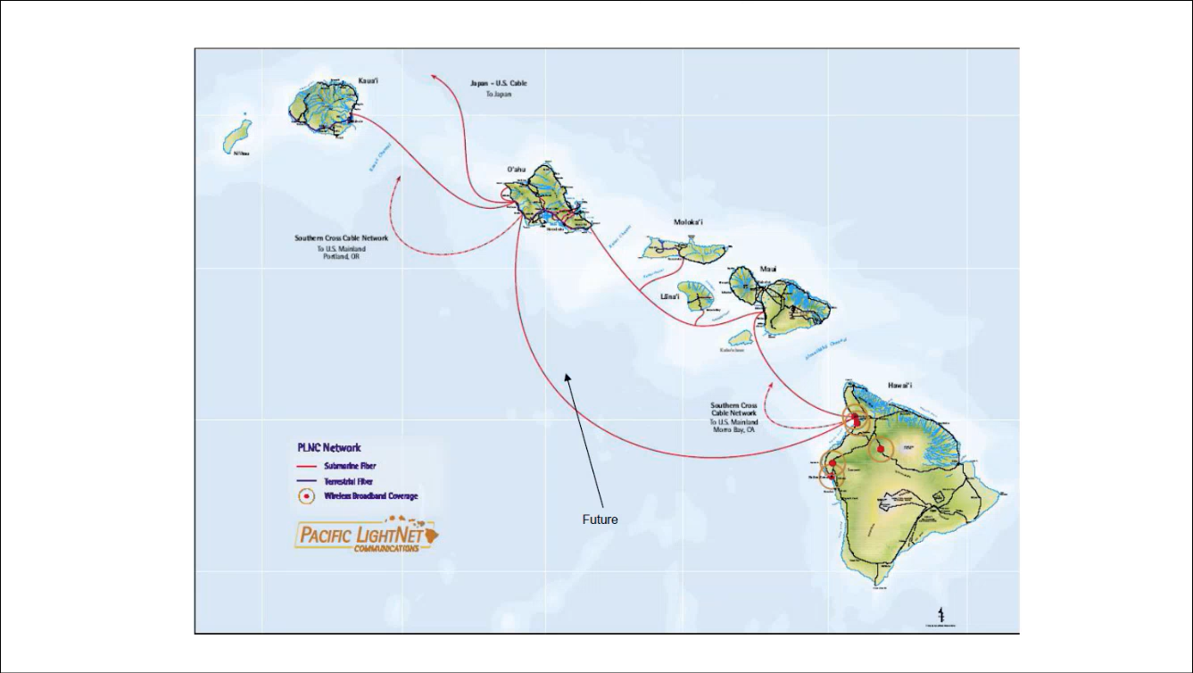
Wayne Hirasa stated that the slide above showcases the older PLNC cable system.

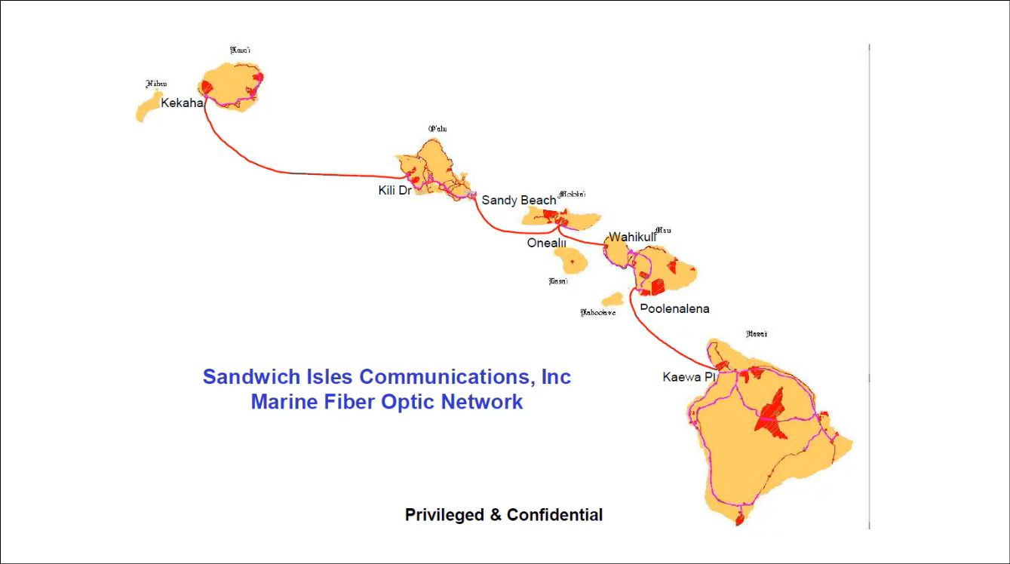
Wayne Hirasa stated that the slide above showcases the Sandwich Isles Communications cable system. He added that he was involved with the development of this cable system during his time at Sandwich Isles Communications. Furthermore, this cable system does not include Lanai.

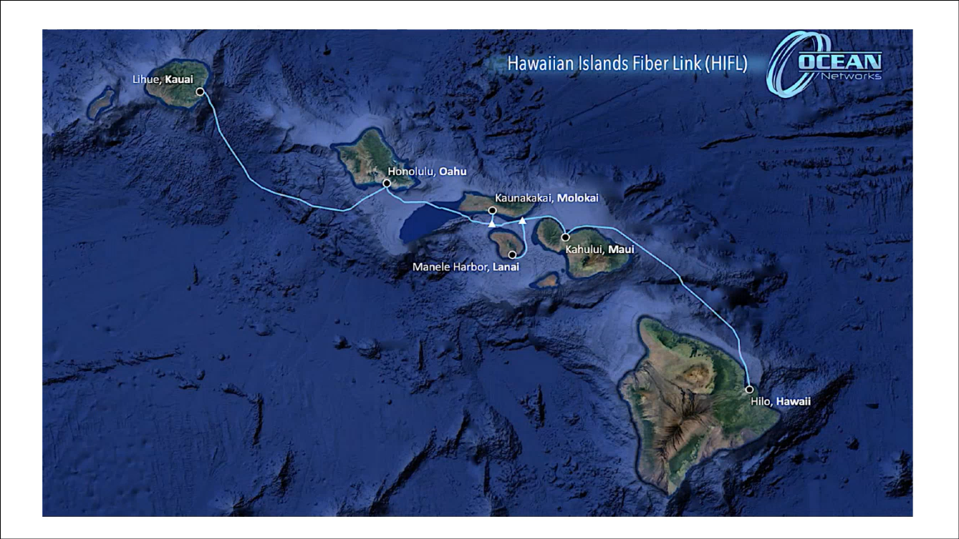
Wayne Hirasa stated that the slide above showcases the Ocean Networks cable system.

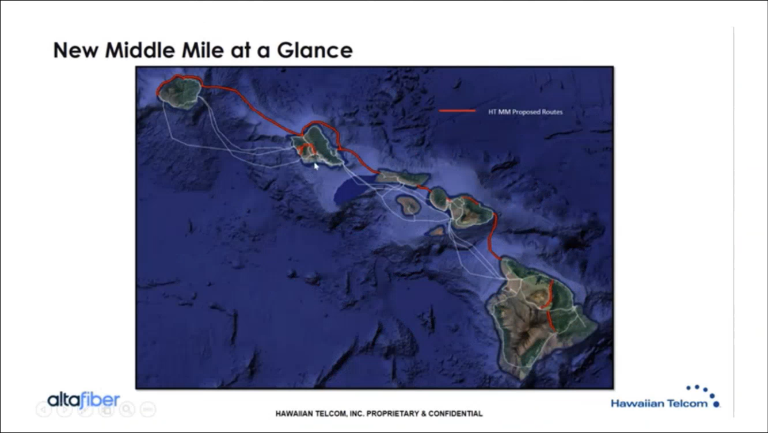
Wayne Hirasa stated that the slide above showcases the Hawaiian Telcom cable system.


Wayne Hirasa posed the question whether or not Hawaii’s 911 network has access to the 2 dark fiber RFPs mentioned earlier in this presentation. He added that Hawaii’s 911 network at a minimum could gain 2 path diversity and a maximum of 4 path diversity based on the cable systems mentioned in the slide above.

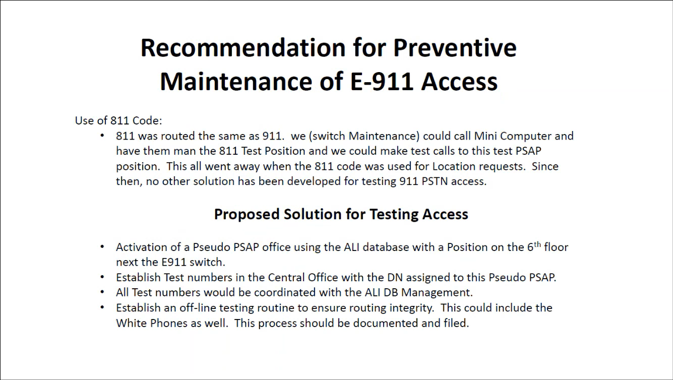
Wayne Hirasa stated that he utilized 811 during his past involvement with 911 services to test and troubleshoot calls, which has since been repurposed. He proposed to reinstate a solution similar to 811 for the purpose of testing and troubleshooting calls to ensure route integrity.

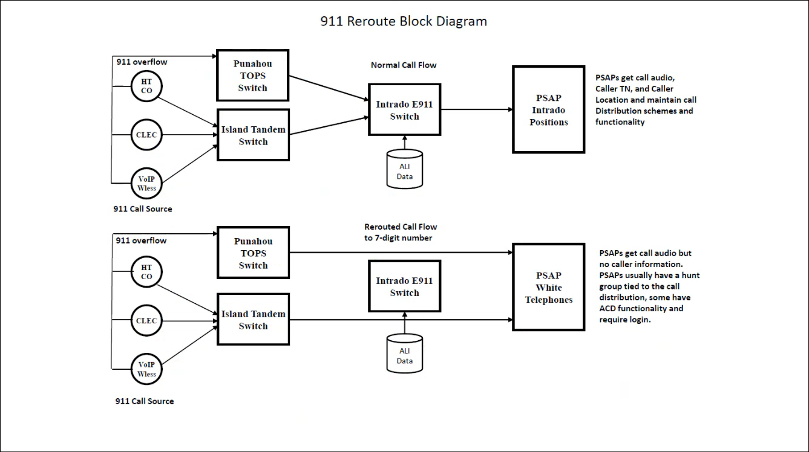
Wayne Hirasa stated that the slide above displays both the normal call flow and re-routed call flow for 911 calls.

Wayne Hirasa volunteered himself to spearhead the initiative to seek access to either or both of the 2 dark fiber RFPs mentioned previously for the purpose of attaining route diversity and redundancy. Corey Shaffer commented that the 911 Board will instead most likely pursue service level agreements with Hawaiian Telcom and Intrado to address any network diversity and/or redundancy requirements.

      - Advisory Committee – Rebecca Lieberman
        - No Updates

  - Finance Committee – Edward Fujioka
    - Review of Monthly Y-T-D (Year to Date) Cash Flow
August 2025 Cashflow Statement:

Surcharge Collection: $1,046,807
Interest Income: $114,874
Total Receipts: $1,161,682
Total Disbursements: ($109,579)
Net Receipts/Disbursements: $1,052,102
Net Encumbrances Adds/(Paydown): ($36,699)
Net Cash Inflow/(Outflow): $1,015,404
Outstanding Encumbrances: $14,783,106
Net Bank Balance: $49,911,788
Unencumbered Cash Balance: $35,128,682

    - Executive Director Requesting $83,480.00 Payment Release for Mission Critical Partners Next Generation 9-1-1 Readiness Assessment & Cost Analysis
Edward Fujioka stated the item above and requested an explanation. The Executive Director explained that this request is to obtain conditional approval to release payment subject to receipt and satisfactory review of final versions for both the readiness assessment and cost analysis. He added that this is to avoid processing a second extension since the contract expires on 9-30-2025. Edward Fujioka asked the Executive Director if the original invoice amount had changed or not. The Executive Director responded stating that the pricing has remained the same. Edward Fujioka asked for a motion to approve. Tony Velasco motioned to approve this request. Matthew Kurihara seconded the motion. A voice vote was taken, motion was unanimously approved.

    - Department of Information Technology Requesting $3,256.02 for NENA 2025 Conference Attendees
Edward Fujioka stated the item above and requested an explanation. The Executive Director explained that this request was encumbered previously but inadvertently returned. Stephen Courtney motioned to approve this request. Liz Gregg seconded the motion. A voice vote was taken, motion was unanimously approved.

    - Hawaii Police Department Requesting $2,025.98 for NENA 2025 Conference Attendees
Edward Fujioka stated the item above and requested an explanation. The Executive Director explained that this request is caused by an overage due to budget misinterpretation by the agency. He provided a reminder that each agency’s budget shows the maximum cost of $5,000.00 per traveler via the travel policy since the conference locations may change each year and it is the agency’s responsibility to budget accordingly after the conference location is determined. Tony Velasco motioned to approve this request. Stephen Courtney seconded the motion. A voice vote was taken, motion was unanimously approved.

    - Honolulu Police Department Requesting $535.61 for NENA 2025 Conference Attendees
Edward Fujioka stated the item above and requested an explanation. The Executive Director explained that this request is caused by an overage due to budget misinterpretation by the agency. He provided a reminder that each agency’s budget shows the maximum cost of $5,000.00 per traveler via the travel policy since the conference locations may change each year and it is the agency’s responsibility to budget accordingly after the conference location is determined. Stephen Courtney motioned to approve this request. Tony Velasco seconded the motion. A voice vote was taken, motion was unanimously approved.

- Public Service Answering Point Status Updates on Recruitment and other Personnel Issues
  - Kauai Police Department – Andrew Muraoka
    - Update on Recruitment Process/Strategies and Personnel Training
Andrew Muraoka stated that they hired 1 former dispatcher and call takers on a contract basis. He added that they are planning to conduct another call taker class to assist with vacancies and staffing shortages.

    - Update on Personnel Issues and Vacancies
Andrew Muraoka stated that they currently have a ~50% vacancy rate.

  - Oahu Police Department – Matthew Kurihara
    - Update on Recruitment Process/Strategies and Personnel Training
Matthew Kurihara stated that they currently have 5 trainees and are planning to start another training class with 5 potential trainees. He added that they hired 2 former dispatchers on a contract basis. Furthermore, he mentioned that they provided refresher training for 7 dispatchers that became officers to assist with vacancies and staffing shortages.

    - Update on Personnel Issues and Vacancies
Matthew Kurihara stated that they currently have a ~34% vacancy rate.

  - Oahu Fire Department – Shawn Kuratani
    - Update on Recruitment Process/Strategies and Personnel Training
Shawn Kuratani stated no updates.

    - Update on Personnel Issues and Vacancies
Shawn Kuratani stated that they are currently fully staffed.

  - Oahu Emergency Medical Services – Lorrin Okumura, Diana Chun, Frannie Chung
    - Update on Recruitment Process/Strategies and Personnel Training
Lorrin Okumura stated that they conducted open recruitment and received 2 applicants from the mainland who are pending interviews. He added that the EMD academy is going well.

    - Update on Personnel Issues and Vacancies
Lorrin Okumura stated no updates.

  - Maui Police Department – Davlynn Racadio
    - Update on Recruitment Process/Strategies and Personnel Training
Melia Johnson on behalf of Davlynn Racadio stated that they are planning to start a training class in December 2025 with 21 trainees. She added that they have 1 potential hire from the mainland who is currently a dispatcher. Furthermore, she mentioned that they hired 1 former dispatcher.

    - Update on Personnel Issues and Vacancies
Melia Johnson on behalf of Davlynn Racadio stated no updates.

  - Molokai Police Department – Davlynn Racadio
    - Update on Recruitment Process/Strategies and Personnel Training
Please see updates under Maui Police Department.

    - Update on Personnel Issues and Vacancies
Please see updates under Maui Police Department.

  - Hawaii Police Department – Zachary Fernando
    - Update on Recruitment Process/Strategies and Personnel Training
The Executive Director on behalf of Zachary Fernando stated that they have 2 trainees who started in September 2025. He added that they continue to conduct continuous recruitment.

    - Update on Personnel Issues and Vacancies
The Executive Director on behalf of Zachary Fernando stated that they currently have a ~44% vacancy rate. He added that 1 personnel will resign.

  - Hawaii Fire Department – Stacy Domingo
    - Update on Recruitment Process/Strategies and Personnel Training
Stacy Domingo stated that 8 out of 38 total candidates accepted interviews, which will take place next week.

    - Update on Personnel Issues and Vacancies
Stacy Domingo stated that they currently have 9 out of 24 total positions filled.

Stephen Courtney asked the PSAPs if they are able to provide each of their vacancy rates during the monthly updates for tracking purposes. There was no objection from the PSAPs.

- Items for Discussion, Consideration, and Action
  - Additional Items Proposed by Meeting Attendees

- Announcements
  - Future Virtual Meeting Dates/Times (9:00AM-12:00PM)
    - Thursday, October 9, 2025 (Combined Meeting)
    - Thursday, November 13, 2025 (Combined Meeting)

  - Future Conference Dates (3 Months of Advanced Approval Required)

  - Additional Announcements from Meeting Attendees

- Open Forum: Public comment on issues not on the Board Meeting Agenda
There was no public comment on issues not on the agenda.

- Adjournment
Board Chair requested a motion to adjourn the meeting. Tony Ramirez motioned to adjourn the meeting. Francis Alueta seconded the motion. A voice vote was taken, adjournment was unanimously approved. The meeting was adjourned.

