JOSH GREEN, M.D.  GOVERNOR  Ke Kiaʻāina |  | KEITH A. REGAN  COMPTROLLER  Ka Luna Hoʻomalu Hana Laulā  MEOH-LENG SILLIMAN  DEPUTY COMPTROLLER  Ka Hope Luna Hoʻomalu Hana Laulā
STATE OF HAWAIʻI | KA Mokuʻāina o Hawaiʻi

DEPARTMENT OF ACCOUNTING AND GENERAL SERVICES | KA ʻOihana LOIHELU A LAWELAWE Laulā
P.O. BOX 119, HONOLULU, HAWAII 96810-0119

Communications, Technical, and Finance Meeting
(Combined Meeting)

Thursday, August 14, 2025
9:00 am – 12:00 pm

Virtually Held Meeting with Physical Location at
Kalanimoku Building Room 426, 1151 Punchbowl Street, Honolulu, Hawaii 96813 is available to the public and is guaranteed to be connected to the remote virtual meeting.

MEETING MINUTES

August 14, 2025: Joint Committee and Board Meeting (youtube.com)

Communications Committee Members Present: Davlynn Racadio (MPD), Ah Lan Leong (HPD)

Communications Committee Members Not Present: Lavina Taovao (KPD)

Technical Committee Members Present: Stacy Domingo (HIFD), Tony Ramirez (V2X), Tony Velasco (DIT)

Technical Committee Members Not Present: Shawn Kuratani (HFD), Thalia Burns (APCO/NENA), David Miyasaki (KPD), Kenison Tejada (FirstNet)

Finance Committee Members Present: Stephen Courtney (C&C of Honolulu), Liz Gregg (AT&T), Matthew Kurihara (HPD), Reed Mahuna (HIPD), Todd Omura (CIO Designee), Tony Velasco (DIT)

Finance Committee Members Not Present: Edward Fujioka (EMS)

Staff: Royce Murakami (911 Board), Benson Leung (911 Board), Stella Kam (AG)

Guests: Maileann Ah Mook Sang-Frank (RDC), Francis Alueta (HT), Brian Boezeman (Intrado), Christian Burns (HT), Frannie Chung (EMS), Ruth Cruz (Intrado), Carla Even (RapidSOS), Zachary Fernando (HIPD), Marisa Fujimoto (HT), Buck Giles (OS), Sherri Griffith Powell (Mission Critical), Melia Johnson (MPD), David Jones (Mission Critical), Stella Kam (AG), Ji Sook Kim (Consumer Advocate Designee), Michelle Kratel (HIPD), Mike Lambert (DLE), Patrick Leddy (LCC), Rebecca Lieberman (Spectrum), Brian McKee (DIT), Jackie Mines (Mission Critical), Robert Mohr (Exacom), Andrew Muraoka (KPD), Tamera Neal (Intrado), Gregg Okamoto (MPD), Lorrin Okumura (EMS), Stacy Perreira (KPD), Jeff Reeve (AT&T), Megan Reilly (EagleView), Ernest Robello (DLE), Justin Rodino (RapidSOS), Corey Shaffer (Verizon), Calvin Sung (HPD), Keola Tom (MPD)

- Call to Order, Public Notice
The meeting was called to order by the Board Chair. Public notice was given.

- Public Testimony Will Be Taken on All Agenda Items as Those Items Occur During the Meeting

- Roll Call, Quorum
A roll call was taken, quorum was present for all committees except the Technical Committee.

- Review and Approval of July Meeting Minutes
Board Chair requested a motion to approve July’s Meeting Minutes. Tony Ramirez motioned to approve July’s Meeting Minutes. Stephen Courtney seconded the motion. A voice vote was taken, motion was unanimously approved.

- Committee Updates by Committee Chairs
  - Communications Committee – Davlynn Racadio
    - Statewide 9-1-1 Outage on 6-5-2025
Davlynn Racadio requested an update from Corey Shaffer regarding the item above.

Corey Shaffer stated that Verizon customers began experiencing disruptions to 911 service on 6-5-2025 at 6:23am HST and calls during early onset were re-routed by Verizon’s wireless network management center to the PSAP’s administrative lines without ANI/ALI. Also, Zachary Fernando notified him that callbacks initiated by the PSAP were failing. Corey Shaffer explained that the outage was caused by the following events below:
- A fiber cut to one of Verizon’s links in California due to vandalism, which was repaired by AT&T after 7 hours and 24 minutes.
- The secondary backup route for bearer traffic maintained its connection but the SS7 signaling did not function properly due to a card failure. He added that Verizon has adjusted its automation to detect not only primary link failure but also signaling link failure as well.
- Verizon’s third backup route did not have enough capacity for TDM and 911 calls since they were both sharing this option and is not sized to handle this amount of traffic.

Stephen Courtney asked Corey Shaffer why did a failure in California impact Hawaii. Corey Shaffer responded stating that call delivery signaling for all wireless carriers in Hawaii is facilitated by infrastructure in the mainland. He added that this outage had no relation to the undersea cables, which are deemed reliable.

    - Maui County Issues with 9-1-1 Calls on 7-23-2025
Davlynn Racadio requested an update from Melia Johnson regarding the item above.

Melia Johnson stated that there were a range of issues from dropped calls, one-way audio issues resulting in callers unable to hear the call takers, and calls from hotels/businesses being routed to Northern911 or Viiz Communications. She added that they were keeping track of the Intrado printouts and the cases, which led them to discover that the call could function normally when the call taker initiated a callback. She mentioned that during a night shift there were 26 calls in a row that experienced one-way audio issues with 808-911-0510 as the caller ID. She stated that the issues appear to be resolved now after working with Hawaiian Telcom and Marisa Fujimoto.

Marisa Fujimoto stated that the one-way audio issues were caused by Hawaiian Telcom’s K-37 and this was resolved by rebuilding the cross connects. She mentioned that Hawaiian Telcom found out about Bandwidth.com routing Maui County’s 911 calls to the national call centers roughly a week or so later. She stated that test calls were conducted yesterday and the call routing issue has been resolved. Melia Johnson concurred with Marisa Fujimoto.

    - Update from Oahu PSAPs regarding Viper 7 Upgrade
Davlynn Racadio requested an update from Ah Lan Leong regarding the item above.

Ah Lan Leong stated that the Oahu PSAPs attended a go/no-go meeting with Hawaiian Telcom and Intrado on 7-29-2025 and they decided to not proceed with the Viper 7 upgrade this month primarily due to the SCC being incapable of showing sectors for wireless phase one calls. She mentioned that they opened an inquiry ticket in March 2025 to address the aforementioned issue. During the meeting, Intrado stated that the feature is not supported at this time and it would have to be a formal feature request, which would take a minimum of 6 months to implement. Additionally, Intrado mentioned that none of their other existing customers utilized phase one. Ah Lan Leong stated that they will not be a part of the September 2025 cutover for this reason and will be eyeing dates in 2026. She then mentioned another concern regarding wireless phase two confidence levels, which have not been tested yet. Davlynn Racadio stated that the former was one of the reasons why Maui did not proceed with the Viper 7 upgrade in March 2024. She added that there is a follow-up meeting with Hawaiian Telcom and Intrado later today to discuss the results from the meeting held on 7-29-2025. Corey Shaffer asked Tony Ramirez when this meeting will take place. Tony Ramirez responded stating that it will start shortly after the 911 Board meeting today. Corey Shaffer and Tony Ramirez agreed to provide an update regarding this matter during next month’s 911 Board meeting.

Marisa Fujimoto mentioned that the aforementioned 6-month timeframe seems to be based on Intrado’s pending workload. She added that Intrado will most likely reassess their current workload to prioritize resolving the issues raised by the PSAPs above since the no-go decision was rendered. She stated that Hawaiian Telcom fully supports the PSAPs’ decision to not move forward until the issues are resolved. Tamera Neal confirmed that the forthcoming meeting will be to discuss the current state, any concerns or questions, and how to progress forward. Tony Ramirez stressed the importance of phase one calls given Hawaii’s remote terrain/locations and not every call is wireless phase two.

Marisa Fujimoto stated that a resolution was rolled out to Kauai a few weeks ago and to Big Island this past week to address the wireless phase two call issue. She then asked Stacy Domingo if this issue was resolved or not. Stacy Domingo responded stating that it has been resolved.

  - Technical Committee – Shawn Kuratani
    - No Updates

      - Advisory Committee – Rebecca Lieberman
        - Updates on Legislative Session
Rebecca Lieberman stated no updates.

  - Finance Committee – Edward Fujioka
    - Review of Monthly Y-T-D (Year to Date) Cash Flow
July 2025 Cashflow Statement:

Surcharge Collection: $1,003,189
Interest Income: $113,629
Total Receipts: $1,116,818
Total Disbursements: ($20,542)
Net Receipts/Disbursements: $1,096,276
Net Encumbrances Adds/(Paydown): ($615,802)
Net Cash Inflow/(Outflow): $483,543
Outstanding Encumbrances: $14,819,805
Net Bank Balance: $48,896,384
Unencumbered Cash Balance: $34,076,579

- Review of Mission Critical Partners Draft Report
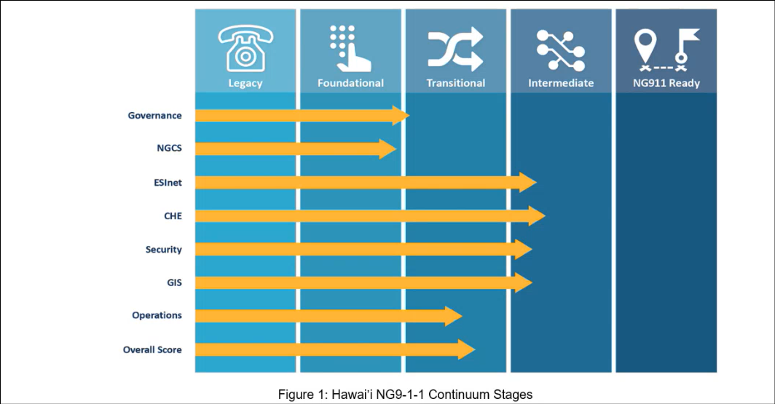
Sherri Griffith Powell stated that the slide above represents Mission Critical Partners’ (“MCP”) current readiness assessment of Hawaii regarding NG911 across various components. She added that it will take approximately 2 years to connect the originating service provider (“OSP”) to the core service provider via SIP after each of the components above have reached the “NG911 Ready” column. She mentioned that the majority of MCP’s recommendations if not all should be implemented to ensure successful transition to NG911.

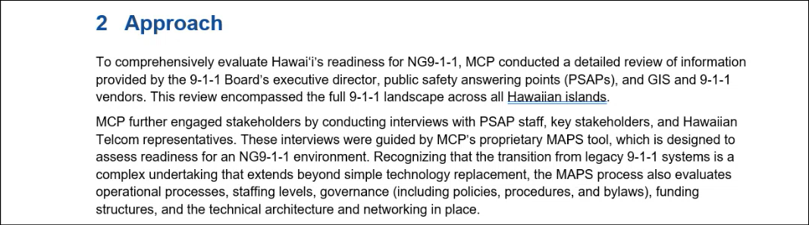
Sherri Griffith Powell reiterated that MCP discussed in detail with the PSAPs, Hawaiian Telcom, Intrado, V2X, and the 911 Board staff to produce this assessment and recommendations.

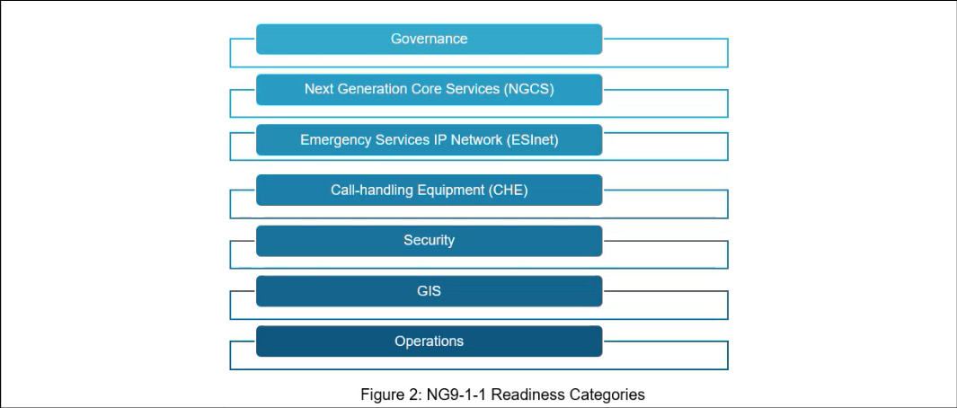
Sherri Griffith Powell stated that the aforementioned conversations with applicable stakeholders revolved around the categories shown in the slide above.

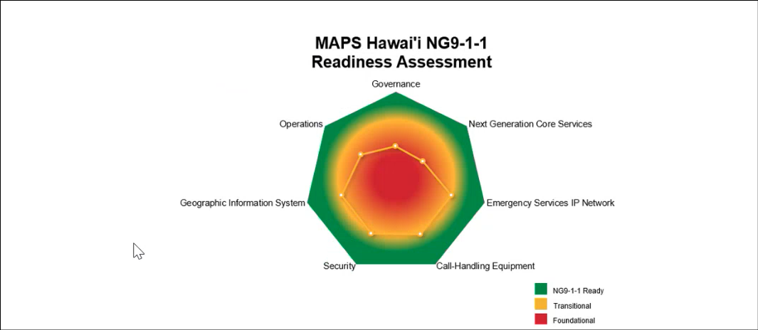
Sherri Griffith Powell stated that the slide above depicts the current assessment for each of Hawaii’s NG911 readiness components.

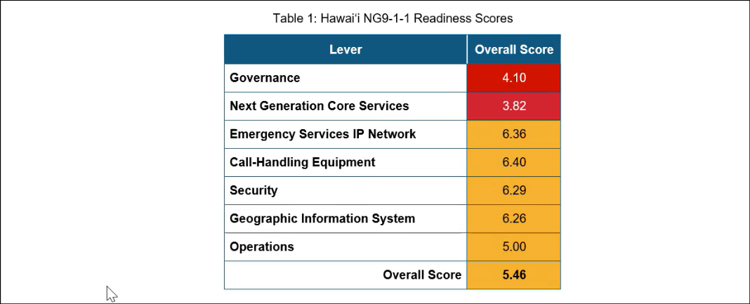
Sherri Griffith Powell stated that the slide above provides a numerical score for each of Hawaii’s NG911 readiness components. She added that these scores range from 1 to 10 with 10 representing fully implemented NG911.

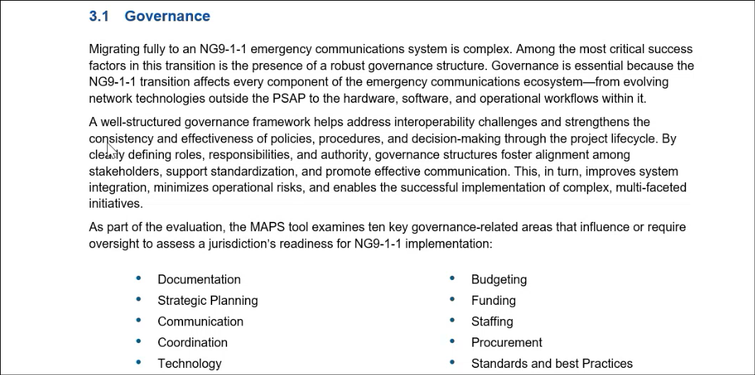
Sherri Griffith Powell highlighted the governance section to convey a distinction that the most successful NG911 implementations involve a prevalent state government presence, which does not have to be authoritarian but instead is supportive and not limited to only being a funding source. She added that it is not mandatory for Hawaii to amend its current legislation and/or alter the existing governance structure to ensure NG911 transition. Furthermore, MCP’s recommendations are based on best practices, industry standards, and their past experiences.

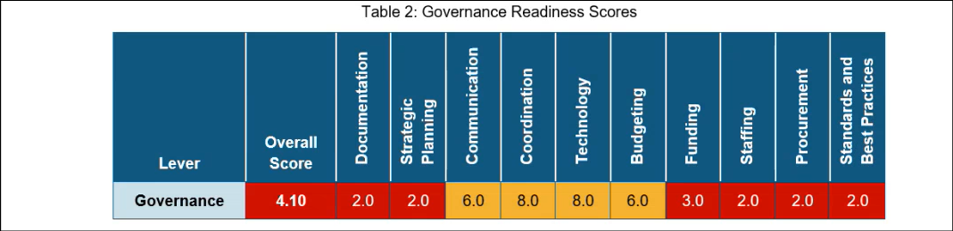
Sherri Griffith Powell stated that Hawaii scored well in the following governance related categories: communication, coordination, technology, and budgeting due to its active board participation along with the defined committees/subcommittees that maintain strong collaboration with one another. She then explained the difference between budgeting and funding in which the latter consists of creating a stable and sustainable structure to support ongoing costs of NG911. Tony Ramirez asked Sherri Griffith Powell if MCP’s report identifies these aforementioned costs and provides recommendations for funding purposes if a surcharge increase is warranted. Sherri Griffith Powell responded stating that there is a forthcoming report which provides details, information, and recommendations regarding cost analysis. Sherri Griffith Powell asked Corey Shaffer how the 911 Board’s funds are distributed. Corey Shaffer responded stating that the distribution of funds is based on the aggregate requests and availability/sustainability. Tony Ramirez added that the tariff solely covers wireline charges and the wireless plus VoIP fees are provided via surcharge collection.

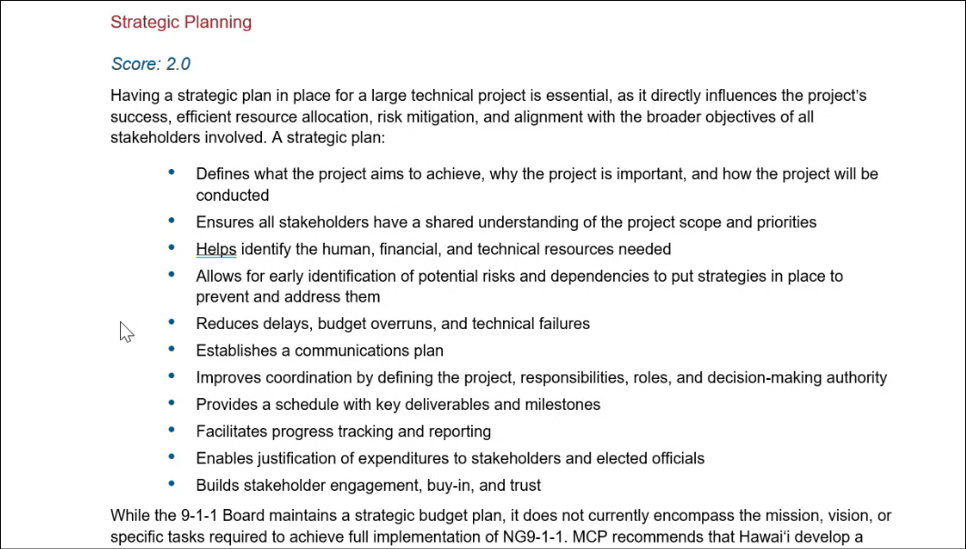
Sherri Griffith Powell mentioned that Hawaii should expand its statewide strategic plan to include aspects such as operational, technical, goals, and a NG911 transition roadmap since it currently only covers financial plus budgeting.

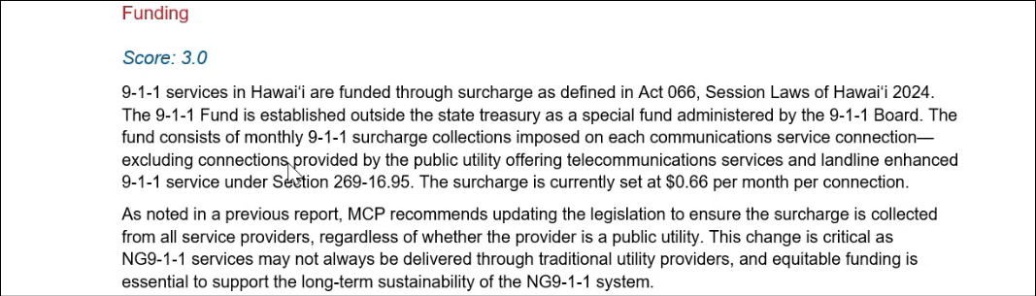
Tony Ramirez asked Sherri Griffith Powell if MCP could provide comparative data and figures regarding surcharge rates after NG911 transition from other states that are similar in population size and call volume as Hawaii. Sherri Griffith Powell responded stating that they will provide the requested information and noted the added costs of shipping due to Hawaii being a remote location. She added that MCP concurs with a previous report provided to the 911 Board that it should update the legislation to ensure surcharge collection is received from all service providers.

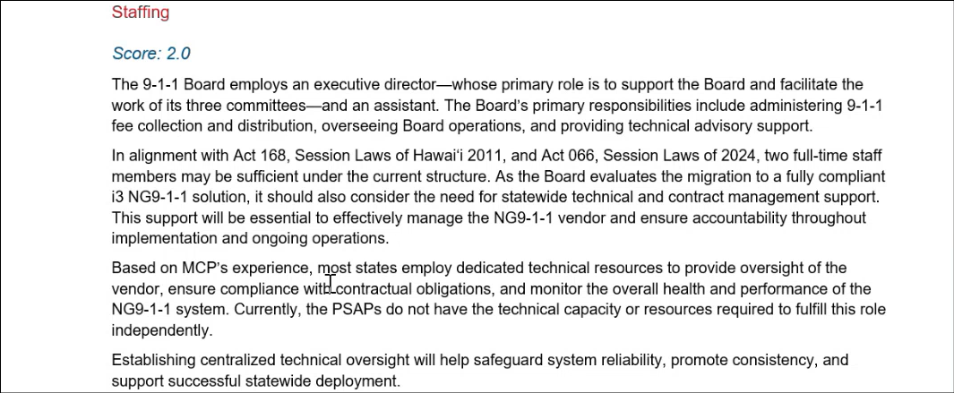
Sherri Griffith Powell stated that it would be beneficial if the 911 Board staff could provide technical support for the PSAPs.

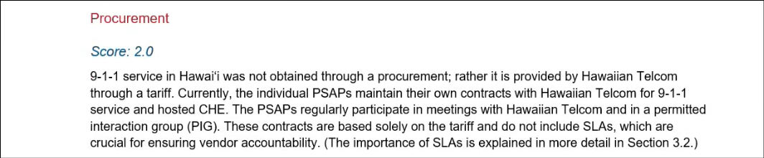
Sherri Griffith Powell mentioned that procurement is conducted through the PSAPs and not on a statewide level. She stated that these contracts should have defined service level agreements (“SLA”) that include expectations, penalties, etc. Corey Shaffer mentioned that the PSAPs rely heavily on Hawaiian Telcom as the primary source for technical knowledge and information. Corey Shaffer asked Sherri Griffith Powell how many states hire support staff versus utilize the service provider or vendor to provide technical expertise. Sherri Griffith Powell responded stating that the majority of states maintain technical staff to ensure the vendors are meeting their contract requirements and for troubleshooting incidents (e.g. outages). She added that other states hire a third party to assess vendors.

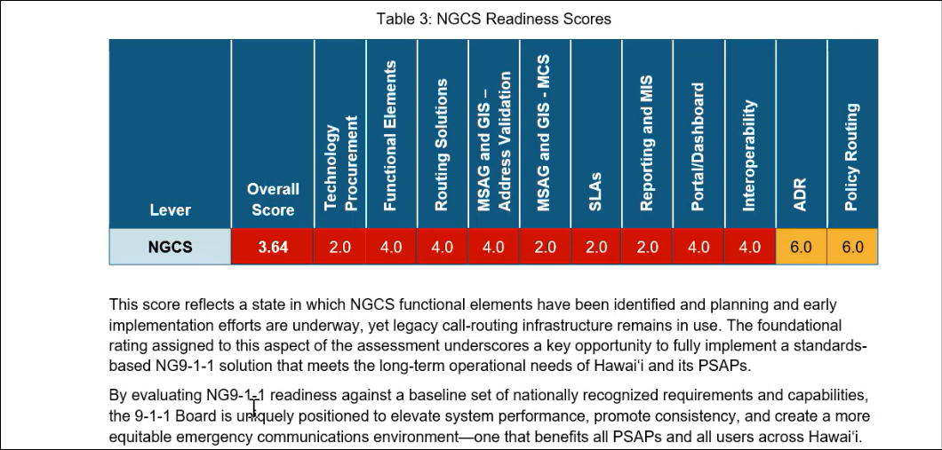
Sherri Griffith Powell stated that the term NG911 hybrid solution is used because the services will be split between the mainland and Hawaii. She added that the usage of the term hybrid does not indicate a lower level of service but rather it is how Intrado references it. Brian Boezeman concurred with Sherri Griffith Powell. He added that call routing decisions will be processed in the mainland and voice will be based in Hawaii. Corey Shaffer stated that the wireless carriers will have their 911 SIP interconnection from the mainland and may need to order additional facilities to connect back. He added that connecting directly to Intrado in the mainland could result in fewer components and has the potential for increased reliability. Furthermore, he mentioned that network reliability might increase if the local and mainland service providers connect to their own respective regions. Tony Ramirez mentioned that the regulatory environment governing the PSAPs will change upon NG911 transition to FCC due to interstate involvement versus the current PUC governance under Hawaiian Telcom. Sherri Griffith Powell added that there is an FCC report regarding OSP migration, which is a part of their oversight.

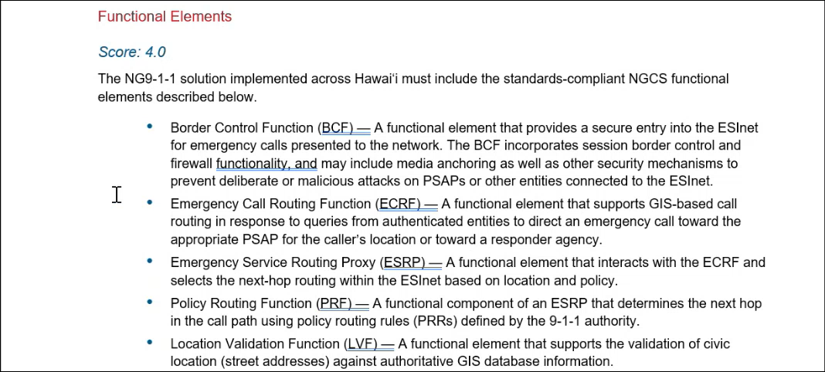
Sherri Griffith Powell stated that the slide above defines the functional elements within Next Generation Core Services (“NGCS”).

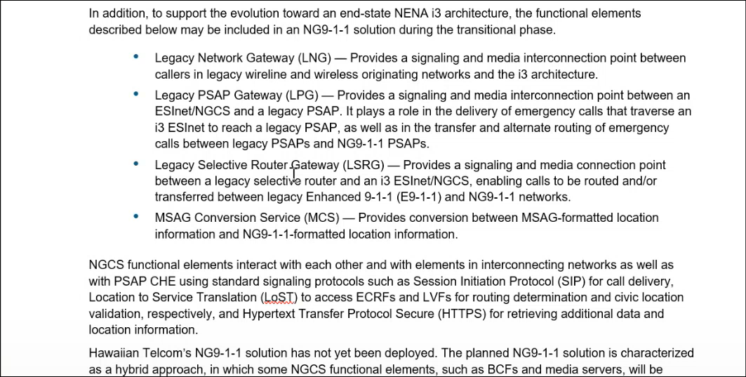
Sherri Griffith Powell stated that the slide above details the legacy and/or transitional elements required for NG911 transition. She reiterated that Hawaii’s NG911 solution is a hybrid approach since functional elements such as border control and media servers will be located in Hawaii while the majority of components are hosted in the mainland.

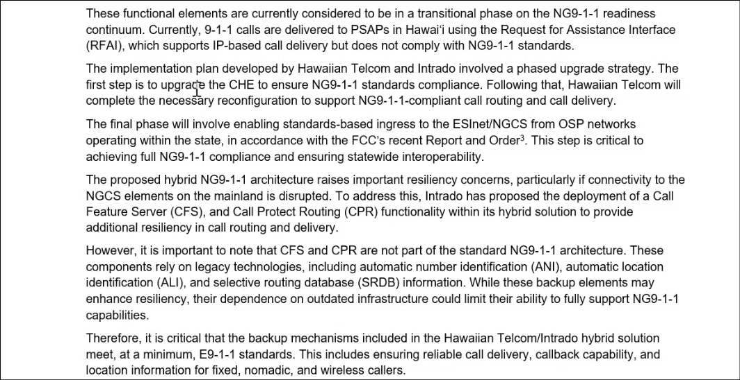
Sherri Griffith Powell stated that Hawaii currently has a transitional state of NG911 from Intrado using the Request for Assistance Interface (“RFAI”) which supports IP based call delivery but does not meet all the i3 standards. She added that Intrado offers i3 service to assist with Hawaii’s transition.

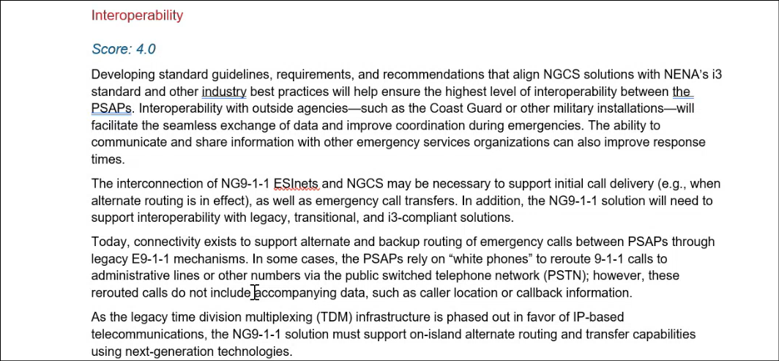
Sherri Griffith Powell stated that MCP’s recommendation is to have session border controllers (“SBC”) on each of the islands since it is related to the ESInet and interoperability.

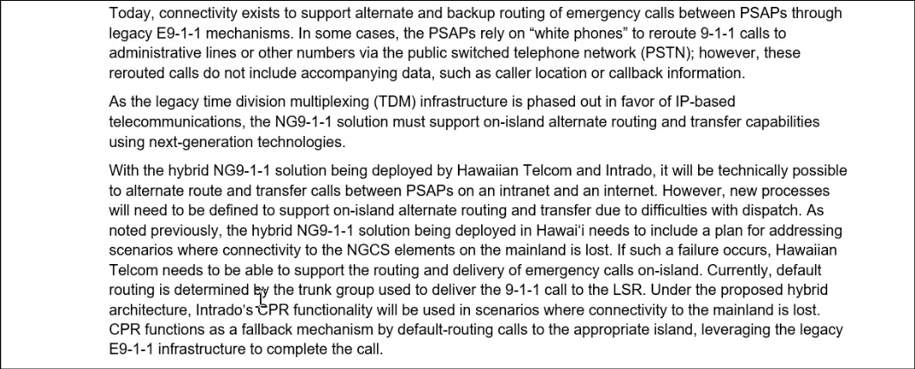
Sherri Griffith Powell stressed the importance of ESInet interconnectivity for situations such as an outage to divert and route calls amongst the islands. She added that this is subject to the operational agreements and ability to dispatch for other islands.

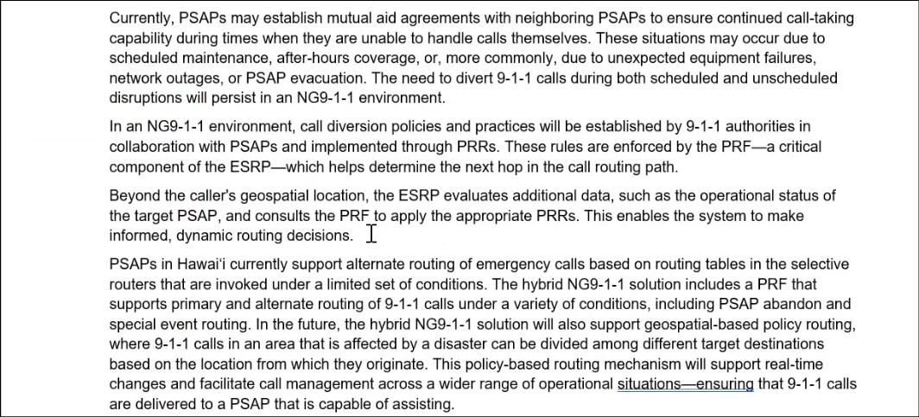
Sherri Griffith Powell stated that ESInet interconnectivity for Hawaii is only within the state given its remote location. She added that this differs from the definition of true end state i3 since the mainland is able to connect with all the other states. Furthermore, she stated that Hawaii will need to be interconnected with the military, coast guard, etc.

Francis Alueta asked Sherri Griffith Powell if each island should have its own ESInet or does the state utilize a single ESInet. Sherri Griffith Powell responded stating that it will be a single ESInet.

Corey Shaffer asked Davlynn Racadio if the islands have the ability to dispatch for each other during an outage. Davlynn Racadio responded stating that Maui does not have this capability currently. Tony Ramirez added that they have the ability to provide statewide GIS to each of the islands but mentioned that the radio dispatch system would require proper setup. Sherri Griffith Powell stated that other PSAPs are able to enter 911 call data into the CAD for dispatch purposes and then route it to the appropriate PSAP through the CAD to CAD interface, which is the vision for end state NG911. She added that this could have been helpful during the Lahaina fires to aid call taking and dispatching. Tony Ramirez mentioned that Maui was able to process majority of the 911 calls aside from the affected burn area in Lahaina. Davlynn Racadio concurred with Tony Ramirez. Sherri Griffith Powell referenced the Verizon outage discussed during the Communications Committee and stated that an interconnected ESInet could have helped alleviate this situation.

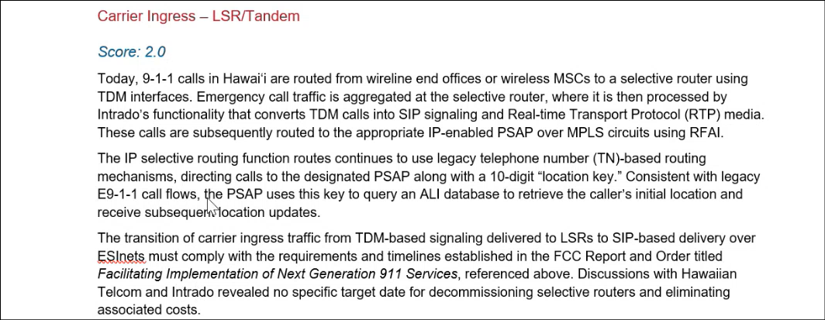
Sherri Griffith Powell stated that after ESInet setup and usage of Intrado’s i3 version of core services takes place then the next focus will be carrier ingress.

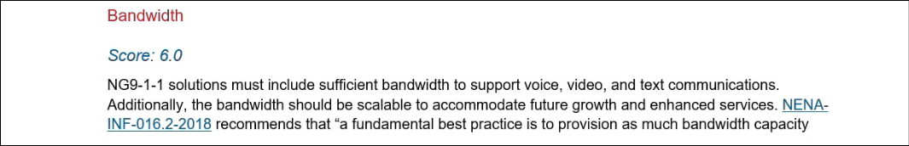
Sherri Griffith Powell recommended that Hawaii should evaluate its last mile connections and confirm the ability to scale up for potential options such as accepting photos/videos and/or cloud-based call handling equipment since it requires a significantly larger last mile connection as compared to an average PSAP.

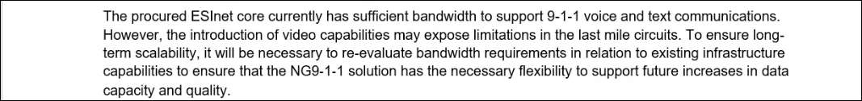
Francis Alueta asked Sherri Griffith Powell if MCP and/or NENA are able to provide guidance on the estimated bandwidth required. Sherri Griffith Powell responded stating that the current bandwidth is sufficient but the introduction of accepting videos may expose limitations, which requires evaluation from both Hawaiian Telcom and Intrado. She added that she will follow up with the MCP team regarding this question.

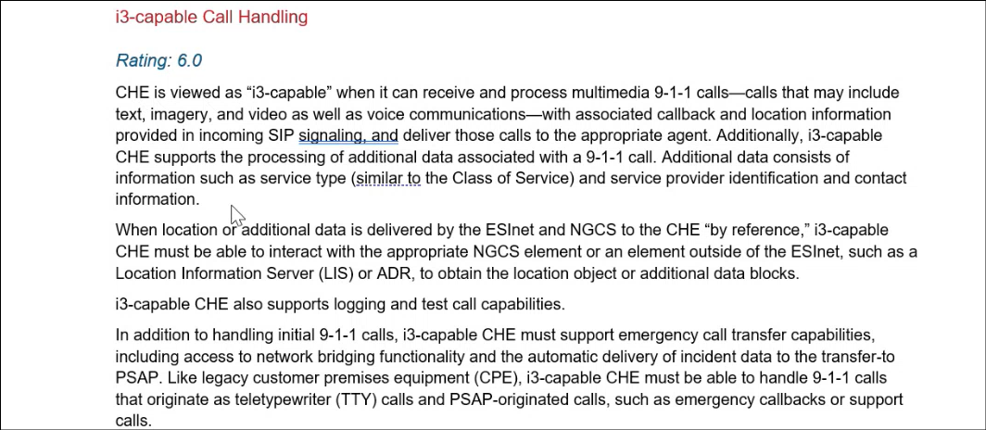
Sherri Griffith Powell stated that i3 capable call handling is defined as the ability to receive and process multimedia plus other capabilities mentioned above. She added that NENA is still working on the PSAP standard, which has not been released yet. Francis Alueta asked Sherri Griffith Powell to clarify the definition of i3 capable. Sherri Griffith Powell responded stating that i3 capable is when the call handling equipment has the ability to receive and process multimedia 911 calls. She added that the i3 capable call handling assessment score will improve post Viper upgrade and implementation.

Sherri Griffith Powell mentioned that MCP does not mandate any PSAP to accept videos. She added that other PSAPs have the option to accept videos without the call taker required to view it. Furthermore, she stated that the PSAPs should make these decisions.

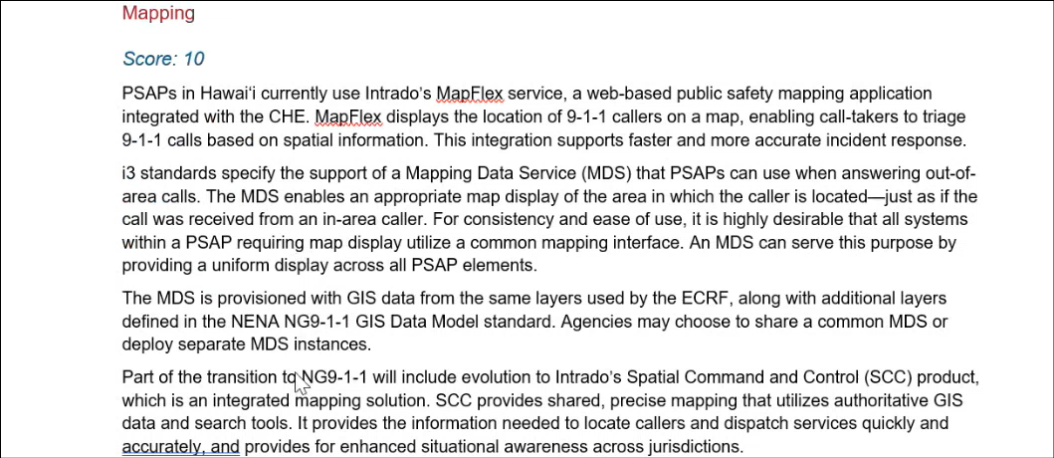
Marisa Fujimoto stated that MapFlex is server-based and SCC is web-based. Brian Boezeman concurred with Marisa Fujimoto. Sherri Griffith Powell asked Brian Boezeman if Intrado is using MapFlex. Brian Boezeman responded stating that the existing Viper system uses MapFlex while SCC is associated with Viper 7. Tony Ramirez added that Hawaii currently maintains a hybrid system with two islands using MapFlex and the other two islands on SCC. Sherri Griffith Powell stated that she will make the correction.

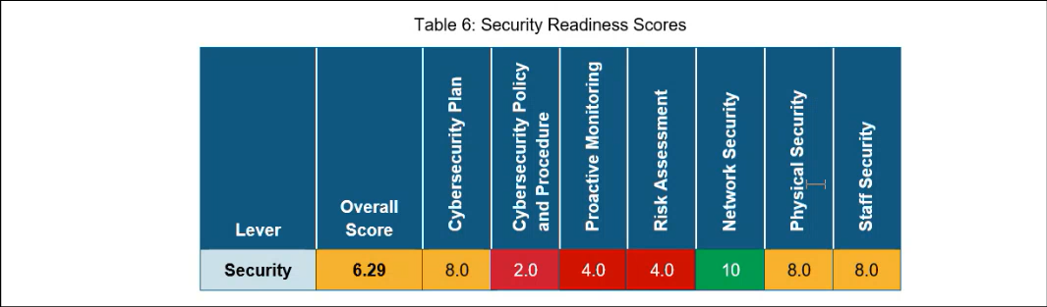
Sherri Griffith Powell stated that Hawaii scored well in network security, physical security, and staff security.

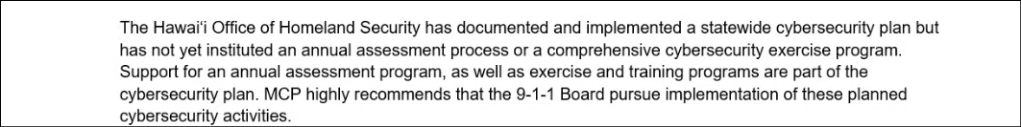
Sherri Griffith Powell recommended that the 911 Board should conduct an annual assessment process or a comprehensive cybersecurity exercise program of its statewide cybersecurity plan documented by the state of Hawaii’s Office of Homeland Security.

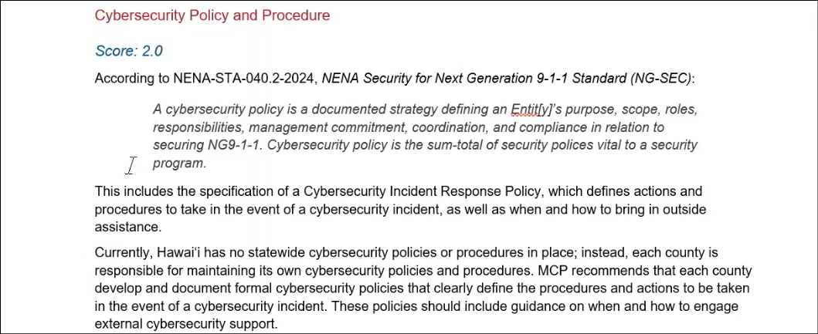
Sherri Griffith Powell stated that Hawaii currently does not have statewide cybersecurity policies or procedures in place. She recommended the 911 Board to create an interconnectivity policy with the associated minimum cybersecurity standards. Furthermore, MCP recommends each county to develop and document a formal cybersecurity policy. Sherri Griffith Powell asked Michelle Kratel if each county’s PSAP maintains its own cybersecurity policy. Michelle Kratel responded stating that Hawaii county does not have its own cybersecurity policy for their PSAP but would develop it if the resources were available. Sherri Griffith Powell stated that she will revise MCP’s recommendation to PSAP level cybersecurity plans instead of at the county level. Corey Shaffer asked Sherri Griffith Powell if MCP is able to provide examples of publicly available cybersecurity plans from other states and counties to assist the Hawaii PSAPs with developing theirs. Sherri Griffith Powell responded stating that most if not all cybersecurity plans are not publicly available to prevent access by illicit users. She added that NENA provides a standard for cybersecurity, CISA has guidelines/resources, and MCP is able to provide guidance.

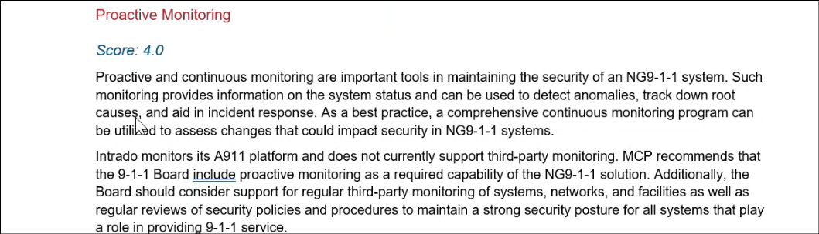
Sherri Griffith Powell stated that Intrado monitors its own platform and does not currently support third party monitoring. She recommended that the 911 Board incorporate proactive monitoring as a required capability of the NG911 solution. She added that this could be a part of the SLA with Hawaiian Telcom and Intrado to proactively monitor the system and provide the PSAPs with dashboards and/or monthly reports. Furthermore, the National Institute of Standards and Technology’s (“NIST”) guidelines recommends third party monitoring to render unbiased assessments. She mentioned that other states hire a vendor to conduct this third-party monitoring on their behalf.

Sherri Griffith Powell asked Corey Shaffer if third party monitoring had been considered or not. Corey Shaffer responded stating that the 911 Board will have to discuss this. Sherri Griffith Powell cited that other home rule states elect a county to take lead on a contract and include any other applicable counties but is funded at the state level.

Corey Shaffer asked Sherri Griffith Powell is the majority of third-party monitoring conducted by outside vendors/private companies or each state’s/county’s IT department. Sherri Griffith Powell responded stating that the majority will hire an outside vendor/private company. Jackie Mines added that a few states with robust IT departments handle the third-party monitoring. Furthermore, Sherri Griffith Powell mentioned that it does not have to be an outside party to handle the third-party monitoring. However, David Jones stated that the standards and best practices recommend an outside party.

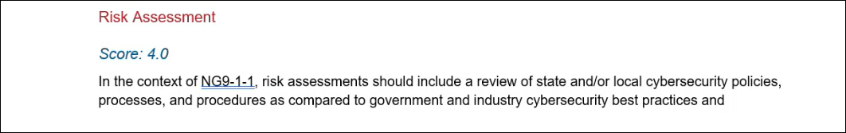
Sherri Griffith Powell stated that a risk assessment should include a review of the state and/or local cybersecurity policies, process, and procedures.

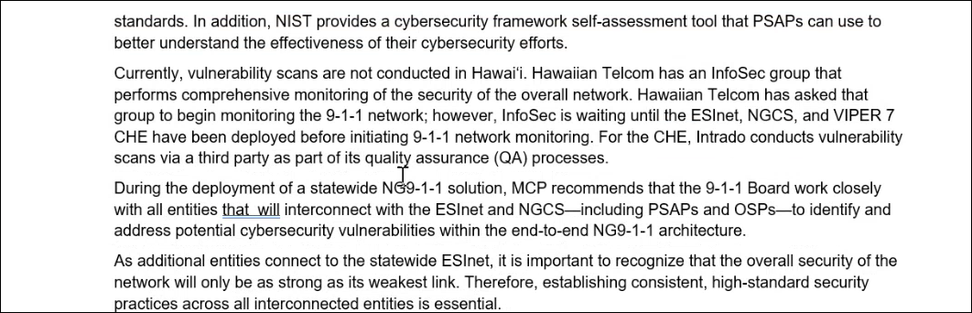
Sherri Griffith Powell stated that NIST provides a cybersecurity framework self-assessment tool that the PSAPs can use to better understand the effectiveness of their cybersecurity efforts. She added that vulnerability scans are not currently being conducted. She mentioned that Hawaiian Telcom’s InfoSec group is waiting until the ESInet, NGCS, and Viper 7 have all been deployed before they begin to monitor the 911 network. She noted that Intrado conducts vulnerability scans and utilizes a third party for quality assurance purposes. She recommended that the 911 Board should work closely with any entities that will interconnect (e.g. military, coast guard, etc.) to address potential cybersecurity vulnerabilities. Furthermore, establishing consistent and high standard security practices across all interconnected entities is essential.

Sherri Griffith Powell asked Corey Shaffer if a committee on the 911 Board has the capacity to develop a document detailing the best practices and recommendations to conduct the self-assessments mentioned above. Corey Shaffer responded stating that this seems feasible and within the purview of a committee on the 911 Board. Tony Ramirez added that a risk assessment checklist could be a requirement from the third-party vendor if the 911 Board decides to pursue this route for proactive monitoring purposes.

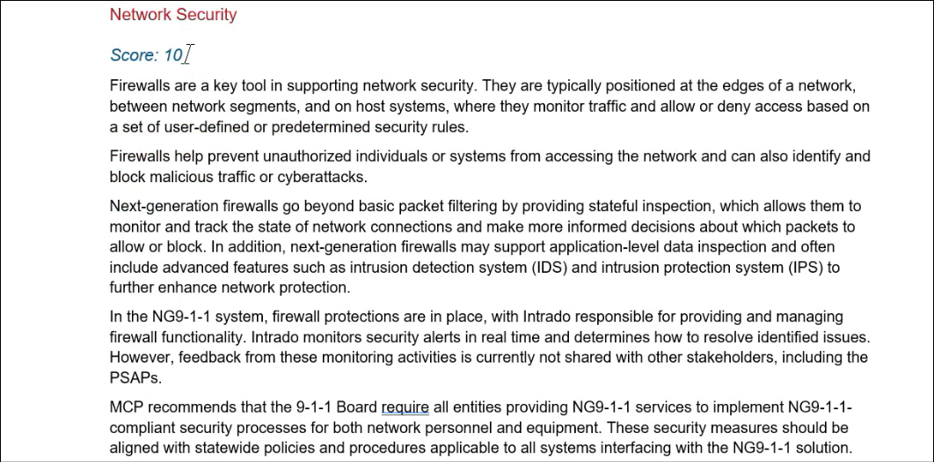
Sherri Griffith Powell stated that Hawaiian Telcom provides robust network security. She added that both physical and staff security are sufficient as well.

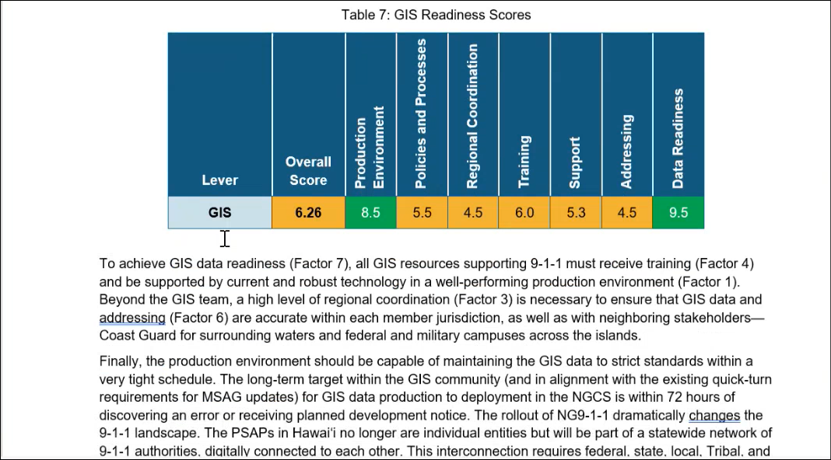
Sherri Griffith Powell stated that Hawaii’s relationship with V2X the GIS vendor for nearly 20 years provides stability and consistency, which is not common amongst the industry. She added that the only concern was to verify each county’s separate contract with V2X is kept up to date to prevent a gap in services since NG911 call routing is driven by GIS data. She mentioned that MCP’s report provides insight into policies and processes for GIS.

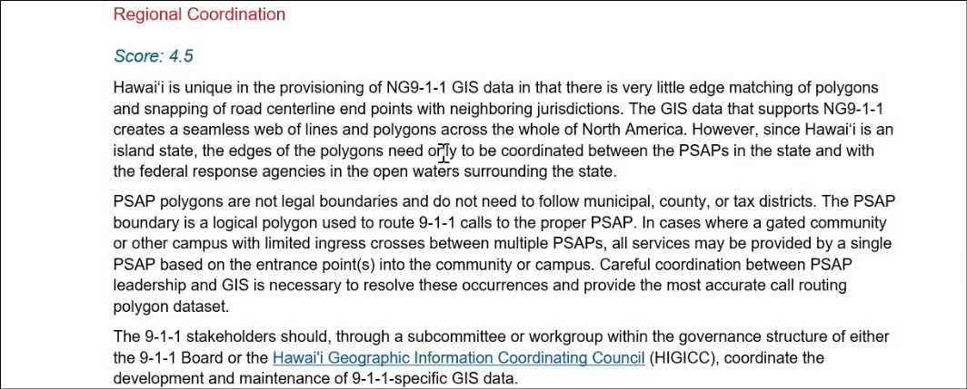
Sherri Griffith Powell stated that Hawaii is unique since it does not encounter any issues with edge matching but should be wary of GIS situations that involve multiple jurisdictions on the same island to ensure coordination. She recommended that Hawaii should coordinate the development and maintenance of 911 specific GIS data through a subcommittee or working group.

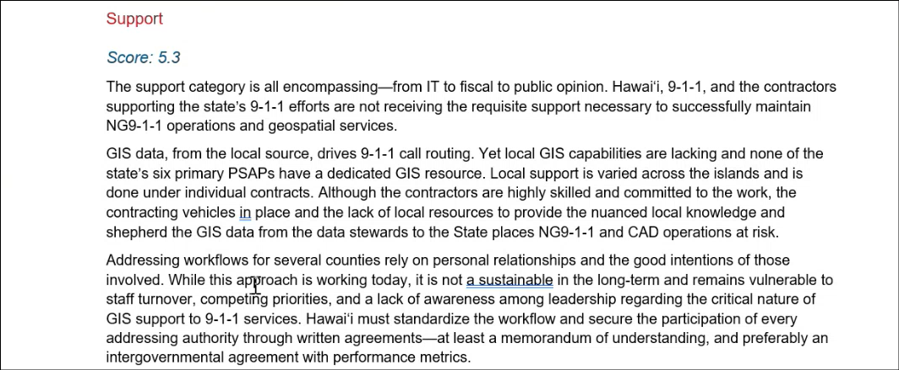
Sherri Griffith Powell recommended that the PSAPs should receive adequate IT and GIS level support.

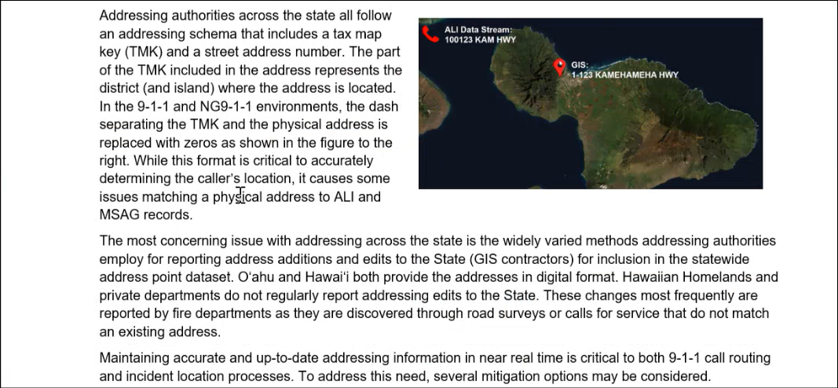
Sherri Griffith Powell stated that drastic changes to addressing information sharing workflows are required to improve this performance metric to an NG911 readiness level and avoid any NG911 operational risk because call routing will be based on GIS data. Tony Ramirez stated that there is sufficient coordination between V2X and the government addressing authority for each county, which includes MSAG translations. He added that this is not conducted on the state level. Sherri Griffith Powell stated that she will follow up and clarify with the MCP team regarding this matter.

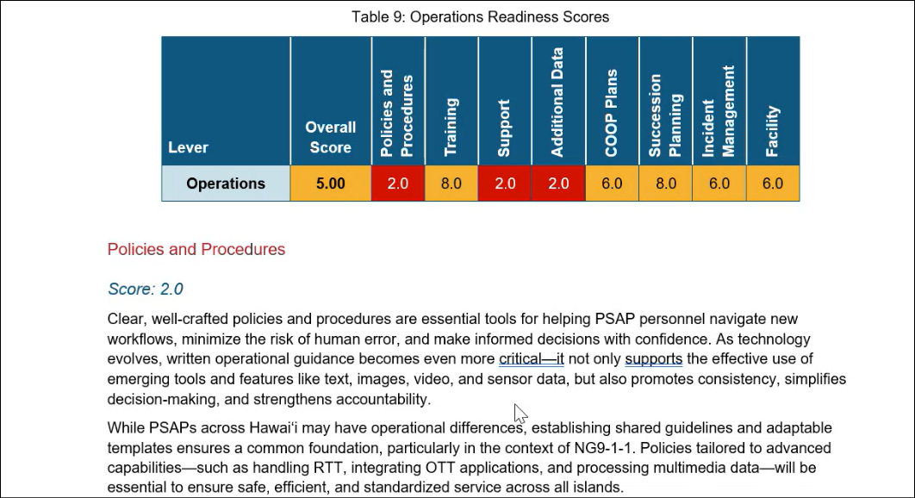
Jackie Mines stated that the PSAPs maintain robust training practices which reference APCO training standards. She added that each PSAP has their own COOP plan but should improve documentation and implementation on a statewide level regarding best practices and integration with each other. Furthermore, she mentioned that the development of the COOP plan should involve the NG911 provider.

Jackie Mines recommended that the PSAPs should develop succession plans but they do not necessarily require proper documentation and could be functional/verbal instead. She added that a viable practice is to have staff backfill and temporarily cover upward positions to gain experience, which helps with succession planning.

Jackie Mines mentioned that incident management could receive more support. She stated the overall consensus was that the facilities felt secure and the software plus hardware were adequate but cited potential issues regarding the 911 call center room.

Jackie Mines stated that policies and procedures were among the weakest areas due to lack of staffing/resources to update them. She recommended the creation of a working group to share policies and templates for information sharing and efficiency purposes.

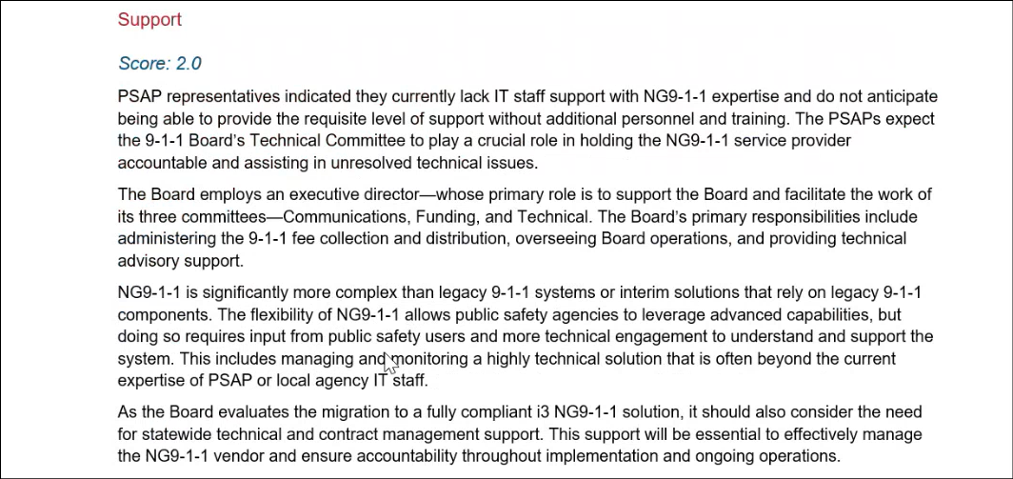
Jackie Mines stated that the PSAPs mentioned a lack of IT staff support in terms of personnel count and NG911 technical expertise.

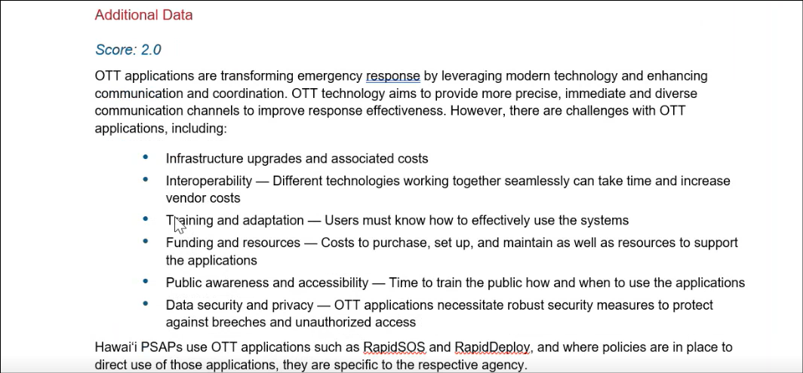
Jackie Mines stated that over-the-top (“OTT”) applications improve response effectiveness and provide additional information/resources. She mentioned that there could be inconsistencies regarding usage and best practices for these OTT applications amongst the various PSAPs. She recommended that the PSAPs should maintain an open dialogue regarding the aforementioned inconsistencies to optimize these OTT applications.

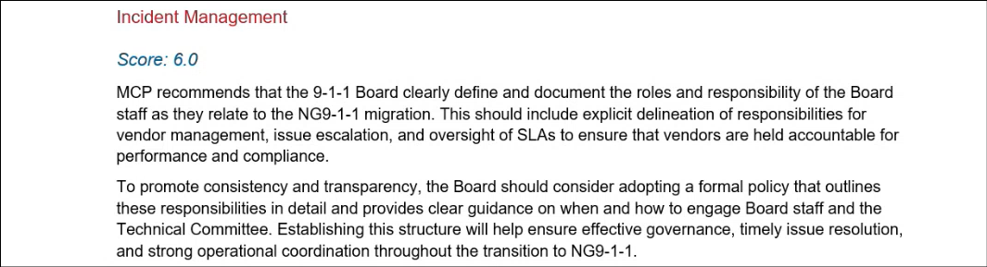
Jackie Mines stated that there were concerns regarding how to raise issues with vendors. She added that NG911 is more complex than legacy 911. She recommended developing a working group on the 911 Board to discuss and provide technical perspectives for any potential issues that may arise. Furthermore, this could provide early detection of widespread issues if multiple PSAPs are experiencing the same thing to escalate the problem and expedite resolution.

Tony Ramirez asked Sherri Griffith Powell if properly documented SLAs from the forthcoming NG911 service provider could prevent and/or resolve a majority of these incident reports. Sherri Griffith Powell responded stating that this is possible as long as the PSAP has the staffing and resources to review and enforce these SLAs to hold the vendor accountable. She added that the SLAs should be created by the end user and not the provider. Jackie Mines mentioned that understanding and troubleshooting SLAs with the vendors could be a time consuming and daunting task. She recommended hiring a dedicated individual to help facilitate communication, provide oversight, and resolve issues.

Sherri Griffith Powell stated that there are tables with summaries and recommendations for each section located at the end of MCP’s report.

- Public Service Answering Point Status Updates on Recruitment and other Personnel Issues
  - Kauai Police Department – Andrew Muraoka
    - Update on Recruitment Process/Strategies and Personnel Training
Andrew Muraoka stated that they are in the midst of revamping their entrance procedures for dispatch.

    - Update on Personnel Issues and Vacancies
Andrew Muraoka stated that they currently have 11 personnel with a ~50% vacancy rate.

  - Oahu Police Department – Matthew Kurihara
    - Update on Recruitment Process/Strategies and Personnel Training
Matthew Kurihara stated that they have approximately 32 applicants vying to fill the recently lost personnel mentioned below, which closes on 8-20-2025. He added that they continue to explore alternate recruitment/hiring methods including retirees as contract hires and sworn personnel. Furthermore, he mentioned that they are in the process of negotiating a retention bonus to assist with both staffing and recruiting.

    - Update on Personnel Issues and Vacancies
Matthew Kurihara stated that they currently have a ~37% vacancy rate. He added that they recently lost 2 personnel.

  - Oahu Fire Department – Shawn Kuratani
    - Update on Recruitment Process/Strategies and Personnel Training
Shawn Kuratani not present to provide an update.

    - Update on Personnel Issues and Vacancies
Shawn Kuratani not present to provide an update.

  - Oahu Emergency Medical Services – Lorrin Okumura, Diana Chun, Frannie Chung
    - Update on Recruitment Process/Strategies and Personnel Training
Lorrin Okumura stated that they currently have 5 personnel and 1 reliever dispatcher in their EMD academy. He added that they recently started console training which will persist for the next couple of months. Furthermore, he expects graduation to take place around November 2025.

    - Update on Personnel Issues and Vacancies
Lorrin Okumura stated no updates.

  - Maui Police Department – Davlynn Racadio
    - Update on Recruitment Process/Strategies and Personnel Training
Davlynn Racadio stated that they are currently working with their DPS and HGEA agents plus administration to upgrade their job descriptions. She added that they will seek a job recruitment push around mid-September 2025. Furthermore, they retained 4 personnel from the last job recruitment push. She also mentioned that they are expediting training for 1 of their personnel that moved back recently. Lastly, she stated that they continue to utilize sworn and civilian personnel to assist with call taking.

    - Update on Personnel Issues and Vacancies
Davlynn Racadio stated no updates.

  - Molokai Police Department – Davlynn Racadio
    - Update on Recruitment Process/Strategies and Personnel Training
Please see updates under Maui Police Department.

    - Update on Personnel Issues and Vacancies
Please see updates under Maui Police Department.

  - Hawaii Police Department – Zachary Fernando
    - Update on Recruitment Process/Strategies and Personnel Training
Zachary Fernando stated that the 3 most recent recruits have resigned. He added that they plan to start another recruitment class in September 2025 with 3 trainees. Furthermore, they currently have 8 applicants in the background check stage. Lastly, they are exploring the idea of retirees as contract hires.

    - Update on Personnel Issues and Vacancies
Zachary Fernando stated that they currently have 16 vacant positions.

  - Hawaii Fire Department – Stacy Domingo
    - Update on Recruitment Process/Strategies and Personnel Training
Stacy Domingo stated that they recently provided a realistic job preview for 12 candidates from a list of 32 individuals. She added that interviews and the selection process are forthcoming.

    - Update on Personnel Issues and Vacancies
Stacy Domingo stated that they currently have 9 personnel. She added that they could potentially lose 1 personnel either temporarily or permanently due to pregnancy.

- Items for Discussion, Consideration, and Action
  - Additional Items Proposed by Meeting Attendees

- Announcements
  - Future Virtual Meeting Dates/Times (9:00AM-12:00PM)
    - Thursday, September 11, 2025 (Combined Meeting)
    - Thursday, October 9, 2025 (Combined Meeting)

  - Future Conference Dates (3 Months of Advanced Approval Required)

  - Additional Announcements from Meeting Attendees

- Open Forum: Public comment on issues not on the Board Meeting Agenda
There was no public comment on issues not on the agenda.

- Adjournment
Board Chair requested a motion to adjourn the meeting. Tony Ramirez motioned to adjourn the meeting. Tony Velasco seconded the motion. A voice vote was taken, adjournment was unanimously approved. The meeting was adjourned.

