JOSH GREEN, M.D.  GOVERNOR  Ke Kiaʻāina | 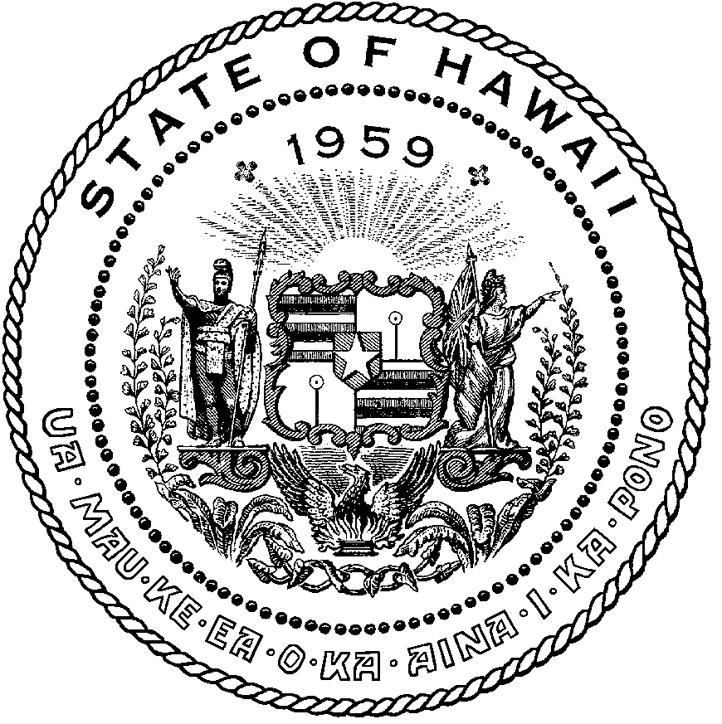 | KEITH A. REGAN  COMPTROLLER  Ka Luna Hoʻomalu Hana Laulā  MEOH-LENG SILLIMAN  DEPUTY COMPTROLLER  Ka Hope Luna Hoʻomalu Hana Laulā
STATE OF HAWAIʻI | KA Mokuʻāina o Hawaiʻi

DEPARTMENT OF ACCOUNTING AND GENERAL SERVICES | KA ʻOihana LOIHELU A LAWELAWE Laulā
P.O. BOX 119, HONOLULU, HAWAII 96810-0119

State of Hawaii 911 Board Meeting

Thursday, July 10, 2025
9:00 am – 12:00 pm

Virtually Held Meeting with Physical Location at
Kalanimoku Building Room 426, 1151 Punchbowl Street, Honolulu, Hawaii 96813 is available to the public and is guaranteed to be connected to the remote virtual meeting.

MEETING MINUTES

July 10, 2025: Joint Committee and Board Meeting (youtube.com)

Board Members Present: Francis Alueta (HT), Stephen Courtney (C&C of Honolulu), Ji Sook Kim (Consumer Advocate Designee), Matthew Kurihara (HPD), Rebecca Lieberman (Spectrum), Gregg Okamoto (MPD), Todd Omura (CIO Designee), Scott Winecoff (T-Mobile)
Board Members Not Present: Corey Shaffer (Verizon), Keola Tom (MPD), Liz Gregg (AT&T), Elliott K. Ke (KPD), Reed Mahuna (HIPD)
Staff: Royce Murakami (911 Board), Benson Leung (911 Board), Stella Kam (AG)
Guests: Stacy Domingo (HIFD), Marisa Fujimoto (HT), Edward Fujioka (EMS), Buck Giles (OS), Roderick Green (KPD), Wayne Hirasa (Alakaina), Melia Johnson (MPD), David Jones (Mission Critical), Stella Kam (AG), Shawn Kuratani (HFD), Ah Lan Leong (HPD), Robert Mohr (Exacom), Tamera Neal (Intrado), Lorrin Okumura (EMS), Davlynn Racadio (MPD), Tony Ramirez (V2X), Calvin Sung (HPD), Lavina Taovao (KPD), Kenison Tejada (FirstNet), Tony Velasco (DIT)

- Call to Order, Public Notice
The meeting was called to order by Shawn Kuratani on behalf of the Board Chair. Public notice was given.

- Public Testimony Will Be Taken on All Agenda Items as Those Items Occur During the Meeting

- Roll Call, Quorum
A roll call was taken, quorum was present for the Board.

- Review and Approval of June Meeting Minutes
Shawn Kuratani on behalf of the Board Chair requested a motion to approve June’s Meeting Minutes. Francis Alueta motioned to approve June’s Meeting Minutes. Rebecca Lieberman seconded the motion. A voice vote was taken, motion was unanimously approved.

- Committee Updates by Committee Chairs
  - Communications Committee – Davlynn Racadio
    - 9-1-1 Outage on 6-5-2025
    - Discussion of Hawaiian Telcom Business Lines
    - Update from Kauai Police Department & Hawaii Police Department regarding Viper 7 Upgrade
Davlynn Racadio stated no further updates.

  - Technical Committee – Shawn Kuratani
    - No Updates

      - Advisory Committee – Rebecca Lieberman
        - Updates on Legislative Session
Rebecca Lieberman stated no further updates.

  - Finance Committee – Edward Fujioka
    - Review of Monthly Y-T-D (Year to Date) Cash Flow
    - Finance Chair to Conduct Community Outreach at Neighborhood Board Meetings
    - Hawaii Fire Department Requesting to Transfer $5,000.00 to Hawaii Police Department for APCO Conference
    - Executive Director Requesting Additional Funds of $375.00 for Increase in NASNA (National Association of State 9-1-1 Administrators) Dues
Edward Fujioka stated no further updates.

- Public Service Answering Point Status Updates on Recruitment and other Personnel Issues
  - Kauai Police Department – Andrew Muraoka
    - Update on Recruitment Process/Strategies and Personnel Training
    - Update on Personnel Issues and Vacancies
Roderick Green on behalf of Andrew Muraoka stated no further updates.
  - Oahu Police Department – Matthew Kurihara
    - Update on Recruitment Process/Strategies and Personnel Training
    - Update on Personnel Issues and Vacancies
Matthew Kurihara stated no further updates.

  - Oahu Fire Department – Shawn Kuratani
    - Update on Recruitment Process/Strategies and Personnel Training
    - Update on Personnel Issues and Vacancies
Shawn Kuratani stated no further updates.

  - Oahu Emergency Medical Services – Lorrin Okumura, Diana Chun, Frannie Chung
    - Update on Recruitment Process/Strategies and Personnel Training
    - Update on Personnel Issues and Vacancies
Lorrin Okumura stated no further updates.

  - Maui Police Department – Davlynn Racadio
    - Update on Recruitment Process/Strategies and Personnel Training
    - Update on Personnel Issues and Vacancies
Melia Johnson on behalf of Davlynn Racadio stated no further updates.

  - Molokai Police Department – Davlynn Racadio
    - Update on Recruitment Process/Strategies and Personnel Training
    - Update on Personnel Issues and Vacancies
Melia Johnson on behalf of Davlynn Racadio stated no further updates.

  - Hawaii Police Department – Zachary Fernando
    - Update on Recruitment Process/Strategies and Personnel Training
    - Update on Personnel Issues and Vacancies
Zachary Fernando not present to provide further updates.

  - Hawaii Fire Department – Stacy Domingo
    - Update on Recruitment Process/Strategies and Personnel Training
    - Update on Personnel Issues and Vacancies
Stacy Domingo stated no further updates.

- Executive Director’s Report
  - FY 2024-2025 Independent Audit of 9-1-1 Fund
The Executive Director stated that the FY 2024-2025 independent audit of the 911 fund will be commencing shortly. He added that he will work with the current auditor on a contract extension since it will expire after the aforementioned audit report.

  - Replacement for Nani Blake as T-Mobile Representative: Scott Winecoff
The Executive Director introduced Scott Winecoff, who is the T-Mobile representative board member replacement for Nani Blake. Scott Winecoff stated that he has been in telecommunications for 26 years at T-Mobile and is in engineering currently. He added that he moved back to Hawaii in 2022.

- Items for Discussion, Consideration, and Action
  - Hawaii Fire Department Requesting to Transfer $5,000.00 to Hawaii Police Department for APCO Conference
Shawn Kuratani on behalf of the Board Chair stated the item above and asked for a motion to approve. Rebecca Lieberman motioned to approve this request. Stephen Courtney seconded the motion. A voice vote was taken, motion was unanimously approved.

  - Executive Director Requesting Additional Funds of $375.00 for Increase in NASNA (National Association of State 9-1-1 Administrators) Dues
Shawn Kuratani on behalf of the Board Chair stated the item above and asked for a motion to approve. Stephen Courtney motioned to approve this request. Francis Alueta seconded the motion. A voice vote was taken, motion was unanimously approved.

  - Additional Items Proposed by Meeting Attendees

- Announcements
  - Future Virtual Meeting Dates/Times (9:00AM-12:00PM)
    - Thursday, August 14, 2025 (Combined Meeting)
    - Thursday, September 11, 2025 (Combined Meeting)

  - Future Conference Dates (3 Months of Advanced Approval Required)
    - APCO Conference (Association of Public-Safety Communications Officials) July 27-30, 2025, Baltimore, MD

  - Additional Announcements from Meeting Attendees
The Executive Director stated that the FYE 2026 balance sheets have been provided to each agency. He added to request any funding letters from him directly if applicable.

- Open Forum: Public comment on issues not on the Board Meeting Agenda
There was no public comment on issues not on the agenda.

- Adjournment
Shawn Kuratani on behalf of the Board Chair requested a motion to adjourn the meeting. Rebecca Lieberman motioned to adjourn the meeting. Stephen Courtney seconded the motion. A voice vote was taken, adjournment was unanimously approved. The meeting was adjourned.

