|  |  |  |
| --- | --- | --- |
| JOSH GREEN, M.D. GOVERNOR  Ke Kiaʻāina |  | KEITH A. REGAN COMPTROLLER  Ka Luna Hoʻomalu Hana Laulā  **MEOH-LENG SILLIMAN**  DEPUTY COMPTROLLER  Ka Hope Luna Hoʻomalu Hana Laulā |
|  | **STATE OF HAWAIʻI | KA Mokuʻāina o Hawaiʻi**  **DEPARTMENT OF ACCOUNTING AND GENERAL SERVICES | KA ʻOihana LOIHELU A LAWELAWE Laulā**  P.O. BOX 119, HONOLULU, HAWAII 96810-0119  **Communications, Technical, and Finance Meeting**  **(Combined Meeting)**  **Thursday, June 12, 2025**  **10:00 am – 1:00 pm**  **Virtually Held Meeting with Physical Location at**  **Kalanimoku Building Room 426, 1151 Punchbowl Street, Honolulu, Hawaii 96813 is available to the public and is guaranteed to be connected to the remote virtual meeting.** |  |

**MEETING MINUTES**

[**June 12, 2025: Joint Committee and Board Meeting (youtube.com)**](https://www.youtube.com/watch?v=ncZgADod_0o)

**Communications Committee Members Present:** Davlynn Racadio (MPD), Ah Lan Leong (HPD)

**Communications Committee Members Not Present:** Lavina Taovao (KPD)

**Technical Committee Members Present:** Shawn Kuratani (HFD), Stacy Domingo (HIFD), Tony Ramirez (V2X), Kenison Tejada (FirstNet), Tony Velasco (DIT)

**Technical Committee Members Not Present:** Thalia Burns (APCO/NENA), David Miyasaki (KPD)

**Finance Committee Members Present:** Edward Fujioka (EMS), Liz Gregg (AT&T), Matthew Kurihara (HPD), Reed Mahuna (HIPD), Todd Omura (CIO Designee), Tony Velasco (DIT)

**Finance Committee Members Not Present:** Stephen Courtney (C&C of Honolulu)

**Staff:** Royce Murakami (911 Board), Benson Leung (911 Board), Stella Kam (AG)

**Guests:** Francis Alueta (HT), Philip Banquel (KPD), Brian Boezeman (Intrado), Frannie Chung (EMS), Carla Even (RapidSOS), Zachary Fernando (HIPD), Marisa Fujimoto (HT), Buck Giles (OS), Roderick Green (KPD), Sherri Griffith Powell (Mission Critical), Wayne Hirasa (Alakaina), Robert Horne (Mission Critical), Melia Johnson (MPD), David Jones (Mission Critical), Stella Kam (AG), Kevin Kaneshiro (HIFD), Elliott K. Ke (KPD), Patrick Leddy (LCC), Jackie Mines (Mission Critical), Andrew Muraoka (KPD), Sherryann Murphy (EMS), Tamera Neal (Intrado), Gregg Okamoto (MPD), Lorrin Okumura (EMS), Gary Pulford (Mission Critical), Kyra Pulliam (Mission Critical), Theresa Reese (Mission Critical), Jeff Reeve (AT&T), Megan Reilly (EagleView), Calvin Sung (HPD), Keola Tom (MPD), Scott Winecoff (T-Mobile)

1. Call to Order, Public Notice

**The meeting was called to order by the Vice Chair on behalf of the Board Chair. Public notice was given.**

1. Public Testimony Will Be Taken on All Agenda Items as Those Items Occur During the Meeting
2. Roll Call, Quorum

**A roll call was taken, quorum was present for all committees.**

1. Review and Approval of May Meeting Minutes

**Vice Chair on behalf of the Board Chair requested a motion to approve May’s Meeting Minutes. Liz Gregg motioned to approve May’s Meeting Minutes. Tony Velasco seconded the motion. A voice vote was taken, motion was unanimously approved.**

1. Update from Mission Critical Partners

**Sherri Griffith Powell provided an overview that the recommendations in the draft report cover state level governance, legislation, documentation review, tariffs, GIS, and discussions with key stakeholders (PSAPs, Hawaiian Telcom, Intrado, and the Executive Director).**

**Sherri Griffith Powell reiterated that the agreed upon goals of this assessment are to determine the current status of NG911 transition and to develop a cost estimate in order to achieve end state NG911.**

**Sherri Griffith Powell stated that the Model for Advancing Public Safety (“MAPS”) assessment has been completed for a significant portion of the states in America and it is based on industry best practices/standards. She added that they also incorporated the Task Force on Optimal Public Safety Answering Point Architecture (“TFOPA”) NG911 assessment into their recommendations as well. She then referenced the above slide regarding key elements and showcased a sample Kiviat diagram.**

**Sherri Griffith Powell stated that the above slide is Mission Critical Partners’ (“MCP”) NG911 readiness assessment of Hawaii. She added that the final report will identify the gaps to transition from legacy 911 to NG911 and provide Kiviat diagrams plus numeric scores for each of these key elements.**

**Sherri Griffith Powell stated bullet points 1 and 2 from the above slide. She added that Hawaii does not have a lot of governance authority at the state level. Despite this, the 911 Board’s committees, members, and staff work well together regarding legislation. Sherri Griffith Powell mentioned that the 911 Board’s current duties are primarily focused on fiduciary responsibilities. Jackie Mines stated that 911 boards from other states formed and established additional work groups to develop strategic plans for NG911 transition. She added that these aforementioned work groups could be bolstered by support from the legislators.**

**Sherri Griffith Powell stated MCP’s first recommendation from the above slide, which does not require changes in legislation. She added that creating state level policies would be helpful in terms of consistency. Jackie Mines added that the aforementioned joint working group has the ability to achieve consensus amongst the PSAPs.**

**Sherri Griffith Powell stated MCP’s second recommendation from the above slide. She added that MCP’s findings from the forthcoming final report should aid in creating a strategic plan focused on measuring goals and tasks.**

**Sherri Griffith Powell stated MCP’s third recommendation from the above slide. She emphasized the importance of a state-level continuity of operations plan (“COOP”). Jackie Mines added that a solid COOP addresses and aligns with certain situations to help facilitate communication and set expectations. Sherri Griffith Powell highlighted the need for Hawaii to create formal documented plans due to its unique situation being non-contiguous.**

**Sherri Griffith Powell stated MCP’s fifth recommendation from the above slide and mentioned that this could be beneficial to provide oversight and hold the NG911 vendor accountable. She added that after discussing with Hawaiian Telcom and Intrado, MCP discovered that each PSAP has its own separate contract for core services. Furthermore, the aforementioned contracts are void of service level agreements (“SLA”) because a portion of these core services are procured via tariff. She then recommended developing SLAs at a state level to maintain vendor accountability.**

**Edward Fujioka asked Sherri Griffith Powell if establishing a joint working group for NG911 transition and integration requires a project management team. Sherri Griffith Powell responded stating that a project management team is not required. She added that this working group/committee should consist of representatives from each PSAP to share information and best practices. She then provided an example that this working group/committee could consolidate best practices from three PSAPs with different TXT2911 policies/procedures into the most optimal singular method. Jackie Mines provided another example to develop a unified best practice regarding the handling of multimedia from NG911 in terms of training, viewing videos/pictures, access rights, etc. Edward Fujioka stated that this recommendation will potentially provide consistency amongst the PSAPs.**

**Edward Fujioka asked Sherri Griffith Powell if the COOP exists in perpetuity with periodic reviews. Sherri Griffith Powell confirmed this is accurate and stated that the industry’s best practice is to exercise the COOP annually. She added that this could be in the form of tabletop exercises and provided examples covering topics such as a pandemic, cybersecurity, and/or evacuation routes. Additionally, she recommended that after action reports should be completed in order to debrief and update the COOP accordingly.**

**Davlynn Racadio asked Sherri Griffith Powell what her recommendation is on how to create a best practice for TXT2911 given the PSAPs having varying capabilities. Sherri Griffith Powell responded stating that the formation of a working group/committee should reveal any inconsistencies to then establish a best practice that is achievable for each PSAP. Jackie Mines concurred with Sherri Griffith Powell’s recommendation.**

**Sherri Griffith Powell stated that Hawaiian Telcom billing and retaining the wireline provider fee for 911 services is not an industry best practice in terms of funding for NG911 transition. She added that in the forthcoming NG911 environment the originating telcos and wireline providers are not the only purveyors of 911 services. Furthermore, she stated that this is a misalignment regarding legislation and the recent FCC order re-established that carrier cost recovery is no longer a reimbursable expense.**

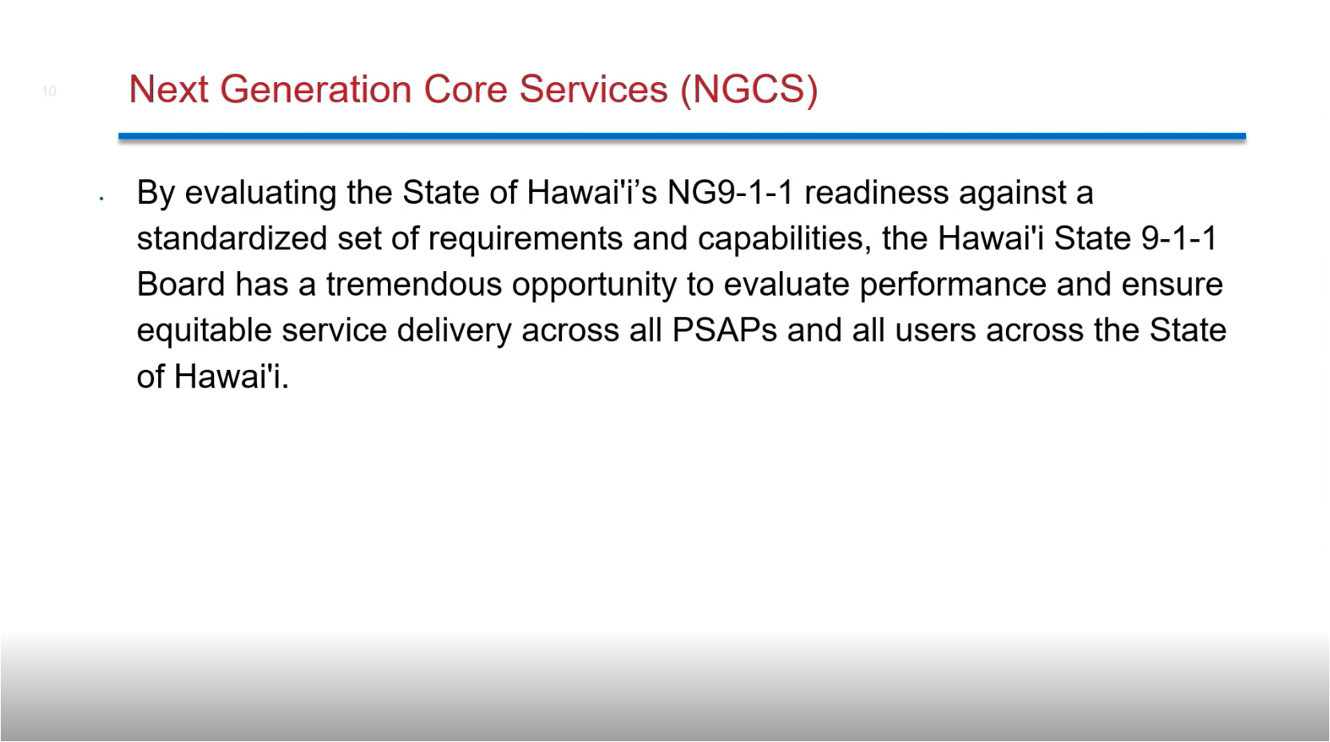

**Theresa Reese stated that MCP conducted discussions with both Hawaiian Telcom and Intrado regarding the state of NGCS in terms of emergency services IP network deployment, requirements, capabilities, opportunities, performance evaluation, and service delivery. She added that this assessment is to determine the current state of NG911 transition.**

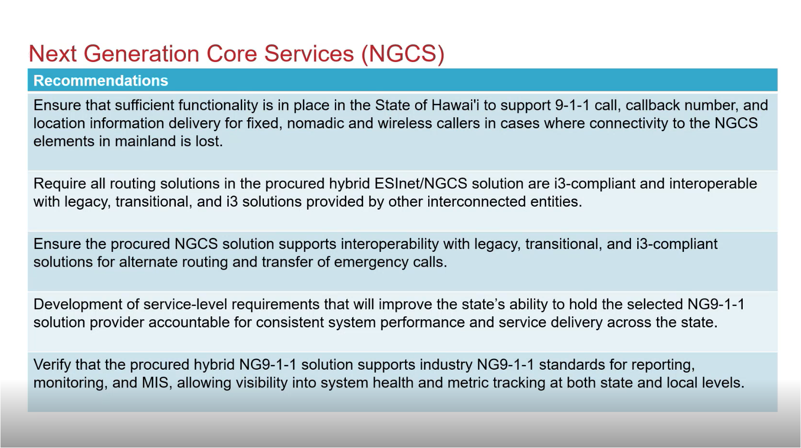

**Theresa Reese stated MCP’s first recommendation from the above slide and highlighted its importance due to Hawaii’s unique and remote infrastructure. Sherri Griffith Powell recommended that the 911 Board have discussions with both Hawaiian Telcom and Intrado regarding the contingency plan if connectivity to the NGCS elements in the mainland are lost. She added that this could be in relation to the aforementioned SLAs.**

**Theresa Reese stated MCP’s second and third recommendations from the above slide. She highlighted the importance of being i3-compliant and addressing functionality during the transitional and end states. Sherri Griffith Powell added that the upcoming Intrado version is i3-compliant and mentioned to verify i3 compliance if the 911 Board decides to switch providers. Theresa Reese concurred with Sherri Griffith Powell.**

**Theresa Reese stated MCP’s fourth and fifth recommendations from the above slide.**

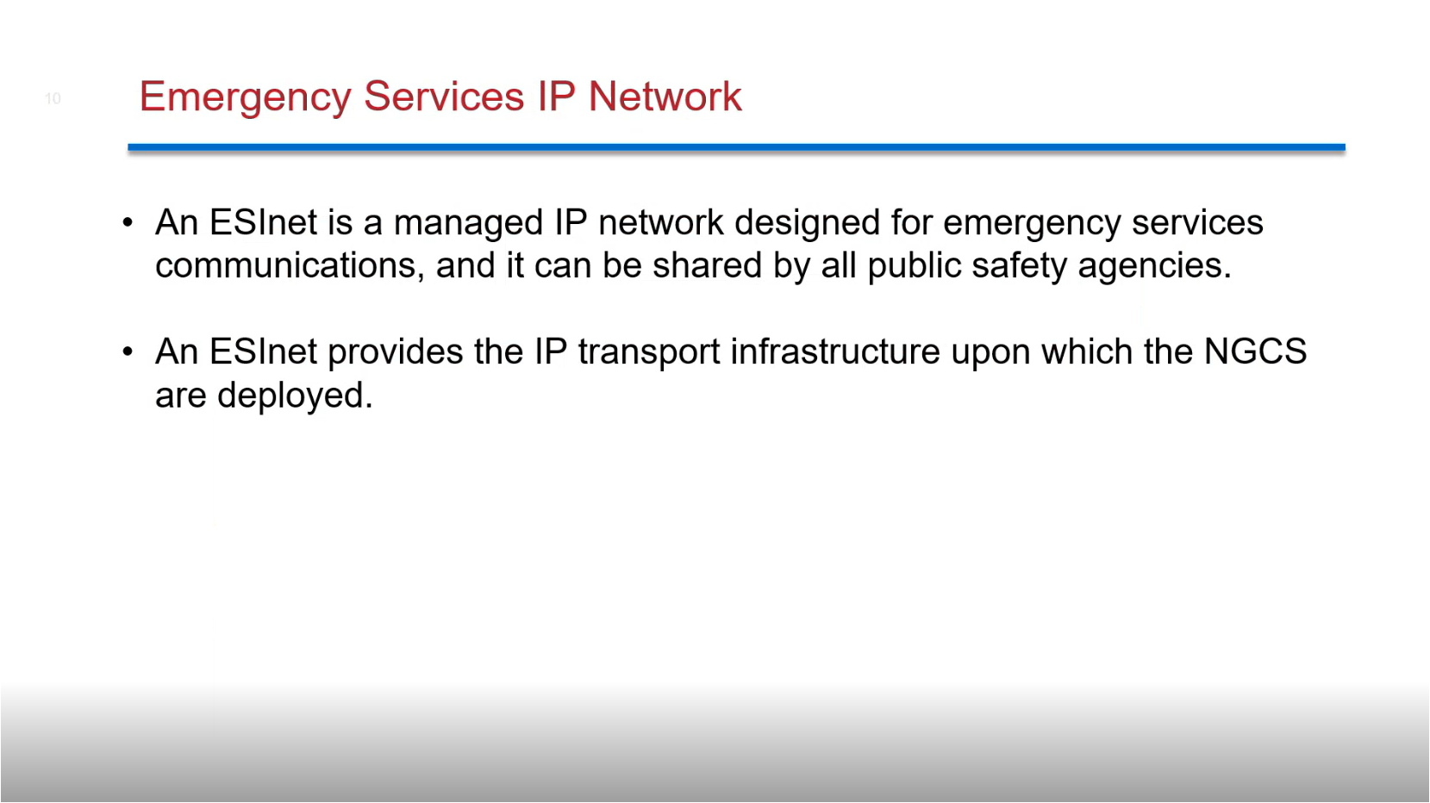

**Theresa Reese stated both bullet points from the above slide.**

**Theresa Reese stated MCP’s first recommendation from the above slide.**

**Theresa Reese stated MCP’s second recommendation from the above slide and made the distinction that there is basic SIP and fully i3 standards compatible SIP signaling. She added that there is a process for the originating service provider (“OSP”) to transition from legacy 911 call delivery to basic SIP and then to NG compliant SIP 911 call delivery, which needs to be in accordance with timelines established by the FCC report in that order.**

**Theresa Reese stated MCP’s third recommendation from the above slide.**

**Reed Mahuna asked Sherri Griffith Powell if a written report will be provided and requested a follow-up meeting for a Q&A session upon receipt and review of the aforementioned report. Sherri Griffith Powell responded stating that a written report will be delivered and agreed to host a Q&A session.**

**Theresa Reese asked the 911 Board if they would be interested in pursuing efforts to create proactive monitoring capabilities regarding visibility, risks, and vulnerabilities of the 911 system. She expanded on this question whether the 911 Board would want to have a role in assessing the selected NG911 solution for any cyber vulnerabilities or not. Reed Mahuna asked Sherri Griffith Powell what the aforementioned role entails. Sherri Griffith Powell responded stating that Intrado has the ability to provide a dashboard to view policy routing information, statistics insights, and monitor the NG911 system. Brian Boezeman concurred with Sherri Griffith Powell and stated that this will be available when they transition to the new system along with customer management portals and standard reports. He added that there will be an optional add-on feature at the network level for bandwidth utilization and the operational statistics of the routers. Theresa Reese asked the 911 Board if they would want the 911 system visibility at a state level or to keep it at the local level under each primary PSAP. Reed Mahuna asked Sherri Griffith Powell who would monitor the aforementioned dashboard and what PSAP statistics are included. Sherri Griffith Powell responded stating that the Executive Director would monitor the dashboard and the PSAP statistics would be aggregated on a state level. She added that this dashboard has the ability to monitor system health, view statistics, and pull reports. Edward Fujioka asked Sherri Griffith Powell if the dashboard has the ability to view individual PSAP statistics or not. Sherri Griffith Powell responded stating that the dashboard has the capability for individual PSAP statistics. Edward Fujioka asked Brian Boezeman if the dashboard is able to timestamp system failures as well as send outage alerts. Brian Boezeman responded stating that the dashboard has the ability to view current network status/issues and historical/live data. He added that the dashboard does not have the capability to act as a notification tool for outage alerts. Francis Alueta asked Brian Boezeman if this dashboard has been previously discussed between Hawaiian Telcom and Intrado. Brian Boezeman responded stating that there were prior discussions regarding this executive network dashboard and offered to host demos to showcase its various capabilities. Francis Alueta added that Hawaiian Telcom inquired about this network dashboard from Intrado, which provides real time insight of the network. Davlynn Racadio asked Francis Alueta when this dashboard was requested. Francis Alueta responded stating that this occurred about 2-3 years ago and it requires Viper 7 for integration.**

**Sherri Griffith Powell stated that having a third-party cybersecurity assessment of the 911 system is an industry best practice recommended by CISA whether it is completed at the state or local level.**

**Robert Horne highlighted the dedication of the state’s GIS vendor, their excellent work, and strong relationship with the 911 authorities.**

**The Executive Director asked Sherri Griffith Powell to send him the draft report and he will compile a list of questions from board members plus meeting attendees to be discussed in the August 2025 monthly meeting. Sherri Griffith Powell responded stating that she will provide the draft report. David Jones added that this is the 911 Board’s opportunity to review recommendations, validate data, and raise questions regarding the aforementioned draft report upon receipt. Tony Ramirez asked Sherri Griffith Powell if it is possible to send today’s presentation as well. Sherri Griffith Powell responded stating that she will provide the presentation to the Executive Director for distribution.**

1. Committee Updates by Committee Chairs
   1. Communications Committee – Davlynn Racadio
      1. Update from Kauai Police Department regarding Viper 7 Upgrade

**Davlynn Racadio requested an update from Andrew Muraoka regarding the item above.**

**Andrew Muraoka stated that they are still getting used to Viper 7 and mentioned that the support from Hawaiian Telcom has been adequate. Davlynn Racadio asked Andrew Muraoka if there are any outstanding support tickets. Andrew Muraoka responded stating that he needs to verify the amount of outstanding support tickets and about 20 have been addressed so far.**

* + 1. Root Cause Analysis (RCA) from Hawaiian Telcom regarding Issue on 5-19-2025

**Davlynn Racadio requested an update from Francis Alueta regarding the item above.**

**Francis Alueta stated that the outage was caused by a controller and rectifier failure resulting in power loss. He added that they are investigating an ANI/ALI issue that was not connected to the dual power feeds. Furthermore, he suspects it is a connection issue since both servers were up and running, which is currently being worked on with Intrado. Lastly, he stated that the rectifiers have been ordered but they do not have a shipping date yet.**

* + 1. 9-1-1 Outage on 6-5-2025

**Davlynn Racadio requested an update from Corey Shaffer regarding the item above.**

**Corey Shaffer was not present to provide an update and this agenda item will be deferred to next month’s meeting.**

* + 1. Discussion of Hawaii Island Emergency Call Center Tour

**Davlynn Racadio stated that she toured Big Island’s new emergency call center on 5-28-2025 with Melia Johnson, Walter Pacheco (MPD radio personnel), the Executive Director, and the Administrative Services Assistant and mentioned that it is a beautiful facility. She recommended that lights should be installed for both the red and emergency phones to alert staff as to which phone is ringing and this inquiry has been mentioned to Hawaiian Telcom. Reed Mahuna stated that this is Big Island’s first purpose-built facility for 911 call taking and dispatch.**

* 1. Technical Committee – Shawn Kuratani
     1. Update from Conference Attendees for CentralSquare ENGAGE, April 27-30, 2025, Kissimmee, FL

**Shawn Kuratani expressed his gratitude to the 911 Board for allowing him to attend the conference mentioned above. He stated that during this CAD focused conference he was able to network and discuss in-person with the CentralSquare team regarding support tickets and any inquiries/issues. He added that he was able to beta test the upcoming software upgrade before it is rolled out for general release to help uncover any problems. Furthermore, he held discussions with the CentralSquare team regarding artificial intelligence implementation of software/capabilities for CAD and cloud backup for disaster recovery to potentially save money on premise hardware systems due to the rising costs of technology.**

**Edward Fujioka asked Shawn Kuratani if there is a growing trend of clients transitioning to cloud based solutions. Shawn Kuratani responded stating that there is slight momentum regarding this and it is mostly smaller PSAPs doing so. He added that the cost savings were not as much as he initially hoped for after receiving the quotes. Furthermore, these quotes were primarily for disaster recovery since he would like to maintain premise hardware systems for production purposes.**

* + 1. Discussion of Hawaiian Telcom Master Agreement Renewal Delay

**Shawn Kuratani stated the item above and mentioned that HFD has been out of contract with Hawaiian Telcom since 6-30-2024 and they have been negotiating a new contract. He added that it does not seem likely they will settle on a new contract by FYE 2025. Furthermore, he anticipates the need to encumber FYE 2025 funds in order to pay past invoices and fees.**

**Francis Alueta asked Shawn Kuratani if this is in regard to the county’s master service agreement or the communication service provider seats plus other services. Shawn Kuratani responded stating that it is the latter. Francis Alueta stated that this is currently being reviewed by Hawaiian Telcom’s legal team and an update will be provided by end of week.**

**Edward Fujioka asked Shawn Kuratani if he could request invoices for encumbrance purposes. Shawn Kuratani responded stating that he is already in the process of acquiring invoices.**

* + 1. Update regarding Intrado Upgrades (Text Translation, Dictation, and Video Calling)

**Shawn Kuratani stated the item above and mentioned that a meeting was held between technical committee members and the PSAPs regarding what Intrado could offer in terms of text translation, dictation, video calling, and other features if it is included in the pending equipment and software upgrade. He added that all the previously mentioned features are add-ons and ala carte options. Furthermore, he stated that quotes were received and it is up to the discretion of each PSAP on which features will be purchased or if a third-party vendor will be selected instead.**

* + - 1. Advisory Committee – Rebecca Lieberman
         1. Updates on Legislative Session

**The Executive Director on behalf of Rebecca Lieberman stated no updates.**

* 1. Finance Committee – Edward Fujioka
     1. Review of Monthly Y-T-D (Year to Date) Cash Flow

**May 2025 Cashflow Statement:**

**Surcharge Collection: $1,078,520**

**Interest Income: $110,389**

**Total Receipts: $1,188,909**

**Total Disbursements: ($1,038,198)**

**Net Receipts/Disbursements: $150,710**

**Net Encumbrances Adds/(Paydown): ($220,476)**

**Net Cash Inflow/(Outflow): ($69,766)**

**Outstanding Encumbrances: $11,333,317**

**Net Bank Balance: $47,429,169**

**Unencumbered Cash Balance: $36,095,852**

* + 1. Hawaii Police Department Requesting $255.62 for Travel Reimbursement to Attend Board Member Full Senate Confirmation Hearing

**Edward Fujioka stated the item above and requested an explanation. Reed Mahuna explained that this request was for him to attend his board member full senate confirmation hearing in Oahu. Edward Fujioka asked for a motion to approve. Tony Velasco motioned to approve this request. Todd Omura seconded the motion. A voice vote was taken, motion was unanimously approved.**

* + 1. Maui Police Department Requesting $48.12 for TXT2911 Shortage

**Edward Fujioka stated the item above and requested an explanation. Keola Tom explained that this request is due to Maui’s new tax rate increase. Edward Fujioka asked for a motion to approve. Tony Velasco motioned to approve this request. Todd Omura seconded the motion. A voice vote was taken, motion was unanimously approved.**

* + 1. Executive Director Requesting $107.64 for Travel Related Costs to Conduct Interisland PSAP Visits

**Edward Fujioka stated the item above and requested an explanation. The Executive Director explained that this requested amount is the budget overage to include the Administrative Services Assistant. Edward Fujioka asked for a motion to approve. Tony Velasco motioned to approve this request. Todd Omura seconded the motion. A voice vote was taken, motion was unanimously approved.**

* + 1. Executive Director Requesting $25,000.00 for Q4 Budget & Finance Revenue Assessment Shortage

**Edward Fujioka stated the item above and requested an explanation. The Executive Director explained that this is due to the interest income generated from the 911 Board’s deposit account. He added that he anticipates using about $15,000.00-$20,000.00 of the requested funds and the $25,000.00 will be utilized as an abundance of caution with any excess to be returned. Edward Fujioka asked for a motion to approve. Tony Velasco motioned to approve this request. Todd Omura seconded the motion. A voice vote was taken, motion was unanimously approved.**

1. Public Service Answering Point Status Updates on Recruitment and other Personnel Issues
   1. Kauai Police Department – Andrew Muraoka
      1. Update on Recruitment Process/Strategies and Personnel Training

**Andrew Muraoka stated that they recently hired 1 personnel who is expected to go solo within the next couple of weeks. He added that ~10 personnel were trained as call takers to assist with vacancies and staffing shortages.**

* + 1. Update on Personnel Issues and Vacancies

**Andrew Muraoka stated that they currently have a ~50% vacancy rate.**

* 1. Oahu Police Department – Matthew Kurihara
     1. Update on Recruitment Process/Strategies and Personnel Training

**Matthew Kurihara stated that they have 4 personnel in training starting next week. He added that they have been exploring alternative recruitment strategies such as utilizing storm personnel and hiring retirees on a contract basis.**

* + 1. Update on Personnel Issues and Vacancies

**Matthew Kurihara stated that they currently have a ~37% vacancy rate. He added that 1 personnel will be transferring to Oahu EMS at the end of this month.**

* 1. Oahu Fire Department – Shawn Kuratani
     1. Update on Recruitment Process/Strategies and Personnel Training

**Shawn Kuratani stated no updates.**

* + 1. Update on Personnel Issues and Vacancies

**Shawn Kuratani stated that they are currently fully staffed.**

* 1. Oahu Emergency Medical Services – Lorrin Okumura, Diana Chun, Frannie Chung
     1. Update on Recruitment Process/Strategies and Personnel Training

**Lorrin Okumura stated that they started their EMD academy and currently have 7 personnel in training.**

* + 1. Update on Personnel Issues and Vacancies

**Lorrin Okumura stated that they recently promoted 1 of their dispatchers to dispatch supervisor. He added that the dispatch supervisor roles are fully staffed.**

* 1. Maui Police Department – Davlynn Racadio
     1. Update on Recruitment Process/Strategies and Personnel Training

**Melia Johnson on behalf of Davlynn Racadio stated that they started a training class in November 2024 with 3 out of the 12 graduating and going solo in May 2025. She added that their training process has been reduced to 6 months total compared to 12 months previously. Additionally, they anticipate another 2 personnel to go solo in September 2025. She stated that they are planning to conduct a recruitment session in October 2025, resulting in two recruitment sessions per year due to scheduling purposes. She hopes to add about 5 dispatchers next year through their recruitment efforts.**

* + 1. Update on Personnel Issues and Vacancies

**Melia Johnson on behalf of Davlynn Racadio stated no updates.**

* 1. Molokai Police Department – Davlynn Racadio
     1. Update on Recruitment Process/Strategies and Personnel Training

**Please see updates under Maui Police Department.**

* + 1. Update on Personnel Issues and Vacancies

**Please see updates under Maui Police Department.**

* 1. Hawaii Police Department – Zachary Fernando
     1. Update on Recruitment Process/Strategies and Personnel Training

**Zachary Fernando stated that they have 2 personnel in training that resigned. He added that they currently have 1 personnel in training and will be training 3 personnel in June 2025.**

* + 1. Update on Personnel Issues and Vacancies

**Zachary Fernando stated that they have 1 dispatcher returning after a 2-month leave who has completed the refresher training and have since assumed full work duties.**

* 1. Hawaii Fire Department – Stacy Domingo
     1. Update on Recruitment Process/Strategies and Personnel Training

**Stacy Domingo stated that a nonprofit organization reached out to them regarding externships to bring in high school teachers to shadow jobs that do not require a college degree for their students who are not college bound to explore alternative career paths.**

* + 1. Update on Personnel Issues and Vacancies

**Stacy Domingo stated that they currently have 9 personnel with a ~37% vacancy rate.**

1. Items for Discussion, Consideration, and Action
   1. Additional Items Proposed by Meeting Attendees

**Davlynn Racadio stated that they recently held a meeting with all of the PSAPs and highlighted the cumbersome process of escalating and reporting business line calls as emergencies from Hawaiian Telcom’s business lines. Francis Alueta responded stating that he will address this issue. Davlynn Racadio mentioned the decline in service quality from Hawaiian Telcom in the past few months. Francis Alueta responded stating that this is due to the loss of key personnel recently.**

1. Announcements
   1. Future Virtual Meeting Dates/Times (9:00AM-12:00PM)
      1. Thursday, July 10, 2025 (Combined Meeting)
      2. Thursday, August 14, 2025 (Combined Meeting)
   2. Future Conference Dates (3 Months of Advanced Approval Required)
      1. NENA Conference (National Emergency Number Association) June 21-26, 2025, Long Beach, CA
      2. APCO Conference (Association of Public-Safety Communications Officials) July 27-30, 2025, Baltimore, MD
   3. Additional Announcements from Meeting Attendees
2. Open Forum: Public comment on issues not on the Board Meeting Agenda

**There was no public comment on issues not on the agenda.**

1. Adjournment

**Vice Chair on behalf of the Board Chair requested a motion to adjourn the meeting. Reed Mahuna motioned to adjourn the meeting. Liz Gregg seconded the motion. A voice vote was taken, adjournment was unanimously approved. The meeting was adjourned.**