JOSH GREEN, M.D.  GOVERNOR  Ke Kiaʻāina | 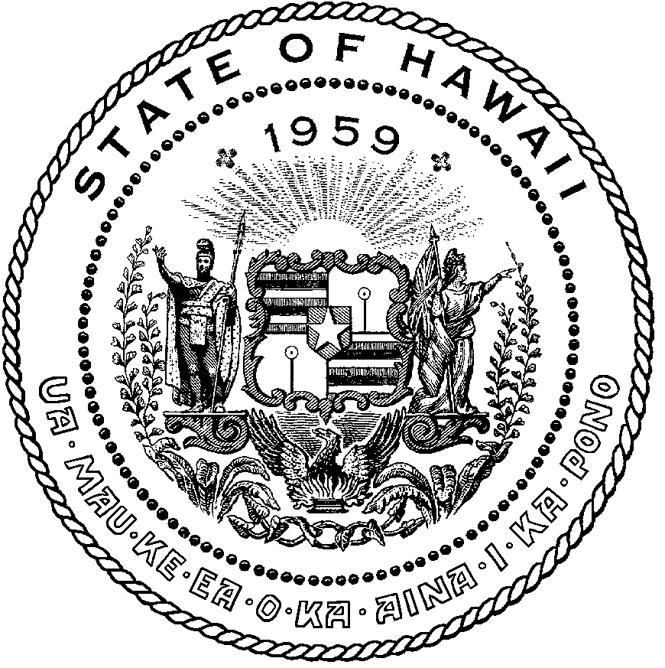 | KEITH A. REGAN  COMPTROLLER  Ka Luna Hoʻomalu Hana Laulā  MEOH-LENG SILLIMAN  DEPUTY COMPTROLLER  Ka Hope Luna Hoʻomalu Hana Laulā
STATE OF HAWAIʻI | KA Mokuʻāina o Hawaiʻi

DEPARTMENT OF ACCOUNTING AND GENERAL SERVICES | KA ʻOihana LOIHELU A LAWELAWE Laulā
P.O. BOX 119, HONOLULU, HAWAII 96810-0119

State of Hawaii 911 Board Meeting

Thursday, March 13, 2025
9:00 am – 12:00 pm

Virtually Held Meeting with Physical Location at
Kalanimoku Building Room 426, 1151 Punchbowl Street, Honolulu, Hawaii 96813 is available to the public and is guaranteed to be connected to the remote virtual meeting.

MEETING MINUTES

March 13, 2025: Joint Committee and Board Meeting (youtube.com)

Board Members Present: Corey Shaffer (Verizon), Keola Tom (MPD), Francis Alueta (HT), Stephen Courtney (C&C of Honolulu), Liz Gregg (AT&T), Ji Sook Kim (Consumer Advocate Designee), Rebecca Lieberman (Spectrum), Reed Mahuna (HIPD), Gregg Okamoto (MPD)
Board Members Not Present: Nani Blake (T-Mobile), Elliott K. Ke (KPD), Matthew Kurihara (HPD), Todd Omura (CIO Designee)
Staff: Royce Murakami (911 Board), Benson Leung (911 Board), Stella Kam (AG)
Guests: Phillip Banquel (KPD), Brian Boezeman (Intrado), Stacy Domingo (HIFD), Zachary Fernando (HIPD), Edward Fujioka (EMS), Stella Kam (AG), Kevin Kaneshiro (HIFD), Shawn Kuratani (HFD), Kainoa Lopes (OSL), Brian McKee (DIT), Andrew Muraoka (KPD), Sherryann Murphy (EMS), Tamera Neal (Intrado), Lorrin Okumura (EMS), Davlynn Racadio (MPD), Tony Ramirez (V2X), Calvin Sung (HPD), Kenison Tejada (FirstNet), Douglas Tom (SWIC), Tony Velasco (DIT)
- Call to Order, Public Notice
The meeting was called to order by the Board Chair. Public notice was given.

- Public Testimony Will Be Taken on All Agenda Items as Those Items Occur During the Meeting

- Roll Call, Quorum
A roll call was taken, quorum was present for the Board.

- Review and Approval of February Meeting Minutes
Board Chair requested a motion to approve February’s Meeting Minutes. Stephen Courtney motioned to approve February’s Meeting Minutes. Rebecca Lieberman seconded the motion. A voice vote was taken, motion was unanimously approved.

- Committee Updates by Committee Chairs
  - Communications Committee – Davlynn Racadio
    - Update from Conference Attendees for 9-1-1 Goes to Washington (GTW), February 23-26, 2025, Arlington, VA
    - Update from Hawaiian Telcom Regarding V2X Report Call Volume Discrepancy
Davlynn Racadio stated no further updates.

  - Technical Committee – Shawn Kuratani
    - No Updates
Shawn Kuratani stated no further updates.

      - Advisory Committee – Rebecca Lieberman
        - Updates on Legislative Session
Rebecca Lieberman stated no further updates.

  - Finance Committee – Edward Fujioka
    - Review of Monthly Y-T-D (Year to Date) Cash Flow
    - Kauai Police Department Requesting $13,500.00 for 3 Additional Personnel to Attend NENA Conference
Edward Fujioka stated no further updates.

- Public Service Answering Point Status Updates on Recruitment and other Personnel Issues
  - Kauai Police Department – Andrew Muraoka
    - Update on Recruitment Process/Strategies and Personnel Training
Andrew Muraoka stated that they have 1 candidate currently going through the 89-day contract hire process.

    - Update on Personnel Issues and Vacancies
Andrew Muraoka stated that they currently have 9 to 10 full-time dispatchers.
  - Oahu Police Department – Matthew Kurihara
    - Update on Recruitment Process/Strategies and Personnel Training
    - Update on Personnel Issues and Vacancies
Calvin Sung on behalf of Matthew Kurihara stated no further updates.

  - Oahu Fire Department – Shawn Kuratani
    - Update on Recruitment Process/Strategies and Personnel Training
    - Update on Personnel Issues and Vacancies
Shawn Kuratani stated no further updates.

  - Oahu Emergency Medical Services – Lorrin Okumura, Diana Chun, Frannie Chung
    - Update on Recruitment Process/Strategies and Personnel Training
    - Update on Personnel Issues and Vacancies
Lorrin Okumura stated no further updates.

  - Maui Police Department – Davlynn Racadio
    - Update on Recruitment Process/Strategies and Personnel Training
    - Update on Personnel Issues and Vacancies
Davlynn Racadio stated no further updates.

  - Molokai Police Department – Davlynn Racadio
    - Update on Recruitment Process/Strategies and Personnel Training
    - Update on Personnel Issues and Vacancies
Davlynn Racadio stated no further updates.

  - Hawaii Police Department – Zachary Fernando
    - Update on Recruitment Process/Strategies and Personnel Training
    - Update on Personnel Issues and Vacancies
Zachary Fernando stated no further updates.

  - Hawaii Fire Department – Stacy Domingo
    - Update on Recruitment Process/Strategies and Personnel Training
    - Update on Personnel Issues and Vacancies
Stacy Domingo stated no further updates.

- Executive Director’s Report
  - Update Regarding DCCA National Consumer Protection Week Fair on March 6, 2025
Executive Director expressed his gratitude to Ji Sook Kim for her assistance with securing a spot for the 911 Board at the DCCA fair mentioned above. Additionally, he thanked Frannie Chung, Ah Lan Leong, and Sean Chun for volunteering at the booth. He stated that overall, the fair went well and in the future will look for events with increased public accessibility. He added that promotional items, a flyer to explain how a 9-1-1 call works, and a handout about text to 9-1-1 were distributed during the fair. Board Chair requested copies of the aforementioned flyer plus handout and asked the Executive Director and Administrative Services Assistant to seek out and propose additional events. Stephen Courtney mentioned that job fairs could be potential venues. Executive Director responded stating that he will provide copies of the flyer plus handout on the 911 Board’s website and offered the inventory of promotional items to the neighbor islands.

  - Discussion of Travel Cost Parameters and Finance Chair Participation in Future Conferences
Executive Director stated the item above and explained that there have been inquiries to re-evaluate the amounts allowable for off-island travel. He proposed increasing each region by $500.00 and asked if there is any opposition to including the finance committee chair for travel reimbursement purposes under the administrative team. Edward Fujioka stated that it has been about 6 years since the last time he attended any 9-1-1 related conference and going forward would like to be apprised of current 9-1-1 trends, costs, NG911, etc. There was no objection from any of the meeting attendees.

  - Initial Submittals Deadline Reminder for Fiscal Year 2026-2030 Strategic Budget Plan
Executive Director reminded the pertinent staff that spreadsheets for the next 5-year budget plan are due tomorrow. He stated to reach out to him if additional time is needed to complete the respective budgets.

  - Honolulu Fire Department Returning $3,068.48 for VMware Overpayment
Shawn Kuratani explained that the return of funds mentioned above was due to the original vendor not being able to fulfill the contract and he had to seek out new quotes, which resulted in a lower contract amount since the specifications had to be reduced for budget purposes.

- Items for Discussion, Consideration, and Action
  - Kauai Police Department Requesting $13,500.00 for 3 Additional Personnel to Attend NENA Conference
Board Chair stated the item above and asked for a motion to approve. Reed Mahuna motioned to approve this request. Francis Alueta seconded the motion. A voice vote was taken, motion was unanimously approved.

  - Additional Items Proposed by Meeting Attendees

- Announcements
  - Future Virtual Meeting Dates/Times (9:00AM-12:00PM)
    - [Tentative] Thursday, April 10, 2025 (Combined Meeting)
    - Thursday, May 8, 2025 (Combined Meeting)

  - Future Conference Dates (3 Months of Advanced Approval Required)
    - Summit Conference (Motorola Solutions) May 12-15, 2025, Grapevine, TX
    - NENA Conference (National Emergency Number Association) June 21-26, 2025, Long Beach, CA
    - APCO Conference (Association of Public-Safety Communications Officials) July 27-30, 2025, Baltimore, MD

  - Additional Announcements from Meeting Attendees
- Open Forum: Public comment on issues not on the Board Meeting Agenda
There was no public comment on issues not on the agenda.

- Adjournment
Board Chair requested a motion to adjourn the meeting. Rebecca Lieberman motioned to adjourn the meeting. Ji Sook Kim seconded the motion. A voice vote was taken, adjournment was unanimously approved. The meeting was adjourned.

