JOSH GREEN, M.D.  GOVERNOR  Ke Kiaʻāina |  | KEITH A. REGAN  COMPTROLLER  Ka Luna Hoʻomalu Hana Laulā  MEOH-LENG SILLIMAN  DEPUTY COMPTROLLER  Ka Hope Luna Hoʻomalu Hana Laulā
STATE OF HAWAIʻI | KA Mokuʻāina o Hawaiʻi

DEPARTMENT OF ACCOUNTING AND GENERAL SERVICES | KA ʻOihana LOIHELU A LAWELAWE Laulā
P.O. BOX 119, HONOLULU, HAWAII 96810-0119

Communications, Technical, and Finance Meeting
(Combined Meeting)

Thursday, January 9, 2025
9:00 am – 12:00 pm

Virtually Held Meeting with Physical Location at
Kalanimoku Building Room 426, 1151 Punchbowl Street, Honolulu, Hawaii 96813 is available to the public and is guaranteed to be connected to the remote virtual meeting.

MEETING MINUTES

January 9, 2025: Joint Committee and Board Meeting (youtube.com)

Communications Committee Members Present: Davlynn Racadio (MPD), Ah Lan Leong (HPD)

Communications Committee Members Not Present: Lavina Taovao (KPD)

Technical Committee Members Present: Shawn Kuratani (HFD), Stacy Domingo (HIFD), Tony Ramirez (V2X), Kenison Tejada (FirstNet), Tony Velasco (DIT)

Technical Committee Members Not Present: Thalia Burns (APCO/NENA), David Miyasaki (KPD)

Finance Committee Members Present: Edward Fujioka (EMS), Stephen Courtney (C&C of Honolulu), Liz Gregg (AT&T), Reed Mahuna (HIPD), Todd Omura (CIO Designee), Tony Velasco (DIT)

Finance Committee Members Not Present: Matthew Kurihara (HPD)

Staff: Royce Murakami (911 Board), Benson Leung (911 Board), Stella Kam (AG)

Guests: Francis Alueta (HT), Phillip Banquel (KPD), Brian Boezeman (Intrado), Carla Even (RapidSOS), Zachary Fernando (HIPD), Buck Giles (OSL), Wayne Hirasa (Alakaina), David Jones (Mission Critical), Stella Kam (AG), Elliott K. Ke (KPD), Ji Sook Kim (Consumer Advocate Designee), Patrick Leddy (LCC), Rebecca Lieberman (Spectrum), Matthew MacDonald (RapidSOS), Brian McKee (DIT), Gregg Okamoto (MPD), Lorrin Okumura (EMS), Gary Pulford (Mission Critical), Ariel Ramos (KPD), Corey Shaffer (Verizon), Calvin Sung (HPD), Douglas Tom (SWIC), Keola Tom (MPD), Seth Wold (RapidSOS), Ruth Zipfel (EagleView)

- Call to Order, Public Notice
The meeting was called to order by the Board Chair. Public notice was given.

- Public Testimony Will Be Taken on All Agenda Items as Those Items Occur During the Meeting

- Roll Call, Quorum
A roll call was taken, quorum was present for all committees.

Board Chair observed a moment of silence to offer condolences for the fallen firefighter Jeffrey Fiala.

- Review and Approval of December Meeting Minutes
Tony Ramirez requested a correction regarding his company name from VSE to V2X. Board Chair requested a motion to approve December’s Meeting Minutes. Tony Velasco motioned to approve December’s Meeting Minutes. Tony Ramirez seconded the motion. A voice vote was taken, motion was unanimously approved with the aforementioned correction.

- Committee Updates by Committee Chairs
  - Communications Committee – Davlynn Racadio
    - Update from Hawaiian Telcom Regarding 9-1-1 Outage (Maui County) on 12/27/2024
Davlynn Racadio requested an update from Francis Alueta regarding the item above and inquired if the root cause analysis has been completed yet or not.

Francis Alueta stated that the referenced outage was caused by a fiber cut that knocked out several circuits, which included the SS7 circuit tied to Wailuku in Maui resulting in isolation. Furthermore, one of the links from the existing simplex condition with multiple links from Wailuku to the STPs in Oahu experienced downtime. He mentioned that there was a scheduled repair on 12/24/2024 but it was postponed due to lack of resources and other various issues. He added that they were able to resolve the outage issue by restoring one of the other links while the fiber cut was being repaired. He concluded stating that both links on Wailuku are functioning properly in duplex inclusive of a primary and backup.

Davlynn Racadio asked Francis Alueta if the Kahului outage in Maui was related to the Wailuku outage. Francis Alueta responded stating that the two outages were affected by the same fiber cut.

Corey Shaffer asked Francis Alueta what Hawaiian Telcom’s target time for simplex repairs is and what was the duration that the Wailuku SS7 was in simplex. Francis Alueta responded stating that Hawaiian Telcom aims to address simplex conditions within 7 to 14 days and the Wailuku SS7 was in simplex for about a month or two. He added that the primary reason for this extended duration was due to the aforementioned simplex being tied to both a circuit and modem issue affecting the legacy switches. Furthermore, he stated that the equipment is on the older side and acquiring modems has been a challenge but was able to secure a replacement modem. In addition to finding a replacement modem, the testing, reconfiguration, and installation added to the total repair time. Corey Shaffer asked Francis Alueta a follow-up question if these older modems present any risks and are there any spares. Francis Alueta responded stating that they are still able to source and test these older modems. He added that there other simplex conditions slated for repair within the next week or two. Additionally, he mentioned that Hawaiian Telcom has implemented changes to the overall process to increase visibility and address simplex conditions.

  - Technical Committee – Shawn Kuratani
    - RapidSOS UNITE AI-Powered Intelligent Safety Platform
Shawn Kuratani expressed his appreciation for the moment of silence observed at the beginning of this meeting.
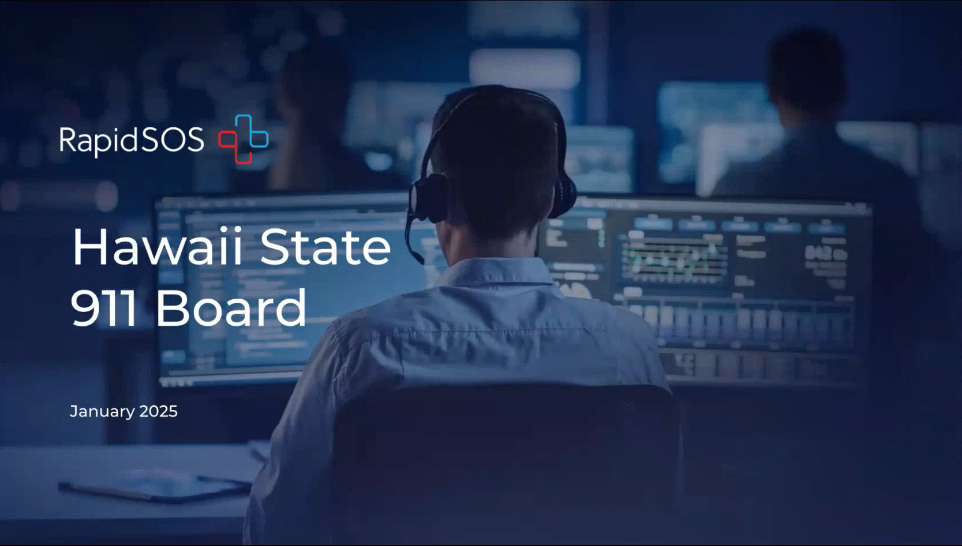
Carla Even introduced herself and gave a brief overview about RapidSOS, which is an intelligent safety platform that provides solutions/assistance to 911 dispatchers. She added that the services include caller locations, staffing issues, call automation, generating reports from Intelligent Analyst, 911 texting, network redundancy, etc. She also mentioned that she was in the 911 dispatch center for 24 years. Matthew MacDonald introduced himself and stated that he is on the sales engineering team at RapidSOS.

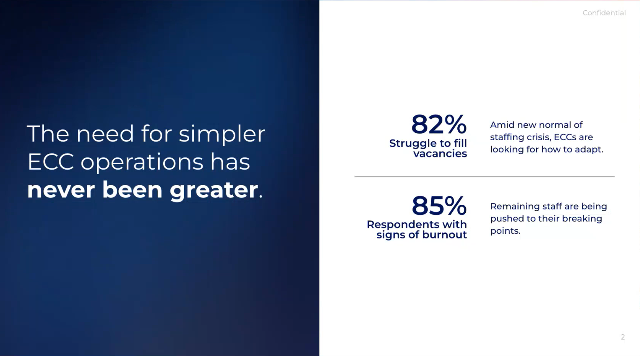
Seth Wold stated that a common issue is staffing shortages caused by burnout, workflow issues, etc.

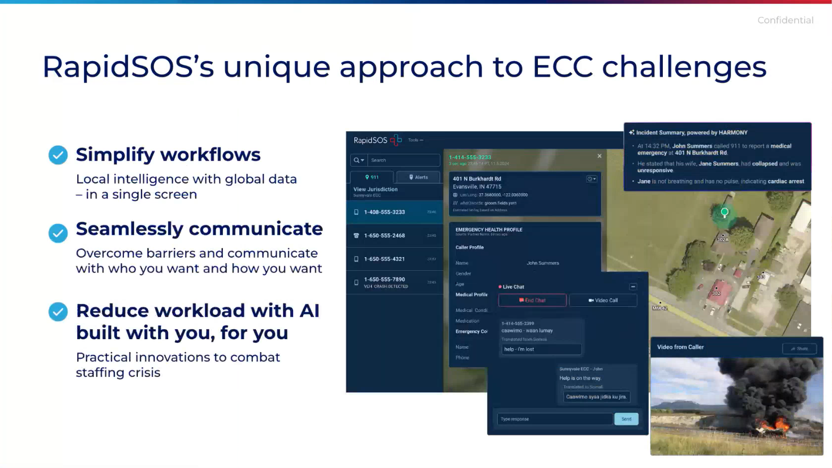
Seth Wold stated that RapidSOS’ solutions are aimed to aid ECC operations by leveraging technology to simplify workflows and alleviate workloads while maintaining a high level of integrity. He then offered to meet with each ECC individually to discuss any questions and/or concerns.

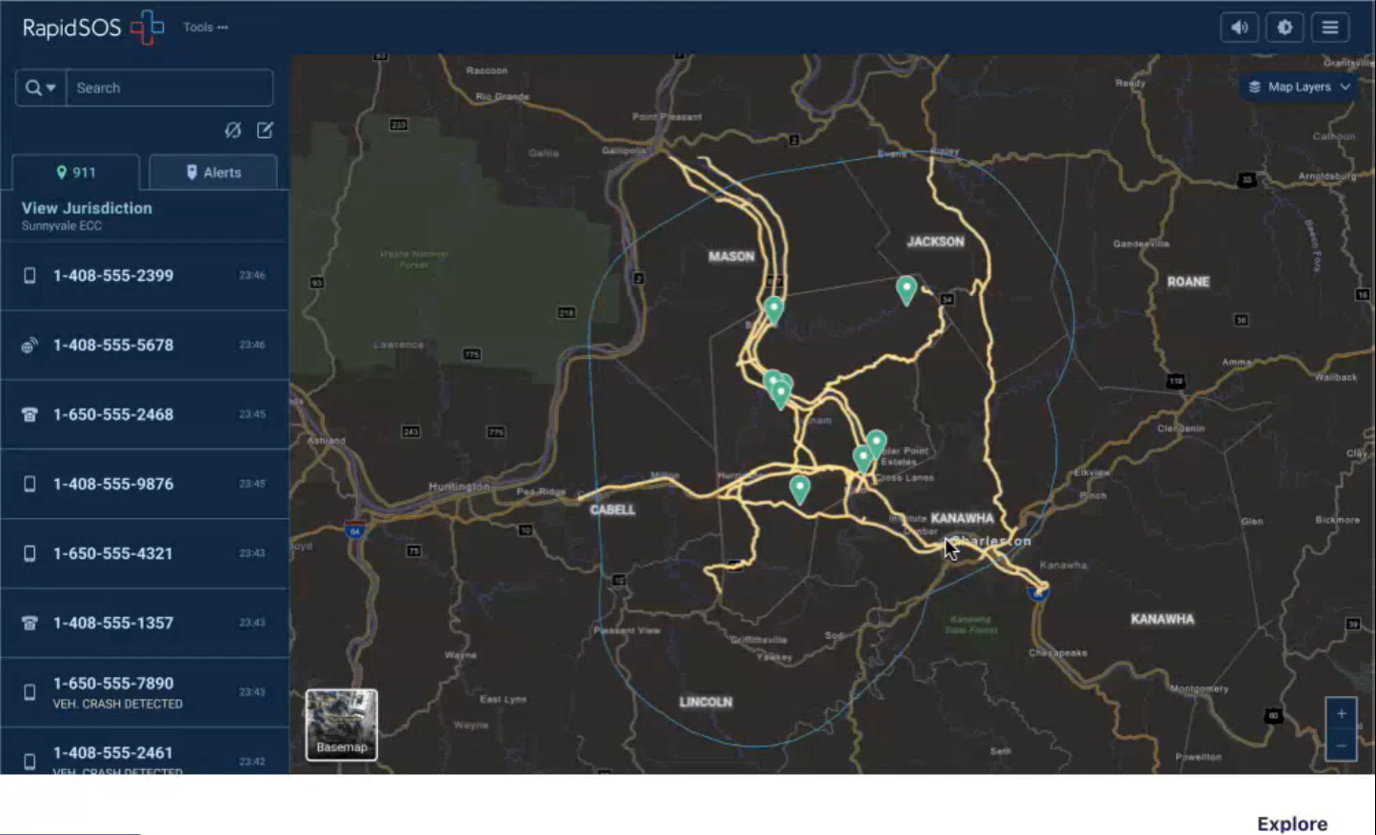
Matthew MacDonald stated that RapidSOS continues to streamline and simplify workflows. The above slide shows the RapidSOS UNITE (“RSOSU”) platform that provides critical information for call handling purposes within the CAD map. He added that the displayed calls on the left column have been expanded from wireless calls only to include both landline and VoIP calls. These calls are taken directly from the ECC itself into RSOSU and are able to synchronize with the call handling system via call taker mode, which allows the user to enter the position ID tied to a console position for integration purposes.

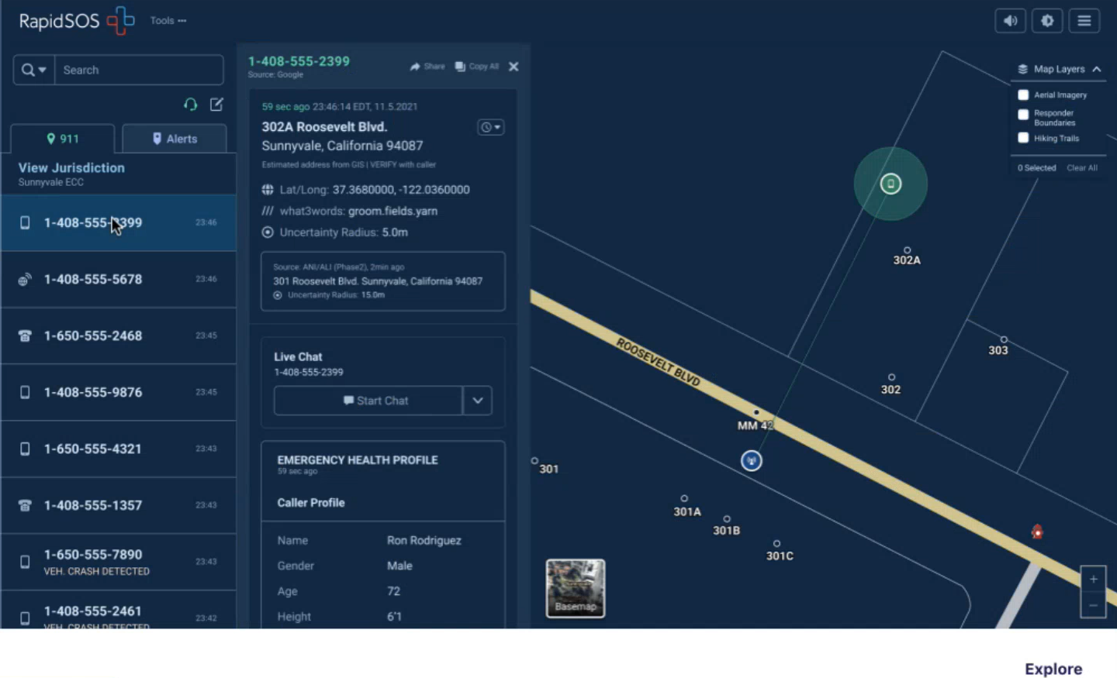
Matthew MacDonald stated that each ECC is able to import its locally authoritative GIS data directly into RSOSU. Furthermore, the platform supports an Esri based map with various layers such as road center lines, address points, fire hydrant locations, satellite view, aerial imagery, etc. He added that it is easily interchangeable within the platform to use either the locally authoritative GIS or Google Maps (Google view features such as street and satellite are both available).

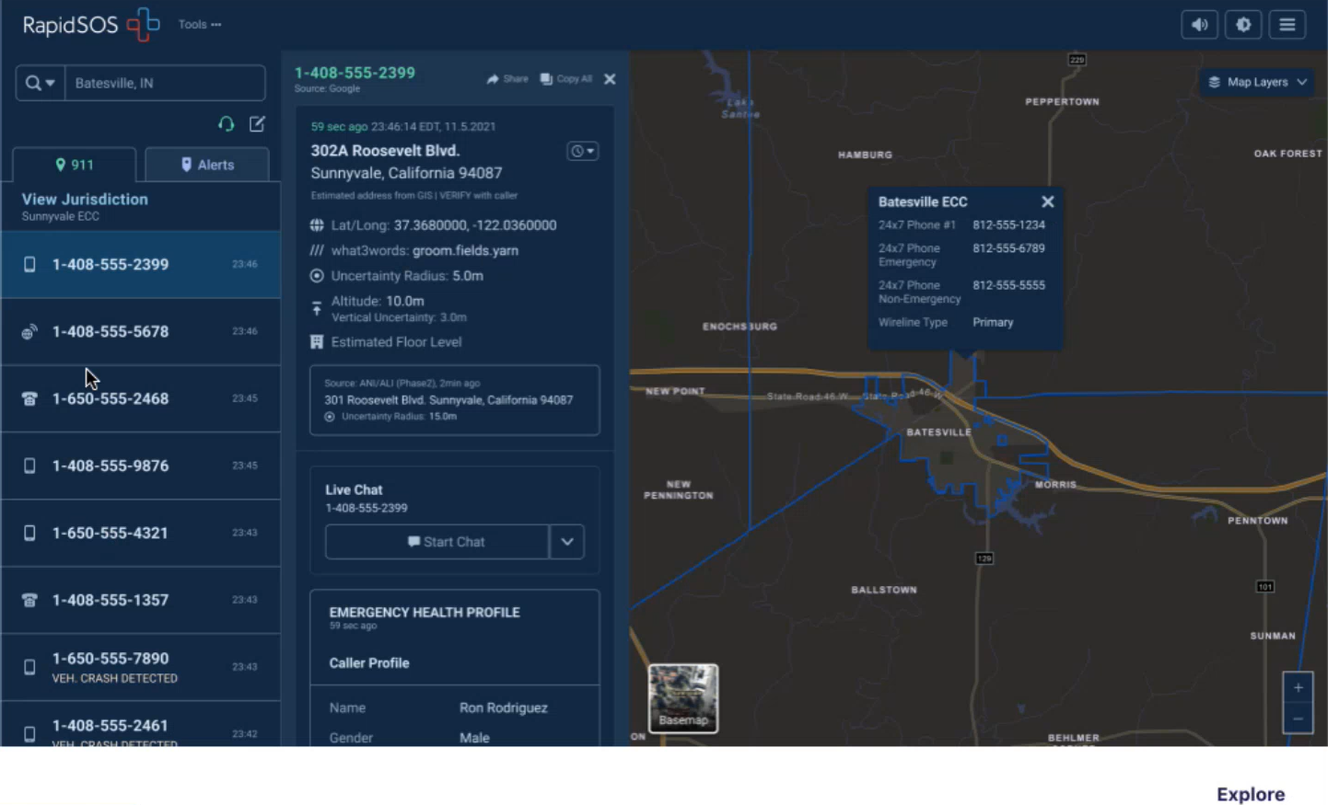
Matthew MacDonald stated that RSOSU integrates the NENA EPRC layer for call boundaries, ECC contact information, etc.

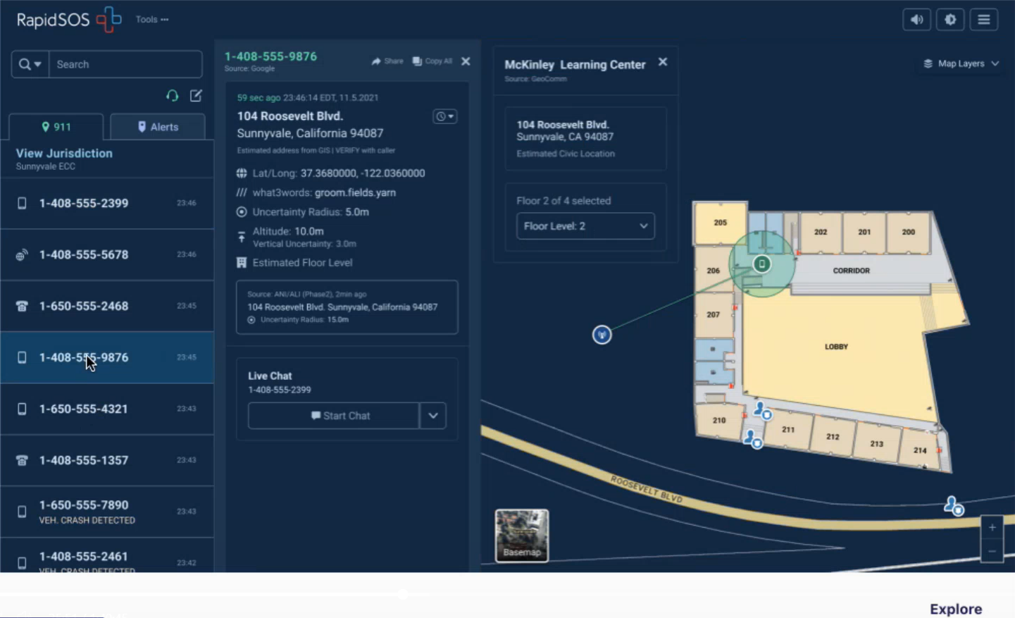
Matthew MacDonald stated that RSOSU added indoor mapping data (provided by GeoComm using Esri data) to enhance situational awareness. He mentioned that the data within RSOSU is hosted in the cloud environment and can potentially be seen as a viable backup option. Carla Even highlighted specific benefits of RSOSU such as call taker mode to allow dispatchers to manage a high volume of calls and the efficiency of a single map tool with multiple layers/features.

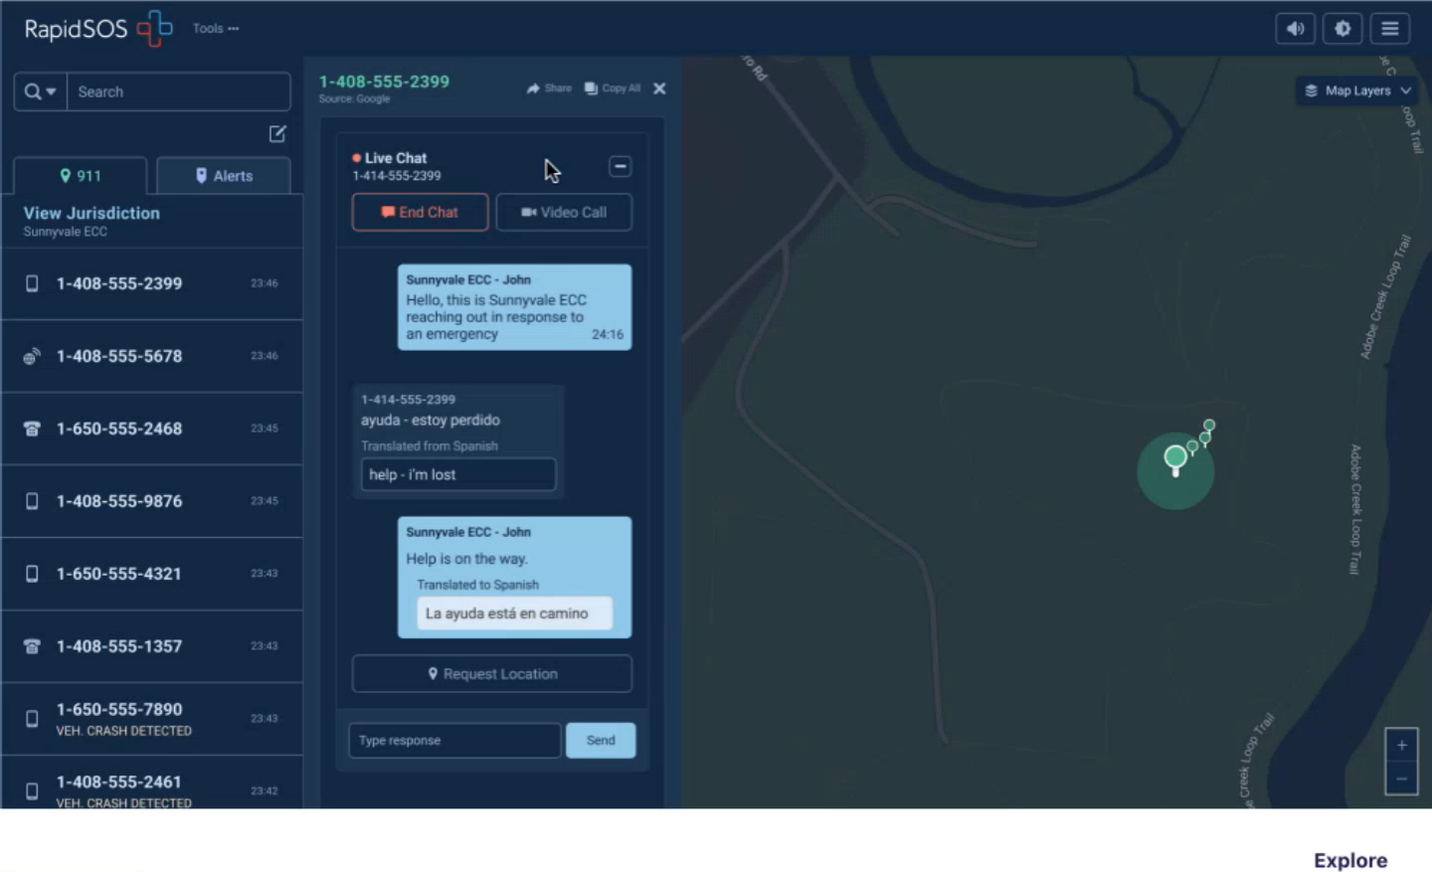
Matthew MacDonald stated that RSOSU has a communication tool to support text from 911 within the platform. He highlighted an example to reach out to an abandoned call via text message. He added that the platform has built-in two-way text translation for over 175 languages.

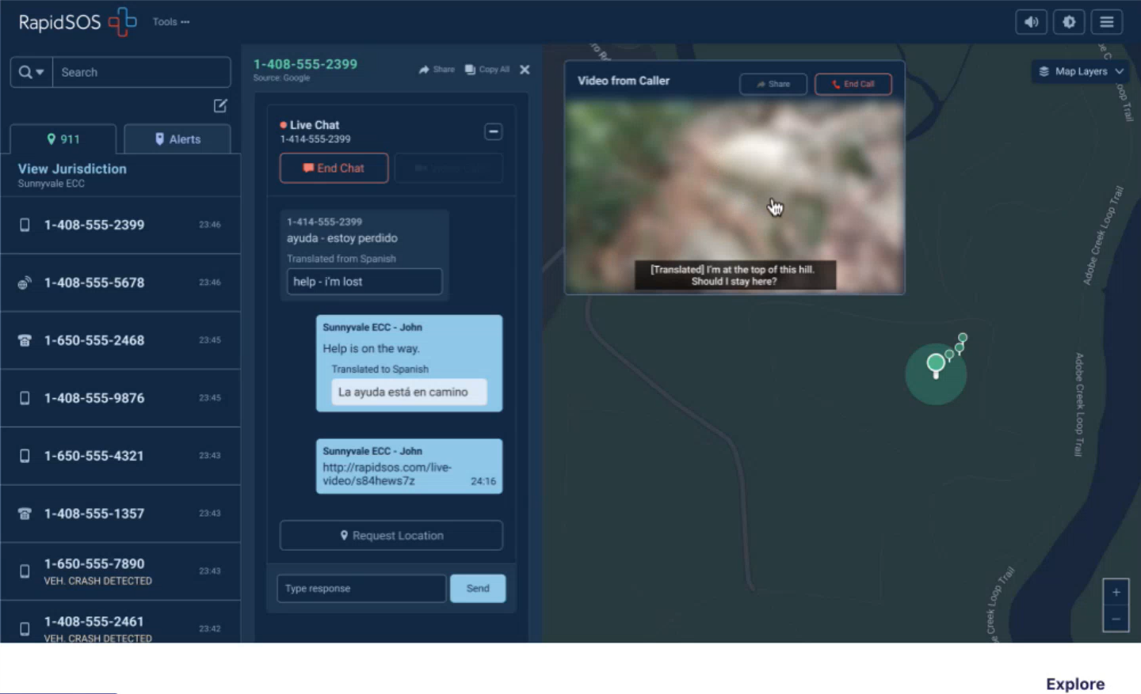
Matthew MacDonald stated that RSOSU supports video calls through links sent by the ECC to the caller. He added that the video call is initially blurred to provide discretion to the call taker/dispatcher on whether or not to keep blurred or unblur. Furthermore, any audio is both transcribed and translated.

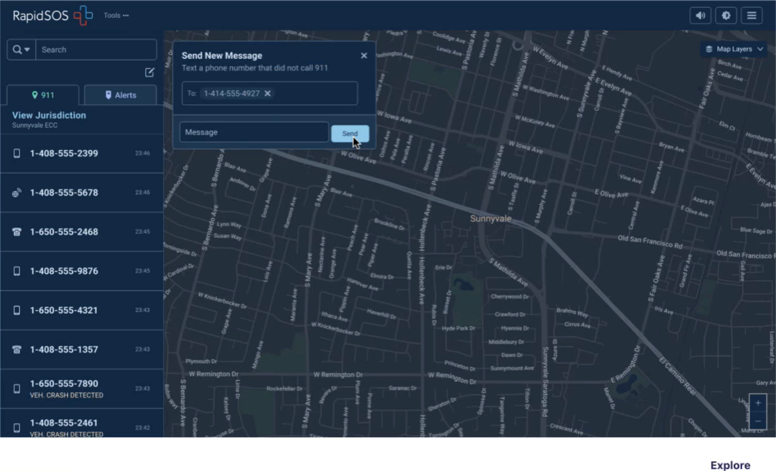
Matthew MacDonald stated that RSOSU provides the user to ability to send out a text message that is not the result of a 911 call for commonly requested information. He added that there is an option for pre-canned texts.

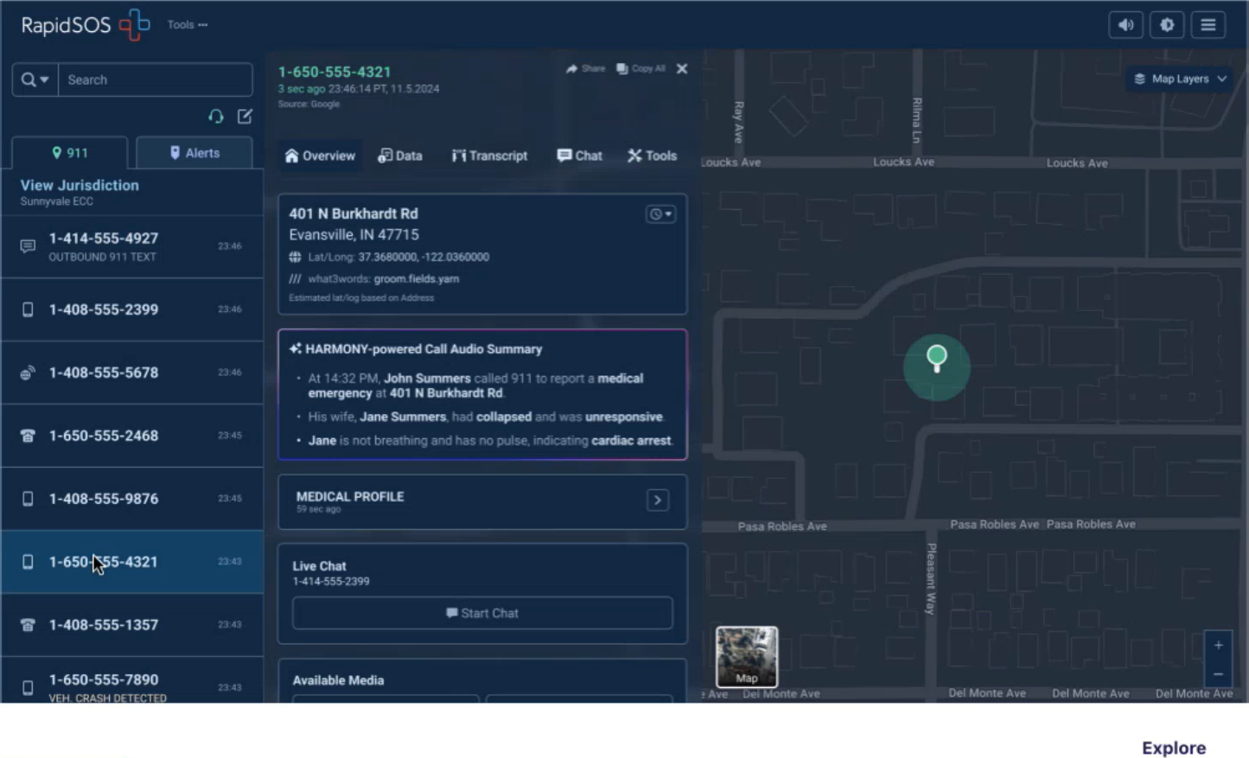
Matthew MacDonald stated that RSOSU’s Harmony AI engine allows the user to ingest audio from 911 calls to provide real-time transcription, summarization, keyword highlighting, translation, etc. Carla Even added that this call summary feature can be utilized to help with staffing issues or for training purposes. She also mentioned that the ability to text from 911 could be useful during phone call failure situations.

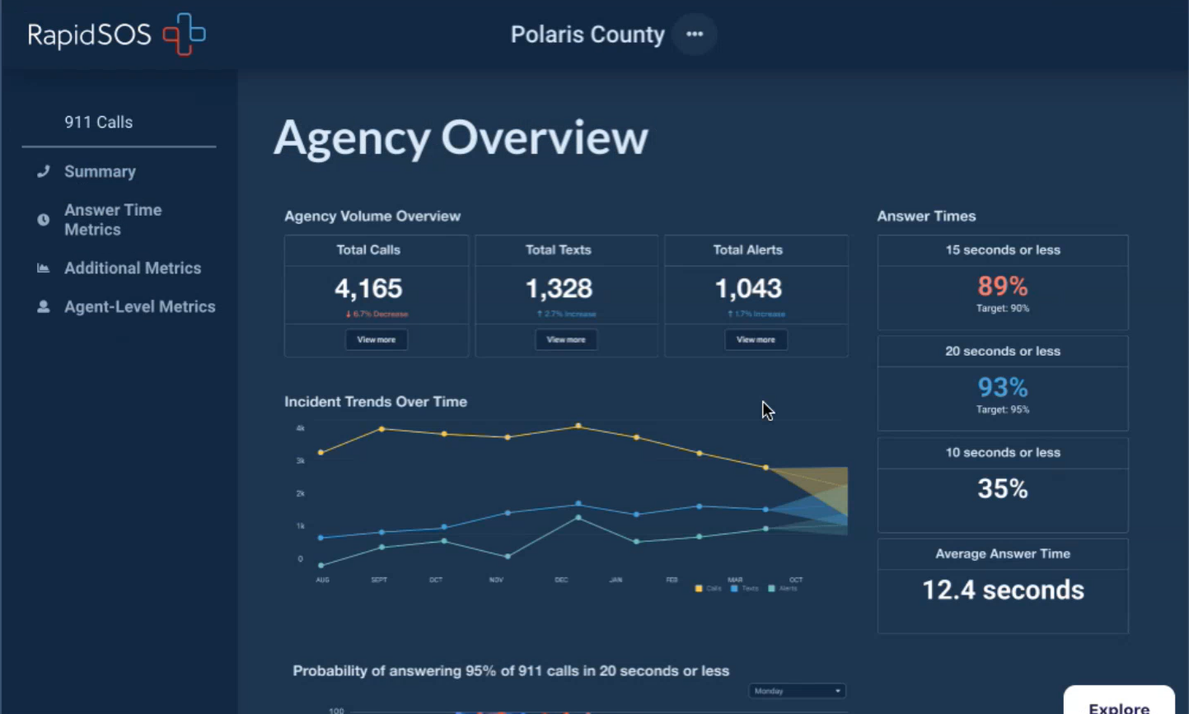
Matthew MacDonald stated that RapidSOS Intelligent Analyst provides analytics/reports to both the call taker and/or administrators. For example, this includes calls/texts volume, performance metrics (e.g. ECC or individual), trends (e.g. answer times and call durations), etc. He added that the information provided by Intelligent Analyst could assist with decision making such as identifying training opportunities. The ECC also has the ability to export the collected raw data for data manipulation and/or advanced filtration. Seth Wold stated that RSOSU collects all the data/information tied to call handling equipment, digital alerts, text messages, etc. He added that this ensures the call takers receive credit for all aspects of their work. Carla Even commented that the dashboards within RSOSU eases the burden to generate reports.

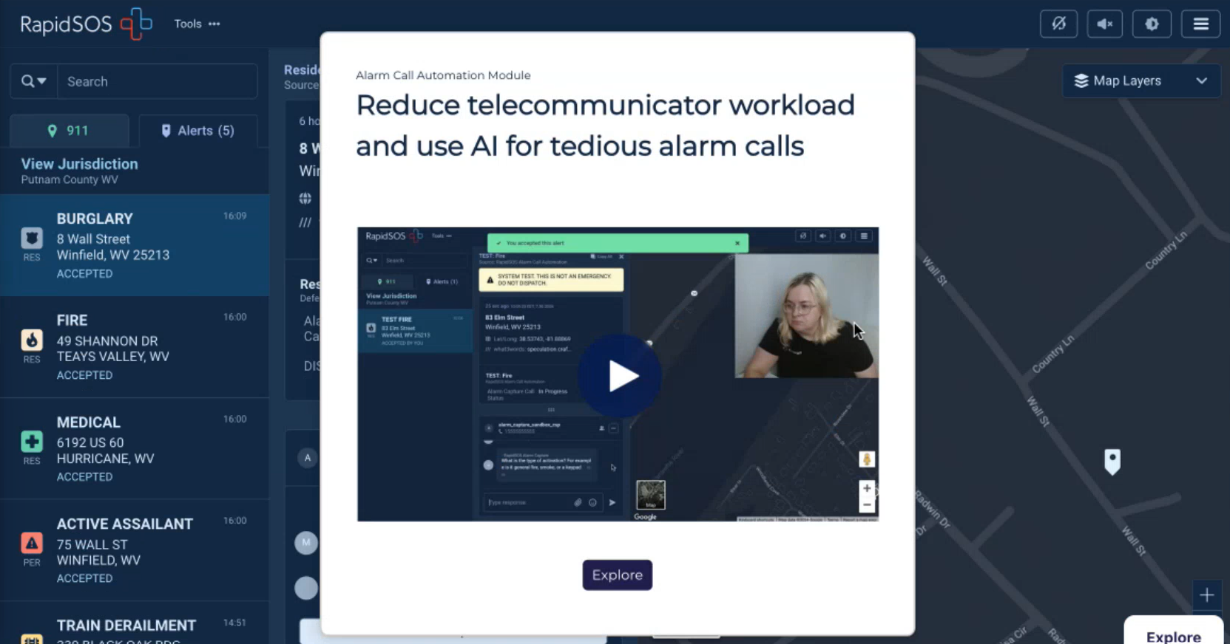
Matthew MacDonald stated that RSOSU has a feature to support call automation for instances such as non-emergency and/or administrative calls. He then showcased an example through a pre-recorded video. He added that all the information, recorded video/audio clips, and transcriptions obtained by the AI powered call taker are captured in the platform for review and use. Carla Even stated that service calls for alarm related alerts can be automated with the use of an API between RSOSU and the ECC’s CAD system, which could help with staffing issues. She added that the types of calls will be expanded in the future. Seth Wold stated that the AI powered call taker’s primary focus is to field routine calls that typically follow the same script and questions.

Stephen Courtney asked Matthew MacDonald if the AI aspect of RSOSU has the ability to assess the sentiment and stress level of the call taker or not. Matthew MacDonald responded stating that summarization and keyword highlighting have been implemented while sentiment analysis is forthcoming as they capture additional data.

Stephen Courtney asked Seth Wold if the RSOSU translation tool includes Filipino languages. Seth Wold responded stating that both Tagalog and Cebuano are supported.

Carla Even commented that RapidSOS offers a multitude of solutions and she is willing to conduct a business review with each ECC if desired to help troubleshoot and alleviate any pain points.

Kenison Tejada asked Matthew MacDonald if the indoor mapping data is updated automatically or if it is changed interactively with the ECCs. Matthew MacDonald responded stating that typically the ECC will lead setup/updates and will collaborate with both RapidSOS and GeoComm. He added that it usually takes about a day or two for the uploads to go live.

Kenison Tejada asked Matthew MacDonald if the mapping data of an ECC experiencing an outage will be available at the ECC they get re-routed to for mutual aid purposes. Matthew MacDonald responded stating that this is possible to share incidents between different accounts and the setup of new boundaries. He added that RapidSOS’ support team is available 24/7. Carla Even added that tactical accounts were set up to assist with the California fires.

Seth Wold commented that Carla Even championed the effort to secure the best pricing options regarding modules for the state of Hawaii.

Shawn Kuratani commented that RapidSOS has been helpful as a backup in situations when ANI/ALI is unavailable.

      - Advisory Committee – Rebecca Lieberman
        - Updates on Legislative Session
Executive Director stated that he attended budget briefings for both the Ways and Means Committee and the Finance Committee this past Tuesday on 1-7-2025. He added that the 911 Board’s budget request is to permanently increase the legislative spending ceiling by $5,000,000.00. He mentioned that there were no immediate comments and/or concerns from either committee.

  - Finance Committee – Edward Fujioka
    - Review of Monthly Y-T-D (Year to Date) Cash Flow
December 2024 Cashflow Statement:

Surcharge Collection: $1,017,657
Interest Income: $114,045
Total Receipts: $1,131,701
Total Disbursements: ($305,133)
Net Receipts/Disbursements: $826,568
Net Encumbrances Adds/(Paydown): ($82,837)
Net Cash Inflow/(Outflow): $743,731
Outstanding Encumbrances: $12,685,133
Net Bank Balance: $46,941,395
Unencumbered Cash Balance: $34,256,262

    - Honolulu Police Department Requesting $4,500.00 for 1 Additional Personnel to Attend 9-1-1 Goes to Washington (GTW) 2025
Edward Fujioka stated the item above. Ah Lan Leong explained that the travel group normally consists of three individuals total and currently for this conference there are only two individuals. Reed Mahuna motioned to approve this request. Tony Velasco seconded the motion. A voice vote was taken, motion was unanimously approved.

- Public Service Answering Point Status Updates on Recruitment and other Personnel Issues
  - Kauai Police Department – Ariel Ramos
    - Update on Recruitment Process/Strategies and Personnel Training
Ariel Ramos stated that they will have a retiree return as a contract hire. She added that they are currently awaiting the status of 2 applicants.

    - Update on Personnel Issues and Vacancies
Ariel Ramos stated that they currently have 9 full-time dispatchers and 1 dispatcher on extended leave. She added that they receive assistance from 5 former dispatchers employed within the county and 5 sworn personnel to alleviate staffing shortages.

  - Oahu Police Department – Matthew Kurihara
    - Update on Recruitment Process/Strategies and Personnel Training
Calvin Sung on behalf of Matthew Kurihara stated that they currently have 2 personnel in training.

    - Update on Personnel Issues and Vacancies
Calvin Sung on behalf of Matthew Kurihara stated that they recently lost 3 personnel due to retirement. He added that they are in the process of working with the union to utilize sworn personnel as non-emergency call takers to alleviate staffing shortages. Furthermore, they are currently pending approval to have retirees as contract hires.

  - Oahu Fire Department – Shawn Kuratani
    - Update on Recruitment Process/Strategies and Personnel Training
Shawn Kuratani stated that they conducted interviews for 2 captain vacancies. He added that the interviewees both have experience in dispatch and upon acceptance are both slated start in February 2025.

    - Update on Personnel Issues and Vacancies
Shawn Kuratani stated that they will be fully staffed if the two interviewees accept their offers.

  - Oahu Emergency Medical Services – Lorrin Okumura, Diana Chun, Frannie Chung
    - Update on Recruitment Process/Strategies and Personnel Training
Lorrin Okumura stated that they conducted internal recruitment for 1 of the supervisor positions and currently have 5 candidates that will be interviewed. He added that the HR department is handling external recruitment for dispatchers. Furthermore, 4 reliever dispatchers are nearing training completion with another 4 slated to start shortly.

    - Update on Personnel Issues and Vacancies
Lorrin Okumura stated that they currently have 9 vacancies.

  - Maui Police Department – Davlynn Racadio
    - Update on Recruitment Process/Strategies and Personnel Training
Davlynn Racadio stated that they currently have 11 personnel in training. She added that there is a recruitment pause since they have a sufficient amount of current trainees.

    - Update on Personnel Issues and Vacancies
Davlynn Racadio stated that they utilize sworn personnel to assist with call taking to alleviate staffing shortages.

  - Molokai Police Department – Davlynn Racadio
    - Update on Recruitment Process/Strategies and Personnel Training
Please see updates under Maui Police Department.

    - Update on Personnel Issues and Vacancies
Please see updates under Maui Police Department.

  - Hawaii Police Department – Robert Fujitake
    - Update on Recruitment Process/Strategies and Personnel Training
Zachary Fernado on behalf of Robert Fujitake stated that they currently have 5 personnel in training. He added that they are scheduled to interview 3 applicants by the end of January 2025.

    - Update on Personnel Issues and Vacancies
Zachary Fernado on behalf of Robert Fujitake stated that they lost 1 personnel due to retirement at the end of December 2024. He added that they have 6 total vacancies.

  - Hawaii Fire Department – Stacy Domingo
    - Update on Recruitment Process/Strategies and Personnel Training
Stacy Domingo stated that they currently have 1 personnel in training. She added that they are in discussion with the HR department to potentially hire personnel around March 2025 or April 2025.

    - Update on Personnel Issues and Vacancies
Stacy Domingo stated that they lost 1 personnel due to resignation in December 2024. She added that they currently have 9 personnel and 15 total vacancies.

- Items for Discussion, Consideration, and Action
  - Additional Items Proposed by Meeting Attendees

- Announcements
  - Future Virtual Meeting Dates/Times (9:00AM-12:00PM)
    - [Tentative] Thursday, February 13, 2025 (Combined Meeting)
    - [Tentative] Thursday, March 13, 2025 (Combined Meeting)

  - Future Conference Dates (3 Months of Advanced Approval Required)
    - 9-1-1 Goes to Washington (GTW) February 23-26, 2025, Arlington, VA
    - NENA Conference (National Emergency Number Association) June 21-26, 2025, Long Beach, CA
    - APCO Conference (Association of Public-Safety Communications Officials) July 27-30, 2025, Baltimore, MD

  - Additional Announcements from Meeting Attendees
Davlynn Racadio questioned the accuracy of the 911 call volume captured in V2X’s December 2024 monthly status report for Maui. Francis Alueta responded stating that he will follow up and look into this inquiry.

Davlynn Racadio requested a list of attendees for 9-1-1 Goes to Washington (GTW) February 23-26, 2025, Arlington, VA that includes name, department, title, and local contact number so that she can handle the arrangements/logistics for the upcoming meetings.

- Open Forum: Public comment on issues not on the Board Meeting Agenda
There was no public comment on issues not on the agenda.

- Adjournment
Board Chair requested a motion to adjourn the meeting. Tony Ramirez motioned to adjourn the meeting. Tony Velasco seconded the motion. A voice vote was taken, adjournment was unanimously approved. The meeting was adjourned.

