JOSH GREEN, M.D.  GOVERNOR  Ke Kiaʻāina |  | KEITH A. REGAN  COMPTROLLER  Ka Luna Hoʻomalu Hana Laulā  MEOH-LENG SILLIMAN  DEPUTY COMPTROLLER  Ka Hope Luna Hoʻomalu Hana Laulā
STATE OF HAWAIʻI | KA Mokuʻāina o Hawaiʻi

DEPARTMENT OF ACCOUNTING AND GENERAL SERVICES | KA ʻOihana LOIHELU A LAWELAWE Laulā
P.O. BOX 119, HONOLULU, HAWAII 96810-0119

Communications, Technical, and Finance Meeting
(Combined Meeting)

Thursday, September 12, 2024
9:00 am – 12:00 pm

Virtually Held Meeting with Physical Location at Kalanimoku Building Room 426, 1151 Punchbowl Street, Honolulu, Hawaii 96813 is available to the public and is guaranteed to be connected to the remote virtual meeting.

MEETING MINUTES

September 12, 2024: Joint Committee and Board Meeting (youtube.com)

Communications Committee Members Present: Davlynn Racadio (MPD)

Communications Committee Members Not Present: Thalia Burns (NENA/APCO), Lavina Taovao (KPD)

Technical Committee Members Present: Shawn Kuratani (HFD), Tony Ramirez (VSE), Kenison Tejada (FirstNet), Tony Velasco (DIT)

Technical Committee Members Not Present: Thalia Burns (NENA/APCO), David Miyasaki (KPD)

Finance Committee Members Present: Edward Fujioka (EMS), Stephen Courtney (C&C of Honolulu), Liz Gregg (AT&T), Matthew Kurihara (HPD), Todd Omura (CIO Designee), Tony Velasco (DIT)

Finance Committee Members Not Present: Reed Mahuna (HIPD)

Staff: Royce Murakami (911 Board), Benson Leung (911 Board), Stella Kam (AG)

Guests: Francis Alueta (HT), Phillip Banquel (KPD), Nani Blake (T-Mobile), Ruth Cruz (Intrado), Stacy Domingo (HIFD), Wayne Hirasa (Alakaina), David Jones (Mission Critical), Stella Kam (AG), Kevin Kaneshiro (HIFD), Elliott K. Ke (KPD), Ji Sook Kim (Consumer Advocate Designee), Glenn Kobashigawa (HT), Patrick Leddy (LCC), Rebecca Lieberman (Spectrum), Lorrin Okumura (EMS), Gary Pulford (Mission Critical), Ariel Ramos (KPD), Corey Shaffer (Verizon), Calvin Sung (HPD), John Talich (HIPD), Keola Tom (MPD), Nathan Wilson (HIFD)

- Call to Order, Public Notice
The meeting was called to order by the Board Chair. Public notice was given.

- Public Testimony Will Be Taken on All Agenda Items as Those Items Occur During the Meeting

- Roll Call, Quorum
A roll call was taken, quorum was present for all committees except the Communications Committee.

- Review and Approval of August Meeting Minutes
Board Chair requested a motion to approve August’s Meeting Minutes. Tony Velasco motioned to approve August’s Meeting Minutes. Rebecca Lieberman seconded the motion. A voice vote was taken, motion was unanimously approved.

- Committee Updates by Committee Chairs
  - Communications Committee – Davlynn Racadio
    - No Updates

  - Technical Committee – Shawn Kuratani
    - AGENT511 Presentation (Jay Malin)
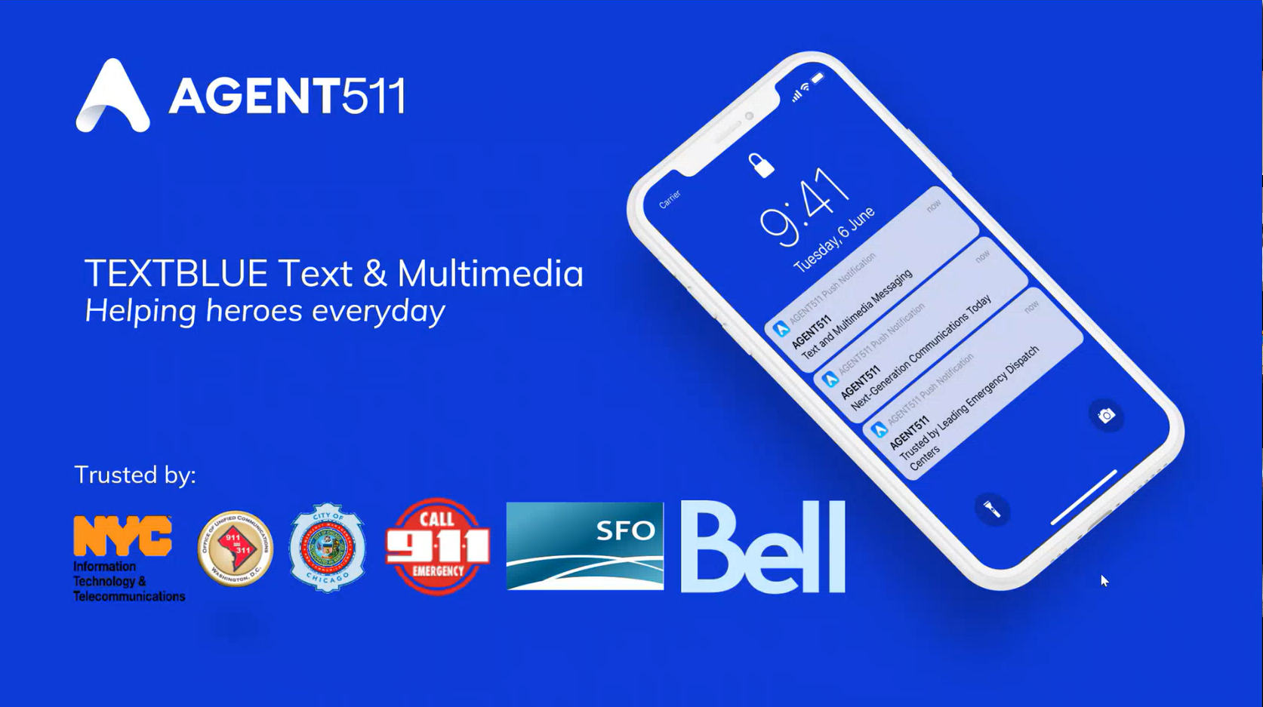
Jay Malin stated he will now give a presentation on AGENT511 and share a demo of the platform known as TEXTBLUE regarding accessible capabilities.

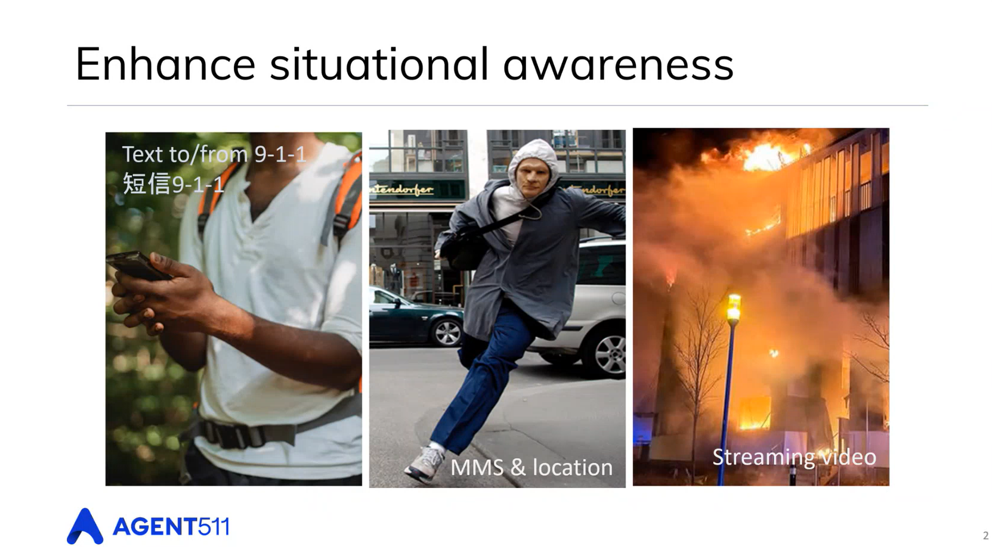
Jay Malin mentioned the prevalence and availability of Text to 9-1-1 in Hawaii. He said the focus of the presentation will be newer features such as Text from 9-1-1, MMS & location, and streaming video capabilities. In addition, integration opportunities will be covered.

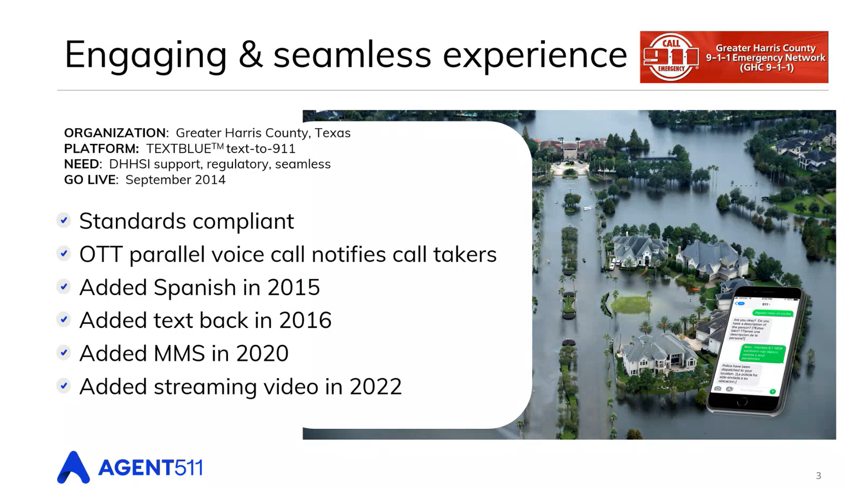
Jay Malin stated that the platform has been available since 2014, which coincides with the proposed rulemaking to deploy Text to 9-1-1. He stated the expansion of Text to 9-1-1 includes multi-language support, text back, MMS prerecorded pictures & videos, streaming video, and developing AI capabilities.

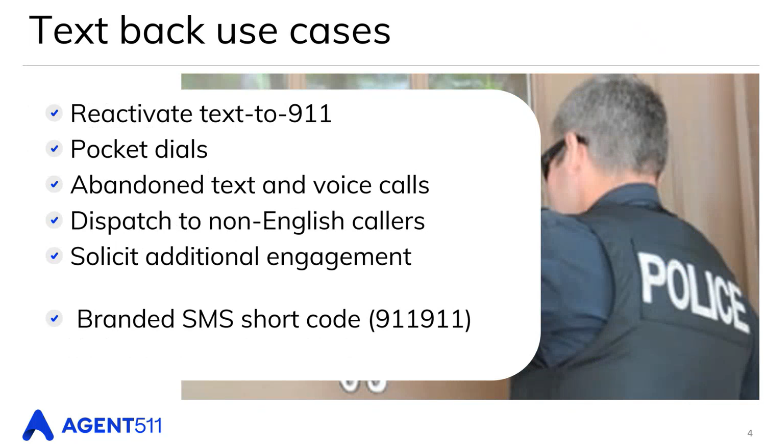
Jay Malin stated that the most common text back use cases include the ability to reactivate Text to 9-1-1 via outbound texting caused by call drops, pocket dials, abandoned calls, language barriers, and to solicit additional engagement in the form of pictures and videos. He added that the text back features a branded SMS number being “911911” to provide the recipient with validity that the messages are from a legitimate ECC or PSAP.

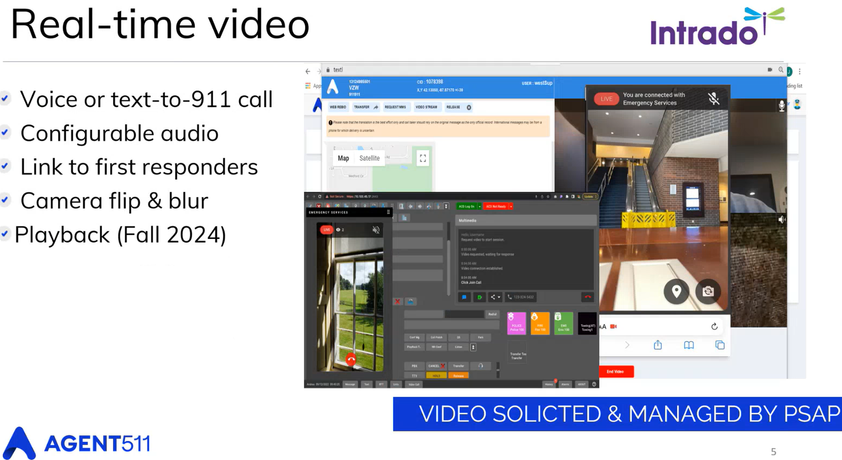
Jay Malin stated the adoption of real-time video being used in 9-1-1 calls has been increasing. He mentioned that AGENT511 has an integration option with Intrado. He added that there is a standalone option within the AGENT511 platform, which is integrated in the RapidSOS portal. He explained that the caller will receive a link via text when where is an opportunity to collect video, which has the capability for one-way or two-way video conversations. He added that the video can be shared to first responders, the ability to connect first responders with the caller, and the dispatcher could disconnect from the call or blur the video. He stated that video playback is forthcoming, which allows users to rewind and/or rewatch recorded videos. He added that the information is archived.

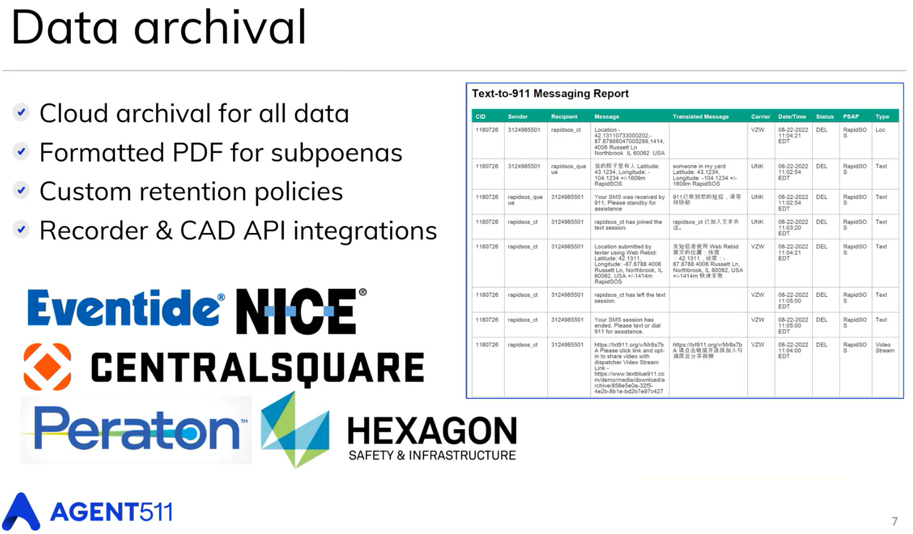
Jay Malin stated that there is a data archival stored within the back end of the AGENT511 platform, which is located in the United States. He added that there are different integration options beyond Intrado or RapidSOS including Eventide, NICE, and other CAD providers. He mentioned the potential capabilities to integrate the platform, the use of familiar common platforms, and standalone options.

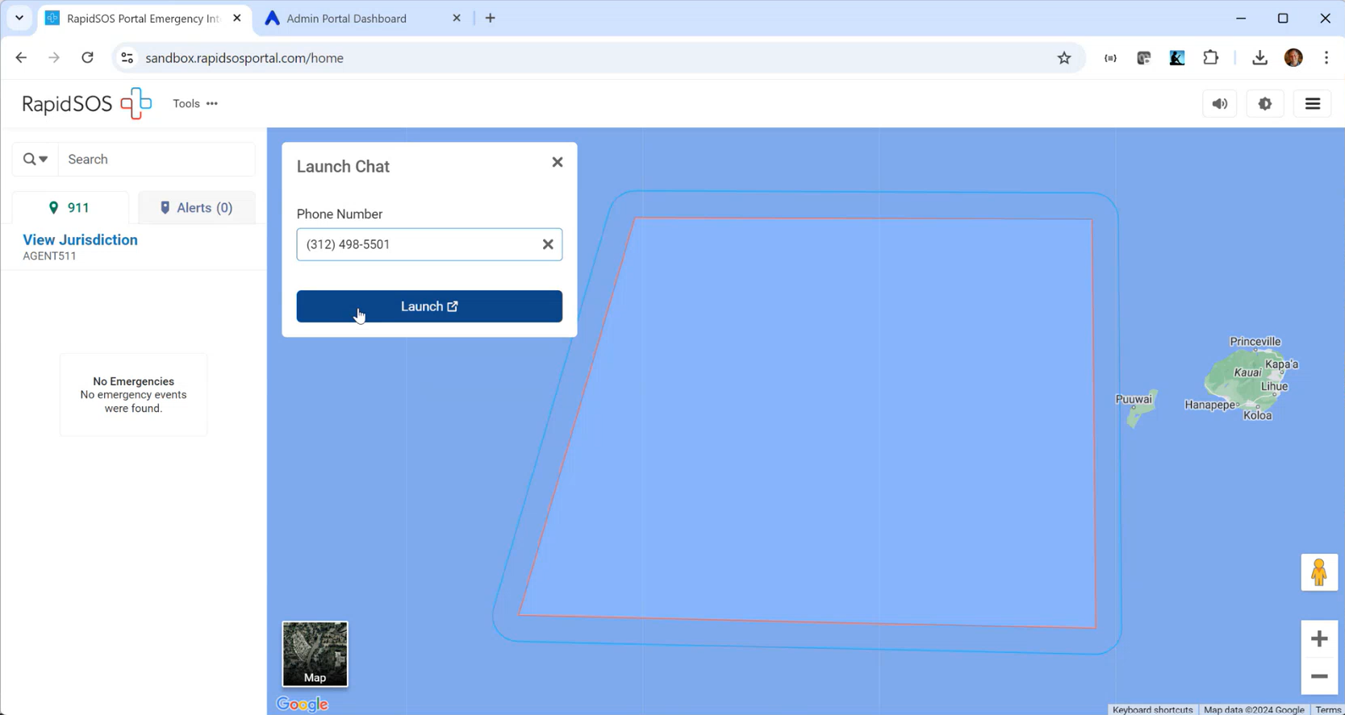
Jay Malin stated that he will now begin the demo by initiating an outbound text within the RapidSOS tool. He added that there is a standalone version within a AGENT511 browser. He stated that this could be used for new text conversations, text back to follow up regarding a prior call or text, and outbound requests for pictures, videos, and/or locations. He mentioned that the platform will identify the caller’s wireless carrier upon initiation of the application. Furthermore, the platform will notify the dispatcher if the recipient’s carrier is unsupported, which will not allow the conversation to be created.

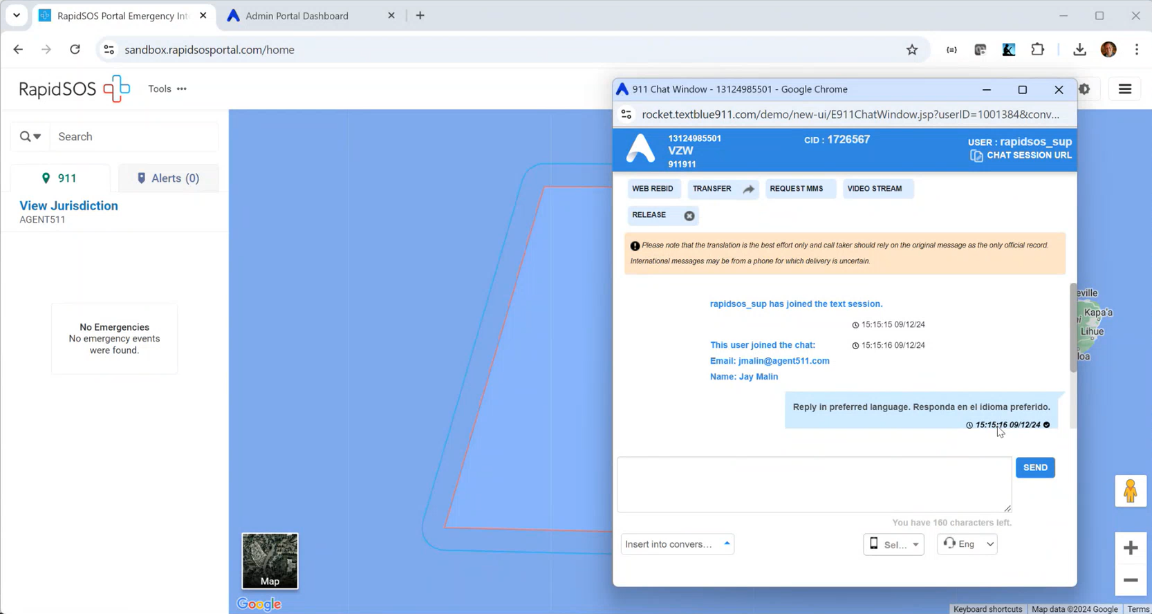
Jay Malin stated that upon conversation creation, the platform will confirm that the user has joined the conversation and sends out a message for the user to participate using their preferred language.

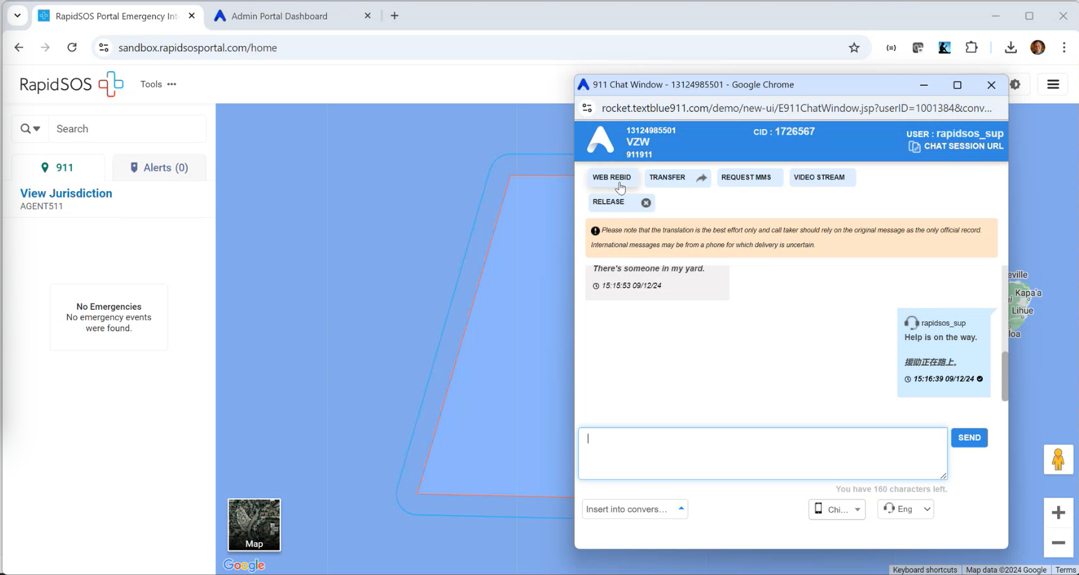
Jay Malin demonstrated the ability to translate messages between the sender and receiver using their preferred languages. He added that Google Translate is embedded within the platform, which can support over 140 different languages. Furthermore, he mentioned the capability to pre-configure messages using any of the supported languages.

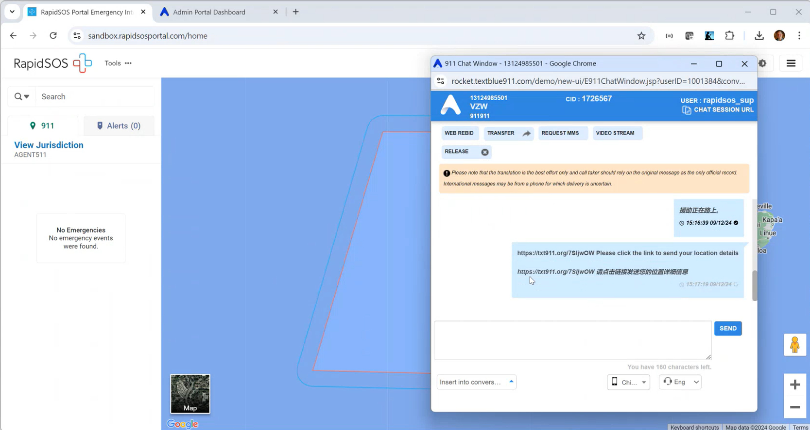
Jay Malin stated that the platform has a built-in option to send out a message to the user if they wish to share their location through a provided link. He added that this utilizes the same GPS location provided to RapidSOS under the privacy considerations from the Wireless Communications and Public Safety Act of 1999.

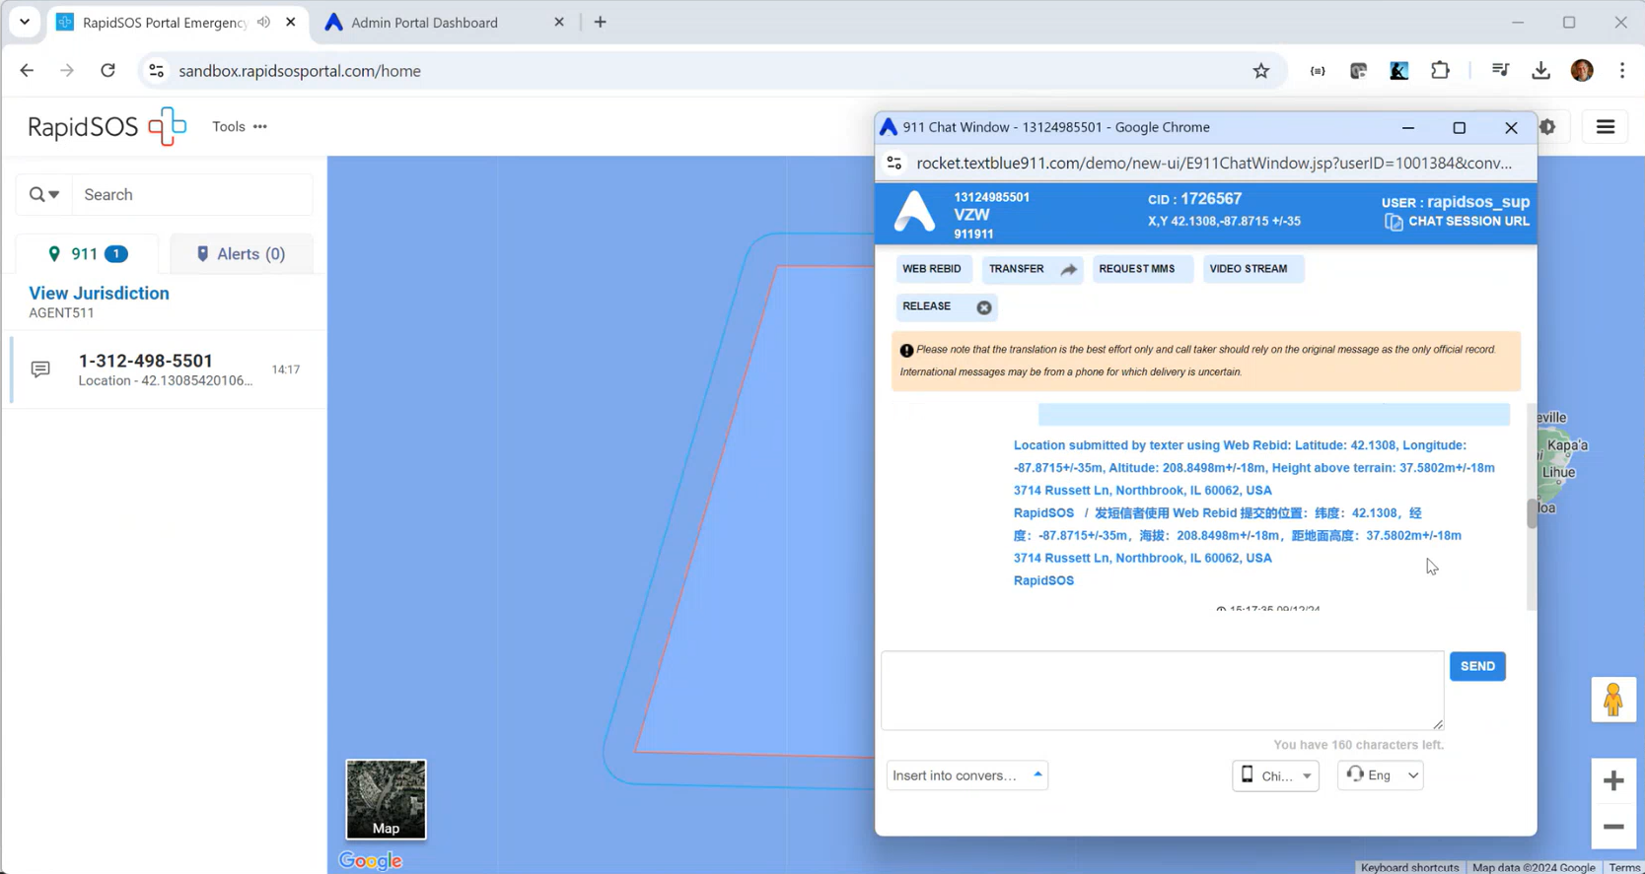
Jay Malin demonstrated an example where the user agreed to share their location, which includes information such as latitude, longitude, z-axis, height above terrain or altitude, and civic address. He mentioned that this location information also populates into RapidSOS. He added that this location information is sent from the device and not through Text to 9-1-1.

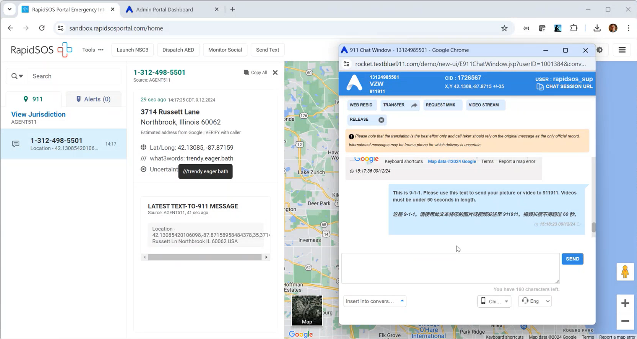
Jay Malin stated that upon receipt of the user’s location information, the conversation may continue with back-and-forth messages and/or requests for pictures or pre-recorded videos (up to 90-seconds in length due to limitations set by carriers). He added that solicitation is required before users are able to send pictures or videos to the 9-1-1 call representative.

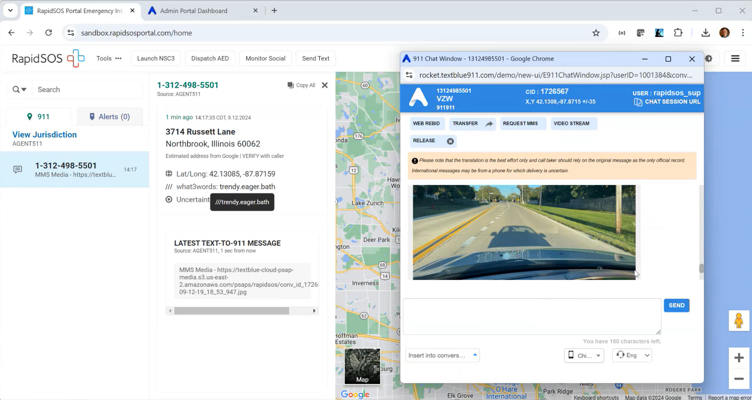
Above slide shows a demonstration of sending a picture with the option for the PSAPs to turn off preview for pictures or videos and require the received media to be fully downloaded. For PSAPs with policies that do not allow call takers and dispatchers to download the received media, they would collect it and have the surveillance officer, supervisor, or position equivalent access it instead.

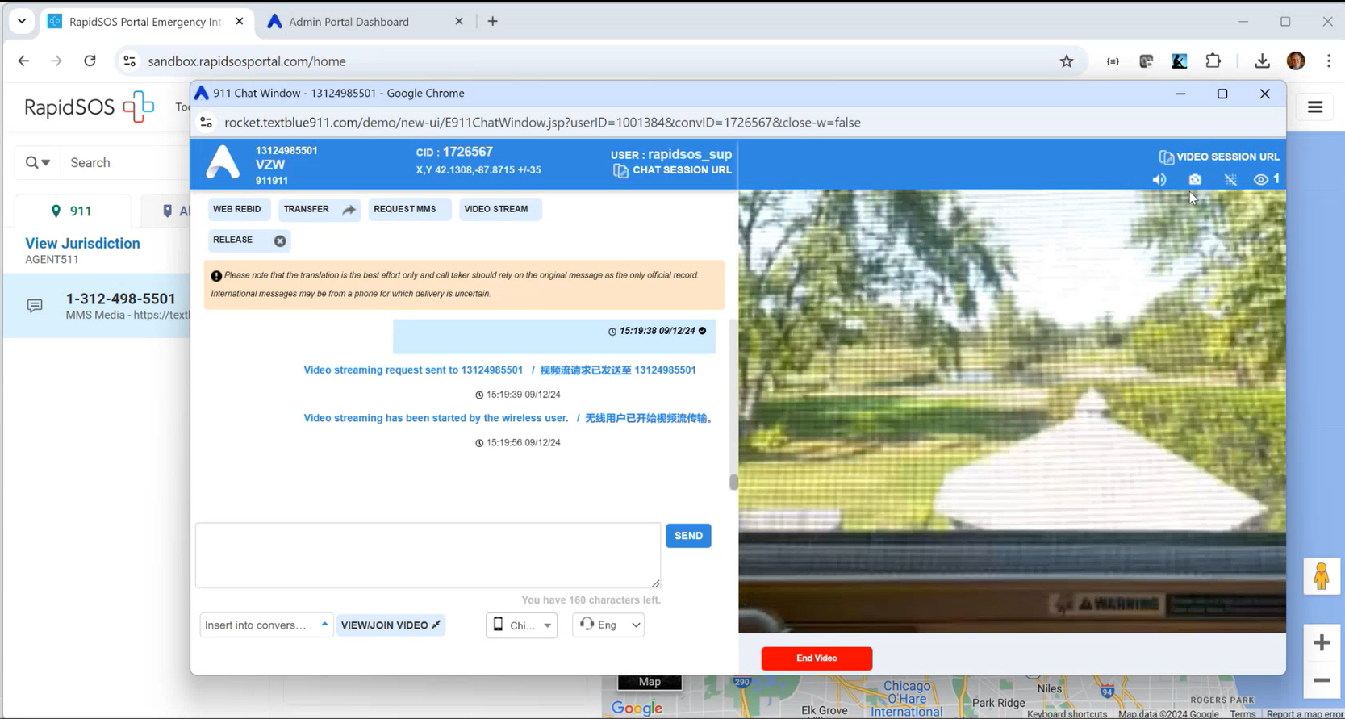
The above slides demonstrate the live streaming of a video call that only allows the call taker/dispatcher to initiate the live video call with added capabilities for the wireless user to share their location, which allows for correlation between what is being shown via video and the physical location. He stated another capability of the product allowing call takers and dispatchers to share an embedded link via text message or CAD incident that connects first responders to the live video call. During the live video call, call takers and dispatchers have the ability to blur the video if deemed necessary and are able to hand off the call to first responders upon successful connection. Furthermore stated, while this hand off is compatible with Next Generation 9-1-1, it is not an inbound video to the ECC or PSAP. All live video calls are fully recorded and available for viewing on the back end post-recording however, reduced bandwidth of the wireless user and PSAP will determine the quality of the video, which will maximize the video quality to the extent that is available and will compress due to the lack of availability.

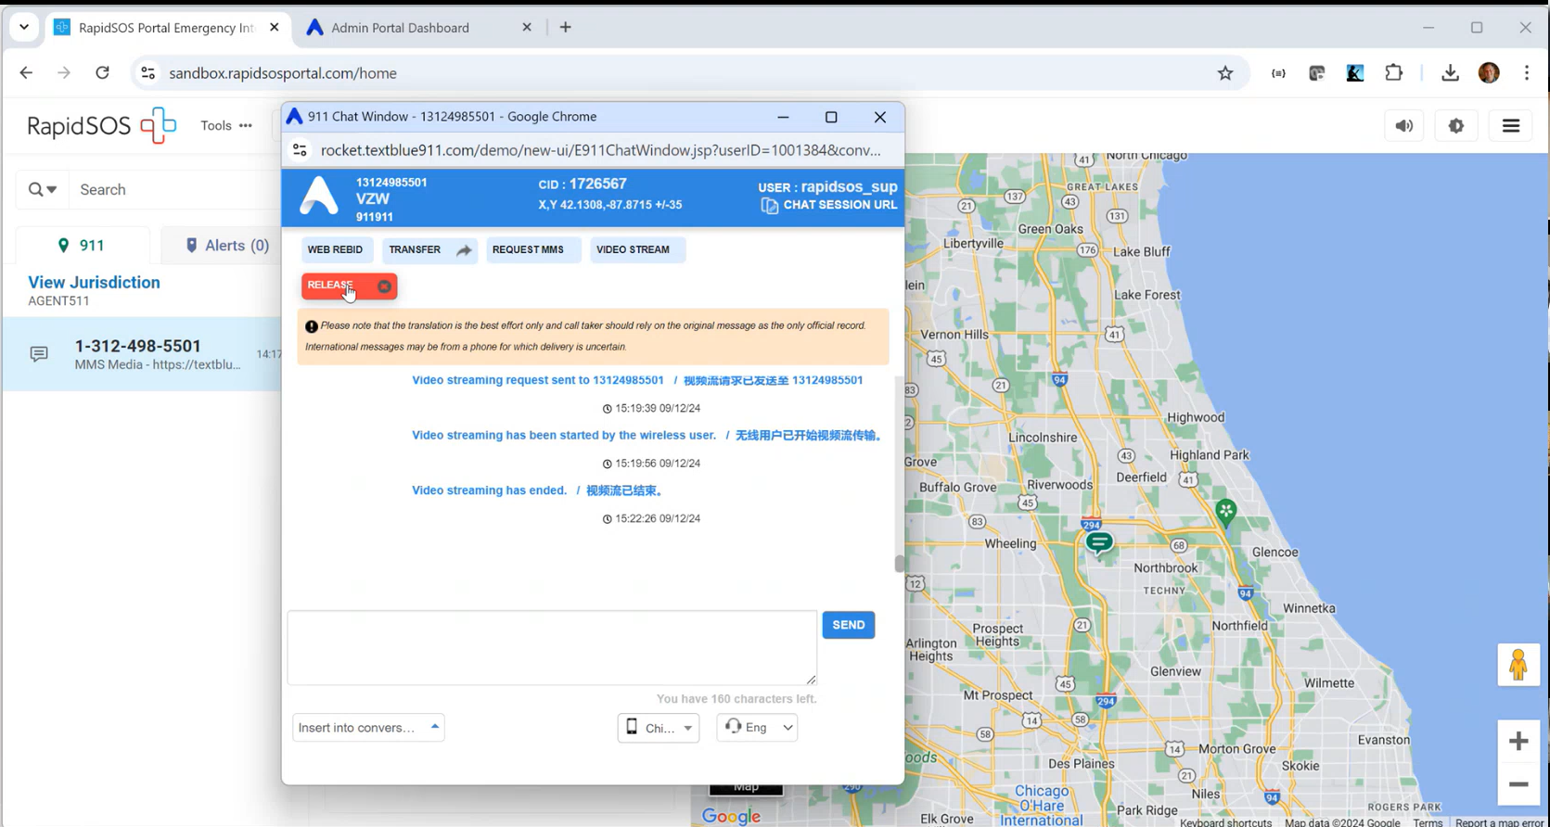
Jay Malin stated that when the live video call ends, the conversation thread remains open for any additional communication and requests for multimedia via text until the call taker or dispatcher decides to release the conversation, which will formally end and close the interaction. He added that the wireless user would then have to send a new text message or call 9-1-1 in order to provide any information. He mentioned the option for two-way video calls and provided an example use case being police officers collecting information for police reports deemed on a non-emergency basis from the public with the aid of video to provide public confidence and comfort.

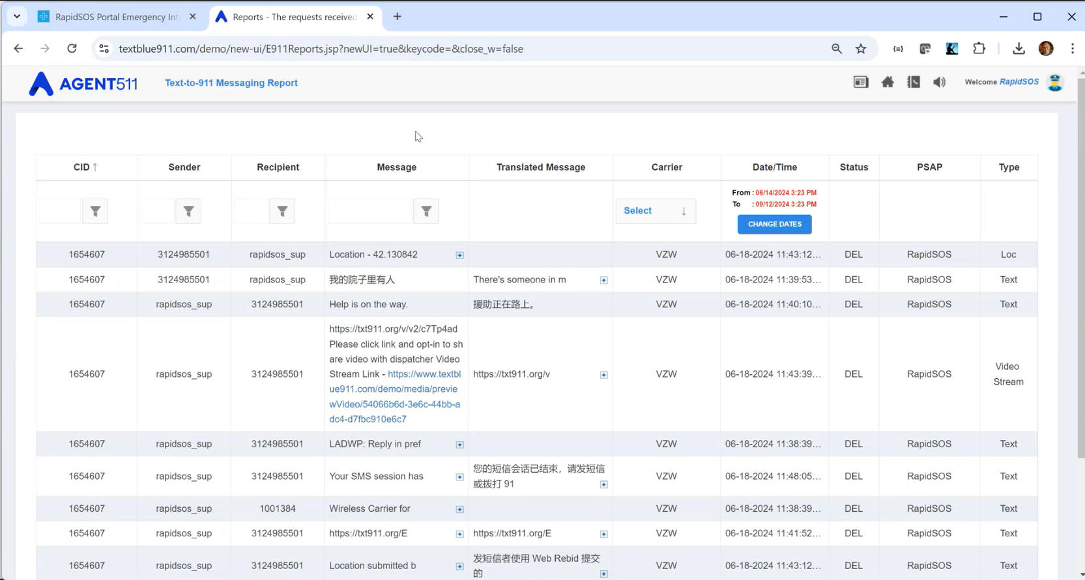
Jay Malin stated that all the text messages (outbound texts, location information, etc.) are collected and saved on the back end. He added that there are integration options for recorders with Eventide, NICE, and some CAD providers. All text and location information are retained and stored for 3 years while multimedia (pictures and videos) for 1 year. He mentioned that the purge policies are customizable based upon the respective State’s requirements and/or individual jurisdictions. He provided an example to showcase the ability to filter/search the archive and download the file if subpoenaed for a specific record.

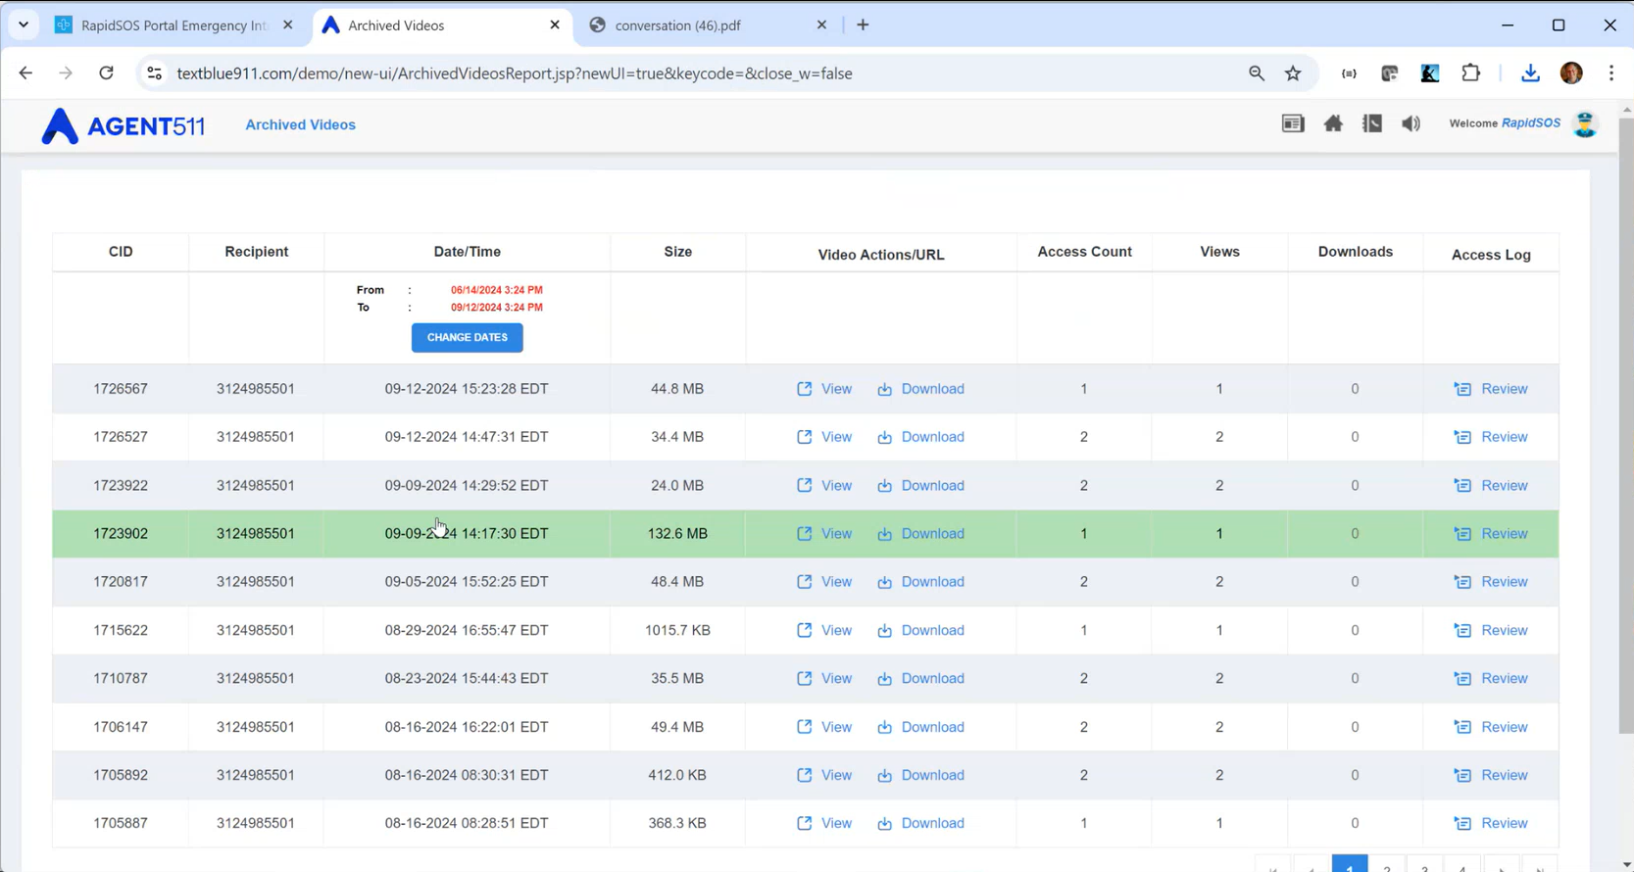
Jay Malin stated that valid login credentials for the platform must be provided in order to view and download files as an added layer of authorization. He added that the embedded link itself will not permit the user to view and/or download any multimedia. If audio is available, the audio is muted upon playback as a default to give the in progress 9-1-1 call precedence. Furthermore, within the platform there is the ability to change the default settings regarding video playback audio.

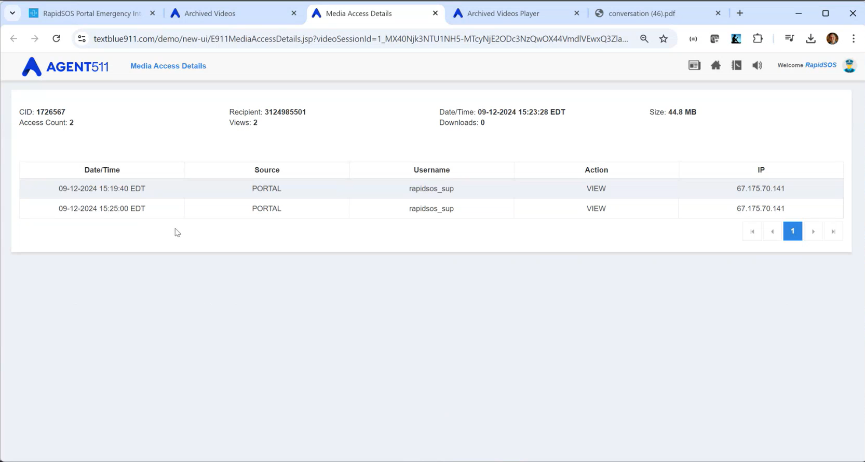
Jay Malin stated there is an audit log to track which users have viewed any recorded videos. Users with valid login credentials may download the video and attach it to a CAD incident or share it with others via email that do not have access to the platform.

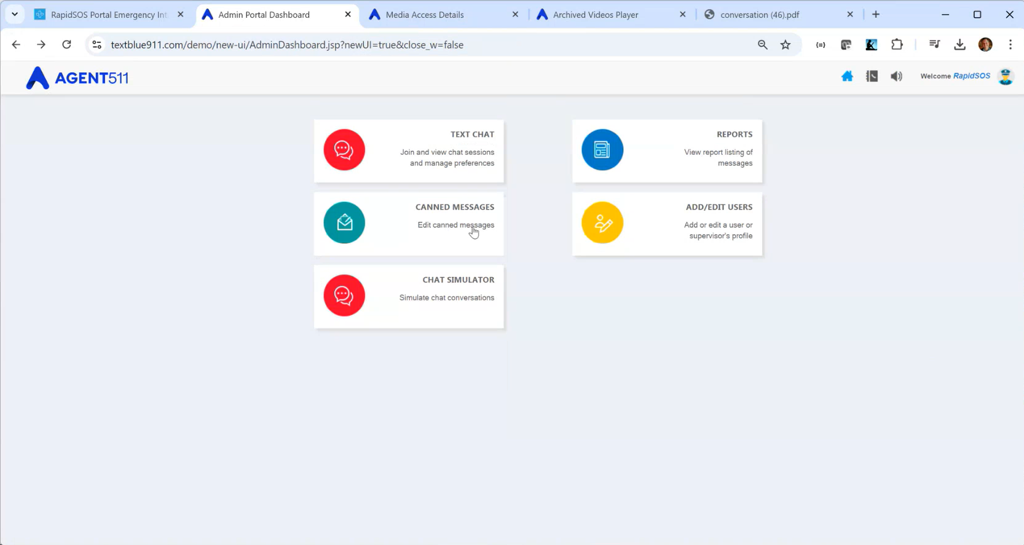
Jay Malin stated that there are additional configuration capabilities for supervisors such as canned messages, adding users, and observe and barge (within the standalone platform or the RapidSOS integrated version). He added that this is also available in call handling within the Intrado platform. He mentioned if there is any interest in pursuing the AGENT511 platform to reach out to the Executive Director for Jay Malin’s contact information and any additional details. Additionally, interested parties may reach out to Intrado directly for any integration demos.

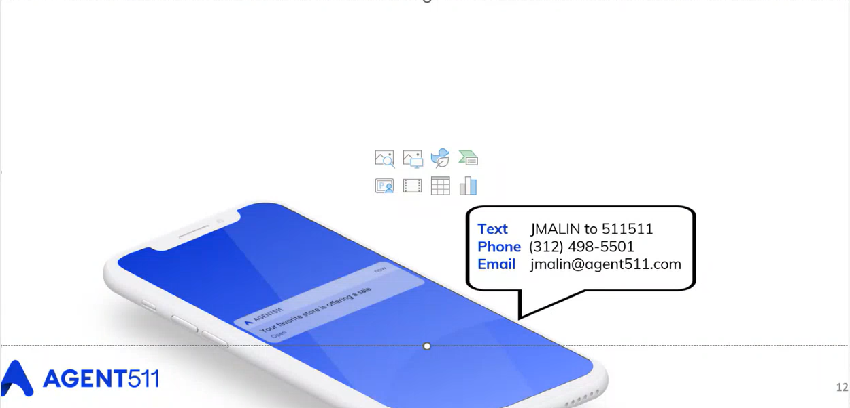
Shawn Kuratani asked Jay Malin if the call taker or dispatcher could send a new text message to an individual recipient or would they need to initiate a call first before the text back feature is available. Jay Malin responded stating that text back capability becomes usable after a voice call or text message to 9-1-1.

Stephen Courtney asked Jay Malin which cloud provider does AGENT511 utilize on the back end. Jay Malin responded stating that AGENT511 uses CloudScale365 and works with two redundant private cloud providers operating out of QTS. He added that videos are stored in a multimedia and AWS CGI compliant bucket. Furthermore, the data centers are located on the U.S. mainland that provide redundant load, balanced support, and low latency.

Edward Fujioka asked Jay Malin if AGENT511 has the capability to import default questions from the call taker or dispatcher into the initial text message. Jay Malin responded stating that there is the ability to pre-configure known questions or canned messages could be used as an alternative to develop a static list of questions. As for branch logic questions, this might be possible for development subject to applicable jurisdictions, integration options, and APIs or interfaces updating canned messages.

Edward Fujioka asked Jay Malin if AGENT511’s Record Management System (“RMS”) has the capability to retain records for up to 7 years. Jay Malin responded stating that this is possible and the platform allows for configurable retention and purge policies. He added that the standard practice is 1 year for multimedia and 3 years for text and location information. Edward Fujioka asked Jay Malin a follow-up question regarding RMS if AGENT511 owns the license for stored/received videos and photos and does the PSAP have the ability to release videos if a subpoena is received or is permission required from AGENT511. Jay Malin responded stating that all information is owned by the individual agency that inputted it into the platform. He added that each agency maintains the capability to retrieve and send any information requested by a subpoena without permission required from AGENT511.

Stephen Courtney asked Jay Malin what is AGENT511’s uptime and if they have experienced any cyberattacks. Jay Malin responded stating that uptime is no less than four nines and close to the five nines over the last several years. He added that the most recent incident was a data center power outage that occurred about four or five years ago, which caused 15 minutes of downtime. Furthermore, as a result of this incident AGENT511 added a public cloud zone at Azure that is a replication to maintain redundancy and include an additional cloud provider that could be used for global load balancing purposes.

      - Advisory Committee – Rebecca Lieberman
        - Updates on Legislative Session
Rebecca Lieberman stated no updates regarding the legislative session. She mentioned the 911 board will not pursue a bill this year and suggested a meeting in a month or two with the Executive Director to prepare for the budget briefing in January 2024.

  - Finance Committee – Edward Fujioka
    - Review of Monthly Y-T-D (Year to Date) Cash Flow
August 2024 Cashflow Statement:

Surcharge Collection: $1,008,335
Interest Income: $131,672
Total Receipts: $1,140,007
Total Disbursements: ($179,119)
Net Receipts/Disbursements: $960,888
Net Encumbrances Adds/(Paydown) Year to Date: ($350,294)
Net Cash Inflow/(Outflow): $610,594
Outstanding Encumbrances: $13,773,904
Net Bank Balance: $44,572,014
Unencumbered Cash Balance: $30,798,110

    - Hawaii Police Department Requesting $3,728 for Additional 8 Personnel APCO Certification Fees
Edward Fujioka stated the item above and asked for a motion to approve. Tony Velasco motioned to approve this request. Stephen Courtney seconded the motion. A voice vote was taken, motion was unanimously approved.

    - Kauai Police Department Requesting $703.78 for PowerPhone Contract Additional Taxes
Edward Fujioka stated the item above. Elliott Ke stated that the original PowerPhone contract did not require KPD to pay taxes but since then PowerPhone changed its policy to collect annual tax payment. He added that the necessary adjustments will be reflected on the annual budget. Edward Fujioka asked for a motion to approve. Tony Velasco motioned to approve this request. Matthew Kurihara seconded the motion. A voice vote was taken, motion was unanimously approved.

- Public Service Answering Point Status Updates on Recruitment and other Personnel Issues
  - Kauai Police Department – Ariel Ramos
    - Update on Recruitment Process/Strategies and Personnel Training
Ariel Ramos stated that they currently have 1 personnel in training that will potentially start field operations training by end of September 2024. She added that a recruitment video was recently filmed for KPD that included dispatch.

    - Update on Personnel Issues and Vacancies
Ariel Ramos stated that they currently have 9 dispatchers and 1 dispatcher on intermittent leave.

  - Oahu Police Department – Matthew Kurihara
    - Update on Recruitment Process/Strategies and Personnel Training
Matthew Kurihara stated that they currently have 1 personnel in training that is undergoing operations training. He added that they are considering the use of sworn officers as personnel and will be meeting with the union to discuss further.

    - Update on Personnel Issues and Vacancies
Matthew Kurihara stated that they currently have a 35% vacancy rate. He added that they will be losing possibly 3-4 more personnel by the end of the year due to retirement and moving out-of-state.

  - Oahu Fire Department – Shawn Kuratani
    - Update on Recruitment Process/Strategies and Personnel Training
Shawn Kuratani stated no updates.

    - Update on Personnel Issues and Vacancies
Shawn Kuratani stated that they currently are fully staffed.

  - Oahu Emergency Medical Services – Lorrin Okumura, Diana Chun, Frannie Chung
    - Update on Recruitment Process/Strategies and Personnel Training
Lorrin Okumura stated no updates.

    - Update on Personnel Issues and Vacancies
Lorrin Okumura stated that they currently have 8 vacancies for dispatchers. He added that they have been working on a 24-hour alternate schedule for the dispatch center. Corey Shaffer asked Lorrin Okumura what prompted the development of the 24-hour alternate schedule and if it is related to staffing shortages. Lorrin Okumura responded stating that the 24-hour alternate schedule is being discussed due to staffing shortages. Corey Shaffer asked everyone if any other PSAPs have tried a 24-hour schedule. Shawn Kuratani responded stating that HFD utilizes a 24-hour schedule that is akin to a typical firefighter shift. Stacy Domingo responded stating that civilians are not allowed to work 24-hour shifts while firefighters are nationally approved to work 24-hour shifts. She added that they experienced challenges when discussing with the union.

  - Maui Police Department – Davlynn Racadio
    - Update on Recruitment Process/Strategies and Personnel Training
Davlynn Racadio stated that they currently have 1 personnel in training that is expected to complete training by end of 2024. She added that recruitment for both Maui and Molokai is a one-stop shop consisting of applicant processing, interviewing, and hiring.

    - Update on Personnel Issues and Vacancies
Davlynn Racadio stated that they currently have 21 dispatchers, which consist of 15 sworn personnel and 6 civilians. Corey Shaffer asked Davlynn Racadio what aspects have been the most helpful regarding recruiting. Davlynn Racadio responded stating that there have been qualified applicants. She added that the primary challenge has been finding applicants with acceptable backgrounds and assessing their fit into the department.

  - Molokai Police Department – Davlynn Racadio
    - Update on Recruitment Process/Strategies and Personnel Training
Please see updates under Maui Police Department.

    - Update on Personnel Issues and Vacancies
Please see updates under Maui Police Department.

  - Hawaii Police Department – Robert Fujitake
    - Update on Recruitment Process/Strategies and Personnel Training
John Talich on behalf of Robert Fujitake stated that they currently have 2 personnel in training on the floor and 1 trainee that will begin next week. He added that there are 6 pending applicant interviews.

    - Update on Personnel Issues and Vacancies
John Talich on behalf of Robert Fujitake stated no updates.

  - Hawaii Fire Department – Stacy Domingo
    - Update on Recruitment Process/Strategies and Personnel Training
Stacy Domingo stated that they currently have 4 trainees on the floor that are expected to complete training at the beginning of 2025.

    - Update on Personnel Issues and Vacancies
Stacy Domingo stated that they currently have 9 dispatchers and 1 is out on extended sick leave.

- Items for Discussion, Consideration, and Action
  - Additional Items Proposed by Meeting Attendees.

- Announcements
  - Future Virtual Meeting Dates/Times (9:00AM-12:00PM)
    - Thursday, October 10, 2024 (Combined Meeting)
    - Thursday, November 14, 2024 (Combined Meeting)
  - Future Conference Dates (3 Months of Advanced Approval Required)
  - Additional Announcements from Meeting Attendees
Kenison Tejada expressed his thanks to Hawaii Civil Defense and HFD for hosting FirstNet’s engagements and demonstrations regarding public safety communications. He also expressed his thanks to EMS for lending its CRD and mini CRD to FirstNet for demonstration purposes.

- Open Forum: Public comment on issues not on the Board Meeting Agenda
There was no public comment on issues not on the agenda.

- Adjournment
Board Chair requested a motion to adjourn the meeting. Tony Ramirez motioned to adjourn the meeting. Stephen Courtney seconded the motion. A voice vote was taken, adjournment was unanimously approved. The meeting was adjourned.

