JOSH GREEN, M.D.  GOVERNOR  Ke Kiaʻāina |  | KEITH A. REGAN  COMPTROLLER  Ka Luna Hoʻomalu Hana Laulā  MEOH-LENG SILLIMAN  DEPUTY COMPTROLLER  Ka Hope Luna Hoʻomalu Hana Laulā
STATE OF HAWAIʻI | KA Mokuʻāina o Hawaiʻi

DEPARTMENT OF ACCOUNTING AND GENERAL SERVICES | KA ʻOihana LOIHELU A LAWELAWE Laulā
P.O. BOX 119, HONOLULU, HAWAII 96810-0119

Communications, Technical, and Finance Meeting
(Combined Meeting)

Wednesday, June 19, 2024
9:00 am – 10:00 am

MEETING MINUTES

Communications Committee Members Present: Thalia Burns (NENA/APCO)

Communications Committee Members Not Present: Davlynn Racadio (MPD), Lavina Taovao (KPD)

Technical Committee Members Present: Shawn Kuratani (HFD), Tony Velasco (DIT), Thalia Burns (APCO/NENA)

Technical Committee Members Not Present: David Miyasaki (KPD), Kenison Tejada (FirstNet), Tony Ramirez (VSE),

Finance Committee Members Present: Edward Fujioka (EMS), Stephen Courtney (C&C of Honolulu), Tony Velasco (DIT), Matthew Kurihara (HPD), Liz Gregg (ATT), Reed Mahuna (HIPD), Todd Omura (CIO Designee)

Finance Committee Members Not Present: Stephen Courtney (C&C of Honolulu)

Staff: Royce Murakami (E911), Stella Kam (AG)

Guests: Francis Alueta (HT), Nani Blake (T-Mobile), Frannie Chung (EMS), Ji Sook Kim (Consumer Advocate Designee), Buck Giles (OS), Patrick Leddy (LCC), Gregg Okamoto (MPD), Keola Tom (MPD), Rebecca Lieberman (Charter), Ariel Ramos (KPD), Phillip Banquel (KPD), Calvin Sung (HPD), Corey Shaffer (Verizon), Carla Even (RapidSOS)

- Call to Order, Public Notice
The meeting was called to order by the Board Chair. Public notice was given.

- Public Testimony Will Be Taken on All Agenda Items as Those Items Occur During the Meeting

- Roll Call, Quorum
A roll call was taken, quorum was only present for the Finance Committee.

- Review and Approval of May’s Meeting Minutes
Board Chair stated May’s Meeting Minutes were approved during the June 13, 2024, Joint Committee Meeting.

- Strategic Budget Plan FY 2025-2029
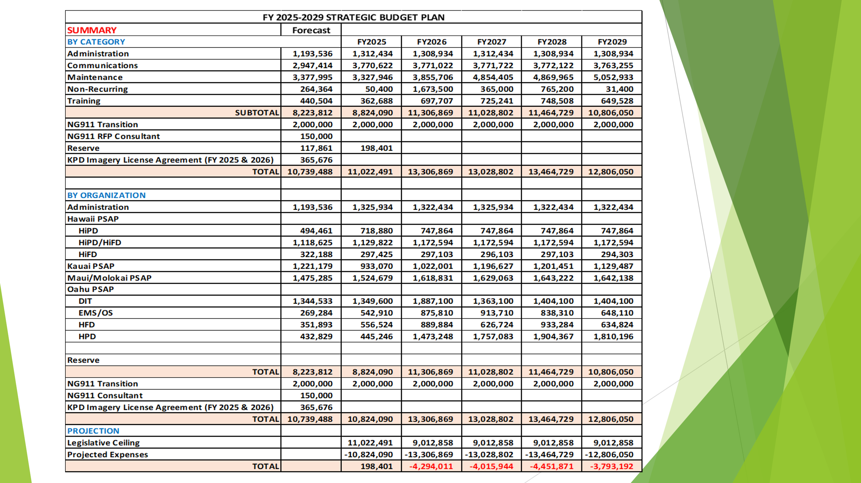
Executive Director stated that he was contacted by Hawaii Fire Department to update the budget to reflect an updated quote from Hawaiian Telcom. He added that adjustments were made to the Communications Section. In conclusion stated, that adjusted to the budget raised the reserve up to $198,401.

- Committee Updates by Committee Chairs
Updates from the Communications and Technical Committees will be moved to the July 11, 2024, Board Meeting

  - Communications Committee – Davlynn Racadio
    - No Updates
  - Technical Committee – Shawn Kuratani
    - HECO Public Safety Power Shutoff Initiative
      - Advisory Committee – Rebecca Lieberman
        - Updates on Legislative Session

  - Finance Committee – Edward Fujioka
    - Approval to use $365,676 of Fiscal Year 2024 Unused Funds to Encumber Fiscal Year 2025 & 2026 Eagleview Imagery License Agreement for Kauai Police Department
Executive Director stated as previously discussed $365,676 of Fiscal Year 2024 unused funds will be used to encumber the first- and second-year anniversary of Kauai Police Department’s Eagleview Imagery License Agreement to free up funding in Fiscal Year 2025 & 2026.

Edward Fujioka asked for a motion to approve $365,676 of Fiscal Year 2024 unused funds to encumber Fiscal Year 2025 & 2026 Eagleview Imagery License Agreement for Kauai Police Department. Reed Mahuna motioned to approve the request. Tony Velasco seconded the motion. A voice vote was taken, motion was unanimously approved.

    - Approval of $51,000 for Procurement of New Auditor for Auditing Services for FY 2023-2025
Executive Director stated that the procurement for the new auditor has been quite challenging and due to limited resources had to raise the contract to entice firms to submit offers. He added that he is asking for $34,000 for the initial year of the contract to cover the Fiscal Year 2023 Audit and $17,000 for the Fiscal Year 2024 Audit. In conclusion, stated that the cost for the Fiscal Year 2025 Audit is reflected on the budget for a total of $32,000.

Edward Fujioka asked for a motion to approve $51,000 for procurement of new auditor for auditing services for Fiscal Year 2023-2025. Tony Velasco motioned to approve this request. Reed Mahuna seconded the motion. A voice vote was taken, motion was unanimously approved.

    - Approval of $100,000 for Budget & Finance Administrative & Revenue Assessment Shortage for FY 2023-2024
Executive Director stated that in the fourth quarter we are projected to have a shortage of $100,000 and will be requesting funding from the reserve.

Edward Fujioka asked for a motion to approve $100,000 for Budget & Finance Administrative & Revenue Assessment shortage for Fiscal Year 2023-2024. Tony Velasco motioned to approve this request. Reed Mahuna seconded the motion. A voice vote was taken, motion was unanimously approved.

    - Kauai Police Department Requesting $1,219.38 for E911/UPS Shortage Fiscal Year 2024
    - Kauai Police Department Requesting $670.28 for PowerPhone Taxes Fiscal Year 2024
    - Kauai Police Department Requesting $9.00 for Alternate Call Routing Service Fiscal Year 2024
    - Kauai Police Department Requesting $306.00 for APCO Public Safety Telecommunicator Course Fiscal Year 2024
Edward Fujioka stated all above items and requested an approval for all items 4-7 for Kauai Police Department. Reed Mahuna motioned to approve the request. Tony Velasco seconded the motion. A voice vote was taken, motion was unanimously approved.

    - Review of Monthly Y-T-D (Year to Date) Cash Flow
May 2024 Cashflow Statement:

Surcharge Collection: $1,021,469
Interest Income: $124,254
Total Receipts: $1,145,724
Total Disbursements: ($253,017)
Net Receipts/Disbursements: $892,706
Net Encumbrances Adds/(Paydown): ($31,949)
Net Cash Inflow /(Outflow): $860,758
Outstanding Encumbrances: $8,313,301
Net Bank Balance: $42,354,452
Unencumbered Cash Balance: $34,041,151

- Public Service Answering Point Status Updates on Recruitment and other Personnel Issues
All Public Safety Answering Point Status Updates on Recruitment and other Personnel Issues will be moved to the July 11, 2024, Board Meeting.

  - Kauai Police Department – Ariel Ramos
    - Update on Recruitment Process/Strategies and Personnel Training
    - Update on Personnel Issues and Vacancies
  - Oahu Police Department – Matthew Kurihara
    - Update on Recruitment Process/Strategies and Personnel Training
    - Update on Personnel Issues and Vacancies
  - Oahu Fire Department – Shawn Kuratani
    - Update on Recruitment Process/Strategies and Personnel Training
    - Update on Personnel Issues and Vacancies
  - Oahu Emergency Medical Services – Lorrin Okumura, Diana Chun, Frannie Chung
    - Update on Recruitment Process/Strategies and Personnel Training
    - Update on Personnel Issues and Vacancies
  - Maui Police Department – Davlynn Racadio
    - Update on Recruitment Process/Strategies and Personnel Training
    - Update on Personnel Issues and Vacancies
  - Molokai Police Department – Davlynn Racadio
    - Update on Recruitment Process/Strategies and Personnel Training
    - Update on Personnel Issues and Vacancies
  - Hawaii Police Department – Robert Fujitake
    - Update on Recruitment Process/Strategies and Personnel Training
    - Update on Personnel Issues and Vacancies
  - Hawaii Fire Department – Stacy Domingo
    - Update on Recruitment Process/Strategies and Personnel Training
    - Update on Personnel Issues and Vacancies
- Items for Discussion, Consideration, and Action
  - Additional Items Proposed by Meeting Attendees.
- Announcements
  - Future Virtual Meeting Dates/Times (9:00AM-12:00PM)
    - Thursday, July 11, 2024 (Combined Meeting)
  - Future Conference Dates (3 Months of Advanced Approval Required)
    - NENA (National Emergency Number Association) Conference June 28 – July 3, 2024, Kissimmee, Florida
    - APCO (Association of Public-Safety Communications Officials) Conference August 4-7, 2024, Orlando Florida
  - Additional Announcements from Meeting Attendees
- Open Forum: Public comment on issues not on the Board Meeting Agenda
There was no public comment on issues not on the agenda.

- Adjournment
Reed Mahuna motioned to adjourn the meeting. Tony Velasco seconded the motion. A voice vote was taken, and the adjournment was unanimously approved. The meeting was adjourned.

