JOSH GREEN, M.D.  GOVERNOR  Ke Kiaʻāina |  | KEITH A. REGAN  COMPTROLLER  Ka Luna Hoʻomalu Hana Laulā  MEOH-LENG SILLIMAN  DEPUTY COMPTROLLER  Ka Hope Luna Hoʻomalu Hana Laulā
STATE OF HAWAIʻI | KA Mokuʻāina o Hawaiʻi

DEPARTMENT OF ACCOUNTING AND GENERAL SERVICES | KA ʻOihana LOIHELU A LAWELAWE Laulā
P.O. BOX 119, HONOLULU, HAWAII 96810-0119

Communications, Technical, and Finance Meeting
(Combined Meeting)

Thursday, June 13, 2024
9:30 am – 12:30 pm

MEETING MINUTES

Communications Committee Members Not Present: Davlynn Racadio (MPD), Thalia Burns (NENA/APCO), Lavina Taovao (KPD)

Technical Committee Members Present: Shawn Kuratani (HFD), Tony Velasco (DIT), Kenison Tejada (FirstNet), Tony Ramirez (VSE)

Technical Committee Members Not Present: David Miyasaki (KPD), Thalia Burns (NENA/APCO)

Finance Committee Members Present: Edward Fujioka (EMS), Stephen Courtney (C&C of Honolulu), Tony Velasco (DIT), Matthew Kurihara (HPD), Liz Gregg (ATT), Reed Mahuna (HIPD)

Finance Committee Members Not Present: Todd Omura (CIO Designee)

Staff: Royce Murakami (E911), Stella Kam (AG)

Guests: Francis Alueta (HT), Stacy Domingo (HIFD), Robert Fujitake (HIPD), Ji Sook Kim (Consumer Advocate Designee), David Jones (Mission Critical), Elliott K. Ke (KPD), Buck Giles (OS), Ah Lan Leong (HPD), Lorrin Okumura (EMS), Gregg Okamoto (MPD), Frank Pace (DOD), Keola Tom (MPD), Rebecca Lieberman (Charter), Ariel Ramos (KPD), Phillip Banquel (KPD), Calvin Sung (HPD), Corey Shaffer (Verizon)

- Call to Order, Public Notice
The meeting was called to order by the Board Chair. Public notice was given.

- Public Testimony Will Be Taken on All Agenda Items as Those Items Occur During the Meeting

- Roll Call, Quorum
A roll call was taken, quorum was present for the Finance and Technical Committee.

- Review and Approval of May’s Meeting Minutes
Board Chair requested a motion to approve May’s Meeting Minutes. Tony Velasco motioned to approve April’s Meeting Minutes. Tony Ramirez seconded the motion. A voice vote was taken, motion was unanimously approved.

- Strategic Budget Plan FY 2025-2029
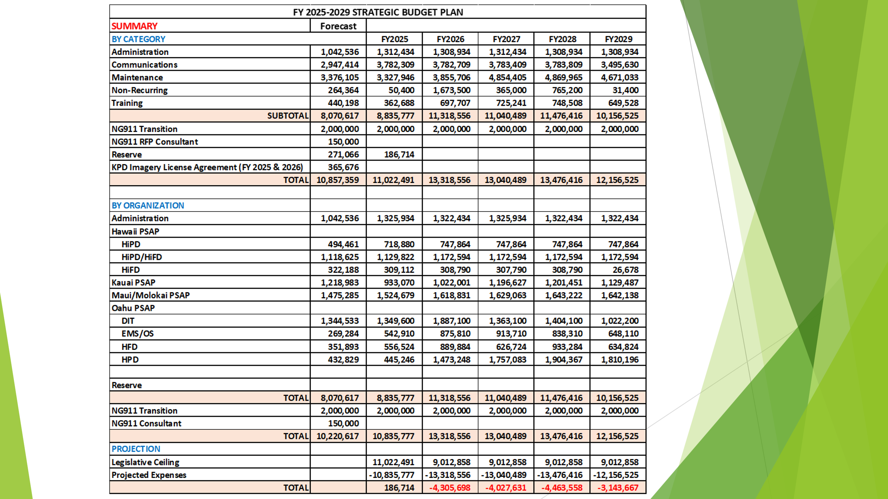
Executive Director stated that he updated the Strategic Budget Plan from his last presentation and calculated the Budget & Finance Administrative & Revenue Assessment shortage that is estimated to be roughly $100,000. He added that the shortage would be covered by the remaining reserves.

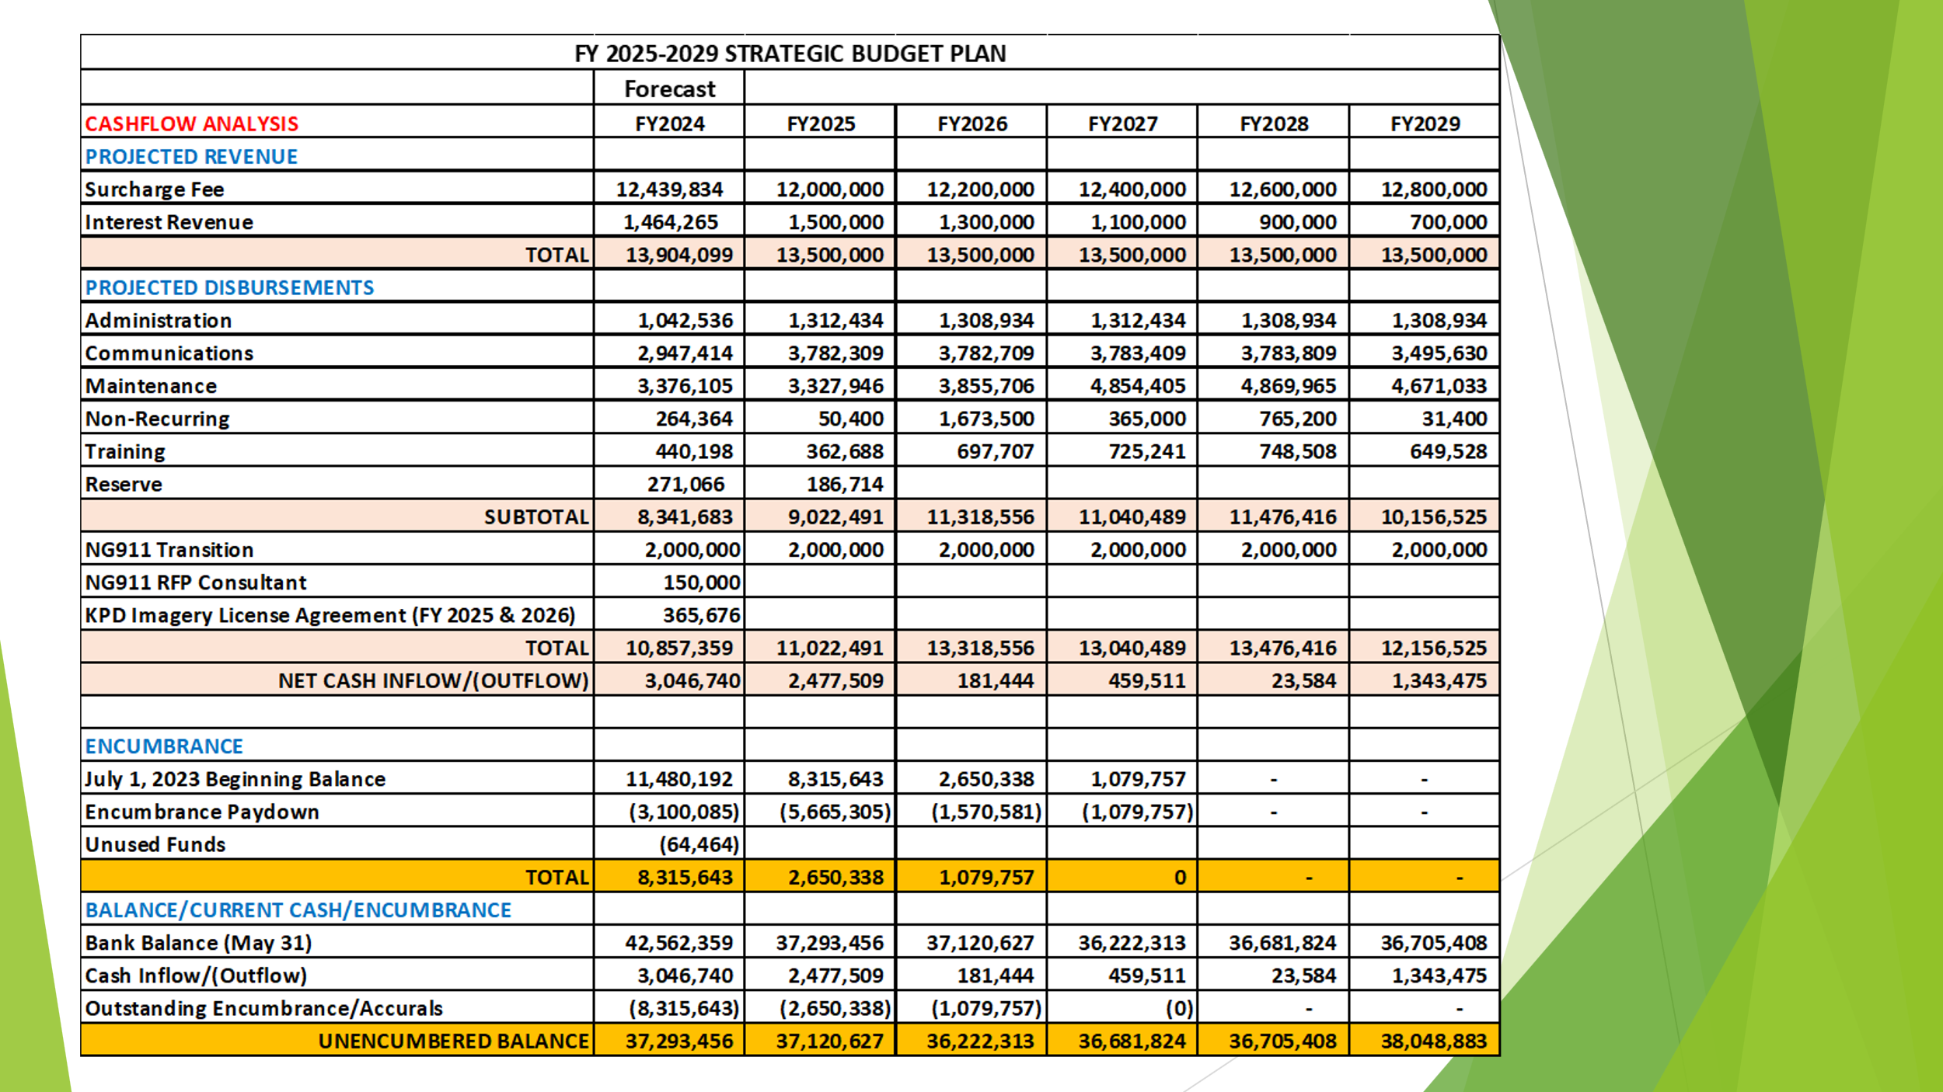
Executive Director stated that he spoke with Kauai Police Department and plans to encumber their Eagleview Imagery License Agreement for Fiscal Year 2025 & 2026 for a total of $365,676 leaving us with a remaining reserve of $271,066. He added that the remaining reserve will be used to approve all other requests for funding on the meeting agenda. Furthermore, stated that encumbering Kauai Police Department’s Eagleview Imagery License Agreement allowed him to return $18,000 for conference travel to all the agencies. In conclusion, stated once all requests for funding is approved on the meeting agenda the forecasted numbers will be updated and final budget will be distributed.

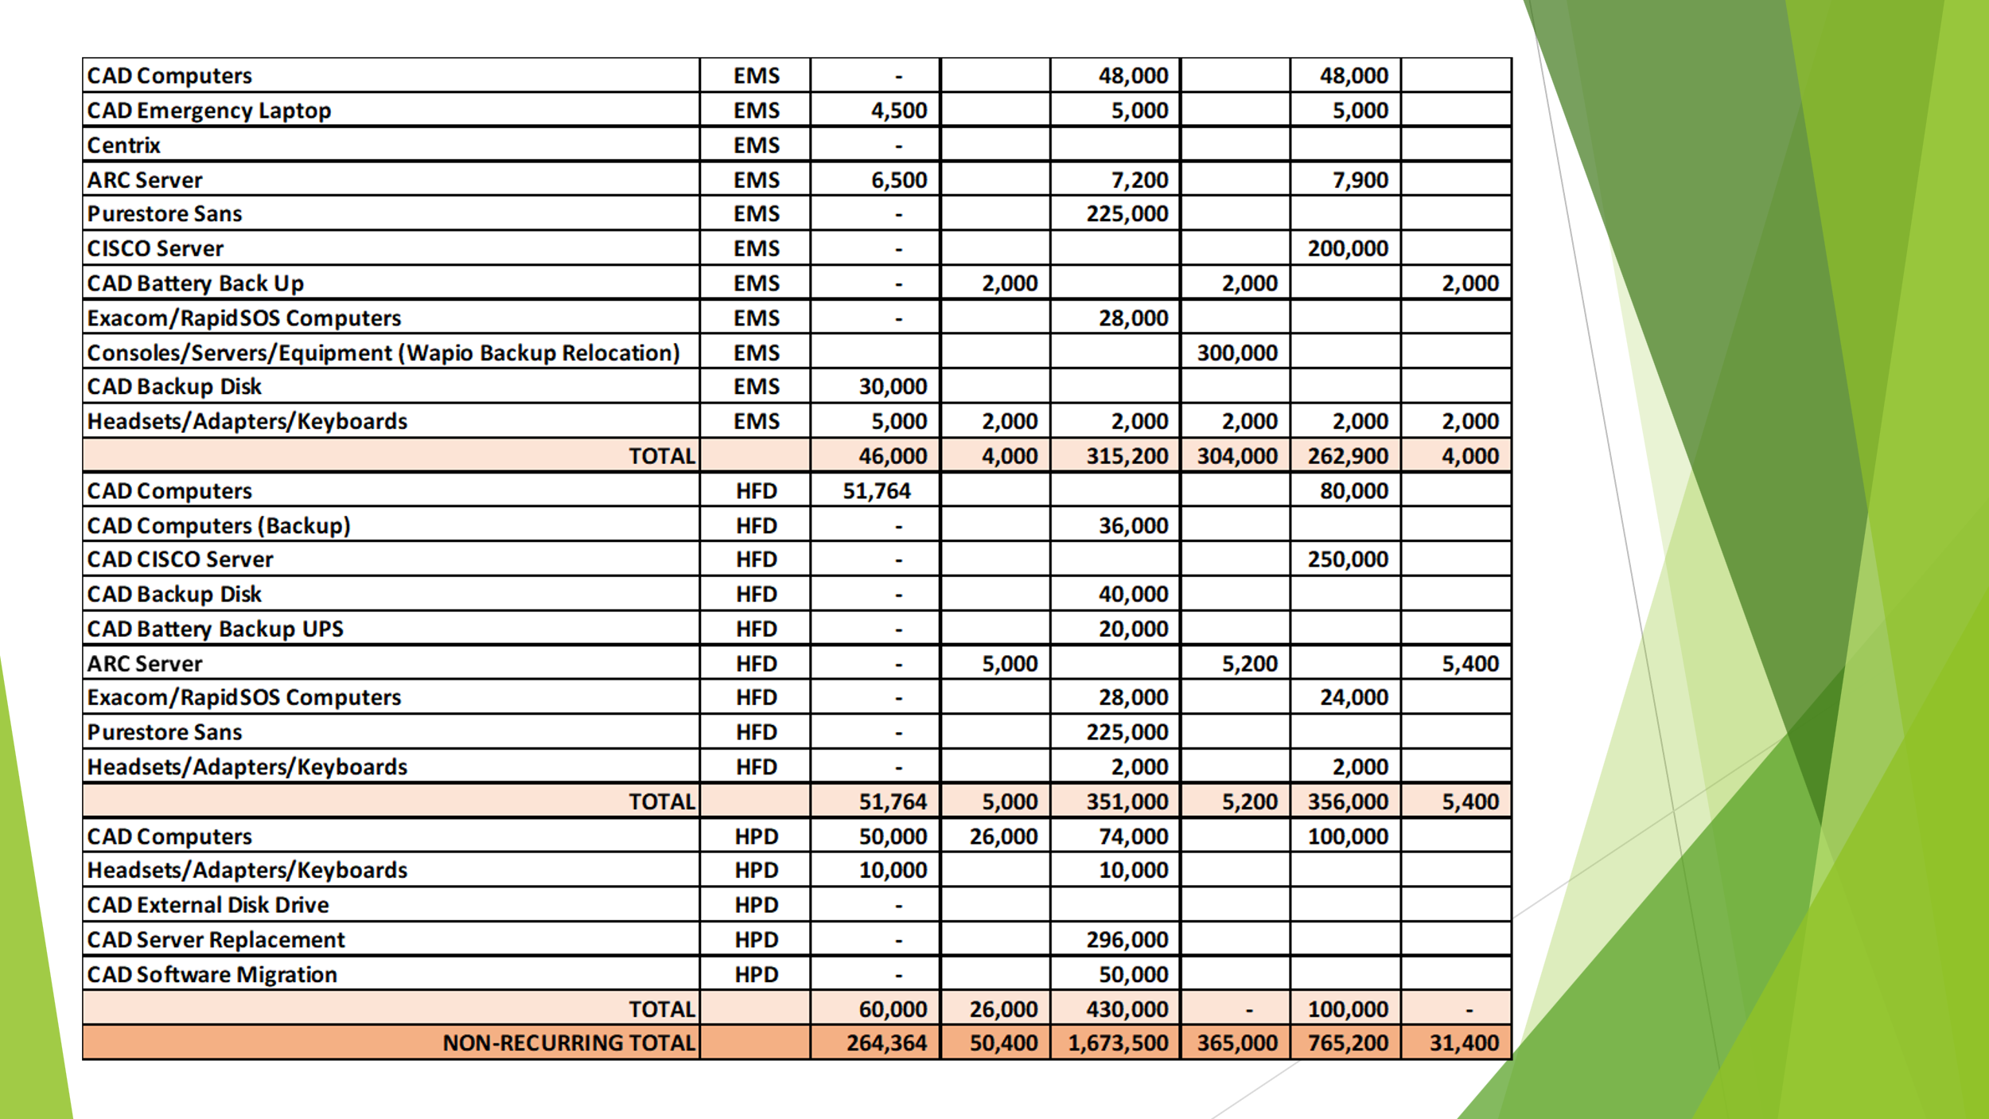
Executive Director stated another adjustment to the budget was a requested by EMS to add $300,000 to Fiscal Year 2027 for Consoles/Servers/Equipment for their Waipio Backup location. Board Chair asked Buck Giles if Ocean Safety has plans on where they will relocate too once EMS moves out of their Koapaka location. Buck Giles responded that he has discussed with Kurt Lager on this matter and will come back to the Board with more information.

Rebecca Lieberman responded stating that after this current legislative session there is a need to spend down the funds and is asking the Board if there are any projects that they are looking into soon. Board Chair stated that Hawaiian Telcom has not anticipated large costs with Next Generation 9-1-1 however, he is hoping in the next 12 months that they can help the Board fully understand what those costs will be in the future. Tony Ramirez responded that unanticipated costs were discussed with legislature regarding forklift and replacement of dispatch and response systems inside the PSAP.

Board Chair stated that a common topic that is discussed in every meeting is the shortage of dispatchers and asks everyone if anyone has any creative ideas on how the Board can use funds to advertise or incentivize dispatchers. Stella Kam responded that salaries are not reimbursable expenses by the Board. Rebecca Lieberman stated that should the Board consider amending the statute to allow funding for bonuses and salaries. Ah Lan Leong responded stating that Honolulu Police Department would use majority of the funding if bonuses and salaries were a reimbursable expense by the Board. She added that she thinks it would be unfair to the other agencies. Stacy Domingo responded stating that one way we could support all the PSAPs towards some level of accreditation within their agency and once they meet that accreditation, they can request from their agency additional pay to indirectly help dispatchers increase their salary.

Calvin Sung stated that another project to consider is that Honolulu Police Department is looking for a new CAD System in the next two to three years that would amount to about $6,000,000 - $7,000,000 with about $500,000 - $600,000 in annual maintenance and support fees. Executive Director requested that Honolulu Police Department submit more information so that Board can review Honolulu Police Department’s request. Board Chair stated that this was a good discussion, however more information will be needed in the next few months as we prepare for the next legislative session.

Joint Committee was cancelled on June 13, 2024, due to power outage. Please see Joint Committee Minutes on June 19, 2024, for continuation of this meeting.

- Committee Updates by Committee Chairs
  - Communications Committee – Davlynn Racadio
    - No Updates
  - Technical Committee – Shawn Kuratani
    - HECO Public Safety Power Shutoff Initiative
      - Advisory Committee – Rebecca Lieberman
        - Updates on Legislative Session
  - Finance Committee – Edward Fujioka
    - Approval to use $365,676 of Fiscal Year 2024 Unused Funds to Encumber Fiscal Year 2025 & 2026 Eagleview Imagery License Agreement for Kauai Police Department
    - Approval of $51,000 for Procurement of New Auditor for Auditing Services for FY 2023-2025
    - Approval of $100,000 for Budget & Finance Administrative & Revenue Assessment Shortage for FY 2023-2024
    - Kauai Police Department Requesting $1,219.38 for E911/UPS Shortage Fiscal Year 2024
    - Kauai Police Department Requesting $670.28 for PowerPhone Taxes Fiscal Year 2024
    - Kauai Police Department Requesting $9.00 for Alternate Call Routing Service Fiscal Year 2024
    - Kauai Police Department Requesting $306.00 for APCO Public Safety Telecommunicator Course Fiscal Year 2024
    - Review of Monthly Y-T-D (Year to Date) Cash Flow
- Public Service Answering Point Status Updates on Recruitment and other Personnel Issues
  - Kauai Police Department – Ariel Ramos
    - Update on Recruitment Process/Strategies and Personnel Training
    - Update on Personnel Issues and Vacancies
  - Oahu Police Department – Matthew Kurihara
    - Update on Recruitment Process/Strategies and Personnel Training
    - Update on Personnel Issues and Vacancies
  - Oahu Fire Department – Shawn Kuratani
    - Update on Recruitment Process/Strategies and Personnel Training
    - Update on Personnel Issues and Vacancies
  - Oahu Emergency Medical Services – Lorrin Okumura, Diana Chun, Frannie Chung
    - Update on Recruitment Process/Strategies and Personnel Training
    - Update on Personnel Issues and Vacancies
  - Maui Police Department – Davlynn Racadio
    - Update on Recruitment Process/Strategies and Personnel Training
    - Update on Personnel Issues and Vacancies
  - Molokai Police Department – Davlynn Racadio
    - Update on Recruitment Process/Strategies and Personnel Training
    - Update on Personnel Issues and Vacancies
  - Hawaii Police Department – Robert Fujitake
    - Update on Recruitment Process/Strategies and Personnel Training
    - Update on Personnel Issues and Vacancies
  - Hawaii Fire Department – Stacy Domingo
    - Update on Recruitment Process/Strategies and Personnel Training
    - Update on Personnel Issues and Vacancies
- Items for Discussion, Consideration, and Action
  - Additional Items Proposed by Meeting Attendees.
- Announcements
  - Future Virtual Meeting Dates/Times (9:00AM-12:00PM)
    - Thursday, July 11, 2024 (Combined Meeting)
  - Future Conference Dates (3 Months of Advanced Approval Required)
    - NENA (National Emergency Number Association) Conference June 28 – July 3, 2024, Kissimmee, Florida
    - APCO (Association of Public-Safety Communications Officials) Conference August 4-7, 2024, Orlando Florida
  - Additional Announcements from Meeting Attendees
- Open Forum: Public comment on issues not on the Board Meeting Agenda
- Adjournment

