JOSH GREEN, M.D.  GOVERNOR  Ke Kiaʻāina | 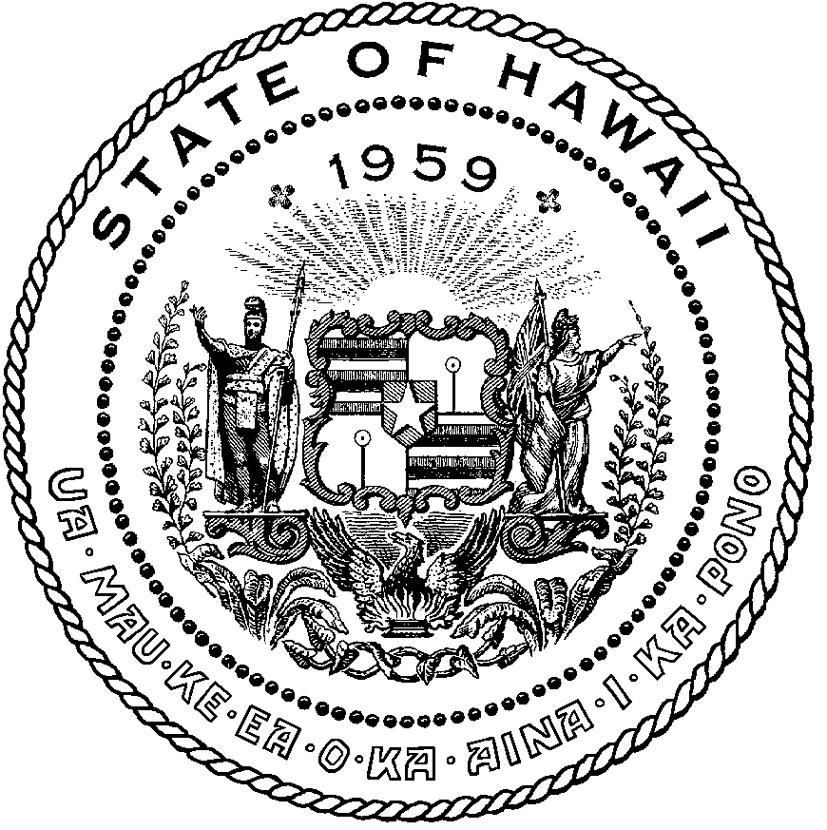 | KEITH A. REGAN  COMPTROLLER  Ka Luna Hoʻomalu Hana Laulā  MEOH-LENG SILLIMAN  DEPUTY COMPTROLLER  Ka Hope Luna Hoʻomalu Hana Laulā
STATE OF HAWAIʻI | KA Mokuʻāina o Hawaiʻi

DEPARTMENT OF ACCOUNTING AND GENERAL SERVICES | KA ʻOihana LOIHELU A LAWELAWE Laulā
P.O. BOX 119, HONOLULU, HAWAII 96810-0119

Communications, Technical, and Finance Meeting
(Combined Meeting)
Virtual Meeting – Microsoft Teams
Call-In: 808-829-4853; Phone Conf ID: 259 721 760#

Physical location: Kalanimoku Bldg. Room 411A, 1151 Punchbowl St., Honolulu, is available to the public and is guaranteed to be connected to the remote virtual meeting.

Join the meeting now
Meeting ID: 237 230 482 585
Passcode: EB5sHW

Contact for Meeting Information/Testimony Submission; Royce Murakami, State of Hawaii, Enhanced 911 Board, Room 411A, 1151 Punchbowl Street, Honolulu, HI 96813
royce.m.murakami@hawaii.gov

Please visit Enhanced 9-1-1 YouTube Channel for all Meeting Recordings

http://www.youtube.com/@StateofHawaiiEnhanced9-1-1Boar

"In the event that audiovisual communication cannot be maintained by all participating board members and quorum is lost, the meeting will automatically be recessed for 30 minutes, during which time an attempt to restore audiovisual communication will be made. If such attempt to restore is unsuccessful within said 30 minutes, all board members, members of the public, staff and other interested individuals shall log on again to the Teams link on this Notice, whereby audio communication will be established for all participants and the meeting will continue. If reconvening the meeting is not possible because audio and visual communication cannot be re-established, the meeting will be terminated."

Wednesday, July 11, 2024
9:00 am – 12:00 pm

Agenda

- Call to Order, Public Notice
- Public Testimony Will Be Taken on All Agenda Items as Those Items Occur During the Meeting
- Roll Call, Quorum
- Review and Approval of June 13th & 19th, 2024 Meeting Minutes
- Committee Updates by Committee Chairs
  - Communications Committee – Davlynn Racadio
    - MSAG Transactions
  - Technical Committee – Shawn Kuratani
    - HECO Public Safety Power Shutoff Initiative
    - Revaluation of Reimbursable Expenses
      - Advisory Committee – Rebecca Lieberman
        - Updates on Legislative Session
  - Finance Committee – Edward Fujioka
    - Review of Monthly Y-T-D (Year to Date) Cash Flow
- Public Service Answering Point Status Updates on Recruitment and other Personnel Issues
  - Kauai Police Department – Ariel Ramos
    - Update on Recruitment Process/Strategies and Personnel Training
    - Update on Personnel Issues and Vacancies
  - Oahu Police Department – Matthew Kurihara
    - Update on Recruitment Process/Strategies and Personnel Training
    - Update on Personnel Issues and Vacancies
  - Oahu Fire Department – Shawn Kuratani
    - Update on Recruitment Process/Strategies and Personnel Training
    - Update on Personnel Issues and Vacancies
  - Oahu Emergency Medical Services – Lorrin Okumura, Diana Chun, Frannie Chung
    - Update on Recruitment Process/Strategies and Personnel Training
    - Update on Personnel Issues and Vacancies
  - Maui Police Department – Davlynn Racadio
    - Update on Recruitment Process/Strategies and Personnel Training
    - Update on Personnel Issues and Vacancies
  - Molokai Police Department – Davlynn Racadio
    - Update on Recruitment Process/Strategies and Personnel Training
    - Update on Personnel Issues and Vacancies
  - Hawaii Police Department – Robert Fujitake
    - Update on Recruitment Process/Strategies and Personnel Training
    - Update on Personnel Issues and Vacancies
  - Hawaii Fire Department – Stacy Domingo
    - Update on Recruitment Process/Strategies and Personnel Training
    - Update on Personnel Issues and Vacancies
- Items for Discussion, Consideration, and Action
  - Additional Items Proposed by Meeting Attendees.
- Announcements
  - Future Virtual Meeting Dates/Times (9:00AM-12:00PM)
    - Thursday, August 15, 2024 (Combined Meeting)
  - Future Conference Dates (3 Months of Advanced Approval Required)
    - APCO (Association of Public-Safety Communications Officials) Conference August 4-7, 2024, Orlando Florida
  - Additional Announcements from Meeting Attendees
- Open Forum: Public comment on issues not on the Board Meeting Agenda
- Adjournment

