JOSH GREEN, M.D.  GOVERNOR  Ke Kiaʻāina |  | KEITH A. REGAN  COMPTROLLER  Ka Luna Hoʻomalu Hana Laulā  MEOH-LENG SILLIMAN  DEPUTY COMPTROLLER  Ka Hope Luna Hoʻomalu Hana Laulā
STATE OF HAWAIʻI | KA Mokuʻāina o Hawaiʻi

DEPARTMENT OF ACCOUNTING AND GENERAL SERVICES | KA ʻOihana LOIHELU A LAWELAWE Laulā
P.O. BOX 119, HONOLULU, HAWAII 96810-0119

Communications, Technical, and Finance Meeting
(Combined Meeting)

Thursday, May 9, 2024
9:00 am – 12:00 pm

MEETING MINUTES

Communications Committee Members Present: Davlynn Racadio (MPD)

Communications Committee Members Not Present: Thalia Burns (HPD), Lavina Taovao (KPD

Technical Committee Members Present: Shawn Kuratani (HFD), Tony Velasco (DIT), Kenison Tejada (FirstNet)

Technical Committee Members Not Present: David Miyasaki (KPD), Thalia Burns (HPD), Tony Ramirez (VSE)

Finance Committee Members Present: Edward Fujioka (EMS), Stephen Courtney (C&C of Honolulu), Tony Velasco (DIT), Todd Omura (CIO Designee), Matthew Kurihara (HPD), Liz Gregg (ATT), Reed Mahuna (HIPD)

Staff: Royce Murakami (E911)

Guests: Francis Alueta (HT), Diana Chun (EMS), Ruth Cruz (Intrado), Stacy Domingo (HIFD), Robert Fujitake (HIPD), Ji Sook Kim (Consumer Advocate Designee), Buck Giles (OS), Glenn Kobashigawa (HT), Darren Rose (KPD), Lorrin Okumura (EMS), Gregg Okamoto (MPD), Keola Tom (MPD), Rebecca Lieberman (Charter), Darren Rose (KPD), Calvin Sung (HPD), Corey Shaffer (Verizon), Buck Giles (OS)

- Call to Order, Public Notice
The meeting was called to order by the Board Chair. Public notice was given.

- Public Testimony Will Be Taken on All Agenda Items as Those Items Occur During the Meeting

- Roll Call, Quorum
A roll call was taken, quorum was present only for the Finance Committee.

- Review and Approval of April’s Meeting Minutes
Board Chair requested a motion to approve April’s Meeting Minutes. Tony Velasco motioned to approve April’s Meeting Minutes. Rebecca Lieberman seconded the motion. A voice vote was taken, motion was unanimously approved.

- Strategic Budget Plan FY 2025-2029
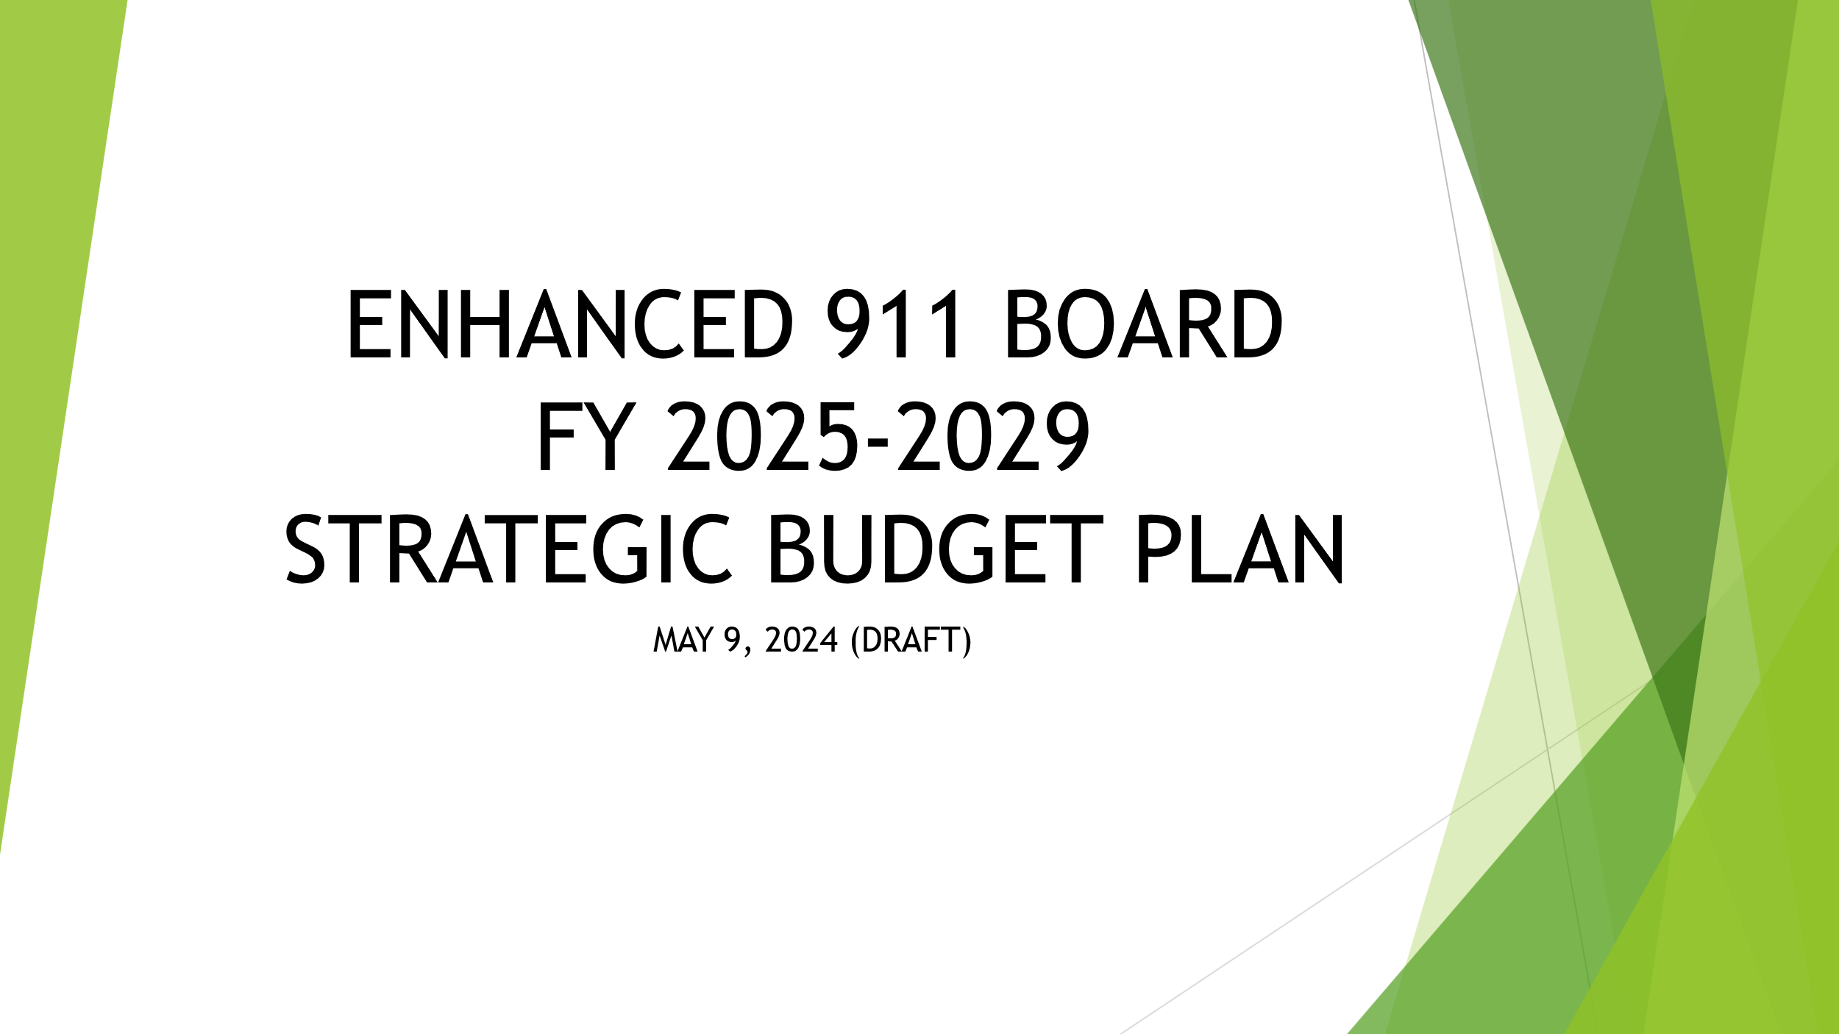
Executive Director stated that we will review the Draft of the Fiscal Year 2025-2029 Strategic Budget Plan. He added that we will not be approving the budget till our June meeting and this presentation will ensure that all requests by each agency are reflected in the budget.

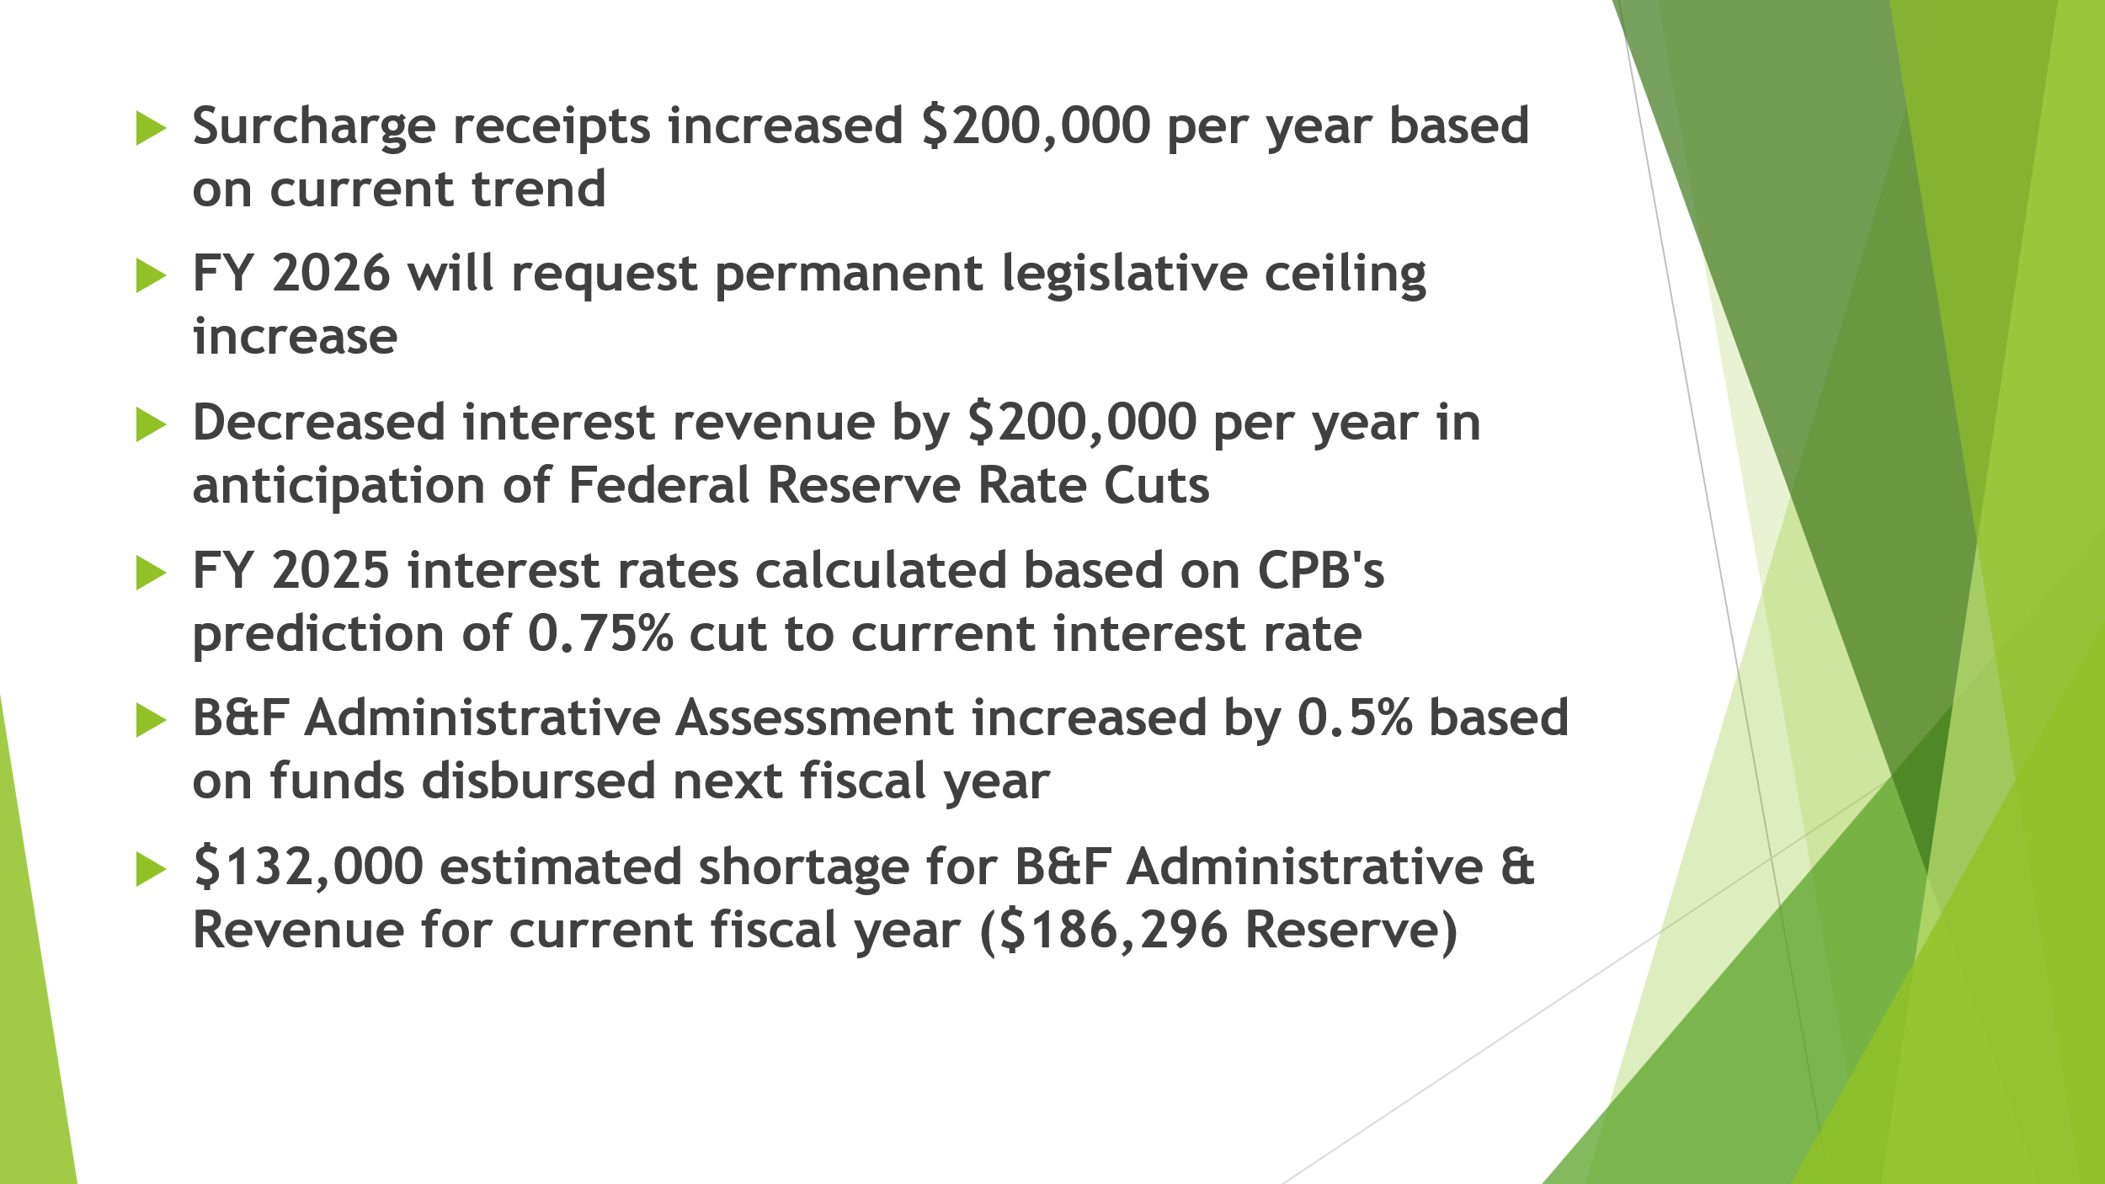
Executive Director reviewed bullet points of the following slide. Regarding Federal Reserve rate cuts he stated that he had a discussion with Central Pacific Bank and is anticipating a 0.75% decrease of the current interest rate that will be decreased in three increments.

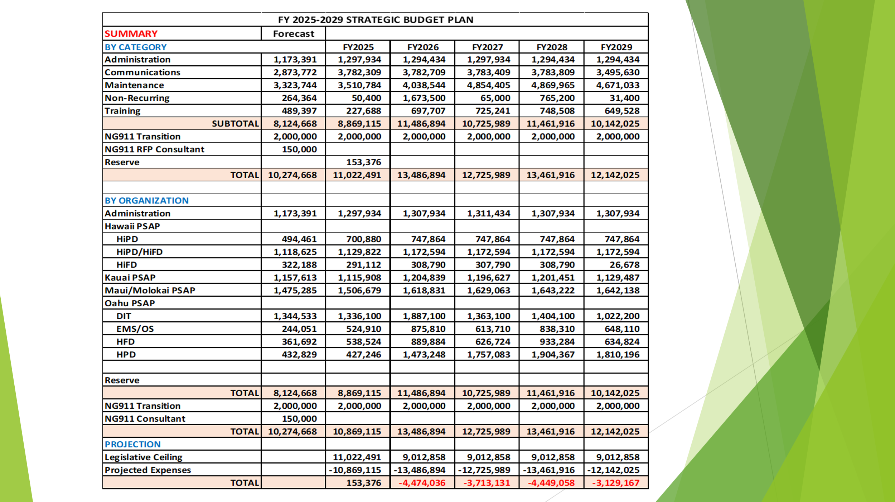
Executive Director stated that the forecast is currently estimated based on projected reimbursements from all the agencies and that he has discussed with all the agencies to submit reimbursements by May 31, 2024. He added that current projected expenses for the current fiscal year are $10,274,688. Furthermore, stated that he will be encumbering the $2,000,000 budgeted for the NG911 Transition as well as the $150,000 budgeted for an NG911 Consultant. Francis Alueta responded stating if the budgeted amounts for the NG911 Transition and Consultant is incremental to the current forecast. Executive Director responded that he is correct and is reserved separately from other categorized expenses. He added that Francis Alueta stated in the previous meeting that we would not anticipate any changes soon however until more concise information is received from Hawaiian Telcom regarding NG911 Transition we will move forward and request a legislative ceiling increase to support the potential expenses we could encounter during the transition.

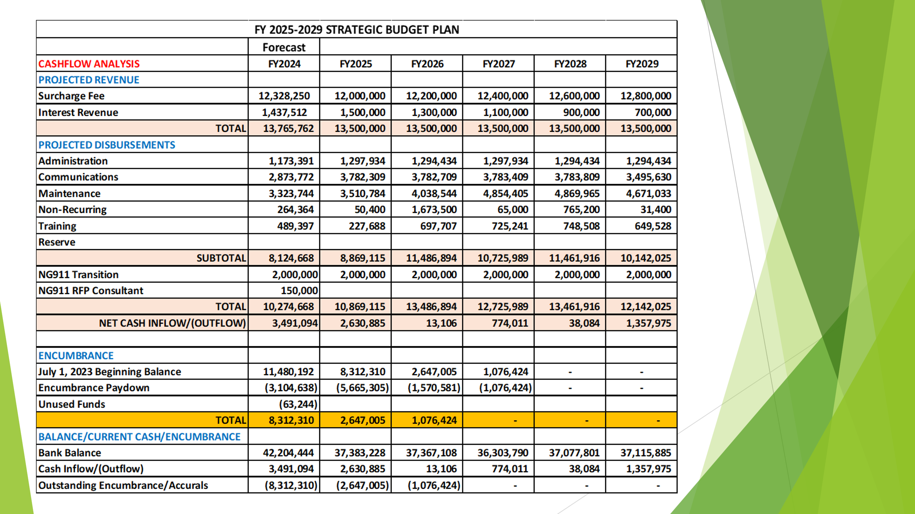
Executive Director stated the following numbers are projections for the current fiscal year.

Surcharge Collection: $12,328,250
Interest Revenue: $1,437,512
Encumbrance Paydown: $3,104,638
Unused Encumbered Funds: $63,244
Outstanding (Encumbrance/Accruals): $8,312,310

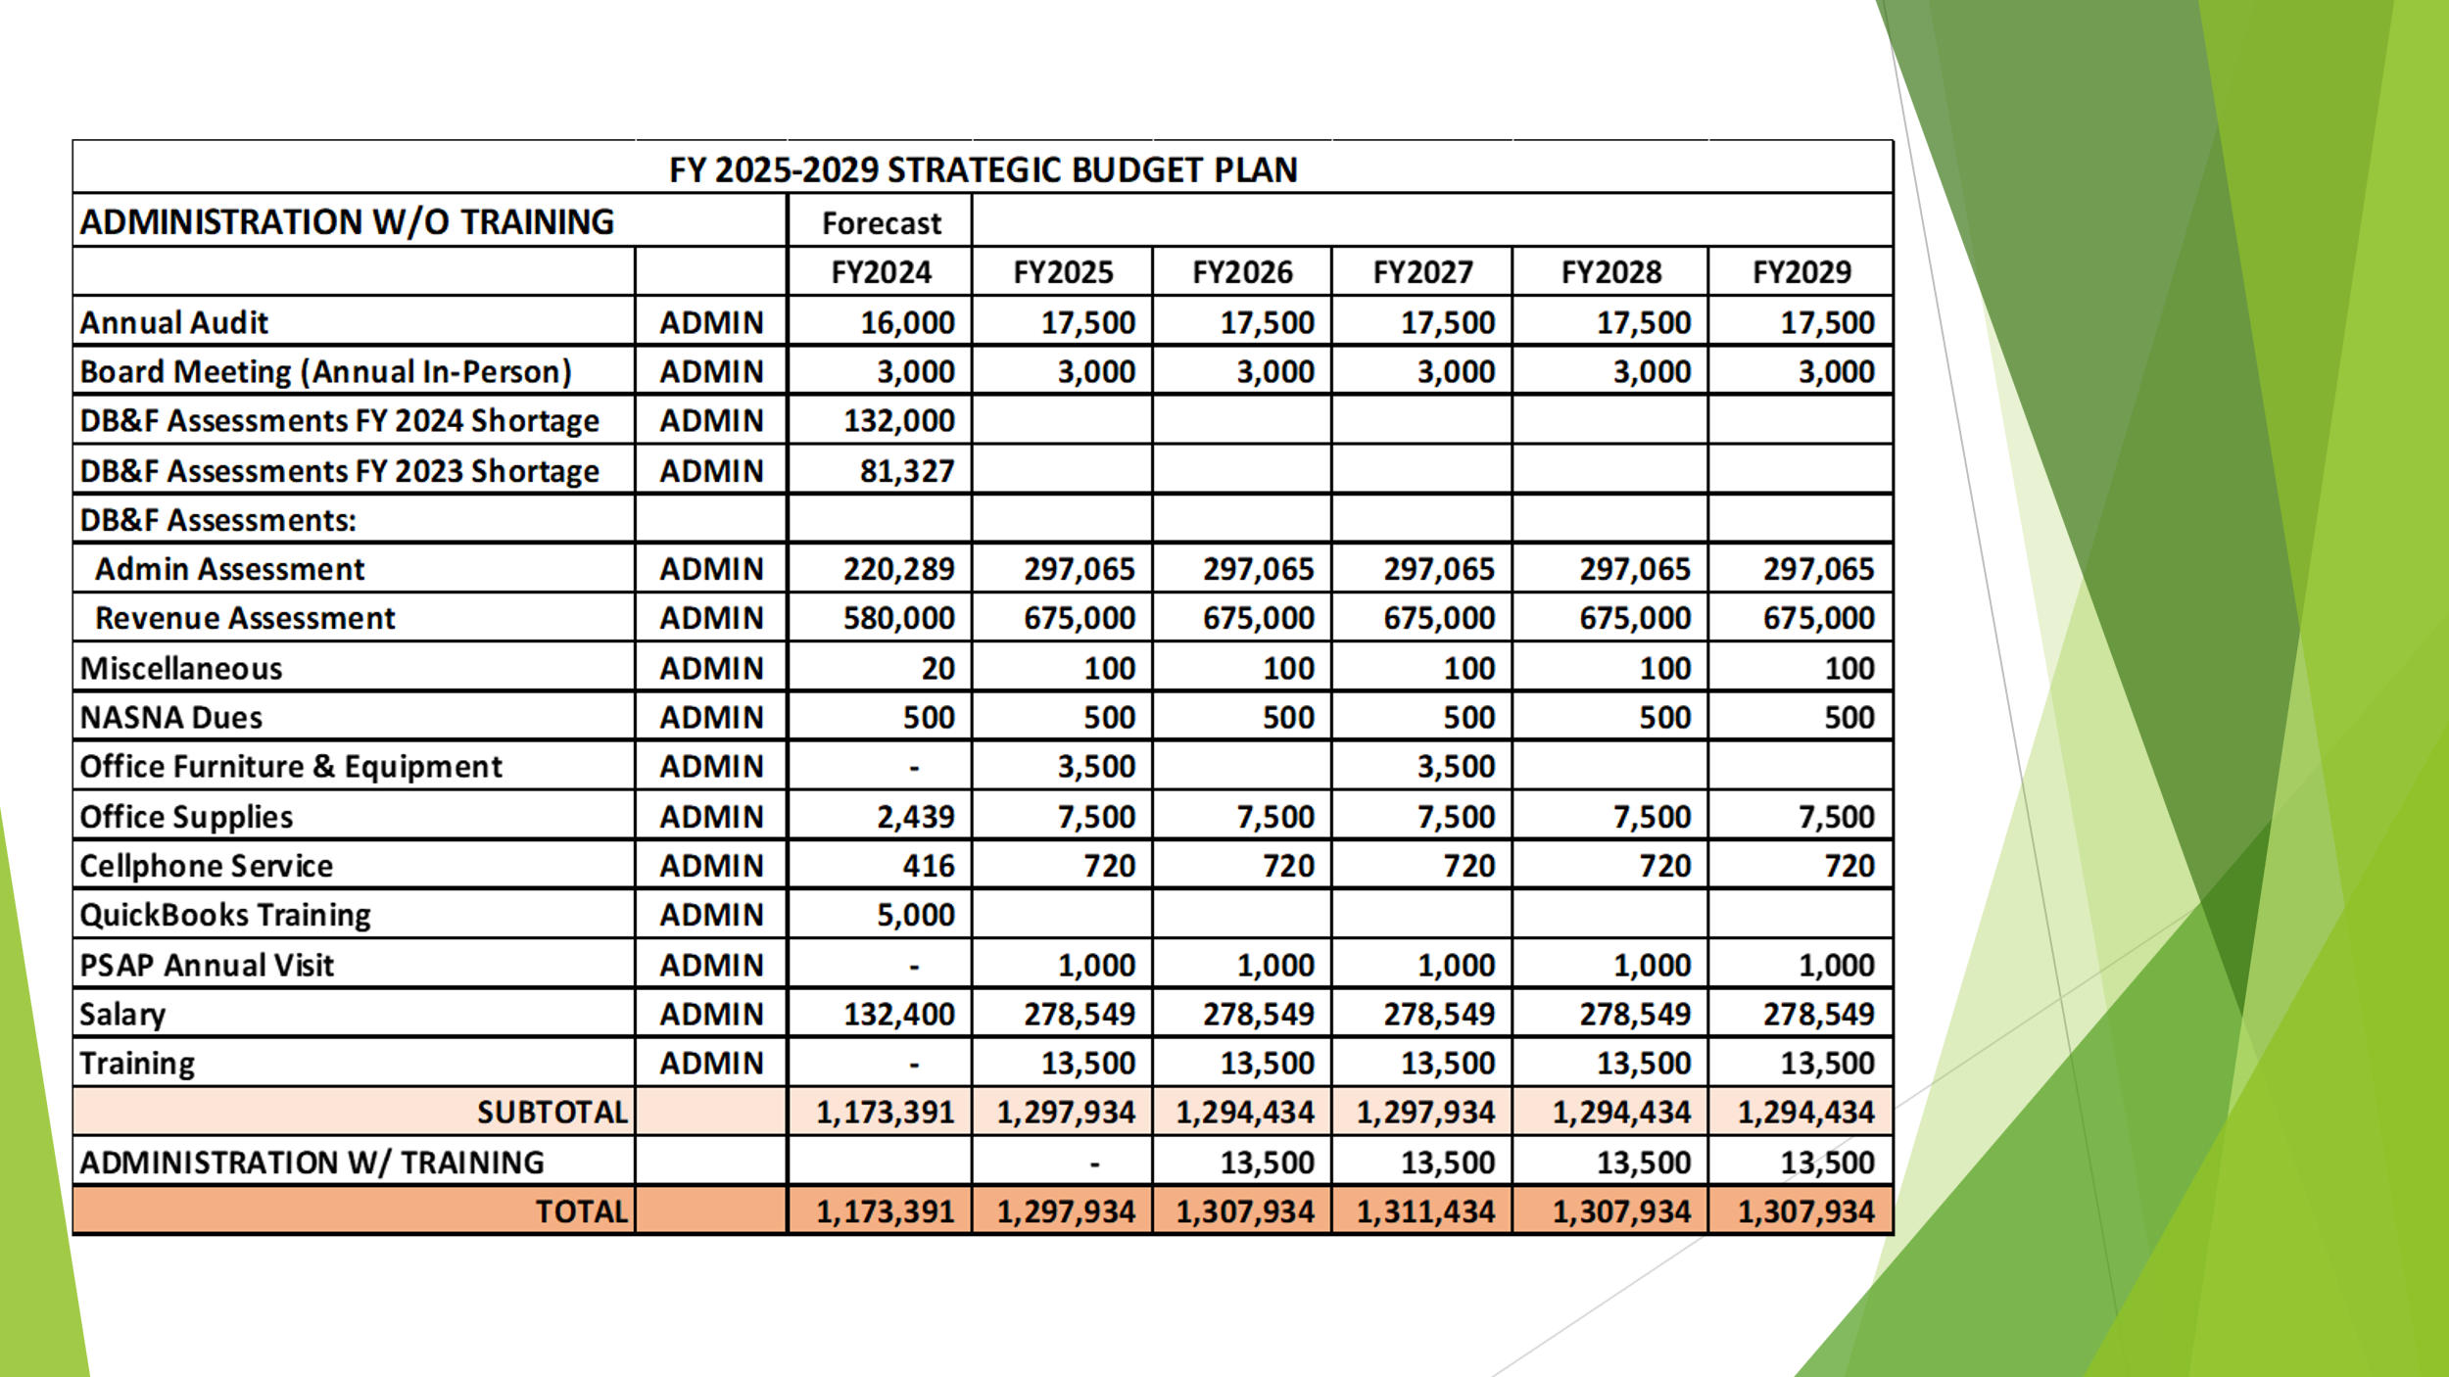

Executive Director stated that currently he is still having difficulties procuring a new auditor and recently extended the solicitation till the beginning of next month. He added in he had had several discussions with other firms on their reason for not submitting a proposal. All firms stated that it was due to a lack of resources and the size and length of the contract not being large enough for them to consider submitting a proposal. Furthermore, stated that to encourage firms to submit proposals that he will request from the Board in our next meeting to increase each year of the contract from $17,500 to $30,000 and eliminate option years so that firms can secure a contract for at least three years. In conclusion, stated that he will work with Edward Fujioka and Stella Kam to amend the solicitation and hopefully procure a new auditor before the end of the fiscal year.

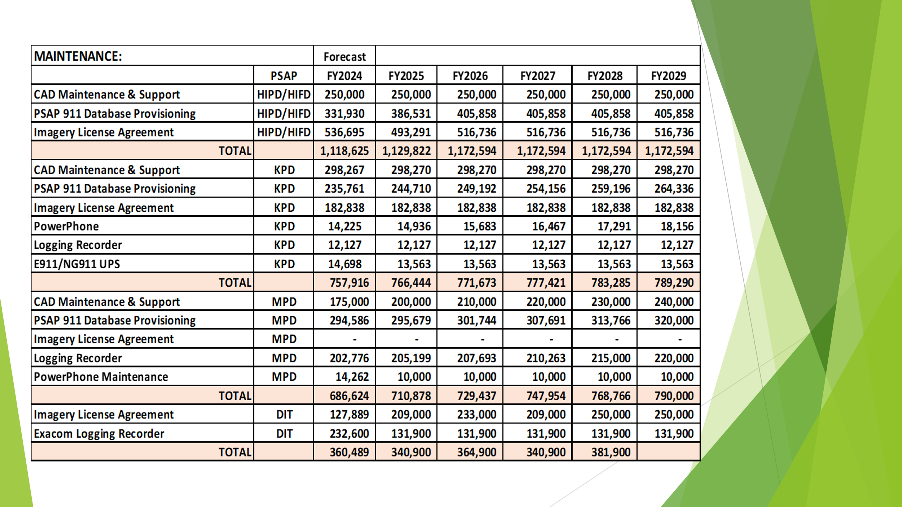
Edward Fujioka asked the Executive Director if DIT’s request for the Exacom Logging Recorder Refresh was captured in the budget. Executive Director stated that it is included in the Non-Recurring Section in Fiscal Year 2026 for $500,000.
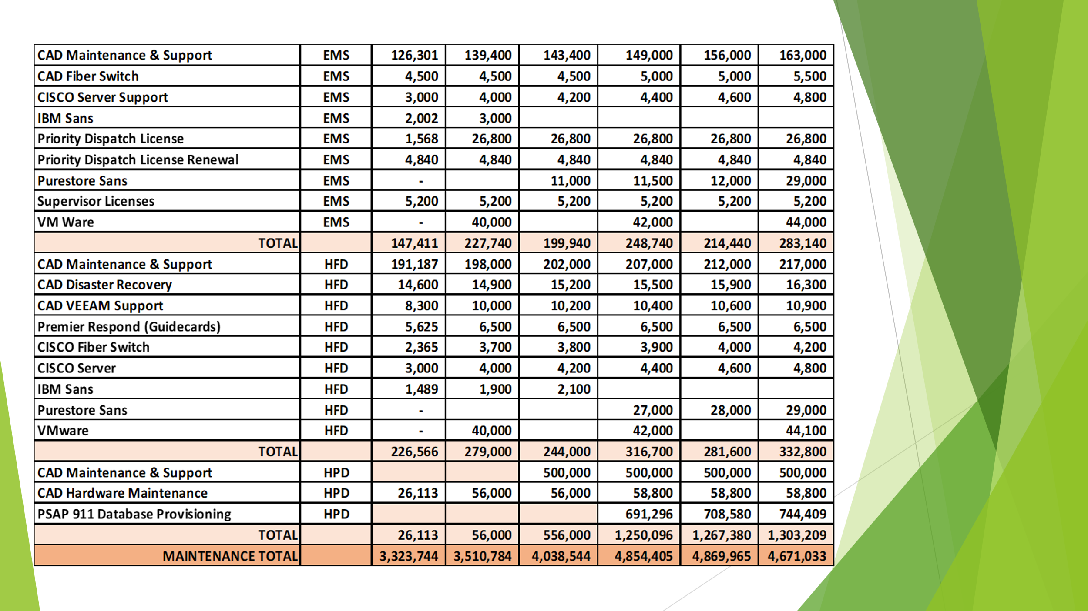

No questions asked on above slide.

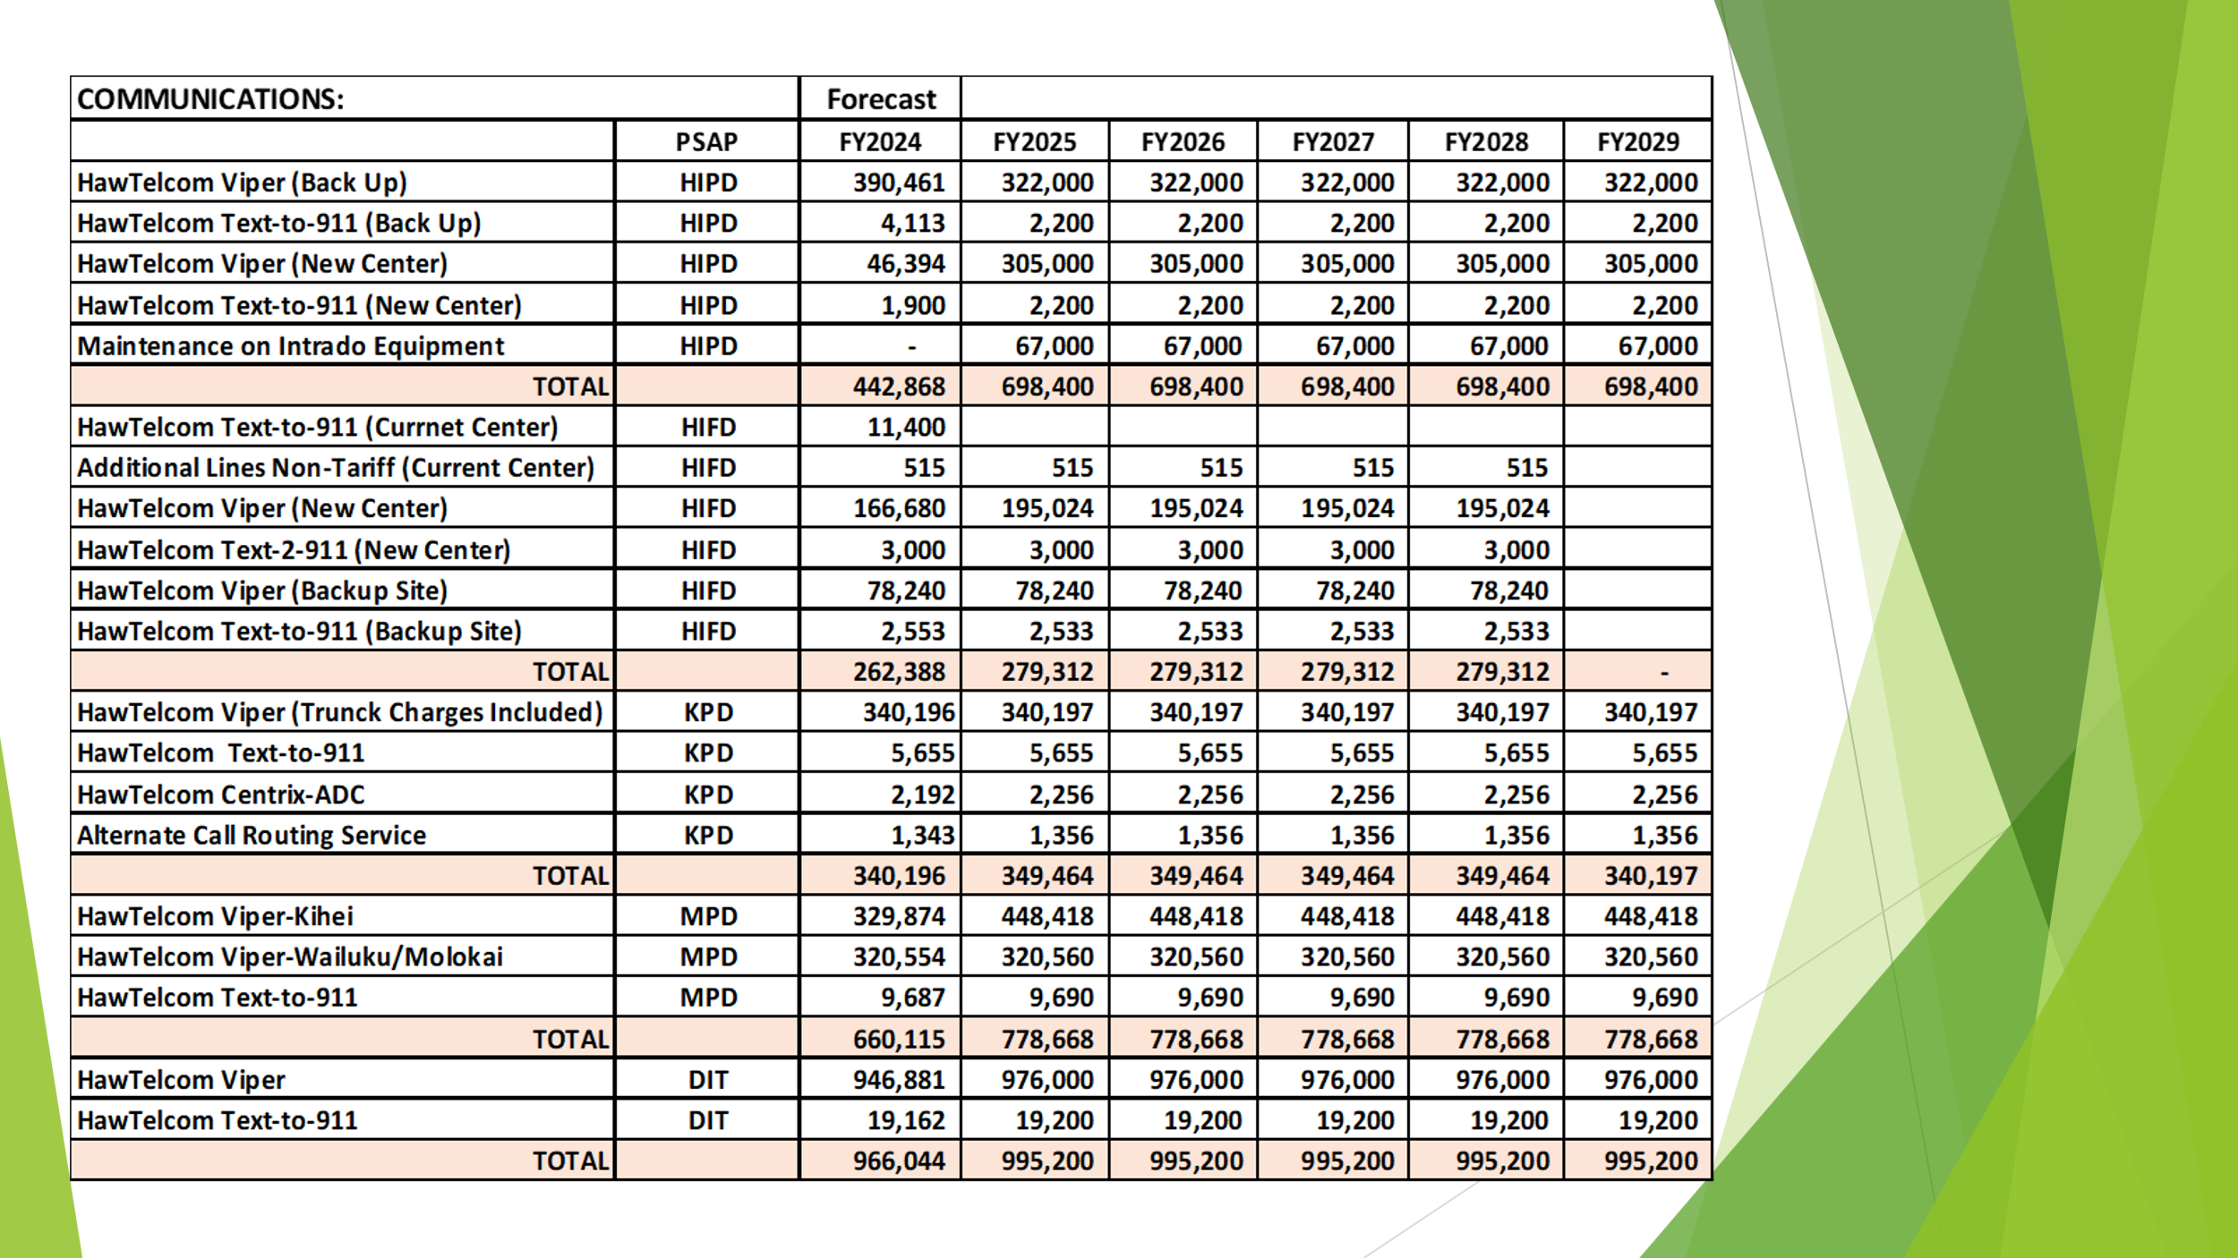
No questions asked on above slide.

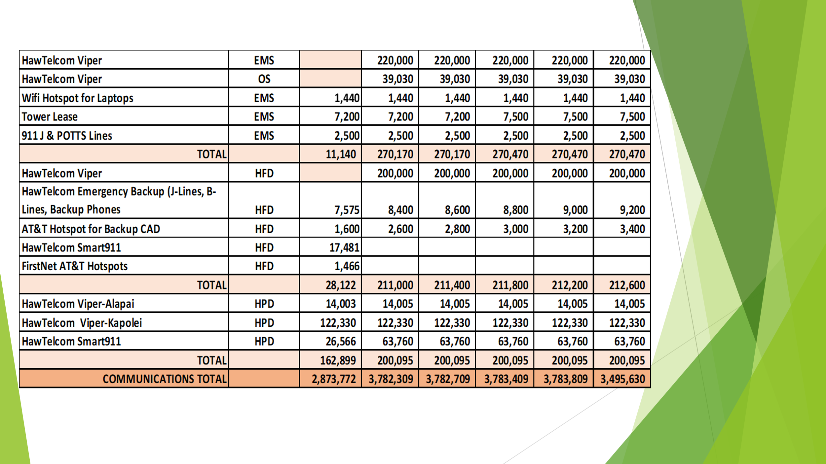
Edward Fujioka responded stating that if EMS and HFD’s Viper Contract will be encumbered once the contract is signed. Executive Director responded stating that is his intention moving forward to encumber the initial year of that contract that would increase the reserve by roughly $400,000 in Fiscal Year 2025. He added that he would then be able to add $18,000 in conference travel for each agency. However, this is pending if the contract is signed before the end of the fiscal year. Tony Velasco stated that the new Viper contract would be for five years.

Stephen Courtney responded stating that he has a general question not pertaining to the current slide. He stated that under items such as maintenance on why expenses remain static across several years. Executive Director responded stating that is due to the length of the contract. Edward Fujioka stated that only for CAD related items you will see gradual increases in maintenance for those contracts. He added that previously he reached out to CAD software vendors to inquire about procuring a master agreement to lock in costs for five-year increments however, they notified him that it would not be possible due to industry standards. In conclusion, stated that since a master agreement was not possible, they estimate an average increase of 2.5% - 5% per year moving forward.

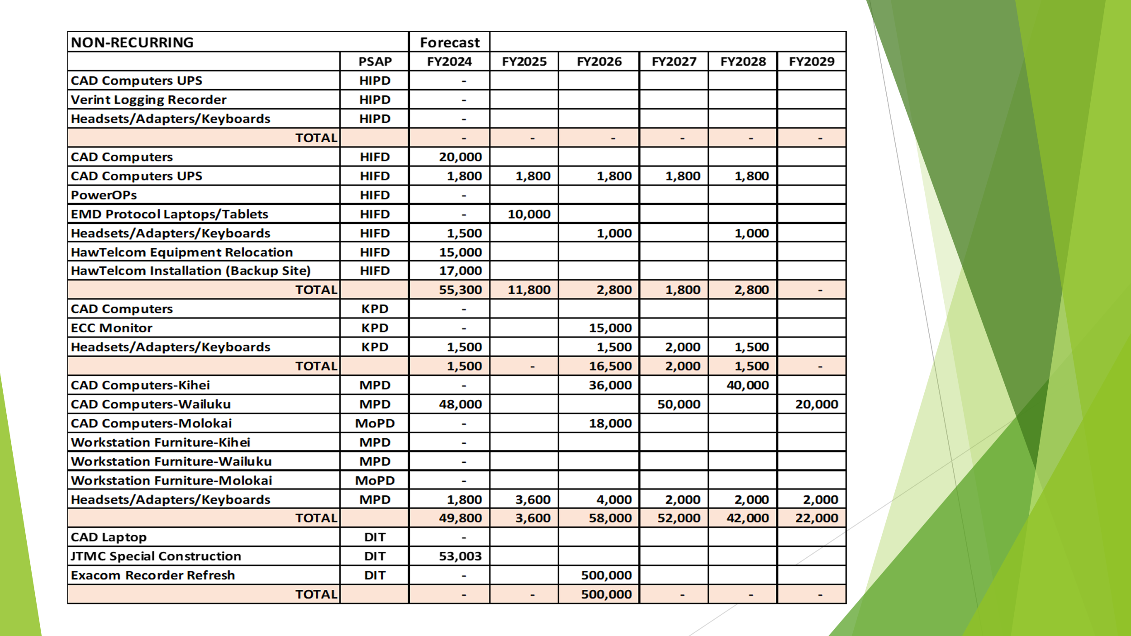
No questions asked on above slide.

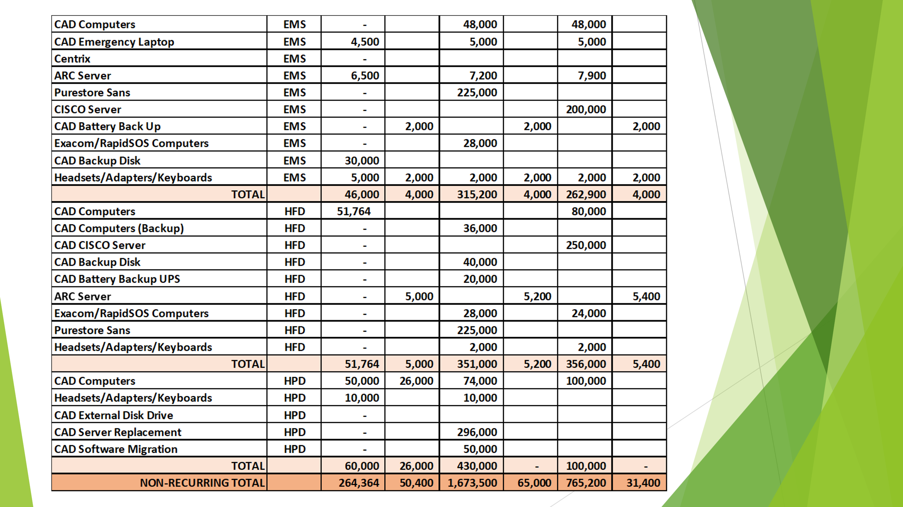
No questions asked on above slide.

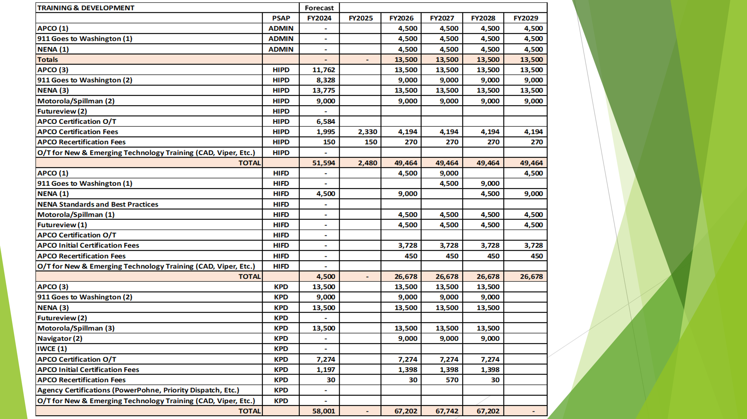
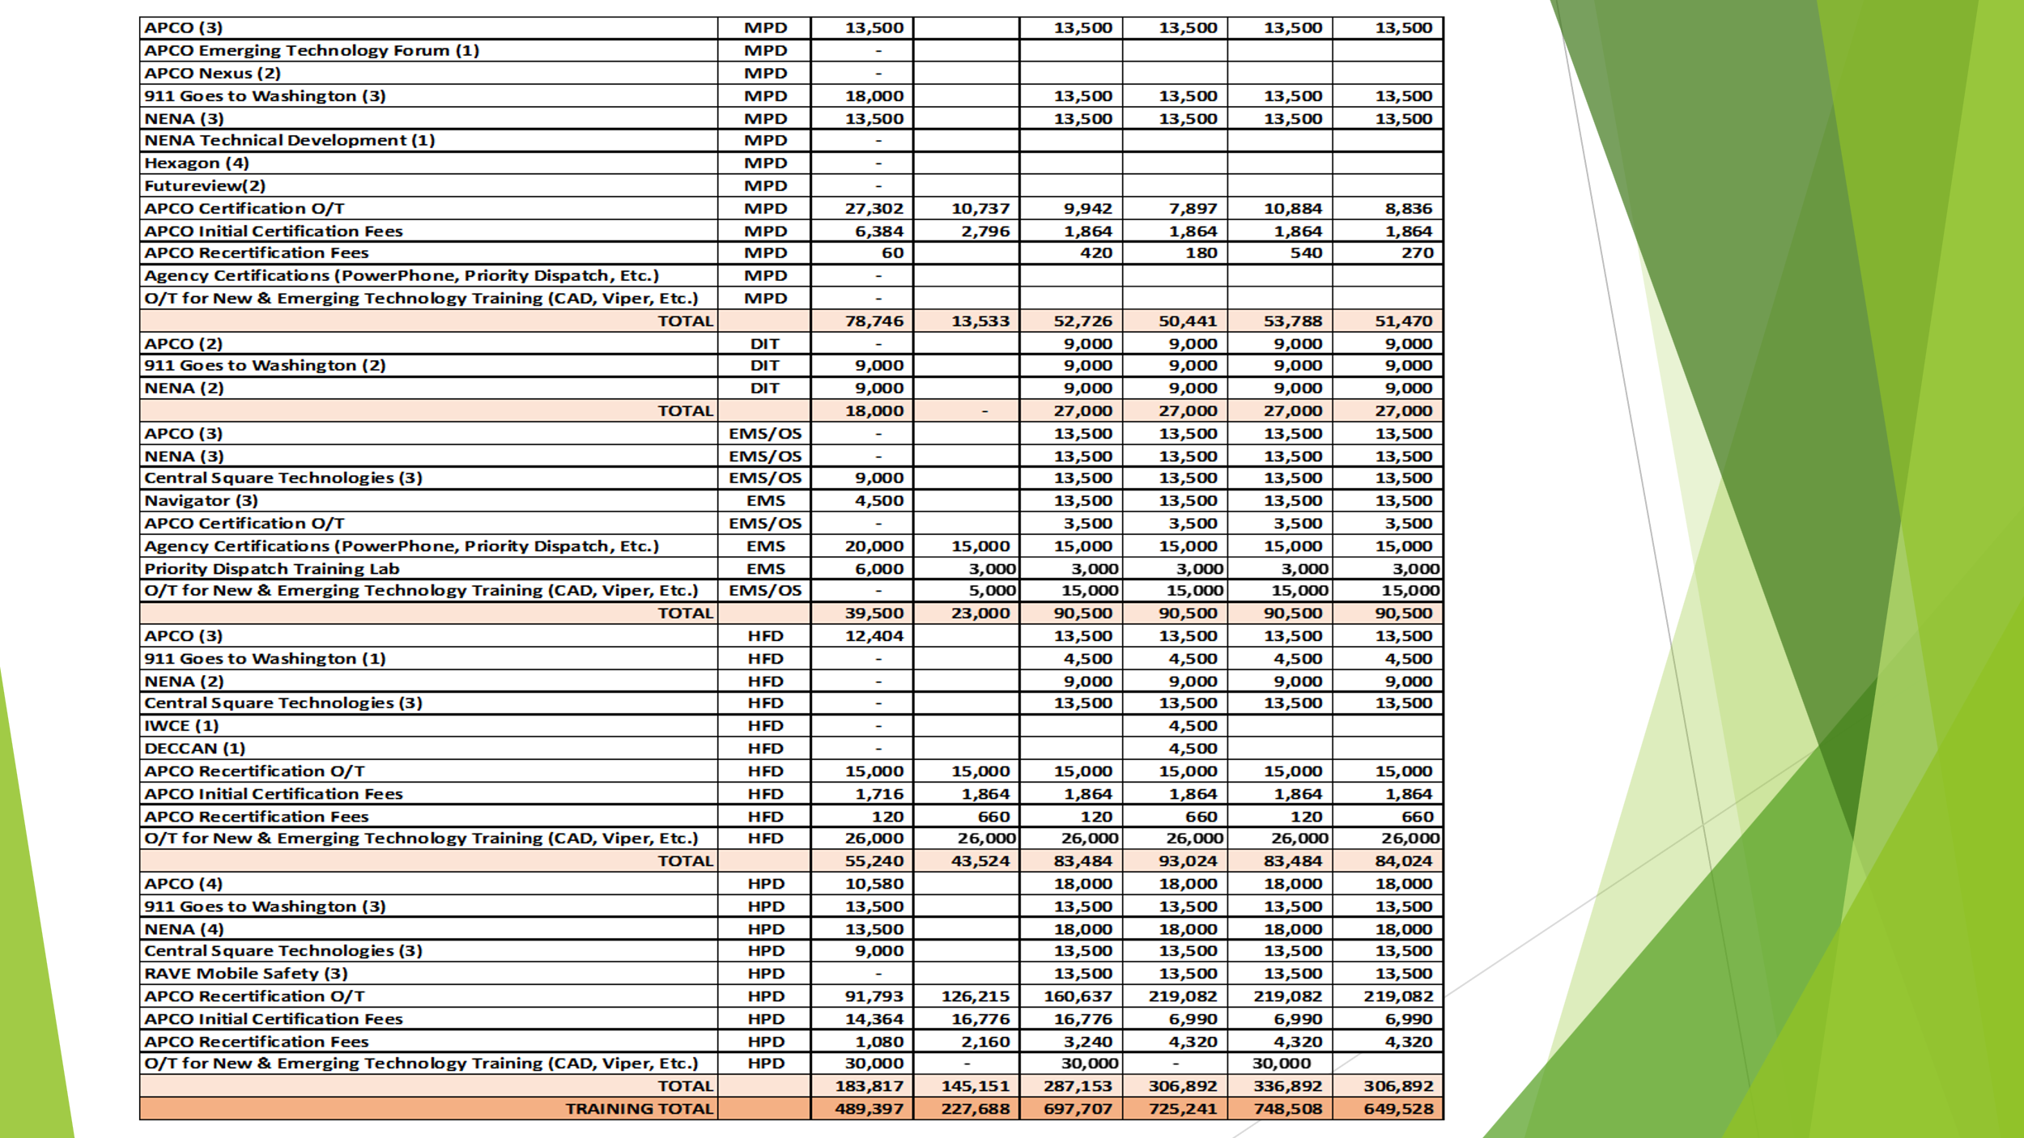
Executive Director stated that he updated the numbers for each agency regarding APCO Initial Certification Fees from $399 to $466 to include taxes for each certification. Shawn Kuratani responded stating that if there is a requirement to maintain the APCO Certifications because it has become administratively cumbersome. Davlynn Racadio responded stating that for civilian dispatchers it is important because it allows them to be recognized as first responders. She added that she does understand that it is cumbersome, but it is important for the agencies with civilian personnel to continue to be active in receiving this certification. Shawn Kuratani responded stating he understands the importance, however, wants to explore more specific training rather than the generic initial dispatcher certifications. Davlynn Racadio responded stating that exploring specific training is beneficial however should be discussed and approved by the Board. Stacy Domingo responded stating that is it required to use APCO or can another vendor by used that provides the same training. Shawn Kuratani stated that HFD began using APCO because they did not have any initial dispatcher training in place at the time and that other agencies use different platforms. Stacy Domingo responded stating that if they are currently not using the APCO Dispatcher Certifications can the funding be used to pay for a different vendor with a similar certification. Board Chair responded stating to please include that in your budget and submit it to the Executive Director so that the Board can discuss and approve that request. He added that if the cost is relatively similar each agency should have the choice to choose their own vendor. However, if there is a big cost disparity he does not believe the Board would approve. Diana Chun responded stating that she agrees with Davlynn Racadio’s previous statement on the importance of having all agencies collectively as a State be certified under one vendor.

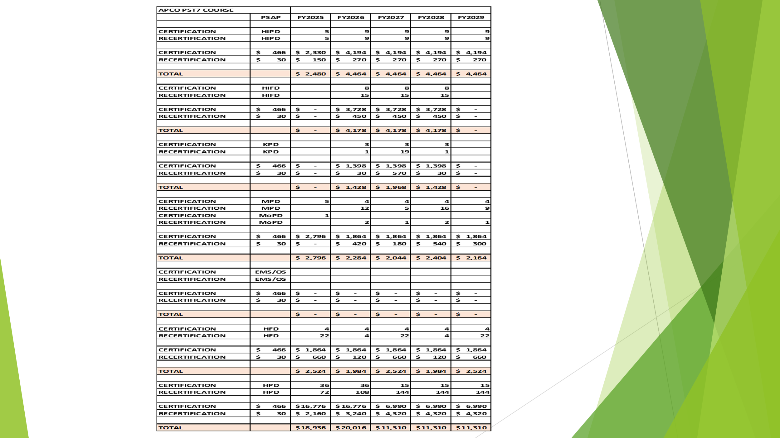
No questions on this slide concludes Fiscal Year 2025-2029 Strategic Budget Plan Presentation.

- Committee Updates by Committee Chairs
  - Communications Committee – Davlynn Racadio
    - Statewide 9-1-1 Outage (April 18, 2024)
Davlynn Racadio asked Hawaiian Telcom to give an update on the Statewide 9-1-1 Outage that occurred on April 18, 2024. Francis Alueta responded stating that the outage that occurred on April 18, 2024, lasted two hours and that they were able to move all PSAPs over to the white phones. During that time the system came back up on its own and they were able to reroute the traffic back to the 911 system within two hours. He added that through their investigation with Intrado they discovered their F5 Load Balancers were affected however, did not fail but were left in a communications state causing one device not being able to receive calls. Furthermore, stated that they did not identify any bugs/alarms and that this event was something that they had not previously encountered before. Intrado is currently installing a trap that would send an alarm if the two devices enter a communication state again. In conclusion, stated that they discussed with Intrado whether the equipment should be replaced before the call routing is upgraded for the A9-1-1 Call Routing is implemented. Davlynn Racadio responded stating that if this incident had any relationship with the Lumen incident that occurred the same day. Francis Alueta responded stating that it was not related and that he will personally investigate the causes of that incident as we move towards Next Generation 9-1-1 as we transition into a cloud-based environment. Davlynn Racadio stated if a press release would have been beneficiary to Hawaii to notify the public that the incident that occurred in Hawaii was not related to the Lumen incident. Francis Alueta responded stating that Hawaiian Telcom did respond to inquires from the press and the Governor’s Office the day of the incident and responded the following day once they were able to confirm with Intrado that the incident was not related.

    - 9-1-1 Telecommunicator’s Week
Davlynn Racadio stated that she wanted to go over a few topics that were discussed during 9-1-1 Telecommunicator’s Week. She stated that Representative Norma Torres gave a speech during 9-1-1 Telecommunicator’s week acknowledging out 9-1-1 dispatchers nationwide. Norma Torres stated “Every single day 9-1-1 dispatchers talk to people during the most difficult times in their lives despite their hard work 9-1-1 dispatchers are classified as clerical workers making them first on the chopping block for budget cuts leading to staffing shortages and already a stressful job. For this reason, I urge Congress to pass my 9-1-1 Saves Act to honor 9-1-1 dispatchers with a well-deserved reclassification”.

Davlynn Racadio stated that she also discovered a congressional record in the House from Representative Jill Tokuda that was published on March 7, 2024, regarding the Lahaina Wildfires. Jill Tokuda stated “All those who answered the call when we need them the most deserved to be recognized what they truly are first responders, that is why I am proud to co-sponsor that bipartisan 9-1-1 Saves Act, led by Representatives Norma Torres and Brian Fitzpatrick in honor of all our dispatchers. It is our turn to answer the call and pass the 9-1-1 Saves Act”. In conclusion, stated that they are still gaining more support on the reclassification for 9-1-1 dispatchers as first responders. However, we as a state need to continue to push for this change as well.

Davlynn Racadio stated that she would also like to discuss the following topics listed below. Links to the following bills are also listed below.

HR 6319 9-1-1 Saves Act of 2023

https://www.congress.gov/bill/118th-congress/house-bill/6319?q=%7B%22search%22%3A%22HR6319%22%7D&s=1&r=1

HR 2763 Protect 9-1-1 Act

https://www.congress.gov/bill/118th-congress/house-bill/2763?q=%7B%22search%22%3A%22HR2763%22%7D&s=2&r=1

HR 6415 CARE for First Responders Act

https://www.congress.gov/bill/118th-congress/house-bill/6415?q=%7B%22search%22%3A%22HR6415%22%7D&s=3&r=1

    - Seeking Volunteers for Communications Committee
Davlynn Racadio stated that she is seeking volunteers for the Communications Committee and is requesting all agencies to have line personnel attend the monthly meetings. She added that line personnel should be included because they are the future and should have a say on what their life will be like in the future.

  - Technical Committee – Shawn Kuratani
    - HECO Public Safety Power Shutoff Initiative
Shawn Kuratani stated that he would like to discuss the HECO Public Safety Power Shutoff Initiative that would shut down power in areas with heightened increase of brush fires with low humidity and high wind. He stated that his concern is that only a 24-hour notice is given to shut down power that could last several days as they inspect lines before power is restored. He added that all counties would be affected except Kaui County and encourages all agencies to view HECO’s map of potential effected areas. Currently Oahu County has conducted meetings with its Interagency Communications group to determine how all agencies would be able to communicate in a worst-case scenario if network, radio, and cell service is lost. Furthermore, stated that he has invited all the major communication service providers to give their input on the effects of the 9-1-1 system and the surrounding cell phone towers. In conclusion, stated that this initiative would go into effective July 1, 2024, and will continue to update the Board on this matter. Board Chair stated that HECO has proactively reached out with the specific circuits that they would be targeting and how critical those designated circuits are to maintain operations. He added that HECO is being very diligent during this process and that it is important that all the agencies are on the same page. Francis Alueta responded stating that Hawaiian Telcom is treating this not like a normal commercial power outage and are currently having discussions on how they will respond during these events.

      - Advisory Committee – Rebecca Lieberman
        - Updates on Legislative Session
Rebecca Lieberman stated HB 2339 H.D.1 S.D.2 C.D.1 was transmitted to the Governor for approval. She added that she would like to thank the Executive Director, Tony Ramirez, and everyone that submitted testimony in support.

  - Finance Committee – Edward Fujioka
    - Review of Monthly Y-T-D (Year to Date) Cash Flow
April 2024 Cashflow Statement:

Surcharge Collection: $999.446
Interest Income: $118,934
Total Receipts: $1,118,380
Total Disbursements: ($808,513)
Net Receipts/Disbursements: $309,867
Net Encumbrances Adds/(Paydown): ($620,616)
Net Cash Inflow /(Outflow): ($310,750)
Outstanding Encumbrances: $8,345,249
Net Bank Balance: $41,493,695
Unencumbered Cash Balance: $33,148,446

- Public Service Answering Point Status Updates on Recruitment and other Personnel Issues
  - Kauai Police Department – Ariel Ramos
    - Update on Recruitment Process/Strategies and Personnel Training
Darren Rose on behalf of Ariel Ramos stated no new updates since last month’s update.

    - Update on Personnel Issues and Vacancies
Darren Rose on behalf of Ariel Ramos stated no new updates since last month’s update.

  - Oahu Police Department – Matthew Kurihara
    - Update on Recruitment Process/Strategies and Personnel Training
Matthew Kurihara stated that they spoke to the media on their staffing issues in hope of receiving more applicants.

    - Update on Personnel Issues and Vacancies
Matthew Kurihara stated that they currently have 37% vacancy rate.

  - Oahu Fire Department – Shawn Kuratani
    - Update on Recruitment Process/Strategies and Personnel Training
Shawn Kuratani stated no new updates since last month’s update.

    - Update on Personnel Issues and Vacancies
Shawn Kuratani stated no new updates since last month’s update.

  - Oahu Emergency Medical Services – Lorrin Okumura, Diana Chun, Frannie Chung
    - Update on Recruitment Process/Strategies and Personnel Training
Lorrin Okumura stated no updates regarding recruitment process/strategies and personnel training.

    - Update on Personnel Issues and Vacancies
Lorrin Okumura stated that they currently have eight vacancies and recently transferred one of their dispatch supervisors to assist with their CAD system.

  - Maui Police Department – Davlynn Racadio
    - Update on Recruitment Process/Strategies and Personnel Training
Davlynn Racadio stated that they currently have eight applicants in the process of finishing their applications and ten applicants in the process of submitting their personal history questionnaire. She added that she is planning to start a class in either June or July.

    - Update on Personnel Issues and Vacancies
Davlynn Racadio stated no updates on personnel issues and vacancies.

  - Molokai Police Department – Davlynn Racadio
    - Update on Recruitment Process/Strategies and Personnel Training
Please see Maui Police Department Updates.

    - Update on Personnel Issues and Vacancies
Please see Maui Police Department Updates.

  - Hawaii Police Department – Robert Fujitake
    - Update on Recruitment Process/Strategies and Personnel Training
Robert Fujitake stated that they started a class of two personnel on May 1, 2024, and are looking to start another class with two personnel on June 3, 2024. He added that they added a second trainer to help with training.

    - Update on Personnel Issues and Vacancies
Robert Fujitake stated that they currently have fourteen vacancies that will decrease to 10 after the start of those two classes.

  - Hawaii Fire Department – Stacy Domingo
    - Update on Recruitment Process/Strategies and Personnel Training
Stacy Domingo stated that they currently have nine dispatchers with an additional five trainees that started in March. She added that they conducted a realistic job preview with 13 applicants attending. Furthermore, stated that out of the 13 applicants they are expected to start a class in September with four to five of those applicants to receive an offer.

    - Update on Personnel Issues and Vacancies
Stacy Domingo stated no updates regarding personnel issues and vacancies.

- Items for Discussion, Consideration, and Action
  - Additional Items Proposed by Meeting Attendees.

- Announcements
  - Future Virtual Meeting Dates/Times (9:00AM-12:00PM)
    - Thursday, June 13, 2024 (Combined Meeting)
  - Future Conference Dates (3 Months of Advanced Approval Required)
    - NENA (National Emergency Number Association) Conference June 28 – July 3, 2024, Kissimmee, Florida
    - APCO (Association of Public-Safety Communications Officials) Conference August 4-7, 2024, Orlando Florida
  - Additional Announcements from Meeting Attendees

- Open Forum: Public comment on issues not on the Board Meeting Agenda
There was no public comment on issues not on the agenda.

- Adjournment
Tony Velasco motioned to adjourn the meeting. Francis Alueta seconded the motion. A voice vote was taken, and the adjournment was unanimously approved. The meeting was adjourned.

