JOSH GREEN, M.D.  GOVERNOR  Ke Kiaʻāina |  | KEITH A. REGAN  COMPTROLLER  Ka Luna Hoʻomalu Hana Laulā  MEOH-LENG SILLIMAN  DEPUTY COMPTROLLER  Ka Hope Luna Hoʻomalu Hana Laulā
STATE OF HAWAIʻI | KA Mokuʻāina o Hawaiʻi

DEPARTMENT OF ACCOUNTING AND GENERAL SERVICES | KA ʻOihana LOIHELU A LAWELAWE Laulā
P.O. BOX 119, HONOLULU, HAWAII 96810-0119

Communications, Technical, and Finance Meeting
(Combined Meeting)

Thursday, December 14, 2023
9:00 am – 12:00 pm

MEETING MINUTES

Communications Committee Members Present: Davlynn Racadio (MPD), Thalia Burns (HPD)

Communications Committee Members Not Present: Lavina Taovao (KPD)

Technical Committee Members Present: Shawn Kuratani (HFD), Tony Ramirez (VSE), Tony Velasco (DIT), Kenison Tejada (FirstNet), Thalia Burns (HPD)

Technical Committee Members Not Present: David Miyasaki (KPD)

Finance Committee Members Present: Stephen Courtney (C&C of Honolulu), Tony Velasco (DIT), Todd Omura (CIO Designee), Reed Mahuna (HIPD), Matthew Kurihara (HPD), Liz Gregg (ATT)

Finance Committee Members No Present: Edward Fujioka (EMS)

Staff: Royce Murakami (E911), Stella Kam (AG)

Guests: Robert Fujitake (HIPD), Nani Blake (T-Mobile), Frannie Chung (EMS) Stacy Domingo (HIFD), Everett Kaneshige (DOD), Wayne Hirasa (Alakaina), E. Kalani Ke. (KPD), Glenn Kobashigawa (HT), Ah Lan Leong (HPD), Rebecca Lieberman (Charter), Lorrin Okumura (EMS), Gregg Okamoto (MPD), Ariel Ramos (KPD), Corey Shaffer (Verizon), Kenison Tejada (FirstNet), Valerie Taylor (Intrado), Buck Giles (OSL), Calvin Sung (HPD), Chris Halliday (RapidSOS), John Edwards (RapidSOS), Michael Notarstefano (RapidSOS).

- Call to Order, Public Notice
The meeting was called to order by the Board Chair. Public Notice was given.

- Public Testimony Will Be Taken on All Agenda Items as Those Items Occur During the Meeting

- Roll Call, Quorum
A roll call was taken, quorum was present for all three committees.

- Updates from RapidSOS – Michael Notarstefano
Michael Notarstefano stated that his colleagues and he will go over a thirty-minute-high level overview of some of the new updates from RapidSOS.
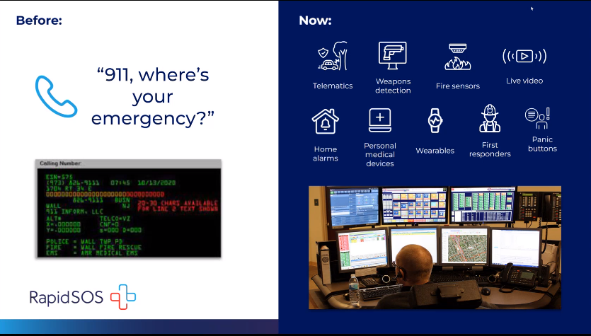
Michael Notarstefano stated that the above slide gives an overview of actionable intelligence. Before RapidSOS and technology that aided dispatchers and telecommunicators in obtaining accurate location from wireless 911 callers we have been limited to 512 bytes of data in the ALI/ANI screen and any additional location information or rich data from IoT devices in our community was not existent or was delivered to silent systems. Currently, RapidSOS has experienced significant growth due to partnerships with 911 and has evolved into an intelligent safety platform. He added that they are now receiving highly accurate device space location from wireless 911 calls while receiving millions of payloads of data from IoT devices in our communities. Furthermore, stated that the above slide shows examples of data that you will be able to see in their platform today which includes cross telematics weapon detection sensors that can detect fires, alarms, wearable devices, and first responder information.

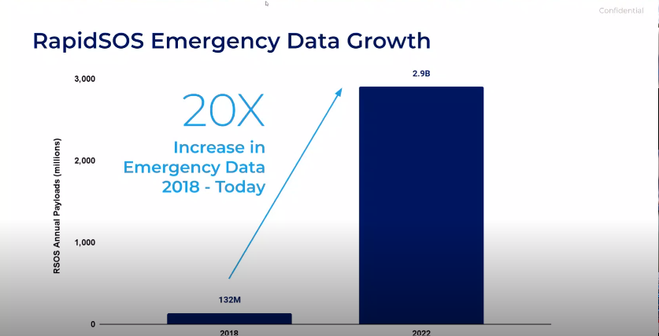
Michael Notarstefano stated that the above snapshot shows the amount of growth in data payloads that RapidSOS has experienced recently from 132 million to 2.9 billion which is due to the increase in IoT connected devices.

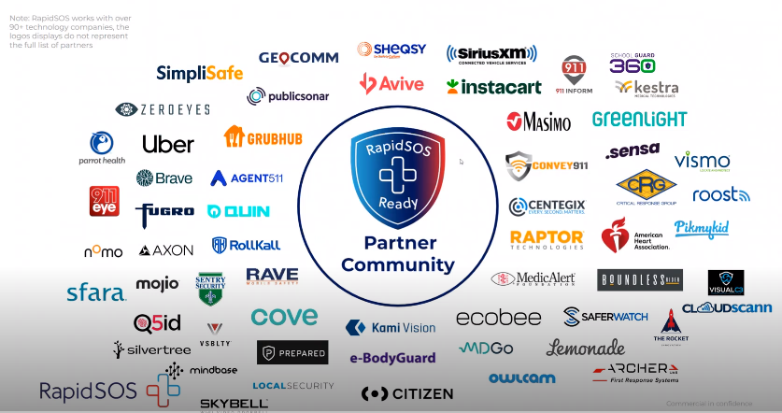
Michael Notarstefano stated that the amount of growth in data payloads was made possible due to the partnerships that we have shown on the above slides. He added that the above slide is an abbreviated list and currently has 90 different technology platforms. RapidSOS is noted in the middle of this slide to show the importance of bridging these platforms to receive highly accurate location information and pertinent rich additional data from the difference IoT device makes and application developers delivering 911.

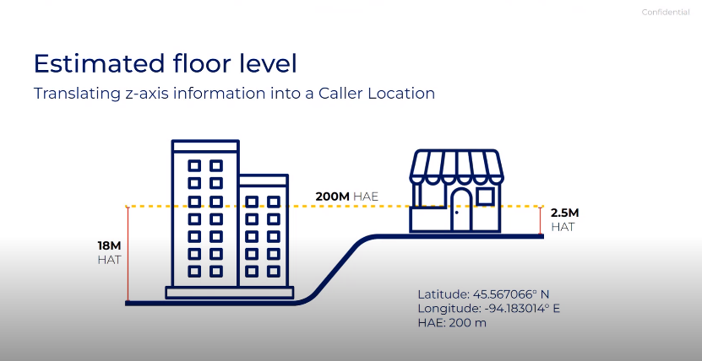
Michael Notarstefano stated the above slide shows a new feature on the RapidSOS Portal called estimated flow level. Currently we are beginning to receive raw z-axis data from device manufactures and wireless carriers. He added that this raw z-axis data is being delivered in a raw format called height above ellipsoid which is not accurate because it does not consider the different levels of terrain. RapidSOS recently entered a partnership with GeoComm, a leading GIS service provider that is utilizing an actionable z-axis location tool that they are incorporating into RapidSOS Portal and Premium. This partnership with GeoComm allows the raw z-axis data to be converted into a heigh above terrain output that will be sent to dispatchers as an actionable dispatchable location.

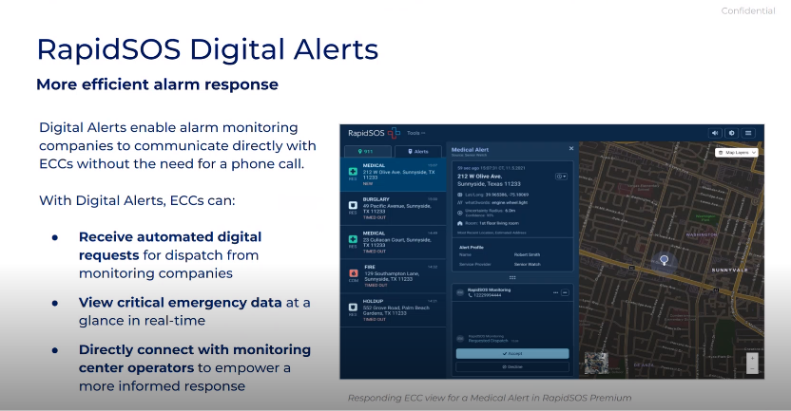
Michael Notarstefano stated that the above slides do not show a function that is new to RapidSOS, however, it is a function that has evolved moving into 2024. Currently RapidSOS receives alarm information for commercial and residential burglary alarms and has now entered into agreements with major companies such as Honeywell to receive fire alarm data. He added that they have also expanded the capability to include active assailant alerts and school safety alerts. These added functions will enable dispatchers and telecommunicators to do more with less and eliminate as many phone calls into the PSAP as possible.

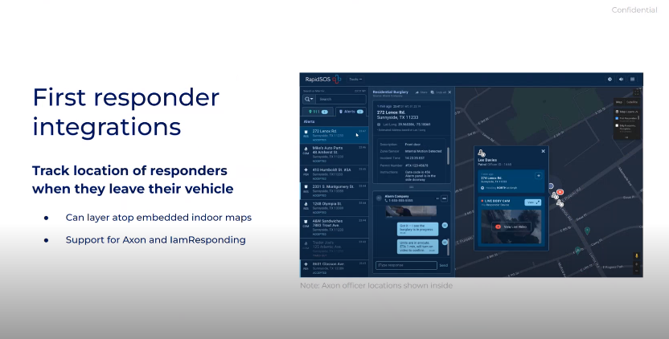
Michael Notarstefano stated that currently Maui and Kaui Police Department has this feature enabled which is the RapidSOS AXON Integration which allows dispatchers and telecommunicators to have access to a togglable map layer in their existing RapidSOS account and see field responder’s locations. He added that it is pertinent for those field responders who exit their vehicles that dispatchers and telecommunicators can track their location.

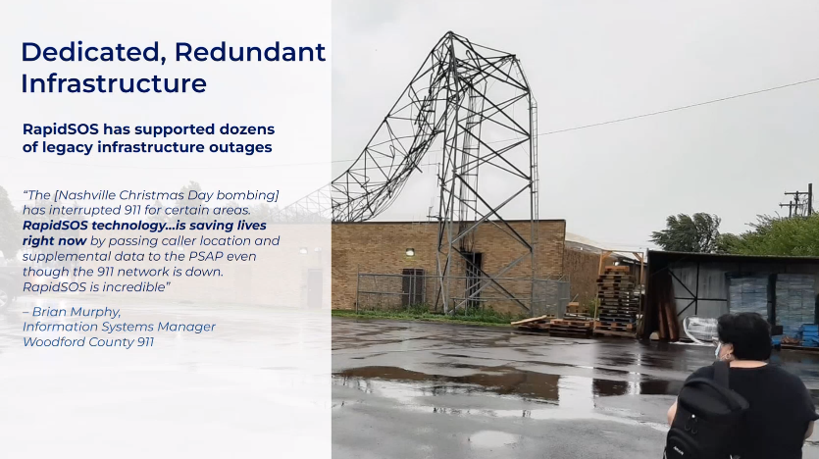
Michael Notarstefano stated in the above slide reviews the redundancy nature of RapidSOS jurisdiction view which any primary PSAP that dispatches for law enforcement has access to today. He added that this critical feature allows for wireless 911 calls from within agencies respective jurisdictions to automatically plot on the RapidSOS map and remains operational in the event of a 911 outage as long as the agency has a means to an active internet connection. Furthermore, stated that this feature is important as it relates to malicious intent to critical infrastructure, natural disasters, or common mistakes that we see across the United States. In conclusion, stated that he would now like to have John Edwards give a brief demonstration of RapidSOS Premium solution.

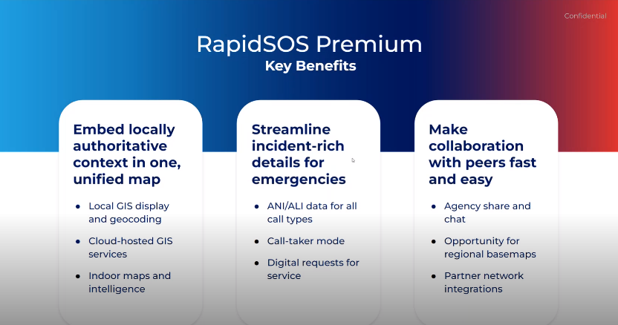
John Edwards stated that he would like to cover some of the key benefits of the RapidSOS Premium solution. He stated that in the premium solution you can take your local GIS data and upload your azure layers to have a base map that has configurable and toggleable layers. He added that all data can be hosted in a cloud that would give access to GIS and mapping data in the event of an outage. Regarding indoor maps, the premium solution allows the ability to display indoor maps from a variety of providers such as 911inform, CRG, and GeoComm. Second key area will allow streamlining of workflows. He stated that currently in the RapidSOS Portal VoIP or Landline calls are not shown however, in the premium solution it will present all your calls on one screen allowing you to consolidate your mapping applications. Last component is interoperability and the ability to share incidents with surrounding PSAPs. He added that options to route alerts, digital alerts, and fire alarms are automatically configured to notify their surrounding PSAPs in real time.

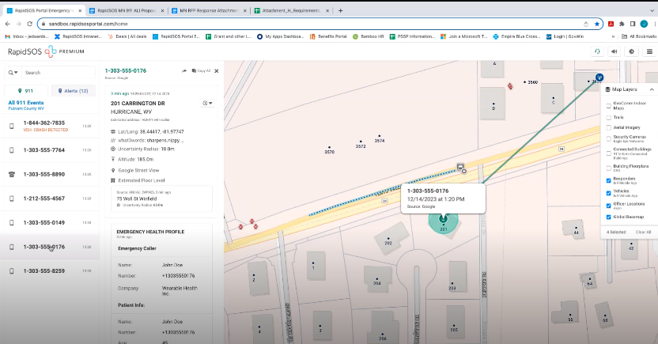
John Edwards stated that above slide will show an overview of the Premium solution. He stated that transitioning from a portal environment to a premium requires very minimal training because the applications operate the same however, utilizes a different GIS foundation. Other features that are available in the premium solution are the capability to display medical information from IoT devices to the PSAP as well as estimated floor level, weapons detection, and indoor mapping that was discussed earlier in the presentation.

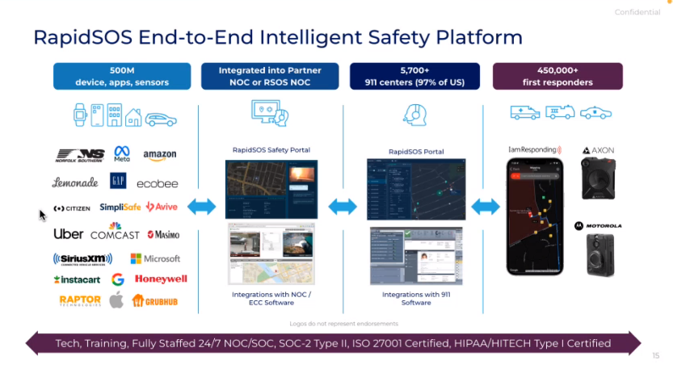
Chris Halliday stated that he would like to give an overview of IamResponding that was created 17 years ago that was initially developed for the purpose of determining who’s coming to a particular call primarily in the volunteer and combination of fire departments. He stated since its inception it has grown considerably and one of the main takeaways that they have realized is that there is a lot of data that comes into the 911 system that first responders either can’t see directly or must rely on a dispatcher to rely on a dispatcher to relay that verbally and paint the picture for the firs responder over the radio.

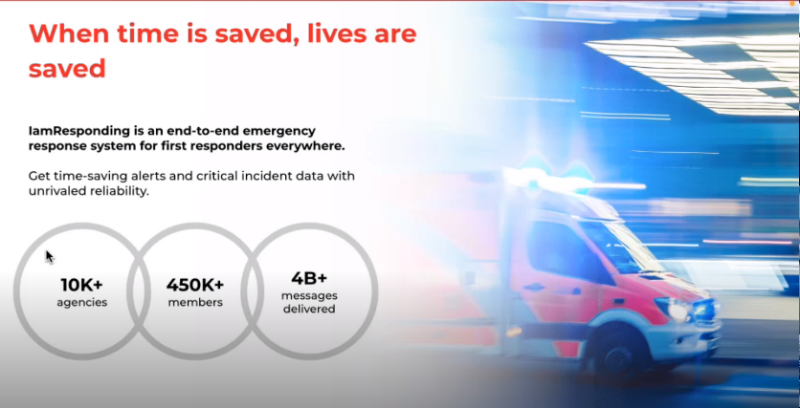
Chris Halliday stated that by combining RapidSOS and IamResponding they can make a truly end-to-end intelligent safety platform that is utilized by over 10,000 agencies with over 450,000 end users that currently use the application. Furthermore, stated that the current system is built off three independent servers so that data can be reliably accessed.

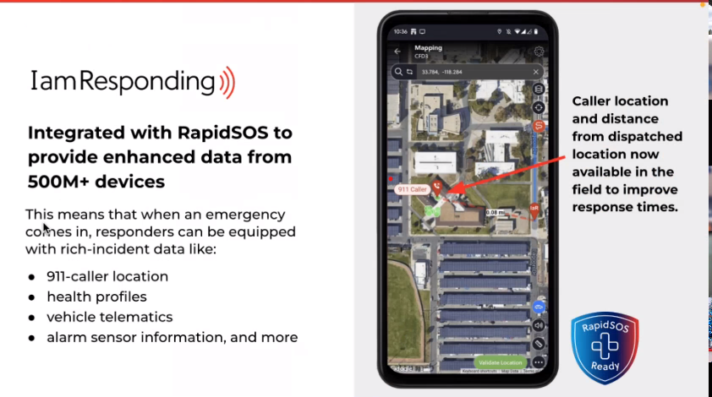
Chris Halliday stated that the application provides exact 911 caller location with turn-by-turn directions that can be accessed by the first responder on their mobile device/tablet. Other additional information that can be accessed through the RapidSOS Portal is health profiles and vehicle telematics that were discussed in the beginning of the presentation. He added that information that would normally be verbally relayed can now be seen directly at the first responder level hopefully saving crucial minutes to responding to the incident.

Chris Halliday stated that the above slide is a companion application called My Local Safety or MyLS which allows your agency to create their own phone application. He added that two features that he would like to highlight are residential pre plans and the ability to communicate to residents. This application is free to download for the public and would ask residents to fill in important information that first responders will ask and save that information and leave a residential pre plan marker on the map that will allow dispatchers and first responders to access this information.
Shawn Kuratani asked Chris Halliday how many members are participating in the MyLS program and what does the buy in process entails. Chris Halliday responded stating that he does not have the exact numbers and will forward that information to him. Regarding the buy in process Chris Halliday stated that all the marketing tools are provided to the agency including templates for press release, social media output, and business cards.
Shawn Kuratani asked Michael Notarstefano if there is any confidence level displayed on z-axis data. Michael Notarstefano stated that to his understanding when you enable the estimated floor location function within the administrative settings of RapidSOS a level of uncertainty depending on the call is provided. He added that typical elevation accuracies are within plus or minus three meters or roughly one floor.
Shawn Kuratani asked Chris Halliday if the turn-by-turn directions include live traffic. Chris Halliday responded stating that it does not currently however, you are able to choose other applications such as Waze or Apple Maps.
Shawn Kuratani asked Chris Halliday if IamResponding has the capability to incorporate other jurisdictions and track their location such as flight path data. Chris Halliday responded that there are no air traffic capabilities now, however, in terms of sharing your location data any agencies that are using IamResponding can give permissions to each other to share data.
Shawn Kuratani asked Chris Halliday if any wearable solutions to track first responders are available that are not cellphone based. Chris Halliday responded stating that on the IamResponding side there is none currently that is not cellphone based.
Robert Fujitake asked Michael Notarstefano regarding location of officers would they need to upgrade to the Premium solution or can they remain on the RapidSOS Portal to have this option available. Michael Notarstefano stated that the Portal would support the AXON Integration however, AXON Body III Hardware or later must be currently used and the agency must maintain an active subscription to AXON’s Respond Platform. He added that once these two prerequisites are met on the AXON side that you can contact RapidSOS to enable the integration.
Kenison Tejada asked John Edwards regarding the Residential Pre-Plan overly with GeoComm mapping and if that is a subscription service or do you need to be subscribed to GeoComm. John Edwards responded stating that it is a subscription that would be paid to GeoComm to perform mapping of the buildings. Davlynn Racadio responded stating if there are any companies that are currently mapping buildings here in Hawaii. Michael Notarstefano stated that he would ask their partners at GeoComm, CRG, and 911inform to see if they can provide any insights. Davlynn Racadio responded stating that she spoke to 911inform, and they stated that currently no one has invited them to provide mapping for Hawaii.
Ah Lan Leong asked Chris Halliday regarding MyLS if any emergency management agencies are using that application. Chris Halliday responded stating that the application is relatively new and is currently being used by individual fire departments. He added that they are open to working with all emergency management agencies. He added that MyLS is a companion application with IamResponding.

- Review and Approval of November’s Meeting Minutes
Board Chair requested a motion to approve July’s Meeting Minutes. Tony Velasco motioned to approve October’s Meeting Minutes. Tony Ramirez seconded the motion. A voice vote was taken, motion was unanimously approved.

- Committee Updates by Committee Chairs
  - Communications Committee – Davlynn Racadio
    - 9-1-1 Goes to Washington February 25-28, 2024.
      - Preparation & Personnel Attending
Davlynn Racadio stated that she sent an email to all agencies to confirm the number of personnel attending. She added that she received notification from NENA that their host hotel at the Ritz Carlton has opened more rooms for the conference. In conclusion, stated that all agencies should be looking for flights as early as possible due to flight costs being relatively high.

      - Maui Police Department Requesting $4,500 for Additional Personnel to Attend 9-1-1 Goes to Washington February 25-28, 2024.
Davlynn Racadio stated that she would like to ask the Board for $4,500 for one additional personnel to attend 9-1-1 Goes to Washington. She added that she will be accompanied by the two Assistant Chiefs and would like to bring Supervisor Maila Johnson who was in charge on the first day of the Maui Wildfires. Furthermore, stated that it will be very beneficial for her to attend because she can share her knowledge and experience during the wildfires to garner support for telecommunicators to be acknowledged as first responders.

  - Technical Committee – Shawn Kuratani
    - Hawaiian Telcom Meeting – November 29, 2023
      - Intrado Laptop Solution
Shawn Kuratani stated that he would like to make the Board aware that this topic was brought up many years ago but was turned down due to security reasons because there was not enough security to protect the Hawaiian Telcom database and infrastructure from outside attacks. He added that the topic was brought up recently with Intrado that was supportive of having laptop positions and is looking for the Board’s support on this matter. Furthermore, stated that his laptop solution will give the PSAPs the ultimate flexibility and to become totally mobile in the event operators need to evacuate. During the APCO Conference there were discussions that were leveraging dispatching from home to increase retention and garner interest in the position. Creating mobile positions would lower turn around rate for dispatchers and reduce the total cost for PSAPs without the need to have hardware at our backup centers.

      - PSAP “Tariff Positions”
Shawn Kuratani stated that on November 29, 2023, he requested Glenn Kobashigawa from Hawaiian Telcom to hold a meeting to review the Tariff Positions and how the PSAPs are charged for the wireless enhanced 911 services provided. He added that he would go over a summary of the tariff and what transpired during the meeting. Tariff was established in 2006 and consisted of two charges for wireline subscribers and wireless charges of $2315 for 51 consoles for the entire state. Wireless and wireline charges are based on a 50/50 split in cost recovery for maintaining the E911 system.

Shawn Kuratani stated that the two focus points of that meeting that he wanted to confirm was who is paying for the tariff positions that are not in contract because referencing the Strategic Budget Plan he does not believe that DIT is submitting reimbursements. Second focus point was to confirm if the PSAPs are paying the correct amount for the wireline portion of the tariff. He added that Tony Ramirez mentioned the FCC 94192 King County Determination which determined the demarcation line of the PSAPs responsibility of charges. In this case it was determined that anything after the selective router includes trunk lines and does not necessarily include sustaining network hardware that is incorporated into recovery costs. In conclusion, he stated that he requested this information from Hawaiian Telcom and is awaiting their response.

Stacy Domingo responded stating that at the end of the meeting they did request for a reassessment of the number of positions that should be covered under the tariff. She added the number of 51 positions was designated over 20 years ago and should be reassessed due to the increase in call volume and the need for more dispatchers. Shawn Kuratani responded stating that Stacy Domingo is correct and added that to his understanding if the tariff were to be renegotiated the cost of wireless charges according to Hawaiian Telcom would significantly increase due to the tariff only being based off cost recovery. He added that Hawaiian Telcom does not see the need to renew or adjust the verbiage in the tariff as this time due to Hawaiian Telcom stating that cost recovery will not increase substantially anytime soon. Thalia Burns responded stating that any positions added after the 51 positions that were created under the tariff are billed to the agency. She added that from her understanding that HFD and the other agencies are renegotiating their contracts for positions outside of the tariff. Shawn Kuratani responded stating that is correct however, he wants to confirm who is paying for the uncontacted positions and who is funding them. Thalia Burns responded stating that the positions are covered by DIT and are listed on the Strategic Budget Plan. Stacy Domingo responded asking to confirm that the tariff positions for Oahu are being paid out under a line item for DIT. Thalia Burns responded stating that is correct and added that every time an agency had a renewal of their contract the cost for position varies widely and a common price for all agencies was never the case.

        - Advisory Committee – Everett Kaneshige
          - December 11, 2023, Meeting Update
Everett Kaneshige stated he would like to give a brief update from the Advisory Committee Meeting that occurred on December 11, 2023. Primary focus of the meeting was the two legislative measures that are pending from the 2023 session. House Bill 1398 that will allow telecommunicators and emergency dispatchers to be separated into a separate bargaining unit. He added that bill passed the House but was stalled in the Senate due to three other public employee groups that were also looking to form a separate bargaining unit. Status of the bill is that the House passed a resolution HCR 61 which requests a study to be prepared by the Hawaii Labor Relations Board to determine if a standard is necessary and when it is appropriate for groups to be separated into separate bargaining units.

Everett Kaneshige stated regarding Davlynn Racadio’s discussion on the reclassification of telecommunicators as first responders at the national level they have introduced the 9-1-1 Saves Act. He added from his experience there has not been much success however, efforts must continue at the local level and wants the Board and the agencies to remain active and advocate for these bills.
Everett Kaneshige stated that he will be retiring at the end of the year and will have Rebecca Lieberman from Spectrum Charter monitor the legislative measures that the Advisory Committee is working on this legislative session.

    - Maui Police Department Requesting $4,500 for Additional Personnel to Attend 9-1-1 Goes to Washington February 25-28, 2024.
Shawn Kuratani asked for a motion to approve Maui Police Department’s request for $4,500 for additional personnel to attend 9-1-1 Goes to Washington to the Finance Committee for approval. Tony Velasco motioned to approve Maui Police Department’s request. Reed Mahuna seconded the motion. A voice vote was taken, motion was unanimously approved.

  - Finance Committee – Edward Fujioka
    - New Finance Committee Members
      - Liz Gregg
      - Matthew Kurihara
Executive Director stated on behalf of Edward Fujioka that he would like to thank Liz Gregg and Matthew Kurihara for volunteering to join the Finance Committee.

    - Review of Monthly Y-T-D (Year to Date) Cash Flow
November 2023 Cashflow Statement:

Surcharge Collection: $1,025,725
Interest Income: $115,382
Total Receipts: $1,141,107
Total Disbursements: ($473,901)
Net Receipts/Disbursements: $677,206
Net Encumbrances Adds/(Paydown): ($787,330)
Net Cash Inflow /(Outflow): ($120,124)
Outstanding Encumbrances: $9,579,260
Net Bank Balance: $39,638,380
Unencumbered Cash Balance: $30,059,120

    - Maui Police Department Requesting $4,500 for Additional Personnel to Attend 9-1-1 Goes to Washington February 25-28, 2024.
Executive asked for a motion to approve Maui Police Department’s request for $4,500 for additional personnel to attend 9-1-1 Goes to Washington to the Board for approval. Tony Velasco motioned to approve Maui Police Department’s request. Reed Mahuna seconded the motion. A voice vote was taken, motion was unanimously approved.

- Public Service Answering Point Status Updates on Recruitment and other Personnel Issues
  - Kauai Police Department – Ariel Ramos
    - Update on Recruitment Process/Strategies and Personnel Training
Ariel Ramos stated that they recently interviewed two applicants and are still actively doing open recruitment.

    - Update on Personnel Issues and Vacancies
Ariel Ramos stated that they currently have twelve dispatchers with one personnel in training. She added that they were notified that they will be having a dispatcher retire at the end of the month and will be losing one due to those personnel accepting another job.

  - Oahu Police Department – Matthew Kurihara
    - Update on Recruitment Process/Strategies and Personnel Training
Matthew Kurihara stated that they currently have three personnel in training. He added that they recently conducted two interviews and will possibly have two new personnel start in February 2024 as PCL I Dispatchers.

    - Update on Personnel Issues and Vacancies
Matthew Kurihara stated that they will be losing one Supervisor and one PCL II Dispatcher.

  - Oahu Fire Department – Shawn Kuratani
    - Update on Recruitment Process/Strategies and Personnel Training
Shawn Kuratani stated no updates regarding recruitment process/strategies and personnel training.

    - Update on Personnel Issues and Vacancies
Shawn Kuratani stated that they recently lost two personnel due to retirement.

  - Oahu Emergency Medical Services – Lorrin Okumura, Diana Chun, Frannie Chung
    - Update on Recruitment Process/Strategies and Personnel Training
Lorrin Okumura stated that they are continuing to conduct open recruitment. He added that they are working on training reliver dispatchers and are looking internally at EMT’s who are interested in working in the dispatch center.

    - Update on Personnel Issues and Vacancies
Lorrin Okumura stated that they currently have six vacancies.

  - Maui Police Department – Davlynn Racadio
    - Update on Recruitment Process/Strategies and Personnel Training
Davlynn Racadio stated that they are continuing to conduct open recruitment.

    - Update on Personnel Issues and Vacancies
Davlynn Racadio stated that she recently conducted four interviews with six applicants in the process of conducting background checks. She added that she will be losing one personnel accepting another job.

  - Molokai Police Department – Davlynn Racadio
    - Update on Recruitment Process/Strategies and Personnel Training
Please see Maui Police Department updates.
    - Update on Personnel Issues and Vacancies
Please see Maui Police Department updates.

  - Hawaii Police Department – Robert Fujitake
    - Update on Recruitment Process/Strategies and Personnel Training
Robert Fujitake stated that they are currently conducting open recruitment and conducted two realistic job previews on two separate dates.

    - Update on Personnel Issues and Vacancies
Robert Fujitake stated that in the pervious meeting he mentioned that they will be losing one personnel due to retirement however, recently rescinded their paperwork. He added that unfortunately the two personnel that transferred from California Highway Dispatch Control will not be joining them due to a family emergency. In conclusion, stated that they are currently at 35% vacancy rate.

  - Hawaii Fire Department – Stacy Domingo
    - Update on Recruitment Process/Strategies and Personnel Training
Stacy Domingo stated that they currently have six dispatchers with four personnel in training.

    - Update on Personnel Issues and Vacancies
Stacy Domingo stated that they have fifteen interviews scheduled and are hoping to start a class early next year.

- Items for Discussion, Consideration, and Action
  - 911 Timeline Update (VSE)
    - Status Report on All Counties
  - Additional Items Proposed by Meeting Attendees.
- Announcements
  - Future Virtual Meeting Dates/Times (9:00AM-12:00PM)
    - Thursday, January 11, 2024 (Combined Meeting)
  - Future Conference Dates (3 Months of Advanced Approval Required)
    - 9-1-1 Goes to Washington February 25-28, 2024, Ritz Carlton, Pentagon City
    - NENA (National Emergency Number Association) Conference June 28 – July 3, 2024, Kissimmee, Florida
    - APCO (Association of Public-Safety Communications Officials) Conference August 4-7, 2024, Orlando Florida
  - Additional Announcements from Meeting Attendees
- Open Forum: Public comment on issues not on the Board Meeting Agenda
There was no public comment on issues not on the agenda.

- Adjournment
Tony Ramirez motioned to adjourn the meeting. Stephen Courtney seconded the motion. A voice vote was taken, and the adjournment was unanimously approved. The meeting was adjourned.

