JOSH GREEN, M.D.  GOVERNOR  Ke Kiaʻāina |  | KEITH A. REGAN  COMPTROLLER  Ka Luna Hoʻomalu Hana Laulā  MEOH-LENG SILLIMAN  DEPUTY COMPTROLLER  Ka Hope Luna Hoʻomalu Hana Laulā
STATE OF HAWAIʻI | KA Mokuʻāina o Hawaiʻi

DEPARTMENT OF ACCOUNTING AND GENERAL SERVICES | KA ʻOihana LOIHELU A LAWELAWE Laulā
P.O. BOX 119, HONOLULU, HAWAII 96810-0119

Communications, Technical, and Finance Meeting
(Combined Meeting)

Thursday, November 9, 2023
9:00 am – 12:00 pm

MEETING MINUTES

Communications Committee Members Present: Davlynn Racadio (MPD), Lavina Taovao (KPD)

Communications Committee Members Not Present: Thalia Burns (HPD)

Technical Committee Members Present: Shawn Kuratani (HFD), Tony Ramirez (VSE), Tony Velasco (DIT), Kenison Tejada (FirstNet)

Technical Committee Members Not Present: David Miyasaki (KPD), Thalia Burns (HPD)

Finance Committee Members Present: Edward Fujioka (EMS), Stephen Courtney (C&C of Honolulu), Tony Velasco (DIT), Todd Omura (CIO Designee), Reed Mahuna (HIPD)

Staff: Royce Murakami (E911), Stella Kam (AG)

Guests: Francis Alueta (HT), Robert Fujitake (HIPD), Ji Sook Kim (Consumer Advocate Designee), Everett Kaneshige (DOD), Wayne Hirasa (Alakaina), E. Kalani Ke. (KPD), Matthew Kurihara (HPD), Glenn Kobashigawa (HT), Kimberly Lee (HPD), Ah Lan Leong (HPD), Shelby Lewis (ATT), Rebecca Lieberman (Charter), Lorrin Okumura (EMS), Gary Pulford (Mission Critical), Daren Rose (KPD), Ariel Ramos (KPD), Jeff Reeve (ATT), Corey Shaffer (Verizon), Keola Tom (MPD), Miranda Winn (NGA), Barbara Winn (NGA), Bradley Riedl (CISA), Thomas Lawless (CISA), Kenison Tejada (FirstNet)

- Call to Order, Public Notice
The meeting was called to order by the Board Chair. Public notice was given.

- Public Testimony Will Be Taken on All Agenda Items as Those Items Occur During the Meeting

- Roll Call, Quorum
A roll call was taken, quorum was present for all three committees.

- 9-1-1/PSAP Cyber Awareness Webinar – Bradley Riedl / Thomas Lawless
Bradley Riedl stated that he is the functional manager within the Cyber Resilient branch within the Emergency Communications division of CISA. He added that he wanted to give a brief overview of the cyber related technical assistance that they offer and will primarily focus on the 9-1-1 PSAP Cyber Awareness Webinar.
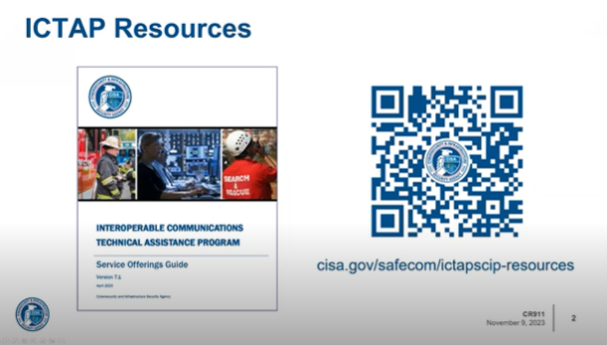
Bradley Riedl stated that the above slide has a QR Code that will direct you to their system technical assistance resource page where all cyber a non cyber related technical assistance offerings are located. He added that along with the service offering guide you will find the assistive technical assistance request form. Any questions regarding this form can be directed to Thomas Lawless, who is the Regional Emergency Communications Coordinator.

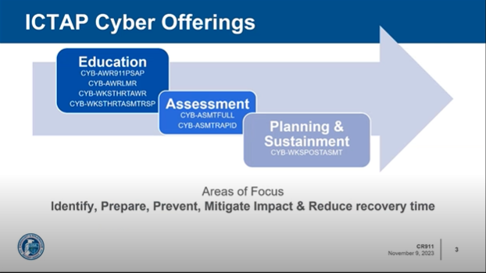
Bradley Riedl stated that the five focus areas are identify, prepare, prevent, mitigate impact, and reduce recovery time. These focus areas are then distributed into three sections which are education, assessment, and planning and sustainment. He added that they provide an LMR Cyber Awareness Webinar, One-Day Threat Cyber Awareness Workshop, and a Two-Day Threat Assessment and Responsive Planning Workshop. Regarding the assessment section he stated that they offer a Full Cyber Assessment and a Rapid Cyber Assessment. Furthermore, stated in the planning and sustainment section that offer a Post Assessment Workshop, Resilient Communication Awareness Training Webinar, Resilient Communication Incident and Communications Management Training Course.

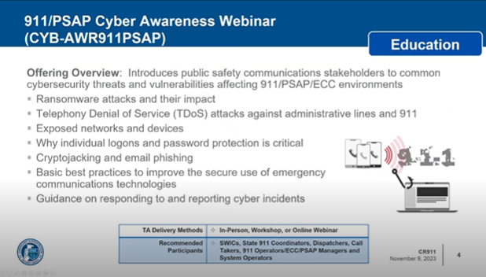
Bradley Riedl stated that the above slide shows the 9-1-1 PSAP Cyber Awareness Webinar that they offer and added that the webinar is typically given via an online webinar but is available in person or as a workshop upon request. He stated that while the evolution of public safety communications including the ongoing transition to Next Generation 9-1-1 has dramatically improved voice and data communications both legacy and Next Generation 9-1-1 systems are vulnerable to cyber security attacks. 9-1-1 PSAP functions are considered high value cyber targets to those looking to disrupt public safety services as well as extort local governments through ransomware or create mischief. ECC environments are unintended targets becoming collateral damage when a municipality or supporting managed service providers attacked the critical nature of 9-1-1 and PSAP operations means that cyber attack against them can result in a large-scale impact on public safety operations. Furthermore, stated that the offering will introduce public safety communication stakeholders to common cyber security threats and vulnerabilities affecting 9-1-1 and PSAP environments that are listed in the above slide. In conclusion, stated that the webinar is typically less than two hours long and can be customized and be determined through discussion after the conclusion of the webinar if an additional one or two-day planning workshop is needed.

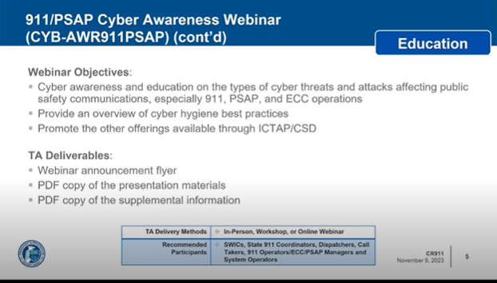
Bradley Riedl stated that their webinar objectives are that they want to build awareness about the threats facing PSAPs and provide an overview of cyber hygiene and best practices as well as promote other offerings available through ICTAP/CSD. He added that some of the major milestones through this process is that they would conduct an initial scoping call once the TA Request is received following an announcement flyer that will be used to advertise the event. He added that the webinar will be delivered within their deliverables.

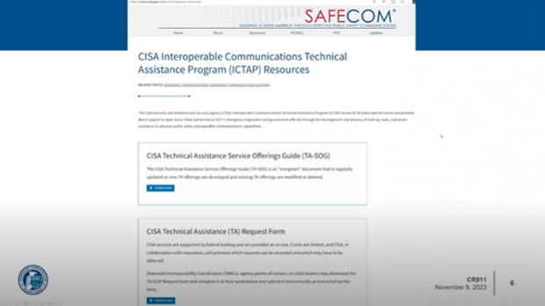
Bradley Riedl stated the above slide shows the page that you would be directed to after scanning the QR Code in the beginning of this presentation. He added that there is a large variety of different offerings that can be found. Currently, the SWIC (Statewide Interoperability Coordinator) for Hawaii is Everett Kaneshige and can assist in filling out the TA Request shown above.

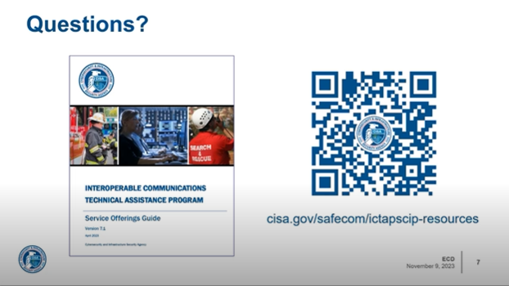
Thomas Lawless stated after Bradley Riedl’s presentation that he wanted to note a trend that he is witnessing as an emergency communications coordinator and responder. He stated that during natural disasters communities are beginning to experience cyber-attacks due to these communities being vulnerable. Stephen Courtney responded stating if the number of attacks on PSAPs are being tracked and regarding trends in what type of cyber-attacks are being experienced. Thomas Lawless responded stating that they have not been able to track that type of data. He added regarding the type of cyber-attacks that are being experienced are directed to public facing services and will target VoIP and CAD systems. Furthermore, stated that currently we rely on many external dependencies that give us a lot of flexibility in public safety it also allows more potential threats. Edward Fujioka responded stating if Next Generation 9-1-1 is more secure or is more prone to cyber-attacks. Thomas Lawless responded stating that they are potentially more threats when migrating to Next Generation 9-1-1 however, if security is kept in mind during the process, he does not see Next Generation 9-1-1 adding more risk to potential threats that we are currently experiencing.

- Review and Approval of October’s Meeting Minutes
Board Chair requested a motion to approve July’s Meeting Minutes. Keola Tom stated that Reed Mahuna was listed twice as being present for October’s Meeting Minutes. Stephen Courtney motioned to approve October’s Meeting Minutes with these revisions. Tony Velasco seconded the motion. A voice vote was taken, motion was unanimously approved.

- Committee Updates by Committee Chairs
  - Communications Committee – Davlynn Racadio
    - Lumen (Provider for Spectrum/TWC) Misconfiguration Issue with Hawaiian Telcom
Davlynn Racadio stated that Glenn Kobashigawa will be giving an update on this issue with Lumen (Provider for Spectrum/TWC) that she believes is a misconfiguration issue. Glenn Kobashigawa stated that this issue with Lumen occurred a couple of weeks ago and was discovered due to calls being received by Oahu PSAPS with either no ANI/ALI or incorrect ANI/ALI. He added that this issue is impacting end users of customers who subscribe to Lumen as a service. Hawaiian Telcom is currently engaging with Lumen’s engineers to make a configuration change to solve the issue which was confirmed via email a couple of days ago. Furthermore, stated that he is currently waiting for a response on the target date that the change will be made. Davlynn Racadio responded stating if any other islands were affected besides Maui and Molokai. Glenn Kobashigawa responded stating that he is not aware of any other islands impacted and only customers subscribed to Lumen as end users. Davlynn Racadio responded stating that she wanted to notify the Board of this issue because medical alerts were being sent to Maui with no information. After interacting with the caller, they were able to determine that it was for Oahu and were able to send it back to the appropriate location. She added that if it is a true emergency, they want to respond in a timely manner to avoid any liability. Glenn Kobashigawa responded stating he would like to give more information on the issue with calls that were being routed to Molokai which was a separate issue. He added that these misrouted calls were caused by a misconfiguration issue in one of the trunks causing certain calls from alarm companies. Furthermore, stated that the trunk did not have a specific transfer feature that allowed the calls to route to the correct destination. In conclusion, he stated that Maui and Molokai should not be receiving misdirected calls as the issue has been resolved on November 6, 2023.

Ah Lan Leong asked Glenn Kobashigawa if he felt Lumen has shown a sense of urgency to resolve this issue because it has been over two months with the number of no ANI/ALI calls have almost doubled. She added that calls went from 0-10 a month to now over 1000 calls with no ANI/ALI. Glenn Kobashigawa responded stating that he didn’t realize the numbers had grown exponentially and will work with Francis Alueta to reach out to higher representatives from Lumen. Francis Alueta responded stating that he was not happy with Lumen’s current response and has escalated up to their wholesale representatives to obtain contacts that they can call in the future so that they will be able to receive a response in a satisfactory timeframe. Edward Fujioka responded asking Francis Alueta if a quick fix is not possible if they can do a rollback because it could become a safety issue. Glenn Kobashigawa stated that he is not sure if it is possible for them to do a rollback because they cannot speak on their network however, they understand what configuration needs to be changed to resolve the issue. Ah Lan Leong responded asking Glenn Kobashigawa if she could have the results from the adjustment of the trunk. Glenn Kobashigawa responded stating that he will send the information over to show the numbers that were identified that were getting misrouted.

    - Intrado Training for ECAPS
Davlynn Racadio stated that she currently postponed upgrading her Intrado system due to target dates that would run into the holidays and to avoid any incidents that could potentially occur if there was a failure that would impact us negatively. She added that they would begin the upgrade in January 2024. Davlynn Racadio asked Glenn Kobashigawa if ECAPS Training would be possible before the upgrade of the Intrado system. Glenn Kobashigawa responded stating that Davlynn Racadio is correct that the upgrade to the Intrado system has been pushed back however, it does work hand in hand with some of the challenges that they have been having in standing up the diverse location for Hawaiian Telcom’s and Intrado’s equipment. Currently the primary and secondary nodes are in their downtown location and are currently creating a truly diverse location in Mililani Mauka location.

Glenn Kobashigawa stated regarding ECAPS which is the new reporting mechanism tool that will replace MIS that is used to pull reports for the State. He added that he confirmed with the Intrado Project Manager that training will be available and will keep the PSAPs informed on any progress.

  - Technical Committee – Shawn Kuratani
      - Advisory Committee – Everett Kaneshige
        - No Updates

  - Finance Committee – Edward Fujioka
    - Requesting Replacement for Aaron Farias on Finance Committee Due to Retirement
Edward Fujioka stated that Aaron Farias retired and is asking for volunteers to join the Finance Committee to replace him. He added that if there is anyone here that is interested to please contact the Executive Director. Executive Director responded stating that no one has shown interest because the announcement was not made until this meeting.

    - Review of Monthly Y-T-D (Year to Date) Cash Flow
October 2023 Y-T-D Cash Flow:

Surcharge Collection: $1,041,994
Interest Income: $119,340
Total Receipts: $1,161,334
Total Disbursements: ($956,759)
Net Receipts/Disbursements: $204,575
Net Encumbrances Adds/(Paydown): ($244,558)
Net Cash Inflow /(Outflow): ($39,983)
Outstanding Encumbrances: $10,262,210
Net Bank Balance: $39,654,124
Unencumbered Cash Balance: $29,391,914

- Public Service Answering Point Status Updates on Recruitment and other Personnel Issues
  - Kauai Police Department – Ariel Ramos
    - Update on Recruitment Process/Strategies and Personnel Training
Ariel Ramos stated that they have one personnel in training and just conducted two interviews with potential applicants.

    - Update on Personnel Issues and Vacancies
Ariel Ramos stated that they currently have twelve full-time dispatchers out of the twenty positions.

  - Oahu Police Department – Matthew Kurihara
    - Update on Recruitment Process/Strategies and Personnel Training
Matthew Kurihara stated that they currently have three personnel in PCL Training, however, two of those personnel will complete their training in a few months. He added to address their staffing shortages there are beginning to do contract hires with previous dispatchers.

    - Update on Personnel Issues and Vacancies
Matthew Kurihara stated that they currently have 34% of vacancies.

  - Oahu Fire Department – Shawn Kuratani
    - Update on Recruitment Process/Strategies and Personnel Training
Shawn Kuratani stated no new updates from last month regarding recruitment process/strategies and personnel training.

    - Update on Personnel Issues and Vacancies
Shawn Kuratani stated no new updates from last month regarding personnel issues and vacancies.

  - Oahu Emergency Medical Services – Lorrin Okumura, Diana Chun, Frannie Chung
    - Update on Recruitment Process/Strategies and Personnel Training
Lorrin Okumura stated that they recently posted a dispatch supervisor position. He added that it is considered an administrative position and will report any potential applicants in next month’s meeting.

    - Update on Personnel Issues and Vacancies
Lorrin Okumura stated that they currently have six vacancies.

  - Maui Police Department – Davlynn Racadio
    - Update on Recruitment Process/Strategies and Personnel Training
Davlynn Racadio stated they currently have three personnel in training and two of those personnel will complete their training in two months. She added that they recently conducted interviews and sent three offers to applicants. Furthermore, stated that she is currently waiting on a new list for interviews.

    - Update on Personnel Issues and Vacancies
Davlynn Racadio stated no updates on personnel issues and vacancies.

  - Molokai Police Department – Davlynn Racadio
    - Update on Recruitment Process/Strategies and Personnel Training

Please see Maui Police Department updates.

    - Update on Personnel Issues and Vacancies
Please see Maui Police Department updates.

  - Hawaii Police Department – Robert Fujitake
    - Update on Recruitment Process/Strategies and Personnel Training
Robert Fujitake stated that they are still conducting continuous recruitment for their PCO I position. He added that two personnel will move to the floor for call taker training and another two personnel will begin radio training.

    - Update on Personnel Issues and Vacancies
Robert Fujitake stated that they currently have eleven vacancies for their PCO II position. He added that they will be losing one veteran supervisor due to retirement.

  - Hawaii Fire Department – Stacy Domingo
    - Update on Recruitment Process/Strategies and Personnel Training
Stacy Domingo was not present to give an update.

    - Update on Personnel Issues and Vacancies
Stacy Domingo was not present to give and update.

- Items for Discussion, Consideration, and Action
  - 911 Timeline Update (VSE)
    - Status Report on All Counties
  - Additional Items Proposed by Meeting Attendees.
- Announcements
  - Future Virtual Meeting Dates/Times (9:00AM-12:00PM)
    - Thursday, December 14, 2023 (Combined Meeting)
    - Thursday, January 11, 2024 (Combined Meeting)
  - Future Conference Dates (3 Months of Advanced Approval Required)
    - 9-1-1 Goes to Washington February 26 – March 1, 2024, Ritz Carlton, Pentagon City
    - NENA (National Emergency Number Association) Conference June 28 – July 3, 2024, Kissimmee, Florida
    - APCO (Association of Public-Safety Communications Officials) Conference August 4-7, 2024, Orlando Florida
  - Additional Announcements from Meeting Attendees
- Open Forum: Public comment on issues not on the Board Meeting Agenda
There was no public comment on issues not on the agenda.

- Adjournment
Tony Ramirez motioned to adjourn the meeting. Tony Velasco seconded the motion. A voice vote was taken, and the adjournment was unanimously approved. The meeting was adjourned.

