JOSH GREEN, M.D.  GOVERNOR  Ke Kiaʻāina | 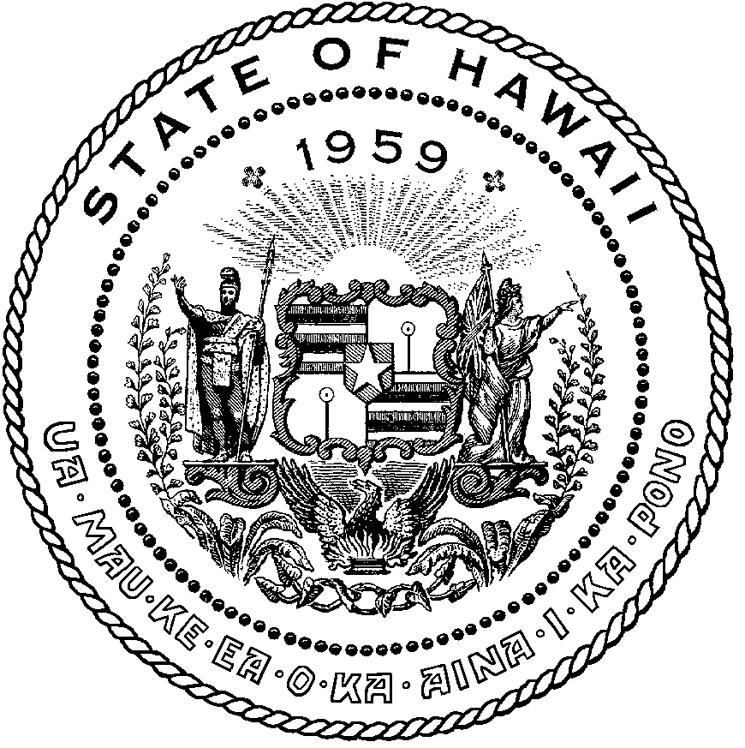 | KEITH A. REGAN  COMPTROLLER  Ka Luna Hoʻomalu Hana Laulā  MEOH-LENG SILLIMAN  DEPUTY COMPTROLLER  Ka Hope Luna Hoʻomalu Hana Laulā
STATE OF HAWAIʻI | KA Mokuʻāina o Hawaiʻi

DEPARTMENT OF ACCOUNTING AND GENERAL SERVICES | KA ʻOihana LOIHELU A LAWELAWE Laulā
P.O. BOX 119, HONOLULU, HAWAII 96810-0119

Communications, Technical, and Finance Meeting
(Combined Meeting)
Virtual Meeting – Microsoft Teams
Call-In: 808-829-4853; Phone Conf ID: 689 403 815#

Physical location: Kalanimoku Bldg. Room 426, 1151 Punchbowl St., Honolulu, is available to the public and is guaranteed to be connected to the remote virtual meeting.

Join on your computer, mobile app or room device
Click here to join the meeting
Meeting ID: 220 632 986 14
Passcode: KYc4Eq
Download Teams | Join on the web

Contact for Meeting Information/Testimony Submission; Royce Murakami, State of Hawaii, Enhanced 911 Board, Room 411A, 1151 Punchbowl Street, Honolulu, HI 96813
royce.m.murakami@hawaii.gov

"In the event that audiovisual communication cannot be maintained by all participating board members and quorum is lost, the meeting will automatically be recessed for 30 minutes, during which time an attempt to restore audiovisual communication will be made. If such attempt to restore is unsuccessful within said 30 minutes, all board members, members of the public, staff and other interested individuals shall log on again to the Teams link on this Notice, whereby audio communication will be established for all participants and the meeting will continue. If reconvening the meeting is not possible because audio and visual communication cannot be re-established, the meeting will be terminated."

Thursday, December 14, 2023
9:00 am – 12:00 pm

Agenda

- Call to Order, Public Notice
- Public Testimony Will Be Taken on All Agenda Items as Those Items Occur During the Meeting
- Roll Call, Quorum
- Updates from RapidSOS – Michael Notarstefano
- Review and Approval of November’s Meeting Minutes
- Committee Updates by Committee Chairs
  - Communications Committee – Davlynn Racadio
    - 9-1-1 Goes to Washington February 25-28, 2024.
      - Preparation & Personnel Attending
      - Maui Police Department Requesting $4,500 for Additional Personnel to Attend 9-1-1 Goes to Washington February 25-28, 2024.
  - Technical Committee – Shawn Kuratani
    - Hawaiian Telcom Meeting – November 29, 2023
    - Intrado Laptop Solution
    - PSAP “Tariff Positions”
      - Advisory Committee – Everett Kaneshige
        - December 11, 2023, Meeting Update
    - Maui Police Department Requesting $4,500 for Additional Personnel to Attend 9-1-1 Goes to Washington February 25-28, 2024.
  - Finance Committee – Edward Fujioka
    - New Finance Committee Members
      - Liz Gregg
      - Matthew Kurihara
    - Review of Monthly Y-T-D (Year to Date) Cash Flow
    - Maui Police Department Requesting $4,500 for Additional Personnel to Attend 9-1-1 Goes to Washington February 25-28, 2024.
- Public Service Answering Point Status Updates on Recruitment and other Personnel Issues
  - Kauai Police Department – Ariel Ramos
    - Update on Recruitment Process/Strategies and Personnel Training
    - Update on Personnel Issues and Vacancies
  - Oahu Police Department – Matthew Kurihara
    - Update on Recruitment Process/Strategies and Personnel Training
    - Update on Personnel Issues and Vacancies
  - Oahu Fire Department – Shawn Kuratani
    - Update on Recruitment Process/Strategies and Personnel Training
    - Update on Personnel Issues and Vacancies
  - Oahu Emergency Medical Services – Lorrin Okumura, Diana Chun, Frannie Chung
    - Update on Recruitment Process/Strategies and Personnel Training
    - Update on Personnel Issues and Vacancies
  - Maui Police Department – Davlynn Racadio
    - Update on Recruitment Process/Strategies and Personnel Training
    - Update on Personnel Issues and Vacancies
  - Molokai Police Department – Davlynn Racadio
    - Update on Recruitment Process/Strategies and Personnel Training
    - Update on Personnel Issues and Vacancies
  - Hawaii Police Department – Robert Fujitake
    - Update on Recruitment Process/Strategies and Personnel Training
    - Update on Personnel Issues and Vacancies
  - Hawaii Fire Department – Stacy Domingo
    - Update on Recruitment Process/Strategies and Personnel Training
    - Update on Personnel Issues and Vacancies
- Items for Discussion, Consideration, and Action
  - 911 Timeline Update (VSE)
    - Status Report on All Counties
  - Additional Items Proposed by Meeting Attendees.
- Announcements
  - Future Virtual Meeting Dates/Times (9:00AM-12:00PM)
    - Thursday, January 11, 2024 (Combined Meeting)
  - Future Conference Dates (3 Months of Advanced Approval Required)
    - 9-1-1 Goes to Washington February 25-28, 2024, Ritz Carlton, Pentagon City
    - NENA (National Emergency Number Association) Conference June 28 – July 3, 2024, Kissimmee, Florida
    - APCO (Association of Public-Safety Communications Officials) Conference August 4-7, 2024, Orlando Florida
  - Additional Announcements from Meeting Attendees
- Open Forum: Public comment on issues not on the Board Meeting Agenda
- Adjournment

