JOSH GREEN, M.D.  GOVERNOR  Ke Kiaʻāina |  | KEITH A. REGAN  COMPTROLLER  Ka Luna Hoʻomalu Hana Laulā  MEOH-LENG SILLIMAN  DEPUTY COMPTROLLER  Ka Hope Luna Hoʻomalu Hana Laulā
STATE OF HAWAIʻI | KA Mokuʻāina o Hawaiʻi

DEPARTMENT OF ACCOUNTING AND GENERAL SERVICES | KA ʻOihana LOIHELU A LAWELAWE Laulā
P.O. BOX 119, HONOLULU, HAWAII 96810-0119

Communications, Technical, and Finance Meeting
(Combined Meeting)

Thursday, September 14, 2023
9:00 am – 12:00 pm

MEETING MINUTES

Communications Committee Members Present: Davlynn Racadio (MPD), Thalia Burns (HPD)

Communications Committee Members Not Present: Lavina Taovao (KPD)

Technical Committee Members Present: Shawn Kuratani (HFD), Tony Ramirez (VSE), Tony Velasco (DIT), Thalia Burns (HPD), Kenison Tejada (FirstNet)

Technical Committee Members Not Present: David Miyasaki (KPD)

Finance Committee Members Present: Edward Fujioka (EMS), Aaron Farias (HPD), Stephen Courtney (C&C of Honolulu), Reed Mahuna (HIPD), Tony Velasco (DIT)

Finance Committee Members Not Present: Todd Omura (CIO Designee)

Staff: Royce Murakami (E911), Stella Kam (AG)

Guests: Francis Alueta (HT), Nani Blake (T-Mobile), Stephen Courtney (C&C of Honolulu), Frannie Chung (EMS), Stacy Domingo (HIPD), Liz Gregg (ATT), Robert Fujitake (HIPD), Ji Sook Kim (Consumer Advocate Designee), Everett Kaneshige (DOD), E. Kalani Ke. (KPD), Matthew Kurihara (HPD), Glenn Kobashigawa (HT), Patrick Leddy (LLC), Kimberly Lee (HPD), Ah Lan Leong (HPD), Lorrin Okumura (EMS), Daren Rose (KPD), Ariel Ramos (KPD), Corey Shaffer (Verizon), Valorie Taylor (Intrado), Ruth Zipfel (Eagleview), Barbara Winn (NGA), Jeff Reeve (ATT), Natasha Reece (AMR), Brian Boezeman (Intrado).

- Call to Order, Public Notice
The meeting was called to order by the Board Chair. Public notice was given.

- Public Testimony Will Be Taken on All Agenda Items as Those Items Occur During the Meeting

- Roll Call, Quorum
A roll call was taken, quorum was present for all three committees.

- Review and Approval of July’s Meeting Minutes
Board Chair requested a motion to approve July’s Meeting Minutes. Tony Ramirez motioned to approve July’s Meeting Minutes. Tony Velasco seconded the motion. A voice vote was taken, motion was unanimously approved.

- Committee Updates by Committee Chairs
  - Communications Committee – Davlynn Racadio
    - Hawaiian Telcom/Intrado Upgrade for the State of Hawaii/Maui County
      - Maui County Schedule for Installation, Training, Cutovers, and Support for Each PSAP.
Davlynn Racadio stated that up until two months ago Maui County was scheduled first for the Hawaiian Telcom/Intrado Upgrade. She added that adjustments have been made and that Ariel Ramos from Kauai County will be handling the upgrade under their county. Davlynn Racadio asked Ariel Ramos if she has any updates to share. Ariel Ramos stated that their cutover date for their alternate site will take place on 10/17/23 and their main dispatch center on 10/25/23. Davlynn Racadio responded stating that she appreciates Kauai County for stepping in to be the first to transition into the Hawaiian Telcom/Intrado Upgrade. Furthermore, stated that the schedule has come out and after Kauai County is completed Maui County and Hawaii County will follow.

      - Update from Attendees APCO (Association of Public-Safety Communications Officials) Conference August 6-9, 2023, Nashville, TN
Davlynn Racadio asked Matthew Kurihara to share their experience at the APCO (Association of Public-Safety Communications Officials) Conference. Matthew Kurihara stated that he felt that the classes that he attended at NENA (National Emergency Number Association) Conference were more beneficial however, APCO offered more vendors that were more interactive. In conclusion, stated that he thought the Intrado Presentation was very beneficial for learning how the 911 System functions.

Davlynn Racadio asked Ah Lan Leong to share her experience at the APCO Conference. Ah Lan Leong stated that she agrees with Matthew Kurihara that the abundance of vendors was beneficial. She added that it was very beneficial to get more exposure to Next Generation 9-1-1 and the different technologies vendors are offering.

Davlynn Racadio asked Robert Fujitake to share his personnels experience at the APCO Conference. Robert Fujitake stated that all his personnel felt that the networking that they made was very beneficial. In conclusion, stated that some of the classes and presentations that they were able to attend were beneficial.

Davlynn Racadio asked Shawn Kuratani to share his personnels experience at the APCO Conference. Shawn Kuratani stated that he sent two personnel to the conference and added that he agrees with the other PSAPs that it was very beneficial to be able to view the equipment that is going to be installed. He added that being able to see the new functionality of the new mapping system was a very good experience for his personnel that attended.

Davlynn Racadio stated that she thought that it was very important for the personnel that attended to be a part of the Intrado training so that they can understand how the new product will interact with the existing system. She added that the personnel that attended will be able to train other personnel when the crossover occurs.

  - Technical Committee – Shawn Kuratani
    - Intrado Roadmap Presentation (30 Mins)
Shawn Kuratani stated that he would like to make aware to the Board members that he experienced this presentation at the APCO Conference and noticed that Next Generation 9-1-1 components are included in the roadmap. He added that as the Board is viewing this presentation that discussions may need to be made separately as far as a new direction for the Technical Committee based on the road map and the components of Next Generation 9-1-1 that will be included in the presentation.

Glenn Kobashigawa stated that he has asked Brian Boezeman from Intrado to give a presentation on the Intrado Roadmap. He added that the reason for this presentation as Davlynn Racadio and Ariel Ramos stated earlier in the meeting is that Hawaiian Telcom is in the process of upgrading Viper and Map Flex. Furthermore, stated that Map Flex is nearing end of life and will be moving to a new platform called Spatial Command and Control SCC. In conclusion, stated that their current contract with Intrado is set to expire at the end of this year and are still in active discussions with Intrado.

Brian Boezeman stated that the focus of this presentation will be on Intrado’s Enhanced 9-1-1 platform which is the Intrado branded name for their IP Selective Router along with their connection core services and all i3 functional elements. He added that this presentation will be a high level about End State i3 and what NENA’s vision of this and how this platform works in a transitional world. Furthermore, stated that the presentation will also cover some of the major changes as well as explaining the current solution for call routing and how the future solution will function.

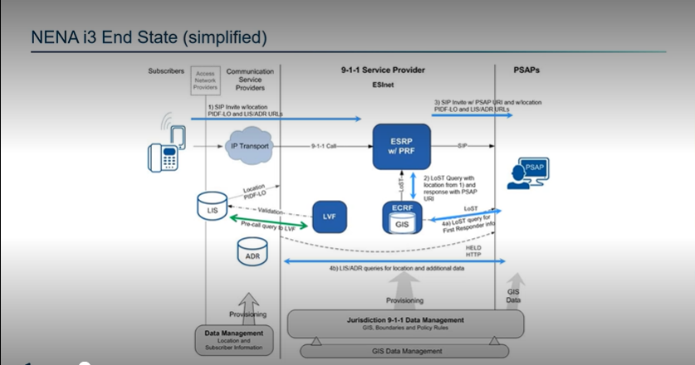
Brian Boezeman stated the above slide is a simplified version of NENA’s i3 Call Flow. He stated that when you discuss about full State i3 it is comprised of three major components which are the Originating Service Providers, ESI Net, and GIS.

Brian Boezeman stated that three components that they are currently upgrading is the call handling software with the help of Hawaiian Telcom for the current Viper system that would be fully i3 capable. He added the next component would be the ESI Net Next Gen Core Services as well as enabling geospatial routing using GIS Data. Furthermore, stated that PSAPs historically have adequate GIS data, however, have only been used for mapping purposes not for call routing purposes.

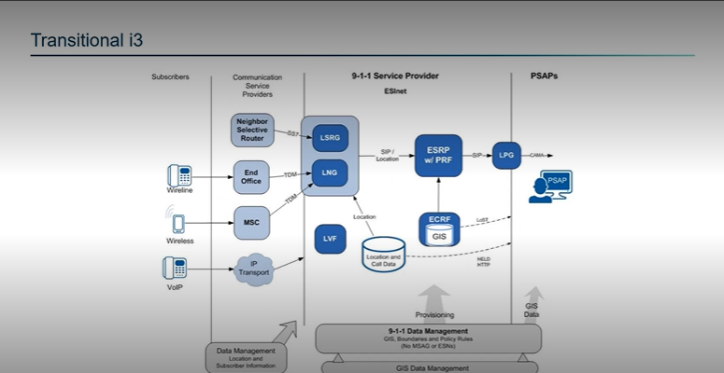
Brian Boezeman stated above shows a transitional model that includes functional elements such as Emergency Service Routing Proxy, Legacy PSAP Gateway, Legacy Selective Router, and Legacy Network Gateway. These functional elements allow PSAPs to connect to an ESI Net that aren’t fully capable now. However, he stated that for Hawaii this would not be a huge factor because we are currently upgrading the call handling equipment now.

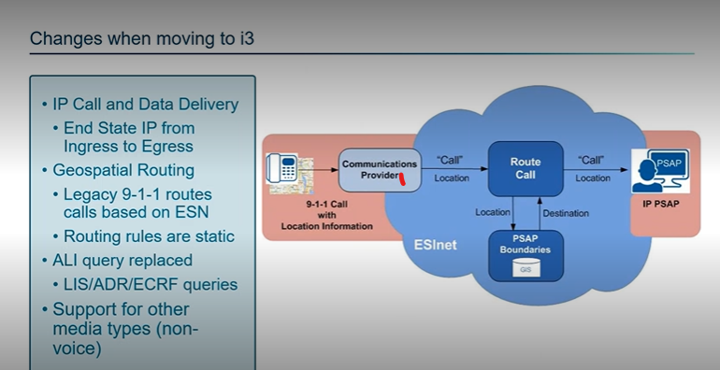
Brian Boezeman stated that the above slide shows a simplified version of the call flow in today’s world. Currently we are routing calls based off a cell site location not the actual caller’s location and basing it off statistically provisioned numbers in the ALI database and the selective router that helps route that call and the information. He added that moving from a legacy format to sending a call with the location instead of after it is received by the PSAP. About fifty percent of calls are currently being sent to PSAPs with the location without delaying the call to route based off the actual caller’s location. Furthermore, stated that there will be changes to how calls are displayed to avoid having to retrain personnel on a completely new format when moving to i3. In conclusion, stated that the last major change is the ability to receive video calls which the ESI Net has been built to support from day one. However, will need carriers to enable that feature.

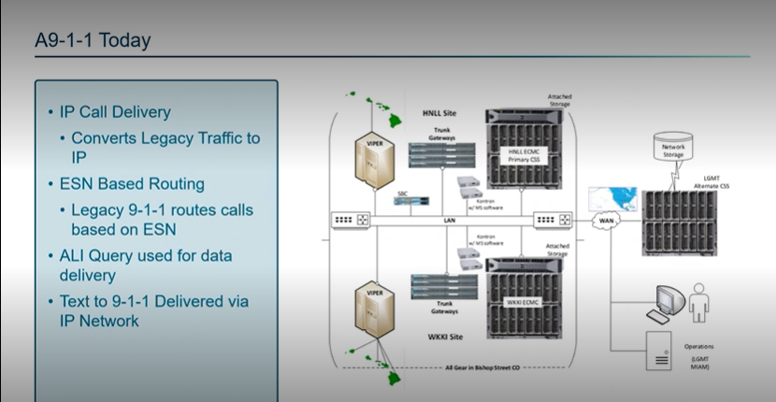
Brian Boezeman stated above slide give an overview of the current system that uses a two-core system that is all located on island. However, stated as Glenn Kobashigawa mentioned that the original solution that was deployed ten years ago is different from the mainland because of the unique circumstances that prevented Intrado from using the two-core system. He added that the current system needs to be replaced and updated to new hardware that will have the capability to be configured to full i3.

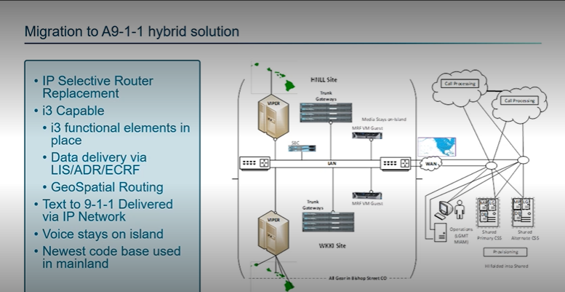

Brian Boezeman stated above slide is the hybrid solution created specifically for Hawaii that they will be implementing that uses multiple call processing cores in the mainland for call routing purposes only that will allow the voice to remain on island. He added that the benefits of this hybrid system allow it to be i3 capable today and would allow the newest code base will offering new functionality to the PSAPs.

Tony Ramirez asked Brian Boezeman if the military recently retrofitted their system and cannot move forward into an IP system because of their equipment capabilities. He added how will Intrado’s system address their requirement to remain on a selective router. Brian Boezeman stated that in discussions with military in the mainland that also mentioned that they do not want to have an IP system and preferring to keep their call handling systems legacy. He added that they would use LPG Functionality that NENA defines to deploy a military base to keep them off a selective router and convert call from SIP back to CAMA.

Edward Fujioka asked Brian Boezeman if the current core needs to be replaced and if connection is lost will we be able to cut over to a cable or satellite to the mainland. Brian Boezeman stated that the core needs to be replaced and that currently the system is designed to be able to deliver calls to PSAP if connectivity is lost. However, would not be able to deliver location if all functionality to the mainland. Edward Fujioka responded with another question stating from the subscriber side how a satellite phone would perform compared to a cell phone. Brian Boezeman stated that most of the satellite providers will not be able to find a location to the granular detail. He added that satellite phones are a unique circumstance however, if satellite phone providers could deliver the location in an i3 manner Intrado would be able to support it with the new system.

Shawn Kuratani asked Brian Boezeman that Intrado stated in their presentation at the APCO Conference that this project would begin at the start of next year and would be i3 compliant. He added that he would like to confirm that Intrado would be responsible for the core services, call handling, and call processing equipment and Hawaiian Telcom would be responsible for the ESI Net. Brian Boezeman stated that statement is true and that it is a common partnership that Intrado uses that would allow them to use Hawaiian Telcom’s underlying network to both acquire location and information from their ALI.

Tony Ramirez asked Brian Boezeman if PSAP’s current dispatch and response equipment will be usable once they migrate to this IP solution. Brian Boezeman stated that when moving over to the new Viper it will communicate to the CAD it will format the information the CAD requires. He added that all the information will be sent to the PSAP in i3 and after will be converted into the legacy format that they are using today. Tony Ramirez responded stating that basically it would be reconverting or the installation of some kind of translator to send back into a CAMA or ALI format so that it can be read by the CAD, AVL, and RMS. Brian Boezeman responded stating that statement is correct and that they would need to conduct operational readiness testing.
Francis Alueta asked Brian Boezeman to expand on Tony Ramirez’s question if the concern is more compatibility with the CAD system when moved to an ECR type of geospatial architecture or is it before the change is made. Brian Boezeman stated that when the Viper is upgraded that they want to ensure that the CAD functions properly. He added that the call handling and Viper is an intermediary between the Next Generation Core Services, CAD, and dispatch equipment. Furthermore, stated that when the solution is deployed operational readiness testing will be conducted during the migration to i3 and once the GIS data is loaded and the decision is made multiple rounds of operational readiness testing are conducted.

Shawn Kuratani stated to the Board that he wants the Board to realize what the Technical Sub Committee is doing in parallel trying to create an RFP for Next Generation 9-1-1 Services. He added that this process is already happening and if the Board would like him to be a part of discussion to notify him.

    - Approval for Underpayment to Hawaii Police Department in the amount of $0.04 for VSE June 2023 Invoice.
Tony Ramirez stated that VSE will waive the $0.04 for VSE June 2023 Invoice to the Hawaii Police Department.

    - Hawaii Police Department Requesting and Additional $19,958.57 to cover Imagery License Agreement for Fiscal Year 2024.
Robert Fujitake stated that when the request was originally submitted for $516,000 over four years however, the amount for the initial year was changed causing a shortage of $19,958.57. Shawn Kuratani asked for a motion to move this item to the Finance Committee. Reed Mahuna motioned to approve Hawaii Police Departments request for an additional $19,958.57 for Imagery License Agreement for Fiscal Year 2024. Tony Ramirez seconded the motion. A voice vote was taken, and the motion was unanimously approved.

    - Hawaii Police Department Requesting to Reduce Fiscal Year 2025 Imagery License Agreement on Fiscal Year 2024-2028 Strategic Budget Plan to $493,291.
Executive Director stated that no approval is needed for this agenda item and was added to document the request made by Hawaii Police Department.

    - Honolulu Fire Department Requesting $1465.93 for FirstNet Cable Hotspots to Replace Current Verizon Hotspots.
Shawn Kuratani stated that this request from Honolulu Fire Department is to replace their Verizon Hotspots to take advantage of the ATT FirstNet for Mobile CAD. He added that this is to replace four hot spots and would be for the equipment only. Shawn Kuratani asked for a motion to move this item to the Finance Committee. Tony Velasco motioned to approve Honolulu Fire Department request for $1465.93 for FirstNet Cable Hotspots to replace current Verizon Hotspots. Tony Ramirez seconded the motion. A voice vote was taken, motion was unanimously approved.

    - Kauai Police Department Requesting Funding Needed to Cover 2023 Encumbrances
- MSAG GIS Database (Akimeka) $18,731.25
- E911/NG911 UPS $1,135.19
- Hawaiian Telecom CML Viper $63,814.80\
E. Kalani Ke. stated that the above amounts shown were previously approved items in Fiscal Year 2023 however, due to contracts where contract terms crossover from one fiscal year to another have caused shortages at the end of the previous fiscal year. Shawn Kuratani asked for a motion to move these items to the Finance Committee. Francis Alueta motioned to approve to approve Kauai Police Department request for MSAG GIS Database (Akimeka) for $18,731.25, E911/NG911 UPS for $1,135.19, and Hawaiian Telcom CML Viper for $63814.80. Liz Gregg seconded the motion. A voice vote was taken, motion was approved. Tony Ramirez stated he abstains the above motion.

      - Advisory Committee – Everett Kaneshige
        - No Updates
Everett Kaneshige stated that he has no updates at this time. However, mentioned regarding the efforts during the last legislative session to establish a separate bargaining unit for the 9-1-1 Telecommunicators. He added that the bill was amended to require a study to be performed to determine when it would be appropriate or standard to have a new bargaining unit created. In conclusion, stated that he has not received an updated on the status of the study and will report his findings in the next Board meeting.

  - Finance Committee – Edward Fujioka
    - Review of Monthly Y-T-D (Year to Date) Cash Flow
July 2023 Y-T-D Cash Flow:

Surcharge Collection: $972,791
Interest Income: 142,872
Total Disbursements: ($1,752)
Net Encumbrances Adds/(Paydown): ($716,677)
Net Cash Inflow /(Outflow): $401.423
Net Bank Balance: $37,623,131
Unencumbered Cash Balance: $26,859,616

August 2023 Y-T-D Cash Flow

Surcharge Collection : $1,295,341
Interest Income: $114,941
Total Disbursements: ($89,756)
Net Encumbrances Adds/(Paydown): ($208,896)
Net Cash Inflow /(Outflow): $1,111,630
Net Bank Balance: $38,734,761
Unencumbered Cash Balance: $28,180,141

Executive Director stated that the increase in surcharge collection in August 2023 was due to service providers completing the transition to the new lockbox address at Central Pacific Bank. He added that he will be reviewing all submittals to ensure all service providers have submitted their surcharge collection for the previous fiscal year.

    - Approval for Underpayment to Hawaii Police Department in the amount of $0.04 for VSE June 2023 Invoice.
Edward Fujioka stated this agenda item was removed from the agenda.

    - Hawaii Police Department Requesting and Additional $19,958.57 to cover Imagery License Agreement for Fiscal Year 2024.
Edward Fujioka asked for a motion to approve Hawaii Police Department request for an additional $19,958.57 for Imagery License Agreement for Fiscal Year 2024. Reed Mahuna motioned to approve Hawaii Police Department request. Aaron Farias seconded the motion. A voice vote was taken, and the motion was unanimously approved.

    - Hawaii Police Department Requesting to Reduce Fiscal Year 2025 Imagery License Agreement on Fiscal Year 2024-2028 Strategic Budget Plan to $493,291.
Edward Fujioka stated this agenda item was removed from the agenda.

    - Honolulu Fire Department Requesting $1465.93 for FirstNet Cable Hotspots to Replace Current Verizon Hotspots.
Edward Fujioka asked for a motion to approve Honolulu Fire Department request for $1465.93 for FirstNet Cable Hotspots to replace current Verizon Hotspots. Tony Velasco motioned to approve Honolulu Fire Department request. Aaron Farias seconded the motion. A voice vote was taken, motion was unanimously approved.

    - Kauai Police Department Requesting Funding Needed to Cover 2023 Encumbrances
- MSAG GIS Database (Akimeka) $18,731.25
- E911/NG911 UPS $1,135.19
- Hawaiian Telecom CML Viper $63,814.80
Edward Fujioka asked for a motion to approve Kauai Police Department request for MSAG GIS Database (Akimeka) for $18,731.25, E911/NG911 UPS for $1,135.19, and Hawaiian Telcom CML Viper for $63814.80. Aaron Farias motioned to approve Kauai Police Department request. Tony Velasco seconded the motion. A voice vote was taken, motion was approved.

- Public Service Answering Point Status Updates on Recruitment and other Personnel Issues
  - Kauai Police Department – Ariel Ramos
    - Update on Recruitment Process/Strategies and Personnel Training
Daren Rose stated regarding recruitment retention pay they currently have a supplemental agreement out for signature between the union and the department that offers a $750 a month retention bonus that is retroactive as of September 1, 2023. In conclusion, stated regarding recruitment they have one applicant that has completed background check and an additional two applicants that have completed interviews and are in the process of background checks.

    - Update on Personnel Issues and Vacancies
Ariel Ramos stated that they currently have fourteen full-time dispatchers with one personnel in training. She added that two dispatchers will be leaving at the end of the month.

  - Oahu Police Department – Aaron Farias
    - Update on Recruitment Process/Strategies and Personnel Training
Matthew Kurihara stated that like Kauai Police Department they are looking into other bonus payouts and incentive pay in parallel with the assistance of their human resources department.

    - Update on Personnel Issues and Vacancies
Matthew Kurihara stated that they recently lost one ERO position however, they are promoting one of their personnel to a Supervisor ERO position. He added that they have three PCO positions that will be starting shortly.

  - Oahu Fire Department – Shawn Kuratani
    - Update on Recruitment Process/Strategies and Personnel Training
Shawn Kuratani stated no updates regarding recruitment process/strategies and personnel training.

    - Update on Personnel Issues and Vacancies
Shawn Kuratani stated that they have no vacancies.

  - Oahu Emergency Medical Services – Lorrin Okumura, Diana Chun, Frannie Chung
    - Update on Recruitment Process/Strategies and Personnel Training
Lorrin Okumura stated that currently there is a discussion with dispatchers, union, and administration that would give dispatchers an alternative schedule for dispatchers. He added if it is approved it will be added to the supplemental agreement. In conclusion, stated that when a decision is made, he will inform the Board of the outcome.

    - Update on Personnel Issues and Vacancies
Lorrin Okumura stated they currently have five vacancies and are currently in the process of filling a fifth supervisor position.

  - Maui Police Department – Davlynn Racadio
    - Update on Recruitment Process/Strategies and Personnel Training
Davlynn Racadio stated that she currently has four personnel attending class training. She added that she will be conducting interviews for eight applicants shortly.

    - Update on Personnel Issues and Vacancies
Davlynn Racadio stated that she currently has two personnel resigning this month and one personnel the following month.

  - Molokai Police Department – Davlynn Racadio
    - Update on Recruitment Process/Strategies and Personnel Training
Please see Maui Police Department updates.

    - Update on Personnel Issues and Vacancies
Please see Maui Police Department updates.

  - Hawaii Police Department – Robert Fujitake
    - Update on Recruitment Process/Strategies and Personnel Training
Robert Fujitake stated they currently have three personnel complete their training however, currently four personnel are in the various stages of call taking and radio training. He added that two personnel from California will be moving to their department as dispatchers. In conclusion, he stated that they will continue to conduct realistic job previews.

    - Update on Personnel Issues and Vacancies
Robert Fujitake stated that they currently have twelve vacancies for PCO II positions.

  - Hawaii Fire Department – Stacy Domingo
    - Update on Recruitment Process/Strategies and Personnel Training
Stacy Domingo stated that currently have five trainees who are approaching the six-month mark and are beginning to work towards having them work independently.

    - Update on Personnel Issues and Vacancies
Stacy Domingo stated that they currently have six dispatchers, however, two of them are out on extended leave. She added that there are currently five vacancies.

- Items for Discussion, Consideration, and Action
  - 911 Timeline Update (VSE)
    - Status Report on All Counties
  - Update on Maui Wildfires
Davlynn Racadio stated that she would like to thank everyone for their support during this difficult time and appreciates the kind words and thoughts. She added that currently the fires are contained and continue to do security at night in the burn areas in Lahaina. Furthermore, stated that only the main roads were opened to the public, however, access to heavily destroyed areas is not as the search for missing people continues.

Glenn Kobashigawa stated he has attended meetings with Maui EOC that have stated that they are currently going through re-population type of mode and allowing residents to return to their homes in zones that have been cleared to be safe. He added that there is a website called mauirecovers.org that will show updated zones of Lahaina that are determined to be safe to enter. In conclusion, stated that HECO, Hawaiian Telcom, and Spectrum are still in active restoration mode.

  - Additional Items Proposed by Meeting Attendees.

- Announcements
  - Future Virtual Meeting Dates/Times (9:00AM-12:00PM)
    - Thursday, October 12, 2023 (Combined Meeting)
    - Thursday, November 9, 2023 (Combined Meeting)
  - Future Conference Dates (3 Months of Advanced Approval Required)
    - 9-1-1 Goes to Washington February 26 – March 1, 2024, Ritz Carlton, Pentagon City
    - NENA (National Emergency Number Association) Conference June 28 – July 3, 2024, Kissimmee, Florida
    - APCO (Association of Public-Safety Communications Officials) Conference August 4-7, 2024, Orlando Florida
  - Additional Announcements from Meeting Attendees
- Open Forum: Public comment on issues not on the Board Meeting Agenda
There was no public comment on issues not on the agenda.

- Adjournment
Francis Alueta motioned to adjourn the meeting. Tony Ramirez seconded the motion. A voice vote was taken, and the adjournment was unanimously approved. The meeting was adjourned.

