JOSH GREEN M.D.  GOVERNOR  Ke Kiaʻāina |  | KEITH A. REGAN  COMPTROLLER  Ka Luna Hoʻomalu Hana Laulā  MEOH-LENG SILLIMAN  DEPUTY COMPTROLLER  Ka Hope Luna Hoʻomalu Hana Laulā
STATE OF HAWAIʻI | KA Mokuʻāina o Hawaiʻi

DEPARTMENT OF ACCOUNTING AND GENERAL SERVICES | KA ʻOihana LOIHELU A LAWELAWE Laulā
P.O. BOX 119, HONOLULU, HAWAII 96810-0119

Communications, Technical, and Finance Meeting (Combined Meeting)

Thursday, June 8, 2023
9:00 am – 12:00 pm

MEETING MINUTES

Communications Committee Members Present: Davlynn Racadio (MPD), Thalia Burns (HPD)

Communications Committee Members Not Present: Lavina Taovao (KPD)

Technical Committee Members Present: Tony Ramirez (VSE), Tony Velasco (DIT), Kenison Tejada (FirstNet), Thalia Burns (HPD), David Miyasaki (KPD)

Technical Committee Members Not Present: Shawn Kuratani (HFD)

Finance Committee Members Present: Edward Fujioka, Chair (EMS), Todd Omura (CIO Designee), Aaron Farias (HPD), Stephen Courtney (C&C of Honolulu), Reed Mahuna (HIPD), Tony Velasco (DIT)

Staff: Royce Murakami (E911), Stella Kam (AG)

Guests: Frannie Chung (EMS), Stacy Domingo (HIPD), Liz Gregg (ATT), Alex Hacker (EagleView), Wayne Hirasa (Alakaina), Everett Kaneshige (DOD), E. Kalani Ke (KPD), Matthew Kurihara (HPD), Glenn Kobashigawa (HT), Patrick Leddy (LLC), Shelby Lewis (ATT), Rebecca Lieberman (Charter), Gregg Okamoto (MPD), Ariel Ramos (KPD), Corey Shaffer (Verizon), Jeff Reeve (ATT), Ji Sook Kim (Consumer Advocate Designee), Steve Raucher (Rapid Deploy), Mike Gudan (Rapid Deploy), Buck Giles (OSL), Christian Stitz (Eagle View), Mandy Stollsteimer (Central Square).

- Call to Order, Public Notice
The meeting was called to order by the Board Chair. Public notice was given.

- Public Testimony Will Be Taken on All Agenda Items as Those Items Occur During the Meeting

- Roll Call, Quorum
A roll call was taken, quorum was present for all three committees.

- Review and Approval of May’s Meeting Minutes
Board Chair requested a motion to approve May’s Meeting Minutes. Tony Ramirez requested a correction to his name and that the company name be changed from Akimeka to VSE. Tony Ramirez motioned to approve May’s Meeting Minutes. Corey Shaffer seconded the motion. A voice vote was taken, motion was unanimously approved.

- Committee Updates by Committee Chairs
  - Communications Committee – Davlynn Racadio
    - AT&T Rapid Deploy Solution Enhanced Next Generation 9-1-1 Features
      - Solution & Impact on Maui Police Department
Davlynn Racadio stated that AT&T and Rapid Deploy Solution will be giving a presentation.

Jeff Reeve from AT&T stated that in 2022 AT&T partnered with Rapid Deploy to implement Next Generation 9-1-1 Solution that both Mike Gudan (Senior Strategic Account Manager) and Steve Raucher (CEO of Rapid Deploy) that are currently present in this meeting. He added that they will be giving a presentation of a brief overview of the impact on Maui Police Department and features that are included in the solution.

Steve Raucher stated that Rapid Deploy works extensively with AT&T and is currently deployed in 20 states of which 10 have statewide deployments. He proceeded to give a brief overview of their Radio Solution which uses cloud native web based primary call taking mapping which integrates with CPE (Call Processing Equipment) and several partners that will be discussed later in the presentation. He added that it is crucial to deliver 9-1-1 Solutions that are cloud native to Hawaii that allows Hawaii to connect the United States Data Centers. Furthermore, stated that ESRI, which is the focus of their platform that integrates GIS and direct Integration with a telephony experience. This allows the call taker to answer the phone and present all the information not just from the CPE but also from Apple, Google, OnStar, and other manufactures around the county are present in the platform in real time.

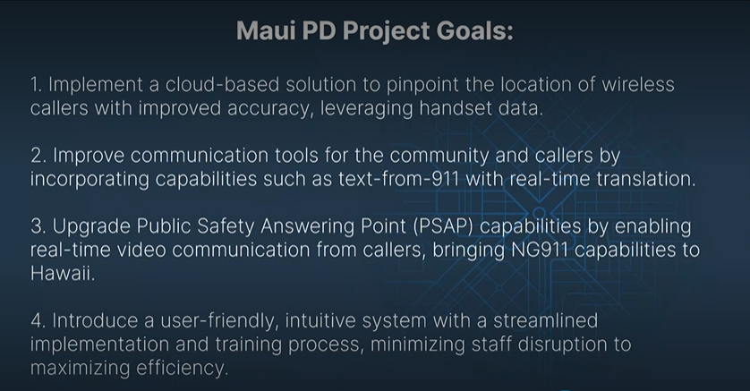

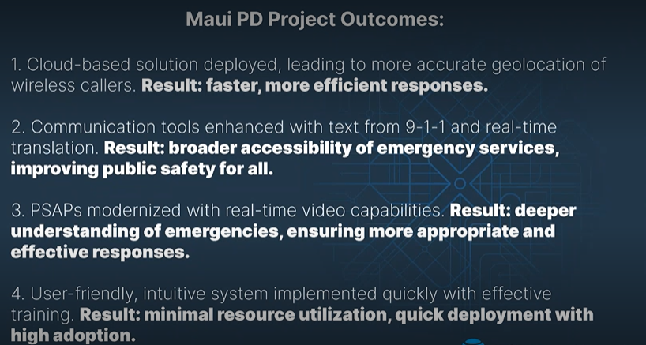

Steve Raucher reviewed both presentation slides above to give an overview of Maui Police Department’s project goals and impact of the successful deployment of AT&T Rapid Deploy Solution for Next Generation 9-1-1.

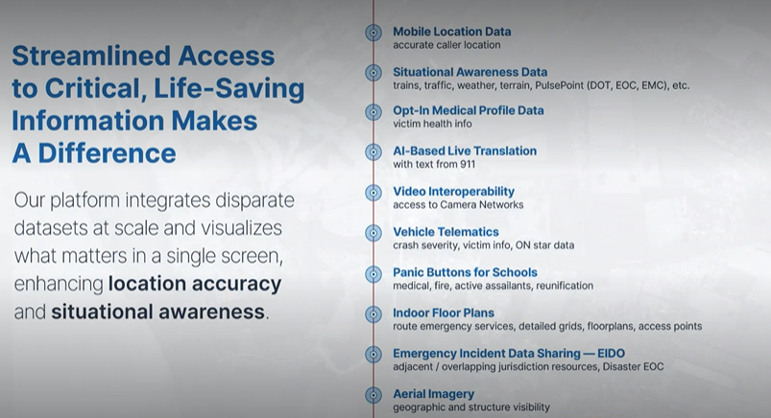

Steve Raucher reviewed both presentation slides above that describe all curated partners of the solution and features of the platform. After reviewing both slides, he asked meeting attendees if there were any questions. Buck Giles responded stating if Rapid Deploy is only fixed on address points and GIS and if latitude/longitude integrate into ocean mapping. Steve Raucher responded stating that the entire platform uses XY axis and will share a link of video footage of a sea-based rescue.

Jeff Reeve asked Davlynn Racadio to give an overview of the implementation process of AT&T Rapid Deploy for the Maui Police Department. Davlynn Racadio stated the reason behind implementing Rapid Deploy was because the Maui Police Department did not have the ability to text out on 9-1-1. She added that service was not available to them, however, was fortunate to have a grant available to her that would allow her to fund this product. Furthermore, stated that the product is outstanding and allows them to perform all the features seamlessly that Steve Raucher reviewed in the presentation. In conclusion stated, that it has many functions that they have not been able to utilize and hopes to take advantage of them as they grow in manpower. Edward Fujioka asked Davlynn Racadio if CAD and Rapid Deploy is used as far as mapping and if the data is sent to the mobile data terminal to the officers. Davlynn Racadio responded stating that they use Rapid Deploy and Rapid SOS if it cannot be located on CAD and that the data does not go to the officers directly it is relayed to them as they are following.

    - Maui Public Safety Answering Point Implementing AXON (BWC) Officer Locator on Rapid SOS Platform as of June 1, 2023.
Davlynn Racadio stated that the launching of AXON Officer Locator on Rapid SOS has been delayed due to not all personnel received proper training. This platform would give them the capability to track the officers with their body camera and record video. She added that they will look to launch the platform on June 13, 2023. In conclusion, stated that this is a free application on Rapid SOS that they are utilizing.

  - Technical Committee – Shawn Kuratani
    - Encumbrance Discussion
      - Update on Paydowns and Unused Funds
Board Chair stated that during the process of reconciling the encumbrances, she and the current Executive Director discovered discrepancies in record keeping that caused shortages. Currently we believe that the encumbrances are now correct and with discussions with DAGS (Department of Accounting and General Services) Administrative Services Office and Auditing Office for guidance on what the best past forward would be for the Board. Some of the options moving forward would be that the agencies would absorb any shortages that were in the encumbrance account or utilize unused funding in the encumbrance accounts for a particular fiscal year.

      - Approval to Utilize $190,382 from Encumbrances to Cover Reimbursement Shortages within the Fiscal Year
Board Chair stated another option discussed with DAGS would be to utilize current fiscal year to cover shortages. She added that she believes that the best path moving forward for the Board is to use unused fiscal year encumbrances to cover shortages within that fiscal year and any differences in shortages would be deducted from the current fiscal year.

      - Board Chair Request to Utilize Unused Fiscal Year 2023 Funds to Cover Shortages Due to Insufficient Funding in Encumbrance Account for Previously Approved Requests
        - Hawaii Police Department for CAD (Computer Aided Dispatch) Upgrade $6,561
        - Honolulu Police Department for CAD (Computer Aided Dispatch) Upgrade $145,005
        - Department of Information Technology for Recorder/CAD (Computer Aided Dispatch) Integration $74,434
        - Maui Police Department for Pictometry Imagery $224,445
Tony Ramirez motioned to amend the agenda to approve the amounts for Hawaii Police Department for CAD for $6561, Honolulu Police Department for CAD for $144,541, Department of Information Technology for Recorder/CAD Integration for $74,434, Maui Police Department for Pictometry Imagery for $224,557, and for Kauai Police Department for $11,801 for Viper/TXT2911/UPS and $140 for Centrix/TXT2911. Corey Shaffer seconded the motion. A voice vote was taken motion was unanimously approved.

Tony Ramirez motioned to approve the amounts of insufficient funding and the amended amounts as recommended in the previous motion and forward this motion to the Finance Committee for consideration for Hawaii Police Department for CAD for $6561, Honolulu Police Department for CAD for $144,541, Department of Information Technology for Recorder/CAD Integration for $74,434, Maui Police Department for Pictometry Imagery for $224,557, and for Kauai Police Department for $11,801 for Viper/TXT2911/UPS and $140 for Centrix/TXT2911. Tony Velasco seconded the motion. A voice vote was taken motion was unanimously approved.

      - Advisory Committee – Everett Kaneshige
        - No Updates

  - Finance Committee – Edward Fujioka
    - New Members
      - Stephen Courtney
      - Tony Velasco
      - Reed Mahuna
Board Chair stated that the new members of the Finance Committee are Stephen Courtney, Tony Velasco, and Reed Mahuna. Furthermore, stated that the new Finance Committee Chair will be Edward Fujioka.

    - Review of Monthly Y-T-D (Year to Date) Cash Flow
Executive Director stated that the Cash Flow for May is not complete but wants to go over the surcharge collection and interest revenue earned in the month in preparation to go over the Fiscal Year 2024-2028 Strategic Budget Plan that will be reviewed in the Board meeting.

Surcharge Collection: $995,167
Interest Income: $193,226
Total Receipts: $1,188,393
Total Disbursements: ($717,393)
Net Receipts/Disbursements: $471,000

    - Solution for Oahu Public Safety Answering Points to Prevent Loss of Funding to General Fund
Edward Fujioka stated that he would like to cover a possible solution to prevent loss of funding to general fund for all Oahu Public Safety Answering Points. He stated that for all Oahu agencies excluding Honolulu Police Department because they have their own Finance Department and have more flexibility in terms of spending.

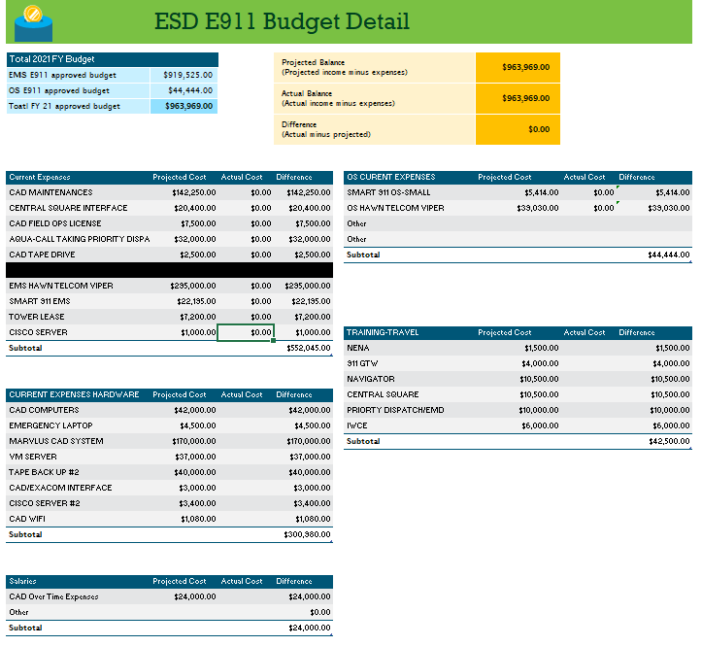
Edward Fujioka stated that the spreadsheet above was submitted by him in Fiscal Year 2021 at the request of the City & County of Honolulu Budget and Finance due to a reimbursement request that was not deposited before the end of the fiscal year and was lost to the city general fund. He added that this spreadsheet was created after the Board approved the strategic budget plan for that year and would be used by the City & County of Honolulu Budget & Finance Department to create an account called a general administrative expense account. This account would allow payment of invoices after the fiscal year has ended and prevent loss of funding to the general fund. Furthermore, stated that Honolulu Fire Department and Emergency Medical Services Department will be drafting a spreadsheet like the spreadsheet above. In conclusion, stated that he will discuss with the Oahu agencies if they have any questions.

- Public Service Answering Point Status Updates on Recruitment and other Personnel Issues
  - Kauai Police Department – Ariel Ramos
    - Update on Recruitment Process/Strategies and Personnel Training
Ariel Ramos stated that they will be reaching out to former dispatchers who still work within the Kauai Police Department to see if they will be assist including any officers that will be willing to be trained in call taking and radio.

    - Update on Personnel Issues and Vacancies
Ariel Ramos stated that they currently have fifteen of their twenty positions filled. She added that one personnel will be resigning on July 23, 2023, and will have two personnel on vacation with another two that will be on extended leave. Currently will be operating with 10 personnel in their dispatch center.

  - Oahu Police Department – Aaron Farias
    - Update on Recruitment Process/Strategies and Personnel Training
Aaron Farias stated that they are still conducting continuous recruitment for their Police Communications Officer I position and will begin processing their vacant ERO positions. He added that a few of his personnel attended Central Square Engage Conference and will have them submit a report to the Board in next month’s meeting. Furthermore, stated that he will have personnel attend the NENA Conference and have them focus primarily on our migration into Next Generation 9-1-1.

    - Update on Personnel Issues and Vacancies
Aaron Farias stated that they remain status quo on personnel.

  - Oahu Fire Department – Shawn Kuratani
    - Update on Recruitment Process/Strategies and Personnel Training
Shawn Kuratani currently not present to give update.

    - Update on Personnel Issues and Vacancies
Shawn Kuratani currently not present to give update.

  - Oahu Emergency Medical Services – Lorrin Okumura, Diana Chun, Frannie Chung
    - Update on Recruitment Process/Strategies and Personnel Training
Frannie Chung stated that they currently have a new EMT recruit class that they will require to complete END training which is a three-day training course.

    - Update on Personnel Issues and Vacancies
Frannie Chung stated that they received one application for their dispatcher position, however, remain understaffed and will begin posting openings again for the position shortly.

  - Maui Police Department – Davlynn Racadio
    - Update on Recruitment Process/Strategies and Personnel Training
Davlynn Racadio stated that they are conducting continuous recruitment. She added that she has two personnel that are in the final stages of their training with another two personnel that will begin training. Furthermore, stated that the two personnel that are to begin training are part of the police recruitment class.

    - Update on Personnel Issues and Vacancies
Davlynn Racadio stated that they have six applicants to interview and will continue to conduct interviews moving forward.

  - Molokai Police Department – Davlynn Racadio
    - Update on Recruitment Process/Strategies and Personnel Training
Please see above update from Maui Police Department.

    - Update on Personnel Issues and Vacancies
Please see above update from Maui Police Department.

  - Hawaii Police Department – Robert Fujitake
    - Update on Recruitment Process/Strategies and Personnel Training
Reed Mahuna on behalf of Robert Fujitake stated that they currently have seven dispatchers that are in various portions of call taking and radio training. He added that they conducted a realistic job preview for new applicants on May 24, 2023. Furthermore, stated that they are currently having ongoing recruitment for Police Communications Officer I and will have three personnel attending the upcoming NENA Conference.

    - Update on Personnel Issues and Vacancies
Reed Mahuna on behalf of Robert Fujitake stated no updates regarding personnel issues or vacancies.

  - Hawaii Fire Department – Stacy Domingo
    - Update on Recruitment Process/Strategies and Personnel Training
Stacy Domingo stated that they currently have six personnel in training due to one individual that submitted her letter of resignation. She added that they are still conducting continuous recruitment and working with Hawaii Police Department to manage their staffing shortage. Furthermore, stated that they engaged in negotiations with HHFA to see if we would be able to integrate firefighters into their dispatch center to mange their staffing shortage.

    - Update on Personnel Issues and Vacancies
Stacy Domingo stated that they currently have six dispatchers, however, one is on extended leave.
- Items for Discussion, Consideration, and Action
  - 911 Timeline Update (Akimeka)
    - Status Reports on All Counties
  - Additional Items Proposed by Meeting Attendees
Tony Ramirez asked if there is any consideration by the Board being given to potentially raise the surcharge collection in the future for the State of Hawaii. He added that the State of Hawaii initiated the Enhanced Wireless 9-1-1 Law in 2004 at a rate of $0.67 and has never increased the rate while at the same time in the mainland almost every single state has raised the surcharge collection with some multiple times. Furthermore, stated that in the past 15-16 years the State of Hawaii has deployed numerous systems and updates all be done with the current rate of $0.67 and wireline still being maintained at $0.27. Stella Kam responded stated that the topic has not been addressed however, can be voted on by the Board to amend and raise the surcharge amount. She added that the current permitted interaction group should focus on amending the chapter to clearly allow Next Generation 9-1-1 funding and then submit a separate bill to increase the surcharge amount if the Board decides to. Tony Ramirez responded that it would be beneficial to conduct an educational process with the legislature to help them understand the difference between a surcharge and a tax due to bills not being passed previously for this reason. Stella Kam responded that if the Board does decide to increase the surcharge collection it can possibly be added as a legislative proposal in the governor’s package. Board Chair responded stating that in the upcoming presentation of the Budget in the Board meeting one of the proposals that will be presented by the Executive Director and herself would be to look at implementing prepaid charges and in essence we would be considering three separate bills. Stella Kam responded stating that the prepaid charges have always been difficult due to pushback by the retailer’s association and the difficulty to explain to legislation how that surcharge will be collected on prepaid. She added that three separate bills would be appropriate so that it will not jeopardize the others that we just discussed.

Mandy Stollsteimer from Central Square stated that she has put her contact information for anyone attending any conferences. She also added that she left the contact information for Karen Mark from Rapid SOS to share information and contacts for anyone that wants more information on how they collect prepaid surcharges in Colorado.

- Announcements
  - Future Virtual Meeting Dates/Times (9:00AM-12:00PM)
    - Thursday, July 13, 2023 (Combined Meeting)
    - Thursday August 10, 2023 (Combined Meeting)
  - Future Conference Dates (3 Months of Advanced Approval Required)
    - NENA (National Emergency Number Association) Conference & Expo, June 17-22nd, Grapevine, TX
    - APCO (Association of Public-Safety Communications Officials) Conference & Expo, August 6-9th, Nashville, TN
  - Additional Announcements from Meeting Attendees
- Open Forum: Public comment on issues not on the Committee Meeting Agenda
There was no public comment on issues not on the agenda.

- Adjournment
Tony Velasco motioned to adjourn the meeting. Corey Shaffer seconded the motion. A voice vote was taken, and the adjournment was unanimously approved. The meeting was adjourned.

