JOSH GREEN, M.D.  GOVERNOR  Ke Kiaʻāina |  | KEITH A. REGAN  COMPTROLLER  Ka Luna Hoʻomalu Hana Laulā  MEOH-LENG SILLIMAN  DEPUTY COMPTROLLER  Ka Hope Luna Hoʻomalu Hana Laulā
STATE OF HAWAIʻI | KA Mokuʻāina o Hawaiʻi

DEPARTMENT OF ACCOUNTING AND GENERAL SERVICES | KA ʻOihana LOIHELU A LAWELAWE Laulā
P.O. BOX 119, HONOLULU, HAWAII 96810-0119

Enhanced 911 Board Meeting
Virtual Meeting – Microsoft Teams

Thursday, June 8, 2023
9:00 am – 12:00 pm

MEETING MINUTES

Board Members Present: Thalia Burns (HPD), Stephen Courtney (C&C of Honolulu), Liz Gregg (ATT), Ji Sook Kim (Consumer Advocate Designee), E. Kalani Ke (KPD), Todd Omura (CIO Designee), Corey Shaffer (Verizon), Reed Mahuna (HIPD), Keola Tom (MPD)

Board Members Not Present: Francis Alueta (HT), Nani Blake (T-Mobile), Rebecca Lieberman (Charter), Gregg Okamoto (MPD)

Staff: Royce Murakami (E911), Stella Kam (AG)

Guests: Stacy Domingo (HIPD), Aaron Farias (HPD), Edward Fujioka (EMS), Everett Kaneshige (DOD), Matthew Kurihara (HPD), Patrick Leddy (LCC), Shelby Lewis (ATT), Ariel Ramos (KPD), Davlynn Racadio (MPD), Tony Ramirez (VSE), Jeff Reeve (ATT), Kenison Tejada (FirstNet), Tony Velasco (DIT), Ruth Zipfel (Eagleview).

- Call to Order, Public Notice
The meeting was called to order by the Board Chair. Public notice was given.

- Public Testimony Will Be Taken on All Agenda Items as Those Items Occur During the Meeting

- Roll Call, Quorum
A roll call was taken, quorum was present for the Board.

- Review and Approval of May’s Meeting Minutes
Board Chair requested a motion to approve May’s Meeting Minutes. Corey Shaffer motioned to approve May’s Meeting Minutes. Elliott K. Ke seconded the motion. A voice vote was taken, motion was unanimously approved.

- Committee Updates by Committee Chairs
  - Communications Committee – Davlynn Racadio
    - AT&T Rapid Deploy Solution Enhanced Next Generation 9-1-1 Features
      - Solution & Impact on Maui Police Department
    - Maui Public Safety Answering Point Implementing AXON (BWC) Officer Locator on Rapid SOS Platform as of June 1, 2023.
Davlynn Racadio stated no further updates.

  - Technical Committee – Shawn Kuratani
    - Encumbrance Discussion
      - Update on Paydowns and Unused Funds
      - Approval to Utilize $190,382 from Encumbrances to Cover Reimbursement Shortages within the Fiscal Year
      - Board Chair Request to Utilize Unused Fiscal Year 2023 Funds to Cover Shortages Due to Insufficient Funding in Encumbrance Account for Previously Approved Requests
        - Hawaii Police Department for CAD (Computer Aided Dispatch) Upgrade $6,561
        - Honolulu Police Department for CAD (Computer Aided Dispatch) Upgrade $145,005
        - Department of Information Technology for Recorder/CAD (Computer Aided Dispatch) Integration $74,434
        - Maui Police Department for Pictometry Imagery $224,445
Shawn Kuratani currently not present no further updates.

    - Advisory Committee – Everett Kaneshige
        - No Updates
Everett Kaneshige stated no further updates.

  - Finance Committee – Edward Fujioka
    - New Members
      - Stephen Courtney
      - Tony Velasco
      - Reed Mahuna
    - Review of Monthly Y-T-D (Year to Date) Cash Flow
    - Solution for Oahu Public Safety Answering Points to Prevent Loss of Funding to General Fund
Edward Fujioka stated no further updates.

- Public Service Answering Point Status Updates on Recruitment and other Personnel Issues
  - Kauai Police Department – Ariel Ramos
    - Update on Recruitment Process/Strategies and Personnel Training
Ariel Ramos stated that they have two possible applicants going through the recruitment process for their dispatch positions. She added that one of their former dispatchers had put in an application to return as a dispatcher.

    - Update on Personnel Issues and Vacancies
Ariel Ramos stated no further updates.

  - Oahu Police Department – Aaron Farias
    - Update on Recruitment Process/Strategies and Personnel Training
    - Update on Personnel Issues and Vacancies
Aaron Farias stated no further updates.

  - Oahu Fire Department – Shawn Kuratani
    - Update on Recruitment Process/Strategies and Personnel Training
    - Update on Personnel Issues and Vacancies
Shawn Kuratani not present no further updates.

  - Oahu Emergency Medical Services – Lorrin Okumura, Diana Chun, Frannie Chung
    - Update on Recruitment Process/Strategies and Personnel Training
    - Update on Personnel Issues and Vacancies
Frannie Chung not present no further updates.

  - Maui Police Department – Davlynn Racadio
    - Update on Recruitment Process/Strategies and Personnel Training
    - Update on Personnel Issues and Vacancies
Davlynn Racadio stated no further updates.

  - Molokai Police Department – Davlynn Racadio
    - Update on Recruitment Process/Strategies and Personnel Training
    - Update on Personnel Issues and Vacancies
Davlynn Racadio stated no further updates.

  - Hawaii Police Department – Robert Fujitake
    - Update on Recruitment Process/Strategies and Personnel Training
    - Update on Personnel Issues and Vacancies
Reed Mahuna on behalf of Robert Fujitake stated no further updates.

  - Hawaii Fire Department – Stacy Domingo
    - Update on Recruitment Process/Strategies and Personnel Training
    - Update on Personnel Issues and Vacancies
Stacy Domingo stated no further updates.

- Executive Director’s Report
  - NASNA Meeting Updates
Executive Director stated that he recently attended the NASNA Monthly Meeting which, is conducted to give a chance for all the Executive Director’s for every state to communicate and discuss current topics and problems they are facing. He added that there is an online forum where you can post any questions you may have, and all the Executive Directors can respond to your questions. Furthermore, stated that if any of the agencies have any topics that would like information about to contact him. In conclusion, stated that this upcoming NASNA Monthly Meeting will have a presentation on the 988 Number and will bring information on that presentation to the Board.

  - Strategic Budget Plan Fiscal Year 2024-2028
Board Chair stated that she and the Executive Director will now review the Strategic Budget Plan for Fiscal Year 2024-2028. (ALL PRESENTATION SLIDES SHOWN / MINUTES WILL BE UNDER SLIDES WITH DISCUSSIONS)
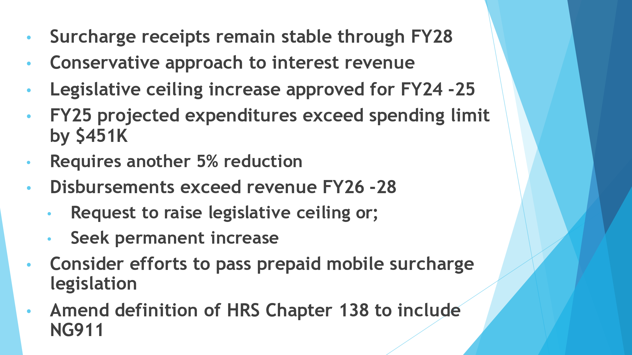
Board Chair stated regarding Fiscal Year 2025 expenditures that all agencies did resubmit their Fiscal Year 2024 and 2025 changes. However, due to many changes to the Strategic Budget Plan is projected to be $451,000 over the legislative spending ceiling. She added that the agencies have time to review and cut expenses. If expenses cannot be reduced the Board could be forced to cut all travel for Fiscal Year 2025, which would reduce expenditures by $261,000.

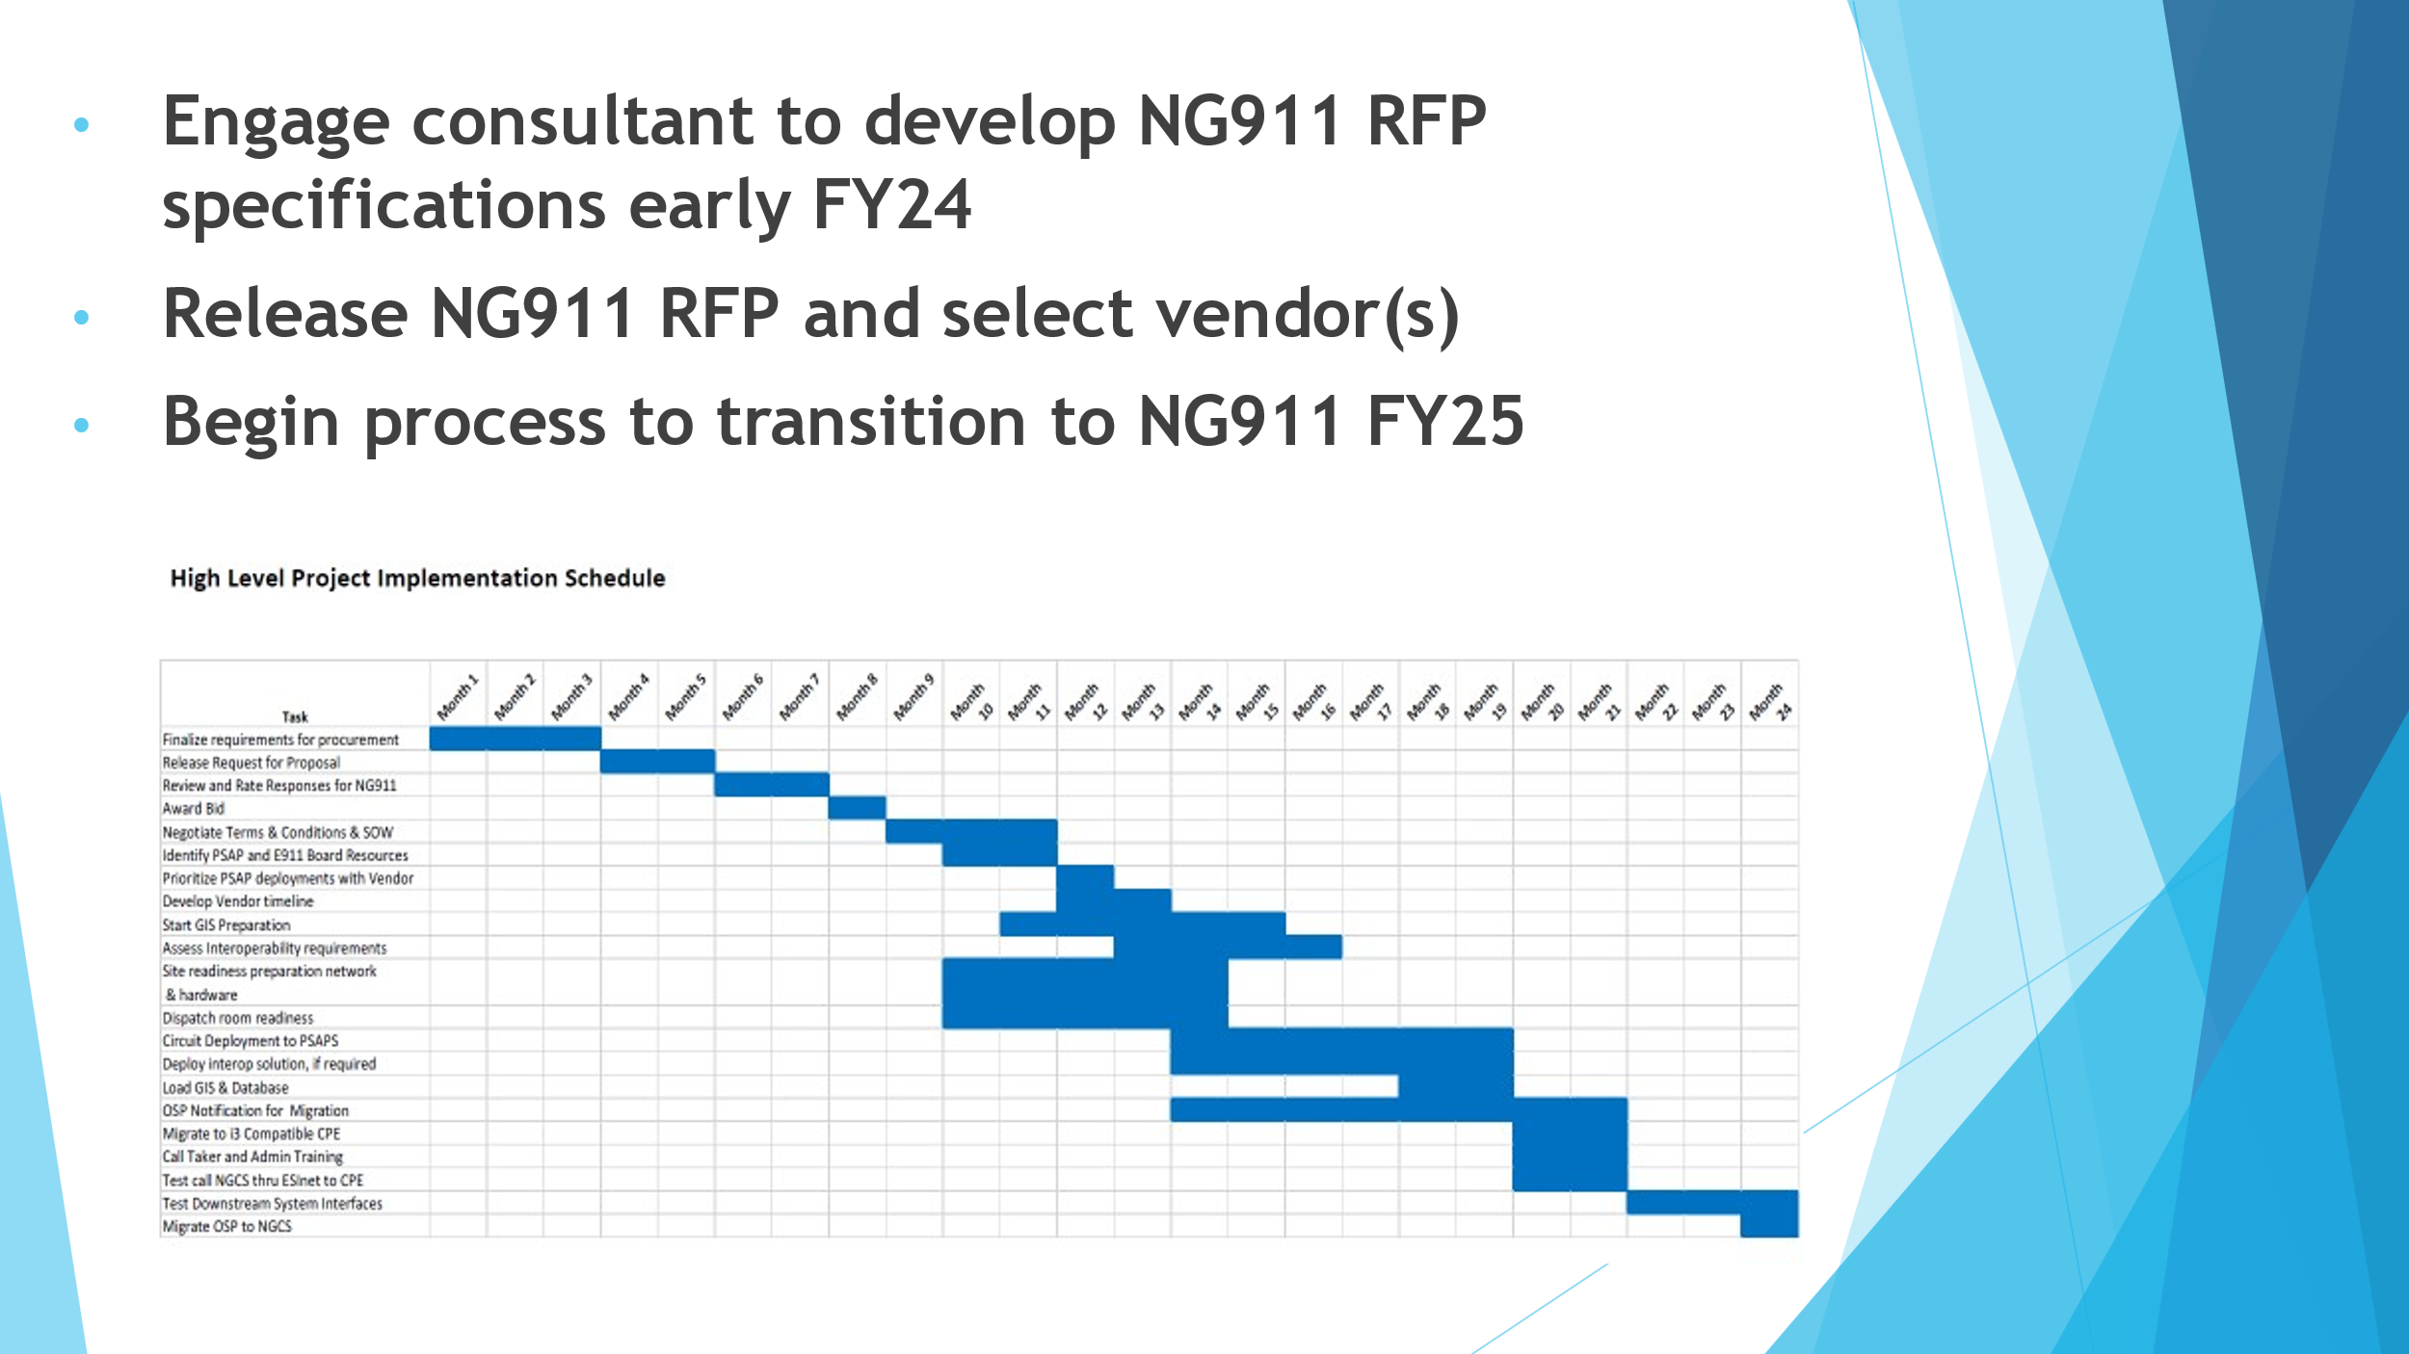
Board Chair stated that the above slide gives a high-level overview of the project implementation schedule that all agencies will receive after the Strategic Budget Plan is approved.

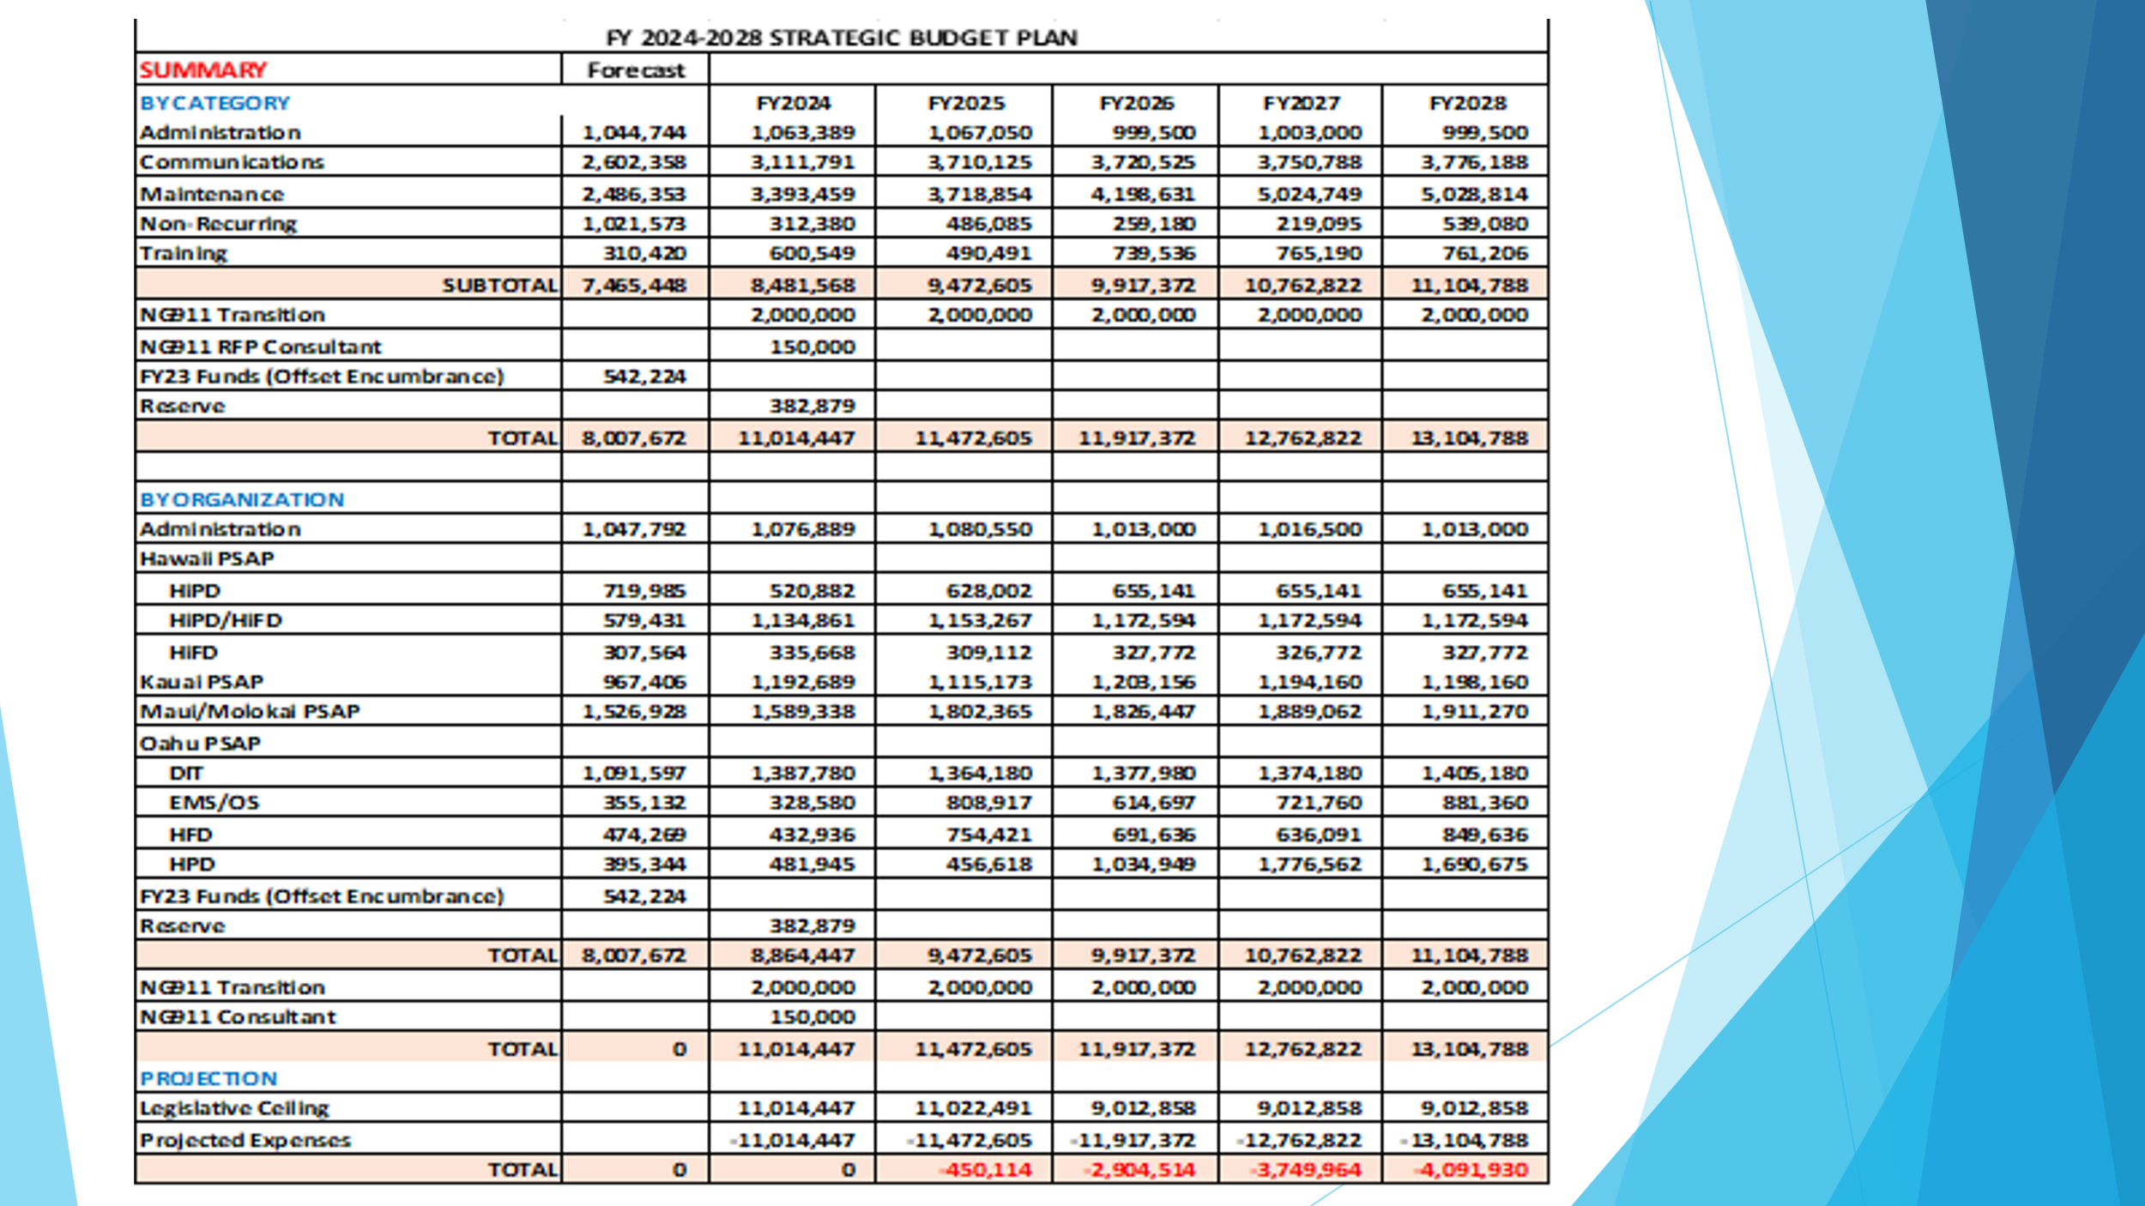
Executive Director stated that total forecast for Fiscal Year 2023 was $7,465,448 and a total of $542,234 will be used of Fiscal Year 2023 funds to offset encumbrances as explained in the Joint Committee Meeting giving us a total forecast of $8,007,672 for Fiscal Year 2023. Per Lisa Hiraoka’s request all Public Safety Answering Points expenditures have been separated in the above slide.
Edward Fujioka asked to confirm that we are projected to be over $451,000 for Fiscal Year 2025. Executive Director responded stating that is correct. Edward Fujioka responded asking if the agencies would be able to request where the reduction in expenditures would come from or will the Board decide where to reduce expenditures. Executive Director responded stating that one solution would be to cut travel out completely for Fiscal Year 2025 or reduce it to one conference per agency. Board Chair responded stating that only Fiscal Year 2025 is in question, and we will need to be revisited in Fiscal Year 2025.

Stacy Domingo asked if it is possible to allot an amount for travel that can be used at the discretion of the agency and if it is stated in the language of the chapter that states that it must be used one way or another. Board Chair stated that there is not, however, historically that is how it has been done but the new Board Chair and the Board can decide how this can be handled in the future.

Reed Mahuna stated for an explanation of how the Board is projected to be over $451,000 for Fiscal Year 2025 and moving forward. Board Chair stated that with the new ceiling increased that was approved was $11,022,491. She added that in future years numbers increase due to the ceiling increase only approved up to Fiscal Year 2025.

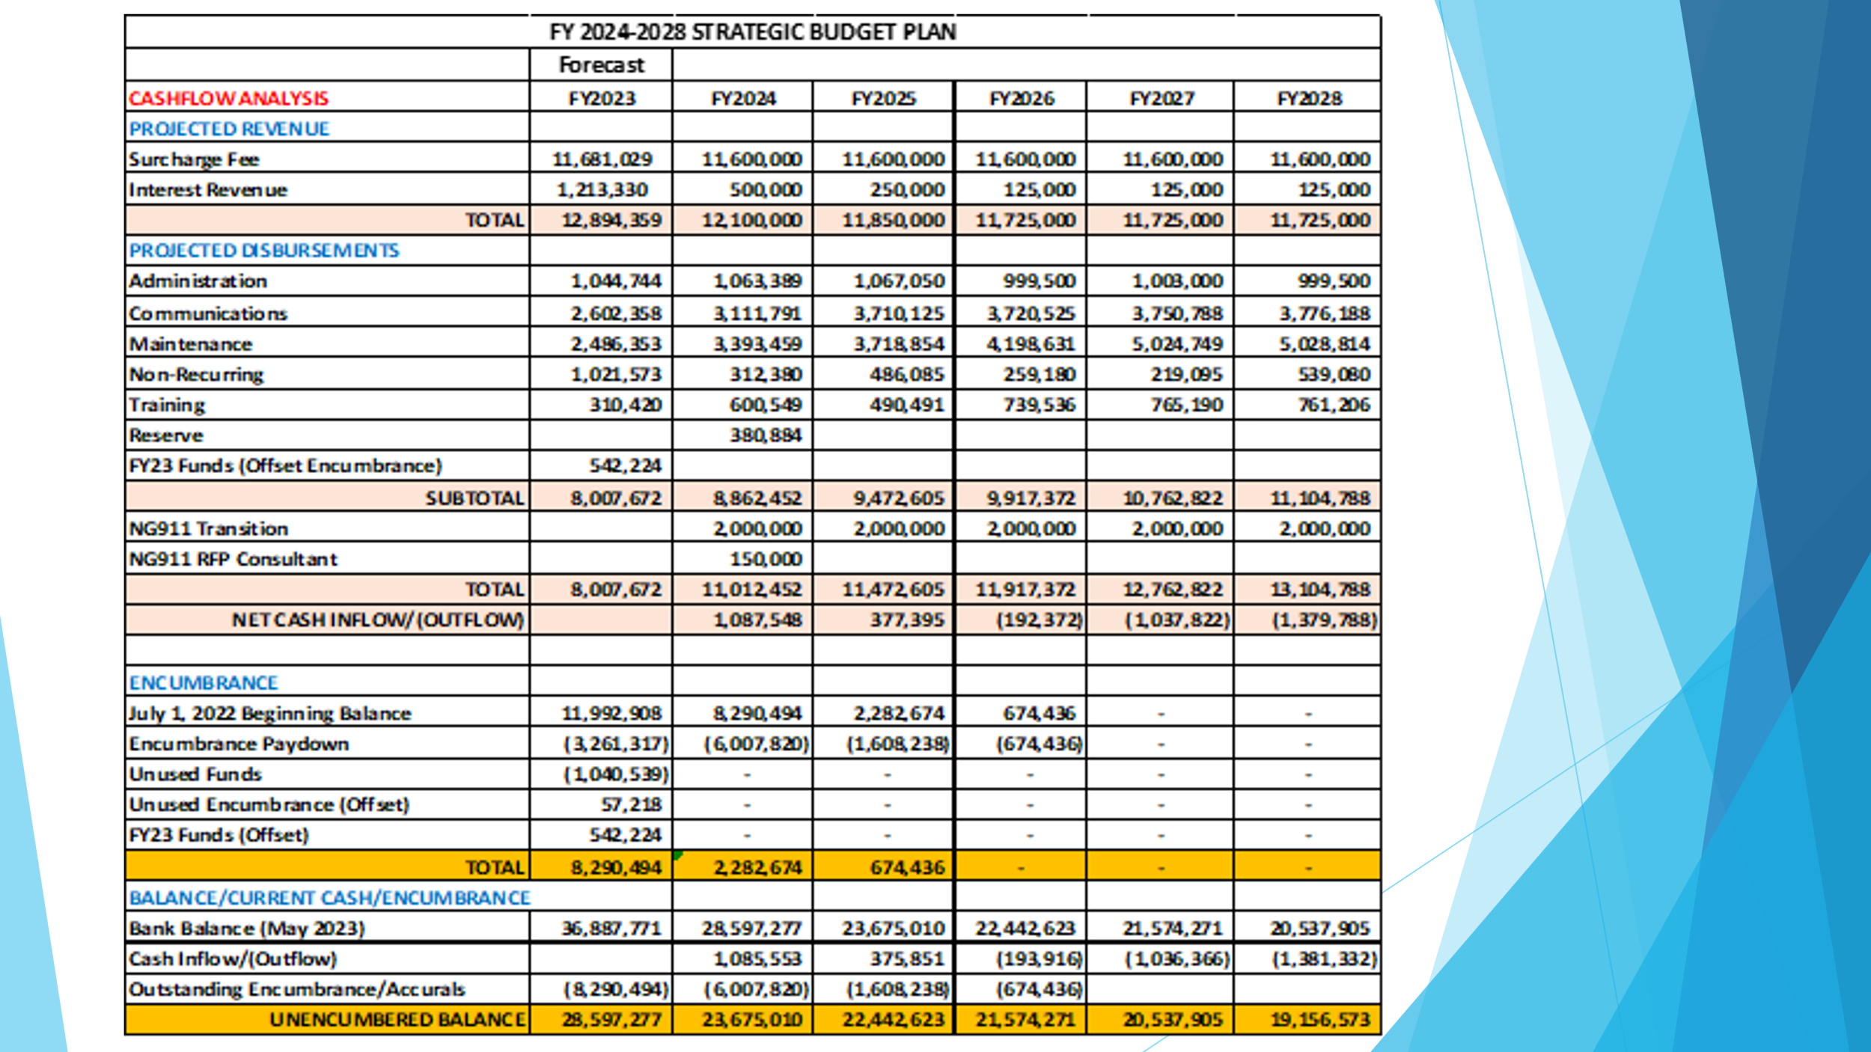
Executive Director stated as mentioned previously that the interest revenue was calculated using a conservative approach and included in the calculation of the Fiscal Year 2023 forecast a total of $542,224 will be used to cover shortages amongst the agencies. He also added that the total of unused encumbrances that would be used to cover shortages would be equal to $57,218. Furthermore, stated that our encumbrance balance will be $8,290,494 and by Fiscal Year 2026 all the current encumbrances will be paid off. Tony Ramirez asked if an agency can no longer encumber funds through the Board, can the agency petition the counties general fund for that encumbrance. Board Chair stated that she is unsure if that can be done and that her and the Executive Director’s intention was if the Board had committed funding and that we wanted to avoid the agencies from absorbing the cost because it was committed. She added that through discussions with DAGS Deputy Comptroller that normally encumbrances do not get carried over for such a long period of time and were satisfied with the progress that we have made to reduce the encumbrances. Furthermore, stated that the counties would have to answer that question and go back to see if funding would be available. However, this solution would allow the Board to honor our commitment to the counties.

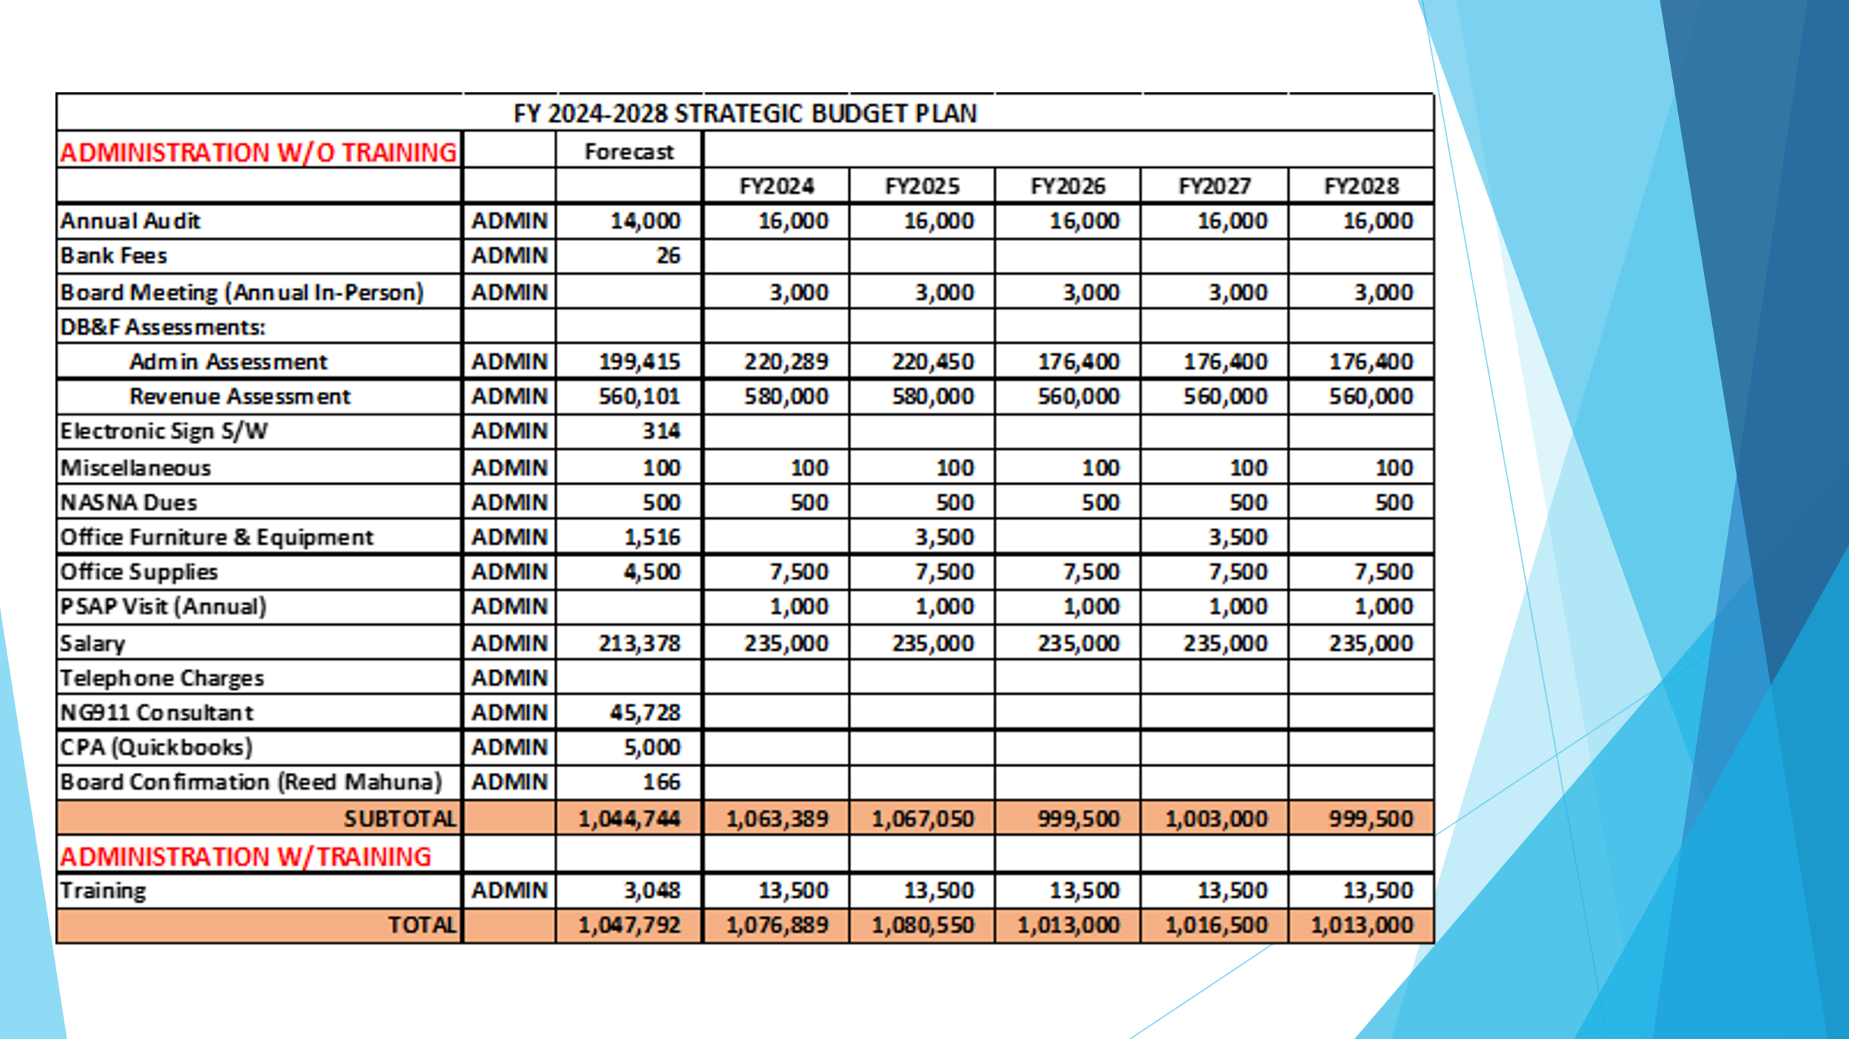

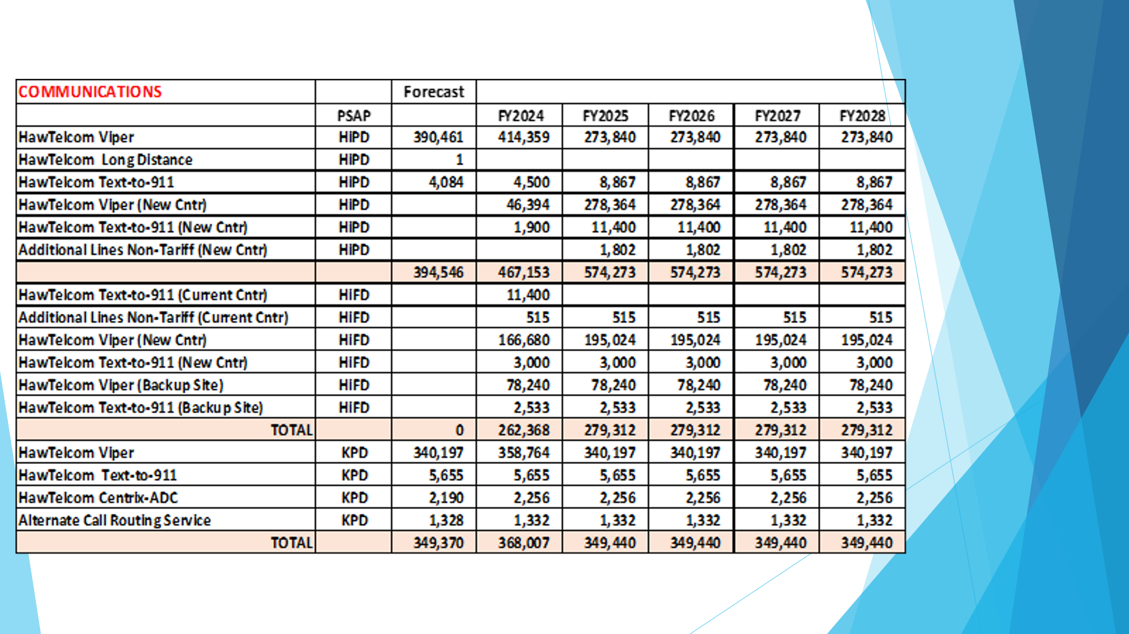
Executive Director stated that on previous Strategic Budget Plans Hawaii Fire Department and Hawaii Police Department expenses were combined as a single line item. Moving forward to have a better understanding of their expenses we have separated each of their expenses. He added that for all agencies regarding Hawaiian Telcom Viper and Trunk Charges they will be combined as one line item moving forward to create less confusion for signatories in the approval process of reimbursement requests. Furthermore, stated that moving forward he recommends that Hawaiian Telcom Long Distance Charges be removed, and the cost covered by the agencies due to the low amount of reimbursement request for that line item.
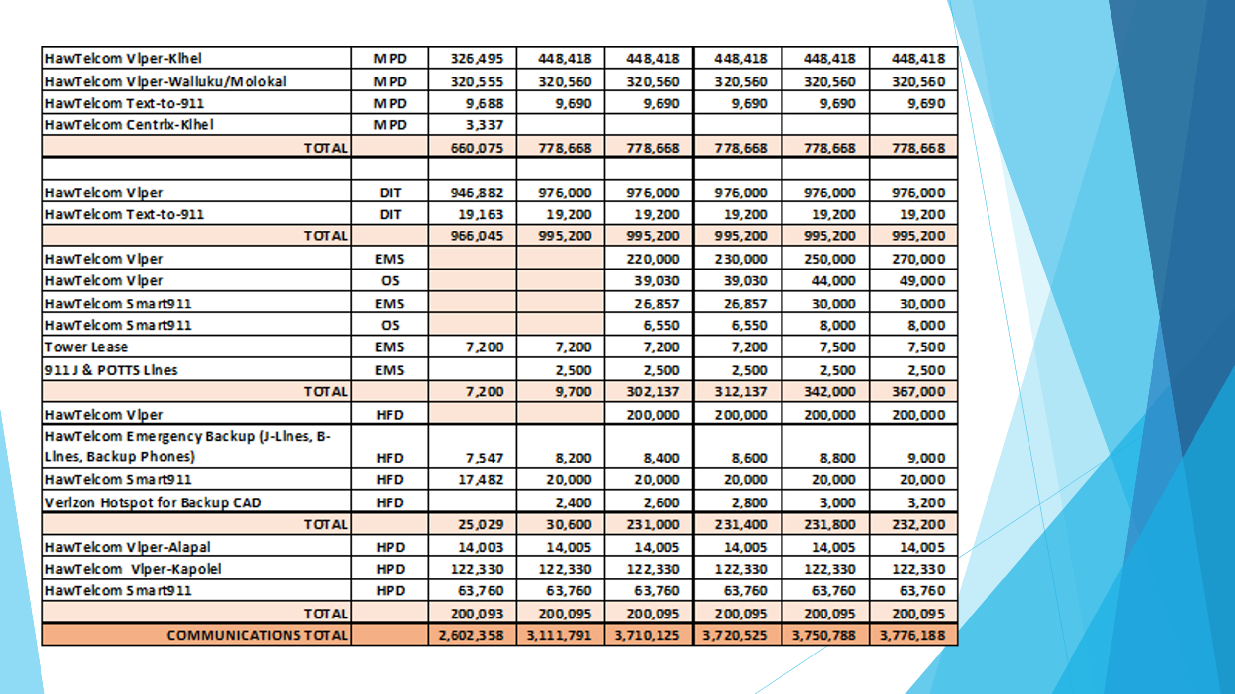
Edward Fujioka asked if there is a master agreement for Smart 9-1-1. Board Chair stated that she is not aware if there was a master agreement and believes that each agency has their own contract. Executive Director stated that from the previous Executive Director’s records that Hawaiian Telcom Viper and Smart 9-1-1 for EMS was encumbered in Fiscal Year 2021 and will be completed in Fiscal Year 2024. Stella Kam responded stating there was a question asked stating why DIT carries the Hawaiian Telcom Viper charges. Board Chair stated that DIT carries the initial Viper charges for the Honolulu County and any additional positions added to their facilities is covered by the agencies.

Davlynn Racadio stated that she wanted to announce that there was a meeting recently that stated that Hawaiian Telcom will not support Smart 9-1-1 at the end of the contract. Board Chair stated that the Oahu agencies are aware and that all Oahu agencies need to come to a decision on what the best path moving forward is. She added that they can still use Smart 9-1-1 however, it needs to be set up in a different method.

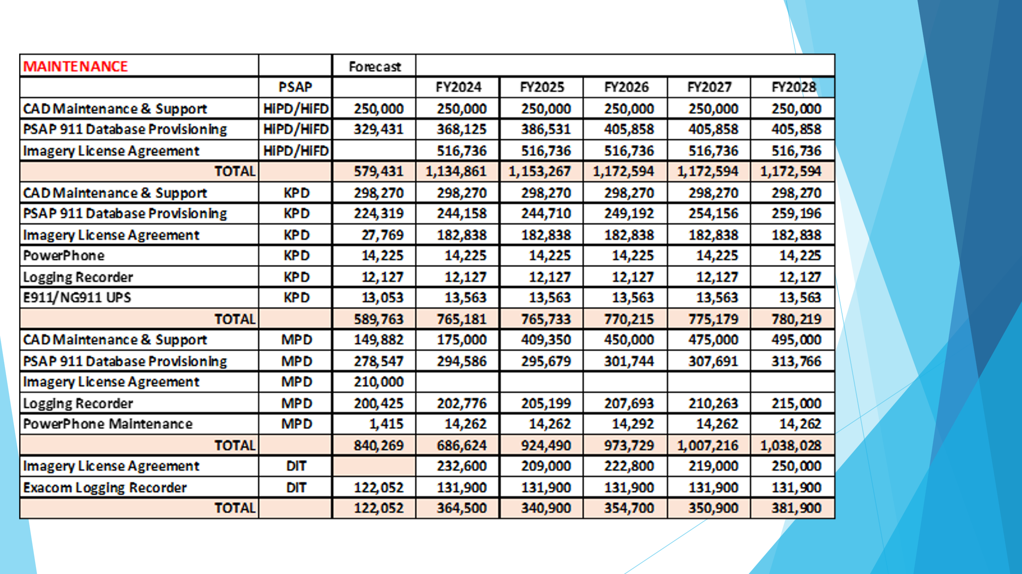

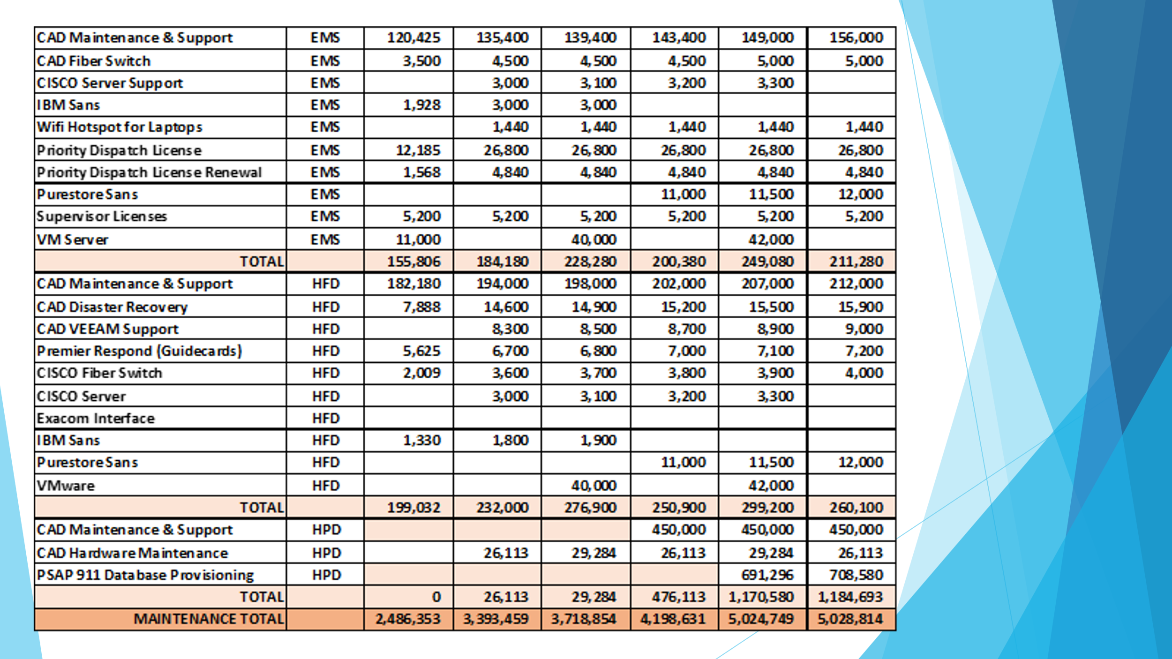

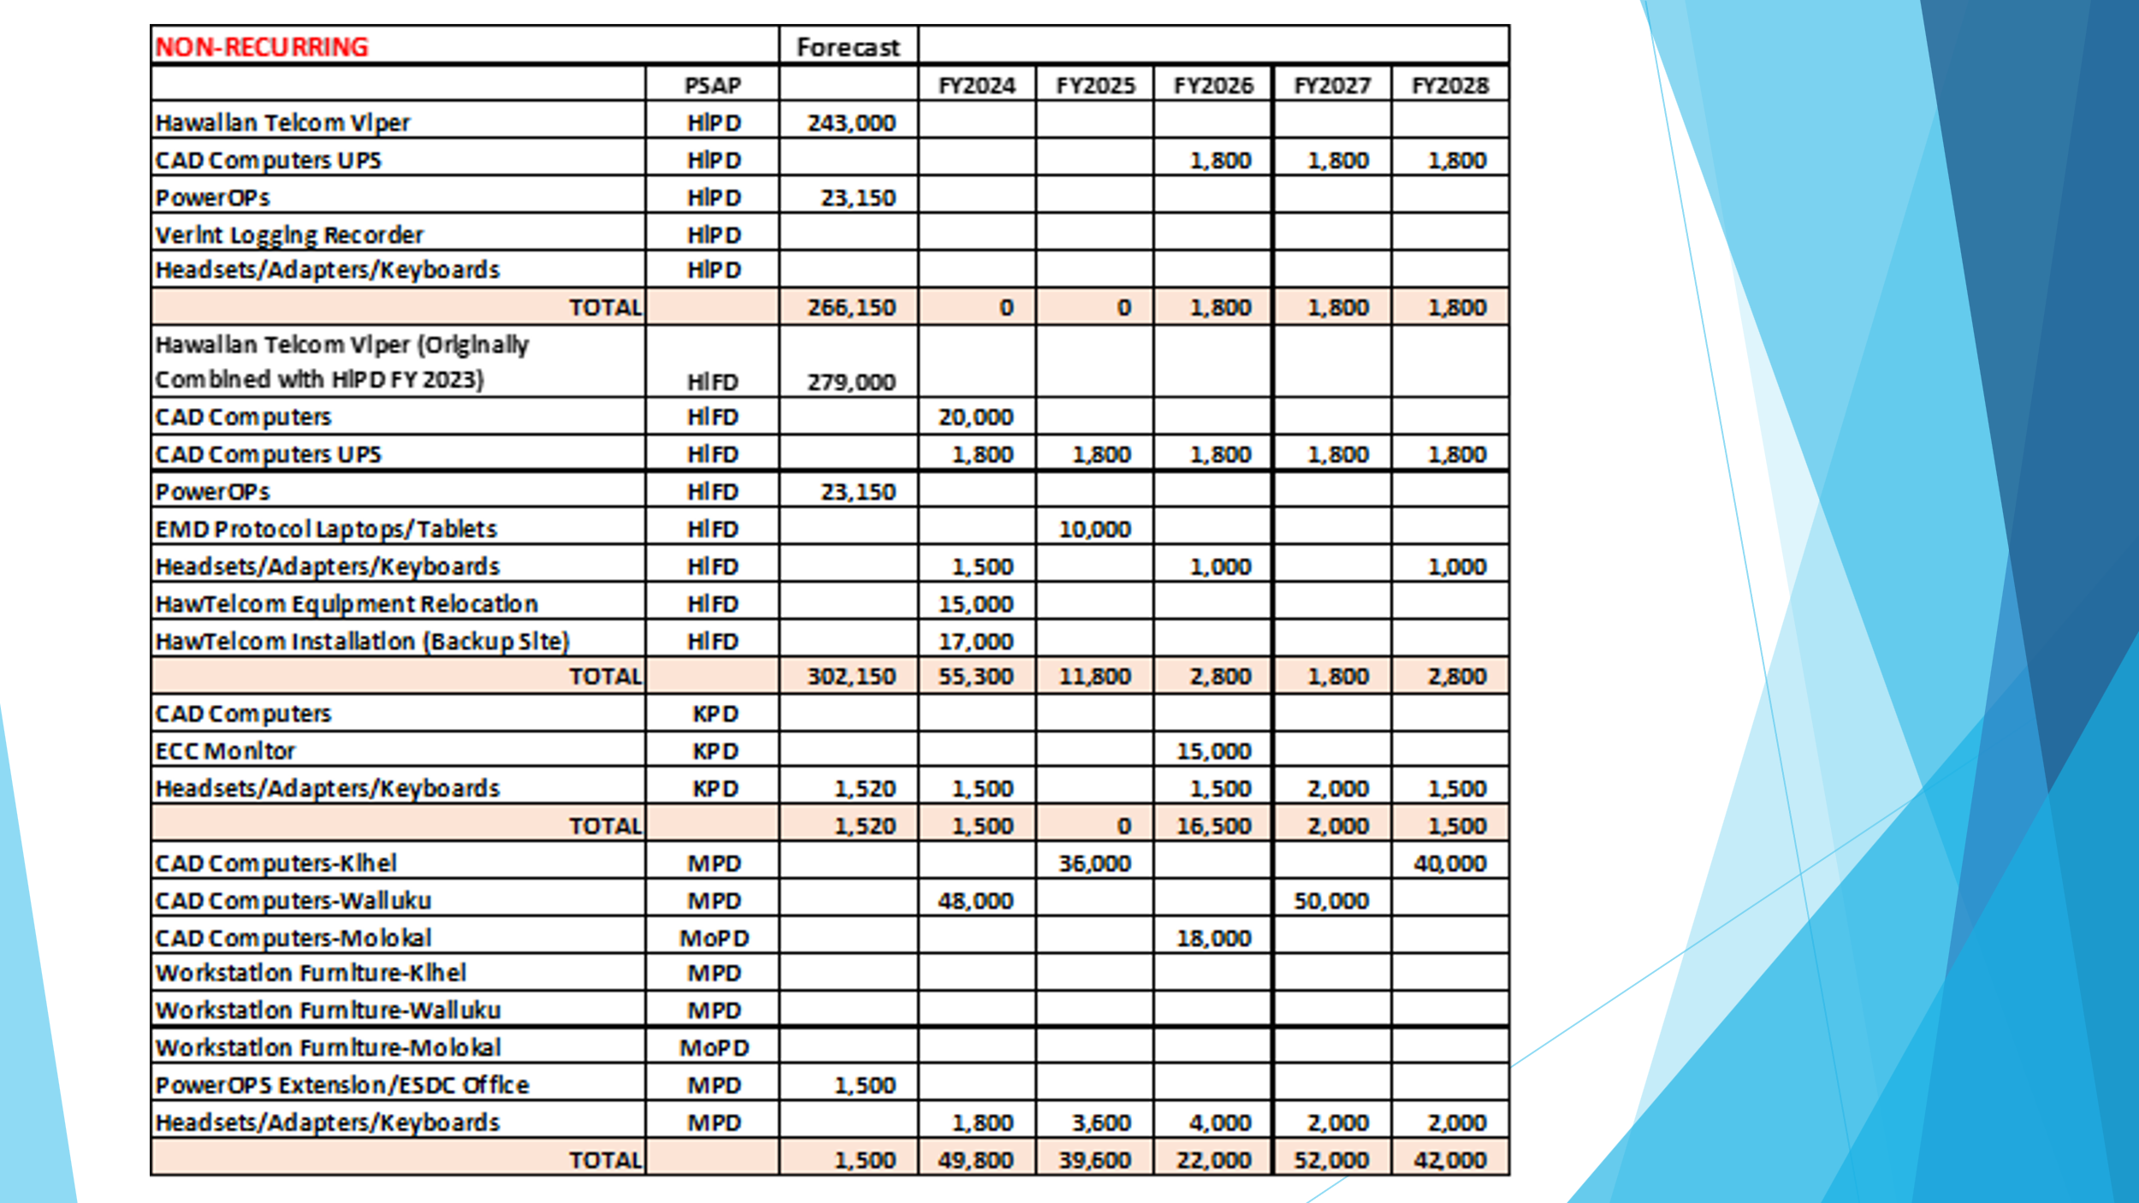

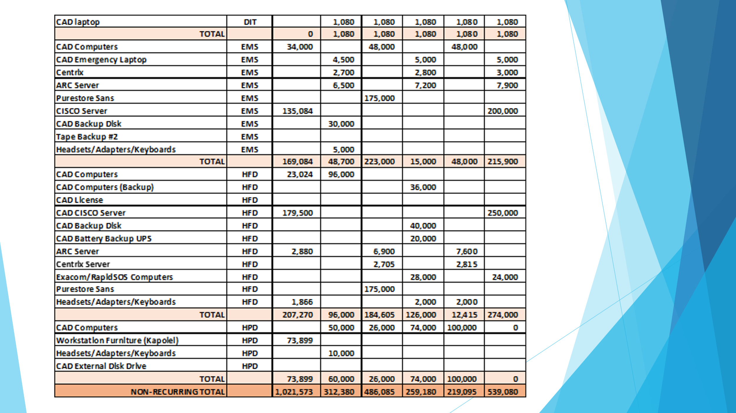

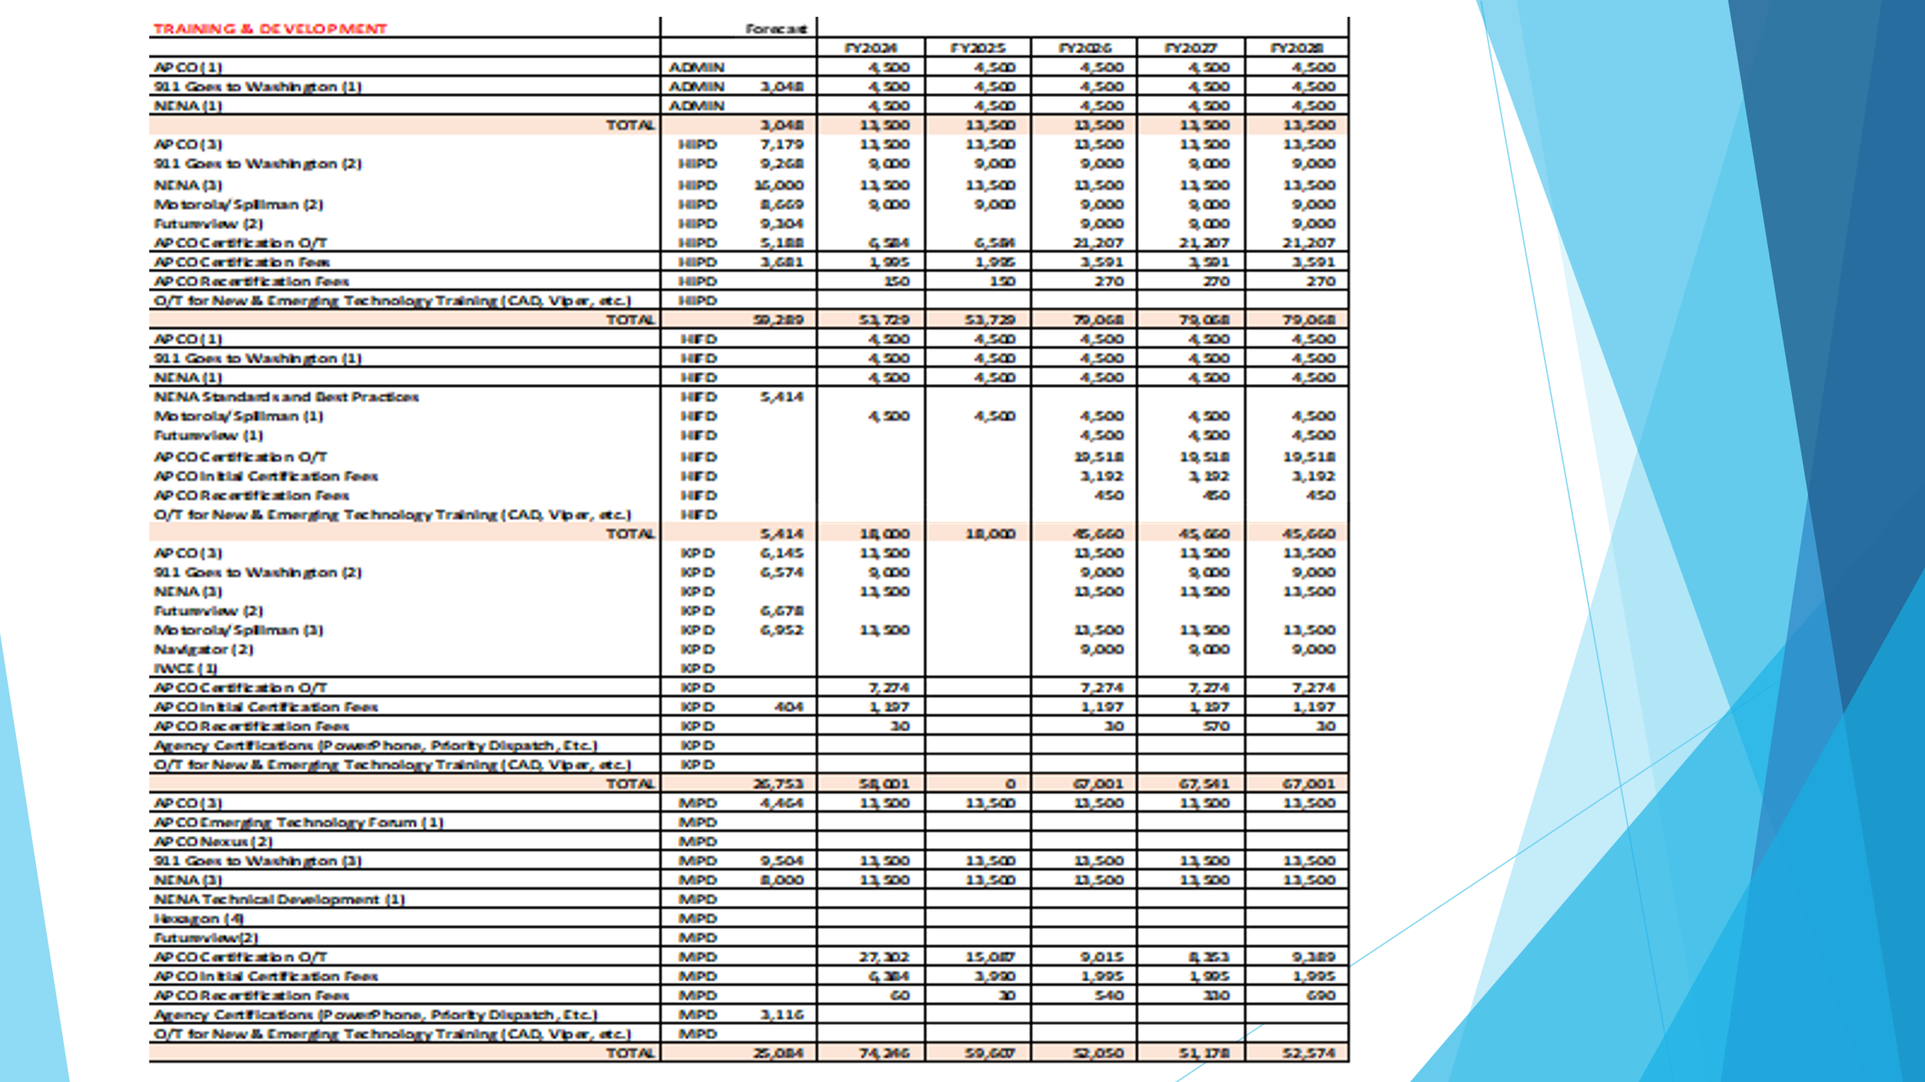

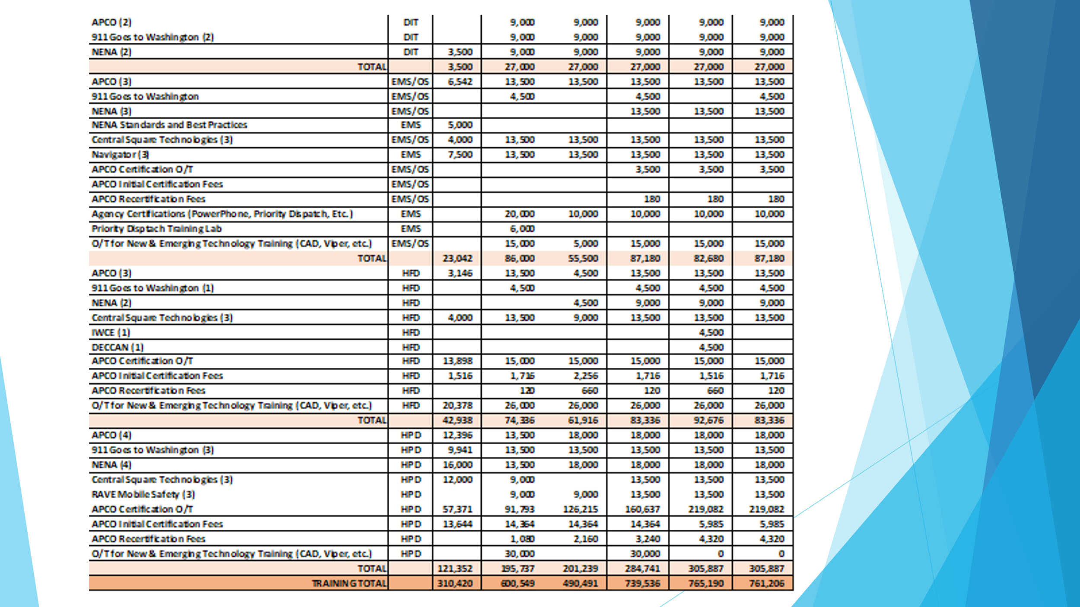
Executive Director stated that on previous Strategic Budget Plans line items for OT for APCO and Initial Certification and Recertification will be combined into one line item to reduce confusion for signatories.

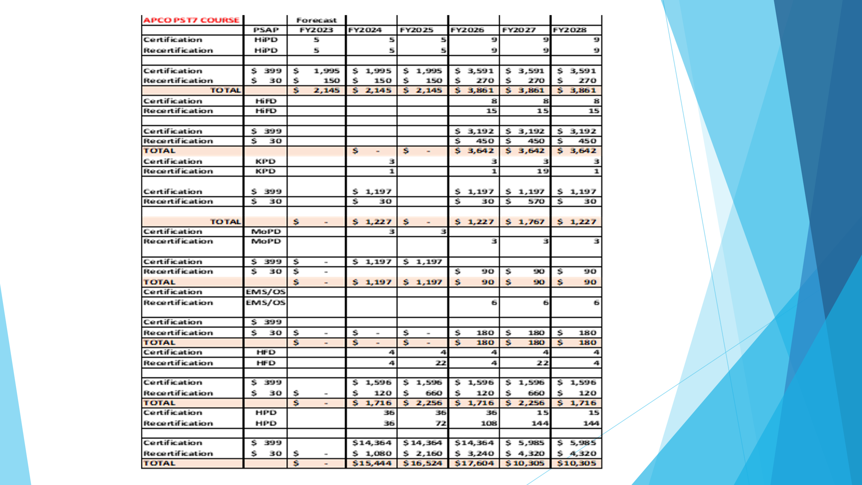

No further questions were asked on any of the following slides of the presentation of Strategic Budget Plan Fiscal Year 2024-2028

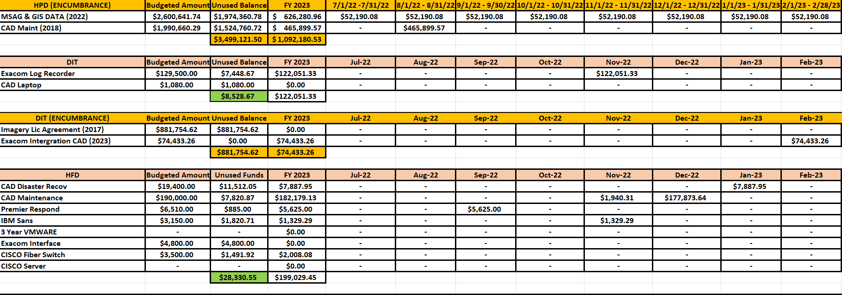
Executive Director stated the above template shows a breakdown of all reimbursement requests for Fiscal Year 2023. This template was created to calculate the forecast for Fiscal Year 2023 and that this template will be used moving forward to track all reimbursement requests by each agency. He added that this template will help all agencies track their requests as well as encumbrances and help avoid any double payments of invoices. Furthermore, stated that this template will be given out to all the agencies and signatories updated with all Fiscal Year 2024 budgeted line items and encumbrances.

Board Chair stated that moving forward DAGS will be receiving more information on our operations and the implementation of these processes. She added regarding encumbrances that we will adopt DAGS process of dissolving encumbrances if it is not requested to be extended. All agencies should send a notification to the Executive Director by the end of the third quarter if these encumbrances are needed. Furthermore, stated that the implementation of these processes and following their guidelines and foundation will prevent all the current problems that we are facing now.

- Items for Discussion, Consideration, and Action
  - 911 Timeline Update (Akimeka)
    - Status Report on All Counties
  - Additional Items Proposed by Meeting Attendees.
Board Chair stated that she will give a brief overview to Todd Omura who just joined the meeting (Please see Joint Committee Minutes Technical Committee Section) before asking for a motion to amend the agenda with the amounts previously discussed for each of the agencies. She added that we need a motion to approve using the unused encumbrance funds and current fiscal years funds to cover shortages to honor commitments made to the agencies by the Board.

Corey Shaffer motioned to amend the agenda to approve the amounts for Hawaii Police Department for CAD for $6561, Honolulu Police Department for CAD for $144,541, Department of Information Technology for Recorder/CAD Integration for $74,434, Maui Police Department for Pictometry Imagery for $224,557, and for Kauai Police Department for $11,801 for Viper/TXT2911/UPS and $140 for Centrix/TXT2911. Furthermore, to amend the agenda to approve $190,382 from encumbrances to cover reimbursement shortages within the fiscal year. Reed Mahuna seconded the motion. A voice vote was taken motion was unanimously approved.

Corey Shaffer motioned to approve the amounts for Hawaii Police Department for CAD for $6561, Honolulu Police Department for CAD for $144,541, Department of Information Technology for Recorder/CAD Integration for $74,434, Maui Police Department for Pictometry Imagery for $224,557, and for Kauai Police Department for $11,801 for Viper/TXT2911/UPS and $140 for Centrix/TXT2911. Furthermore, to approve $190,382 from encumbrances to cover reimbursement shortages within the fiscal year. Elliott K. Ke seconded the motion. A voice vote was taken motion was unanimously approved.

Board Chair asked for a motion to amend the agenda to include the approval of the Strategic Budget Plan Fiscal Year 2024-2028 under Items for Discussion, Consideration, and Action. Corey Shaffer motioned to amend the agenda to include the approval of the Strategic Budget Plan Fiscal Year 2024-2028 under Items for Discussion, Consideration, and Action. Reed Mahuna seconded the motion. A voice vote was taken, motion was unanimously approved.

Board Chair asked for a motion to approve the Strategic Budget Plan Fiscal Year 2024-2028. Elliott K. Ke motioned to approve the Strategic Budget Plan Fiscal Year 2024-2028. Keola Tom seconded the motion. A voice vote was taken, motion was unanimously approved.

- Announcements
  - Future Virtual Meeting Dates/Times (9:00AM-12:00PM)
    - Thursday, July 13, 2023 (Combined Meeting)
    - Thursday August 10, 2023 (Combined Meeting)
  - Future Conference Dates (3 Months of Advanced Approval Required)
    - NENA (National Emergency Number Association) Conference & Expo, June 17-22nd, Grapevine, TX
    - APCO (Association of Public-Safety Communications Officials) Conference & Expo, August 6-9th, Nashville, TN
  - Additional Announcements from Meeting Attendees
Board Chair stated that she would like to announce that this will be her last official meeting due to her term ending at the end of the month. She added that Matthew Kurihara will be her replacement on the Board. Furthermore, stated that with the Board’s permission she would like to continue to volunteer to assist the Executive Director with some of the challenges we are still trying to resolve. In conclusion, stated that a new chair must be nominated for next month’s meeting.

- Open Forum: Public comment on issues not on the Board Meeting Agenda
There was no public comment on issues not on the agenda.

- Executive Session
  - The E911 Board anticipates the need to meet in executive session pursuant to section 92-5(a)(2) and (4), HRS, to discuss personnel matters and to consult with the Board's attorney on questions and issues pertaining to the Board's powers and duties.
- Adjournment
Corey Shaffer motioned to adjourn the meeting. Reed Mahuna seconded the motion. A voice vote was taken, and the adjournment was unanimously approved. The meeting was adjourned.

