JOSH GREEN M.D.  GOVERNOR  Ke Kiaʻāina | 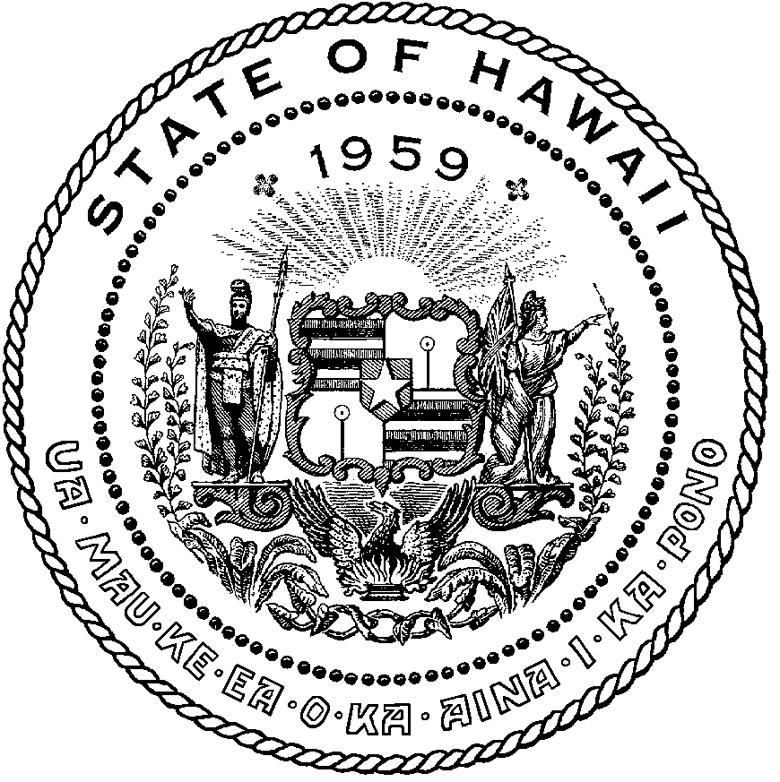 | KEITH A. REGAN  COMPTROLLER  Ka Luna Hoʻomalu Hana Laulā  MEOH-LENG SILLIMAN  DEPUTY COMPTROLLER  Ka Hope Luna Hoʻomalu Hana Laulā
STATE OF HAWAIʻI | KA Mokuʻāina o Hawaiʻi

DEPARTMENT OF ACCOUNTING AND GENERAL SERVICES | KA ʻOihana LOIHELU A LAWELAWE Laulā
P.O. BOX 119, HONOLULU, HAWAII 96810-0119

Communications, Technical, and Finance Meeting (Combined Meeting)

Thursday, March 9, 2022
9:00 am – 12:00 pm

MEETING MINUTES

Communications Committee Members Present: Davlynn Racadio (MPD) Chair, Thalia Burns (HPD)

Communications Committee Members Not Present: Lavina Taovao (KPD)

Technical Committee Members Present: Shawn Kuratani (HFD) Chair, Tony Ramirez (Akimeka), Tony Velasco (DIT), Kenison Tejada (FirstNet), Thalia Burns (HPD)

Finance Committee Members Present: Lisa Hiraoka (Consumer Advocate Designee) Chair, Edward Fujioka (EMS), Todd Omura (CIO Designee), Aaron Farias (HPD)

Staff: Royce Murakami (E911), Stella Kam (AG)

Guests: Francis Alueta (HT), Stephen Courtney (C&C of Honolulu), Frannie Chung (EMS), Diana Chun (EMS), Robert Fujitake (HIPD), Alex Hacker (Eagleview), Wayne Hirasa (Alakaina), Kimberly Lee (HPD), Matthew Kurihara (HPD), Ah Lan Leong (HPD), Shelby Lewis (ATT), Glenn Kobashigawa (HT), Kurt Lager (OSL), Rebecca Lieberman (Charter), Reed Mahuna (HIPD), Ariel Ramos (KPD), (Lorrin Okumura (EMS), Corey Shaffer (Verizon), Kenison Tejada (First Net), Keola Tom (MPD), Jeff Reeve (ATT), Barbara Winn (NGA), Geoffrey Shon (EMS), Julie Heimkes (Winbourne), Owen Fukumoto (Egami & Ichikawa CPA)

- Call to Order, Public Notice
The meeting was called to order by the Board Chair. Public notice was given.

- Public Testimony Will Be Taken on All Agenda Items as Those Items Occur During the Meeting

- Roll Call, Quorum
A roll call was taken, and a quorum was present for all three committees.

- Presentation of Fiscal Year 2021-2022 Audit Report by Egami & Ichikawa CPA Inc.
Owen Fukumoto stated that the scope of engagement was the audit of the financial statements of the Enhanced 911 Fund for the year ended June 30th, 2022, and added that this is the final year of the extended contract. He added that the audit was performed in accordance with auditing standards generally accepted in the United States and government auditing standards. The objective of the audit is to assist the Board in fulfilling its fiduciary responsibility and to ensure that internal controls have been established to safeguard assets and proper usage of funds. Furthermore, stated to ensure that all receipts and expenditures were properly recorded in financial records for the Enhanced 911 Fund and were in accordance with laws, rules, and regulations, and policies and procedures of the State of Hawaii.

Owen Fukumoto stated highlights of the Enhanced 911 Fund. (See Information Below)
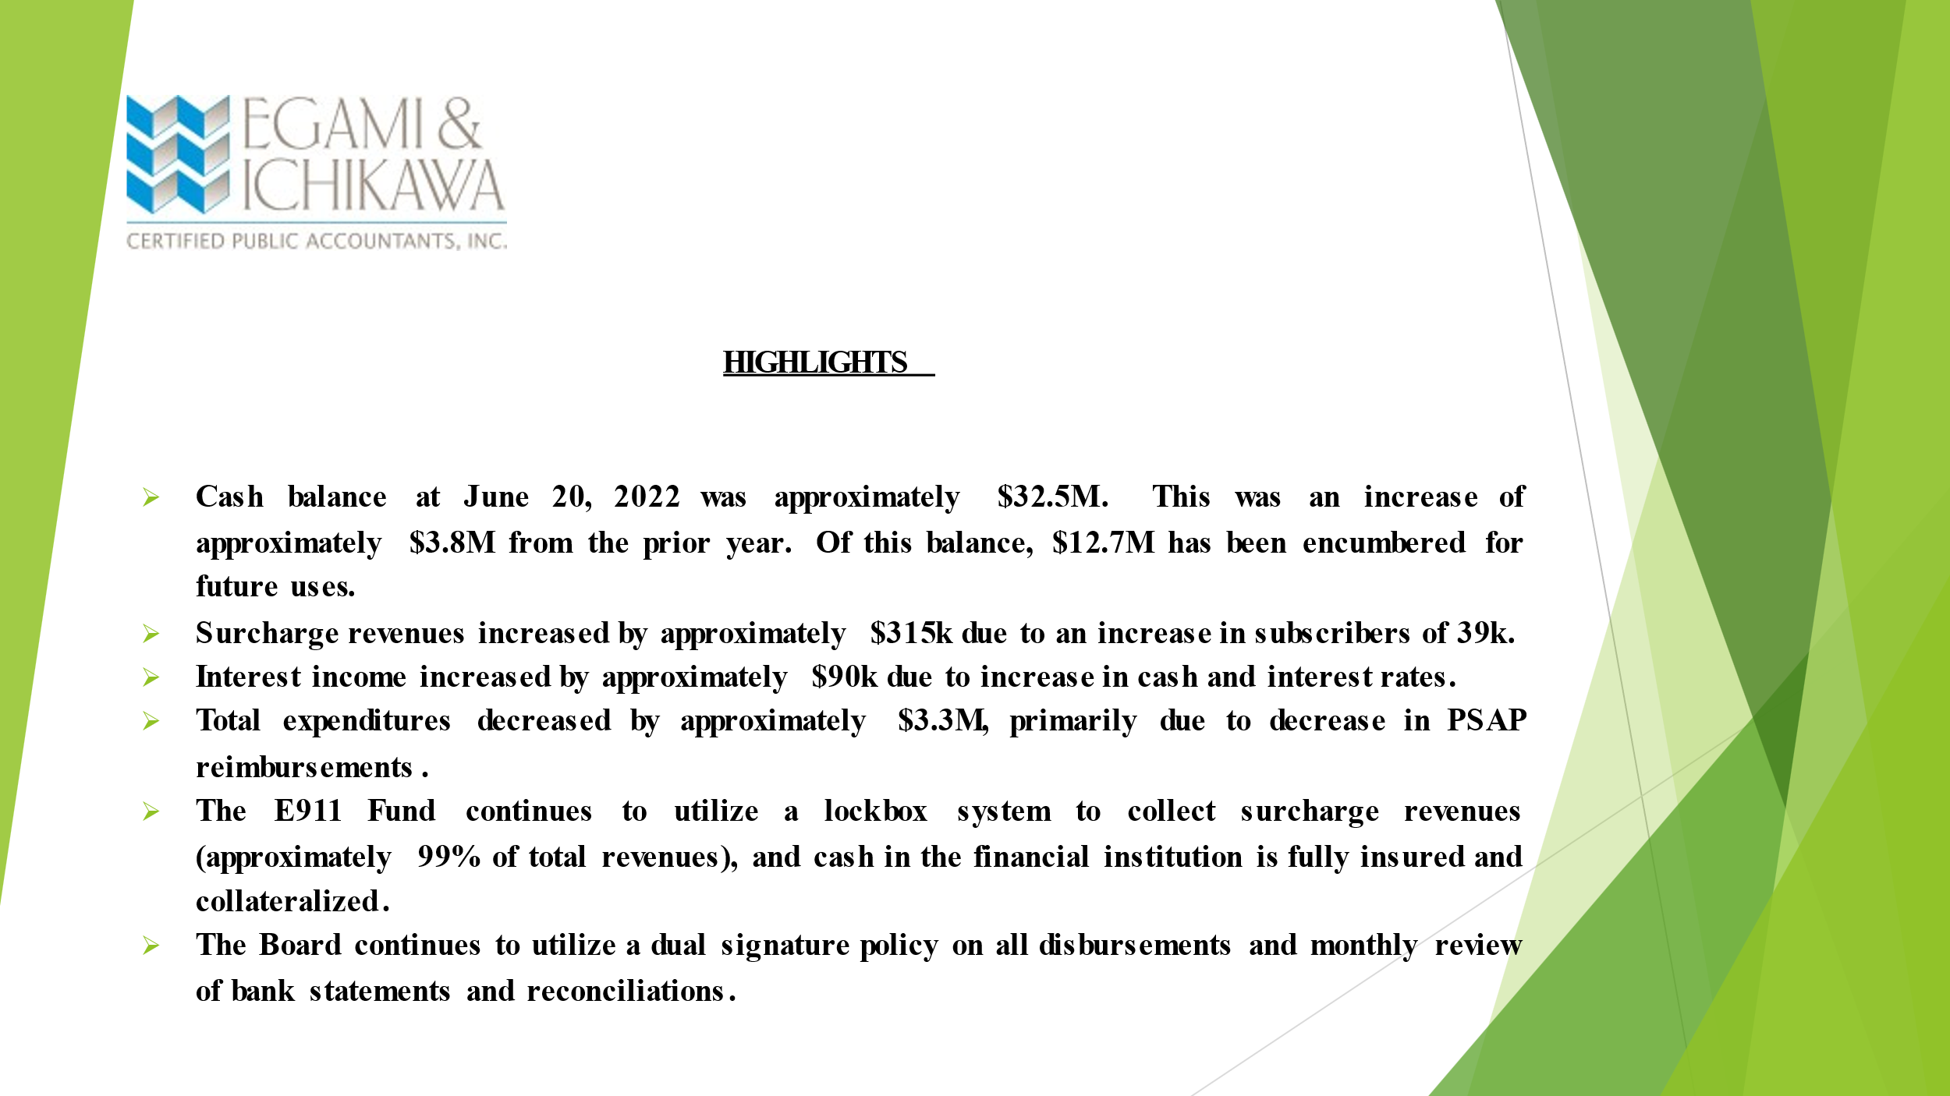
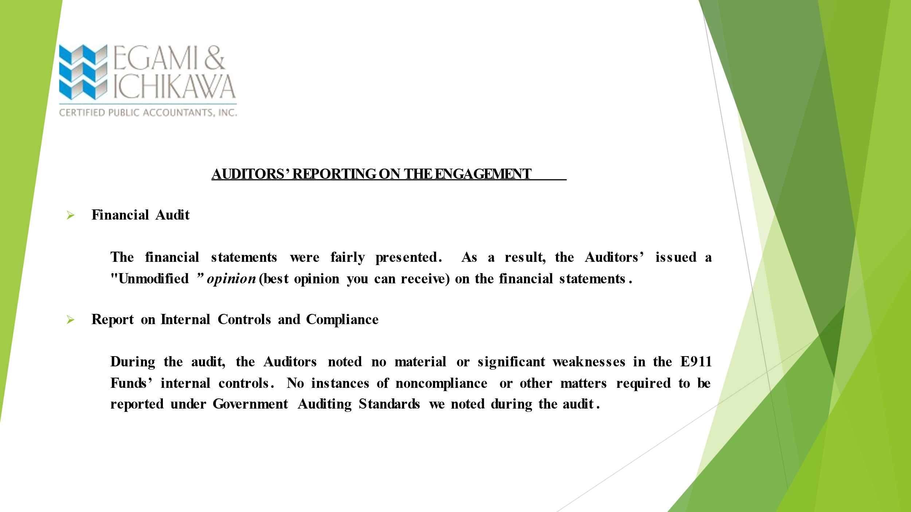
Owen Fukumoto stated in conclusion that he believes the Enhanced 911 Fund remains very stable with solid controls. However, the main issue is to be able to continue to spend resources to keep up with technology and the needs of the public. Lisa Hiraoka asked if there could be any improvements or suggestions. Owen Fukumoto responded stating that the Enhanced 911 Board must continue to ensure proper staffing to keep all administrative duties operational which can affect our accounting and reporting to the Board. He added to also ensure that resources are spent wisely to ensure that we keep up with technology to address public issues to avoid scrutiny due to the public viewing our cash balance. Lisa Hiraoka responded stating another question regarding any expected changes in standards, laws, regulation, and policies that the Board should be concerned about for future audits. Owen Fukumoto responded stating that the GASBY (Government Accounting Standards Board) which controls the reporting standards continues to constantly change however, the way the Board’s operation is set up is very simplistic compared to many other departments within the state. He added that due to the type of operations that we have any new changes in the future will be nominal at best and would not require revamping our account. Lisa Hiraoka responded with another question stating if he has any recommendations during the transition to Central Pacific Bank that we should be aware of. Owen Fukumoto responded stating that during the transition period that both banks work together to ensure that providers are sending payment to the correct bank moving forward. Francis Alueta asked Owen Fukumoto if there were any concerns from moving from physical signing of checks to online signing and disbursement. Owen Fukumoto responded stating that he does not foresee any major problems if we continue to have proper documentation on file for audit purposes to show that all transactions are being reviewed and properly approved. Furthermore, stated that regardless of whether it is all by paper or online that you still need to document that process and have that on file during the auditing process. Francis Alueta stated no further questions.

- Review and Approval of February’s Meeting Minutes
Rebecca Lieberman motioned to approve the February 2023 Meeting Minutes including the amendment to Section 6C to change Shawn Kuratani to being present. Tony Velasco seconded the motion. A voice vote was taken, and the motion was approved unanimously.

- Committee Updates by Committee Chairs
  - Communications Committee – Davlynn Racadio
    - Update on 9-1-1 Goes to Washington Conference and Meeting with our Legislators.
Davlynn Racadio stated that thirteen personnel attended 9-1-1 Goes to Washington Conference with every county represented. She added that all their appointments with Representative Ed Case, Representative Jill Tokuda, Senator Brain Schatz, and Senator Hirono went very well and were only limited in attendance to Senator Hirono’s office. Furthermore, stated that everyone in attendance entered the hill with a team perspective and united front to keep the lines of communication open and if they needed to visit any of the PSAPs that they were open to their request.

Davlynn Racadio asked Matthew Kurihara to give a briefing of his experience at 9-1-1 Goes to Washington Conference. Matthew Kurihara responded stating that three different issues were presented which were Next Generation 9-1-1, pushing for funding to offset Spectrum ban from the military, and lastly to be recognized by the Labor and Statistics Board to have dispatch personnel be recognized as first responders. He added that all representatives seemed very receptive to listening to their concerns and felt that it was a great experience for everyone, especially the telecommunicators personnel that attended the conference.

Davlynn Racadio asked Ariel Ramos to give a briefing on her experience at 9-1-1 Goes to Washington Conference. Ariel Ramos responded stating that even though she has only been in the position for three months she thought it went well and appreciated the mentorship she received. She added that all the personal stories that she heard gave her a more realistic view of why we need to make these changes and move to Next Generation 9-1-1.

Davlynn Racadio asked Keola Tom to give a briefing on his experience at 9-1-1 Goes to Washington Conference. Keola Tom responded that it was his first time attending the conference and believes that the representatives were very receptive to their needs and is hopeful that they will follow up and go through with the needs of the agencies that they requested. Davlynn Racadio responded stating that she did get several requests back from the offices that they are receptive to helping the agencies however, asking the agencies to fill out paperwork to fill out paperwork for Next Generation 9-1-1.

Davlynn Racadio asked Thalia Burns to give a briefing on her experience at 9-1-1 Goes to Washington. Thalia Burns stated that all agencies put forward a unified front to express the needs of the state. She added that they were successful in doing their task for funding for Next Generation 9-1-1 and assistance with upgrading the Telecommunicators to Protective Service Classification. Furthermore, they stated that they learned from the staffers that there are grants that could be available to help with funding efforts for Next Generation 9-1-1. Davlynn Racadio responded that she believes that the state was well represented and would like to thank the Board for the opportunity to attend this conference.

    - National Telecommunicators Week April 9-15, 2023; Volunteer Agency Needed to Draft the Proclamation for the Governor’s Signature.
Board Chair asked Davlynn Racadio to look for a volunteer agency to draft the proclamation for governor’s signature. Davlynn Racadio responded stating that she would volunteer and asked Ah Lan Leong to send her a copy of the last proclamation that was used. Ah Lan Leong responded stating that she will send a copy to her.

  - Technical Committee – Shawn Kuratani
    - Creation of Legislative Committee to Revise HRS Chapter 138
Shawn Kuratani stated that the creation of the Legislative Committee to revise HRS Chapter 138 is based on Stella Kam’s recommendation in the previous meeting where a legislative committee should be formed to change HRS Chapter 138 to allow reimbursement to Next Generation 9-1-1. The focus of this group would be to add the changes to HRS Chapter 138 to the Governor’s package for the next legislative session. Stella Kam responded stating that a permitted interaction group would need to be formed. The purpose of this group is to draft the legislation and to also give background information to legislators and submit this before the end of August 2023. Shawn Kuratani responded stating that in the previous meeting that the existing Technical Subcommittee members agreed to form the Legislative Committee to revise HRS Chapter 138. Rebecca Lieberman responded stating that she would also like to join the Legislative Committee. Stella Kam responded stating that the Legislative Committee has been formed and will be dissolved after reporting to the Board their recommendation at which point another permitted interaction group will be formed to meet with legislators. The Board Chair stated that she agrees to the formation of the Legislative Committee.

    - Update on 20 Character Limit in Location Field for 9-1-1 Calls
Shawn Kuratani stated that he has asked Glenn Kobashigawa to give an update on the 20 character limit in the location field for 9-1-1 calls. Glenn Kobashigawa stated that the ALI (Automatic Location Identification) format which has traditionally been 10 characters has increased to 20 characters. He added that Hawaiian Telcom is working with Intrado and is ready to move forward with testing that will begin on March 21, 2023, at 5:00AM. Furthermore, stated that this test will ensure that all the appropriate information is being presented and from there hand off the calls from the PSAP (Public Safety Answering Point) to the respected agencies. Tony Ramirez from Akimeka noted that they would be able to identify from this test if any adjustments or configurations need to be made to the CAD (Computer Aided Dispatch). In conclusion, stated that Intrado will make the change to the new ALI format and once the test is done revert it back to its current state. From this point the test will reveal the next steps to take with assistance from Corey Shaffer that will aid in conducting tests on the more difficult accounts that need to be tested.

    - Honolulu Police Department Requesting to Increase Tricon/Central Square Conference from $11,250 to $12,000
Shawn Kuratani asked Ah Lan Leong to give input on this request by the Honolulu Police Department. Ah Lan Leong stated that after the last board meeting the Honolulu Police Department began looking for quotes for the upcoming conference and realized that the total cost for three personnel to attend the conference was too close to the previously budgeted amount. She added that she believes it is necessary for these three personnel including herself to attend this conference and is asking the Board to increase the budgeted amount from $11,250 to $12,000. Shawn Kuratani asked for a motion to approve Honolulu Police Departments request to increase Tricon/Central Square Conference from $11,250 to $12,000 and move this to the Finance Committee for approval. Tony Velasco motioned to approve Honolulu Police Department's request. Tony Ramirez seconded the motion. A voice vote was taken, the motion was unanimously approved.

    - Maui Public Safety Answering Point Requesting $415,000 for the Last Pictometry Flyover.
Shawn Kuratani asked Keola Tom to give input on this request by Maui Public Safety Answering Point. Keola Tom stated that excess funding for their CAD was returned to the Board and is requesting $415,000 for their last Pictometry flyover that was not included in their budget. Board Chair responded stating that as of December 2022 the reserves are roughly $429,600 and currently after committing some funding to other items and Maui Public Safety Answering Point returning funding the Board’s current reserves are $450,051. She added that if the Board were to approve this request and move to the Finance Committee it would leave $35,051 in the reserves. She is requesting a discussion about whether the entire amount or part of the amount will be moved to the Finance Committee. Furthermore, stated that she asked Royce Murakami to ask all the agencies to review their budgets that were approved for fiscal year 2023 to determine if any unused funding can be returned to the Board to fund requests from other agencies who need funding. Keola Tom responded asking for approval from the Board to receive $210,000 for the Last Pictometry Flyover. Shawn Kuratani responded asking for a motion to approve Maui Public Safety Answering Point requests for $210,000 for the Last Pictometry Flyover. Tony Ramirez motioned to approve Maui Public Safety Answering Points request. Tony Velasco seconded the motion. A voice vote was taken, motion was unanimously approved.

    - Advisory Committee – Everett Kaneshige (Ah Lan Leong)
      - Status Update on HB 1398 (Formation of Bargaining Unit for 9-1-1 Telecommunicators
Shawn Kuratani asked Ah Lan Leong to give updates for the Advisory Committee on behalf of Everett Kaneshige. Ah Lan Leong responded stating that the Advisory Committee met on February 21, 2023 and it was discussed that HB 1398 was heard and passed by the Legislative Committee on February 14, 2023. However, at the conclusion of that hearing Committee Chair Matayoshi expressed some concerns about the number of bills that were being proposed for separate bargaining units. Committee Chair Matayoshi also expressed concerns that no one really provided any standards on when a bargaining unit should be established. In response to Committee Chair Matayoshi’ s concerns Everett Kaneshige asked his legislative intern to research the issue and prepare a memo for review and input from the committee. Ah Lan Leong added that the memo was reviewed and completed and reviewed with Representative Nakamura on February 28th, 2023. Representative Nakamura only requested a few revisions be made. She added that HB 1398 was heard by the House Judiciary and Hawaiian Affairs Committee on March 2, 2023, and crossed over to the Senate. In conclusion, she stated that the Department of Human Resources for the City and County of Honolulu submitted testimony opposing HB 1398. Members of that Committee from the City and County of Honolulu will discuss amongst themselves possible alternatives if any before approaching the Department of Human Resources to not oppose the bill.

      - Status Update on SB 1572 SD1 (Creates a Separate Bargaining Unit (16) for City & County of Honolulu Emergency Services Department Employees)
Ah Lan Leong stated that the Advisory Committee was made aware of a separate bill SB 1572 that also proposes to create a separate bargaining unit (16) for the City and County of Honolulu Emergency Services Department employees. She added that this bill was creating confusion and being mistaken for HB 1398. Ah Lan Leong asked members of the Advisory Committee to share any comments. Edward Fujioka stated that he did submit testimony and support and reviewed the City and County Department of Human Resources testimony in the previous meeting. He added that in his testimony he clarified the difference between HB 1398 and SB 1572.

      - Research on the Emergency Operations Center (EOC) Grant Program on the Eligibility Requirements.
Agenda item was not discussed.

  - Finance Committee – Lisa Hiraoka
    - Review of Monthly Y-T-D (Year to Date) Cash Flow
Lisa Hiraoka stated that she will review both January and February 2023 Cash Flow Statements. She added that revisions were made to the January 2023 Cash Flow Statement because we did not have all the information on what was paid in terms of the current fiscal year expenses versus encumbrances. In comparison to the previous January 2023 Cash Flow Statement disbursement amounts were corrected and encumbrances pay downs were properly accounted for.

January 2023 Cash Flow Statement:

Net Receipts/Disbursements: $847,323
Net Encumbrance Adds/Paydowns: ($120,915)
Unencumbered Cash Balance: $25,683,688

February 2023 Cash Flow Statement:

Surcharge Collection: $975,123
Interest Income: $120,426
Total Disbursements: ($436,940)
Net Receipts/Disbursements: $658,609
Net Encumbrance Adds/Paydowns: ($457,454)
Net Cash Inflow/(Outflow): $201,155
Unencumbered Cash Balance: $26,342,297

    - Requesting all Public Service Answering Points Submit Balances of Encumbrances
Lisa Hiraoka stated that she is requesting all agencies to please send in all reimbursement requests as soon as possible rather than waiting until the end of the fiscal year to submit reimbursement requests. Furthermore, she stated that all agencies submit information on all prior year encumbrances. This information is to be submitted to Royce Murakami by March 23, 2023 that shows in detail the year of the encumbrance, original amount of encumbrance, and current balance of encumbrance. In conclusion, stated that if there are any amounts that should be returned or unencumbered to notify us as soon as possible to ensure records are accurate and to date as possible.

    - Honolulu Police Department Requesting to Increase Tricon/Central Square Conference from $11,250 to $12,000
Lisa Hiraoka asked for a motion to approve Honolulu Police Departments request to increase Tricon/Central Square Conference from $11,250 to $12,000. Edward Fujioka motioned to approve Honolulu Police Departments request. Todd Omura seconded the motion. A voice vote was taken, motion was unanimously approved.

    - Maui Public Safety Answering Point Requesting $415,000 for the Last Pictometry Flyover.
Lisa Hiraoka asked for a motion to amend the agenda to approve Maui Safety Answering Points request for $415,000 to $210,000 for the last Pictometry Flyover. Edward Fujioka motioned to amend the agenda to approve Maui Public Safety Answering Points request. Todd Omura seconded the motion. A voice vote was taken, motion was unanimously approved.

Lisa Hiraoka asked for a motion to approve Maui Public Safety Answering Points request of $210,000 for last Pictometry Flyover. Edward Fujioka motioned to approve Maui Public Safety Answering Points request. Todd Omura seconded the motion. A voice vote was taken, motion was unanimously approved.

- Public Service Answering Point Status Updates on Recruitment and other Personnel Issues
  - Kauai Police Department – Ariel Ramos
    - Update on Recruitment Process/Strategies and Personnel Training
Ariel Ramos stated that their Human Resources Department expressed that they would conduct testing on March 15, 2023, however, until testing is conducted, and a recommended list is provided we do not know how many people are applying for the dispatch position.

    - Update on Personnel Issues and Vacancies
Ariel Ramos stated that they have seventeen out of twenty positions with currently one personnel on family leave and other personnel that said that she will be leaving due to health reasons. She added in either May or June 2023 that other personnel will be retiring.

  - Oahu Police Department – Aaron Farias
    - Update on Recruitment Process/Strategies and Personnel Training
Aaron Farias stated that their Human Resources Department has been working closely with our Communications Divisions Training Committee who have been assisting in recruiting. He added that they did their first in person information session for prospective applicants for our Police Communications Officers positions at the JTMC (Joint Traffic Management Center). Applicants received a presentation about the job and were given the opportunity to ask questions and were given a tour of the JTMC.

    - Update on Personnel Issues and Vacancies
Aaron Farias stated that they currently have a 30% vacancy rate with currently four vacancies for their Emergency Response Operators and are currently conducting interviews for eleven applicants.

  - Oahu Fire Department – Shawn Kuratani
    - Update on Recruitment Process/Strategies and Personnel Training
Shawn Kuratani stated he would like to notify everyone that took the APCO Dispatcher Class is set to expire in April 2023 and will need to retake the test and submit credential hours on the APCO website.

    - Update on Personnel Issues and Vacancies
Shawn Kuratani stated that they currently have one reported vacancy.

  - Oahu Emergency Medical Services – Lorrin Okumura, Diana Chun, Frannie Chung
    - Update on Recruitment Process/Strategies and Personnel Training
Lorrin Okumura stated no updates on recruitment process/strategies and personnel training.

    - Update on Personnel Issues and Vacancies
Lorrin Okumura stated that they completed two interviews for their Dispatch Supervisor positions out of four applicants that they will be selecting two momentarily. He added that they currently have six vacancies for the dispatcher position that they will be interviewing soon.

  - Maui Police Department – Davlynn Racadio
    - Update on Recruitment Process/Strategies and Personnel Training
Davlynn Racadio stated that they currently have two ESD (Emergency Services Dispatchers) personnel in training. She added that four personnel are in the end process of hiring and conducted four interviews earlier this week with more planned for the following week.

    - Update on Personnel Issues and Vacancies
Davlynn Racadio stated that two new personnel will begin employment on March 20th and April 3rd, 2023.

  - Molokai Police Department – Davlynn Racadio
    - Update on Recruitment Process/Strategies and Personnel Training
Please see above update for Maui Police Department.

    - Update on Personnel Issues and Vacancies
Please see above update for Maui Police Department.

  - Hawaii Police Department – Robert Fujitake
    - Update on Recruitment Process/Strategies and Personnel Training
Robert Fujitake stated at the end of February they held a realistic job interview for Police Communications Officer positions. He added that a couple weeks ago interviews for those positions were conducted and two applicants were sent conditional offers.

    - Update on Personnel Issues and Vacancies
Robert Fujitake stated that there is one vacancy for Supervisor Police Communications Officer that three of their veteran dispatchers will be applying for. He added that they will begin interviewing for the position next week and that there are currently five personnel conducting radio training.

  - Hawaii Fire Department – Vern Hara
    - Update on Recruitment Process/Strategies and Personnel Training
Vern Hara is currently not present to give update.

    - Update on Personnel Issues and Vacancies
Vern Hara is currently not present to give update.

- Items for Discussion, Consideration, and Action
  - 911 Timeline Update (Akimeka)
    - Status Reports on All Counties
  - Additional Items Proposed by Meeting Attendees
- Announcements
  - Future Virtual Meeting Dates/Times (9:00AM-12:00PM)
    - Thursday, April 13, 2023 (Combined Meeting)
    - Thursday, May 11, 2023 (Combined Meeting)
    - Thursday, June 8, 2023 (Combined Meeting)
  - Future Conference Dates (3 Months of Advanced Approval Required)
    - Pictometry/EagleView, April 24-27th, San Antonio, TX
    - NENA (National Emergency Number Association) Conference & Expo, June 17-22nd, Grapevine, TX
    - APCO (Association of Public-Safety Communications Officials) Conference & Expo, August 6-9th, Nashville, TN
  - Additional Announcements from Meeting Attendees
- Open Forum: Public comment on issues not on the Committee Meeting Agenda
There was no public comment on issues not on the agenda.

- Adjournment
Tony Ramirez motioned to adjourn the meeting. Tony Velasco seconded the motion. A voice vote was taken, and the adjournment was unanimously approved. The meeting was adjourned.

