JOSH GREEN M.D.  GOVERNOR  Ke Kiaʻāina | 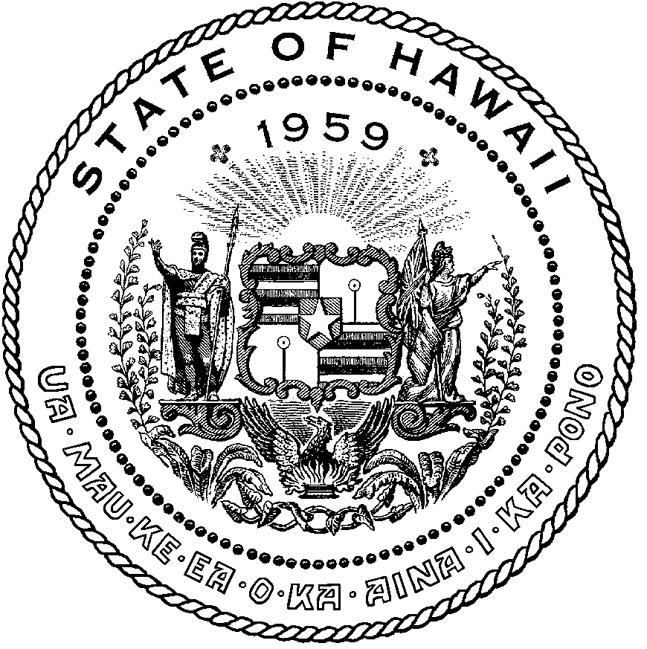 | KEITH A. REGAN  COMPTROLLER  Ka Luna Hoʻomalu Hana Laulā  MEOH-LENG SILLIMAN  DEPUTY COMPTROLLER  Ka Hope Luna Hoʻomalu Hana Laulā
STATE OF HAWAIʻI | KA Mokuʻāina o Hawaiʻi

DEPARTMENT OF ACCOUNTING AND GENERAL SERVICES | KA ʻOihana LOIHELU A LAWELAWE Laulā
P.O. BOX 119, HONOLULU, HAWAII 96810-0119

Communications, Technical, and Finance Meeting (Combined Meeting)
Virtual Meeting – Microsoft Teams
Call-In: 808-829-4853; Phone Conf ID: 668 922 150#

Physical location: Kalanimoku Bldg. Room 426, 1151 Punchbowl St., Honolulu, is available to the public and is guaranteed to be connected to the remote virtual meeting.

Join on your computer, mobile app or room device
Click here to join the meeting
Meeting ID: 277 677 568 403
Passcode: g3snhg
Download Teams | Join on the web

Contact for Meeting information/testimony submission; Royce Murakami, State of Hawaii, Enhanced 911 Board, Room 411A, 1151 Punchbowl Street, Honolulu, HI 96813
royce.m.murakami@hawaii.gov

"In the event that audiovisual communication cannot be maintained by all participating board members and quorum is lost, the meeting will automatically be recessed for 30 minutes, during which time an attempt to restore audiovisual communication will be made. If such attempt to restore is unsuccessful within said 30 minutes, all board members, members of the public, staff and other interested individuals shall log on again to the Teams link on this Notice, whereby audio communication will be established for all participants and the meeting will continue. If reconvening the meeting is not possible because audio and visual communication cannot be re-established, the meeting will be terminated."

Thursday, March 9, 2022
9:00 am – 12:00 pm

Agenda

- Call to Order, Public Notice
- Public Testimony Will Be Taken on All Agenda Items as Those Items Occur During the Meeting
- Roll Call, Quorum
- Presentation of Fiscal Year 2021-2022 Audit Report by Egami & Ichikawa CPA Inc.
Please click link for Fiscal Year 2021-2022 Audit Report
Microsoft Word - {3031ACBB-A431-4DEE-9DC0-9F574DCE87F0}.docx (hawaii.gov)
- Review and Approval of February’s Meeting Minutes
- Committee Updates by Committee Chairs
  - Communications Committee – Davlynn Racadio
    - Update on 9-1-1 Goes to Washington Conference and Meeting with our Legislators.
    - National Telecommunicators Week April 9-15, 2023; Volunteer Agency Needed to Draft the Proclamation for the Governor’s Signature.
  - Technical Committee – Shawn Kuratani
    - Creation of Legislative Committee to Revise HRS Chapter 138
    - Update on 20 Character Limit in Location Field for 9-1-1 Calls
    - Honolulu Police Department Requesting to Increase Tricon/Central Square Conference from $11,250 to $12,000
    - Maui Public Safety Answering Point Requesting $415,000 for the Last Pictometry Flyover.
    - Advisory Committee – Everett Kaneshige (Ah Lan Leong)
      - Status Update on HB 1398 (Formation of Bargaining Unit for 9-1-1 Telecommunicators
      - Status Update on SB 1572 SD1 (Creates a Separate Bargaining Unit (16) for City & County of Honolulu Emergency Services Department Employees)
      - Research on the Emergency Operations Center (EOC) Grant Program on the Eligibility Requirements.
  - Finance Committee – Lisa Hiraoka
    - Review of Monthly Y-T-D (Year to Date) Cash Flow
    - Requesting all Public Service Answering Points Submit Balances of Encumbrances
    - Honolulu Police Department Requesting to Increase Tricon/Central Square Conference from $11,250 to $12,000
    - Maui Public Safety Answering Point Requesting $415,000 for the Last Pictometry Flyover.
- Public Service Answering Point Status Updates on Recruitment and other Personnel Issues
  - Kauai Police Department – Ariel Ramos
    - Update on Recruitment Process/Strategies and Personnel Training
    - Update on Personnel Issues and Vacancies
  - Oahu Police Department – Aaron Farias
    - Update on Recruitment Process/Strategies and Personnel Training
    - Update on Personnel Issues and Vacancies
  - Oahu Fire Department – Shawn Kuratani
    - Update on Recruitment Process/Strategies and Personnel Training
    - Update on Personnel Issues and Vacancies
  - Oahu Emergency Medical Services – Lorrin Okumura, Diana Chun, Frannie Chung
    - Update on Recruitment Process/Strategies and Personnel Training
    - Update on Personnel Issues and Vacancies
  - Maui Police Department – Davlynn Racadio
    - Update on Recruitment Process/Strategies and Personnel Training
    - Update on Personnel Issues and Vacancies
  - Molokai Police Department – Davlynn Racadio
    - Update on Recruitment Process/Strategies and Personnel Training
    - Update on Personnel Issues and Vacancies
  - Hawaii Police Department – Robert Fujitake
    - Update on Recruitment Process/Strategies and Personnel Training
    - Update on Personnel Issues and Vacancies
  - Hawaii Fire Department – Vern Hara
    - Update on Recruitment Process/Strategies and Personnel Training
    - Update on Personnel Issues and Vacancies
- Items for Discussion, Consideration, and Action
  - 911 Timeline Update (Akimeka)
    - Status Reports on All Counties
  - Additional Items Proposed by Meeting Attendees
- Announcements
  - Future Virtual Meeting Dates/Times (9:00AM-12:00PM)
    - Thursday, April 13, 2023 (Combined Meeting)
    - Thursday, May 11, 2023 (Combined Meeting)
    - Thursday, June 8, 2023 (Combined Meeting)
  - Future Conference Dates (3 Months of Advanced Approval Required)
    - Pictometry/EagleView, April 24-27th, San Antonio, TX
    - NENA (National Emergency Number Association) Conference & Expo, June 17-22nd, Grapevine, TX
    - APCO (Association of Public-Safety Communications Officials) Conference & Expo, August 6-9th, Nashville, TN
  - Additional Announcements from Meeting Attendees
- Open Forum: Public comment on issues not on the Committee Meeting Agenda
- Adjournment

