DAVID Y. IGE  GOVERNOR  Ke Kiaʻāina | 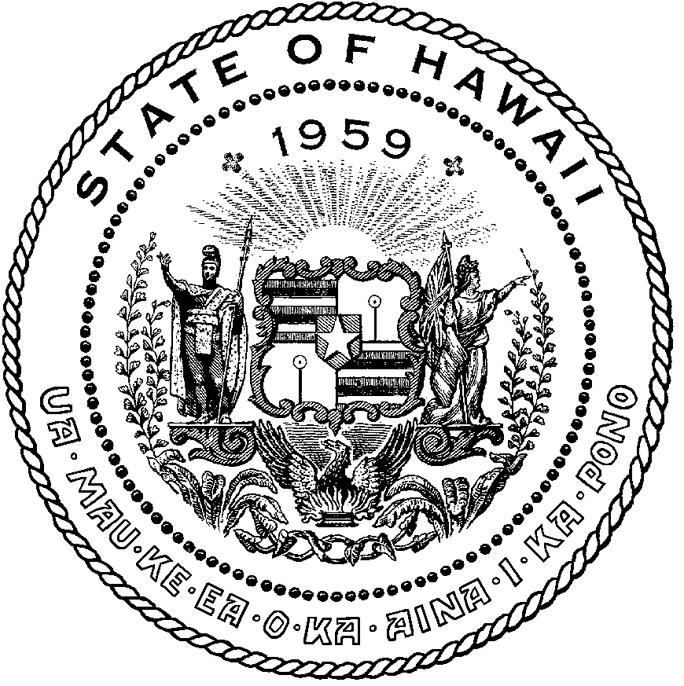 | AUDREY HIDANO  COMPTROLLER  Ka Luna Hoʻomalu Hana Laulā  MEOH-LENG SILLIMAN  DEPUTY COMPTROLLER  Ka Hope Luna Hoʻomalu Hana Laulā
STATE OF HAWAII

Enhanced 911 Board Meeting

Thursday, December 8, 2022
9:00 am – 12:00 pm

MEETING MINUTES

Board Members Present: Francis Alueta (HT), Nani Blake (T-Mobile), Stephen Courtney (C&C of Honolulu), Liz Gregg (ATT), Lisa Hiraoka (Consumer Advocate Designee), Todd Omura (CIO Designee), Rebecca Lieberman (Charter), E. Kalani Ke (KPD)

Board Members Not Present: Thalia Burns (HPD), Gregg Okamoto (MPD), Keola Tom (MPD, Corey Shaffer (Verizon)

Staff: Courtney Tagupa (E911), Royce Murakami (E911), Stella Kam (AG)

Guests: Frannie Chung (EMS), Diana Chun (EMS), Stacy Domingo (EMS), Aaron Farias (HIPD), Edward Fujioka (EMS), Robert Fujitake (HIPD), Vern Hara (HIPD), Everett Kaneshige (DOD), Glenn Kobashigawa (HT), Shawn Kuratani (HFD), Patrick Leddy (LCC), Reed Mahuna (HIPD), Lorrin Okumura (EMS), Davlynn Racadio (MPD), Tony Ramirez (Akimeka), Jeff Reeve (ATT), Kenison Tejada (First Net), Tony Velasco (DIT), Ruth Zipfel (Eagle View)

- Call to Order, Public Notice
The meeting was called to order by Shawn Kuratani. Public notice was given.

- Public Testimony Will Be Taken on All Agenda Items as Those Items Occur During the Meeting

- Roll Call, Quorum
A roll call was taken, quorum was present for the Board.

- Review and Approval of November’s Meeting Minutes
Elliot Kalani Ke motioned to approve the November 2022 Meeting Minutes. Francis Alueta seconded the motion. A voice vote was taken, and the motion was approved unanimously.

- Committee Updates by Committee Chairs
  - Communications Committee – Davlynn Racadio
    - No Updates to Report
Davlynn Racadio stated no further updates. Please see Joint Committee Minutes.

  - Technical Committee – Shawn Kuratani
    - Discussion on Transition to Next Generation 911 to include Next Steps and Request for Proposal
    - Technical Committee Chair requests to add Chief Hara to Technical Subcommittee
    - Approval to add additional member of Technical Subcommittee to attend Next Generation 9-1-1 Standards & Best Practices Conference in the amount of $3500
Shawn Kuratani stated no further updates. Please see Joint Committee Minutes.

  - Educational Investigative Committee – (Chair of Educational Investigative Committee Undecided)
  - Advisory Committee – Everett Kaneshige
    - Status Update on Telecommunicator Reclassification Project and Legislative Outreach
Everett Kaneshige stated no further updates. Please see Joint Committee Minutes.

  - Finance Committee – Lisa Hiraoka
    - Review of Monthly Y-T-D (Year to Date) Cash Flow
    - Approval of Additional Funds for Department of Budget and Finance Fiscal Year 2021-2022 Assessment.
    - Approval to add additional member of Technical Subcommittee to attend Next Generation 9-1-1 Standards & Best Practices Conference in the amount of $3500
Lisa Hiraoka stated no further updates. Please see Joint Committee Minutes.

- Public Service Answering Point Status Updates on Recruitment and other Personnel Issues
  - Kauai Police Department – E. Ke Kalani
    - Update on Recruitment Process/Strategies and Personnel Training
    - Update on Personnel Issues and Vacancies
Elliot Ke Kalani stated no further updates. Please see Joint Committee Minutes.

  - Oahu Police Department – Aaron Farias
    - Update on Recruitment Process/Strategies and Personnel Training
    - Update on Personnel Issues and Vacancies
Aaron Farias stated no further updates. Please see Joint Committee Minutes.

  - Oahu Fire Department – Shawn Kuratani
    - Update on Recruitment Process/Strategies and Personnel Training
    - Update on Personnel Issues and Vacancies
Shawn Kuratani stated no further updates. Please see Joint Committee Minutes.

  - Oahu Emergency Medical Services – Lorrin Okumura, Diana Chun, Frannie Chung
    - Update on Recruitment Process/Strategies and Personnel Training
    - Update on Personnel Issues and Vacancies
Lorrin Okumura stated no further updates. Please see Joint Committee Minutes.

  - Maui Police Department – Davlynn Racadio
    - Update on Recruitment Process/Strategies and Personnel Training
    - Update on Personnel Issues and Vacancies
Davlynn Racadio stated no further updates. Please see Joint Committee Minutes.

  - Molokai Police Department – Davlynn Racadio
    - Update on Recruitment Process/Strategies and Personnel Training
    - Update on Personnel Issues and Vacancies
Davlynn Racadio stated no further updates. Please see Joint Committee Minutes.

  - Hawaii Police Department – Robert Fujitake
    - Update on Recruitment Process/Strategies and Personnel Training
    - Update on Personnel Issues and Vacancies
Robert Fujitake stated no further updates. Please see Joint Committee Minutes.

  - Hawaii Fire Department – Vern Hara
    - Update on Recruitment Process/Strategies and Personnel Training
    - Update on Personnel Issues and Vacancies
Stacy Domingo on behalf of Vern Hara stated no further updates. Please see Joint Committee Minutes.

- Executive Director’s Report
  - Discussion and Selection of Bank Proposals from Central Pacific Bank, Bank of Hawaii, and First Hawaiian Bank
Executive Director stated that this agenda item will be discussed in the following meeting due to the absence of the Board Chair and Vice Chair. He added that he believes that this issue is particularly important and will wait for those two individuals to be present.

  - Update on Review of Encumbrances for Fiscal Year 2015-2017

Outstanding Encumbrances
Year
 | PSAP | Item | Amount | Explanation
FY 2015 | HIPD | Spillman CAD Upgrade | 267,938.26 | Last payment
FY 2016 | Maui | Viper Equipment | 118,255.78 | need further research
FY 2017 | Kauai | Imagery-EagleView | 125,242.50 | Last payment
FY 2017 | Maui | Imagery-EagleView | 839,538.76 | need further research
FY 2017 | Oahu-DIT | Imagery-EagleView | 967,089.40 | Contractually committed
FY 2018 | Maui | CAD Upgrade | 950,016.15 | need further research
FY 2018 | Oahu-HPD | CAD Upgrade | 2,003,879.95 | remaining amount for CAD Maintenance
 |  | Total | 5,271,960.80
Executive Director stated as requested by the Finance Chair the above image shows the outstanding encumbrances by each respective organization responsible for these encumbrances. He added that he reached out to each organization to provide an explanation to these encumbrances of they should be lapsed of continued. Each organization has made a commitment except for Maui due to having requested more time to determine if these encumbrances need to be removed or continued with a commitment. Regarding the item Imagery-EagleView that experienced problems due to the pandemic which delayed activity and subsequently no payments were made. In conclusion, the Executive Director stated Oahu-HPD has an existing contract with Central Square for the continuing CAD Maintenance. Lisa Hiraoka stated that she wanted to thank the Executive Director for reaching out to all the PSAPs to verify these encumbrances and would like to ask if this can be a regular exercise on an annual basis to check the status of the encumbrances.

Francis Alueta stated for clarification on Kauai’s item for FY 2017 Imagery EagleView in the amount of $125,242.50 and asked if that is the total encumbered amount for that fiscal year. He added that he is assuming that similar payments have been made and if this amount is what is needed for FY 2017. Executive Director stated the above shows the existing remaining balance on the contract and includes the fiscal year it was encumbered. In conclusion, stated that he was advised that the remaining balance should be paid shortly. Francis Alueta stated that he has no further questions.

  - Update on Increase of Legislative Spending Ceiling for Fiscal Year 2024-2025
Executive Director stated that he had discussions with the Budget & Finance Department regarding the Board’s request to increase the legislative spending ceiling. He added that our request went unchallenged and was approved by the Governor. Currently the request is in the process of being approved by the Legislature by July 2023. Lisa Hiraoka stated that if any documentation needs to be submitted to the legislature for the upcoming session. Executive Director stated that no further documentation has ever been needed in previous requests but will confirm and report back to the Finance Chair.
- Items for Discussion, Consideration, and Action
  - 911 Timeline Update (Akimeka)
    - Status Report on All Counties
  - Approval of Additional Funds for Department of Budget and Finance Fiscal Year 2021-2022 Assessment.
Lisa Hiraoka asked for a motion to amend the agenda to include payment of $9265.36 to cover the remaining balance of the Budget & Finance FY 2021-22 Assessment. Elliot Ke. Kalani motioned to amend the agenda to include payment of $9265.36 to cover the remaining balance of the Budget & Finance FY 2021-22 Assessment. Francis Alueta seconded the motion. A voice vote was taken, motion was unanimously approved.

Lisa Hiraoka asked for a motion to approve the payment of $9265.36 to cover the remaining balance of the Budget & Finance FY 2021-22 Assessment. Elliot Ke. Kalani motioned to approve the payment of $9265.36 to cover the remaining balance of the Budget & Finance FY 2021-22 Assessment. Stephen Courtney seconded the motion. A voice vote was taken, motion was unanimously approved.

  - Approval to add additional member of Technical Subcommittee to attend Next Generation 9-1-1 Standards & Best Practices Conference in the amount of $3500
Shawn Kuratani asked for a motion to amend the agenda to include approval to increase the budgeted amount of $14000 to $15000 for three personnel from the Technical Subcommittee to attend the Next Generation 9-1-1 Best Standards & Practices Conference. Rebecca Lieberman motioned to approve this request. Francis Alueta seconded the motion. A voice vote was taken, motion was unanimously approved.

Shawn Kuratani asked for a motion to increase the budgeted amount of $14000 to $15000 for three personnel from the Technical Subcommittee to attend the Next Generation 9-1-1 Best Standards & Practices Conference. Elliot Ke. Kalani motioned to approve this request. Francis Alueta seconded the motion. A voice vote was taken, motion was unanimously approved.

  - Update on Policy Committee to Review Conference and Travel Guidelines
Shawn Kuratani stated this agenda item will be postponed till January 2023 Board and Joint Committee Meeting.

  - Additional Items Proposed by Meeting Attendees
Shawn Kuratani asked for a motion to approve to add Chief Hara as a member of the Technical Subcommittee. Lisa motioned to approve this request. Stephen Courtney seconded the motion. A voice vote was taken, motion was unanimously approved.

- Announcements
  - Future Virtual Meeting Dates/Times (9:00AM-12:00PM)
    - Thursday, January 12, 2023 (Combined Meeting)
    - Thursday, February 9, 2023 (Combined Meeting)
    - Thursday, March 9, 2023 (Combined Meeting)
  - Future Conference Dates (3 Months of Advanced Approval Required)
    - Next Generation 9-1-1 Standards & Best Practices Conference, January 16-19, 2023, Clearwater, FL
    - 911 GTW (Goes to Washington) Conference, February 26-March 1, 2023, Arlington, VA
    - Pictometry/EagleView, April 24-27th, San Antonio, TX
  - Additional Announcements from Meeting Attendees

- Open Forum: Public comment on issues not on the Committee Meeting Agenda
There was no public comment on issues not on the agenda.

- Adjournment
Stephen Courtney motioned to adjourn the meeting. Lisa Hiraoka seconded the motion. A voice vote was taken, and the adjournment was unanimously approved. The meeting was adjourned.

