DAVID Y. IGE  GOVERNOR  Ke Kiaʻāina | 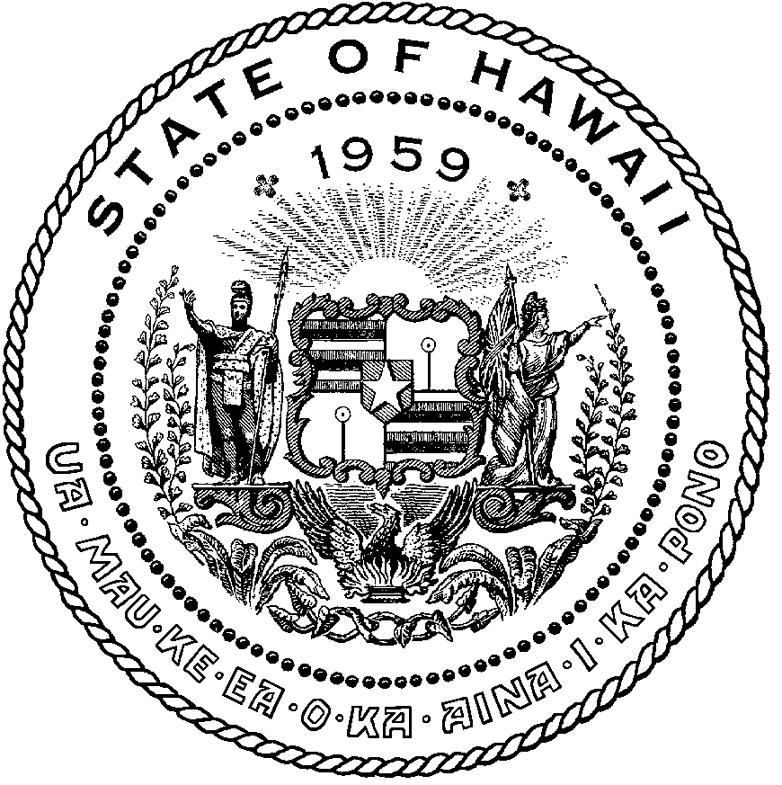 | AUDREY HIDANO  COMPTROLLER  Ka Luna Hoʻomalu Hana Laulā  MEOH-LENG SILLIMAN  DEPUTY COMPTROLLER  Ka Hope Luna Hoʻomalu Hana Laulā
STATE OF HAWAII

Communications, Technical, and Finance Meeting (Combined Meeting)
Virtual Meeting – Microsoft Teams
Call-In: 808-829-4853; Phone Conf ID: 797 962 398#

Physical location: Kalanimoku Bldg. Room 426, 1151 Punchbowl St., Honolulu, is available to the public and is guaranteed to be connected to the remote virtual meeting.

PLEASE CLICK LINK BELOW TO JOIN MICROSOFT TEAMS MEETING

Join on your computer, mobile app or room device
Click here to join the meeting
Meeting ID: 284 407 499 25
Passcode: RUL8v9
Download Teams | Join on the web

Contact for Meeting information/testimony submission; Courtney Tagupa, State of Hawaii, Enhanced 911 Board, Room 411A, 1151 Punchbowl Street, Honolulu, HI 96813
courtney.tagupa@hawaii.gov

"In the event that audiovisual communication cannot be maintained by all participating board members and quorum is lost, the meeting will automatically be recessed for 30 minutes, during which time an attempt to restore audiovisual communication will be made. If such attempt to restore is unsuccessful within said 30 minutes, all board members, members of the public, staff and other interested individuals shall log on again to the Teams link on this Notice, whereby audio communication will be established for all participants and the meeting will continue. If reconvening the meeting is not possible because audio and visual communication cannot be re-established, the meeting will be terminated."

Thursday, December 8, 2022
9:00 am – 12:00 pm

Agenda

- Call to Order, Public Notice
- Public Testimony Will Be Taken on All Agenda Items as Those Items Occur During the Meeting
- Roll Call, Quorum
- Review and Approval of November’s Meeting Minutes
- Committee Updates by Committee Chairs
  - Communications Committee – Davlynn Racadio
    - No Updates to Report
  - Technical Committee – Shawn Kuratani
    - Discussion on Transition to Next Generation 911 to include Next Steps and Request for Proposal
    - Technical Committee Chair requests to add Chief Hara to Technical Subcommittee
    - Approval to add additional member of Technical Subcommittee to attend Next Generation 9-1-1 Standards & Best Practices Conference in the amount of $3500
  - Educational Investigative Committee – (Chair of Educational Investigative Committee Undecided)
  - Advisory Committee – Everett Kaneshige
    - Status Update on Telecommunicator Reclassification Project and Legislative Outreach
  - Finance Committee – Lisa Hiraoka
    - Review of Monthly Y-T-D (Year to Date) Cash Flow
    - Approval of Additional Funds for Department of Budget and Finance Fiscal Year 2021-2022 Assessment.
    - Approval to add additional member of Technical Subcommittee to attend Next Generation 9-1-1 Standards & Best Practices Conference in the amount of $3500
- Public Service Answering Point Status Updates on Recruitment and other Personnel Issues
  - Kauai Police Department – E. Ke Kalani
    - Update on Recruitment Process/Strategies and Personnel Training
    - Update on Personnel Issues and Vacancies
  - Oahu Police Department – Aaron Farias
    - Update on Recruitment Process/Strategies and Personnel Training
    - Update on Personnel Issues and Vacancies
  - Oahu Fire Department – Shawn Kuratani
    - Update on Recruitment Process/Strategies and Personnel Training
    - Update on Personnel Issues and Vacancies
  - Oahu Emergency Medical Services – Lorrin Okumura, Diana Chun, Frannie Chung
    - Update on Recruitment Process/Strategies and Personnel Training
    - Update on Personnel Issues and Vacancies
  - Maui Police Department – Davlynn Racadio
    - Update on Recruitment Process/Strategies and Personnel Training
    - Update on Personnel Issues and Vacancies
  - Molokai Police Department – Davlynn Racadio
    - Update on Recruitment Process/Strategies and Personnel Training
    - Update on Personnel Issues and Vacancies
  - Hawaii Police Department – Robert Fujitake
    - Update on Recruitment Process/Strategies and Personnel Training
    - Update on Personnel Issues and Vacancies
  - Hawaii Fire Department – Vern Hara
    - Update on Recruitment Process/Strategies and Personnel Training
    - Update on Personnel Issues and Vacancies
- Items for Discussion, Consideration, and Action
  - 911 Timeline Update (Akimeka)
    - Status Reports on All Counties
  - Additional Items Proposed by Meeting Attendees
- Announcements
  - Future Virtual Meeting Dates/Times (9:00AM-12:00PM)
    - Thursday, January 12, 2023 (Combined Meeting)
    - Thursday, February 9, 2023 (Combined Meeting)
    - Thursday, March 9, 2023 (Combined Meeting)
  - Future Conference Dates (3 Months of Advanced Approval Required)
    - Next Generation 9-1-1 Standards & Best Practices Conference, January 16-19, 2023, Clearwater, FL
    - 911 GTW (Goes to Washington) Conference, February 26-March 1, 2023, Arlington, VA
    - Pictometry/EagleView, April 24-27th, San Antonio, TX
  - Additional Announcements from Meeting Attendees
- Open Forum: Public comment on issues not on the Committee Meeting Agenda
- Adjournment

