|  |  |  |
| --- | --- | --- |
| DAVID Y. IGE GOVERNOR |  | CURT T. OTAGURO COMPTROLLER  **AUDREY HIDANO**  DEPUTY COMPTROLLER |
|  | **STATE OF HAWAII**  **Communications, Technical, and Finance Meeting (Combined Meeting)**  **Thursday, September 8, 2022**  **9:00 am – 12:00 pm** |  |

**MEETING MINUTES**

**Communications Committee Members Present:** Davlynn Racadio (MPD) Chair, Thalia Burns (HPD), Lavina Taovao (KPD)

**Technical Committee Members Present:** Shawn Kuratani (HFD) Chair, Thalia Burns (HPD), Tony Ramirez (Akimeka), Tony Velasco (DIT), Kenison Tejada (FirstNet)

**Technical Committee Members Not Present:** David Miyasaki (KPD)

**Finance Committee Members Present:** Lisa Hiraoka (Consumer Advocate Designee) Chair, Edward Fujioka (EMS), Todd Omura (CIO Designee), Aaron Farias (HIPD)

**Finance Committee Members Not Present:** Kenneth Bugado (HIPD)

**Staff:** Courtney Tagupa (E911), Royce Murakami (E911), Stella Kam (AG)

**Guests:** Francis Alueta (HT), Stephen Courtney (C&C of Honolulu), Frannie Chung (EMS), Diana Chung (EMS), Stacy Domingo (EMS), Robert Fujitake (HIPD), Liz Gregg (ATT), Vern Hara (HIFD), Shon Geoffrey (EMS), Alex Hacker (Eagle View), Julie Heimkes (Winbourne), John Holland (ATT), Glenn Kobashigawa (HT), Kurt Lager (OSL), Kimberly Lee (HPD), Rebecca Lieberman (Charter), Lorrin Okumura (EMS), Corey Shaffer (Verizon), Valerie Taylor (Intrado), Ruth Zipfel (Eagle View), Sherryan Murphy (EMS), Kim Caplan (PREPARED).

1. Call to Order, Public Notice

**The meeting was called to order by the Chair. Public notice was given**.

1. Public Testimony Will Be Taken on All Agenda Items as Those Items Occur During the Meeting
2. Roll Call, Quorum

**A roll call was taken, and a quorum was present for all three committees.**

1. DEMO of “PREPARED” - Kim Caplan

**Shawn Kuratani stated that one of his personnel that attended the APCO Conference brought to his attention a program called PREPARED. He stated that it is a program that integrates with Rapid SOS that allows video to be seen by the dispatcher from callers that are directly on the scene of the incident. Furthermore, stated that this service is free of charge and will be having Kim Caplan present a demonstration of the program.**

**Kim Caplan began her presentation and stated that her company is called PREPARED and her program that she will be presenting today is called LIVE. She stated that when you log into the Rapid SOS Sandbox you will also be logged into PREPARED Live. From the menu you will be able to see any incident that you were on with Rapid SOS and will automatically populate the phone number into the incident. The application also allows you to send a message to the caller and have the caller open a link with or without Rapid SOS.**

**Features of Application:**

* **Live Stream Video**
* **Video Recording**
* **Live Chat**
* **Predetermined Canned Messages**
* **Link Allows Caller to Send Photos and Videos**
* **Capability to Blur and Darken Screen**
* **Customization of Nature Codes**
* **Requests Location of Caller**
  + **Continuous Ping on Location**
* **Downloadable Report with Timestamps**

**Kim Caplan stated that all the services are free and no additional hardware needs to be added to the agencies’ existing system. She added the caller does not need to download an application as well because the program is entirely web-based. In terms of storage, she stated that service is free and will store all documents according to each agency’s retention period. Geoff Shon asked Kim Caplan how they offer this service for free. Kim Caplan responded that due to investors and wanting to expand their portfolio, this allows them to offer this service for free. In the future other products would be offered at a price however, PREPARED Live will remain at no cost. Shawn Kuratani asked Kim Caplan if the training and the policy help was included in the initial set up of the program or if there is a separate charge. Kim Caplan responded that it is included in the initial set up of the program. She added that during the set up they will help train personnel as well as set nature codes, canned messages, and writing policies for each agency.**

**Geoff Shon asked Kim Caplan if this program is a standalone application or is Rapid SOS required and if the GPS is acquired directly from the cellphone itself. Kim Caplan responded that it is a standalone application, and that the GPS is acquired directly from the cellphone itself. Francis Alueta asked Kim Caplan how the information is secured on the cloud and how does the PSAP move that information to a more secured evidence storage. Kim Caplan responded that the information is stored on the AWS for their cloud and if the information wanted to be stored in a more secure location the report is downloadable as well as the links.**

**Shawn Kuratani asked Kim Caplan if their personnel would be able to stream these videos or recordings to their vehicles. Kim Caplan responded stating that videos from callers that were recorded prior to calling dispatch can be sent out so that their personnel can determine the necessary equipment needed. However, she added that being able to share the live stream feature to dispatch is still in the process. Shawn Kuratani asked Kim Caplan if she could share how many counties have started using PREPARED Live. Kim Caplan responded stating currently as of March 2022 a total of 260 PSAPs have begun using this program. Shawn Kuratani asked Kim Caplan if she could share the possible charges for services that would be available in the future. Kim Caplan responded stating that integrating the program into the CAD would be a service that they would charge. She added that there are other features that they are working on but does not want to make any commitments to these features at this time.**

**Kenison Tejada asked Kim Caplan if the unions were accepting of this technology. Kim Caplan responded that unions have been accepting of the technology and she has not had any problems. Edward Fujioka asked Kim Caplan a question regarding privacy policies and if there are any safeguards from allowing someone to send a link or photo/video to themselves or others. Kim Caplan responded stating that the privacy policies would be driven by each agency. Furthermore, stated that they do have encryption for security purposes.**

1. Review and Approval of August’s Meeting Minutes

**Corey Shaffer motioned to approve the August 2022 Meeting Minutes. Rebecca Lieberman seconded the motion. A voice vote was taken, and the motion was approved unanimously.**

1. Committee Updates by Committee Chairs
   1. Communications Committee – Davlynn Racadio
      1. Problem that occurred on August 23, 2022, with island wide outage.

**Davlynn Racadio stated that Hawaiian Electric informed them that the island wide power outage for Maui County occurred at 2:45AM. However, their department was not affected till 3:10AM. Furthermore, stated that their power supply or UPS did not activate. After a short period of time the CAD system and power supply was restored however, the UPS and radios remained offline. Regarding the CAD system some radio positions were down one to multiple monitors. During this time the positions were able to answer the phone, but the callers could not hear them. To restore all equipment, it took approximately two hours. In conclusion, Davlynn Racadio stated that she wanted to share her experiences with the Board so that all the agencies can be prepared if a problem such as this occurs again. She also stated that if this problem occurs again, she will ensure that she has her IT Department report to her and confirm that all equipment is connected in the appropriate area. Lastly, stated to have her personnel check on their UPS monthly.**

* + 1. HTEL update on switching issue with the backup phones that occurred on July 18, 2022

**Davlynn Racadio asked that Hawaiian Telcom give an update of the problem that occurred on July 18, 2022. Francis Alueta responded stating that the problem that occurred when switching over to the black phones was due to moving from a permissive 10-digit dialing to a mandatory 10-digit dialing. Currently a script has been developed to speed up the process to move the calls or reroute the calls to the backup phones. However, during the process of updating the script and testing it, the actual test was done when the problem occurred. During the test some errors were found in the script and were fixed during the test. Additional testing was performed recently with all the PSAPs on the routing. During those tests, feedback was given, and some errors were found but were not confirmed that those errors were on the script.**

* 1. Technical Committee – Shawn Kuratani
     1. DEMO of “PREPARED” that integrates with RAPIDSOS. Brings E911 video into the call center (Free service including video storage)

**Refer to DEMO of “PREPARED”**

* + 1. Adjustment to reimbursement request for ARCserver: HFD requested 2,600. Actual quote came in over at $2,879.58. ArcServers allow the CAD data to be synced with Backup CAD.

**Thalia Burns stated that a motion must be made to approve to this request and move the item to the Finance Committee. Corey Shaffer motioned to approve and send this request to the Finance Committee. Francis Alueta seconded the motion. A voice vote was taken, and the motion was approved unanimously.**

* + 1. Discussion on Transition to NG 911 to include Next Steps and RFP
       1. Update for Technical Subcommittee for consult to draft RFP

**Shawn Kuratani stated that the Subcommittee meeting took place on September 2, 2022, with all counties represented. During the meeting the Subcommittee wanted clarification on the legislative verbiage if Hawaiian Telcom is required to provide 911 services for the State of Hawaii. Clarification is needed because if Hawaiian Telcom is required to be the provider for 911 services for the State of Hawaii an RFP would not need to be obtained. Stella Kam will be following up on finding clarification on this item for the Subcommittee.**

**Thalia Burns inquired if the Subcommittee has more than two board members. Shawn Kuratani responded stating that there is only one board member on the Subcommittee so Permitted Interaction Group is not needed. Kenison Tejada stated if SPO was contacted regarding the cooperative purchase that would allow the other counties to roll over services. Shawn Kuratani responded stating that they will reach out to SPO when clarification on the legislative verbiage is received.**

**Stella Kam asked for clarification if the RFP is for the consultant and not for the actual services. Shawn Kuratani responded stating that is correct, however if the services are accounted for through Hawaiian Telcom he believes a consultant is not necessary. Stella Kam responded stating that she is unsure and would follow up if the services provided through the PUC Tariff supports NG911 and if it would be subject to PUC regulation. Francis Alueta stated that Winbourne stated that because NG911 is based on IP which is not regulated, the PUC doesn’t have jurisdiction over it. Corey Shaffer added that Francis Alueta’s statement is consistent with his recollection and understanding that the PUC is not able to regulate IP based companies. Francis Alueta added that he feels the question is more about the service of 911 under the jurisdiction rather than how it is offered. He also states that the 911 service is very different from the 911 or E911 service and what it can deliver. Shawn Kuratani responded stating that the Subcommittee discussed this and wanted to wait for clarification to avoid problems in the future.**

**Stephen Courtney stated that he attended a presentation during the APCO Conference that presented a guide to NG911 and how to prepare an RFP and procure consultant services as well as how to evaluate an RFP. Furthermore, he added that he would like to offer his support to the Subcommittee. Shawn Kuratani responded stating that he would welcome his participation to the group.**

* 1. Educational Investigative Committee – TBD

**No Update currently for the Educational Investigative Committee.**

* 1. Advisory Committee – Everett Kaneshige (Davlynn Racadio)
     1. 911 Telecommunicator Reclassification Update

**Davlynn Racadio is speaking on behalf of Everett Kaneshige. She stated that the Matrix has been completed that shows a combination of both civilian, fire department, and EMS. The matrix separates each of those groups by tab and gives all information needed about each group such as union association and the amount of personnel.**

* + 1. 911 Information PowerPoint

**Davlynn Racadio is speaking on behalf of Everett Kaneshige. She stated that the PowerPoint is currently being revised and will be shared with the Board as soon as it is completed.**

* 1. Finance Committee – Lisa Hiraoka
     1. Review of Monthly Y-T-D Cash Flow

**Lisa Hiraoka reviewed the monthly YTD Cash Flow**

**Total Receipts: $1,033,082**

**Total Disbursements: ($158,291)**

**Net Receipts/(Disbursements): $874,791**

**Net Bank Balance: $33,503,460**

**Executive Director added that this is the first month where he has experienced total receipts over $1,000,000. This was caused by the surcharge collections and interest income increasing. In conclusion, stated that receipts of surcharge collections could exceed $12,000,000 in the future.**

**Lisa Hiraoka stated in respect cash flow she asked the Executive Director to prepare a schedule of outstanding encumbrances that date as far back as Fiscal Year 2015. She recommended the Executive Director to prepare this schedule to determine the status of these encumbrances from the PSAPs and if it would be possible to release these funds back to the E911 Board. This would need to be determined to request a ceiling increase due to expected increases in expenses for NG911. Another reason that the encumbrances are being evaluated is that it is growing, and, in the future, it will be important for the Board to show the legislature that the Board is mindful of the funds and accounts for all the encumbrances as well.**

* + 1. Discussion to raise the E911 Legislative Spending Ceiling for FY 2024 & 2025

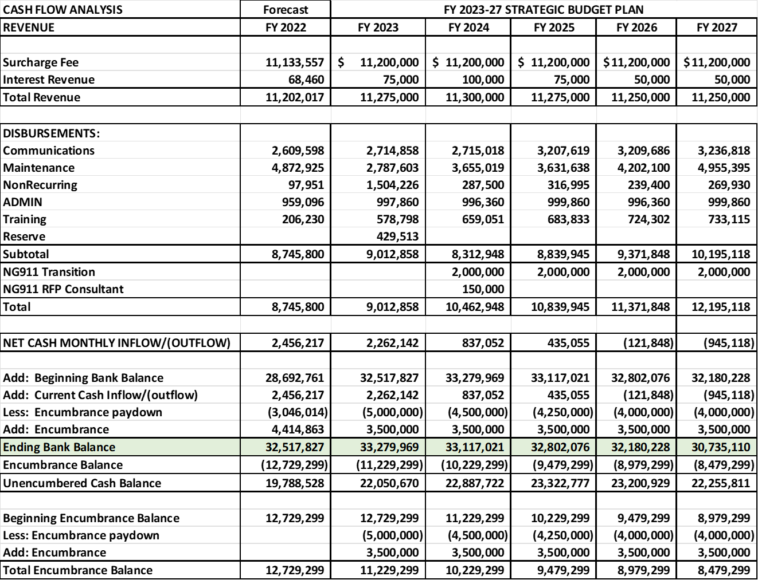

**Lisa Hiraoka stated that she would like to ask the Board for approval to increase legislative spending ceiling for Fiscal Years 2024 & 2025 to $11,000,000. Referring to the Strategic Budget Plan FY 2023-2027 in Fiscal Years 2024 & 2025 show expected expenditures over $11,000,000 however, the current budget ceiling is at $9,012,858. She stated that only those two years be increased because the Board would not know the full extent of the expenses for the NG911 Transition.**



**Lisa Hiraoka asked the Executive Director to speak on possible room for expenses on the current budget. Executive Director stated that one of the issues that was addressed regarding the $2,000,000 budgeted for the NG911 Transition. He stated that most of the funding exists now will be transitioned over into NG911 shown in the table titled NG911 Equipment Redundancy.**

**MSAG FY 2024 Total: $1,504,710**

**MSAG FY 2025 Total: $1,531,676**

**Viper FY 2024 Total: $1,822,185**

**Viper FY 2025 Total: $1,822,185**

**Trunk Charges FY 2024 Total: $1,198,796`**

**Trunk Charges FY 2025 Total: $1,198,796**

**Total of All Items FY 2024: $4,525,691**

**Total of All Items FY 2025: $4,552,657**

**CAD Maintenance Total: $1,271,070**

**Executive Director stated that the total of all these redundancies would be $5,796,761. Furthermore, if you factor in the funding budgeted for the NG911 Transition the total increases to $7,796,761. Referring to Deliverable 6 from Winbourne they state the high-end cost of the transition would be around $7,500,000. Based on current projections the Board would be able to fund the high-end solution stated by Winbourne.**

**Winbourne Deliverable 6**

**Annual Estimated Costs**

**Low End: $2,800,000**

**High End: $5,500,000**

**Nonrecurring Estimated Costs**

**Low End: $ 1,050,000**

**High End: $1,325,000**

**Additional Cost Items**

**Low End: $390,000**

**Hight End: $660,000**

**Total Solution Cost**

**Low End: $4,240,000**

**High End: $7,485,000**

**Lisa Hiraoka added that while current projections would be able to fund the high-end solution, she believes that the legislative spending ceiling should be increased. The Executive Director stated that he agrees with Lisa Hiraoka.**

**Tony Ramirez asked a question regarding the recently signed HB 2171 by Governor Ige which created a new law enforcement agency for the state. Tony Ramirez stated that he attended a meeting which discussed the new agency joining E911 or NG911 system to allow them to receive emergency calls. Furthermore, he added if any budgetary considerations have been given to this new agency with the signing of HB 2171. Executive Director stated that he would investigate the signing of the new bill. Lisa Hiraoka asked Tony Ramirez if there is any information about the scope of the funds of the new agency. Tony Ramirez responded by stating the idea was that the new law enforcement agency would integrate into one of the counties 911 system and branch out to the other counties over time. During the meeting, it was not decided if they would have a primary or secondary PSAP. In conclusion, he stated that if this agency were to join E911 or NG911 and start receiving 911 calls for the state it would impact the budget.**

**Aaron Farias added that Tony Ramirez was asked by HPD to attend the meeting to give a briefing on the migration of the State Department of Law Enforcement that would begin in January 2023. In that discussion, the geographic location of this new entity would most likely begin on Oahu and then branch out to other counties. This entity would consist of the existing Department of Public Safety, Department of Attorney General, and Investigators. Aaron Farias added that he met with the State Department of Law Enforcement and gave a presentation of their PSAP at the Joint Traffic Management Center on August 23, 2022. In conclusion, he added that he would speak to the retired HPD Assistant Chief Doug Aton to determine a timeline for the implementation of the State Department of Law Enforcement. Lisa Hiraoka asked Aaron Farias if there was any funding mechanism included into the new bill. Aaron Farias stated that he believes there is but is unable to verify that because he has not read the bill in its entirety.**

**Lisa Hiraoka stated that if the decision to increase the legislative ceiling for FY 2024-2025 should be moved to next month’s meeting until the board can discuss HB 2171. Thalia Burns stated based on the information received from DAGS that the board should move forward in the process of increasing the legislative ceiling to ensure all timelines are met. Lisa Hiraoka stated that she briefly reviewed the HB 2171, and it states that $900,000 in general funds is appropriated for FY 2022-2023. She added that she agrees that the board can move forward with the process of increasing the legislative ceiling.**

**Lisa Hiraoka asked for a motion from the Finance Committee to increase the legislative ceiling for FY 2024-2025 to $11,000,000. Edward Fujioka motioned to increase the legislative ceiling for FY 2024-2025 to $11,000,000. Corey Shaffer seconded the motion. A voice vote was taken, and the motion was unanimously approved.**

**Lisa Hiraoka asked for a motion to amend the Finance Committee agenda to include a discussion to increase reimbursement request for HFD’s ARCServer. Edward Fujioka motioned to amend the agenda. Francis Alueta seconded the motion. A voice vote was taken, and the motion was unanimously approved.**

**Lisa Hiraoka asked for a motion to approve the increase in reimbursement request for HFD’s ARCServer from $2600 to $2879.58. Edward Fujioka motioned to approve the increase. Francis Alueta seconded the motion. A voice vote was taken, and the motion was unanimously approved.**

1. PSAP Status Updates on Recruitment and other Personnel Issues
   1. Kauai KPD – Stacy Perreira

**Lavina Taovao on behalf of Stacy Perreira stated that KPD lost one dispatcher due to transferring to the Records Department. Currently only have two dispatchers training with two vacant positions.**

* 1. Oahu PD – Aaron Farias

**Nathan Wharton on behalf of Aaron Farias stated that currently they have four dispatchers in radio training however, recently had two personnel resign because they felt that they were not confident in that position. Regarding vacancies currently at the same amount and working on filling four of their ERO positions by November 2022. In conclusion, the recruitment team is actively hiring to fill those positions.**

* 1. Oahu HFD – Shawn Kuratani

**Shawn Kuratani stated that HFD has nothing to report at this time.**

* 1. Oahu EMS – Lorrin Okumura, Diana Chun, Frannie Chung

**Lorrin Okumura stated that he would like to thank both HFD and HPD dispatch centers for helping EMS gain information on the catastrophic incident that happened on August 24th, 2022. The situation is still under investigation to determine the root of the problem that occurred. Regarding the dispatch center they are currently going through a mandatory training refresher for all dispatchers. Furthermore, this training will cover all procedures and policies for the JTMC and Priority Dispatch Pro QA.**

* 1. Maui PD – Davlynn Racadio

**Davlynn Racadio stated that MPD has obtained a list of applicants. No further updates on recruitment and personnel issues currently.**

* 1. Molokai PD – Davlynn Racadio

**Refer to Maui PD above.**

* 1. Hawaii PD – Robert Fujitake

**Robert Fujitake stated that currently six new PCO1 positions will begin employment on September 16, 2022. A realistic job preview for interested candidates for the position was conducted and a total of five applicants have scheduled interviews. In conclusion, with the addition of those six hires the total number of vacancies will be at ten.**

* 1. Hawaii FD – Vern Hara

**Stacy Domingo on behalf of Vern Hara stated that four of five trainees left prior to finishing training. The remaining trainee was promoted after she completed her training however, resigned shortly after. Currently they are 4 trainees that have started that HFD will be moving forward with.**

1. Items for Discussion, Consideration, and Action
   1. 911 Timeline Update
   2. Others
2. Announcements
   1. Future Virtual Meeting Dates/Times (9:00AM-12:00PM)
      1. Thursday, October 13, 2022 (Combined Meeting)
      2. Thursday, November 10, 2022 (Combined Meeting)
      3. Thursday, December 8, 2022 (Combined Meeting)
   2. Future Conference Dates (3 Months of Advanced Approval Required)
      1. 911 GTW Conference, February 26-March 1, 2023, Arlington, VA
      2. Pictometry/EagleView, April 24-27th, San Antonio, TX
   3. Others
3. Open Forum: Public comment on issues not on the Committee Meeting Agenda

**There was no public comment on issues on the agenda.**

1. Adjournment

**Tony Ramirez motioned to adjourn the meeting. Corey Shaffer seconded the motion. A voice vote was taken, and the adjournment was unanimously approved. The meeting was adjourned.**