|  |  |  |
| --- | --- | --- |
| DAVID Y. IGE GOVERNOR |  | CURT T. OTAGURO COMPTROLLER  **AUDREY HIDANO**  DEPUTY COMPTROLLER |
|  | **STATE OF HAWAII**  **Enhanced 911 Board Meeting**  **Friday, August 12, 2022**  **9:00 am – 12:00 pm** |  |

**MEETING MINUTES**

**Board Members Present:** Thalia Burns (HPD),Nani Blake (T-Mobile), Kenneth Bugado (HIPD), Aaron Farias (HIPD), Lisa Hiraoka (Consumer Advocate Designee), E. Kalani Ke (KPD), Todd Omura (CIO Designee), Rebecca Liberman (Charter), Corey Shaffer (Verizon), Keola Tom (MPD)

**Board Members Not Present:** Francis Alueta (HT), Stephen Courtney (C&C of Honolulu), Liz Gregg (ATT), Gregg Okamoto (MPD)

**Staff:** Courtney Tagupa (E911), Royce Murakami (E911), Stella Kam (AG)

**Guests:** Diana Chung (EMS), Edward Fujioka (EMS), Robert Fujitake (HIPD), Everett Kaneshige (DOD), Shawn Kuratani (HFD), Kurt Lager (OSL), Patrick Leddy (LCC), Lorrin Okumura (EMS), Stacy Perreira (KPD), Davlynn Racadio (MPD), Tony Ramirez (Akimeka), Valerie Taylor (Intrado), Tony Velasco (DIT), Ruth Zipfel (Eagle View)

1. Call to Order, Public Notice

**The meeting was called to order by the Chair. Public notice was given.**

1. Public Testimony Will Be Taken on All Agenda Items as Those Items Occur During the Meeting
2. Roll Call, Quorum

**A roll call was taken, and a quorum was present for the Board Meeting.**

1. Review and Approval of July’s Meeting Minutes

**Rebecca Liberman motioned to approve the July Meeting Minutes. Lisa Hiraoka seconded the motion. A voice vote was taken, and the motion was approved unanimously.**

1. Committee Updates by Committee Chairs
   1. Communications Committee – Davlynn Racadio
      1. Failure that occurred on July 18, 2022

**Davlynn Racadio stated that she has no further updates. Refer to Joint**

**Committee Minutes.**

* 1. Technical Committee – Shawn Kuratani
     1. Update on Central Square reimbursement and request that payment be processed through the City’s E911 Account

**Shawn Kuratani stated that he has no further updates. Refer to Joint Committee Minutes.**

* + 1. Discussion on Transition to NG 911

**Shawn Kuratani stated that he is requesting the Board give clarification on what is expected after the meeting is conducted with all the agencies regarding the RFP. Thalia Burns stated the first RFP is for the consultant and that Shawn Kuratani is tasked with gathering all the PSAPs and conclude on who will participate in the dedicated committee. Furthermore, he must notify the Chair if there will be more than two board members in that group. If there are more than two members a Permitted Interaction Group (PIG) would be formed. Corey Shaffer added that a PSAP needs to be identified as the agency that will take the lead effort to communicate with SPO to obtain information and guidance on the creation of a joint contract to execute the second RFP.**

**Other than the clarification, Shawn Kuratani stated he has no further updates. Refer to Joint Committee Minutes.**

* 1. Educational Investigative Committee – TBD

**Refer to Joint Committee Minutes.**

* 1. Advisory Committee – Everett Kaneshige
     1. 911 Telecommunicator Reclassification Update
     2. 911 Information PowerPoint
     3. RADO Class Update
     4. ITSL Class: November 1-4, 2022
     5. FCC CSRIC VIII Public Safety Benefits Workgroup Update

**Refer to Joint Committee Minutes.**

* 1. Finance Committee – Lisa Hiraoka
     1. Review of Monthly Y-T-D Cash Flow
     2. Review and Approval of Winbourne’ s Deliverable 7 for $45,728

**Refer to Joint Committee Minutes.**

1. PSAP Status Updates on Recruitment and other Personnel Issues
   1. Kauai KPD – Stacy Perreira

**Stacy Perreira stated she has no further updates. Refer to Joint Committee Minutes.**

* 1. Oahu PD – Aaron Farias

**Aaron Farias stated he has no further updates. Refer to Joint Committee Minutes.**

* 1. Oahu HFD – Shawn Kuratani

**Shawn Kuratani stated that he has no further updates. Refer to Joint Committee Minutes.**

* 1. Oahu EMS – Lorrin Okumura, Diana Chun, Frannie Chung

**Lorrin Okumura stated that he has no further updates. Refer to Joint Committee Minutes.**

* 1. Maui MPD – Davlynn Racadio

**Davlynn Racadio stated that she has no further updates. Refer to Joint Committee Minutes.**

* 1. Molokai MPD – Davlynn Racadio

**Davlynn Racadio stated that she has no further updates. Refer to Joint Committee Minutes.**

* 1. Hawaii PD – Robert Fujitake

**Robert Fujitake stated that he has no further updates. Refer to Joint Committee Minutes.**

* 1. Hawaii FD – Vern Hara

**Vern Hara is not present currently to share update for HIFD.**

1. Executive Director’s Report
   1. FY 2023-27 Strategic Budget Plan
      1. Review and Approval of FY 2023-27 Strategic Budget Plan

**Executive Director stated that he will be reviewing the changes that were required from the August Meeting as well as reviewing some of the major changes to items in the Strategic Budget Plan.**

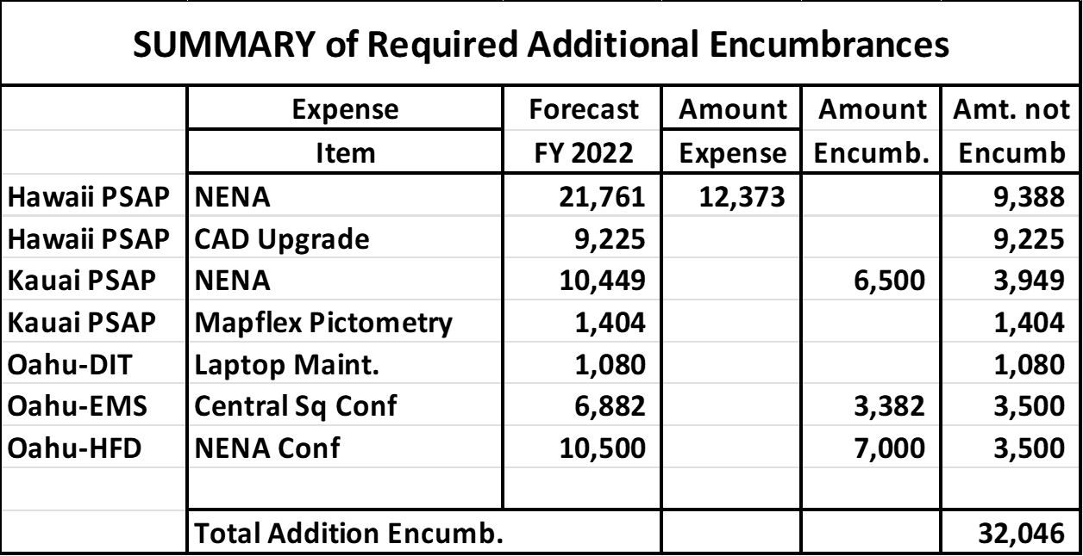

**Executive Director stated that in the table shown above the items that needed to be encumbered but were not included totaled $32,046.**



**Executive Director stated for HIPD the CAD Maintenance for Fiscal Year 2022 was reduced from $250,000 to $9,225 because that item was encumbered in Fiscal Year 2015. The amount of $9,225 was requested as additional funds to cover the remaining payment. Thalia Burns stated that the $9,225 did not go through Board approval for additional funding over their initially requested contract. Kenneth Bugado responded and stated that he was not aware of the additional funds that were needed and asked that the additional funding go through the Board for approval.**



**Executive Director stated for MPD the CAD Maintenance for Fiscal Year 2022 was reduced from $361,600 to $90,594. In the table shown above for Fiscal Year 2022 it was reduced to $29,847 which is the remaining amount needed to cover the remaining payment. Thalia Burns stated that MPD does not have an issue because they are within their initial asking for CAD Maintenance.**



**Executive Director stated for DIT the Imagery License Agreement for Fiscal Year 2022 the initial request was for $209,000 however there was an existing encumbrance of $960,089. The request of $209,000 was redundant. Thalia Burns stated that she understands the adjustment however, she is recommending that the Executive Director provide the Finance Chair a list of the encumbrances for each agency. This list should include the initial amount requested, the total of encumbrances used and the remaining balance.**



**Executive Director stated in the previous meeting the main concern that the Board had was the amounts set for the NG911 Transition starting in Fiscal Year 2024-2027 was understated. He noted that however, during the transition to NG911 there will be a reduction in existing expenses from Communication and Maintenance expenses which is currently included in the Strategic Budget Plan. Furthermore, stated that without an RFP it would be difficult to calculate how much the expenses would be reduced and included in the NG911 Transition. Another change to the Strategic Budget Plan includes the addition of $150,000 for the NG911 Consultant. In conclusion, the Executive Director feels that this Strategic Budget Plan satisfies the need of the PSAPs.**

**Davlynn Racadio asked the Executive Director if the funds that are set aside for the NG911 Transition is a sufficient cushion for the Board to start the process for the state. Executive Director responded that personally he feels that it will be sufficient but until the RFP is created and responses are received from potential venders he cannot commit to any amount at this time. Lastly stated that there are sufficient existing funds that would transfer if needed for the NG911 Transition.**

**Thalia Burns stated that starting from Fiscal Year 2024 and moving forward that the budget would be over the ceiling and if the Board should be asking for an increase as soon as possible. Executive Director responded that he is aware and can move forward with the process of increasing the ceiling with the Board’s permission however, he would prefer not to increase the ceiling. He mentioned that a permanent increase could be possible however, due to the cash flow being inconsistent he is not comfortable going that route. In a situation where expenditures were to increase gradually, he believes that it would be more receptive to implement a permanent increase. Lisa Hiraoka asked the Executive Director when should we start the process to request an increase and what the deadline would be. The Executive Director responded that he would start the process of increasing the ceiling as soon as possible and the deadline to submit would be before the beginning of the new session. Lisa Hiraoka stated that she wants to ensure that this process is completed in a timely manner so that there is no issue the following years. Thalia Burns stated that due to the projections being over the ceiling in the Strategic Budget Plan for Fiscal Years 2024-2027 the process to increase the ceiling must be completed and submitted.**



**Executive Director stated that the Cash Flow Analysis shows a reduction in cash inflow in Fiscal Year 2026-2027 which includes carrying forward an unencumbered balance of $22,255,811 for Fiscal Year 2027. He also stated the amount that is being carried forward is being reduced each year without the benefit of increased revenue. In response to this he assumed that he would increase the encumbrance data to reduce the amount of carryover for the encumbrances to cause a greater ending balance in future years. In conclusion, stated that without any increase, the revenue will slowly decrease over time causing the unencumbered cash balance to be $8,479,299 in Fiscal Year 2027.**

**Thalia Burns asked for a motion to approve the Strategic Budget Plan for Fiscal Year 2023-2027 eliminating the line item from HIPD of $9,225 and leaving it open for HIPD to come to the Board if the funding is needed to complete their CAD Project. Lisa Hiraoka motioned to approve the Strategic Budget Plan for Fiscal Year 2023-2027 as amended. Corey Shaffer seconded the motion. A voice vote was taken, and the motion was approved unanimously.**

1. Items for Discussion, Consideration, and Action
   1. 911 Timeline Update
   2. Others
2. Announcements
   1. Future Virtual Meeting Dates/Times (9:00AM-12:00PM)
      1. Thursday, September 8, 2022 (Combined Meeting)
      2. Thursday, October 13, 2022 (Combined Meeting)
      3. Thursday, November 10, 2022 (Combined Meeting)
      4. Thursday, December 8, 2022 (Combined Meeting)
   2. Future Conference Dates (3 Months of Advanced Approval Required)
      1. 911 GTW Conference, February 26-March 1, 2023, Arlington, VA
   3. Others
3. Open Forum: Public comment on issues not on the Committee Meeting Agenda

**There was no public comment on issues on the agenda.**

1. Executive Session
   1. Discussion of Personnel Matters
2. Adjournment

**Todd Omura motioned to adjourn the meeting. Kenneth Bugado seconded the motion. A voice vote was taken, and the adjournment was unanimously approved. The meeting was adjourned.**