DAVID Y. IGE  GOVERNOR | 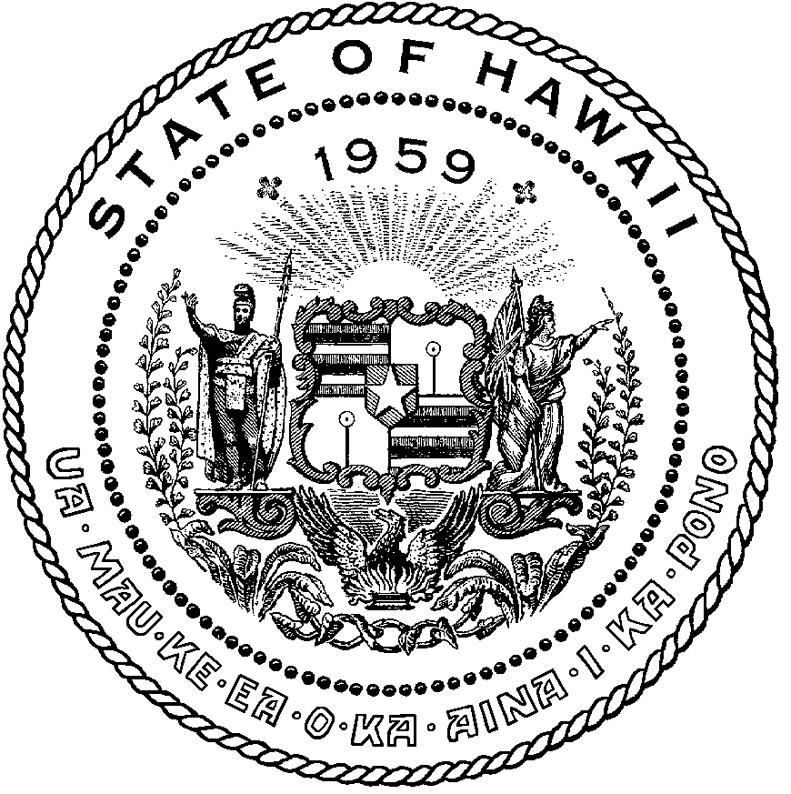 | CURT T. OTAGURO  COMPTROLLER  AUDREY HIDANO  DEPUTY COMPTROLLER
STATE OF HAWAII

Enhanced 911 Board Meeting
Virtual Meeting – Microsoft Teams
Call-In: 808-829-4853; Phone Conf ID: 748 965 909#

Physical location: Kalanimoku Bldg. Room 426, 1151 Punchbowl St., Honolulu, is available to the public and is guaranteed to be connected to the remote virtual meeting.

Contact for Meeting information/testimony submission; Courtney Tagupa, State of Hawaii, Enhanced 911 Board, Room 411A, 1151 Punchbowl Street, Honolulu, HI 96813

"In the event that audiovisual communication cannot be maintained by all participating board members and quorum is lost, the meeting will automatically be recessed for 30 minutes, during which time an attempt to restore audiovisual communication will be made. If such attempt to restore is unsuccessful within said 30 minutes, all board members, members of the public, staff and other interested individuals shall log on again to the Teams link on this Notice, whereby audio communication will be established for all participants and the meeting will continue. If reconvening the meeting is not possible because audio and visual communication cannot be re-established, the meeting will be terminated."

Thursday, August 12, 2022
9:00 am – 12:00 pm

Agenda

- Call to Order, Public Notice
- Public Testimony Will Be Taken on All Agenda Items as Those Items Occur During the Meeting
- Roll Call, Quorum
- Review and Approval of July’s Meeting Minutes
- Committee Updates by Committee Chairs
  - Communications Committee – Davlynn Racadio
    - Failure that occurred on July 18, 2022
      - Hawaiian Telcom’s input and the effects on our PSAPs
  - Technical Committee – Shawn Kuratani
    - Update on Central Square reimbursement and request that payment be processed through the City’s E911 Account
    - Discussion on Transition to NG 911
  - Educational Investigative Committee – TBD
  - Advisory Committee – Everett Kaneshige
    - 911 Telecommunicator Reclassification Update
    - 911 Information PowerPoint
    - RADO Class Update
    - ITSL Class: November 1-4, 2022
    - FCC CSRIC VIII Public Safety Benefits Workgroup Update
  - Finance Committee – Lisa Hiraoka
    - Review of Monthly Y-T-D Cash Flow
    - Review and Approval of Winbourne’ s Deliverable 7 for $45,728
- PSAP Status Updates on Recruitment and other Personnel Issues
  - Kauai KPD – Stacy Perreira
  - Oahu PD – Aaron Farias
  - Oahu HFD – Shawn Kuratani
  - Oahu EMS – Lorrin Okumura, Diana Chun, Frannie Chung
  - Maui MPD – Davlynn Racadio
  - Molokai MPD – Davlynn Racadio
  - Hawaii PD – Robert Fujitake
  - Hawaii FD – Vern Hara
- Executive Director’s Report
  - FY 2023-27 Strategic Budget Plan
    - Review and Approval of FY 2023-27 Strategic Budget Plan
- Items for Discussion, Consideration, and Action
  - 911 Timeline Update
  - Others
- Announcements
  - Future Virtual Meeting Dates/Times (9:00AM-12:00PM)
    - Thursday, September 8, 2022 (Combined Meeting)
    - Thursday, October 13, 2022 (Combined Meeting)
    - Thursday, November 10, 2022 (Combined Meeting)
    - Thursday, December 8, 2022 (Combined Meeting)
  - Future Conference Dates (3 Months of Advanced Approval Required)
    - 911 GTW Conference, February 26-March 1, 2023, Arlington, VA
  - Others
- Open Forum: Public comment on issues not on the Committee Meeting Agenda
- Executive Session
  - Discussion of Personnel Matters
- Adjournment

