Storage of Inactive Paper Records
State Records Center, Records Management Branch,
Archives Division, Department of Accounting and General Services
729-B Kakoi Street, Honolulu, Hawaii 96819
Telephone: 831-6770
Email: recordscenter@hawaii.gov

TABLE OF CONTENTS:
I. RECORDS STORAGE Pages 1-6
II. RECORDS RETRIEVAL AND REFILE Pages 7-8
III. RECORDS DESTRUCTION Pages 9-10

I. RECORDS STORAGE
A. Storage Eligibility Requirements:
State Records Center (SRC) provides off-site storage of inactive non-permanent paper records. Storage, retrieval/refile and destruction services for general-funded programs of the executive branch are FREE OF CHARGE.

As authorized by Comptroller’s Memorandum 2017-08, the Department of Education, the University of Hawaii, Judiciary, non-state agencies, and non-general funded programs of the executive branch will be charged storage, retrieval and refile, and destruction fees.

Records Storage
Storage | $ .50 per 15” L x 12” W x 10” H box / per month
Microfilm | $ .50 per 16mm reel / per year
Microfiche  (up to approximately 500 fiches) | $ 1.00 per 12” L x 6.26” W x 4.75” H box / per year
Records Retrieval/Refile
Retrieval | $ 2.25 per retrieval
Refile | $ 1.25 per refile
Microfilm or microfiche retrieval  (up to approximately 84-16mm reels) | $ 3.00 per 15” L x 12” W x 10” H box (film) or 12” L x 6.26” W x 4.75” H box (fiche)
Microfilm or microfiche refile  (up to approximately 84-16mm reels) | $ 3.00 per 15” L x 12” W x 10” H box (film) or 12” L x 6.26” W x 4.75” H box (fiche)
Records Destruction
Destruction with retrieval fee | $ 4.00 per 15” L x 12” W x 10” H box
Retrieve for destruction by agency | $ 1.00 per 15” L x 12” W x 10” H box
Permanent removal of microfilm or microfiche (up to approximately 84-16mm reels) | $ 4.00 per 15” L x 12” W x 10” H box
Destruction of microfilm or microfiche with retrieval fee  (up to approximately 84-16mm reels) | $14.00 per 15" L x 12" W x 10" H box (film) or 12" L x 6.26" W x 4.75" H box (film)
Destruction of microfiche with retrieval fee (up to approximately 500 fiches) | $14.00 per 12” L x 4.25” W x 6.26” H box

All stored paper records must be:
- Non-current non-permanent paper records.
- Listed on an approved records retention and disposition schedule. General and department specific retention schedules can be downloaded from: http://ags.hawaii.gov/archives/about-us/records-management/records-retention-and-disposition-schedules/
- Records with remaining retention requirement of two years or more at time of delivery.
- Insect-free. The depositing agency must certify that the records are insect-free or were fumigated prior to transfer.

B. Packing Instructions:
- Use only Heavy Duty Bankers box with these specifications:
- Dimensions: 15”L x 12”W x 10”H
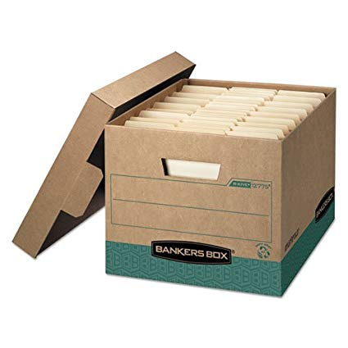
- Heavy-duty, triple end, double side, double bottom
- Stacking strength 800-850 lbs.
- Examples:
  - R-Kive 743 (pack of 10)
  - R-Kive 724 (black)
  - R-Kive 7241 (green)
  - R-Kive 7242 (red)
  - R-Kive 7243 (blue)
  - R-Kive 725 (wood grain)
  - R-Kive 12775 (recycled)
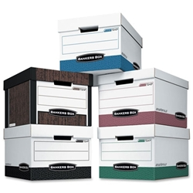
2. Pack boxes
- Make sure the records are free of bugs.
- Legal size files should face right on the long side of the box.
- Letter size records should face front on short end of the box.
- Pack records in the same order as they are filed in the agency.
- All records in each box must have the same destruction date.
- Leave about 1-inch space in each box to facilitate retrieval.
- DO NOT FILL TOP PORTION OF THE BOX WITH FILES FILED HORIZONTALLY. It makes retrieval of files for you more challenging for SRC staff.
- If boxes are not full and have more than 25% open space, fill gap with crumpled paper so files won’t curve.
- Boxes should weigh no more than 35 pounds.
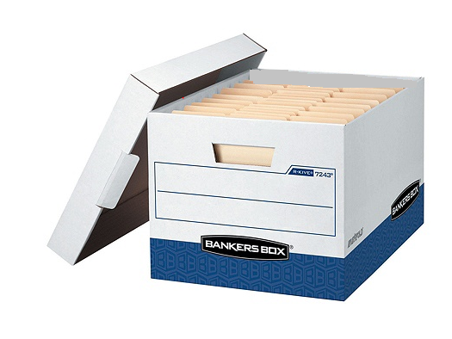
Front
1 inch space
3. Complete box labels
- Leave top label line for Records Center use.
- Write information directly on bottom label area.
- Make sure this is the designated front of the box (letter size folders are facing front, legal size folders are facing right).
- DO NOT USE ADHESIVE LABELS OR ATTACH PAPER LABELS WITH TAPE. These will fall off over time.
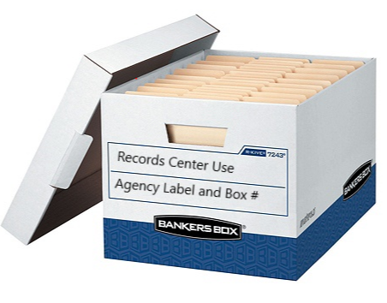

4. Repair boxes as needed.
- When repairing torn boxes, use masking tape.
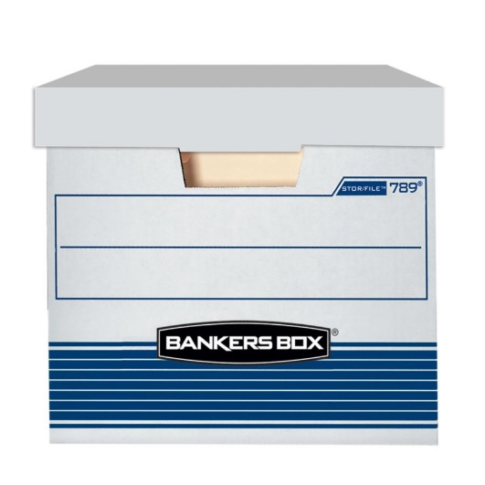
- DO NOT USE SHINY TAPE because you will be unable to write information over this type of tape.
5. Stack boxes for loading, transporting and delivery to SRC.
- Boxes should be delivered stacked in reverse numerical order and stacked no more than “4 high.”
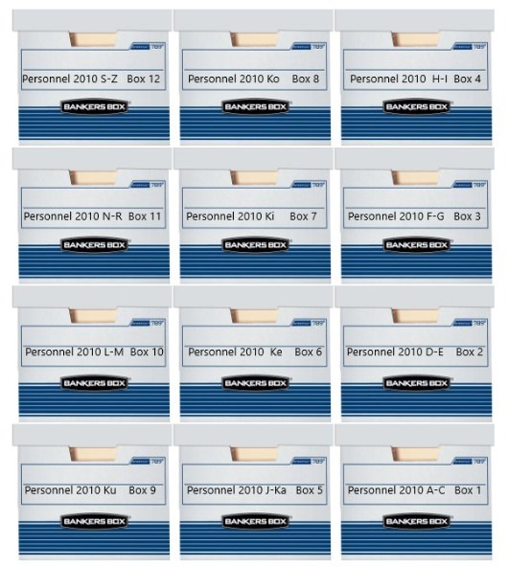
- Please instruct your delivery personnel.
C. Records Transmittal Requirement:
- List records to be stored at the SRC on an ARM-5, Records Transmittal and Shelf List Form. Form instructions and sample can be downloaded from: http://ags.hawaii.gov/archives/about-us/records-management/records-management-forms/
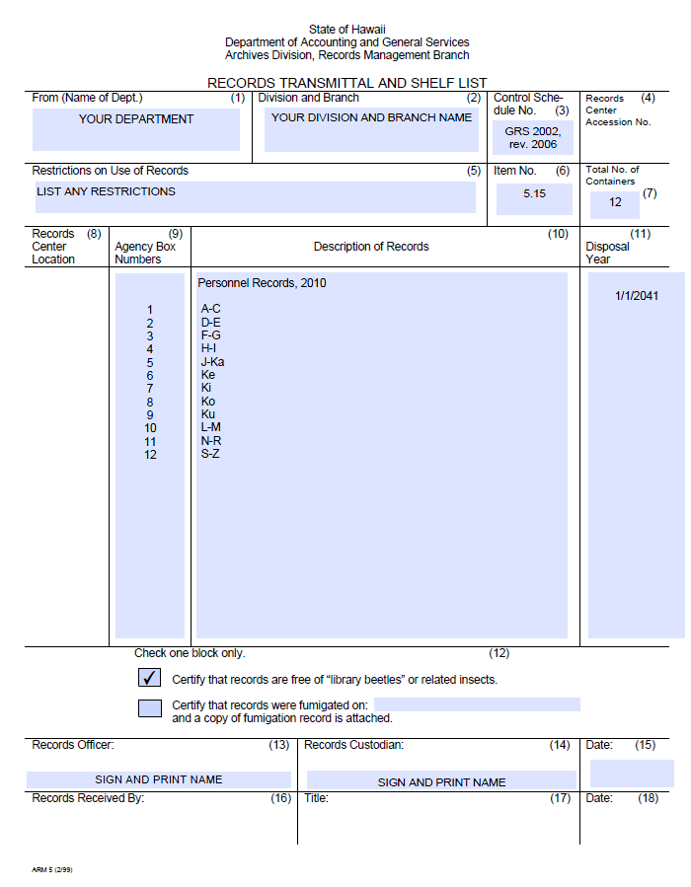
- Depositing agency must maintain a comprehensive index to boxed contents.
- If you are new to sending records to SRC, draft an ARM-5 form and send to recordscenter@hawaii.gov for review before getting the form signed by the Departmental Records Officer and the Records Custodian. Everyone else, send ARM-5 to recordscenter@hawaii.gov.
- After ARM-5 is reviewed and approved, SRC staff will contact agency to schedule delivery. Each agency must arrange for delivery of its own records to SRC, including paying for any moving costs. The State messenger will not deliver boxes.
II. RECORDS RETRIEVAL AND REFILE
To request access to your records:
- Download and complete a Records Request Form from: https://ags.hawaii.gov/archives/about-us/records-management/records-management-forms/
- Use information from completed ARM-5 forms and detailed listing to complete request.
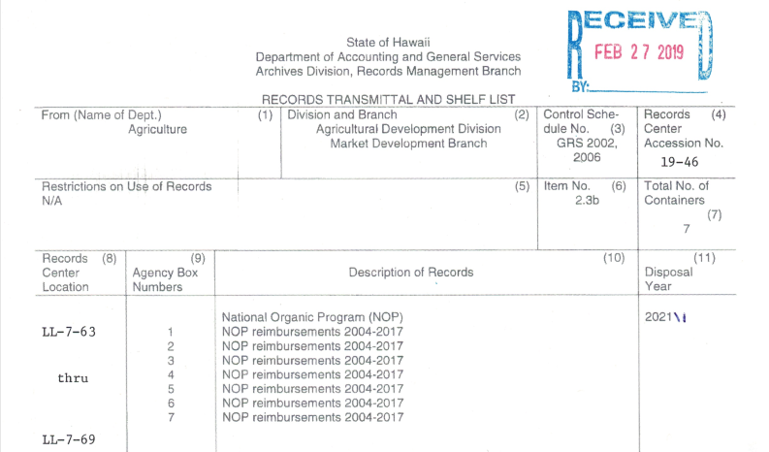
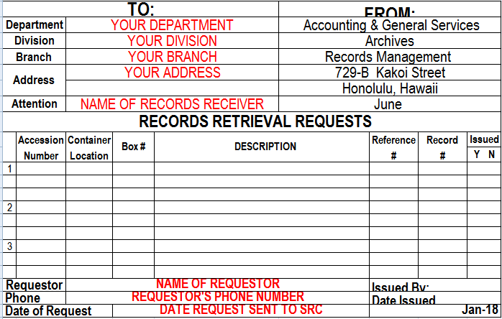
File number, title, etc.

- Send completed request form via email attachment to recordscenter@hawaii.gov. Your files will be sent via state messenger unless you tell us that you want to come to SRC to pick up or to view the files at SRC.
- Return files via messenger to State Records Center when done. SRC staff will refile your records.
III. RECORDS DESTRUCTION
A. Records Custodian’s Responsibilities:
When records destruction dates are imminent, SRC staff will send ARM-4, Notice of Records Eligible for Destruction Forms to the records custodians and departmental records officers. It is the records custodian’s responsibility within 10 working days to:
- Review the records listed on the form and determine if:
  - Okay to destroy – sign and date the form.
  - Extension is necessary due to litigation, audit, or change in laws affecting records retention – write down the reason for the extension request and the new destruction date.
  - Records are needed back at the office – write down “Recall” and list the boxes you need to recall. If some boxes are okay to destroy, write down “Okay to destroy” and list boxes that are approved for destruction.
- Sign and date form. Scan the form(s) and send to recordscenter@hawaii.gov.
- If forms are signed electronically, send to recordscenter@hawaii.gov.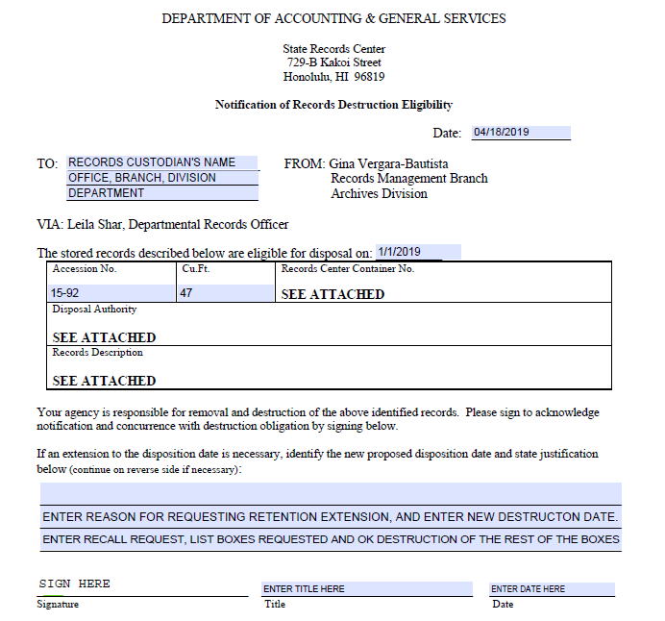
B. Archives Division Responsibilities:
1. Records approved for destruction:
After approved records are destroyed, the destruction date and method will be entered by SRC staff on the ARM-4 form and a digital copy will be sent to the records custodian and departmental records officer.
2. Retention extended:
When retention extension is approved, the ARM-5 form on file and the database entry at SRC will be updated to reflect the extension.
3. Records recalled:
SRC staff will schedule with the records custodian the pickup date for the recalled records. Records will not be accepted back into SRC because retention requirement at this point is less than two years. It is the agency’s responsibility to destroy these records when no longer needed by the agency.

