Employee Self Service (ESS) Change Report
Navigation: Main Menu > State of Hawaii > Reports > ESS Changes Report
- Enter a Run Control ID
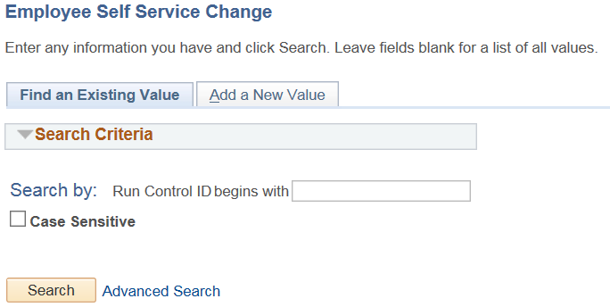
- When running these reports for the first time you will need to create a Run Control ID for each report. Once you have done this you will not need to create it again. To do so click on the Add a New Value Tab.
  - Note when running the report for a second time and going forward, you will just need to click the search button to bring you to the Run Control page.

Report Request Parameters
- Enter the From Date and the To Date
- Select the Actions of data you would like to review
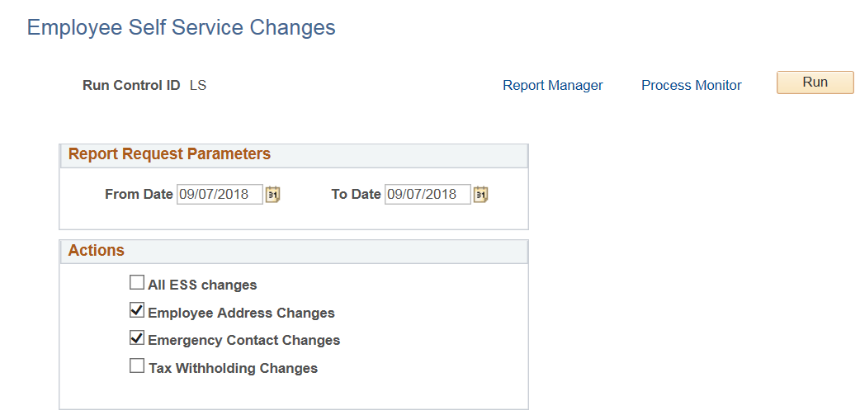
- Click the Run Button

On the Process Scheduler Request
- Make sure the Type is WEB and the format is TXT
- Click OK
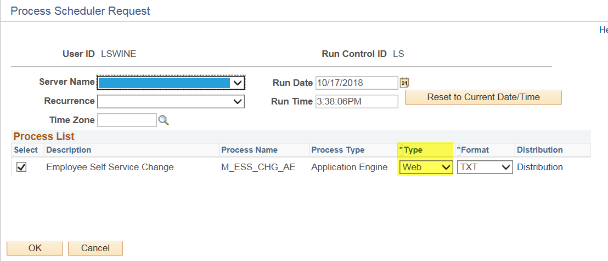
- You can click on Process Monitor to review the status of the report being completed. Once the process has gone to “Success” and “Posted” you are able to see the results and move forward.
- Navigate to Main Menu > Reporting Tools > Report Manager
- Click on the Administration Tab
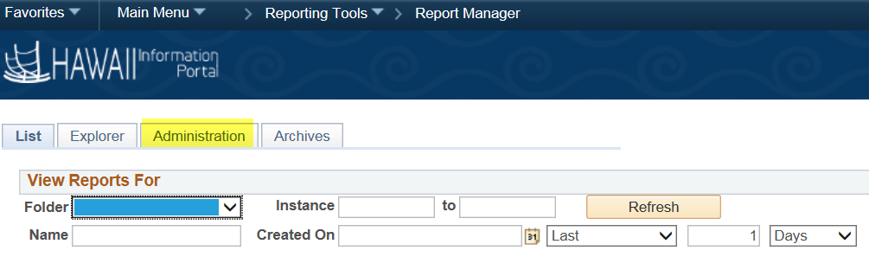
- Click on the File name in the Description filed.
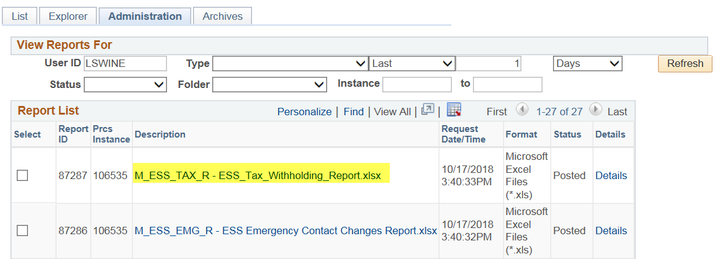
- Click on the file name again on the Report Detail popup to open your results in Excel.
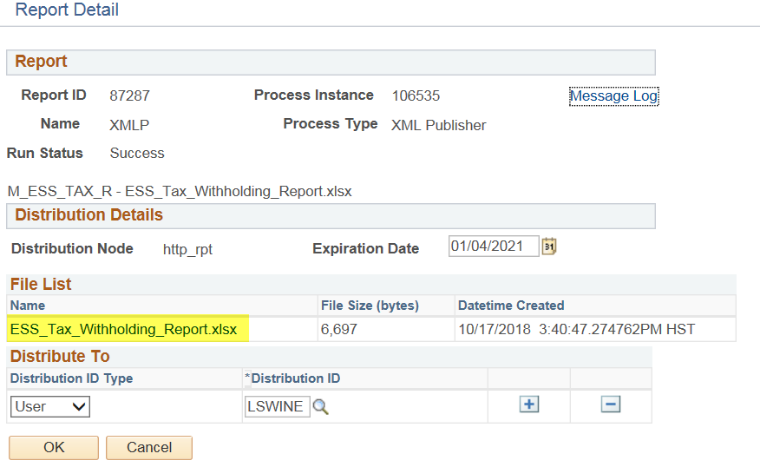
Note: if the file comes up blank that means that no transactions were entered during the dates selected.
