- In Google Chrome, click on the three dots in upper right hand corner, and click on Bookmarks, and click on Bookmark manager. (Shortcut is Ctrl + Shift + O)
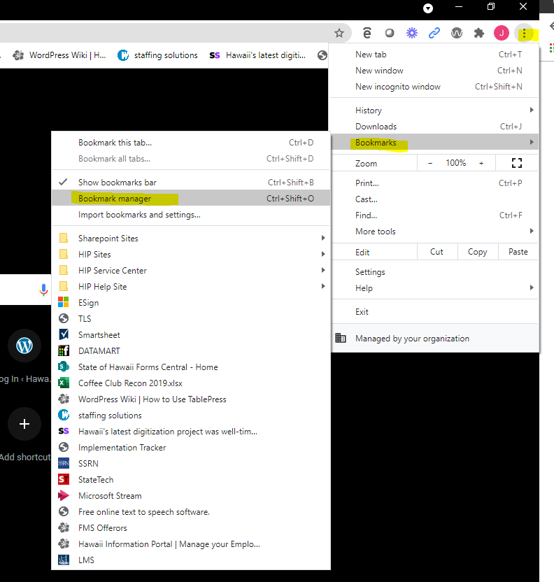

2) Look for the three dots in the upper right hand corner and click.
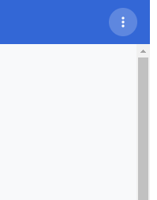
3) Click Add new bookmark
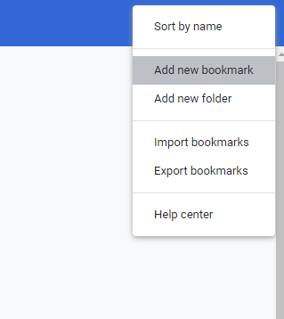

4) Name it what you want.
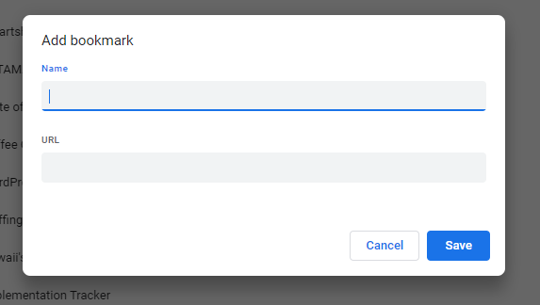

5) Right click on this link https://execsso.hip.hawaii.gov/, select copy hyperlink. Paste in URL box above. Click Save button.
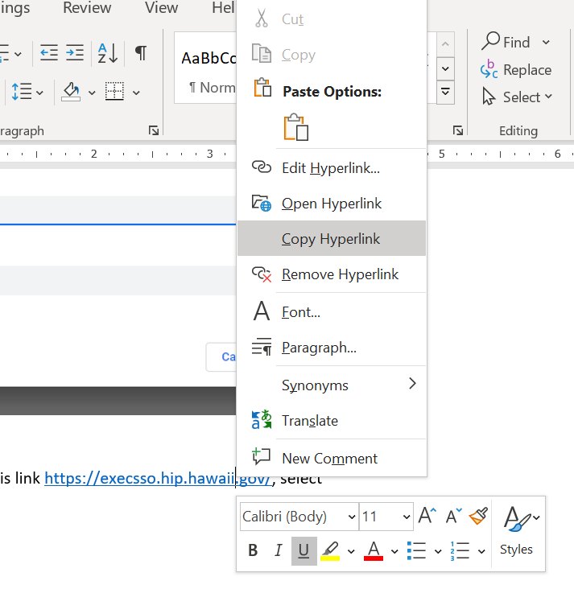
6) Your new HIP SSO bookmark will appear on your Google Chrome bookmarks bar. You can arrange your bookmarks by going back to the Chrome bookmark manager.

