Time & Leave – Entering Time for Hourly Employees
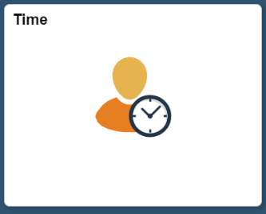
Below is the process for an hourly employee to enter time in HIP. Employees needing to complete these timesheets will be hourly, casual, emergency hire, or 89-day hire employees. Hourly employees will need to enter all time for payment.
- Time Tile: Employee will start on the Employee Self Service screen and click on the Time tile.

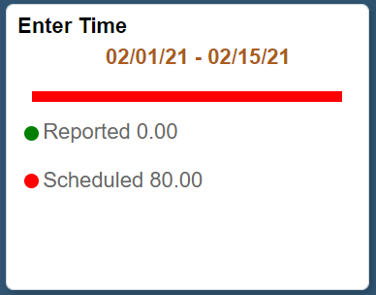
- Enter Time: Click on Enter Time tile to enter all time worked and other Time Reporting Codes (TRCs) onto the timesheet.

- Employee will then enter the In, Lunch, In (from lunch) (if the employee has a lunch break), and Out times onto their timesheet for all times that they have worked.
  - Note: Time Reporting Codes (TRCs) available to employees will be dependent on what Bargaining Unit they are a part of.
4. Click ‘Submit’ to submit your timesheet for supervisory approval.
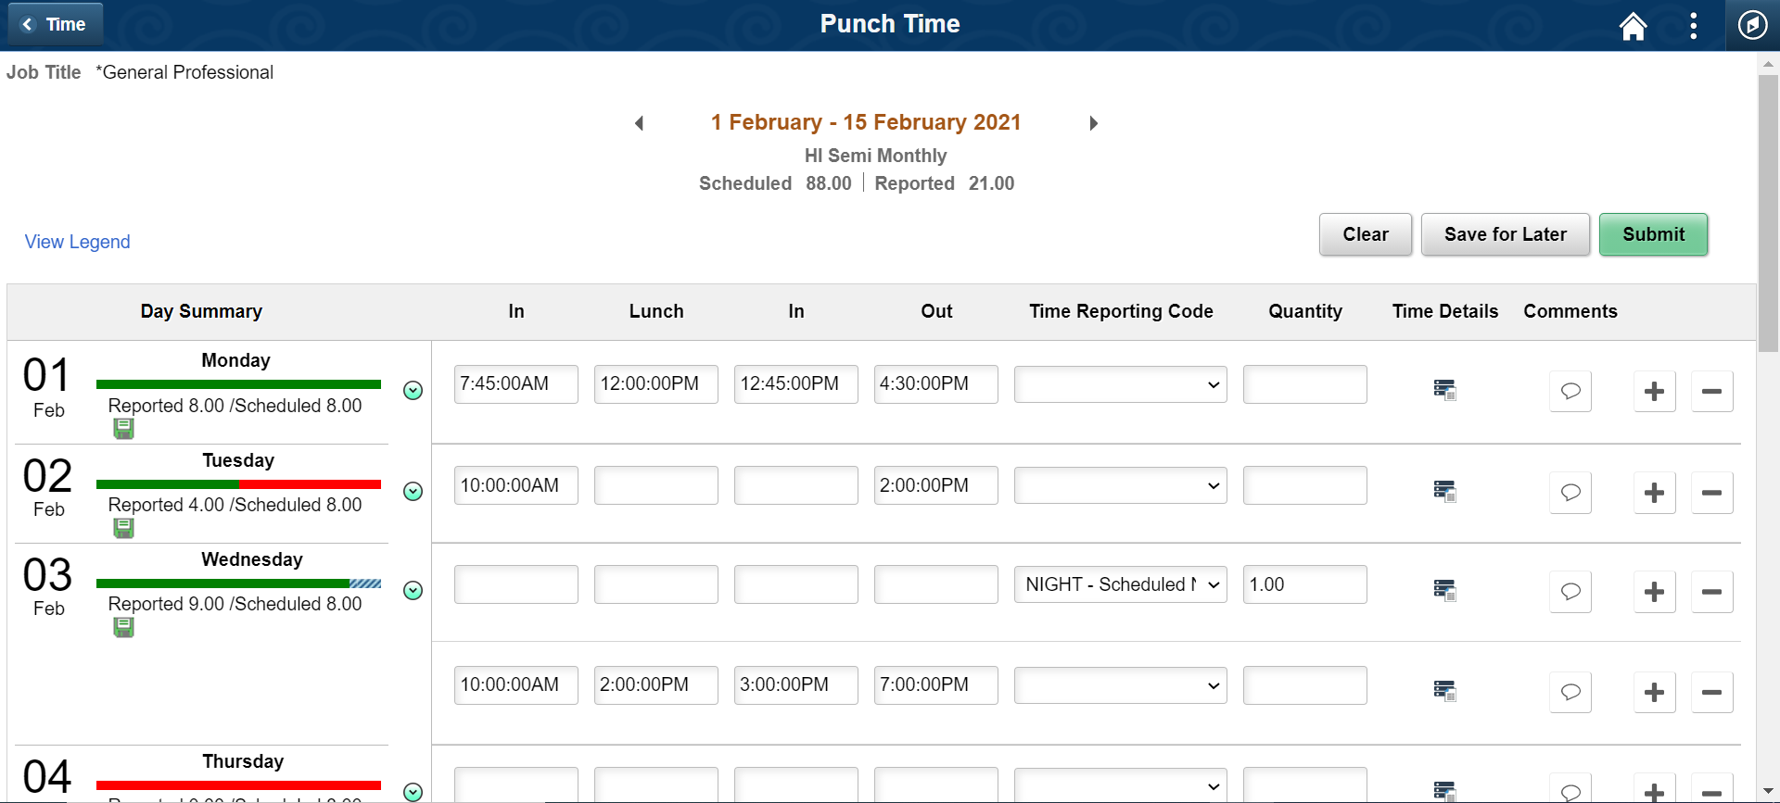
3c. Click on the “+” sign to insert a new row, then enter the appropriate Time Reporting Code (TRC) and Quantity. You will also need to enter a comment with the time and reason for the code.
Note: Upon submission, your Day Summary will update with the hours that you have entered.
3b. If additional time for differentials, etc. are needed, enter your regular work time on one row.
3a. If you did not take a lunch break, then just enter the In and Out times.
3. Enter the In, Lunch, In (from lunch), and Out times for all times that you have worked.

