101 – ESS Salaried (Elapsed) Time Entry
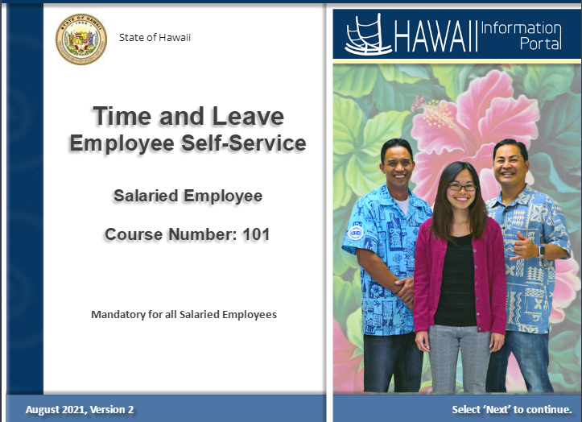

Duration


This course will take approximately one to two hours.

You can complete it all today or by sections.

It’s really up to you.

You can take the training how it best fits in your schedule.

Preparation
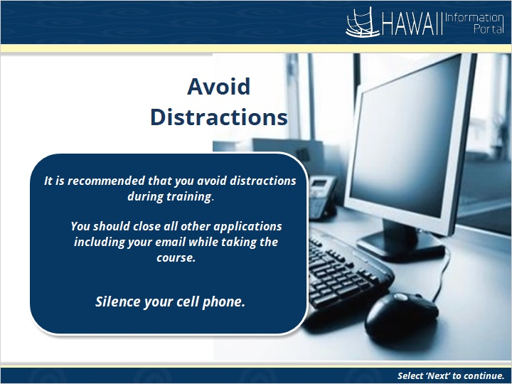

It is recommended that you avoid distractions during your training session.

You should close all other applications including your email while taking the course and silence your cell phone.

Table of Contents


- Course Objectives
- Key Terminology
- Timesheet Tour
- Salaried Reporting Key Points
- Enter Salaried Time
- Overtime/Comp Time Requests
- Need Help?

Course Objectives
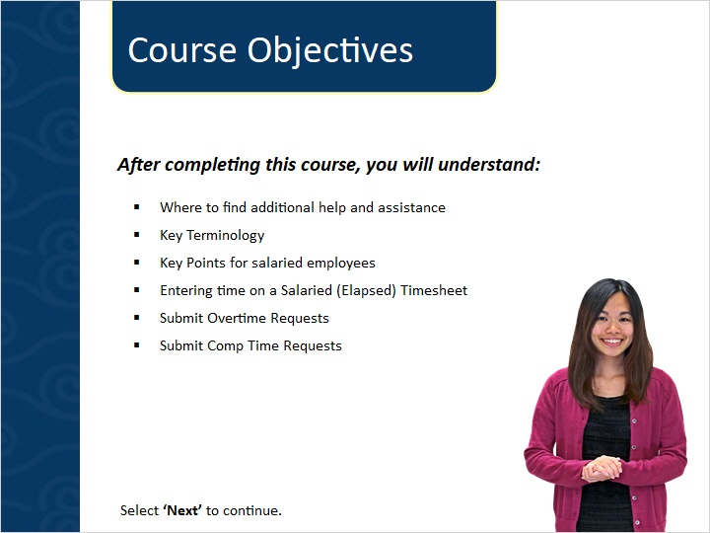

After completing this course you will understand how to:

- Where to find additional help and assistance
- Key Terminology
- Key Points for salaried employees
- Entering time on a Salaried (Elapsed) Timesheet
- Submit Overtime Requests
- Submit Comp Time Requests

Need Help?
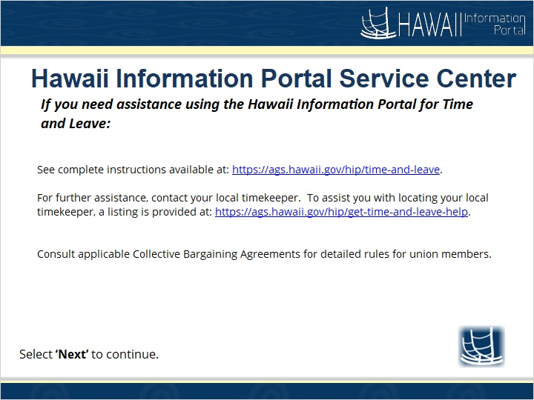

See complete instructions available at: https://ags.hawaii.gov/hip/time-and-leave.

For further assistance, contact your local timekeeper. To assist you with locating your local timekeeper, a listing is provided at: https://ags.hawaii.gov/hip/get-time-and-leave-help.

Consult applicable Collective Bargaining Agreements for detailed rules for union members.

Key Terminology
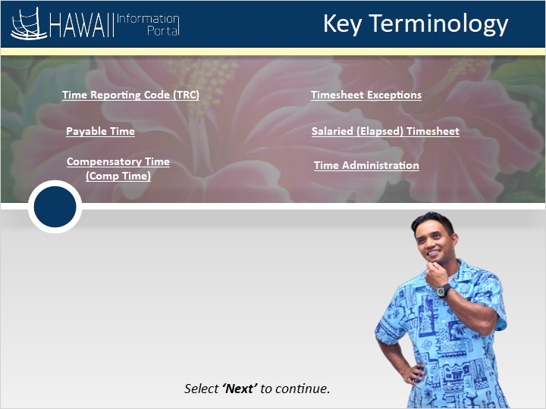

Time Reporting Code (TRC)
Payable Time
Compensatory Time (Comp Time)
Timesheet Exceptions
Salaried (Elapsed) Timesheet
Time Administration

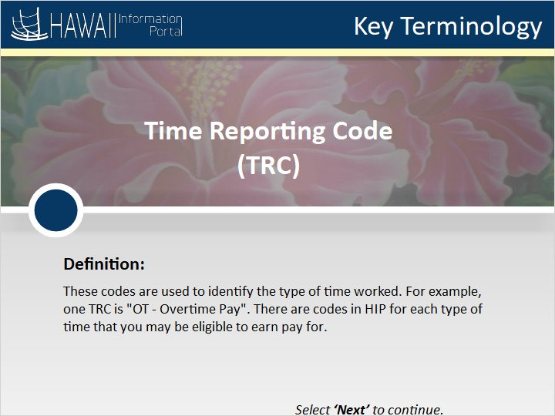

Definition:
These codes are used to identify the type of time worked.
For example, one TRC is “OT - Overtime Pay”. There are codes in HIP for each type of time that you may be eligible to earn pay for.

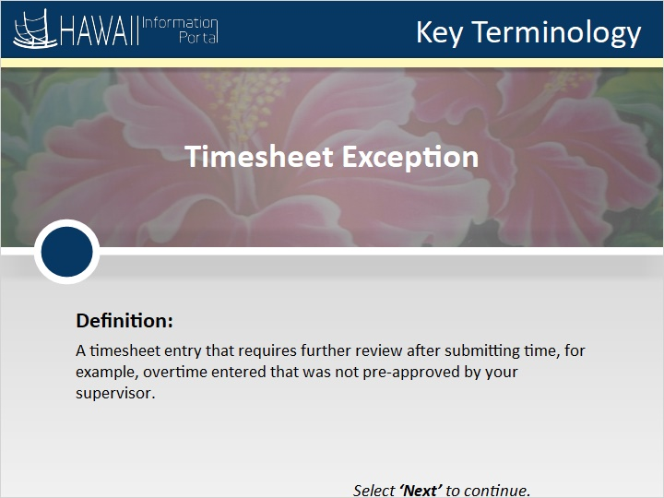

Definition:
A timesheet entry that requires further review after submitting time, for example, overtime entered that was not pre-approved by your supervisor.

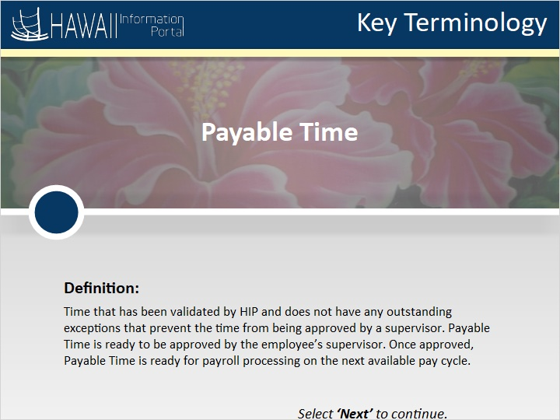

Definition:
Time that has been validated by HIP and does not have any outstanding exceptions that prevent the time from being approved by a supervisor. Payable Time is ready to be approved by the employee’s supervisor. Once approved, Payable Time is ready for payroll processing on the next available pay cycle.

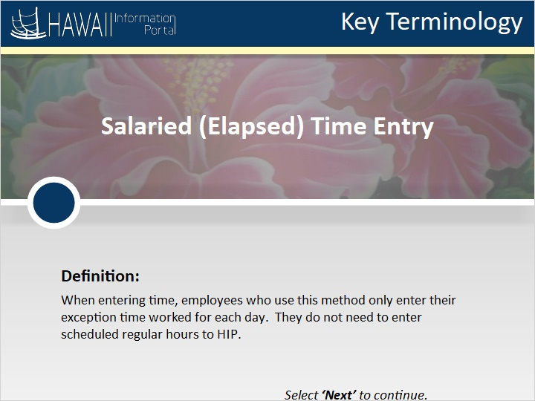

Definition:
When entering time, employees who use this method only enter their exception time worked for each day. They do not need to enter their scheduled regular hours to HIP.

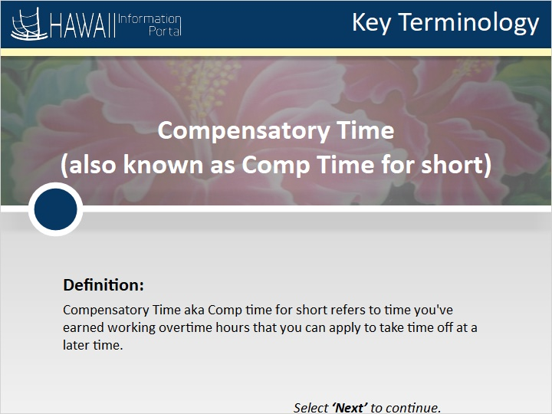

Definition:
Compensatory Time, also known as Comp time for short, refers to time you've earned working overtime hours that you can apply to take time off at a later time.

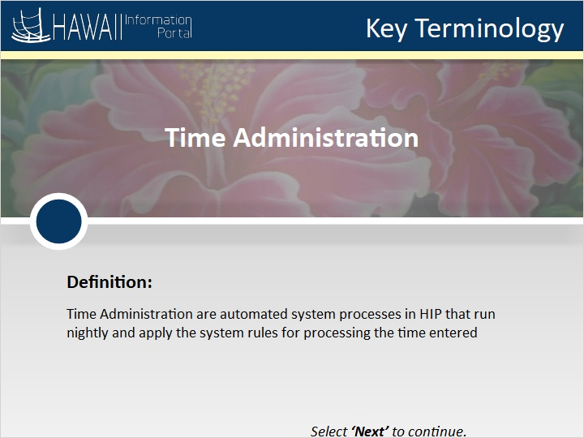

Definition:
Time Administration are automated system processes in HIP that run nightly and apply the system rules for processing the time entered.

Tour of Timesheet
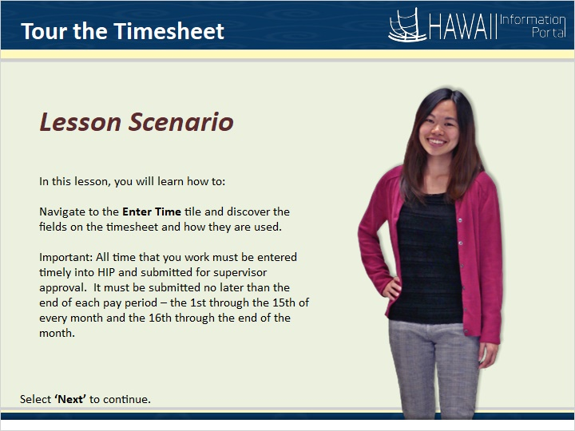

In this lesson, you will learn how to:

Navigate to the Enter Time tile and discover the fields on the timesheet and how they are used.

Important: All time that you work must be entered timely into HIP and submitted for supervisor approval. It must be submitted no later than the end of each pay period - the 1st through the 15th of every month and the 16th through the end of the month.

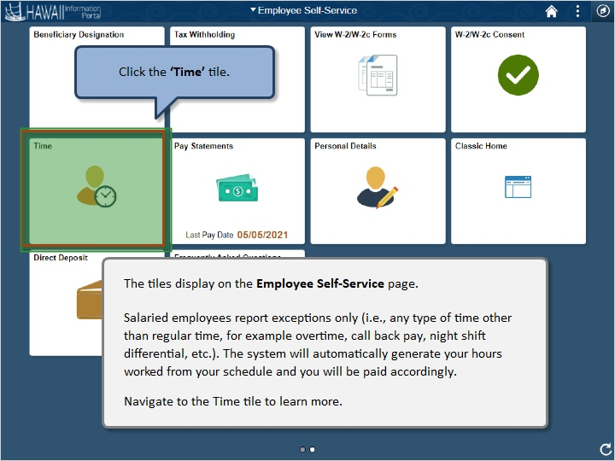

The tiles display on the Employee Self-Service page.

Salaried employees report exceptions only (i.e. any other type of time other than regular time e.g. overtime, call back pay, night shift differential). The system will automatically generate your hours worked from your schedule and you will be paid accordingly.

Navigate to the Time tile to learn more.

Click the ‘Time’ tile.

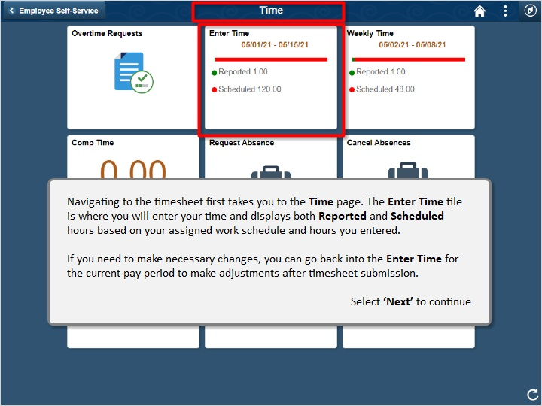

Navigating to the timesheet first takes you to the Time page. The Enter Time tile is where you will enter your time and displays both Reported and Scheduled hours based on your assigned work schedule and hours you entered.

If you need to make necessary changes, you can go back into the Enter Time for the current pay period to make adjustments after timesheet submission.

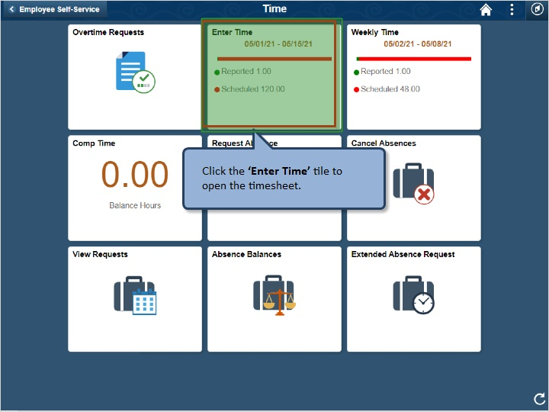

Click the ‘Enter Time’ tile to open the timesheet.

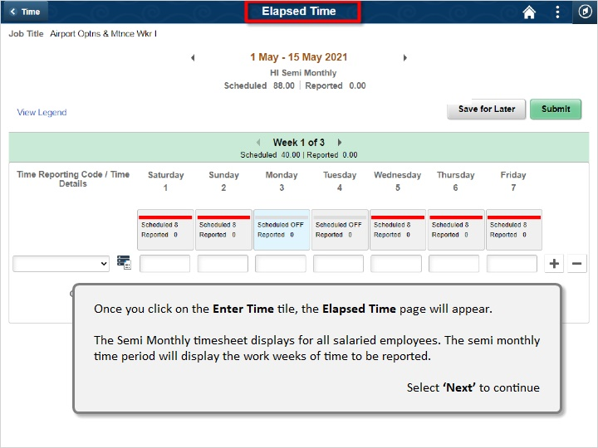

Once you click on the Enter Time tile, the Elapsed Time page will appear.

The Semi Monthly timesheet displays for all salaried employees. The semi- monthly time period will display the work weeks of time to be reported.

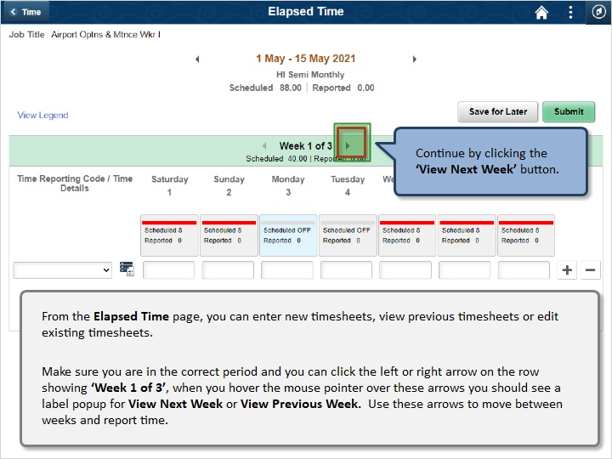

From the Elapsed Time page, you can enter new timesheets, view previous timesheets or edit existing timesheets.

Make sure you are in the correct period and you can click the left or right arrow on the row showing ‘Week 1 of 3’, when you hover the mouse pointer over these arrows you should see a label popup for View Next Week or View Previous Week. Use these arrows to move between weeks and report time.
Continue by clicking the ‘View Next Week’ button
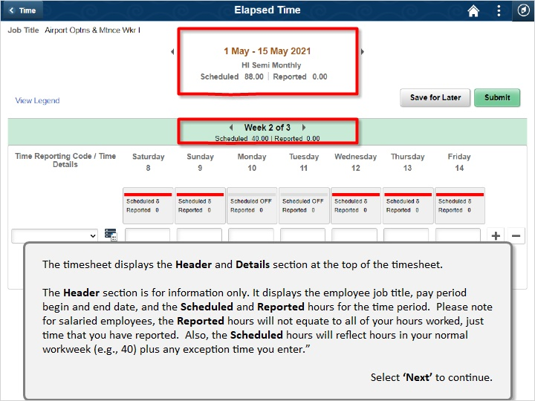

The timesheet displays the Header and Details section at the top of the timesheet.

The Header section is for information only. It displays the employee job title, pay period begin and end date, and the Scheduled and Reported hours for the time period. Please note for salaried employees, the Reported hours will not equate to all of your hours worked, just time that you have reported. Also, the Scheduled hours will reflect hours in your normal workweek (e.g., 40) plus any exception time you enter.”

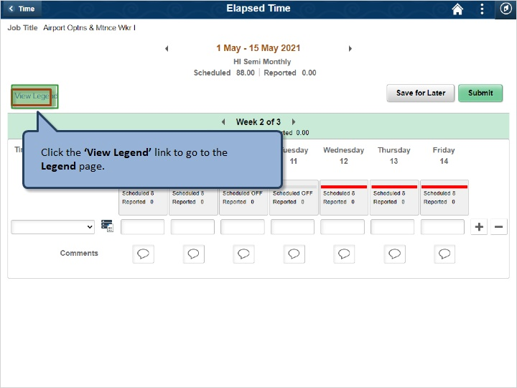

Click the ‘View Legend’ link to go to the Legend page.

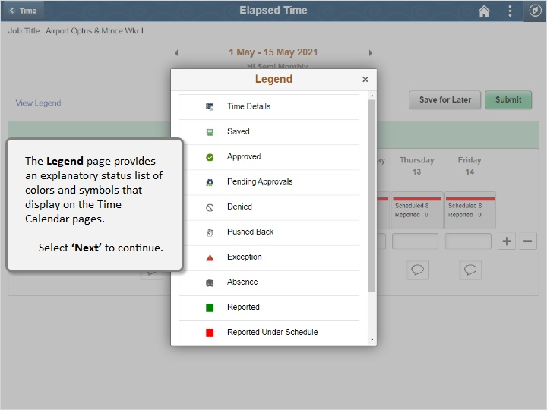

The Legend page provides an explanatory status list of colors and symbols that display on the Time Calendar pages.

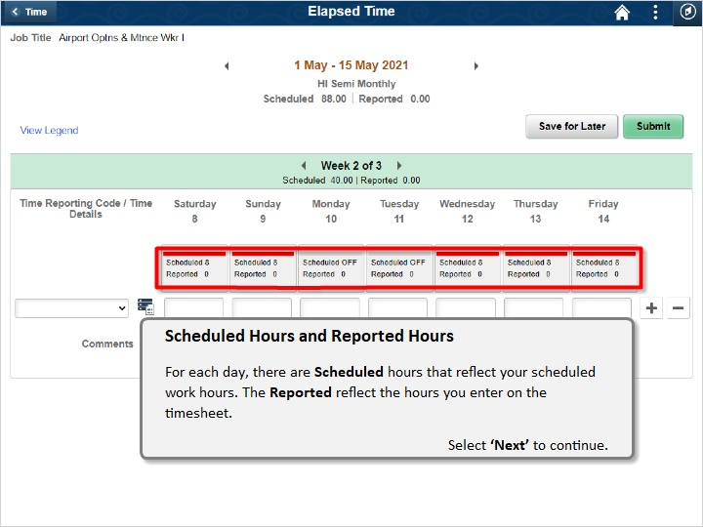

Scheduled Hours and Reported Hours
For each day, there are Scheduled hours that reflect your scheduled work hours. The Reported reflect the hours you enter on the timesheet.

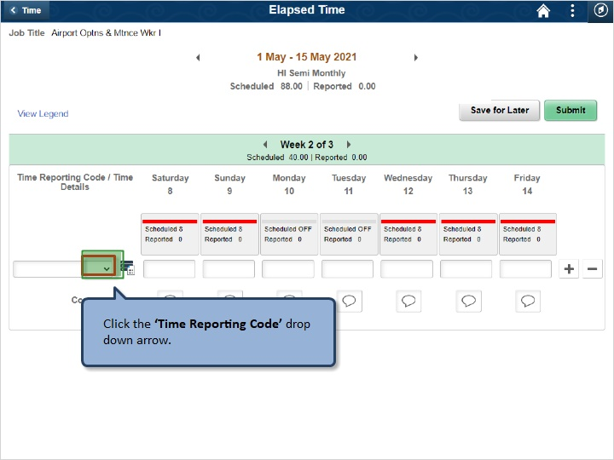

Click the ‘Time Reporting Code’ drop down arrow.

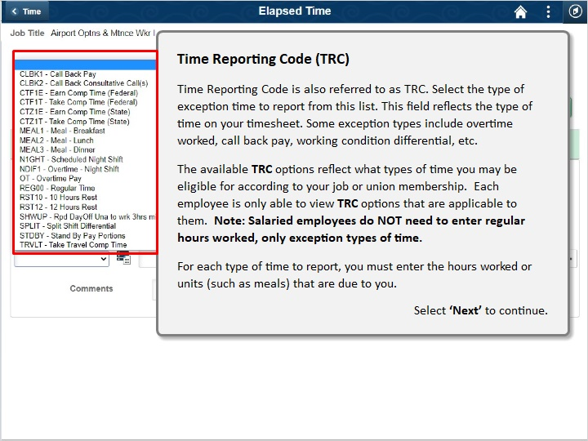

Time Reporting Code (TRC)
Time Reporting Code is also referred to as TRC. Select the type of exception time to report from this list. This field reflects the type of time on your timesheet. Some exception types include overtime worked, call back pay, working condition differential, etc.

The available TRC options reflect what types of time you may be eligible for according to your job or union membership. Each employee is only able to view TRC options that are applicable to them. Note: salaried employees do NOT need to enter regular hours worked, only exception types of time.

For each type of time to report, you must enter the number of hours or units (such as meals) that are due to you.
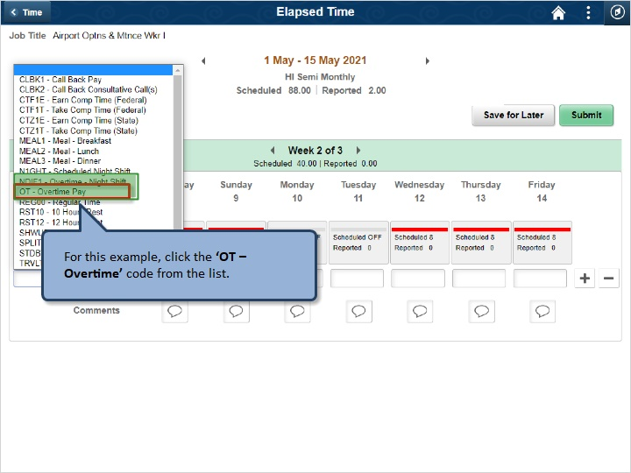

For this example, click the ‘OT - Overtime’ code from the list.

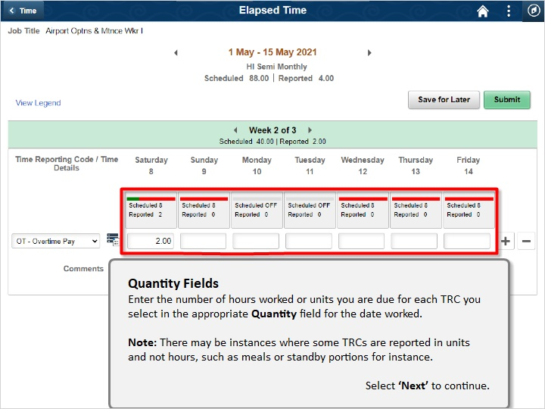

Quantity Fields
Enter the number of hours worked or units you are due for each TRC you select in the appropriate Quantity field for the date worked.

Note: There may be instances where some TRCs are reported in units and not hours, such as meals or standby portions for instance.

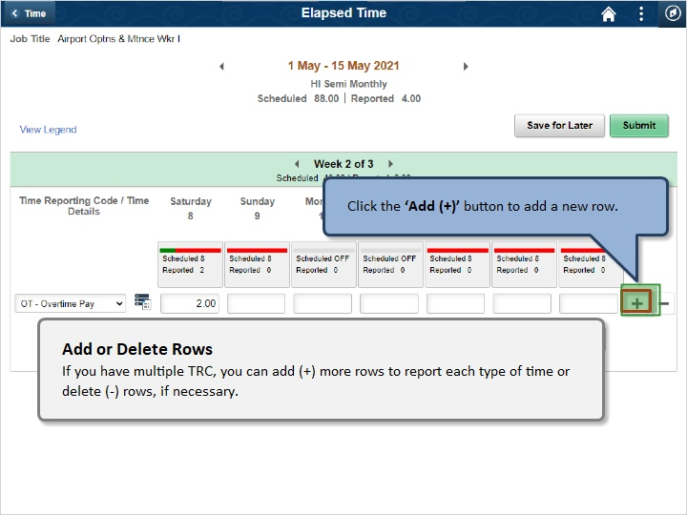

Add or Delete Rows
If you have multiple TRC, you can add (+) more rows to report each type of time or delete (-) rows, if necessary.
Click the ‘Add (+)’ button to add a new row.

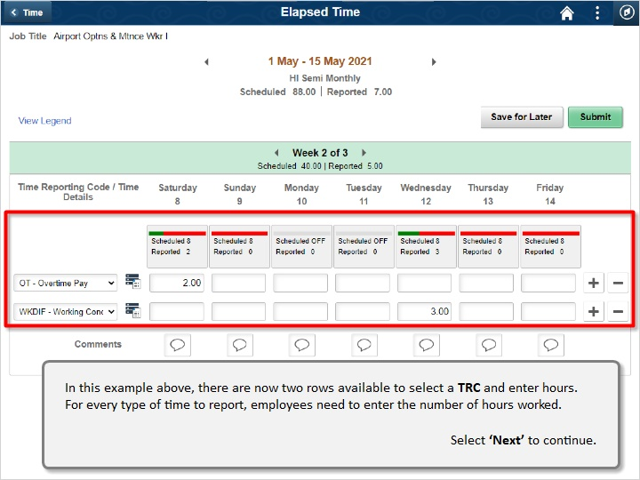

In this example above, there are now two rows to select a TRC and enter hours. For every type of time to report, employees need to enter the number of hours worked.

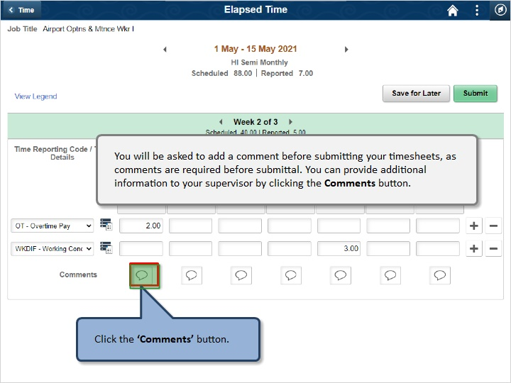

You will be asked to add a comment before submitting your timesheets, as comments are required before submittal. You can provide additional information to your supervisor by clicking the Comments button.

Click the ‘Comments’ button.

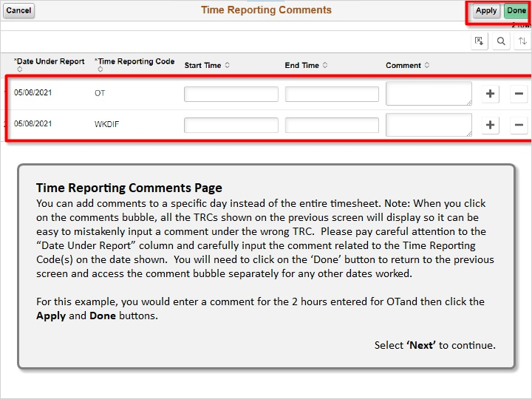

Time Reporting Comments Page
You can add comments to a specific day instead of the entire timesheet. Note: When you click on the comments bubble, all the TRCs shown on the previous screen will display so it can be easy to mistakenly input a comment under the wrong TRC. Please pay careful attention to the “Date Under Report” column and carefully input the comment related to the Time Reporting Code (s) on the date shown. You will need to click on the ‘Done’ button to return to the previous screen and access the comment bubble separately for any other dates worked.

For this example, you would enter a comment for the 2 hours entered for OT and then click the Apply and Done buttons.

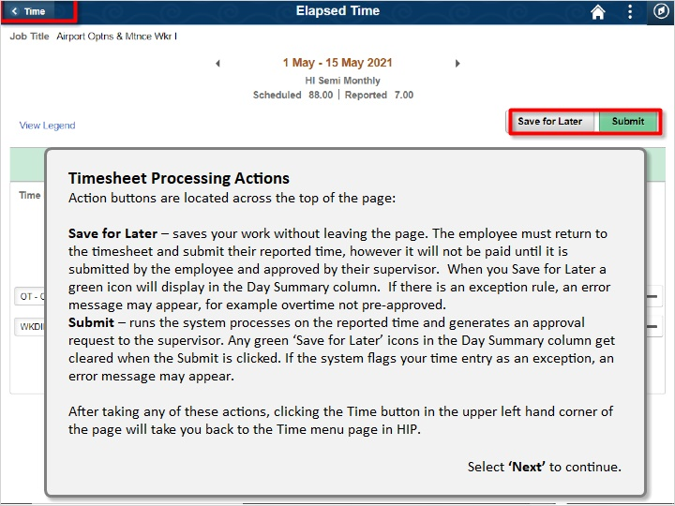

Timesheet Processing Actions
Action buttons are located across the top of the page:
Save for Later - saves your work without leaving the page. The employee must return to the timesheet and submit their reported time, however it will not be paid until it is submitted by the employee and approved by their supervisor. When you Save for Later a green icon will display in the Day Summary column. If there is an exception rule, an error message may appear, for example overtime not pre-approved.
Submit - runs the system processes on the reported time and generates an approval request to the supervisor. Any green ‘Save for Later’ icons in the Day Summary column get cleared when the Submit is clicked. If the system flags your time entry as an exception, an error message may appear.
After taking any of these actions, clicking the Time button in the Upper left hand corner of the page, will take you back to the Time menu page in HIP.
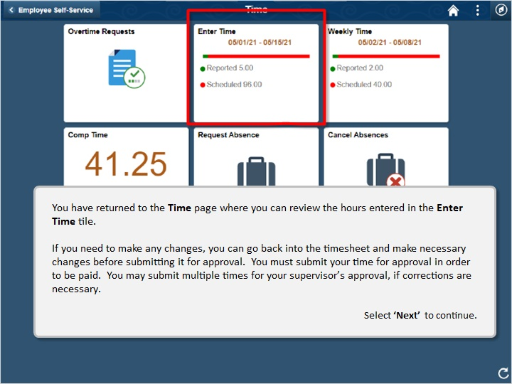

You have returned to the Time page where you can review the hours entered in the Enter Time tile.

If you need to make any changes, you can go back into the timesheet and make necessary changes before submitting it for approval. You must submit your time for approval in order to be paid. You may submit multiple times for your supervisor’s approval, if corrections are necessary.



Congratulations!

You’ve successfully completed this lesson.

Salary Reporting Key Points
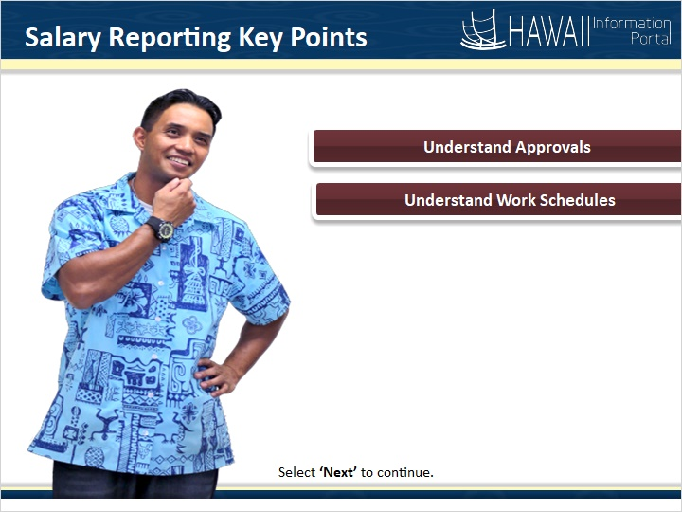

- Understand Approvals
- Understand Work Schedules

Approval Process
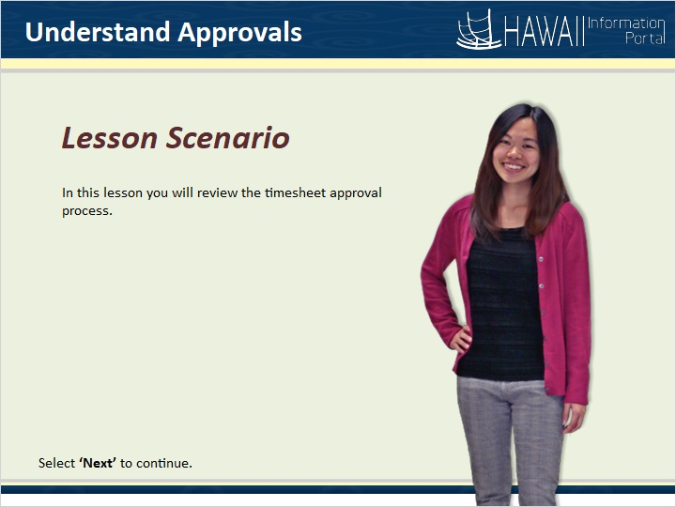

In this lesson you will review the timesheet approval process.

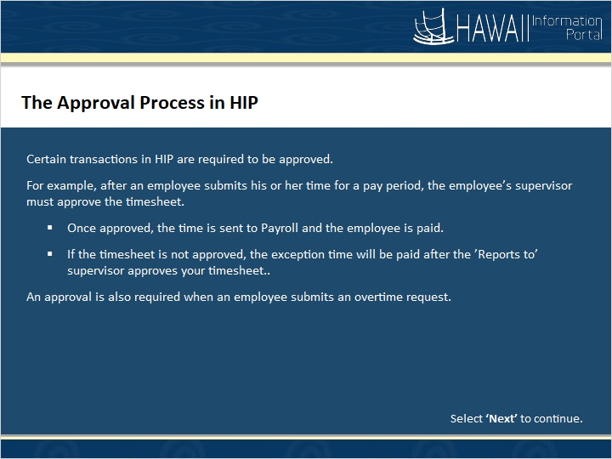

The Approval Process in HIP
Certain transactions in PeopleSoft Time and Labor are required to be approved.
For example, after an employee submits his or her time for a pay period, the employee’s supervisor must approve the timesheet.
- Once approved, the time is sent to Payroll and the employee is paid.
- If the timesheet is not approved, the exception time will be paid after the ‘Reports to’ supervisor approves your timesheet.
An approval is also required when an employee submits an overtime request.

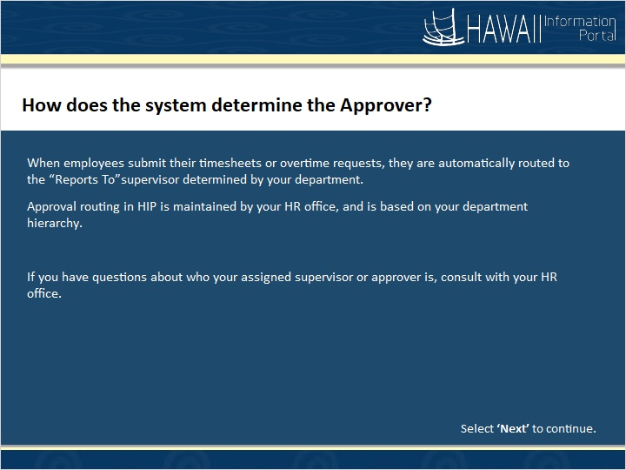

How does the system determine the Approver?

When employees submit their timesheets or overtime requests, they are automatically routed the ‘Reports To’ supervisor determined by your department.
Approval routing in HIP is maintained by your HR office, and is based on your department hierarchy.

If you have questions about who your assigned supervisor is, consult with your HR office.

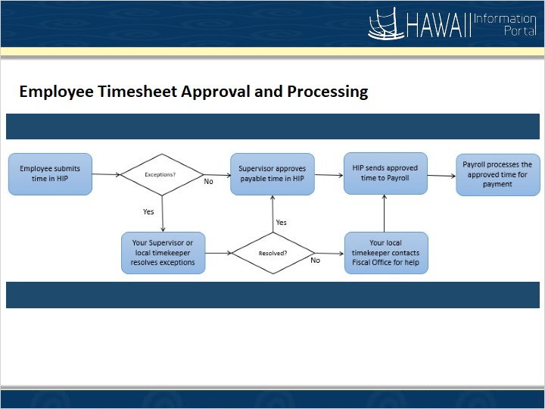

Employee Timesheet Approval and Processing

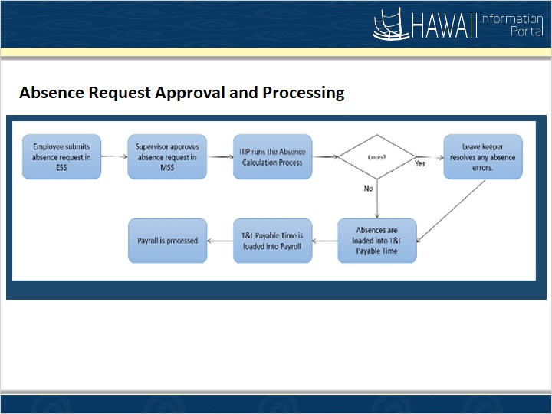

Absence Request Approval and Processing

Congratulations!
You’ve successfully completed this lesson.

Work Schedules
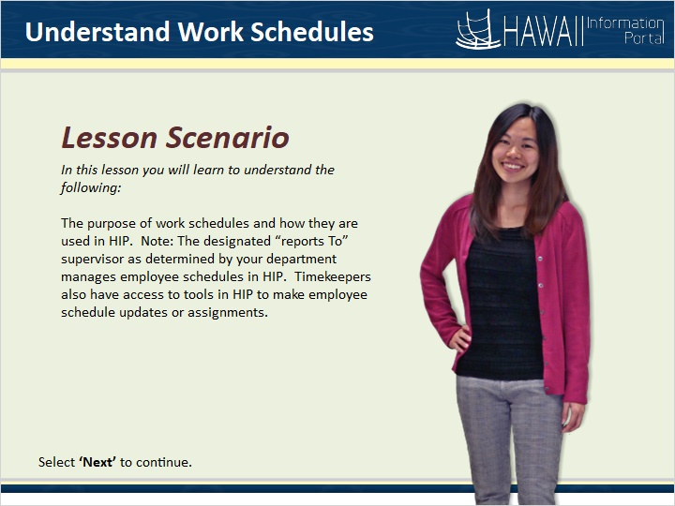

In this lesson you will learn to understand the following:

The purpose of work schedules and how they are used in HIP. Note: The designated “reports To” supervisor as determined by your department manages employee schedules in HIP. Timekeepers also have access to tools in HIP to make employee schedule updates or assignments.

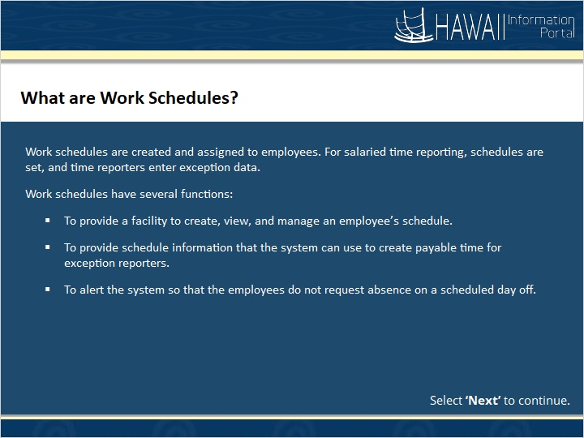

Work schedules are created and assigned to employees. For salaried time reporting, schedules are set, and time reporters enter exception data.
Work schedules have several functions:
- To provide a facility to create, view, and manage an employee’s schedule.
- To provide schedule information that the system can use to create payable time for exception reporters.
- To alert the system so that the employees do not request absence on a scheduled day off.

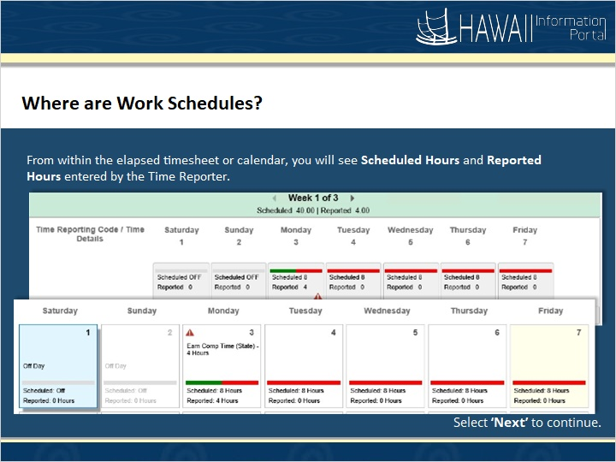

From within the elapsed timesheet or calendar, you will see Scheduled Hours and Reported Hours entered by the time reporter.

Congratulations!
You’ve successfully completed this lesson.

Salaried Time Entry
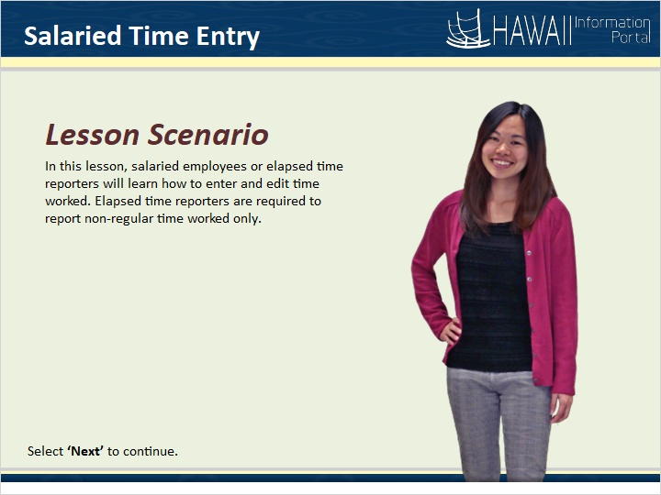

In this lesson, salaried employees or elapsed time reporters will learn how to enter and edit time worked. Elapsed time reporters are required to report non-regular time worked only.

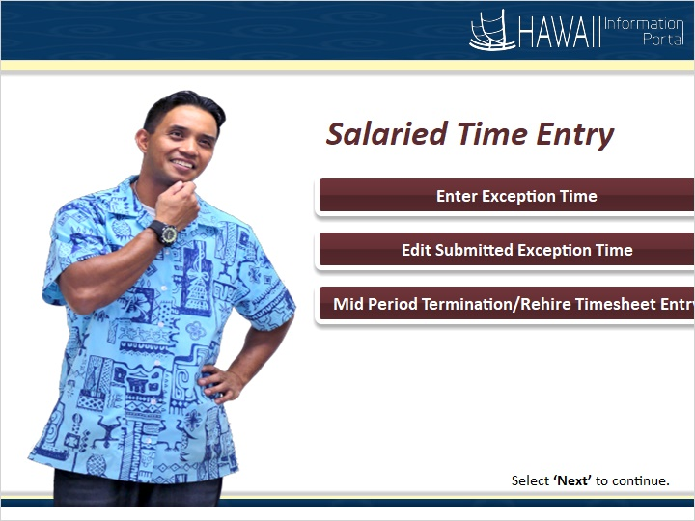

Enter Exception Time
Edit Submitted Exception Time
Mid Period Termination/Rehire Timesheet Entry

Enter Salaried Time
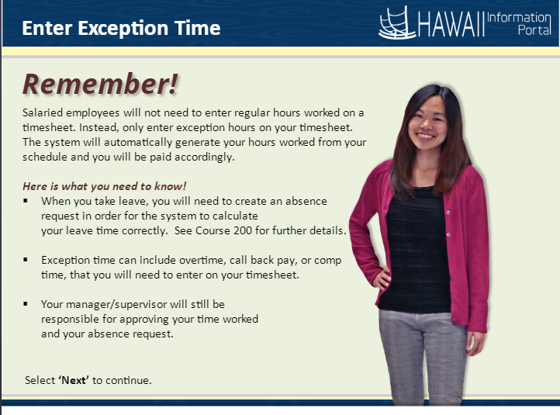

Salaried employees will not need to enter regular hours worked on a timesheet. Instead, only enter exception hours on your timesheet. The system will automatically generate your hours worked from your schedule and you will be paid accordingly.

Here is what you need to know!
- When you take leave, you will need to create an absence request in order for the system to calculate your leave time correctly. See Course 200 for further details.
- Exception time can include overtime, call back pay, or comp time, that you will need to enter on your timesheet.
- Your manager/supervisor will still be responsible for approving your time worked and your absence request.
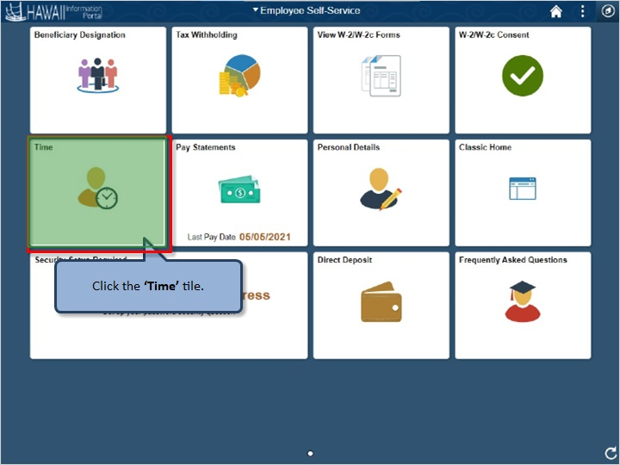

Click the ‘Time’ tile.

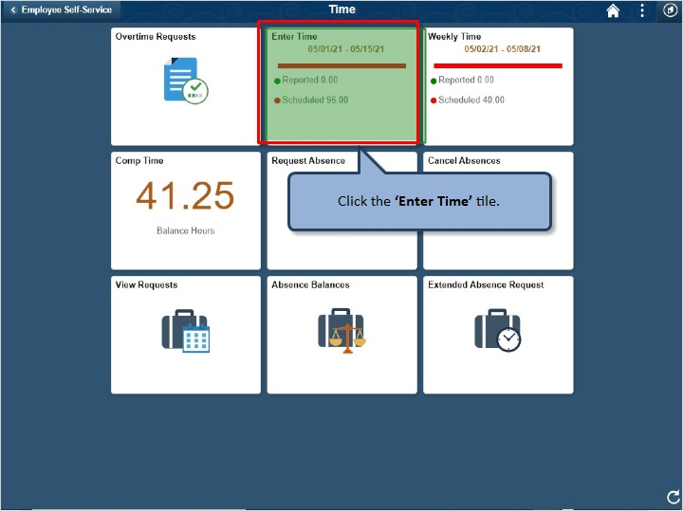

Click the ‘Enter Time’ tile.

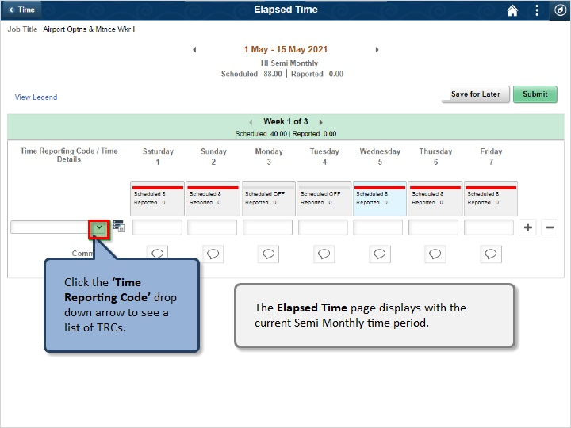

Click the ‘Time Reporting Code’ drop down arrow to see a list of TRCs.

The Elapsed Time page displays with the current Semi Monthly time period.

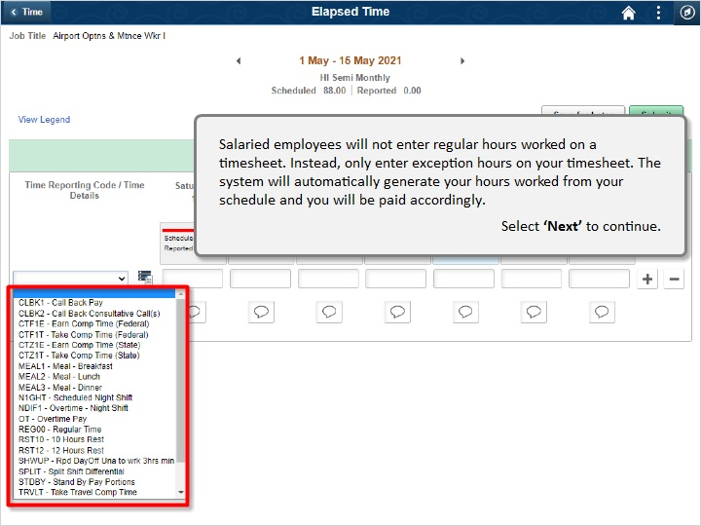

Salaried employees will not enter regular hours worked on a timesheet. Instead, only enter exception hours on your timesheet. The system will automatically generate your hours worked from your schedule and you will be paid accordingly.

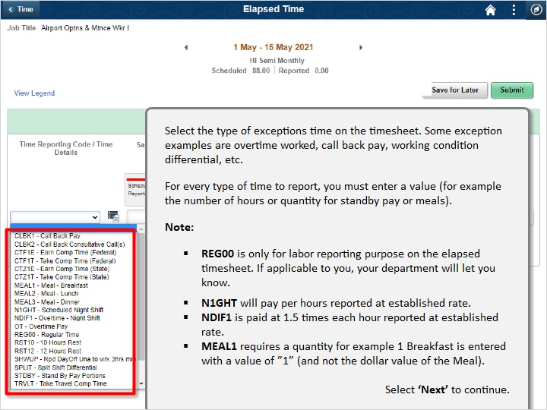

Select the type of exceptions time on the timesheet. Some exception examples are overtime worked, call back pay, working condition differential, etc.
For every type of time to report, you must enter a value (for example the number of hours or quantity for standby pay or meals).
Note:
- REG00 is only for labor reporting purpose on the elapsed timesheet. If applicable to you, your department will let you know.
- N1GHT will pay per hours reported at established rate.
- NDIF1 is paid at 1.5 times each hour reported at established rate.
- MEAL1 requires a quantity for example 1 Breakfast is entered with a value of “1” (and not the dollar value of the Meal)
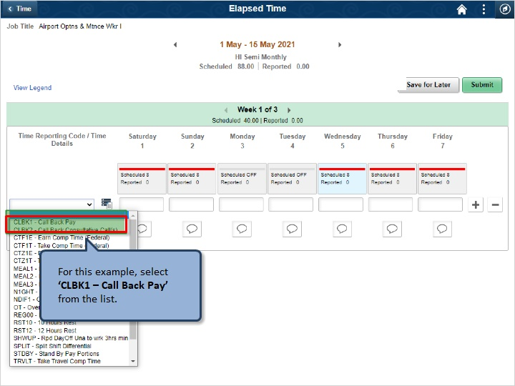

For this example, select ‘CLBK1 - Call Back Pay’ from the list.

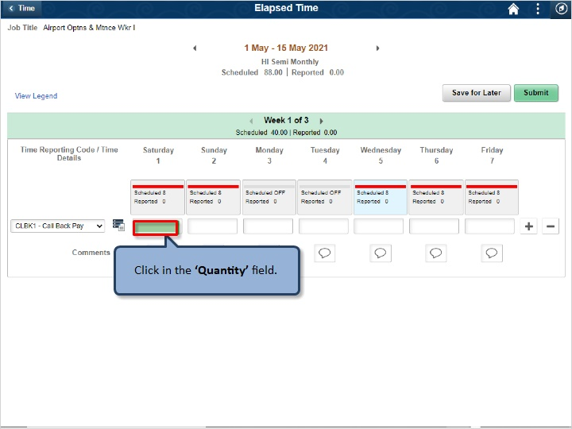

Click in the ‘Quantity’ field.

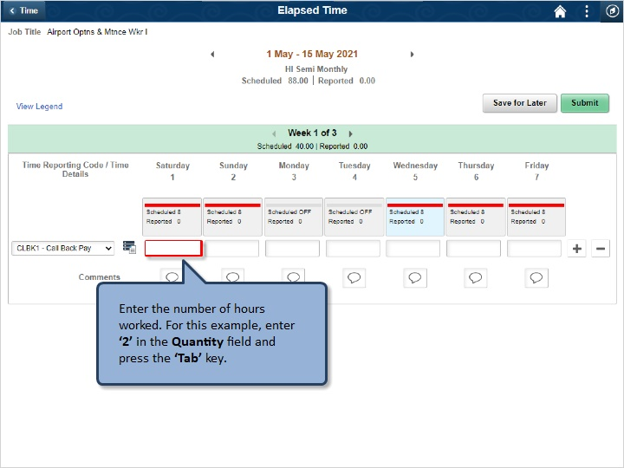

Enter the number of hours worked. For this example, enter ‘2’ in the Quantity field and press the ‘Tab’ key.

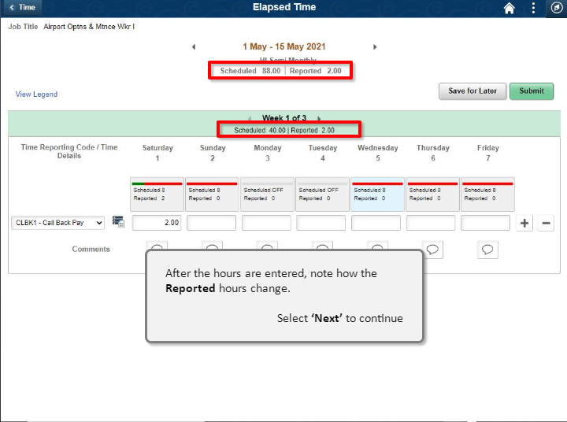

After the hours are entered, note how the Reported hours change.

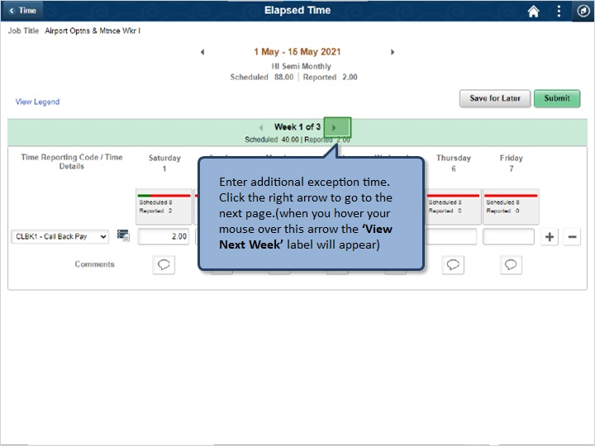

Enter additional exception time. Click the right arrow to go to the next page (when you hover your mouse over this arrow the ‘View Next Week’ label will appear).

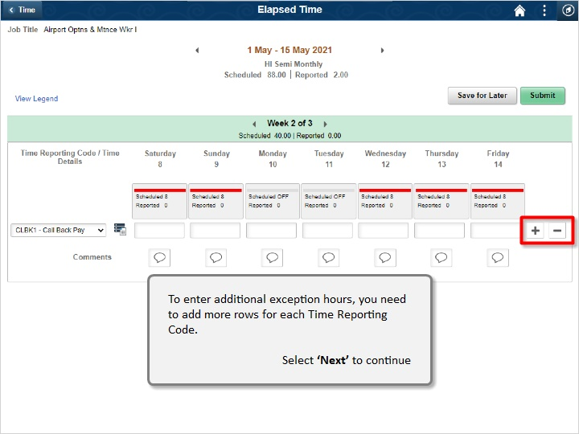

To enter additional exception hours, you need to add more rows for each Time Reporting Code.

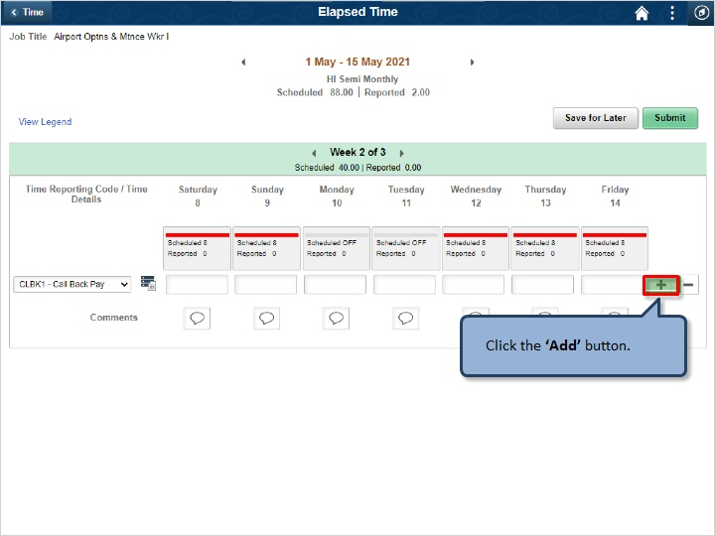

Click the ‘Add’ button.

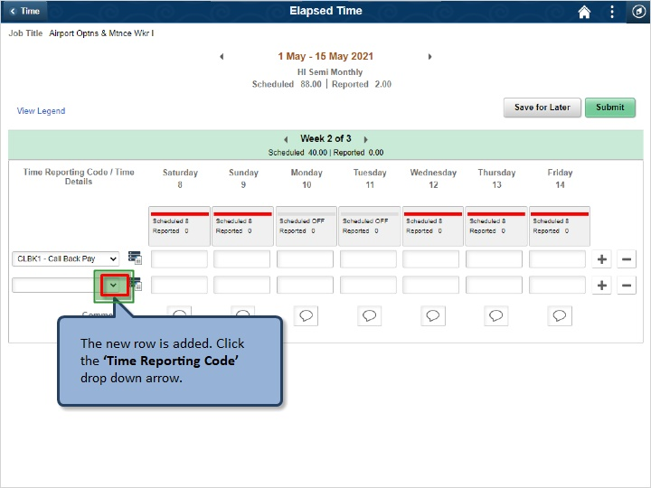

The new row is added. Click the ‘Time Reporting Code’ drop down arrow.

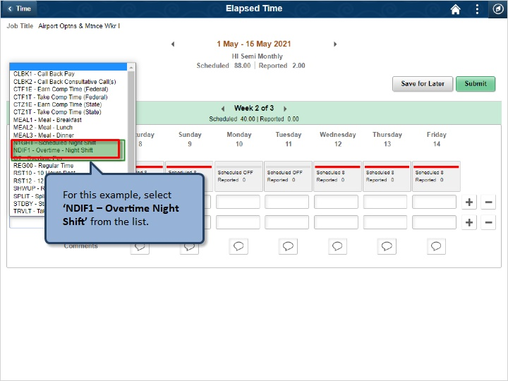

For this example, select ‘NDIF1 – Overtime Night Shift’ from the list.

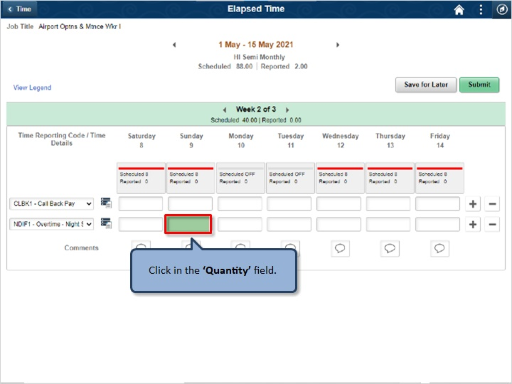

Click in the ‘Quantity’ field.

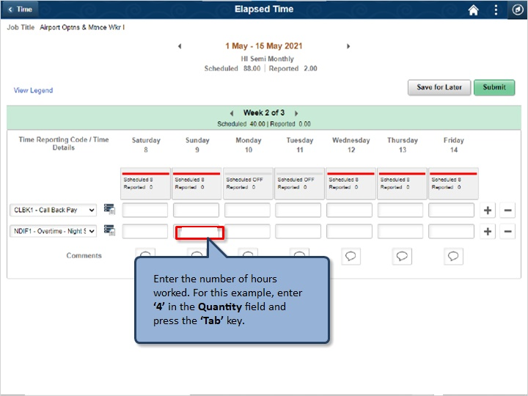

Enter the number of hours worked. For this example, enter ‘4’ in the Quantity field and press the ‘Tab’ key.

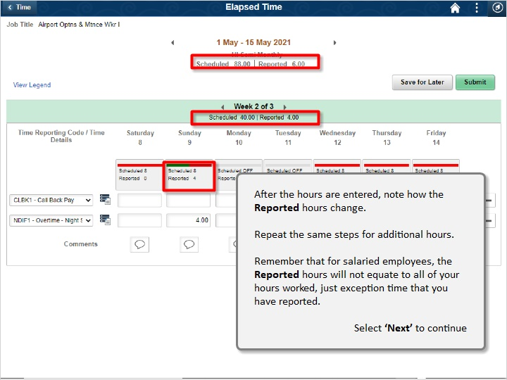

After the hours are entered, note how the Reported hours change.

Repeat the same steps for additional hours.

Remember that for salaried employees, the Reported hours will not equate to all of your hours worked, just exception time that you have reported.

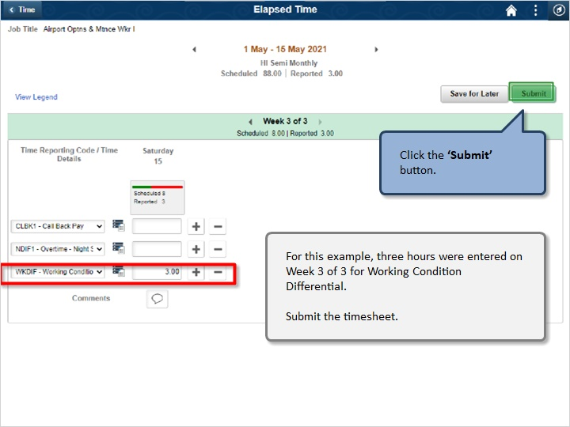

For this example, three hours were entered on Week 3 of 3 for Working Condition Differential.

Submit the timesheet.

Click the ‘Submit’ button.

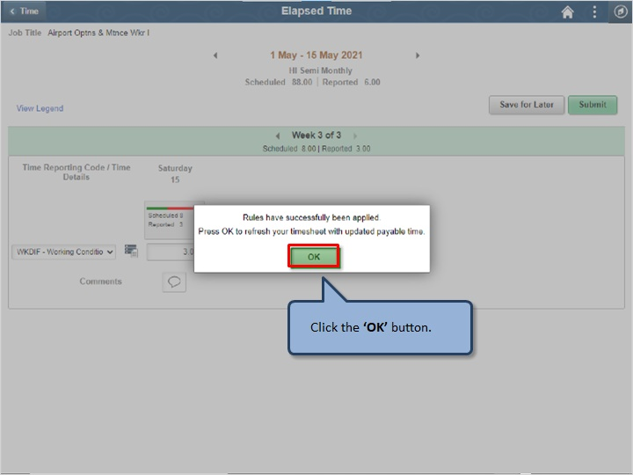

Click the ‘OK’ button.

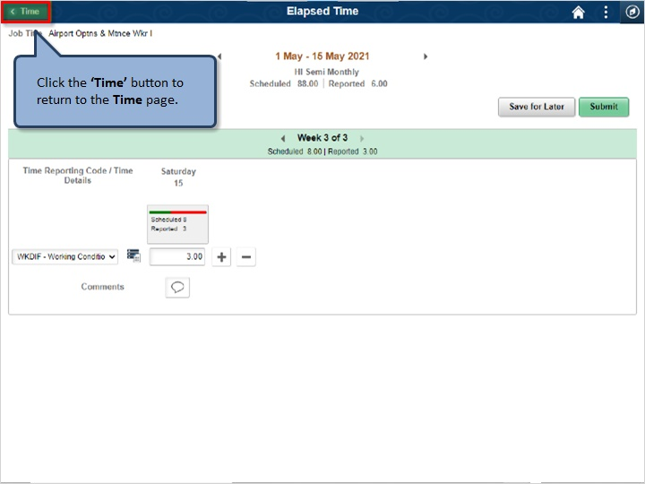

Click the ‘Time’ button to return to the Time page.

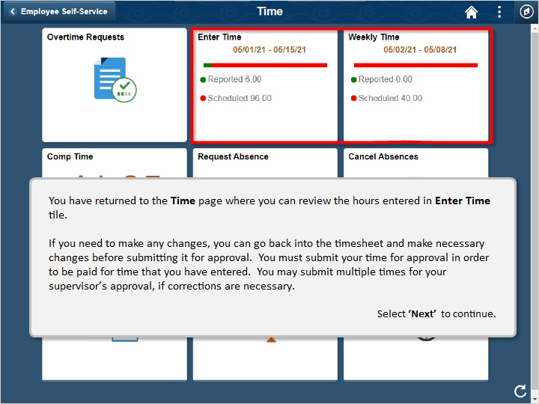

You have returned to the Time page where you can review the hours entered in Enter Time tile.

If you need to make any changes, you can go back into the timesheet and make necessary changes before submitting it for approval. You must submit your time for approval in order to be paid for time that you have entered. You may submit multiple times for your supervisor’s approval, if corrections are necessary.

Congratulations!

You’ve successfully completed this lesson.

Edit Salaried Time
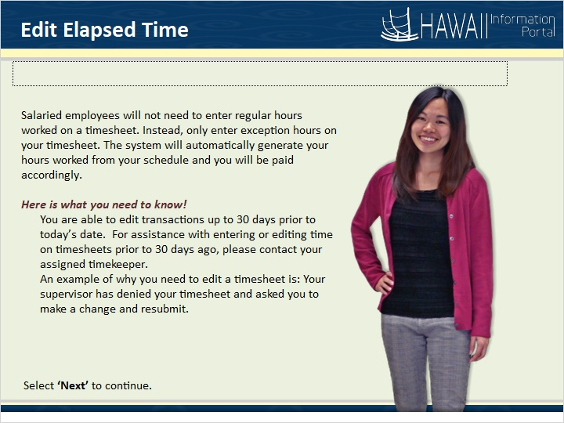

Salaried employees will not need to enter regular hours worked on a timesheet. Instead, only enter exception hours on your timesheet. The system will automatically generate your hours worked from your schedule and you will be paid accordingly.

Here is what you need to know!
You are able edit transactions up to 30 days prior to today’s date. For assistance with entering or editing time on timesheets prior to 30 days ago, please contact your assigned timekeeper.
An example of why you need to edit a timesheet is: Your supervisor has denied your timesheet and asked you to make a change and resubmit.

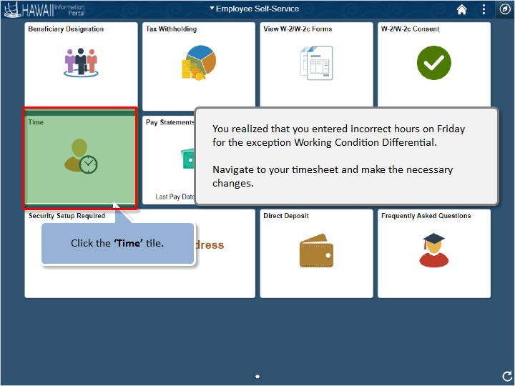

Click the ‘Time’ tile.

You realized that you entered incorrect hours on Friday for the exception Working Condition Differential.

Navigate to your timesheet and make the necessary changes.

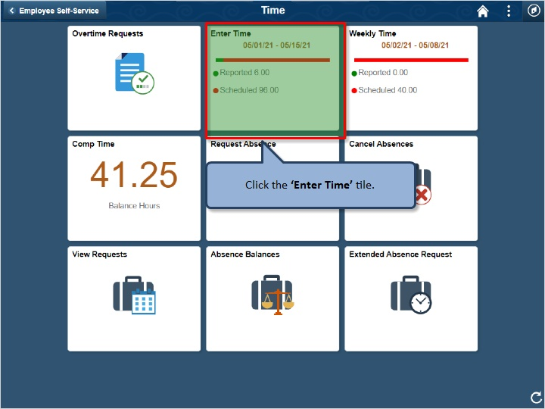

Click the ‘Enter Time’ tile.

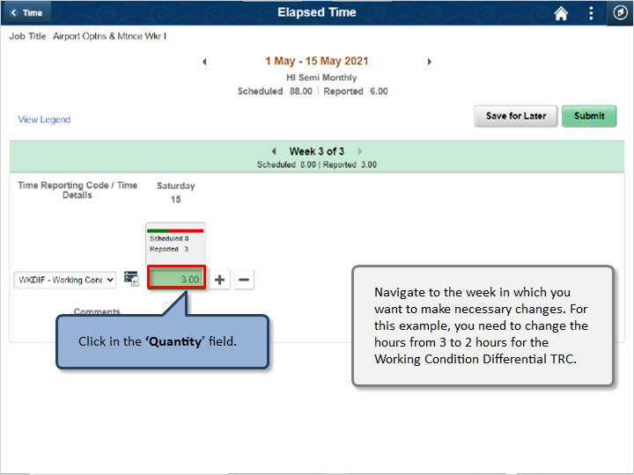

Click in the ‘Quantity’ field.

Navigate to the week in which you want to make necessary changes. For this example, you need to change the hours from 3 to 2 hours for the Working Condition Differential TRC.

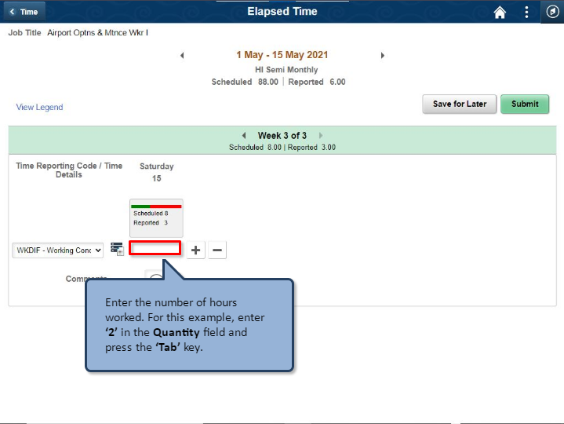

Enter the number of hours worked. For this example, enter ‘2’ in the Quantity field and press the ‘Tab’ key.

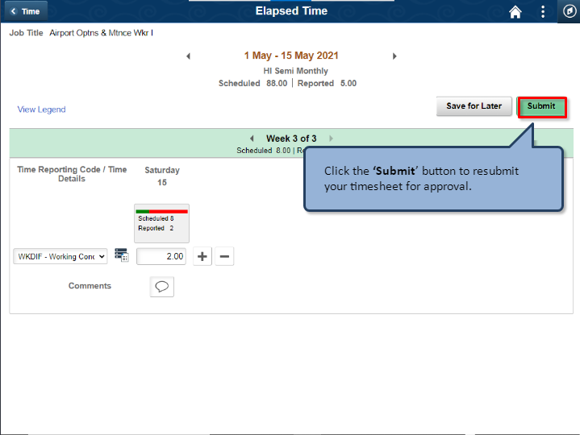

Click the ‘Submit’ button to resubmit your timesheet for approval.

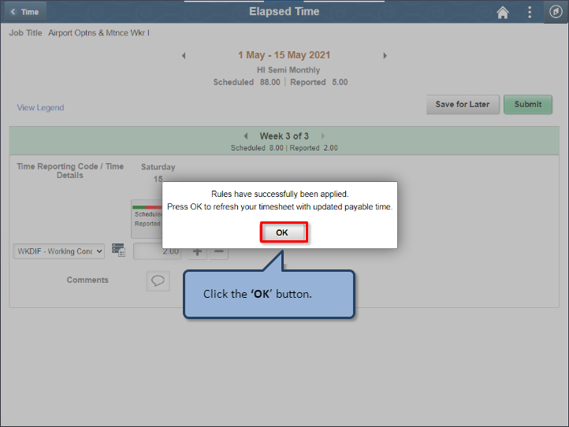

Click the ‘OK’ button.

Congratulations!

You’ve successfully completed this lesson!

Timesheet Editable
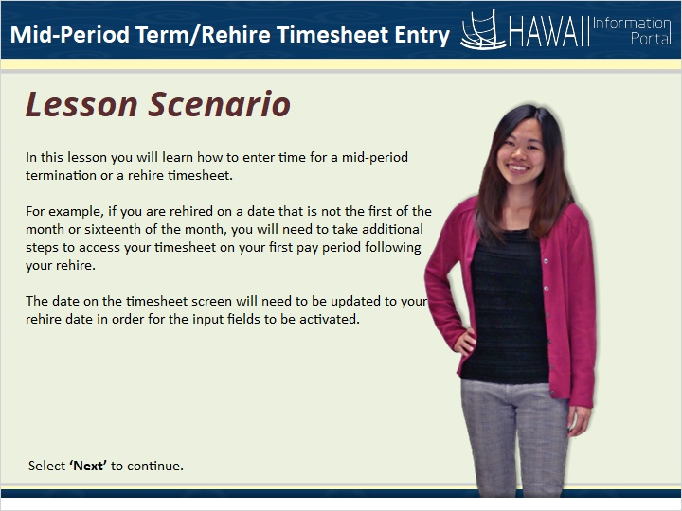

In this lesson you will learn how to enter time for a mid-period termination or a rehire timesheet.
For example, if you are rehired on a date that is not the first of the month or sixteenth of the month, you will need to take additional steps to access your timesheet on your first pay period following your rehire.
The date on the timesheet screen will need to be updated to your rehire date in order for the input fields to be activated..

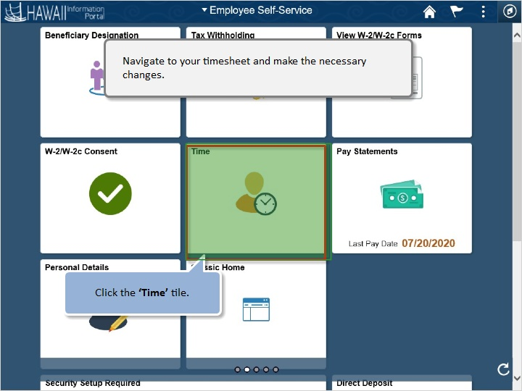

Navigate to your timesheet and make the necessary changes.

Click the ‘Time’ tile.

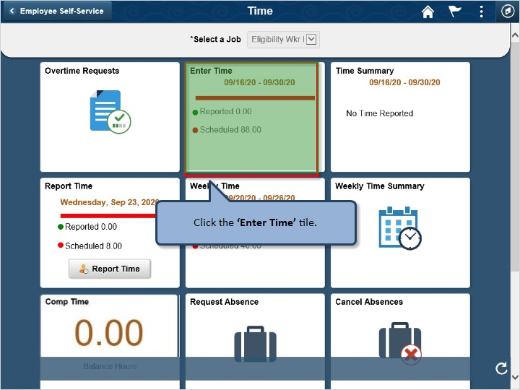

Click the ‘Enter Time’ tile.

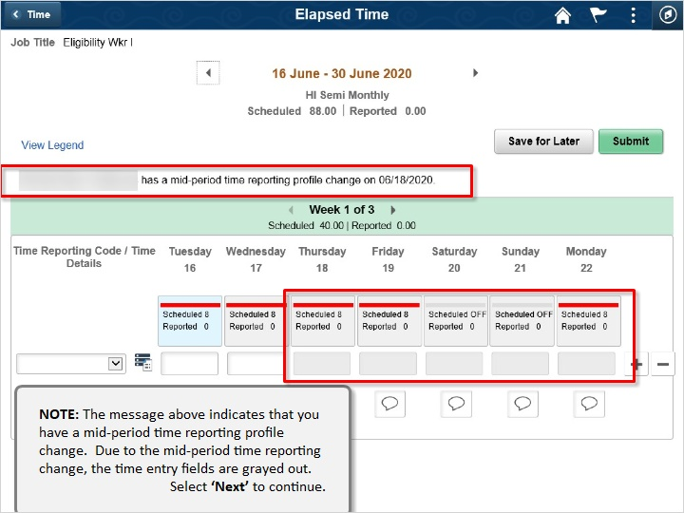

NOTE: The message above indicates that you have a mid-period time reporting profile change. Due to the mid-period time reporting change, the time entry fields are grayed out.

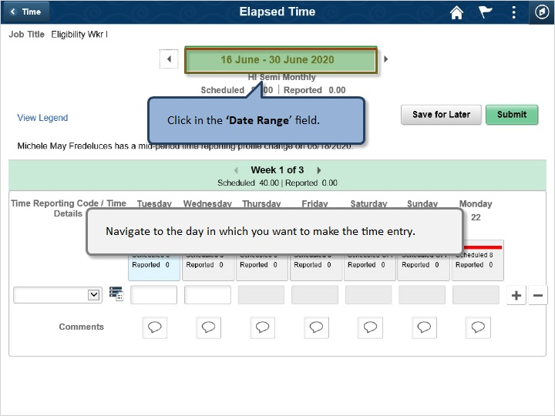

Navigate to the day in which you want to make the time entry.

Click on the ‘Date Range’ field.

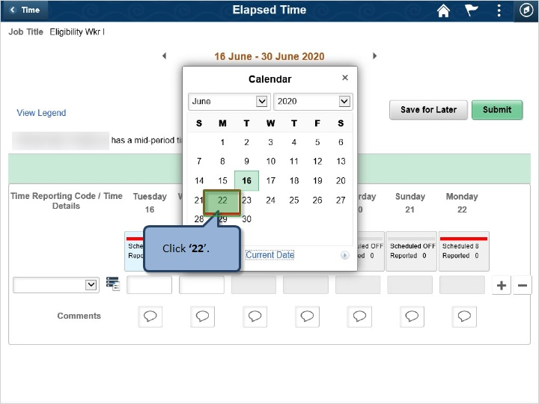

Click ‘22’

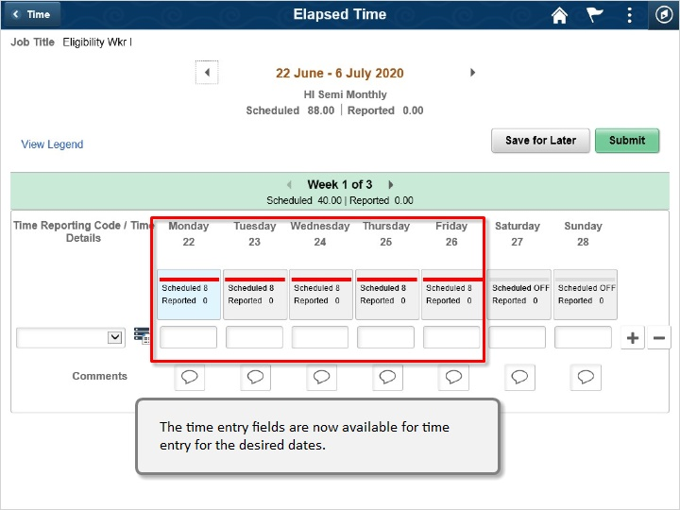

The time entry fields are now available for time entry for the desired dates.

Congratulations!

You’ve successfully completed this lesson!

Overtime/Comp Time Entry
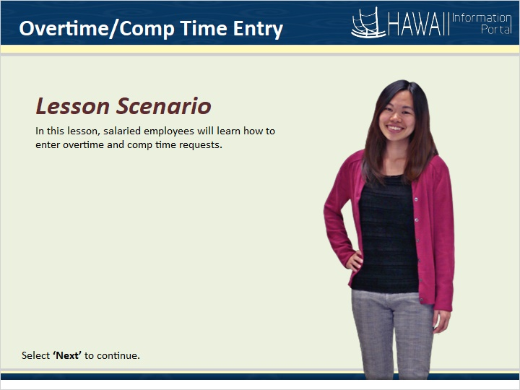

In this lesson, salaried employees will learn how to enter overtime and comp time requests.

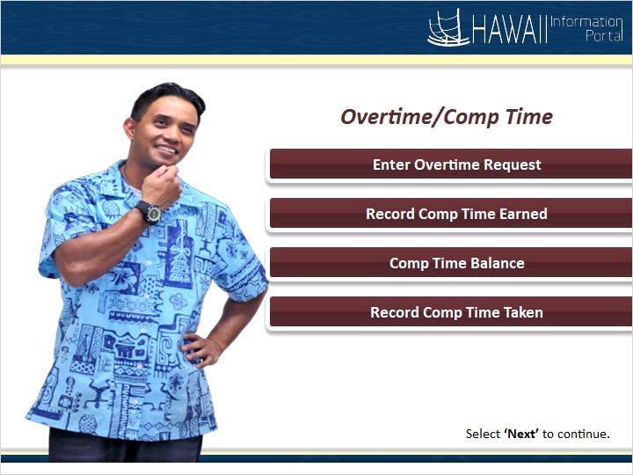

Overtime/Comp Time

Enter Overtime Request
Record Comp Time Earned
Comp Time Balance
Record Comp Time Taken

Overtime Request
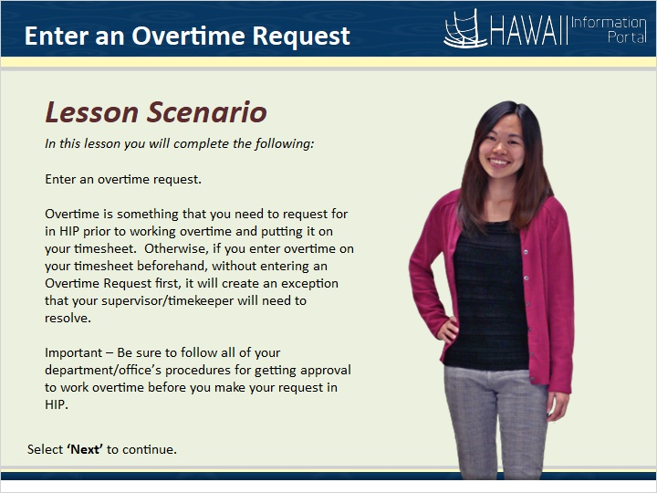

In this lesson you will complete the following:

Enter an overtime request.

Overtime is something that you need to request for in HIP prior to working overtime and putting it on your timesheet. Otherwise, if you enter overtime on your timesheet beforehand, without entering an Overtime Request first, it will create an exception that your supervisor/timekeeper will need to resolve.

Important - Be sure to follow all of your department/office’s procedures for getting approval to work overtime before you make your request in HIP.

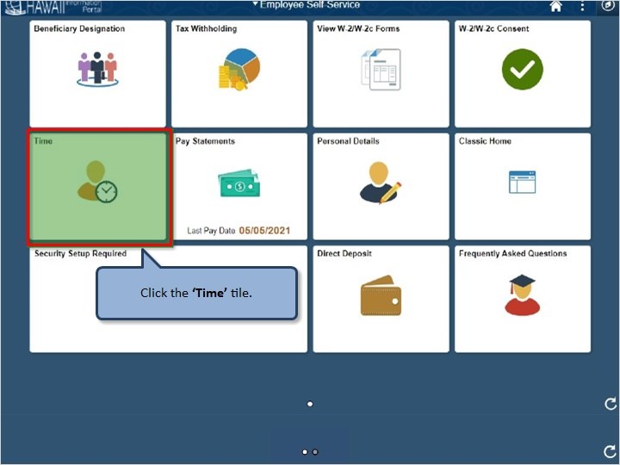

Click the ‘Time’ tile.

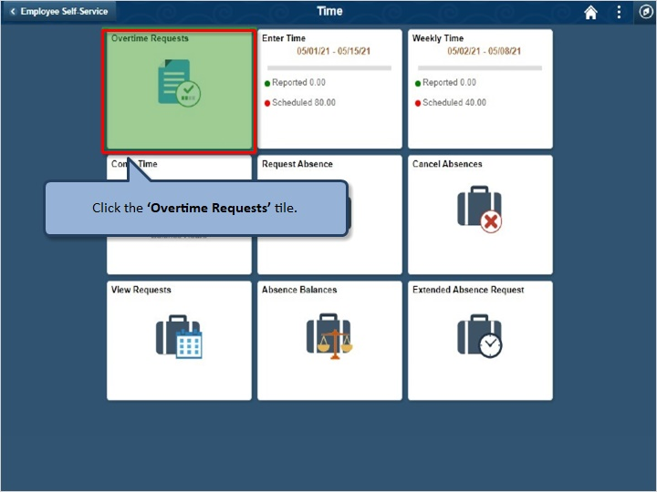

Click the ‘Overtime Requests’ tile.

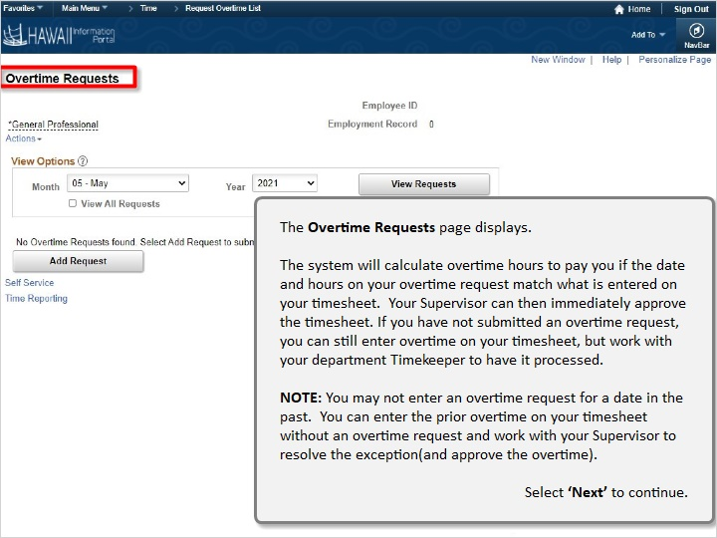

The Overtime Requests page displays.

The system will calculate overtime hours to pay you if the date and hours on your overtime request match what is entered on your timesheet. Your Supervisor can immediately approve the timesheet. If you have not submitted an overtime request, you can still enter overtime on your timesheet, but work with your department Timekeeper to have it processed.

NOTE: You may not enter an overtime request for a date in the past. You can enter the prior overtime on your timesheet without an overtime request and work with your Supervisor to resolve the exception (and approve the overtime).

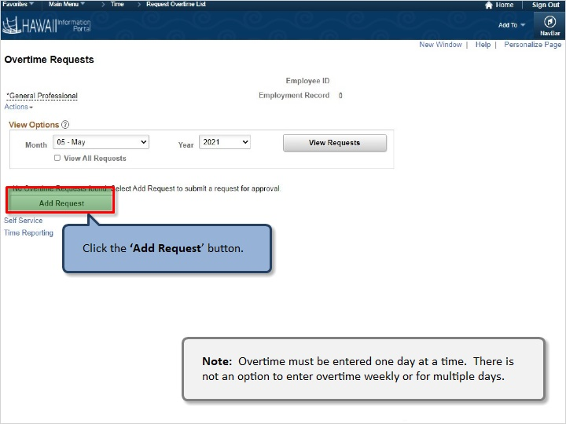

Click the ‘Add Request’ button.

Note: Overtime must be entered one day at a time. There is not an option to enter overtime weekly or for multiple days.

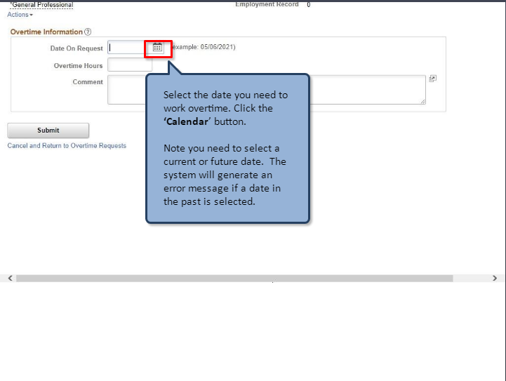

Select the date you need to work overtime. Click the ‘Calendar’ button.

Note you need to select a current or future date. The system will generate an error message if a date in the past is selected.

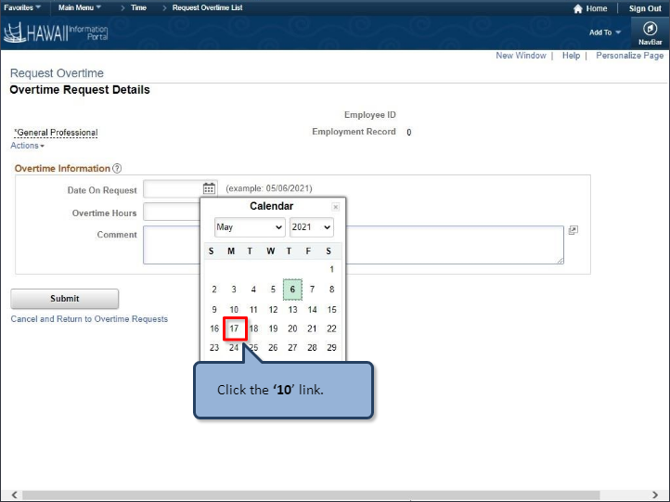

Click the ‘10’ link.

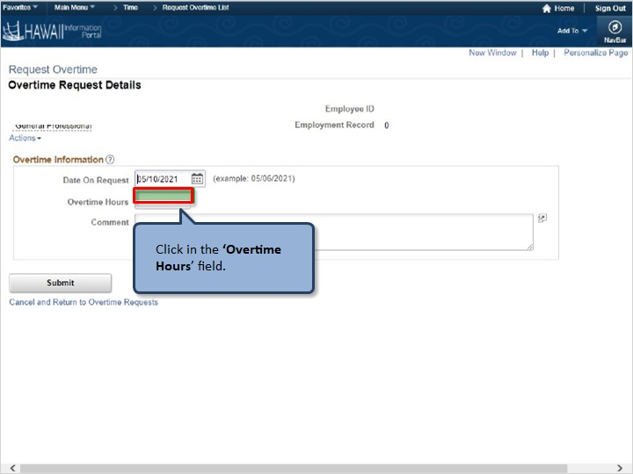

Click in the ‘Overtime Hours’ field.

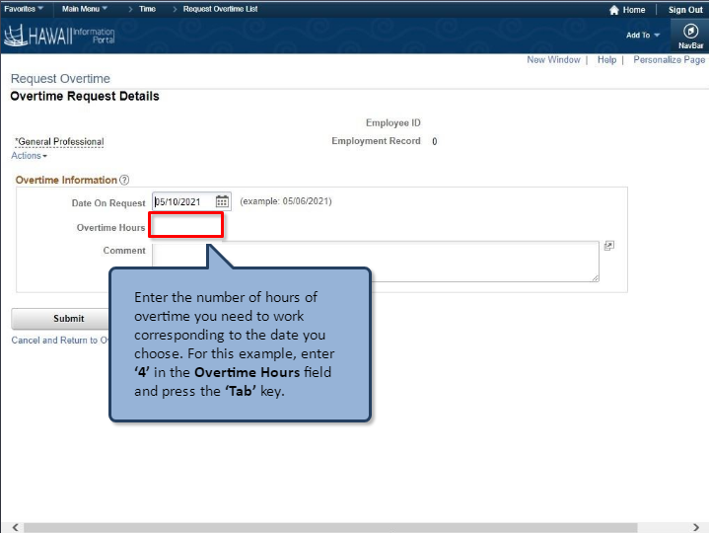

Enter the number of hours you want to work corresponding to the date you choose. For this example, enter ‘4’ in the Overtime Hours field and press the ‘Tab’ key.

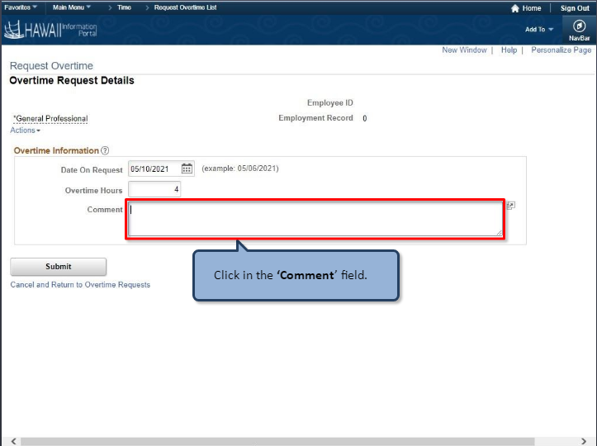

Click in the ‘Comment’ field.

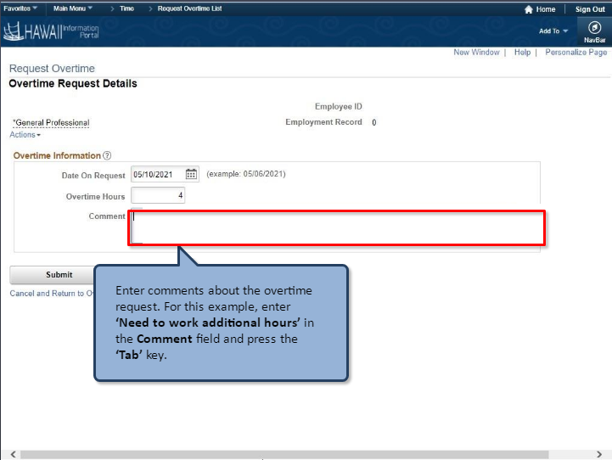

Enter comments about the overtime request. For this example, enter ‘Need to work additional hours’ in the Comment field and press the ‘Tab’ key.

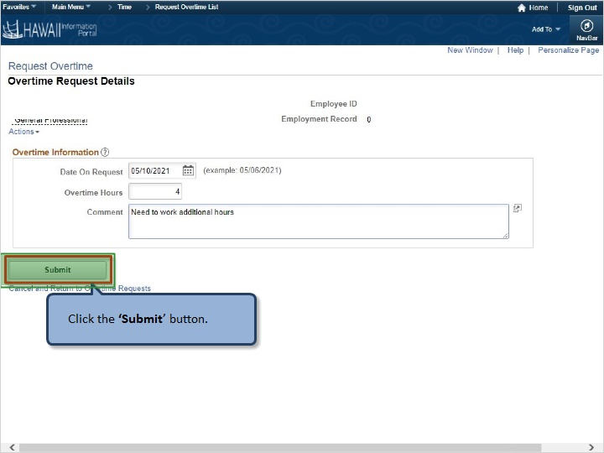

Click the ‘Submit’ button.

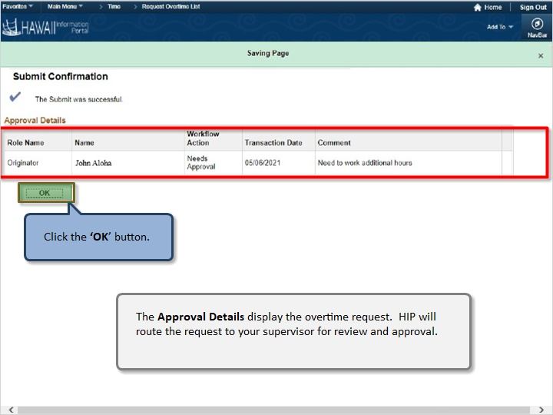

Click the ‘OK’ button.

The Approval Details display the overtime request. HIP will route the request to your supervisor for review and approval.

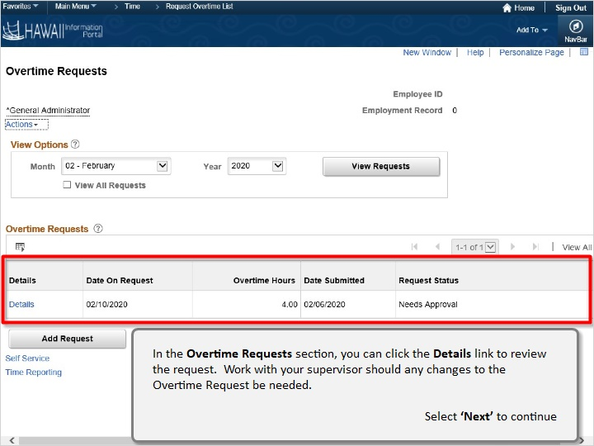

In the Overtime Requests section, you can click the Details link to review the request. Work with your supervisor should any changes to the Overtime Request be needed.

Select ‘Next’ to continue

Congratulations!

You’ve successfully completed this lesson.

Comp Time Earned
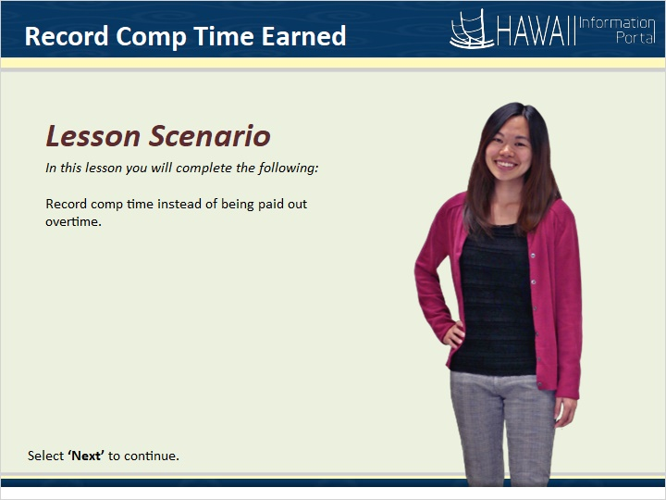

In this lesson you will complete the following:

Record comp time instead of being paid out overtime.

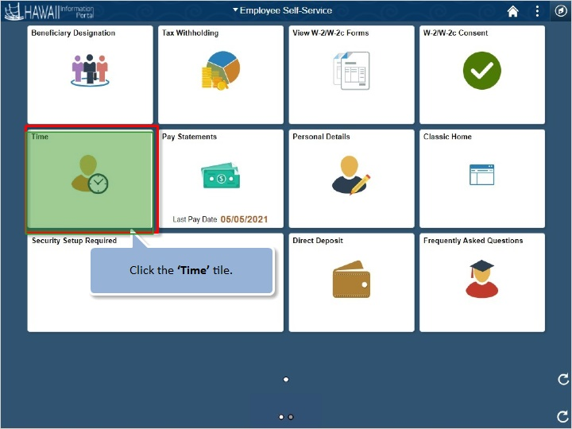

Click the ‘Time’ tile.

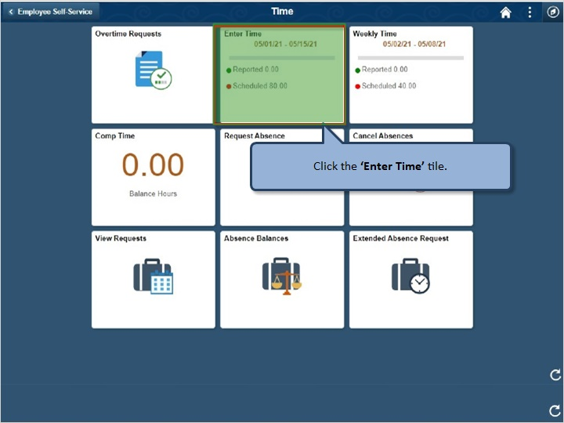

Click the ‘Enter Time’ tile.

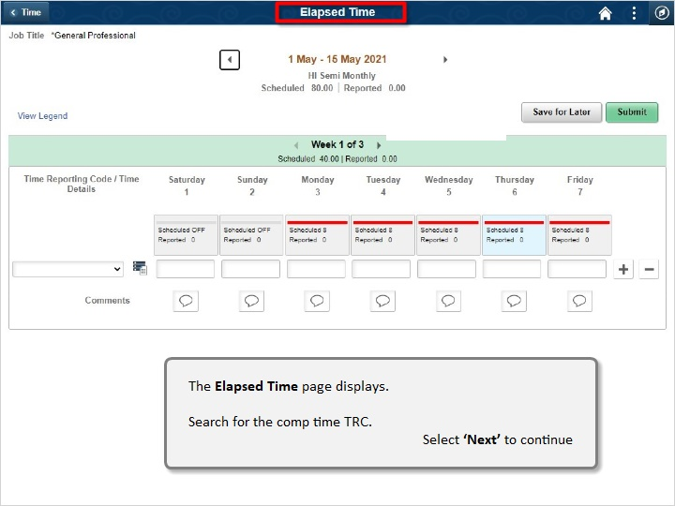

The Elapsed Time page displays.

Search for the comp time TRC.

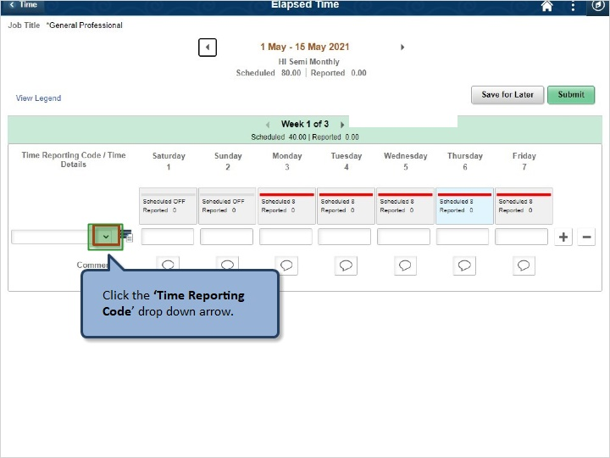

Click the ‘Time Reporting Code’ drop down arrow.

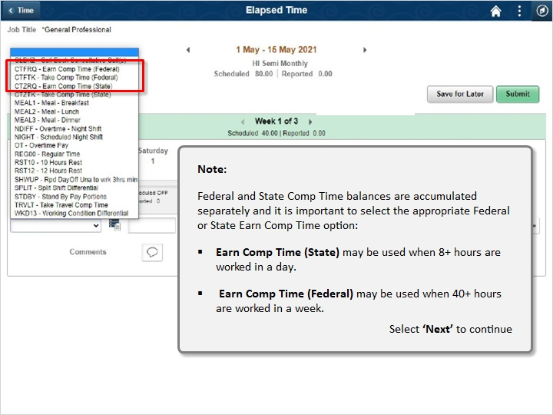

Note:
Federal and State Comp Time balances are accumulated separately, and it is important to select the appropriate Federal or State Earn Comp Time option:
- Earn Comp Time (State) may be used when 8+ hours are worked in a day,
- Earn Comp Time (Federal) may be used when 40+ hours are worked in a week.

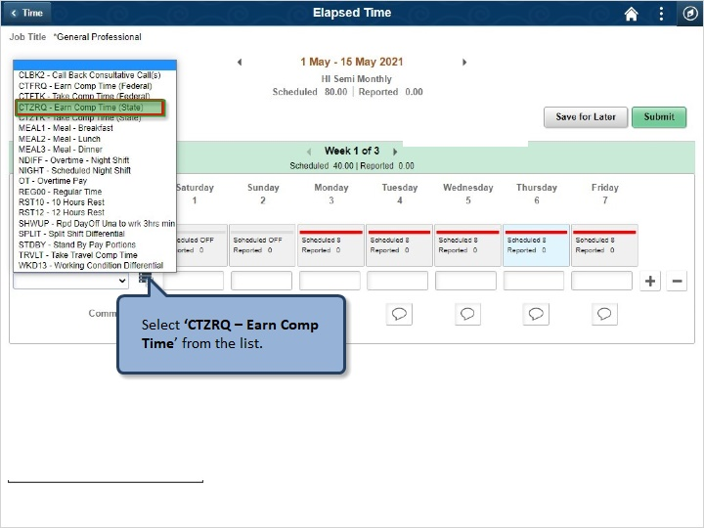

Select ‘CTZRQ - Earn Comp Time’ from the list.

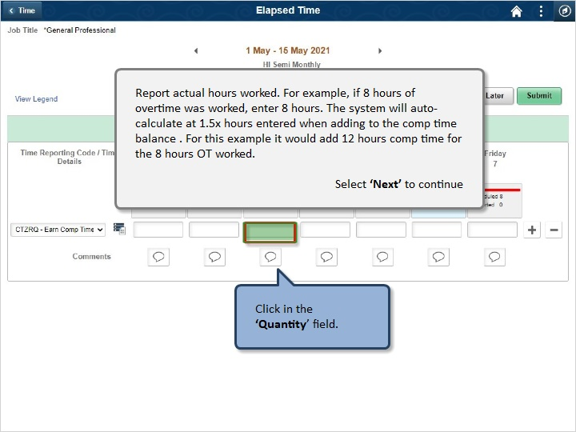

Report actual hours worked. For example, if 8 hours of overtime was worked, enter 8 hours. The system will auto-calculate at 1.5x hours entered when adding to the comp time balance. For this example it would add 12 hours comp time for the 8 hours OT worked.

Click in the ‘Quantity’ field.

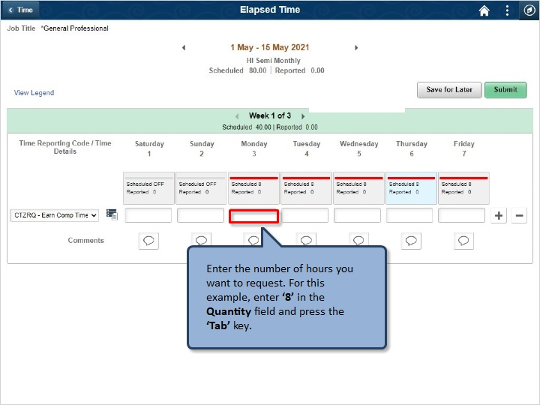

Enter the number of hours you want to request. For this example, enter ‘8’ in the Quantity field and press the ‘Tab’ key.

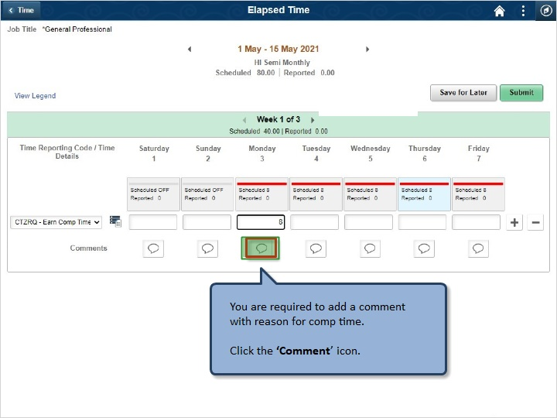

You are required to add a comment with reason for comp time.

Click the ‘Comment’ icon.

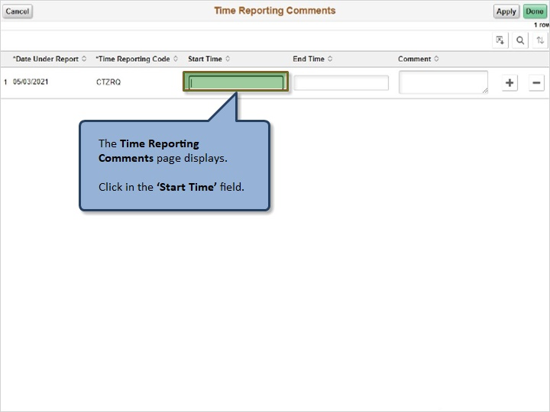

The Time Reporting Comments page displays.

Click in the ‘Start Time’ field.

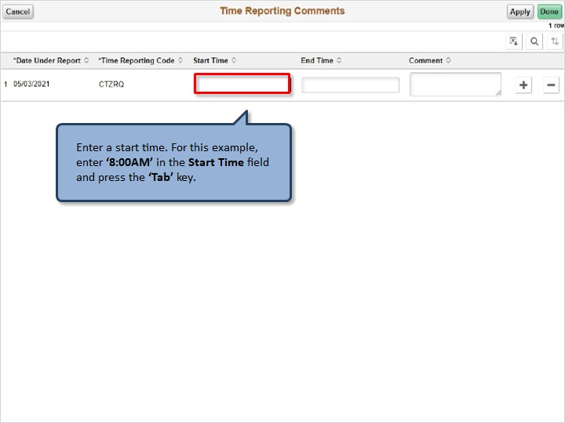

Enter a start time. For this example, enter ‘8:00AM’ in the Start Time field and press the ‘Tab’ key.

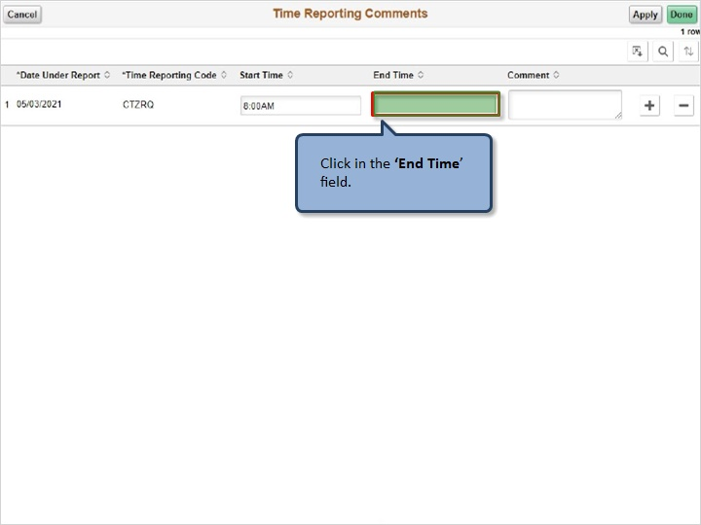

Click in the ‘End Time’ field.

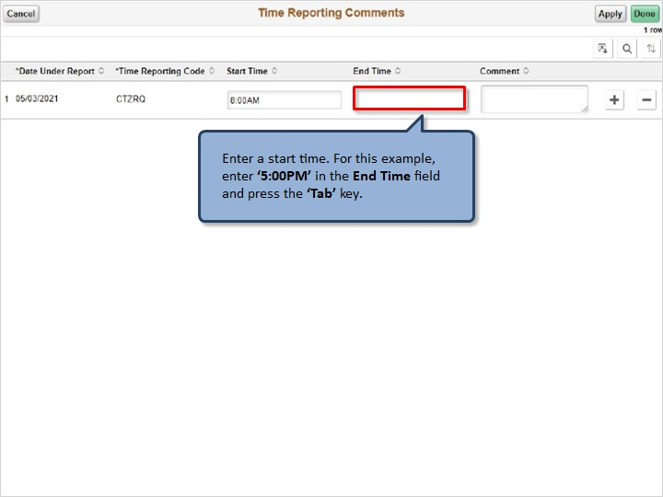

Enter a start time. For this example, enter ‘5:00PM’ in the End Time field and press the ‘Tab’ key.

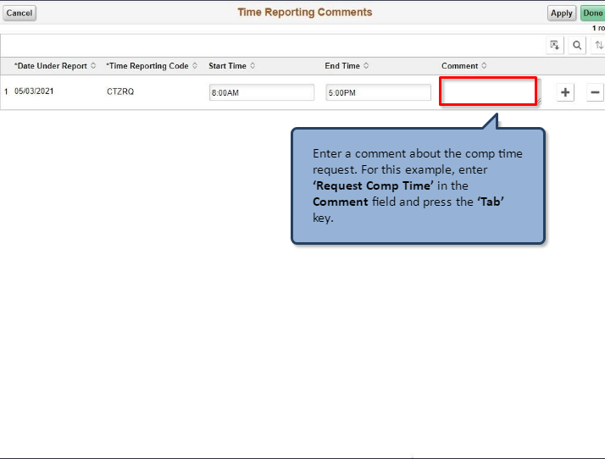

Enter a comment about the comp time request. For this example, enter ‘Request Comp Time’ in the End Time field and press the ‘Tab’ key.

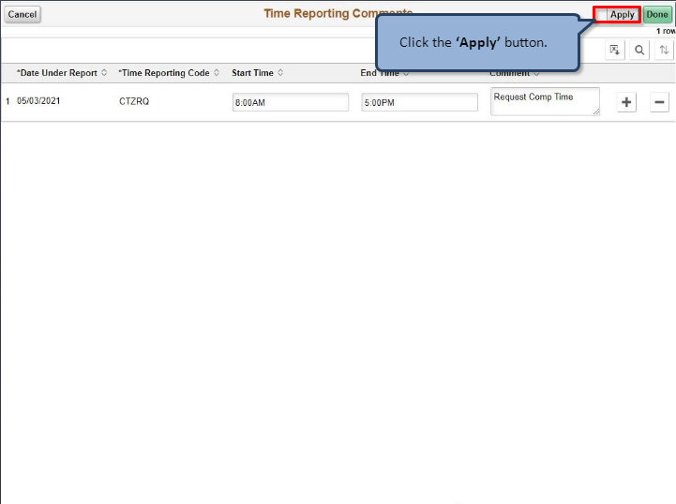

Click the ‘Apply’ button.

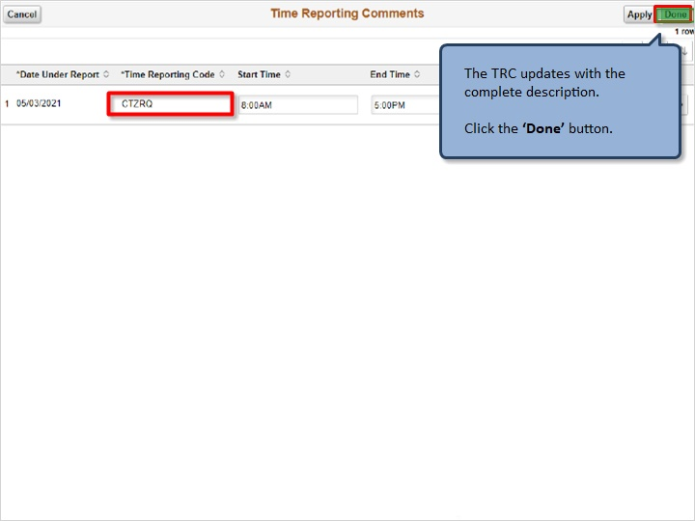

The TRC updates with the complete description.

Click the ‘Done’ button.

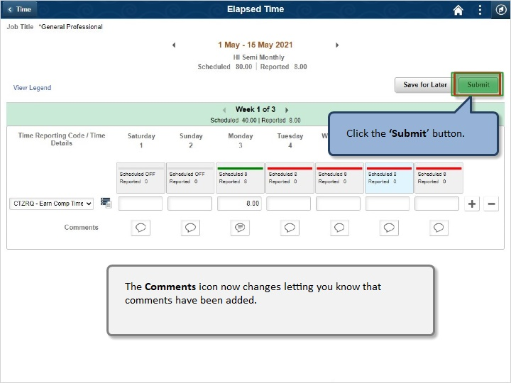

Click the ‘Submit’ button.

The Comments icon now changes letting you know that comments have been added.

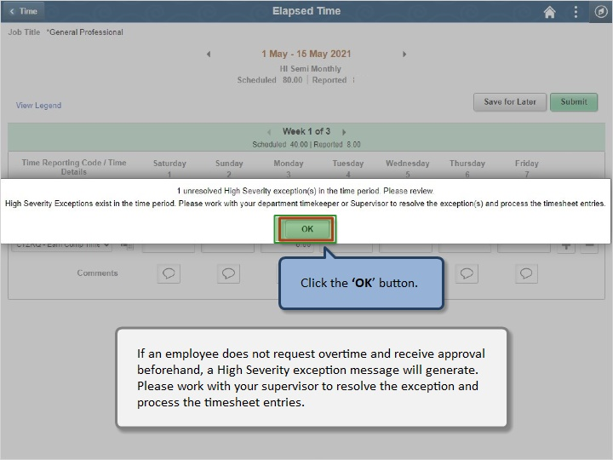

Click the ‘OK’ button.

If an employee does not request overtime and receive approval beforehand, a High Severity exception message will generate. Please work with your supervisor to resolve the exception and process the timesheet entries.

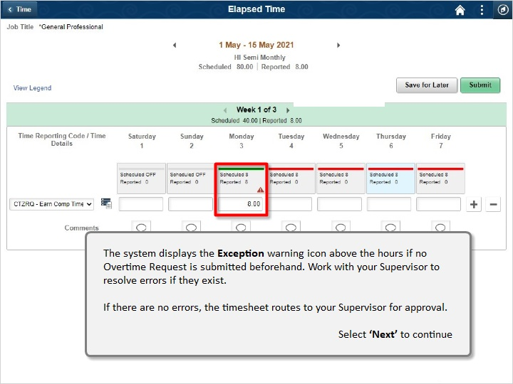

The system displays the Exception warning icon above the hours if no Overtime Request is submitted beforehand. Work with your Supervisor to resolve errors if they exist.

If there are no errors, the timesheet routes to your Supervisor for approval.

Congratulations!

You’ve successfully completed this lesson.

Comp Time Taken
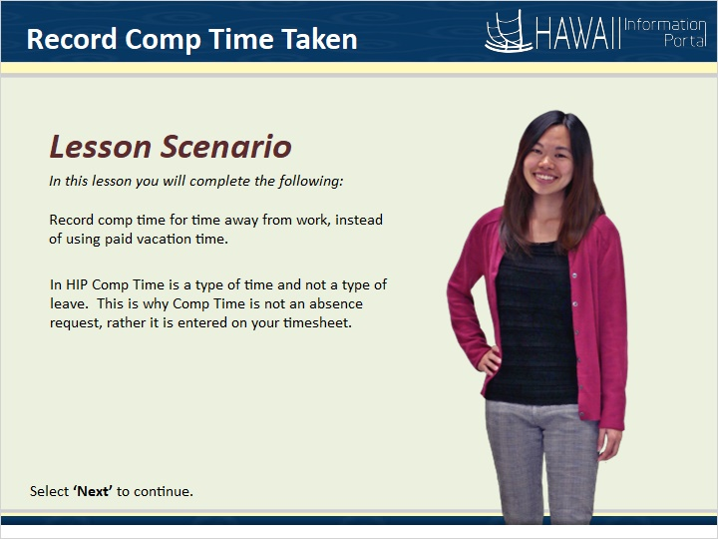

In this lesson you will complete the following:
Record comp time for time away from work, instead of using paid vacation time.
In HIP Comp Time is a type of time and not a type of leave. This is why Comp Time is not an absence request, rather it is entered on your timesheet.
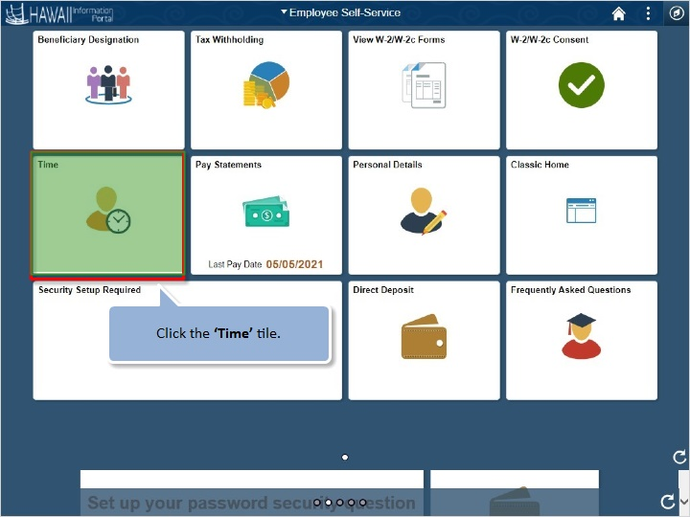

Click the ‘Time’ tile.

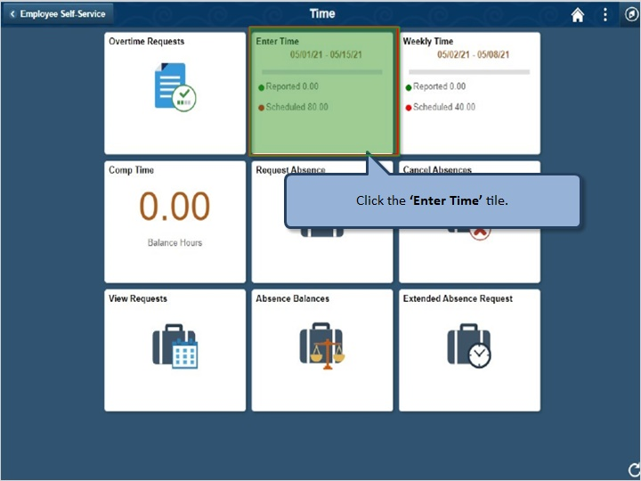

Click the ‘Enter Time’ tile.

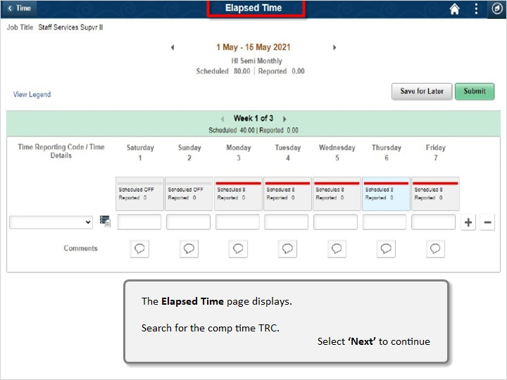

The Elapsed Time page displays.

Search for the comp time TRC.

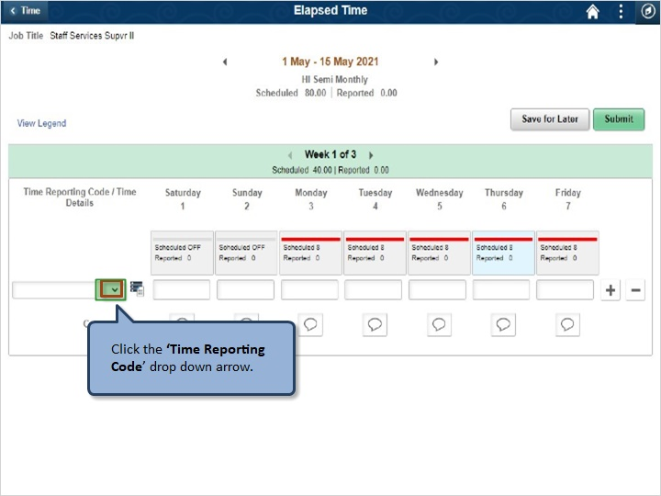

Click the ‘Time Reporting Code’ drop down arrow.

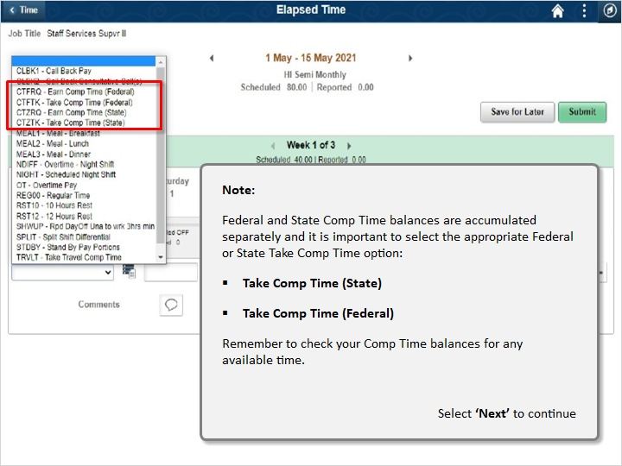

Note:
Federal and State Comp Time balances are accumulated separately, and it is important to select the appropriate Federal or State Earn Comp Time option:
- Take Comp Time (State)
- Take Comp Time (Federal)
Remember to check your CompTime balances for any available time.
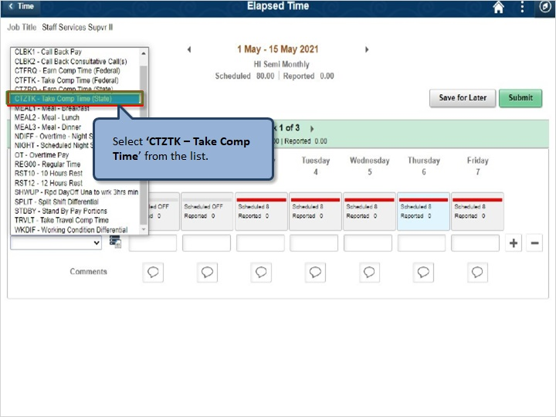

Select ‘CTZTK - Take Comp Time’ from the list.

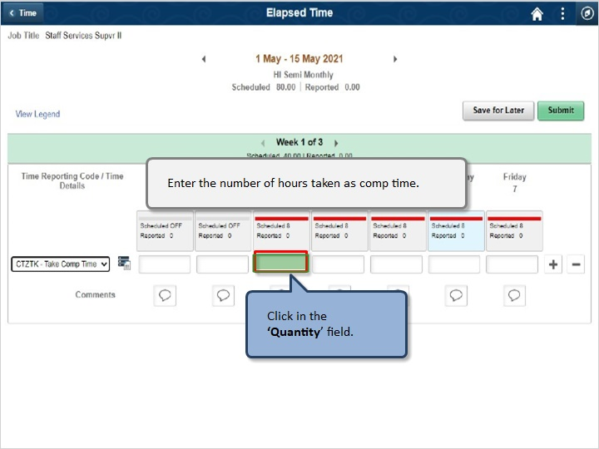

Enter the number of hours taken as comp time.

Click in the ‘Quantity’ field.

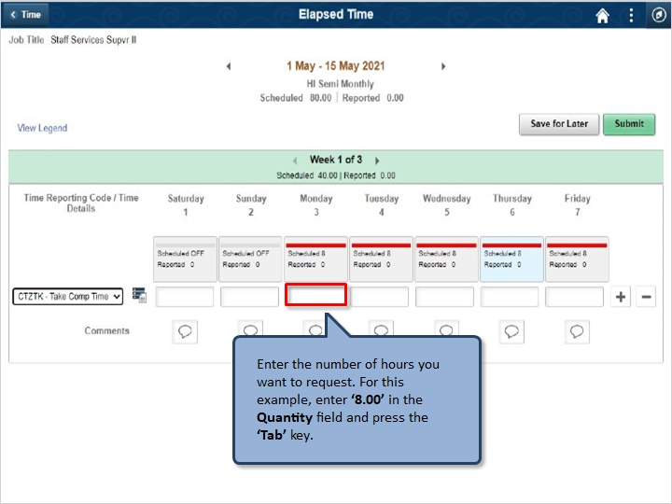

Enter the number of hours you want to request. For this example, enter ‘8’ in the Quantity field and press the ‘Tab’ key.

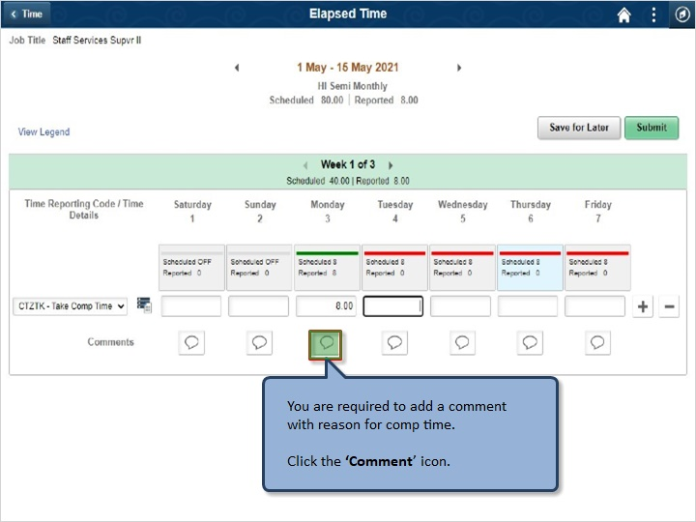

You are required to add a comment with reason for comp time.

Click the ‘Comment’ icon.

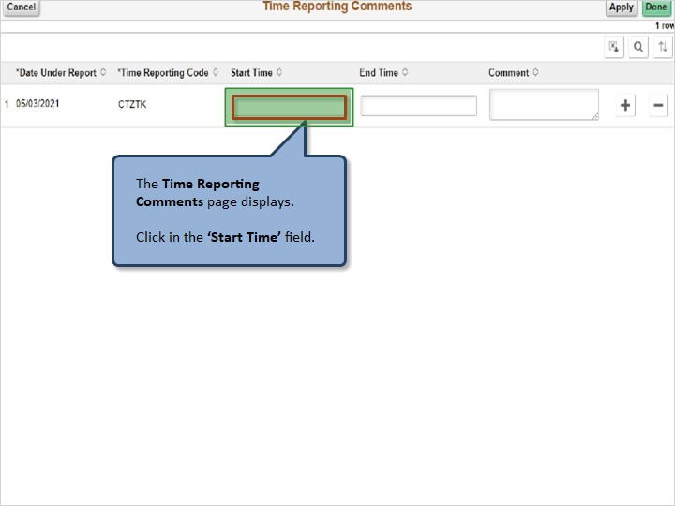

The Time Reporting Comments page displays.

Click in the ‘Start Time’ field.

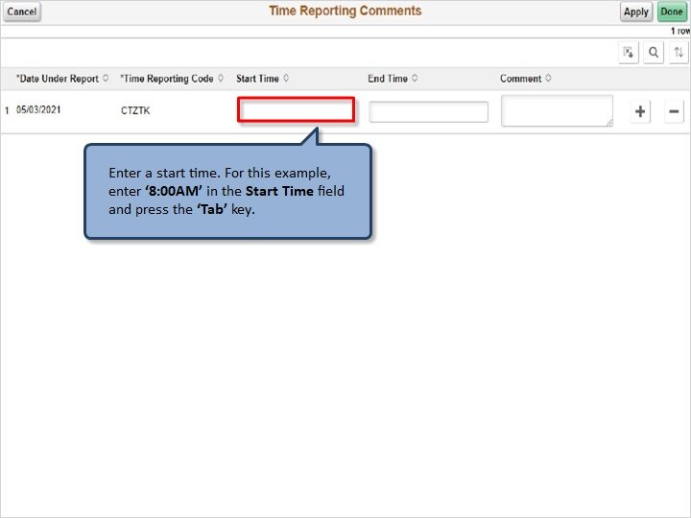

Enter a start time. For this example, enter ‘8:00AM’ in the Start Time field and press the ‘Tab’ key.

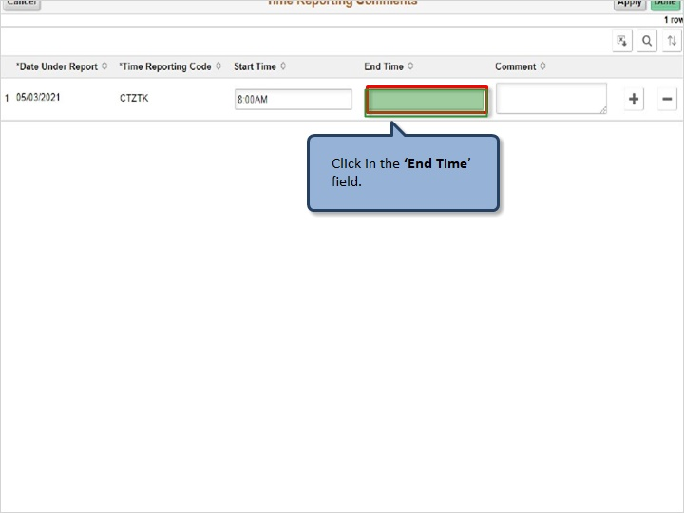

Click in the ‘End Time’ field.

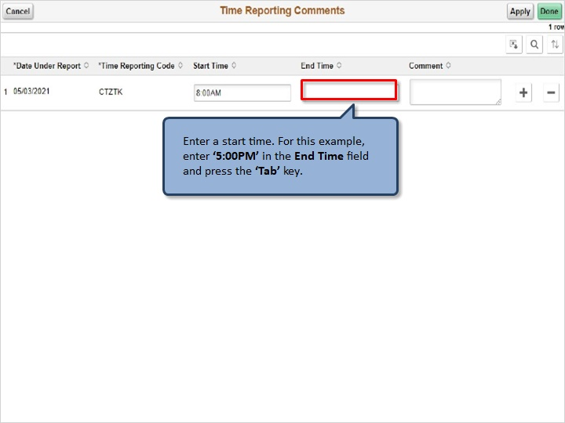

Enter a start time. For this example, enter ‘5:00PM’ in the End Time field and press the ‘Tab’ key.

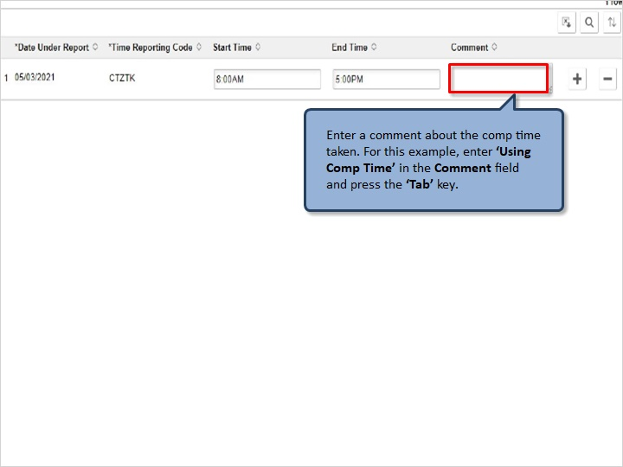

Enter a comment about the comp time taken. For this example, enter ‘Using Comp Time’ in the Comment field and press the ‘Tab’ key.

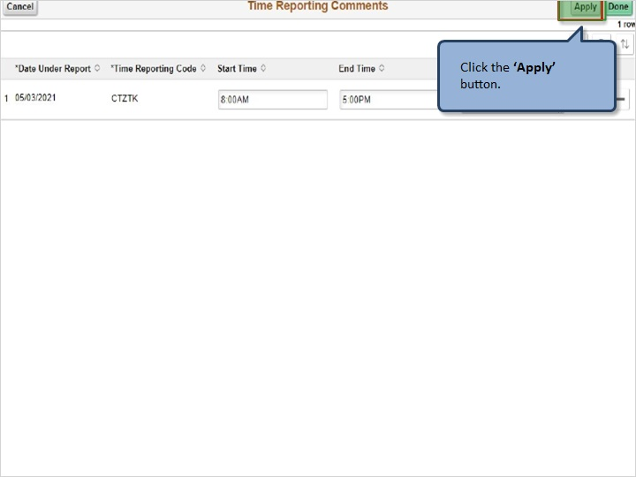

Click the ‘Apply’ button.

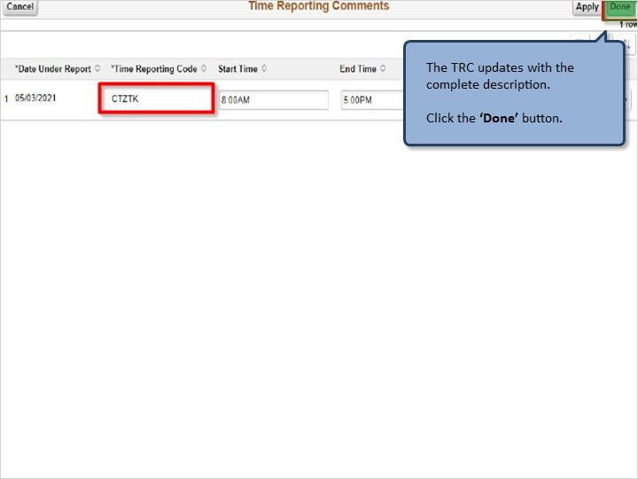

The TRC updates with the complete description.

Click the ‘Done’ button.

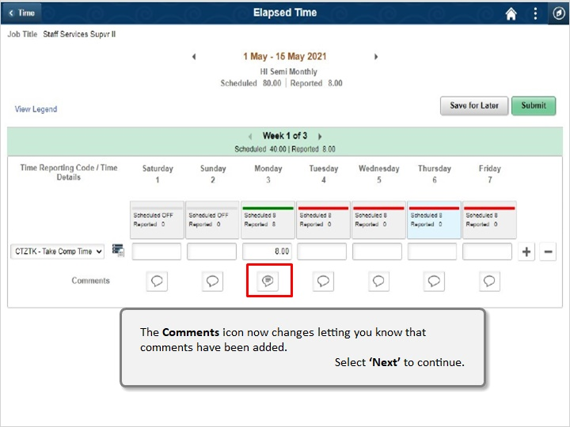

The Comments icon now changes letting you know that comments have been added.

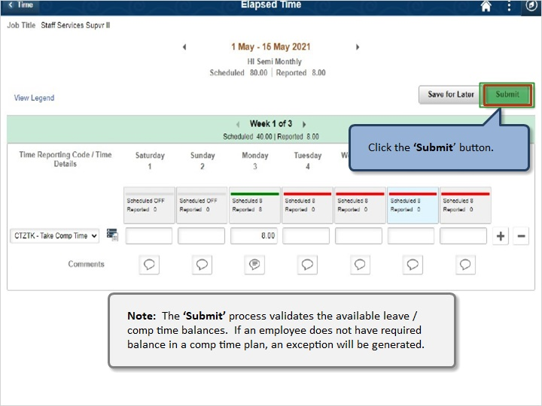

Click the ‘Submit’ button.

Note: The ‘Submit’ process validates the available leave / comp time balances. If an employee does not have required balance in a comp time plan, an exception will be generated.

Congratulations!

You’ve successfully completed this lesson.

Comp Time Balances
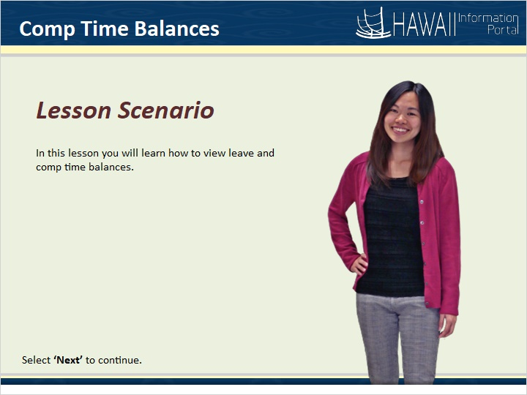

In this lesson you will learn how to view leave and comp time balances.

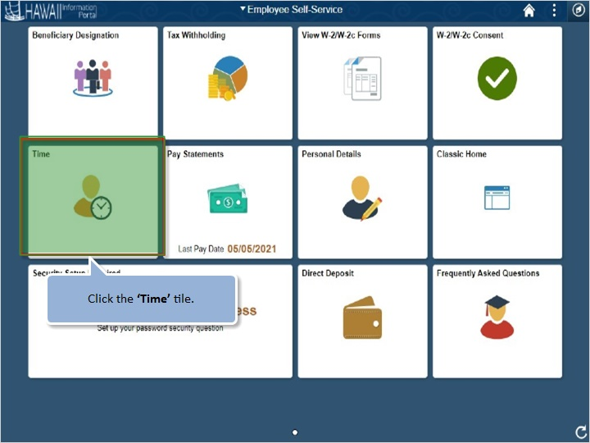

Click the ‘Time’ tile.

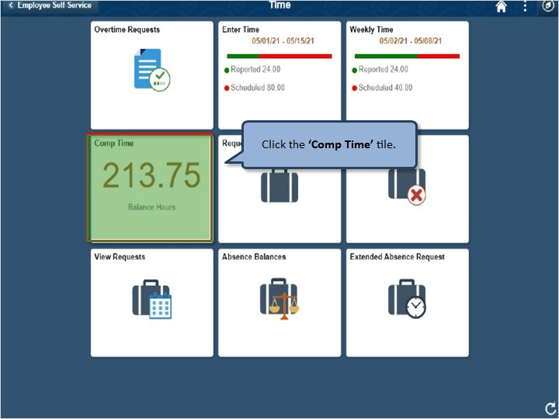

Click the ‘Comp Time’ tile.

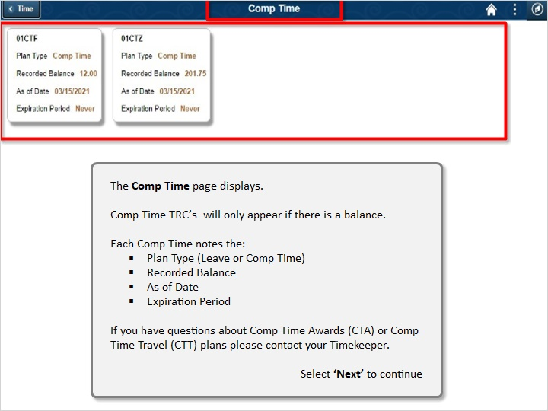

The Comp Time page displays.

Comp Time TRC’s will only appear if there is a balance.

Each Comp Time notes the:
- Plan Type (Leave or Comp Time)
- Recorded Balance
- As of Date
- Expiration Period
If you have questions about CompTime Awards (CTA) or Comp Time Travel (CTT) plans please contact your Timekeeper.
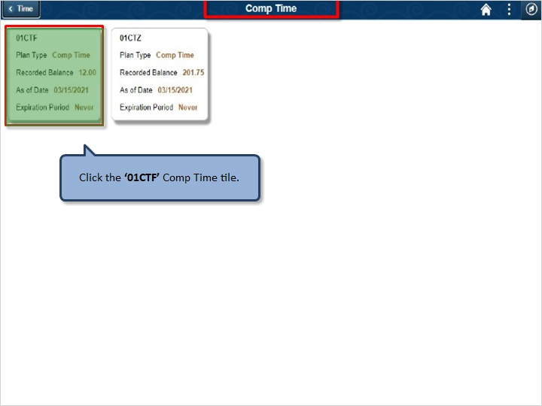

Click the ‘01CTF’ Comp Time tile.

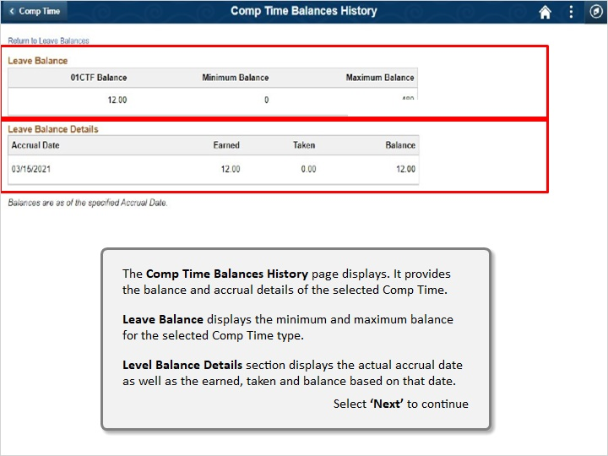

The Comp TIme Balances History page displays. It provides the balance and accrual details of the selected Comp Time.

Leave Balance displays the minimum and maximum balance for the selected Comp Time type.

Level Balance Details section displays the actual accrual date as well as the earned, taken and balance based on that date.

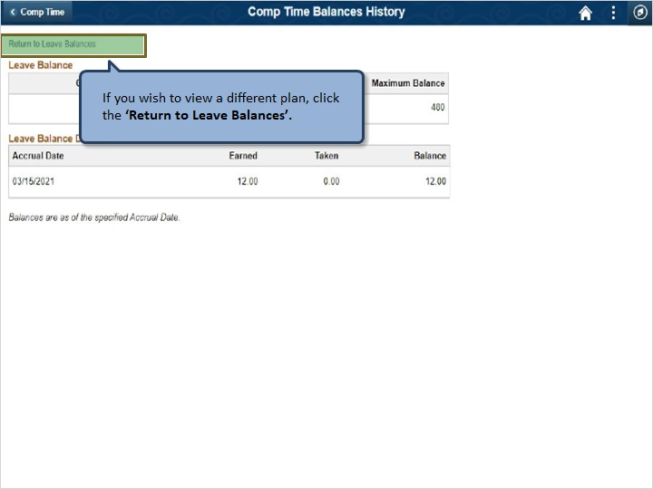

If you wish to view a different plan, click the ‘Return to Leave Balances’.

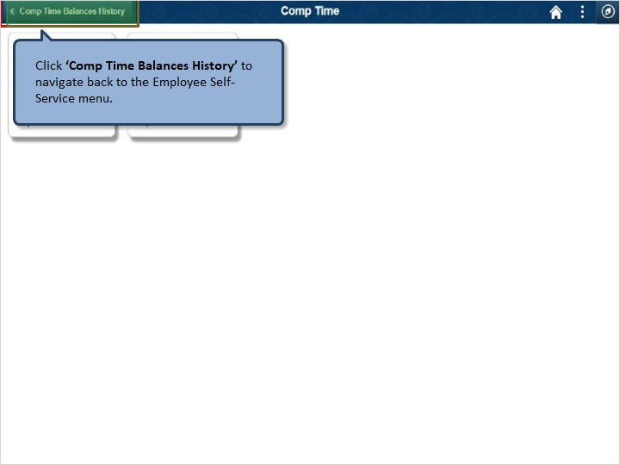

Click ‘Comp Time Balances History’ to navigate back to the Employee Self-Service menu.

Congratulations!

You’ve successfully completed this lesson.

End

