Time & Leave – Employee Self Service Extended Absence Request
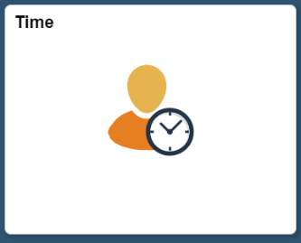
Below is the process for an employee to request an extended absence. This process is used for eligibility purposes and to start communication with your HR office.
- Time Tile: Employee will start on the Employee Self Service screen and click on the Time tile.

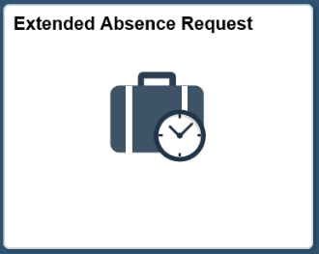
- Request Extended Absence: Employee can request an absence using the Extended Absence Request tile.
- Employee will click on the sign to initiate a new request.

- The following screen should appear:
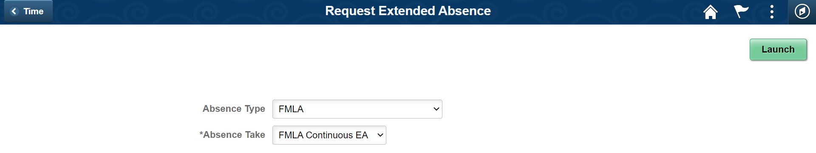
6. Click Launch.
5. Select the appropriate Absence Take. The options are programmed based on the Absence Type selected.
4. Select the Absence Type.
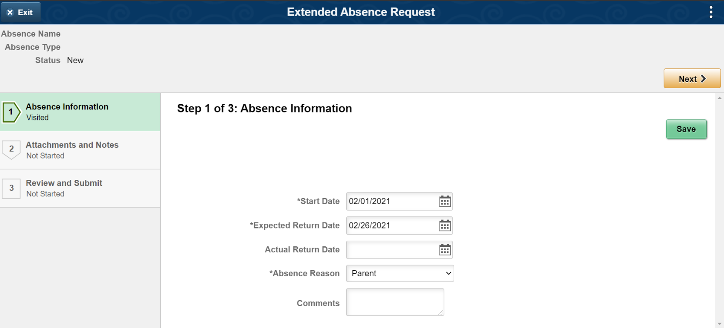

11. Click ‘Next’ to continue with the request.
10. Click ‘Save’ to save part 1 of this request.
9. Input a comment for your HR Admin to review per your departmental standards.
8. Select the appropriate Absence Reason.
7. Input the Start and Expected Return Date (also known as the last day of leave).

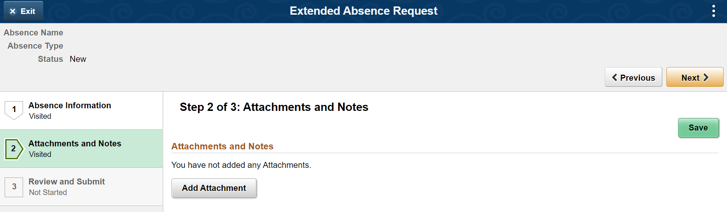
13. Click ‘Next’ to continue with the request.

12a. Click ‘Save’ to save Part 2 of the request. If you have attachments, please ensure that you save, otherwise the attachments will not appear with the submission.
12. You can add an attachment here. Follow your department’s procedures on what documentation you need.

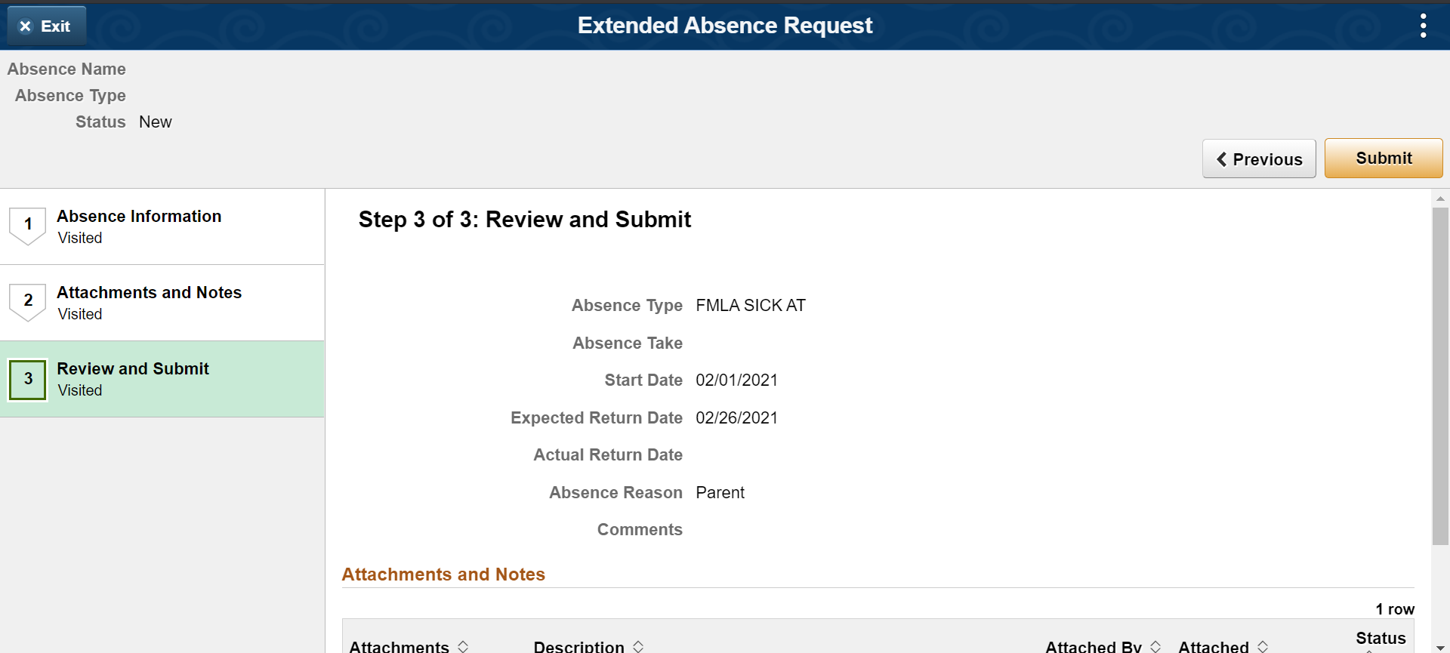

15. Click ‘Submit’ to submit the request to your HR Admin.
14. Review all the information prior to submitting. Attachments will appear at the bottom of the screen.

