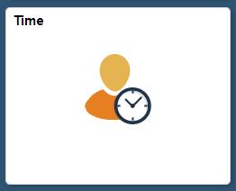

1. Click on the **Time** tile

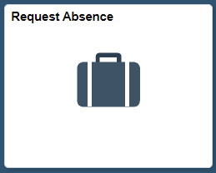

1. Click on the **Request Absence** tile

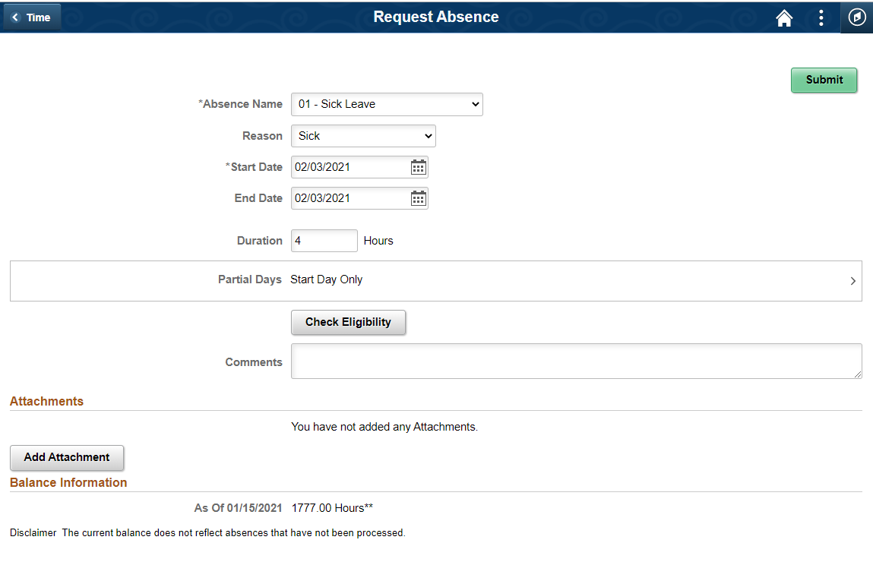

9) Click **Check Eligibility**. It will tell you if you have enough hours to take the leave.

10) **Click Submit.** You’ll get an email once it’s approved that will include any of your supervisor’s comments.

3) Pick the type of leave you’re taking as Absence Name

7) Enter any comments you’d like your supervisor to see.

6) If you’re taking leave for a portion of a day, click on Partial Days, select which partial day you want to take, and enter the number of hours. It will populate the Duration box based on your selection.

8) Add any attachments that are applicable such as a parent teacher conference form or a doctor’s note, if applicable. Skip this step if you don’t have an attachment

5) Pick your start and end dates; if only one day, use the same date.

4) Pick the reason for your absence which will pop-up after selecting Absence Name