Time & Leave – Compensatory Time Off
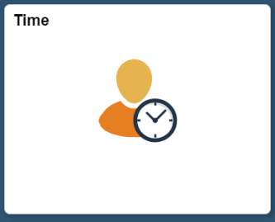
Below is the process for an employee to input earned and taken compensatory time off. Comp Time is considered as a type of time as opposed to a type of leave and can be used in lieu of paying overtime.
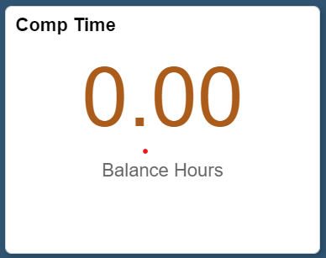
- Time Tile: Employee will start on the Employee Self Service screen and click on the Time tile.

- Viewing Comp Time Balance: Employee can view their current Comp Time balance by using the Comp Time tile.
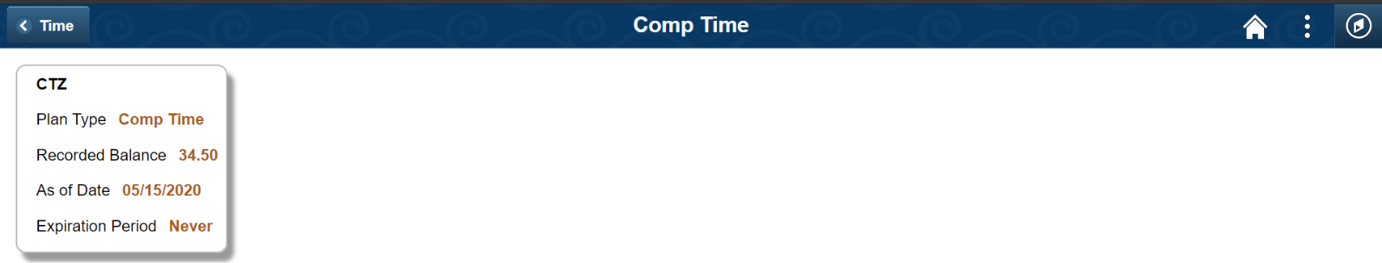
  - If an employee has a Comp Time balance, they will see a screen like below:
  - If no balance, there will be nothing to display.
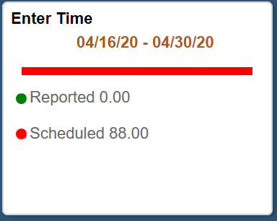
  - Enter Time: Employee will enter Time Reporting Code (TRC) to report earned and/or used Comp Time using the Enter Time tile.
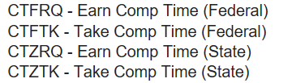
  - Employee will see the following Comp Time codes:
  - Depending on the employee’s bargaining unit, the TRC will be named differently, but the base CTZ (State) and CTF (Federal) code will be in the name.
  - Employee will then submit their timesheet for supervisory approval.
- What is the difference?
  - CTZRQ (State) (or equivalent bargaining unit code) earned Comp Time is used when the employee works more than 8 hours during the workday.
  - CTFRQ (Federal) (or equivalent bargaining unit code) earned Comp Time is used when the employee works more than 40 hours in the workweek.
  - State and Federal Comp Time balances are held separately.
- How does Employee use Comp Time? Employee will request Comp Time off per their departmental procedures, and then will enter the CTZTK or CTFTK (or equivalent code depending on the bargaining unit) TRC on their timesheet for supervisory approval.

