Time & Leave – Entering Time for Salaried Employees
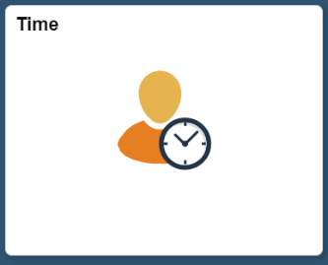
Below is the process for a salaried employee to enter time in HIP. Salaried employees only need to report ‘Exceptions’ to their regular time (e.g. Overtime, differentials, etc.). If there are no exceptions reported, the employee will be paid their base salary for the pay period.
- Time Tile: Employee will start on the Employee Self Service screen and click on the Time tile.

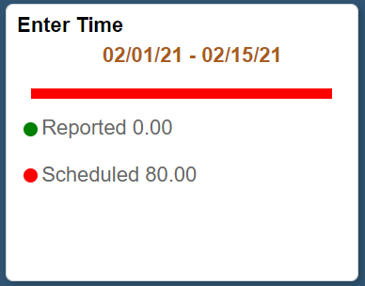
- Enter Time: Employee will use the Enter Time tile to enter any exceptions that they may have reported in the pay period.

- Employee will then enter the appropriate Time Reporting Codes (TRCs) onto their timesheet. To add multiple rows of TRCs onto their timesheet, they will click on the sign to add a row.
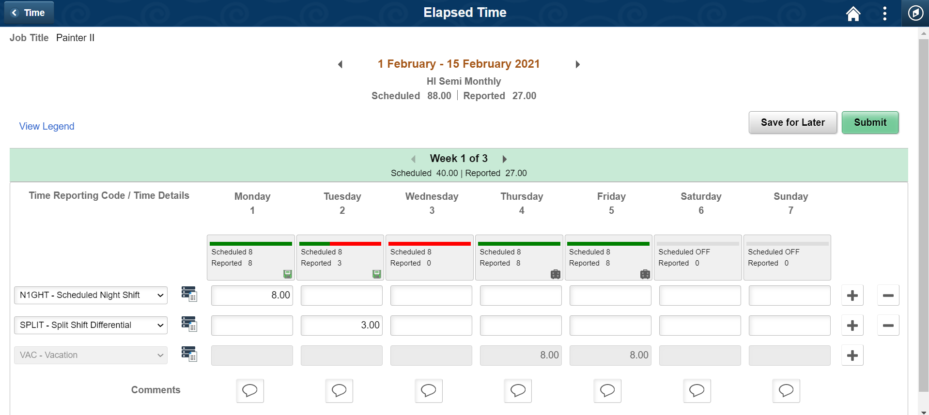
  - Note: Time Reporting Codes (TRCs) available to employees will be dependent on what Bargaining Unit they are a part of.
5. Click on the comment box to insert a comment for each TRC applied that day.
4. Input the number of hours (or portions for Stand By Pay) for each day the TRC is applied. The TRC carries over to each week.
Note: Toggle between pay periods here. You can also click on the orange text to bring up a calendar to pick dates.
Note: Toggle between weeks in the pay period here.
Note: Approved leave requests will appear in gray on the timesheet.
Note: If multiple TRCs are needed, click on the “+” to add a new row.
6. Click ‘Submit’ to submit your timesheet for supervisory approval.
3. Click on the drop-down field here to insert a TRC.

