Time & Leave – Overtime Process
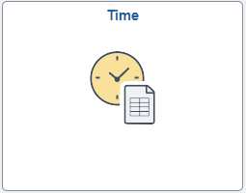
Below is the process for the employee to request overtime in HIP. If there is additional documentation or departmental approvals needed for budgetary purposes, the employee and supervisor need to complete that in addition to the below process.
- Time Tile: Employee will start on the Employee Self Service screen and click on the Time tile.
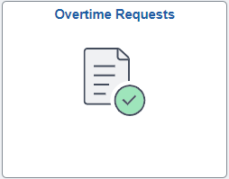
- Overtime Request: Employee will use the Overtime Requests tile to request the overtime.
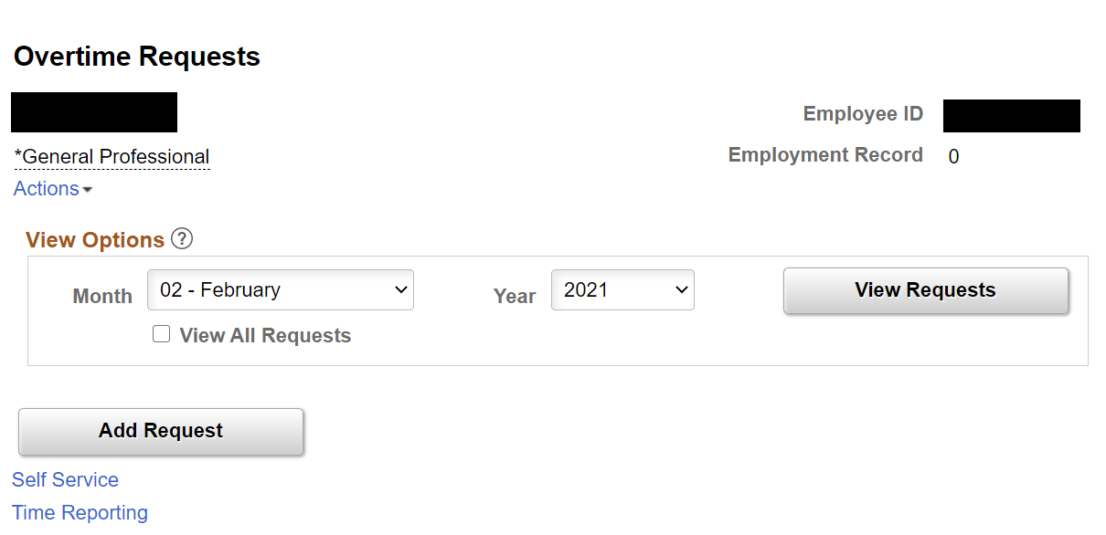

3. Click on ‘Add Request’ to add an overtime request.
Note: You can click on ‘View Requests’ to see previous overtime requests.

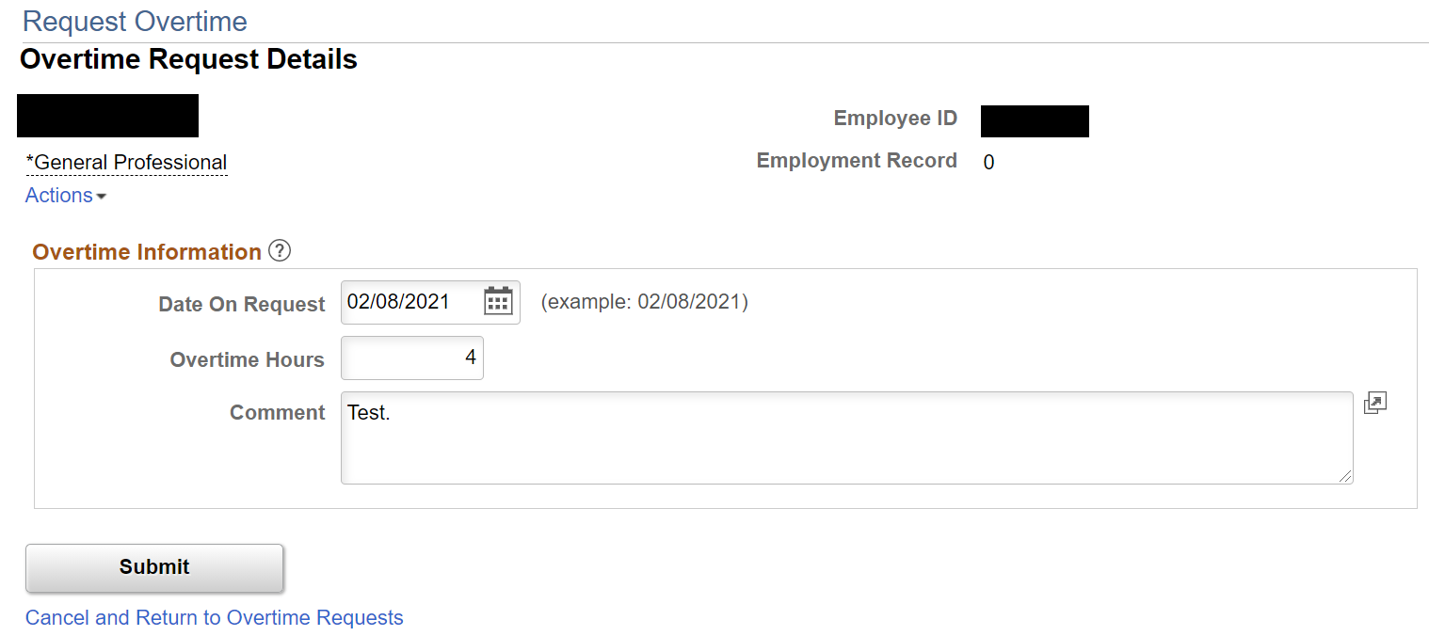

4. Input the date of the request. The date must be the present date or a future date. Note that Overtime Requests to be inputted on a per-day basis.

5. Put in the number of hours.
7. Click ‘Submit’ to submit the request for your supervisor’s approval.
6. Input a comment for your supervisor’s review per your departmental standards.

- Enter Time: Once the overtime request is approved, employee will then enter the overtime onto the timesheet.
  - Note: If the Overtime Request was not submitted/approved, a high-level exception on the timesheet will appear for the overtime reported, and the Supervisor/Timekeeper will need to allow the exception before the supervisor is able to approve the timesheet.
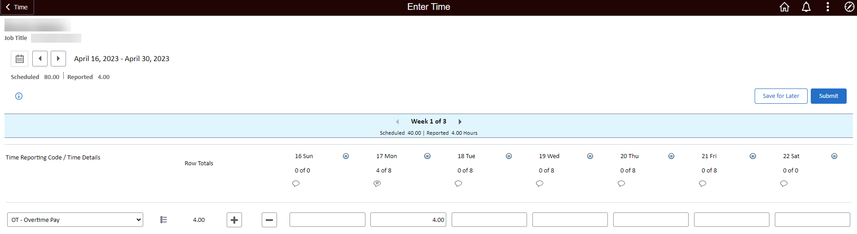
11. Click ‘Submit’ to submit the timesheet for supervisory approval.

9. Select the Overtime Pay TRC.

10. Input the hours and comment.

  - Employee will see the below message if overtime was reported on the timesheet without approved Overtime Request.
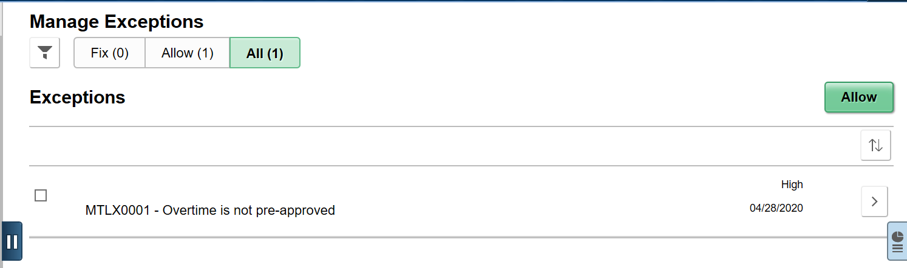
  - Supervisor/Timekeeper will need to allow the exception before the supervisor can approve the employee’s timesheet.

