Supervisors will be required to approve timesheets (also known as Payable Time), all requests for Overtime/Compensatory Time, and all leave requests. There will be two ways in which supervisors will be notified that they have something to approve.
- Supervisors who have a State email address will receive an email from noreply@notify.hip.hawaii.gov. Supervisors will receive an email that has summary information about what needs to be approved as well as a link that will take them to logon to HIP and then to see the transaction. The supervisor will follow the link provided in the email. If a supervisor fails to take action, they’ll also get a daily reminder email each evening.
SAMPLE
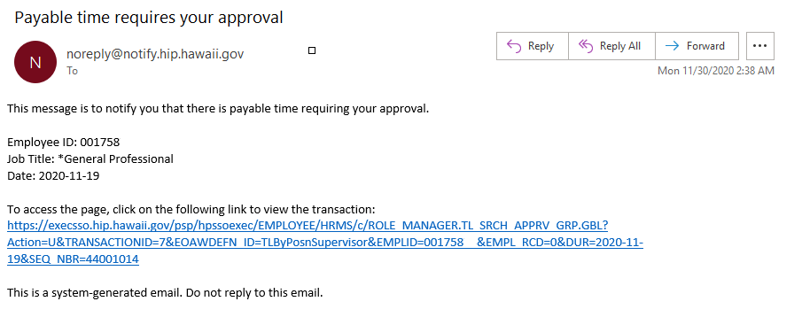
- Any supervisor may also logon to HIP and check their Approvals tile at any time to see what is pending for them to approve. The menu at the top should be toggled to “Manager Self-Service” to see the Approvals tile. Once the tile is clicked a list of items pending approval will display. A supervisor may click on any item on the list to open it and take action.
The number on the tile shows how many pending approvals there are
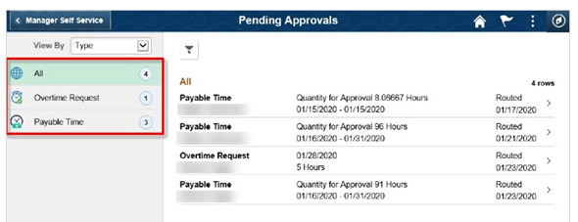
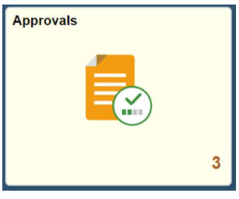

Click on any row to take action

