**Approve Extended Absence – HR Administrator**

1. Approve extended request by navigating to *Manager Self Service> Approvals*

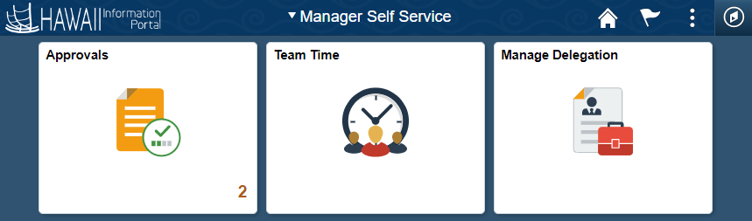

1. Select the **Extended Absence**

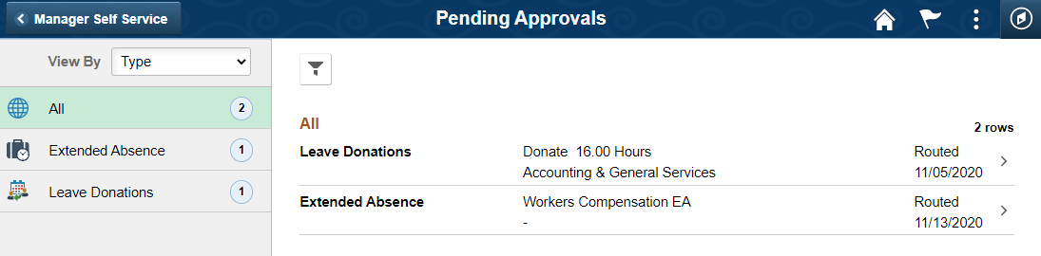

1. Click **Approve**
   * Or you may also Pushback the request if necessary

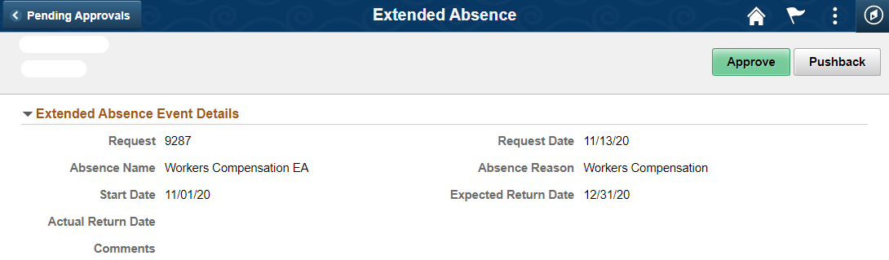

1. You may also add comments then click **Submit**

