Administer Extended Absence – HR Administrator

This “Administer Extended Absence” guide is used by HR Administrators when an extended leave has already been approved by the Department and they need to subsequently record leave takes against that extended leave record. For instance, employee X has been approved for Workers’ Compensation for the period of 11/1/2020 to 12/31/2020. These are the steps they would take to record the employee’s Workers’ Compensation Leave days off, totaling 24 hours from 11/1 to 11/5. Days off must be recorded accurately against the extended leave approval so that there’s a history of when the employee was not at work.

- Navigate to NavBar> Navigator> Global Payroll & Absence Mgmt> Payee Data> Maintain Absences> Administer Extended Absence

- Search for employee the click Edit

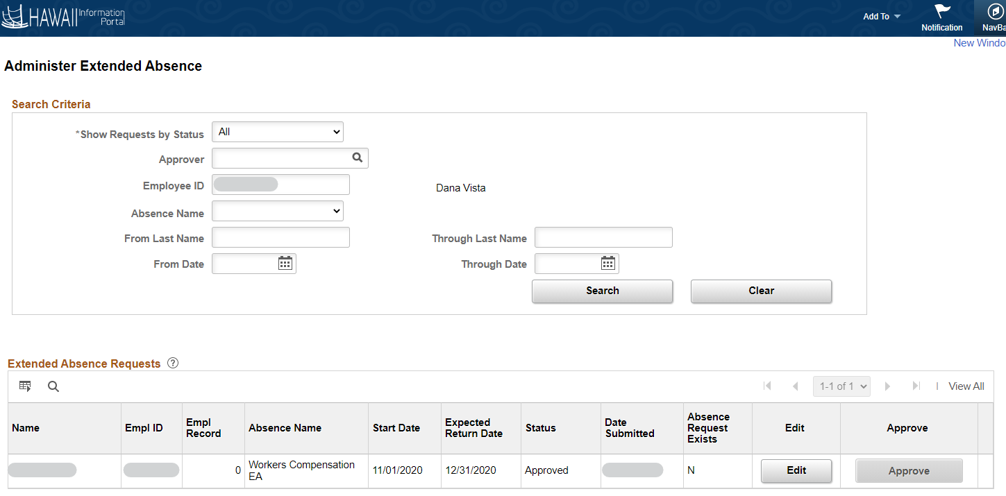

- Click Add New Absence

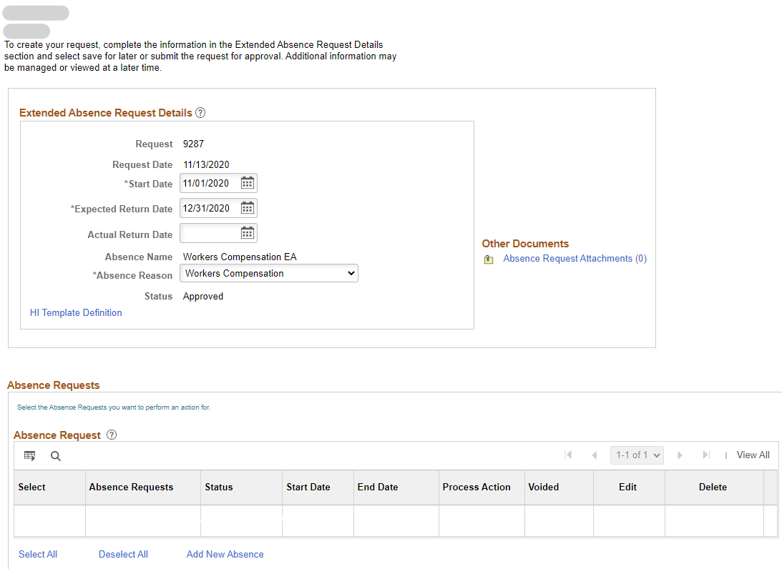

- Complete the Details section of the page
  - In this example, HR is supplementing Workers’ Comp vacation leave

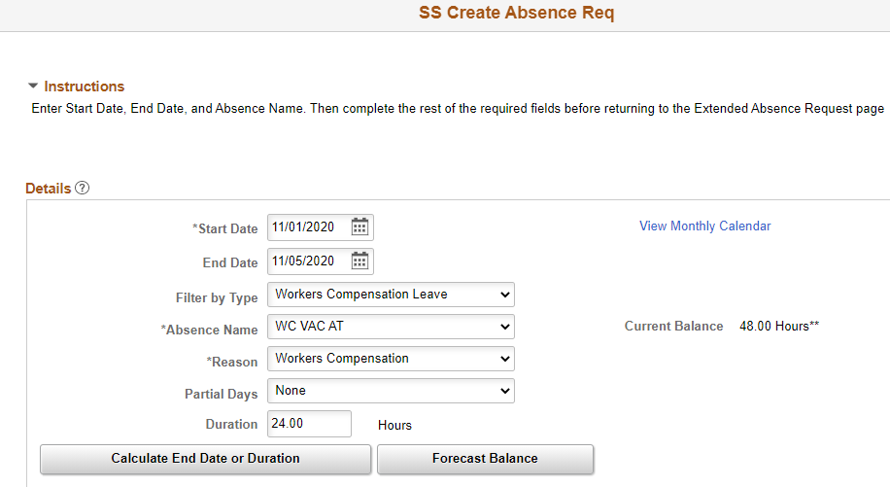

- Click Calculate End Date or Duration then Forecast Balance

- Click OK and it will return to Administer Extended Absence > Request Extended Absence Page

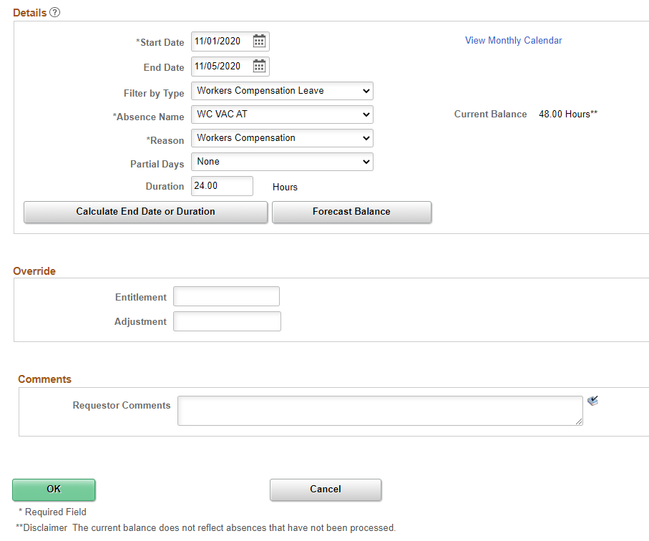

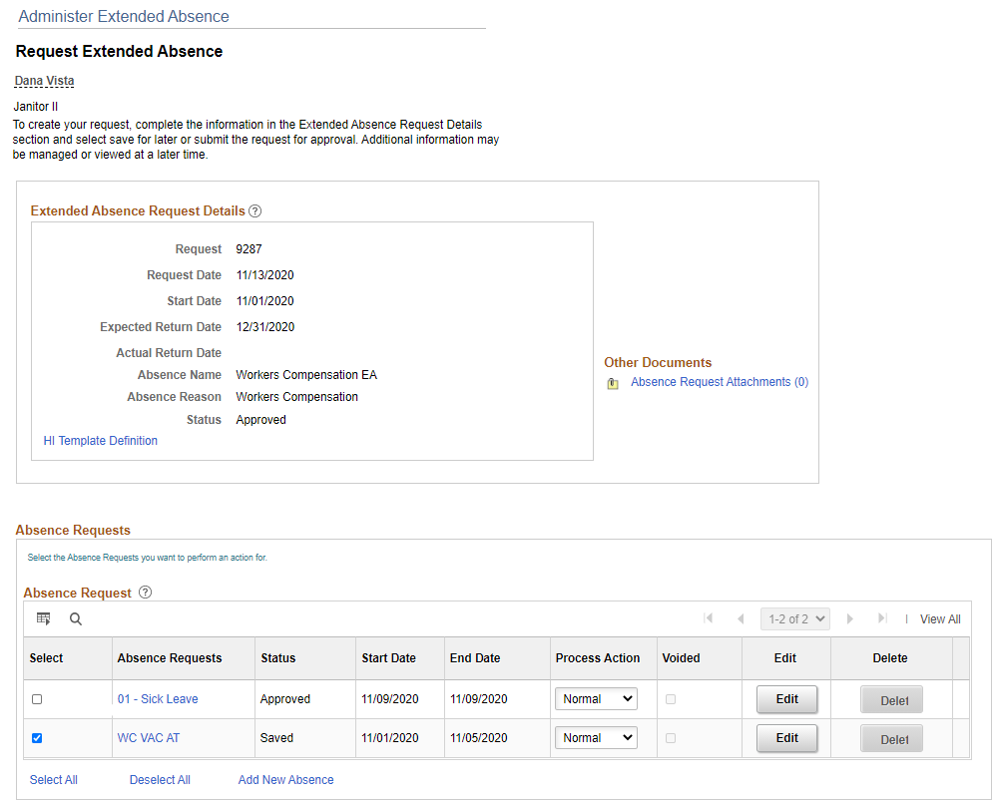

- Select the supplemental Absence Request then click Submit

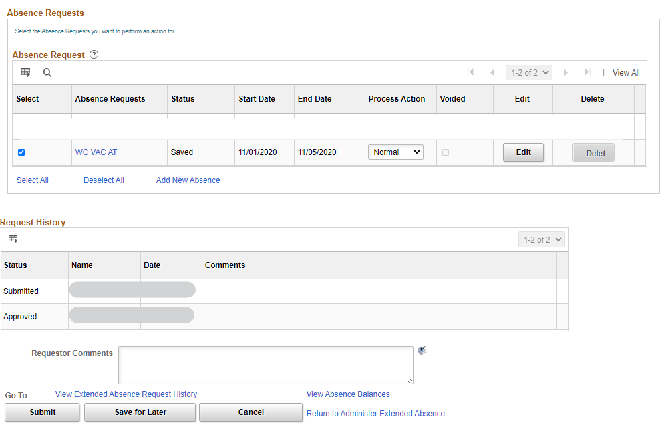

- Click Yes to confirm

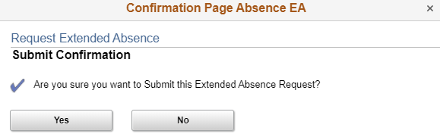

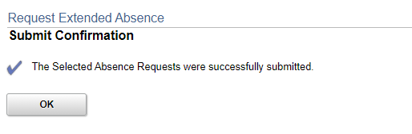

- Approve the supplemental Absence Request by navigating back to Manager Self Service> Approvals

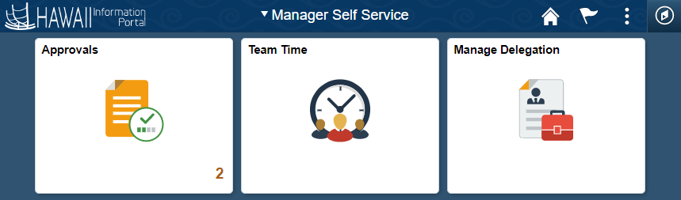

- Select the Absence Request

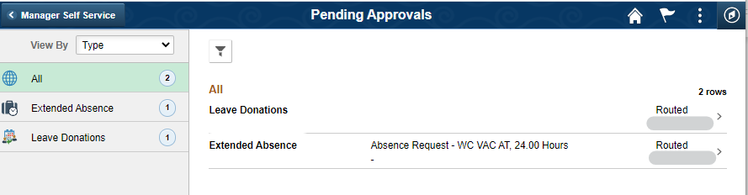

- Review then click Approve

