120 ABSENCE Management - Leave Keeper
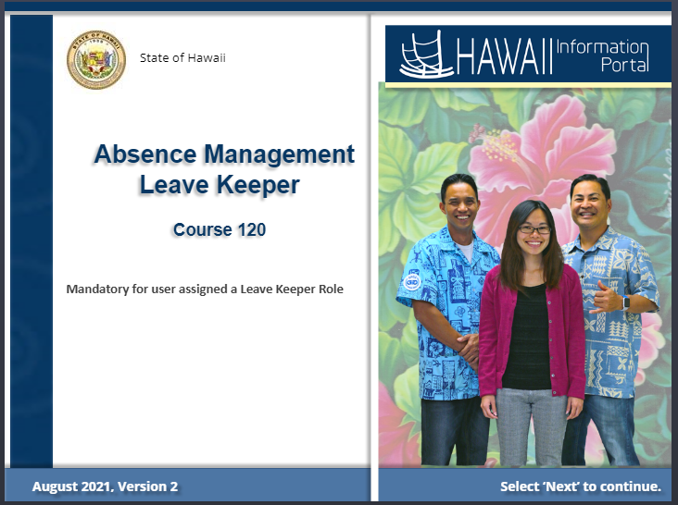

Duration


This course will take approximately 2 -3 hours.

You can complete it all today or by sections as needed.

It’s really up to you.

You can take the training how it best fits in your schedule.

Preparation
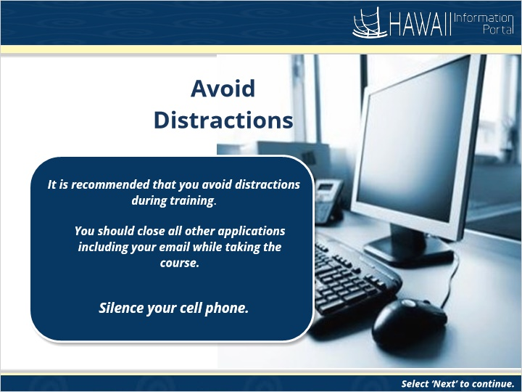

Avoid Distractions

It is recommended that you avoid distractions during your training session. You should close all other applications including your email while taking the course and silence your cell phone.

Table of Contents
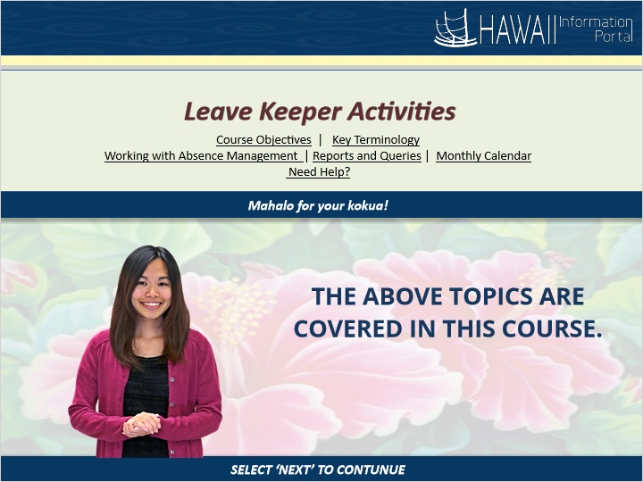

Leave Keeper Activities
Course Objectives
Key Terminology
Working with Absence Management
Reports and Queries
Monthly Calendar
Need Help?

Course Objectives
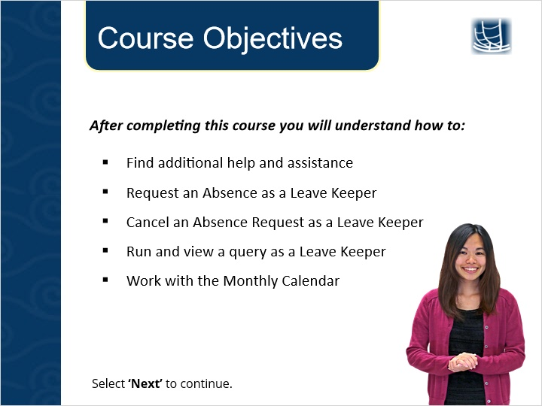

After completing this course you will understand how to

- Request an Absence as a Leave Keeper
- Cancel an Absence Request as a Leave Keeper
- Run and view a query as a Leave Keeper
- Work with the Monthly Calendar

Need Help?
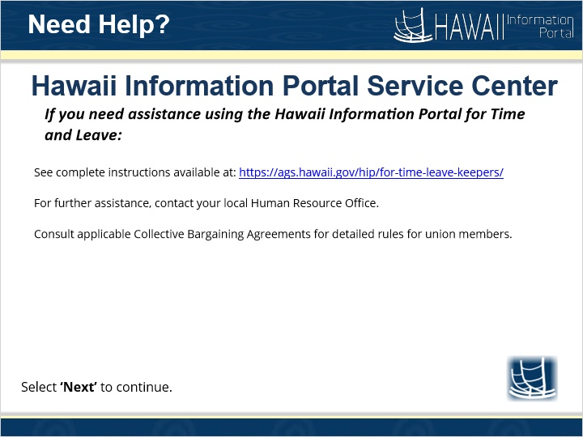

See complete instructions available at: https://ags.hawaii.gov/hip/for-time-leave-keepers/

For further assistance, contact your local HR Office.

Consult applicable Collective Bargaining Agreements for detailed rules for union members.

Key Terminology
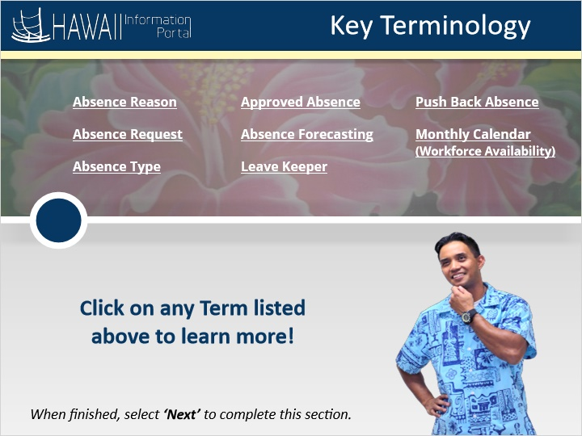

Absence Reason
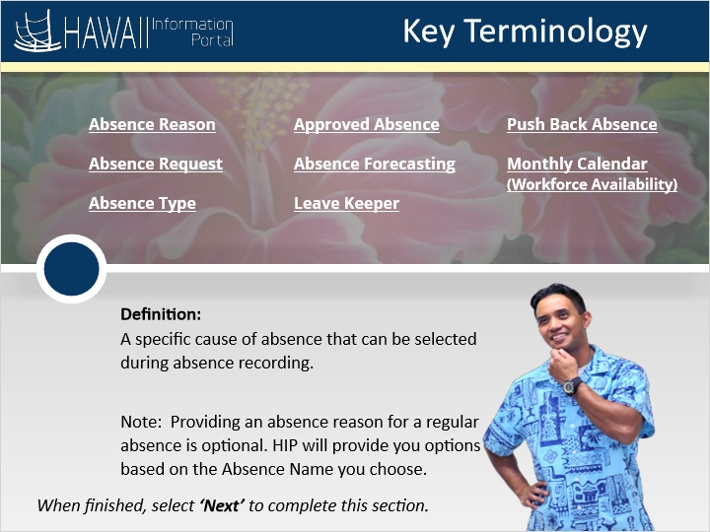

Absence Reason-A specific cause of absence that can be selected during absence recording. Note: Providing an absence reason for a regular absence is optional. HIP will provide you options based on the Absence Name you choose.

Absence Request
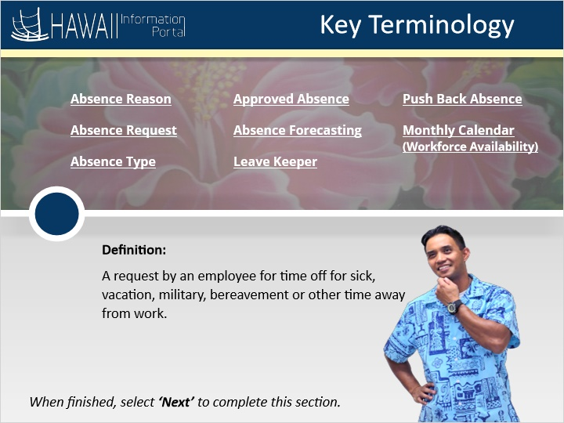

Absence Request-A request by an employee for time off for sick, vacation, military, bereavement or other time away from work.

Absence Type
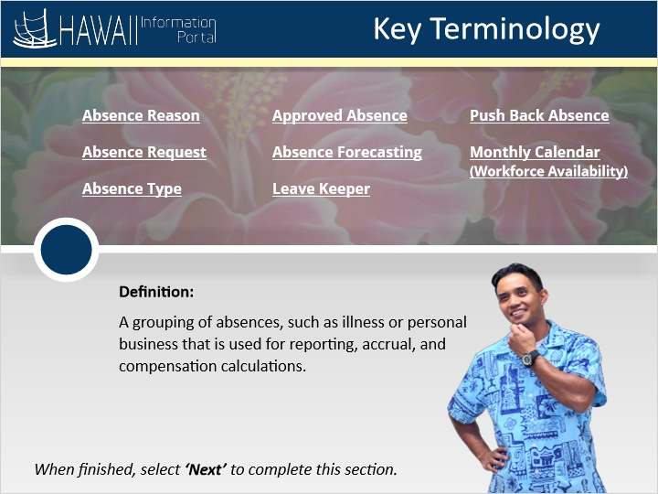
Absence Type - A grouping of absences, such as illness or personal business that is used for reporting, accrual, and compensation calculations.

Approved Absence
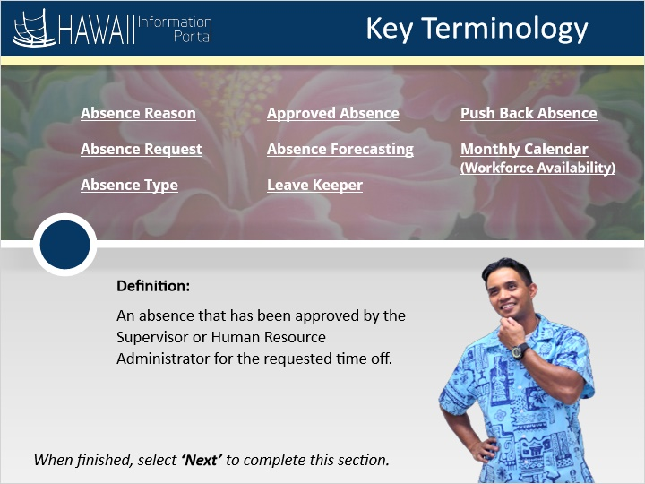

Approved Absence - An absence that has been approved by the Supervisor or Human Resource Administrator for the requested time off.

Absence Forecasting
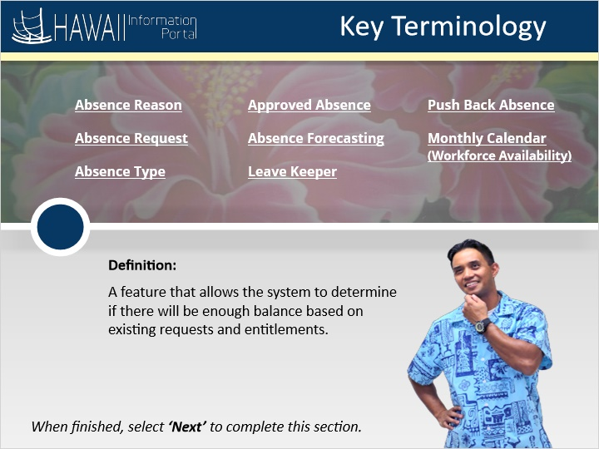

Absence Forecasting - A feature that allows the system to determine if there will be enough balance based on existing requests and entitlements.

Leave Keeper
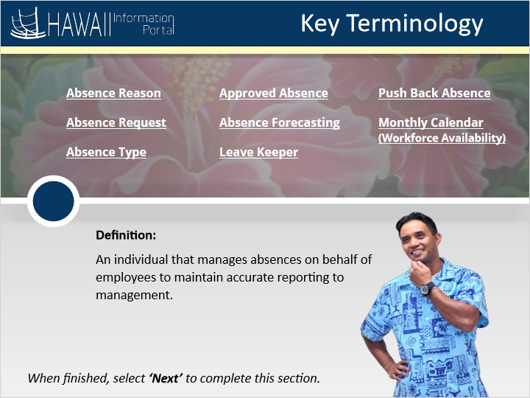

Leave keeper - An individual that manages absences on behalf of employees to maintain accurate reporting to management.

Push Back Absence
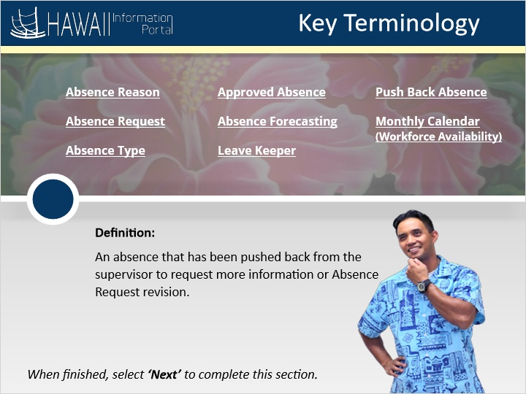

Push Back Absence - An Absence that has been pushed back from the supervisor to request more information or absence request revision.

Monthly Calendar Workforce Availability
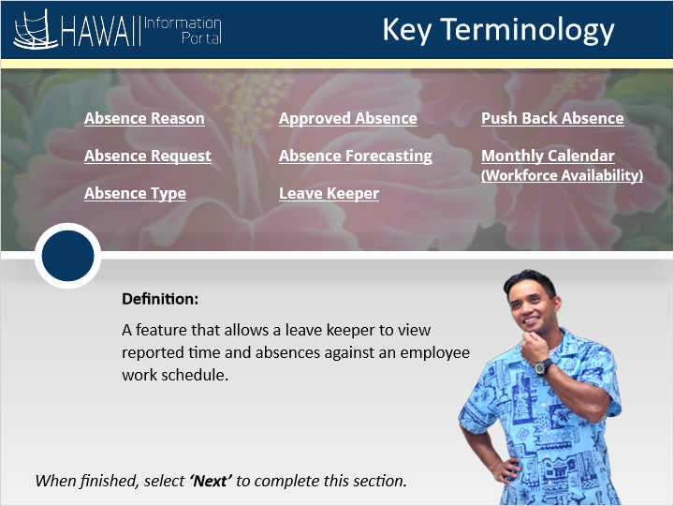

Monthly Calendar (Workforce Availability) - A feature that allows a leave keeper to view reported time and absences against an employee work schedule.

Working with Absence Management
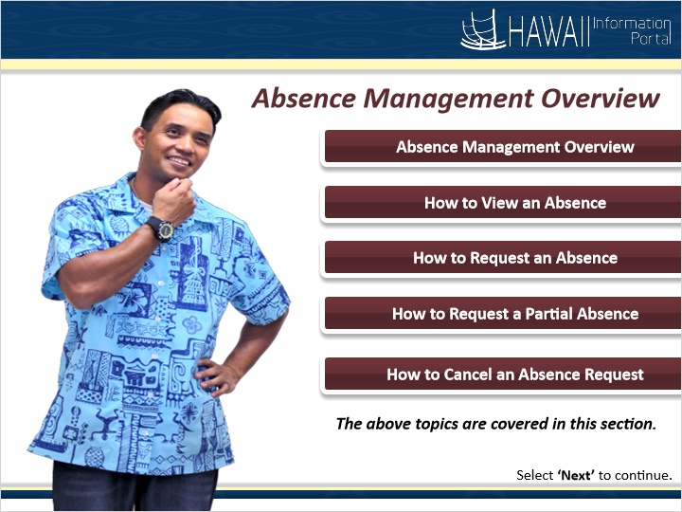

- Absence Management Overview
- How to View an Absence
- How to Request an Absence
- How to Request a Partial Absence
- How to Cancel an Absence Request

Absence Management Overview
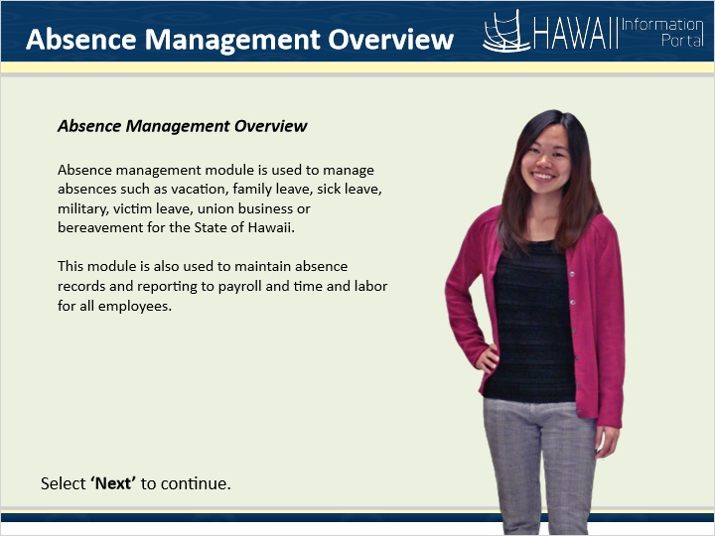

START HERE!

Absence management module is used to manage absences such as vacation, family leave, sick leave, military, victim leave, union business or bereavement for the State of Hawaii. This module is also used to maintain absence records and reporting to payroll and time and labor for all employees.

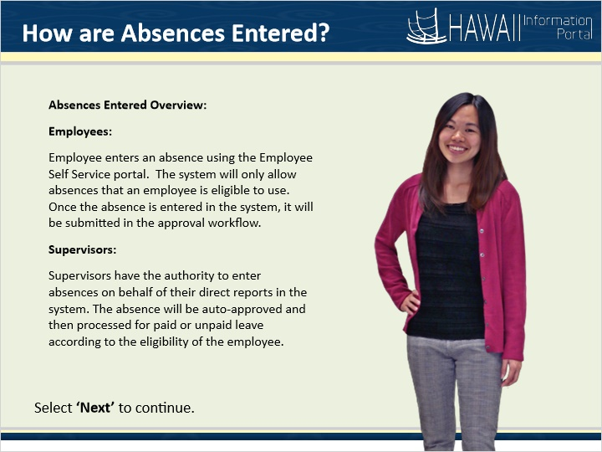
How are Absences Entered?

Absences Entered Overview:

Employees:
Employee enters an absence using the Employee Self Service portal. The system will only allow absences that an employee is eligible to use. Once the absence is entered in the system, it will be submitted in the approval workflow.

Supervisors:
Supervisors have the authority to enter absences on behalf of their direct reports in the system. The absence will be auto-approved and then processed for paid or unpaid leave according to the eligibility of the employee.

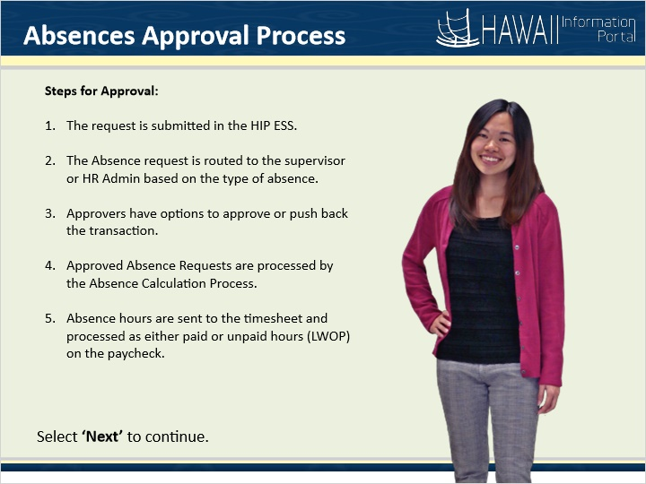
Absences Approval Process

Steps for Approval:

- The request is submitted in the workflow approval process.
- The Absence request is routed to the manager, supervisor or HR Admin based on the type of absence.
- Approvers have options to approve or push back the transaction.
- Approved Absence Requests are processed by the Absence Calculation Process.
- Absence balances are updated to be sent to the time sheet and corresponding paid and unpaid elements are generated.

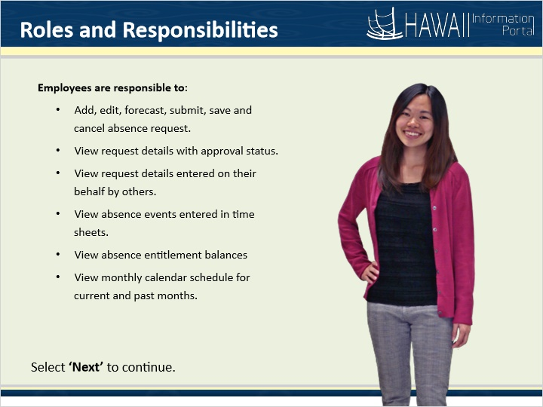

Roles and Responsibilities

Employee to:
- Add, edit, forecast, submit, save and cancel absence request
- View request details with approval status
- View request details entered on your behalf by others
- View absence events entered in time sheets
- View absence entitlement balances
- View monthly calendar schedule for current and past months

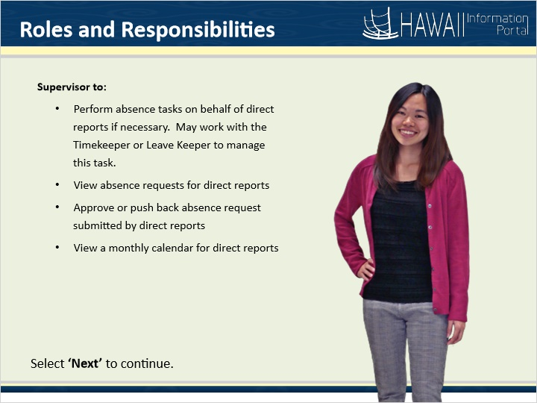

Supervisor to:
- Perform absence tasks on behalf of direct reports if necessary. May work with the Timekeeper or Leave Keeper to manage this task.

- View absence requests for direct reports

- Approve or push back absence request submitted by direct reports

- View a monthly calendar for direct reports

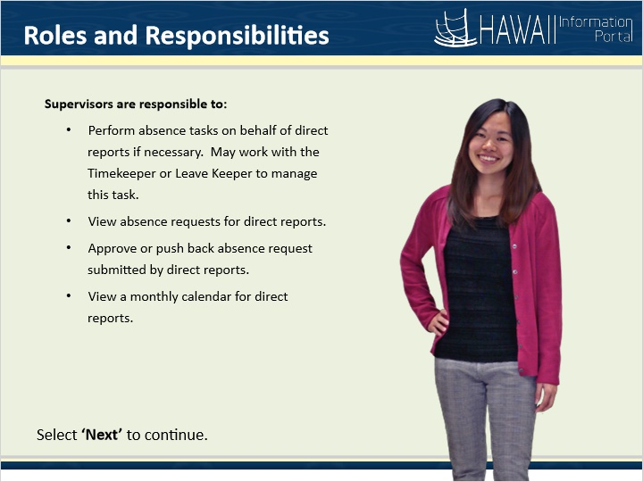

Manager to:
- Perform all employee self service absence tasks on behalf of direct reports
- View absence requests for direct reports
- Approve, deny, or push back absence request submitted by direct reports
- View a monthly calendar for direct reports

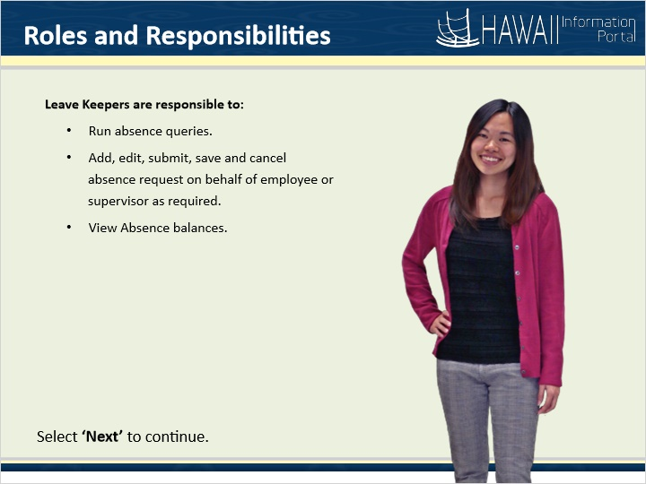

Leave Keeper to:
- Run absence queries

- Add, edit, submit, save and cancel absence request on behalf of employee or supervisor as required

- View Absence balances

- Manage absence exceptions
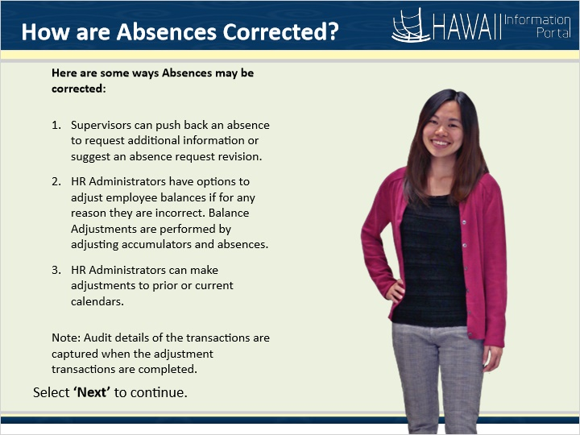

How are Absences Corrected?

Here are some ways Absences may be corrected:

- Supervisors can push back an absence to request additional information or suggest an absence request revision.
- HR Administrators have options to adjust employee balances if for any reason they are incorrect. Balance Adjustments are performed by adjusting accumulators and absences.
- HR Administrators can make adjustments to prior or current calendars.

Note: Audit details of the transactions are captured when the adjustment transactions are completed.



Congratulations!
You’ve successfully completed this lesson.

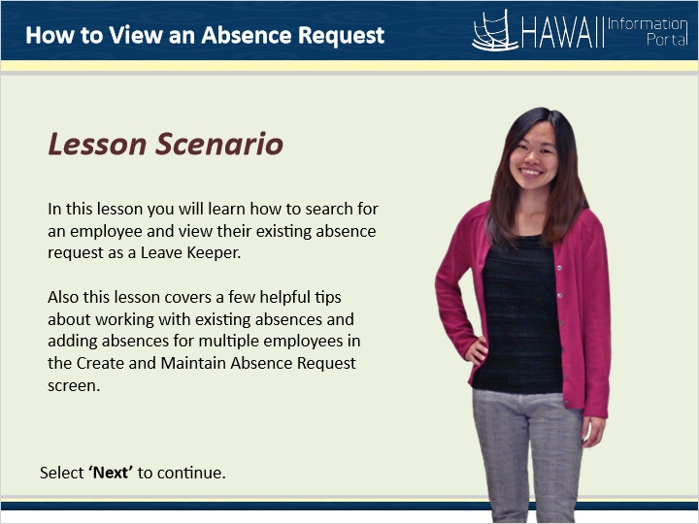

Lesson Scenario

In this lesson you will learn how to search for an employee and view their existing absence request as a Leave Keeper.

Also, this lesson covers a few helpful tips about working with existing absences and adding absences for multiple employees in the Create and Maintain Absence Request screen.

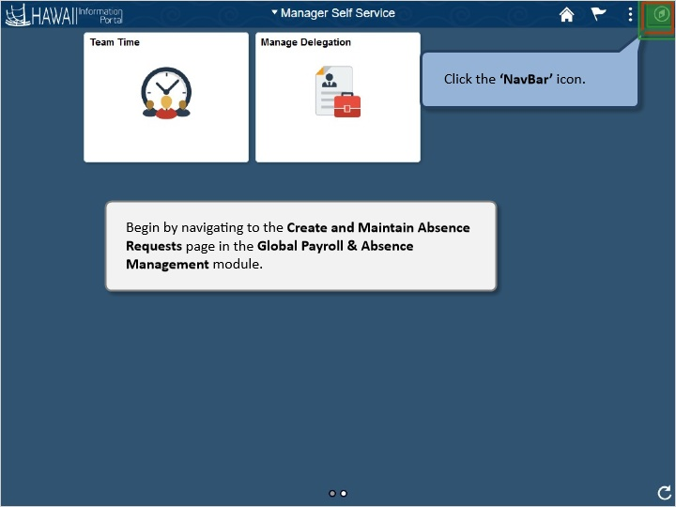

Begin by navigating to the Create and Maintain Absence Requests page in the Global Payroll & Absence Management module.

Click the ‘NavBar’ button.

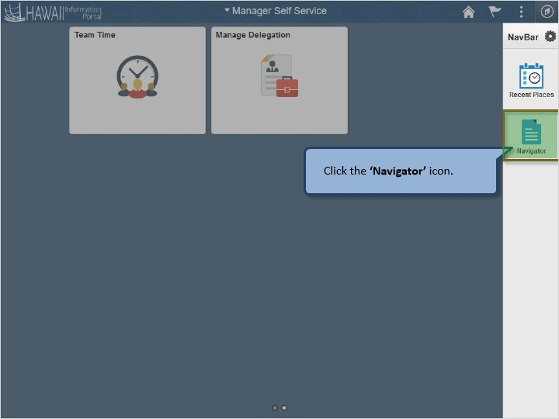

Click the ‘Navigator’ icon.

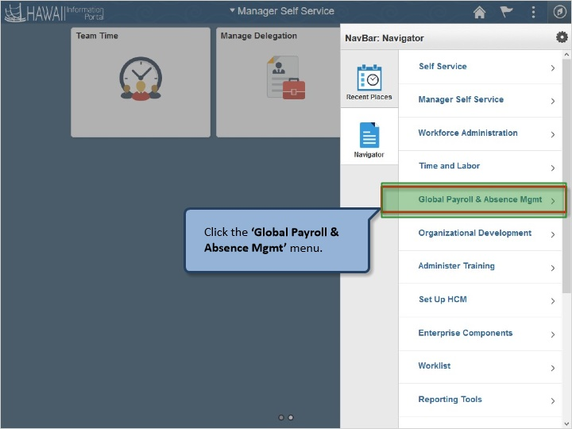

Click the ‘Global Payroll & Absence Mgmt’ menu.

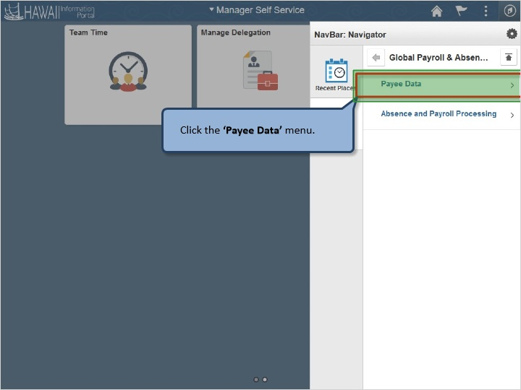

Click the ‘Payee Data’ menu.

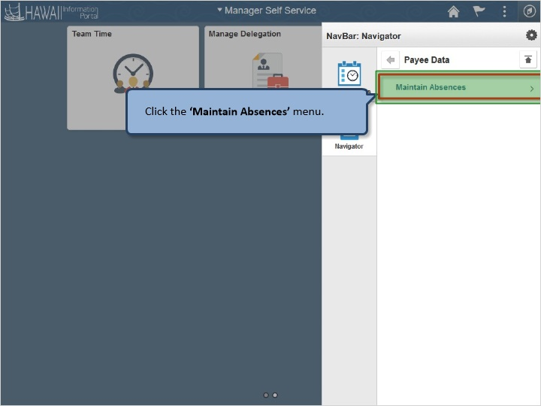

Click the ‘Maintain Absences’ menu.

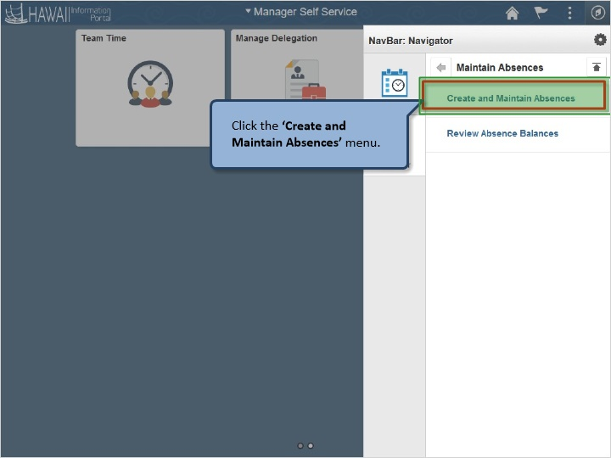

Click the ‘Create and Maintain Absences’ menu.

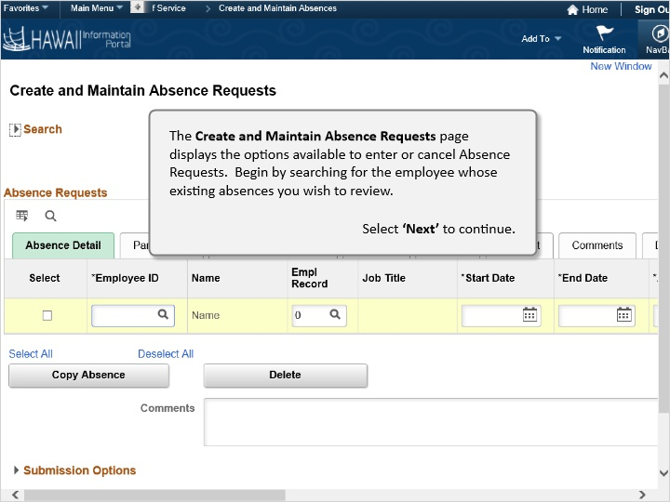

The Create and Maintain Absence Requests page displays the options available to enter, cancel and approve Absence Requests. Begin by searching for the employee whose existing absences you wish to review.

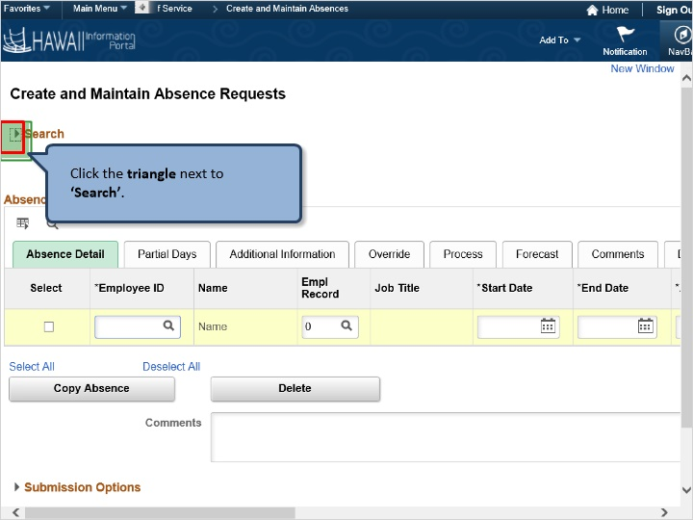

Click in the ‘*Employee ID’ field

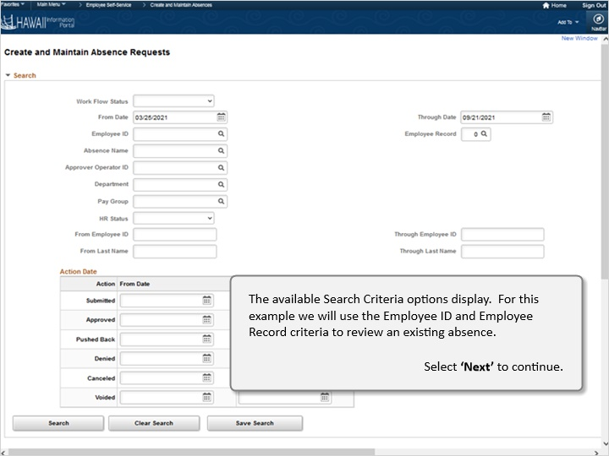

The available Search Criteria options display. For this example, we will use the Employee ID and Employee Record criteria to review an existing absence.

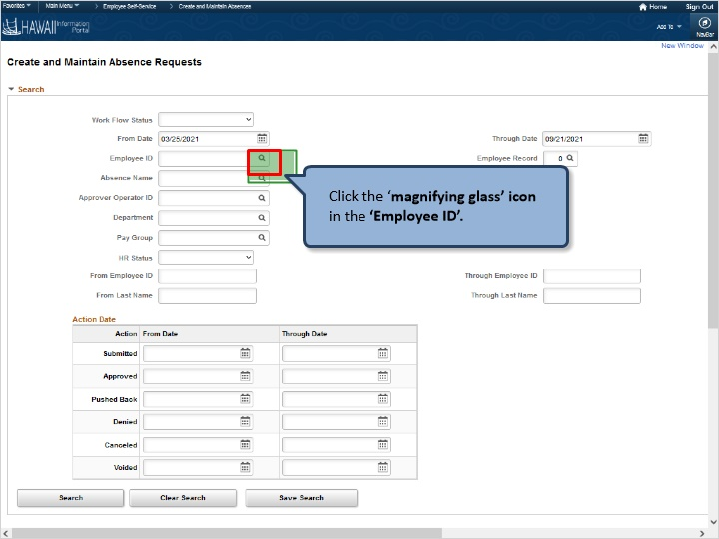

Click the ‘magnifying glass’ icon in the ‘*Employee ID’ field

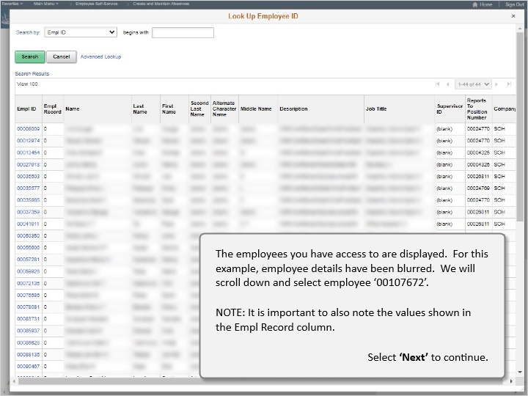

The employees you have access to are displayed. For this example, employee details have been blurred. We will scroll down to select employee ‘00107672’.

NOTE: It is important to also note the values shown in the Empl Record column.

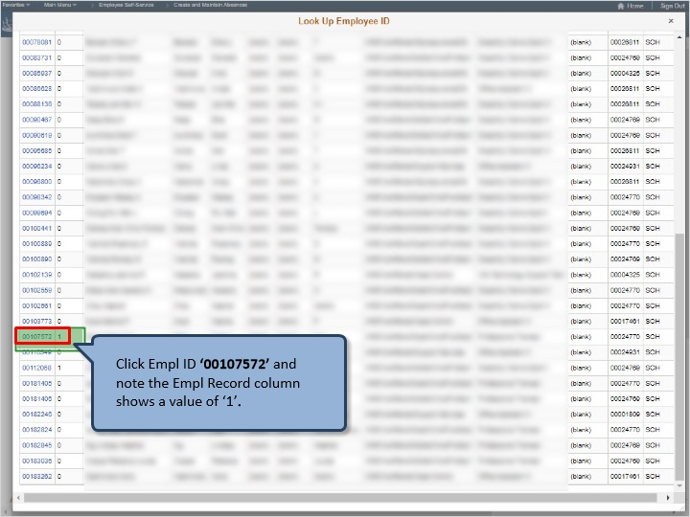

Click Empl ID ‘00107572’ and note the Empl Record column shows a value of ‘1’.

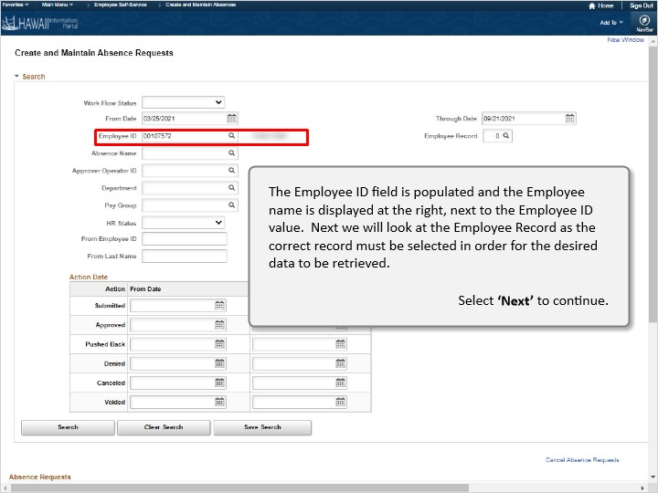

The Employee ID field is populated and the Employee name is displayed at the right, next to the Employee ID value. Next, we will look at the Employee Record as the correct record must be selected in order for the desired data to be retrieved.

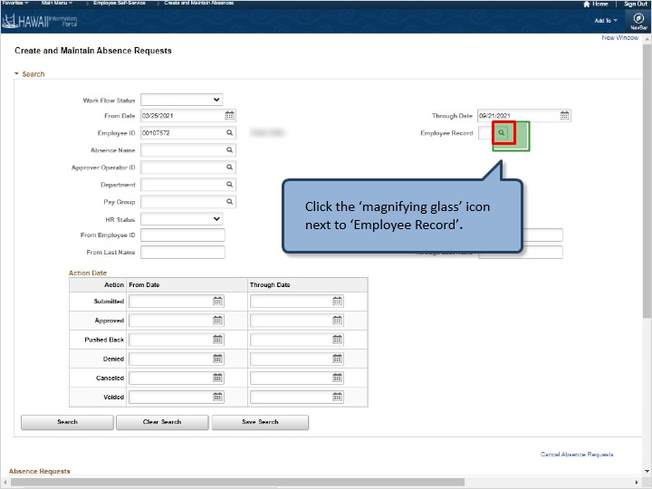

Click the ‘magnifying glass‘ icon next to *Employee Record’

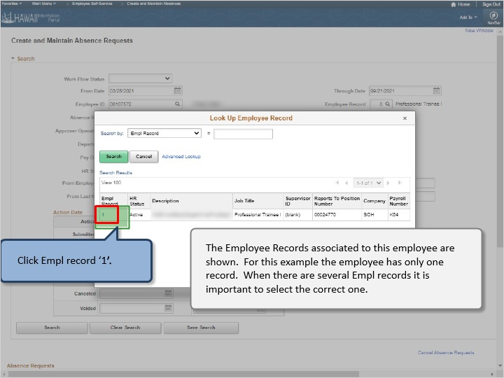

The Employee Records associated to this employee are shown. For this example, the employee has only one record. When there are several Empl records it is important to select the correct one.

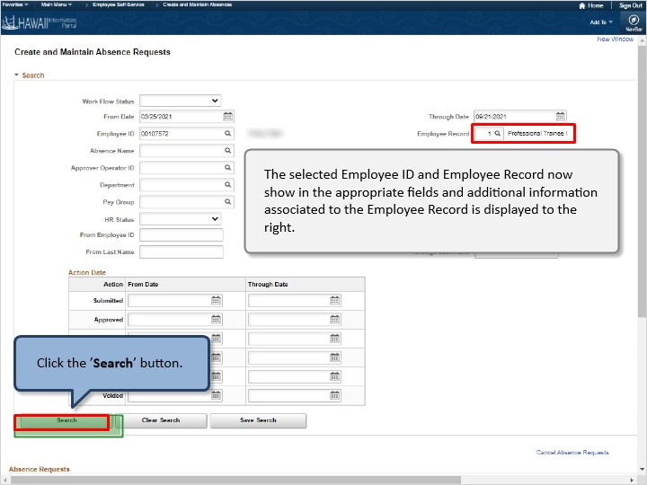

The selected Employee ID and Employee Record now show in the appropriate fields and additional information associated to the Employee Record is displayed to the right.

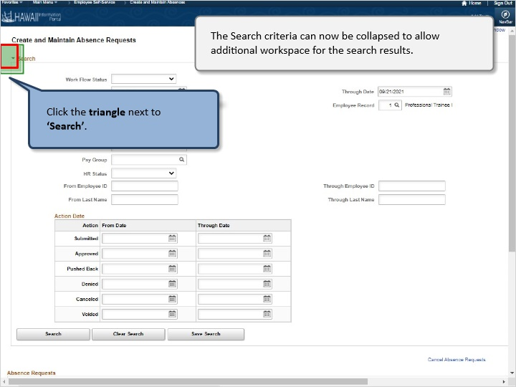

The Search criteria can now be collapsed to allow additional workspace for the search results.

Click the triangle next to ‘*Search’

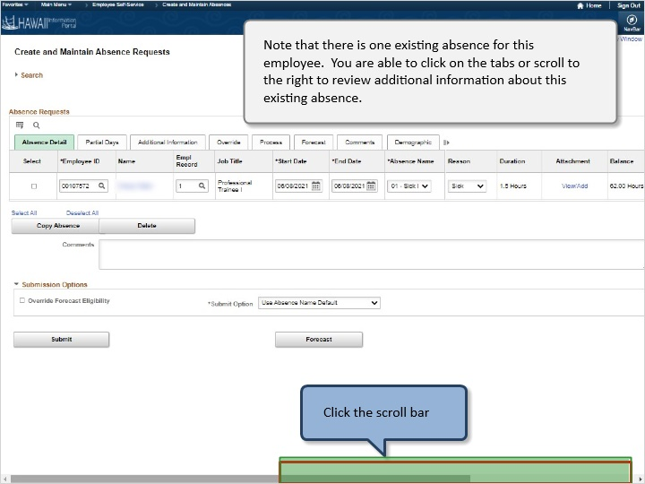

Note that there is one existing absence for this employee. You are able to click on the tabs or scroll to the right to review additional information about this existing absence.

Click the scroll bar

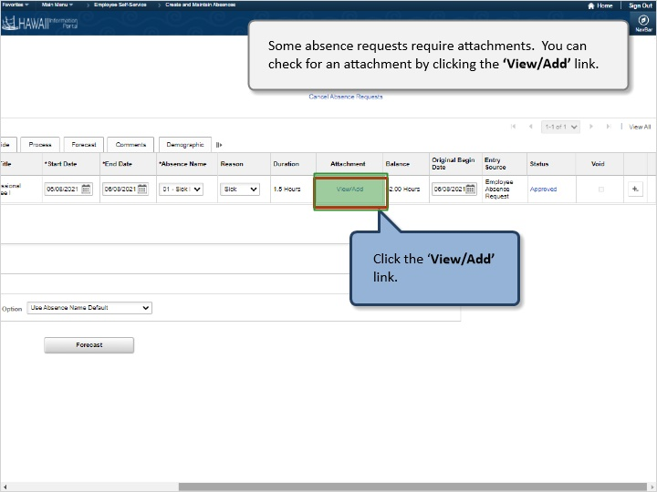

Some absence requests require attachments. You can check for an attachment by clicking the ‘View/Add‘ link. Click the ‘View/Add‘ link

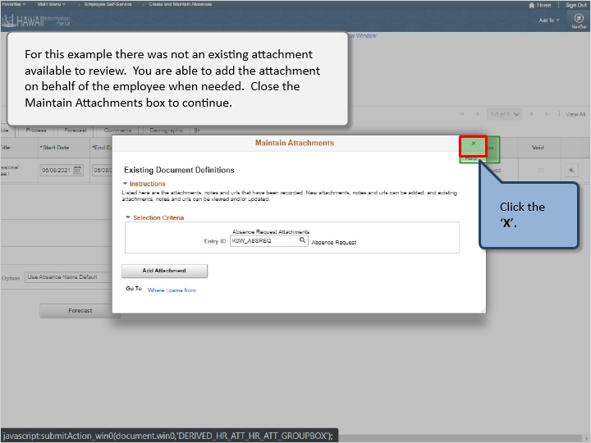

For this example, there was not an existing attachment available to review. You are able to add the attachment on behalf of the employee when needed. Closed the Maintain Attachments box to continue.

Click the ‘X’

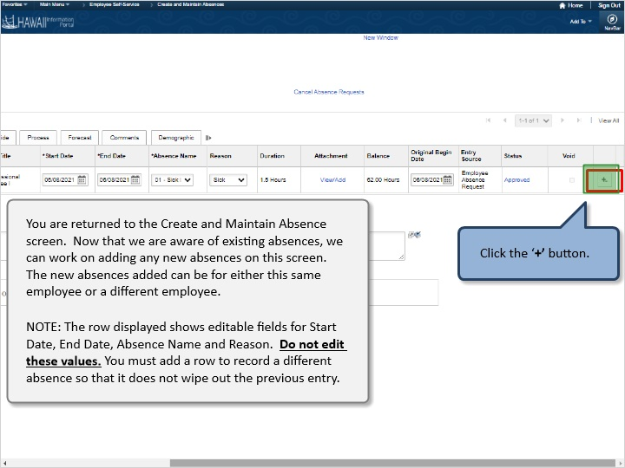

You are returned to the Create and Maintain Absence screen. Now that we are aware of existing absences, we can work on adding any new absences on this screen. The new absences added can be for either this same employee or a different employee.

NOTE: The row displayed shows editable fields for Start Date, End Date, Absence Name and Reason. Do not edit these values. You must add a row to record a different absence so that it does not wipe out the previous entry.

Click ‘+’ button.

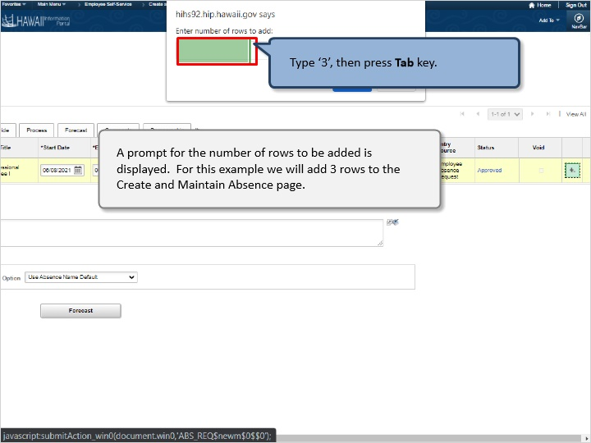
A prompt for the number of rows to be added is displayed. For this example, we will add 3 rows to the Create and Maintain Absence page.

Type ‘3’, then press Tab key.

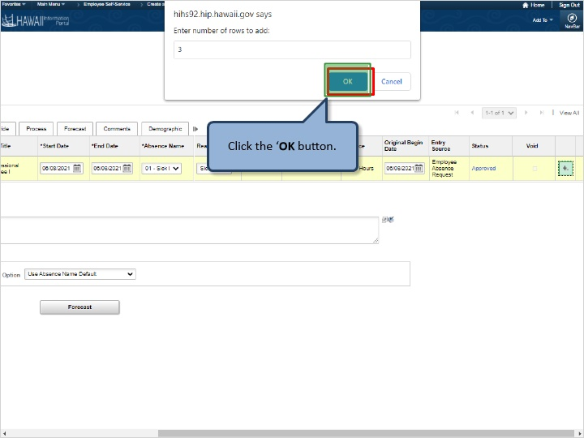

Click the ‘OK’ button.

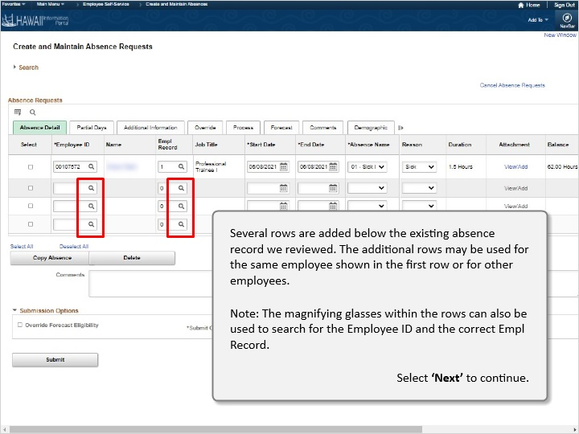

Several rows are added below the existing absence record we reviewed. The additional rows may be used for the same employee shown in the first row or for other employees.

Note: The magnifying glasses within the rows can also be used to search for the Employee ID and the correct Empl Record.

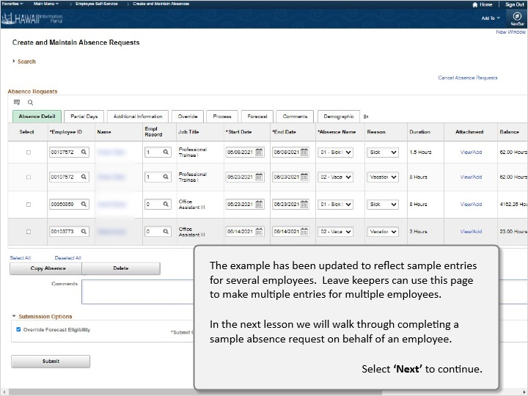

The example has been updated to reflect sample entries for several employees. Leave keepers can use this page to make multiple entries for multiple employees.

In the next lesson we will walk through completing a sample absence request on behalf of an employee.

Congratulations!
You’ve successfully completed this lesson.

How to Request an Absence
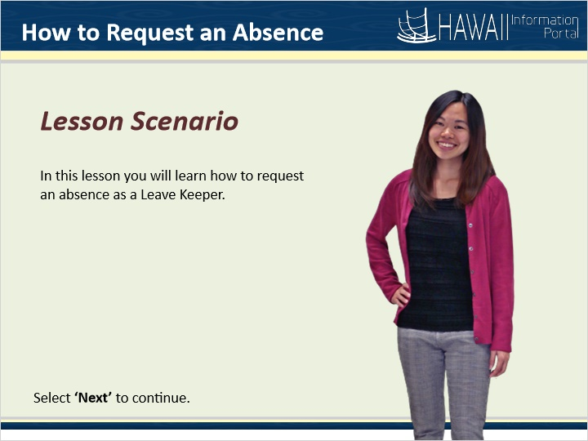

Lesson Scenario

In this lesson you will learn how to request an absence as a Leave Keeper.

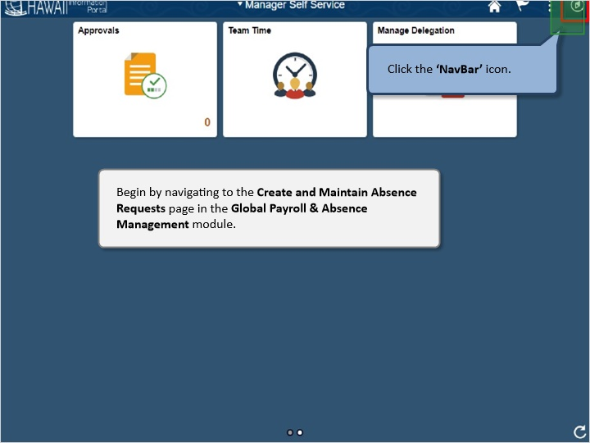
Begin by navigating to the Create and Maintain Absence Requests page in the Global Payroll & Absence Management module.

Click the ‘NavBar’ icon.

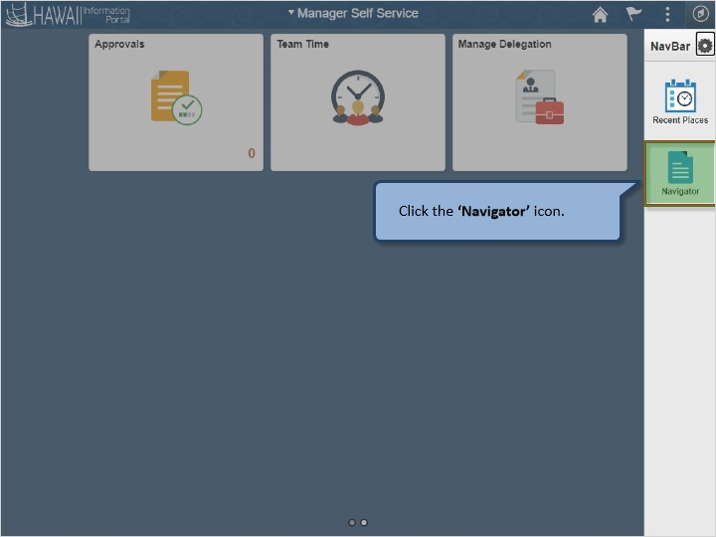

Click the ‘Navigator’ icon.

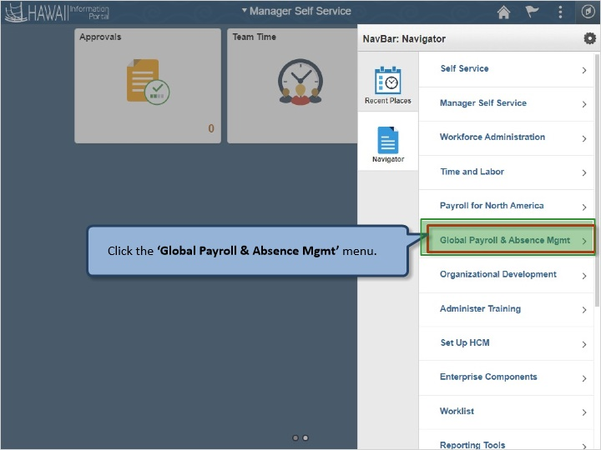

Click the ‘Global Payroll & Absence Mgmt’ menu.

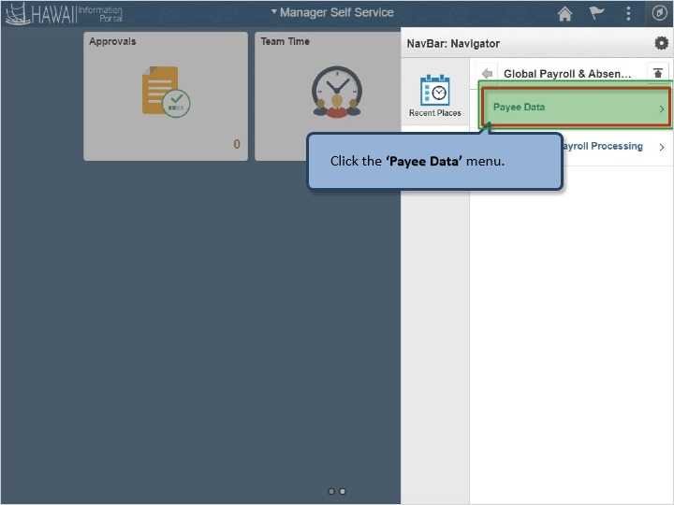

Click the ‘Payee Data’ menu.

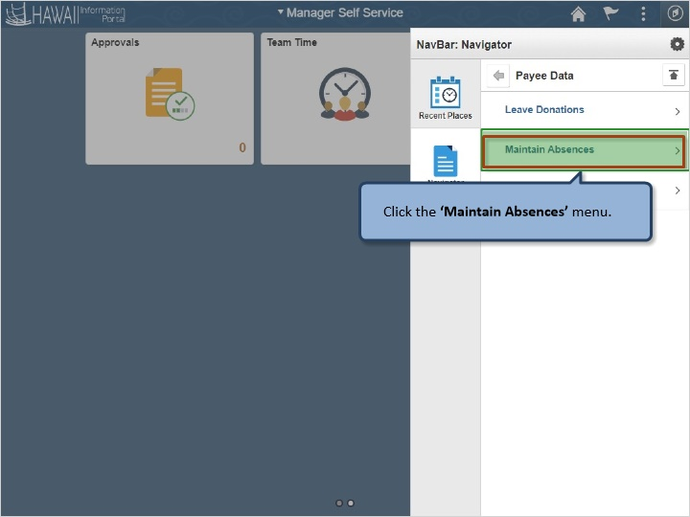

Click the ‘Maintain Absences’ menu.

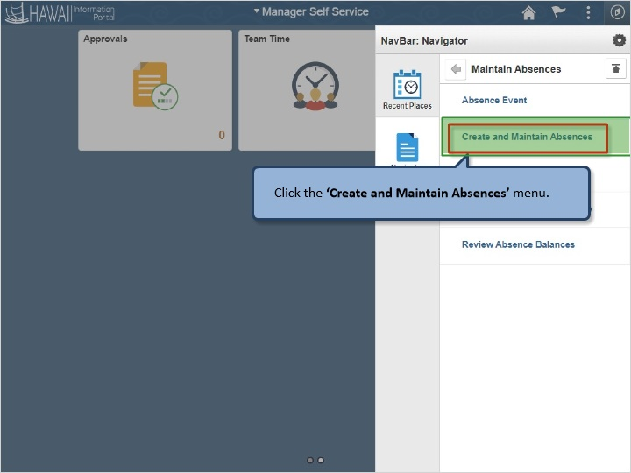

Click the ‘Create and Maintain Absences’ menu.

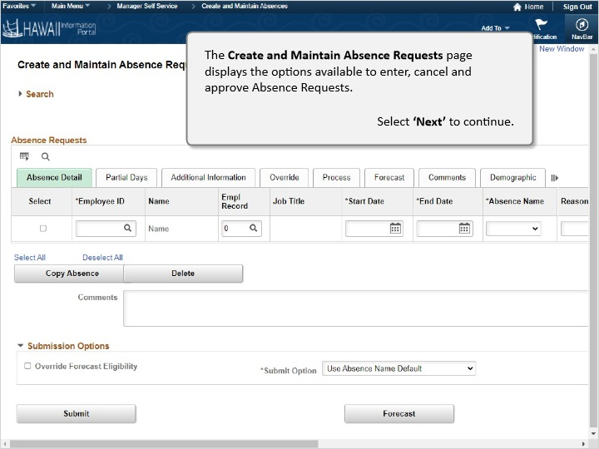

The Create and Maintain Absence Requests page displays the options available to enter, cancel and approve Absence Requests.

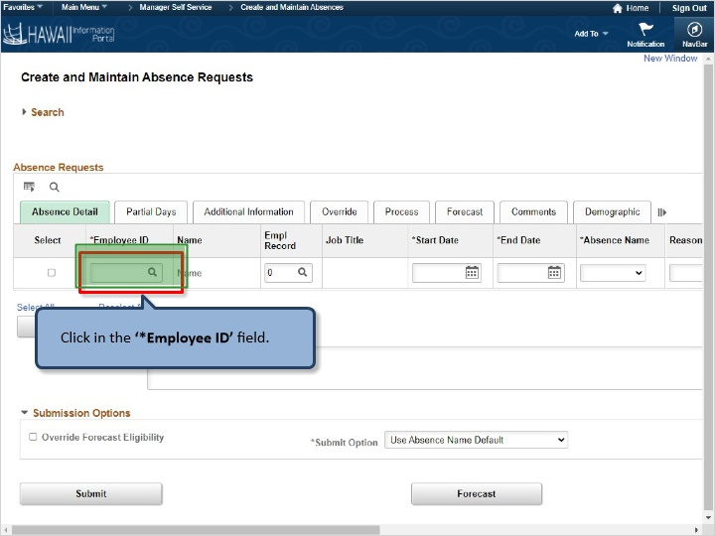

Click in the ‘*Employee ID’ field.

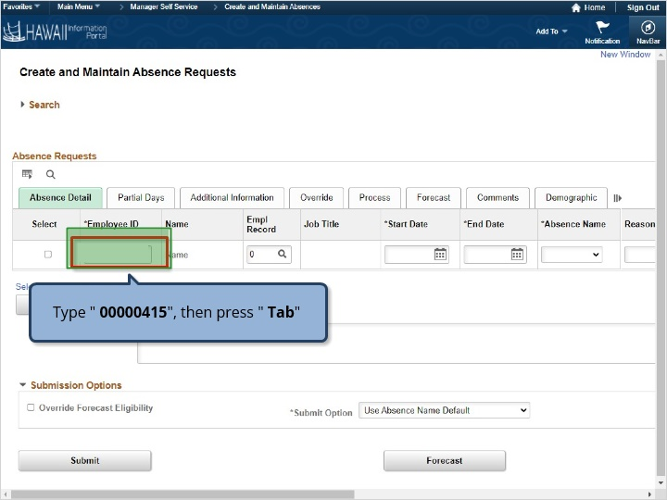

Type " 00000415", then press " Tab"

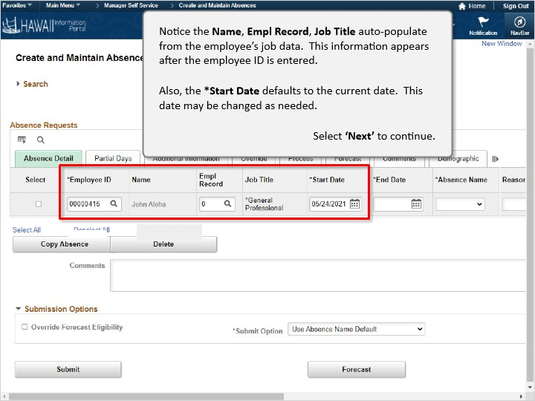

Notice the Name, Empl Record, Job Title auto-populate from the employee’s job data. This information appears after the employee ID is entered.

Also, the *Start Date defaults to the current date. This date may be changed as needed.

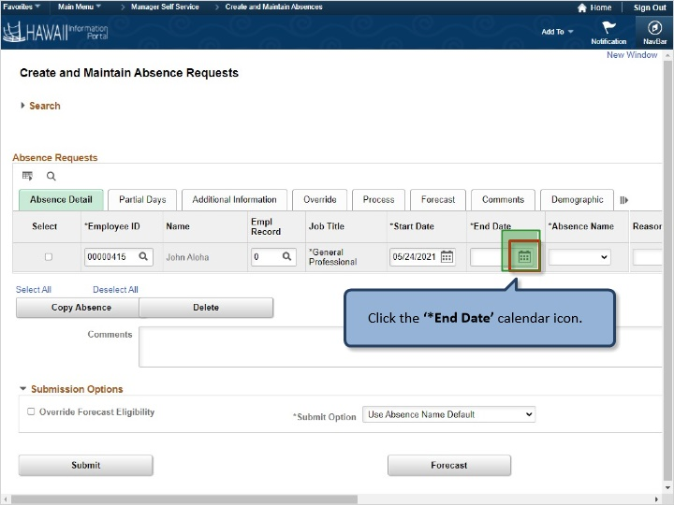

Click the ‘*End Date’ calendar icon.

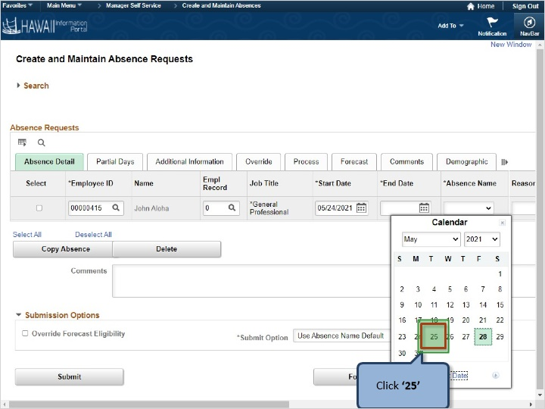

Click ‘25’

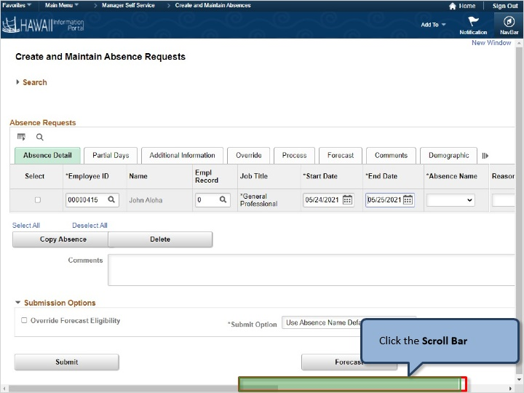

Click the Scroll Bar

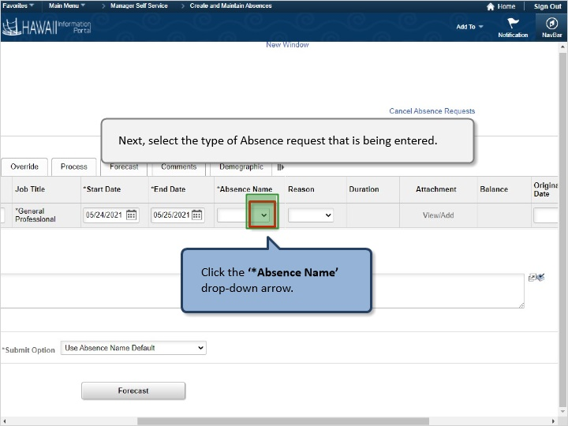

Next, select the type of Absence request that is being entered.

Click the ‘*Absence Name’ drop-down arrow.

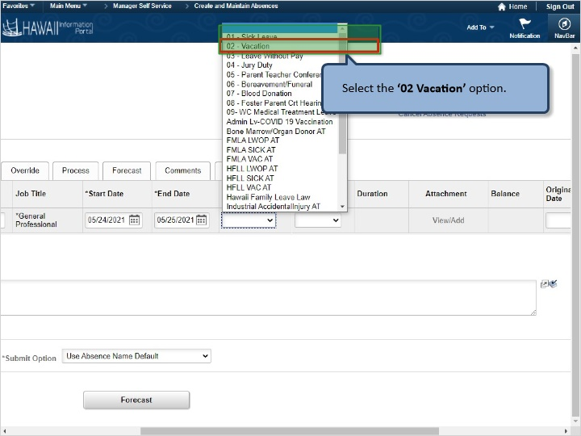

Select the ‘02 Vacation’ option.

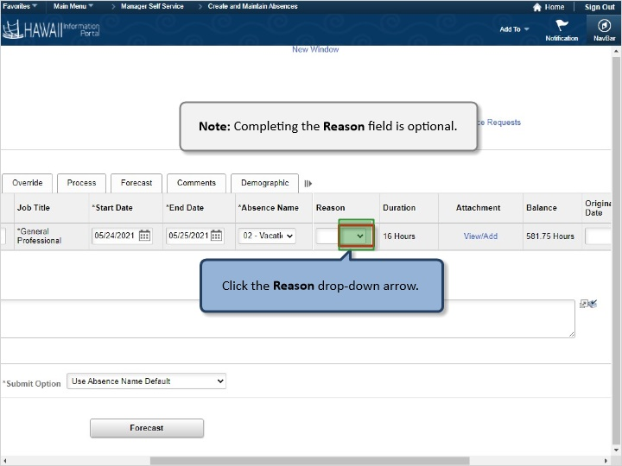

Note: Completing the Reason field is optional.

Click the Reason drop-down arrow.

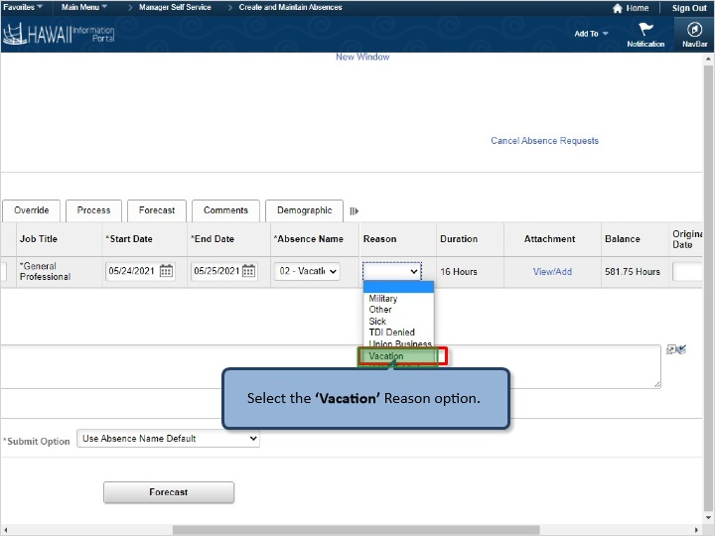

Select the ‘Vacation’ Reason option.

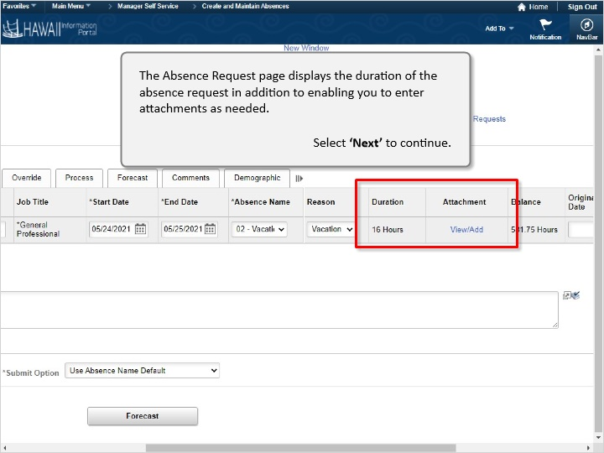

The Absence Request page displays the duration of the absence request in addition to enabling you to enter attachments as needed.

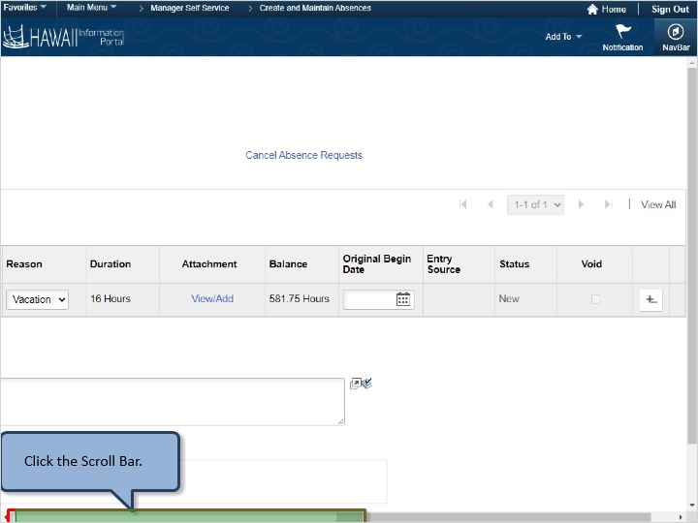

Click the Scroll Bar.

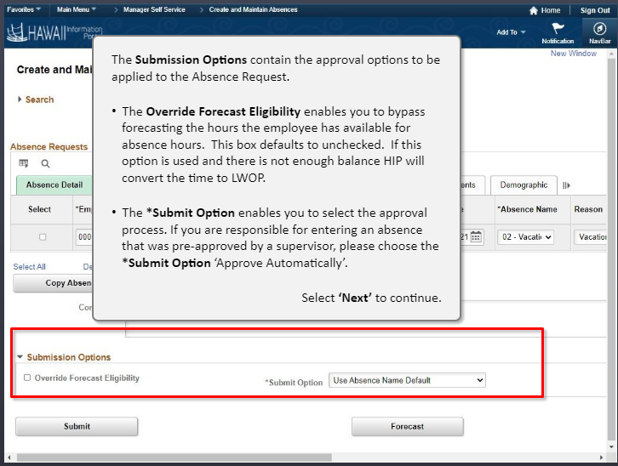

The Submission Options contain the approval options to be applied to the Absence Request.

- The Override Forecast Eligibility enables you to bypass forecasting the hours the employee has available for absence hours. This box defaults to unchecked. If this option is used and there is not enough balance HIP will convert the time to LWOP.

- The *Submit Option enables you to select the approval process. If you are responsible for entering an absence that was pre-approved by a supervisor, please choose the *Submit Option ‘Approve Automatically’.

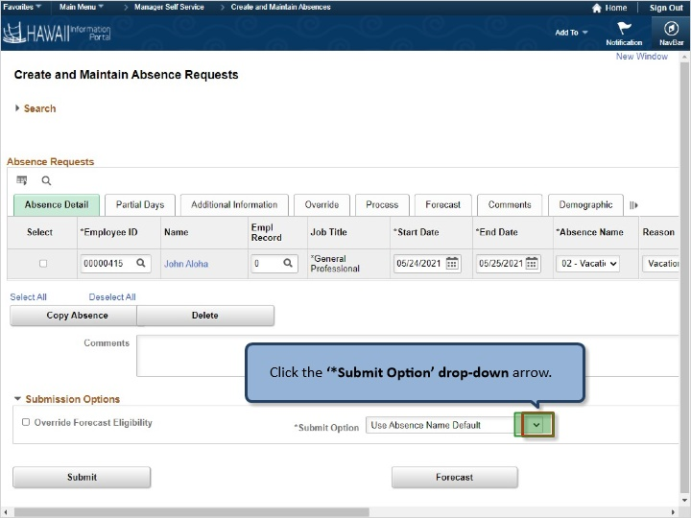

Click the ‘*Submit Option’ drop-down arrow.

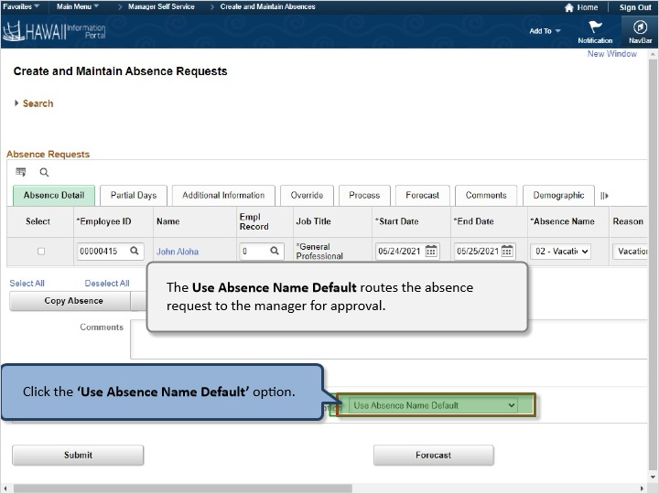

The Use Absence Name Default routes the absence request to the manager for approval.

Click the ‘Use Absence Name Default’ option.

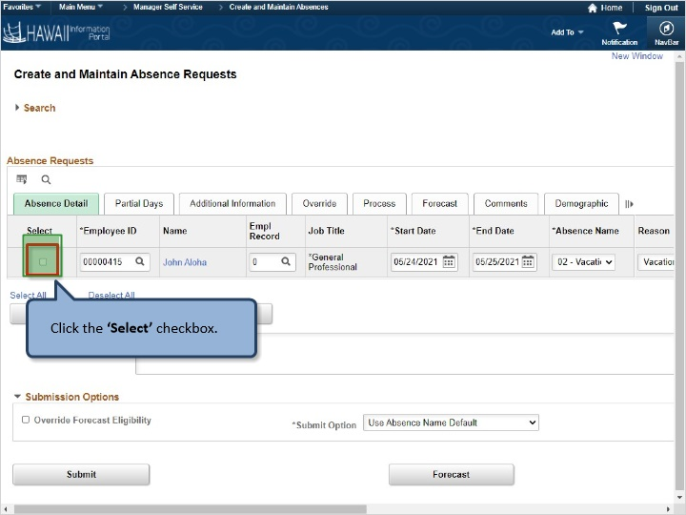

Click the ‘Select’ checkbox.

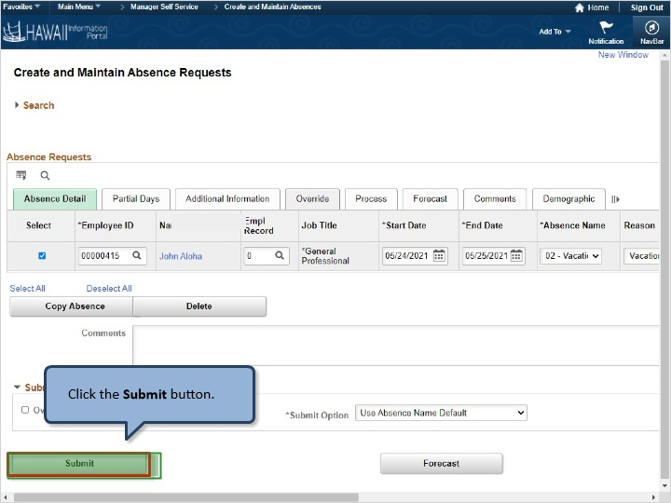

Click the Submit button.

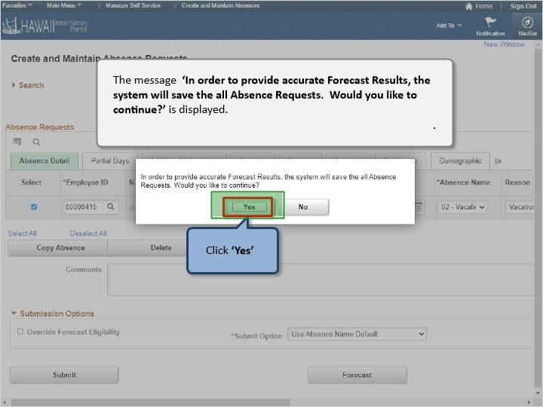

The message ‘In order to provide accurate Forecast Results, the system will save the all Absence Requests. Would you like to continue?’ is displayed.

Click ‘Yes’

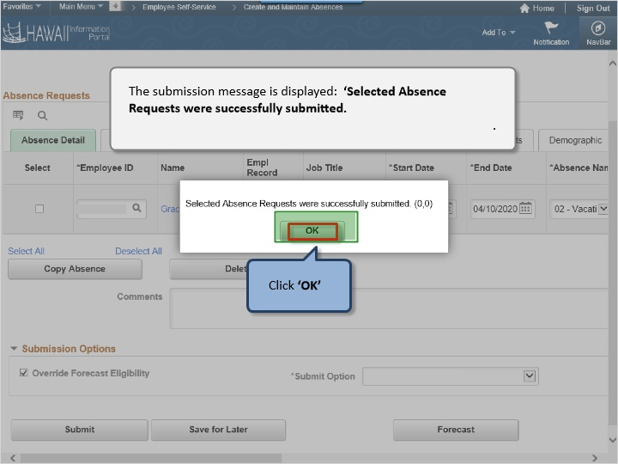

The submission message is displayed: ‘Selected Absence Requests were successfully submitted.

Click ‘OK’

Congratulations!
You’ve successfully completed this lesson.

How to Request a Partial Day Absence
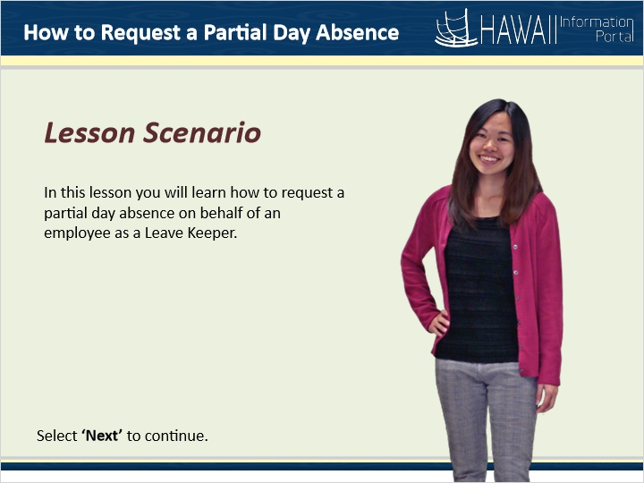

Lesson Scenario

In this lesson you will learn how to request a partial day absence on behalf of an employee as a Leave Keeper.
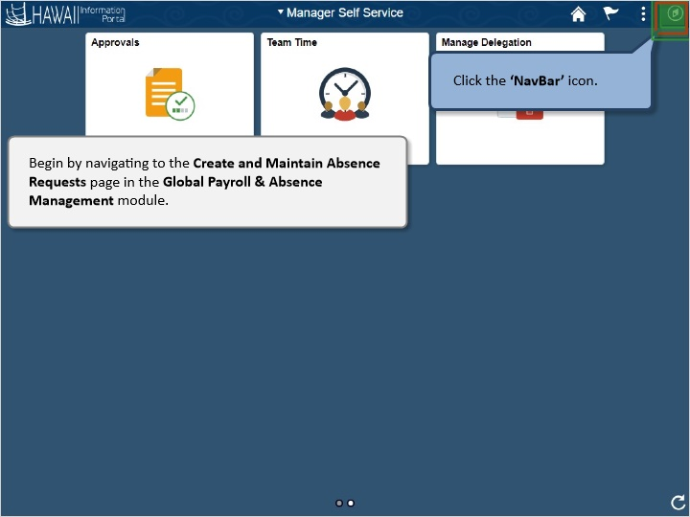

Begin by navigating to the Create and Maintain Absence Requests page in the Global Payroll & Absence Management module.

Click the ‘NavBar’ icon.

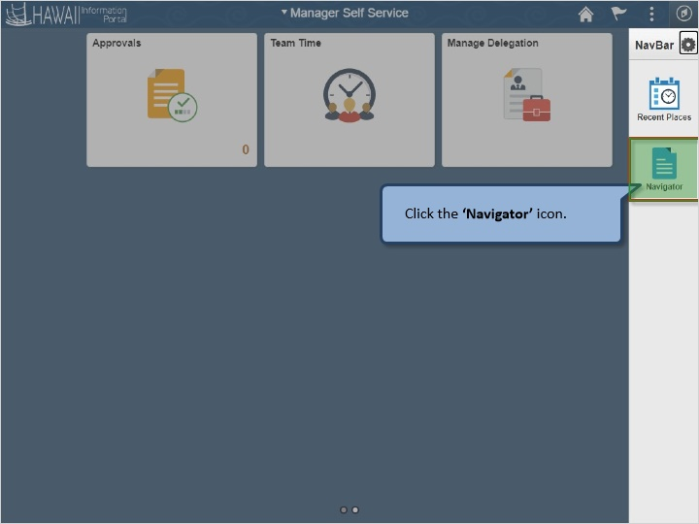

Click the ‘Navigator’ icon.

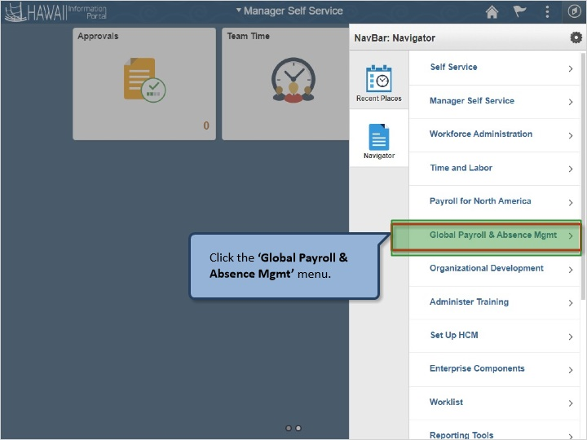

Click the ‘Global Payroll & Absence Mgmt’ menu..

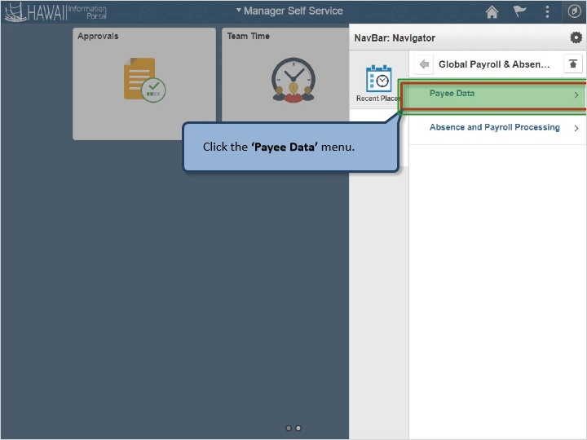

Click the ‘Payee Data’ menu.

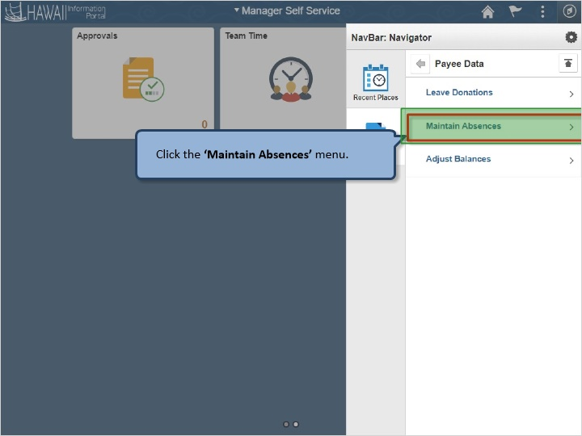

Click the ‘Maintain Absences’ menu.

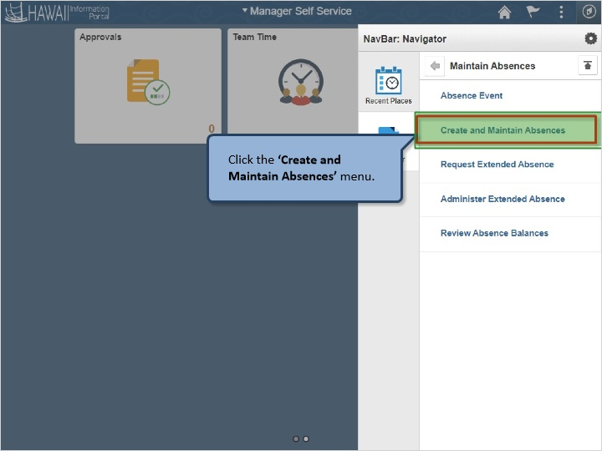

Click the ‘Create and Maintain Absences’ menu.

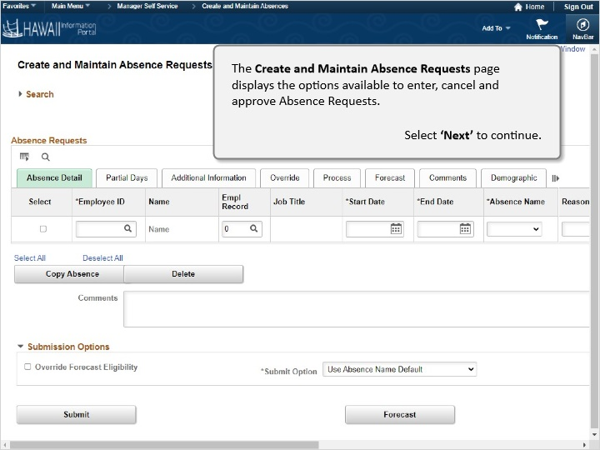

The Create and Maintain Absence Requests page displays the options available to enter, cancel and approve Absence Requests.

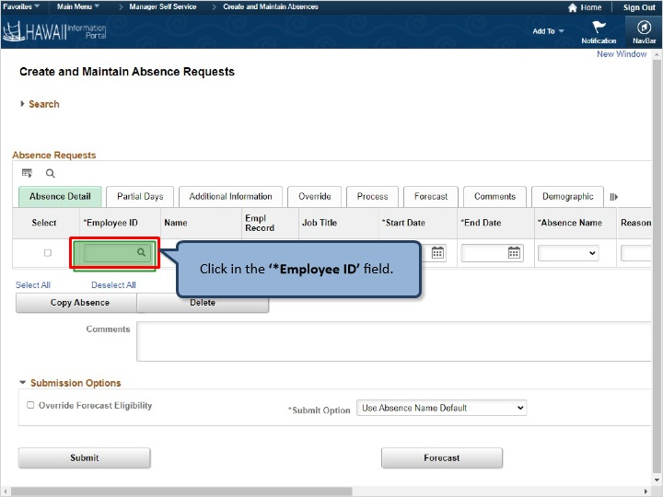

Click in the ‘*Employee ID’ field

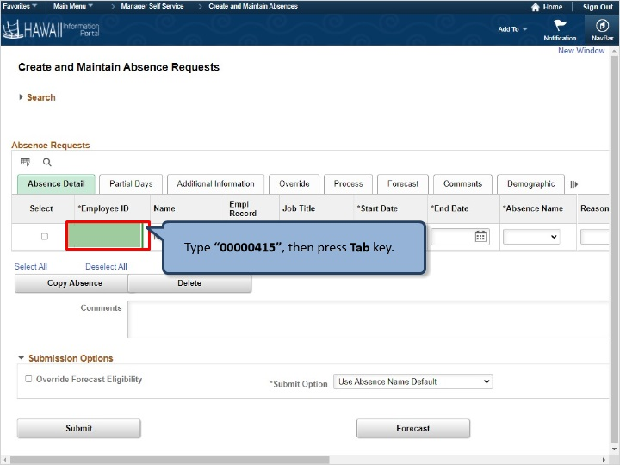

Type “00000415”, then press Tab key.

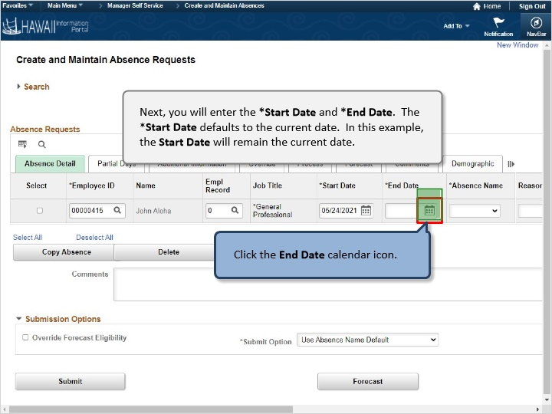

Next, you will enter the *Start Date and *End Date. The *Start Date defaults to the current date. In this example, the Start Date will remain the current date.

Click the End Date calendar icon.

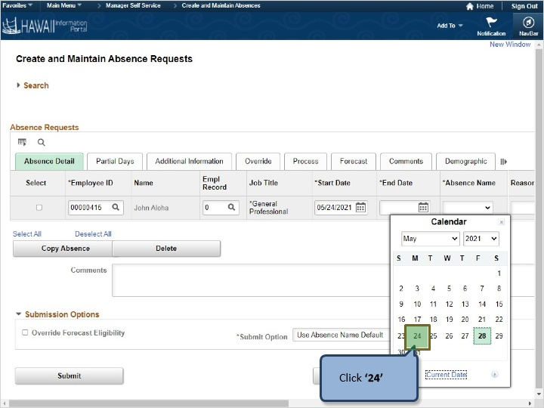

Click ‘24’

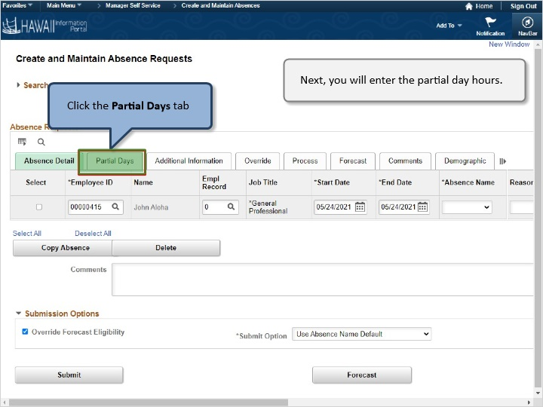

Next, you will enter the partial day hours.

Click Partial Days tab

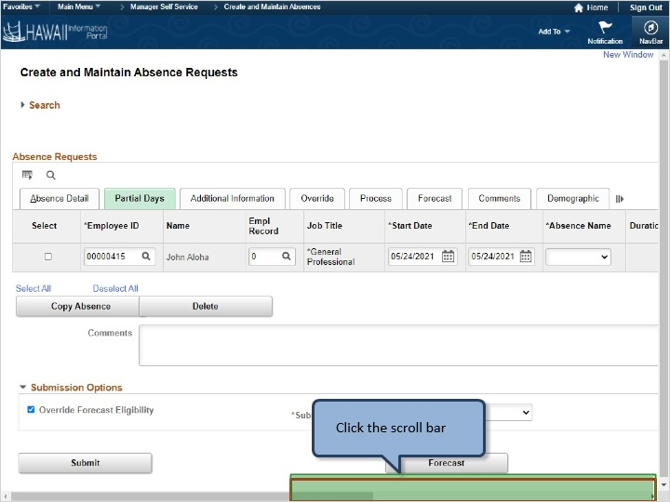

Click the scroll bar

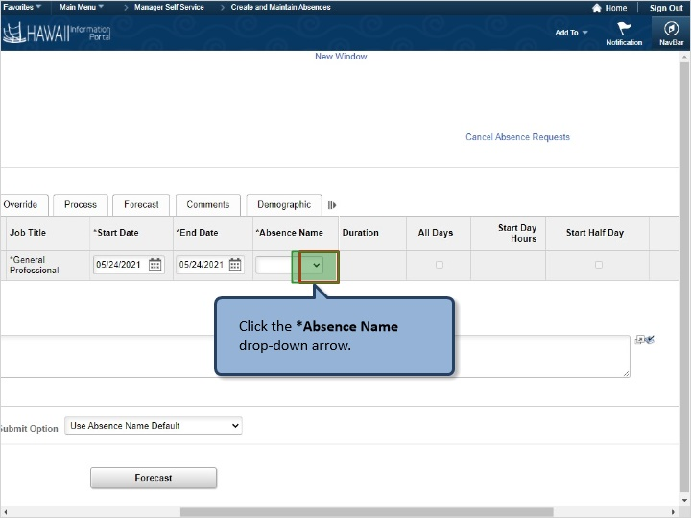

Click the *Absence Name drop-down arrow.

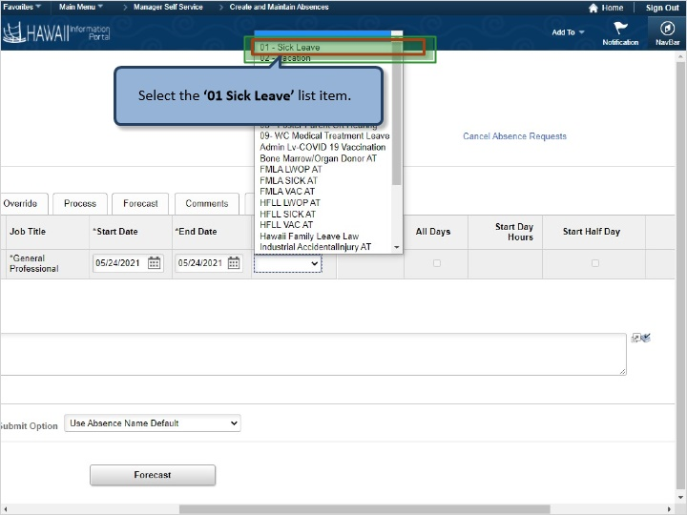

Select the ‘01 Sick Leave’ list item.

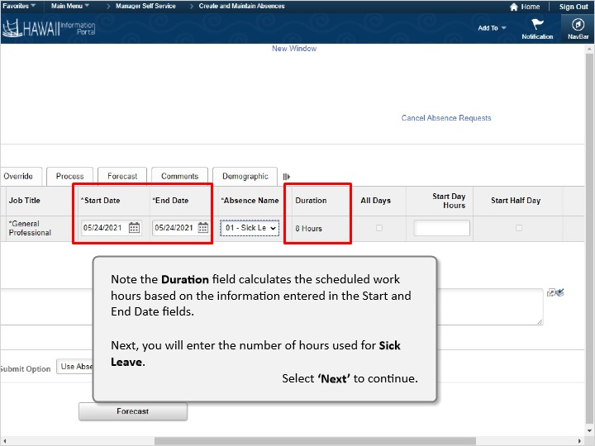

Note the Duration field calculates the scheduled work hours based on the information entered in the Start and End Date fields.

Next, you will enter the number of hours used for Sick Leave.

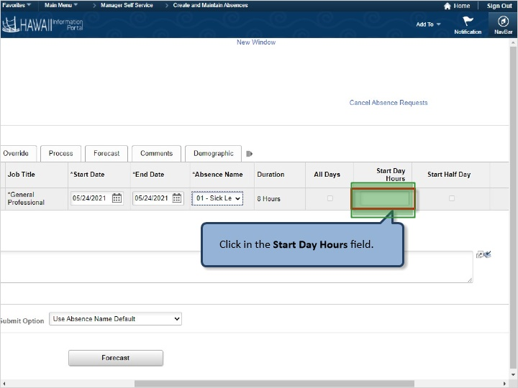

Click in the Start Day Hours field.

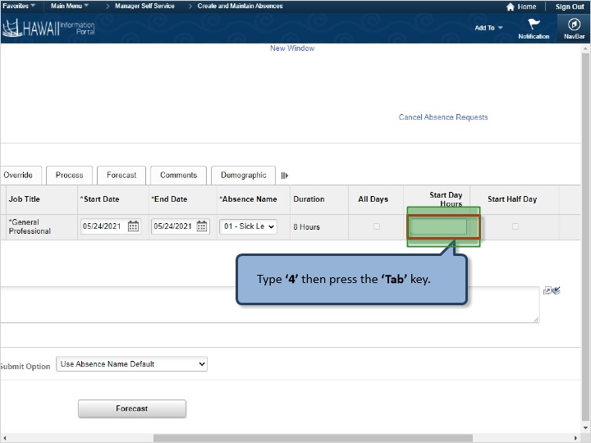

Type ‘4’ then press the ‘Tab’ key.

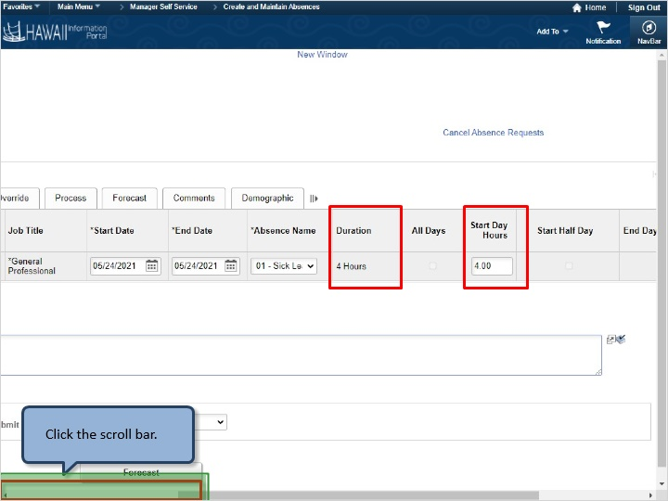

Click the scroll bar.

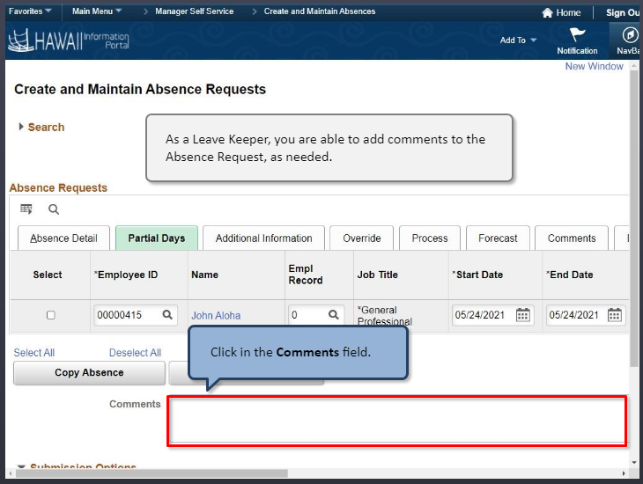

As a Leave Keeper, you are able to add comments to the Absence Request, as needed.

Click in the Comments field.

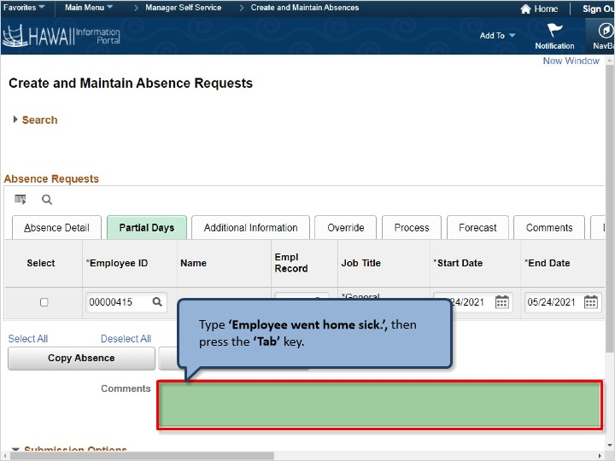

Type ‘Employee went home sick.’, then press the ‘Tab’ key.

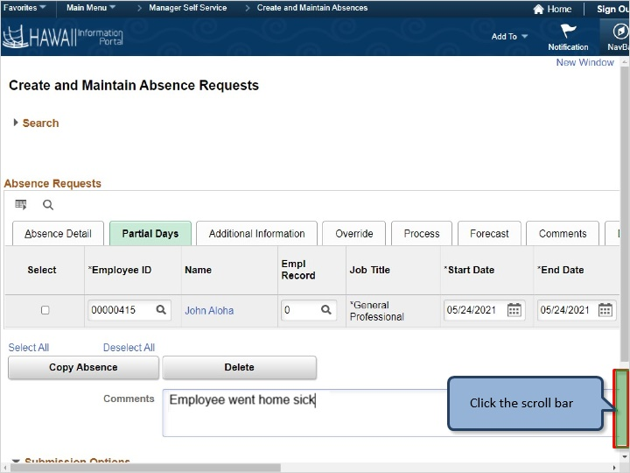

Click the scroll bar

The Submission Options contain the approval options to be applied to the Absence Request.

- The Override Forecast Eligibility enables you to bypass the hours the employee has available for absence hours. The box defaults to unchecked. If this option is used and there is not enough balance HIP will convert the time to LWOP.
- The *Submit Option enables you to select the approval process. If you are responsible for entering an absence that was pre-approved by a supervisor, please choose the *Submit Option ‘Approve Automatically’

.

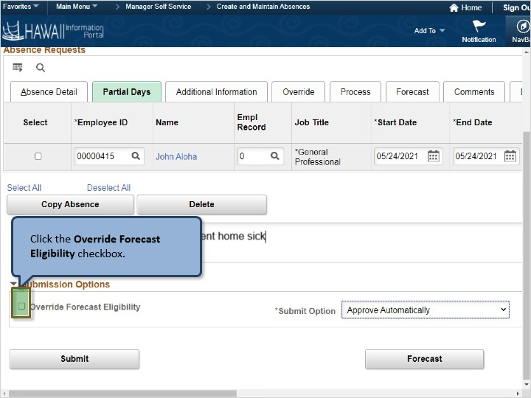

Click the Override Forecast Eligibility checkbox.

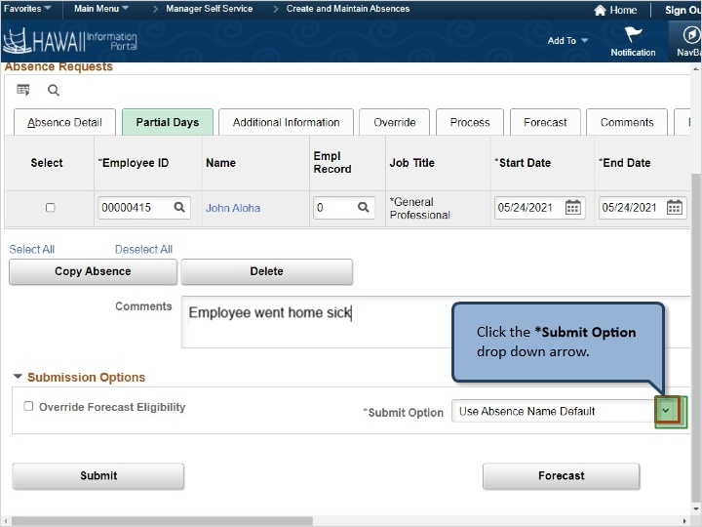

Click the *Submit Option drop down arrow.

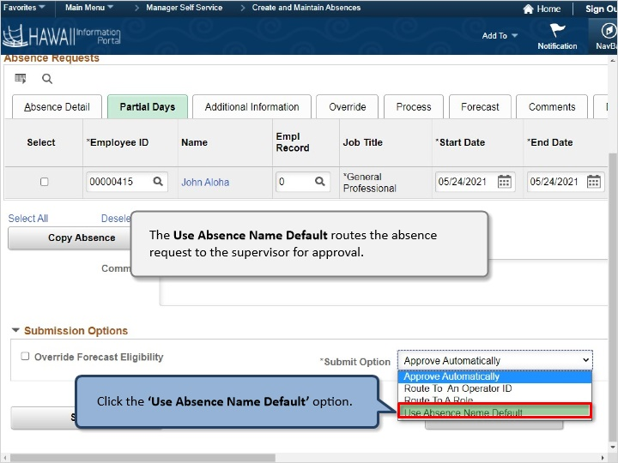

The Use Absence Name Default routes the absence request to the supervisor for approval.

Click the ‘Use Absence Name Default’ option

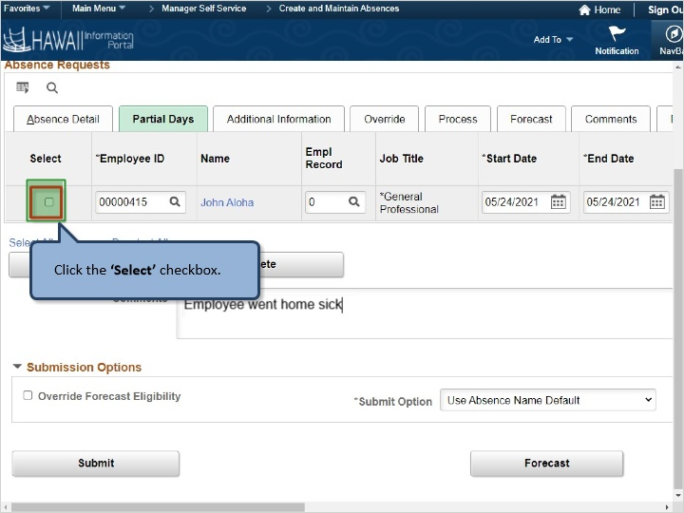

Click the ‘Select’ checkbox.

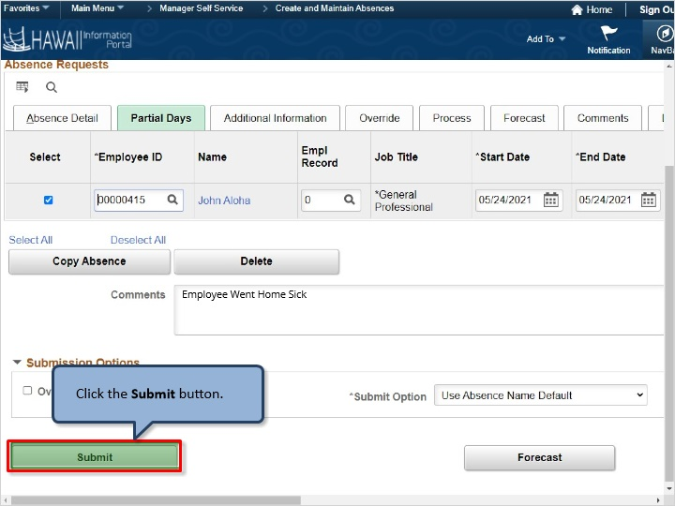

Click the Submit button.

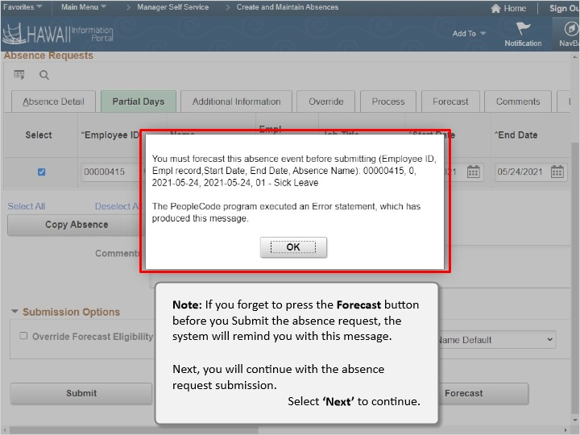

Note: If you forget to press the Forecast button before you Submit the absence request, the system will remind you with this message.

Next, you will continue with the absence request submission.

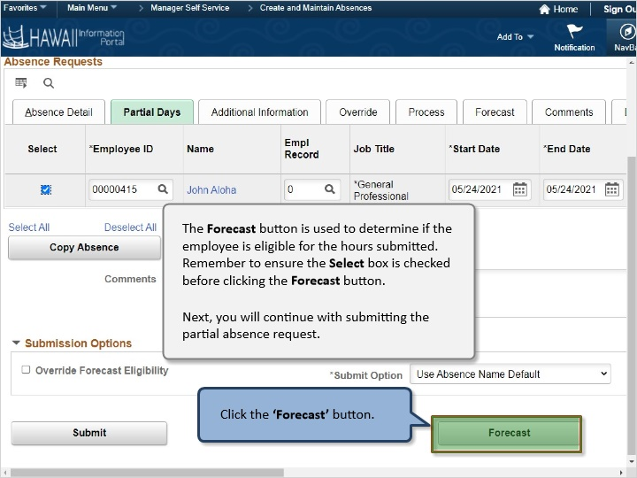

The Forecast button is used to determine if the employee is eligible for the hours submitted. Remember to ensure the Select box is checked before clicking the Forecast button.

Next, you will continue with submitting the partial absence request.

Click the ‘Forecast’ button.

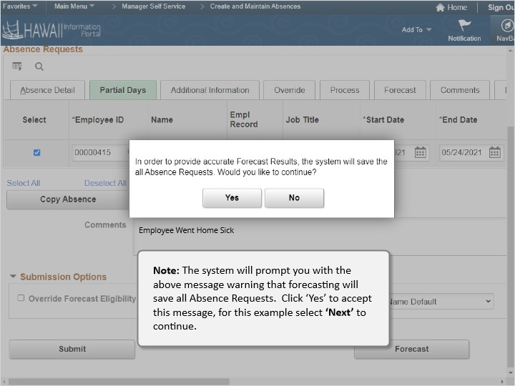

Note: The system will prompt you with the above message warning that forecasting will save all Absence Requests. Click ‘Yes’ to accept this message, for this example select ‘Next’ to continue.

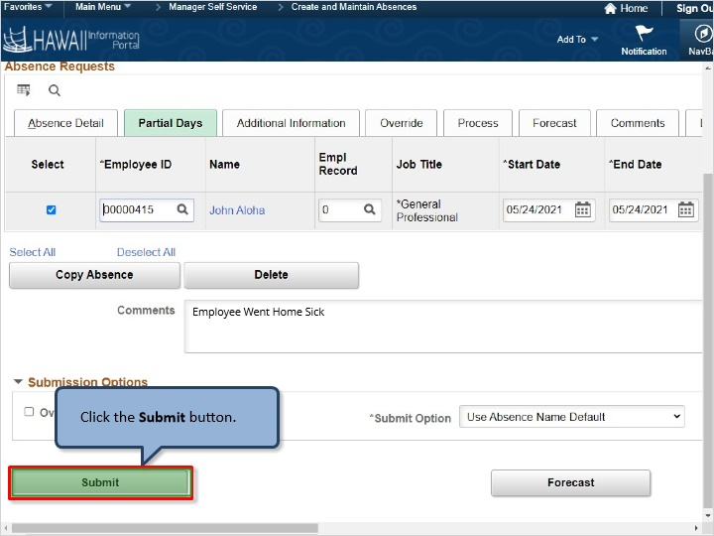

Click the Submit button.
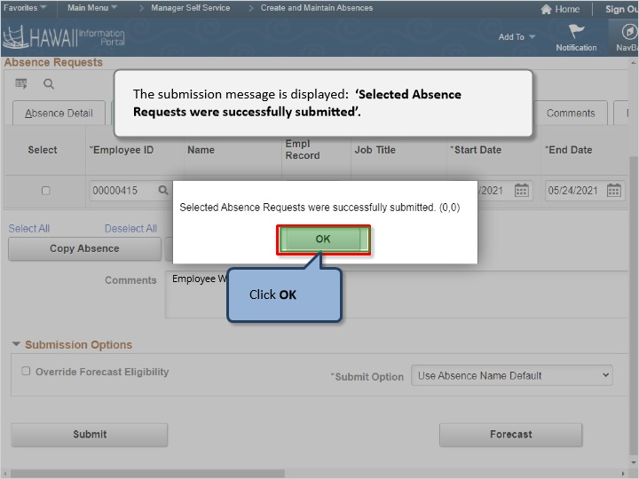

The submission message is displayed: ‘Selected Absence Requests were successfully submitted’.

Click OK

Congratulations!
You’ve successfully completed this lesson.

How to Cancel an Absence - Leave Keeper
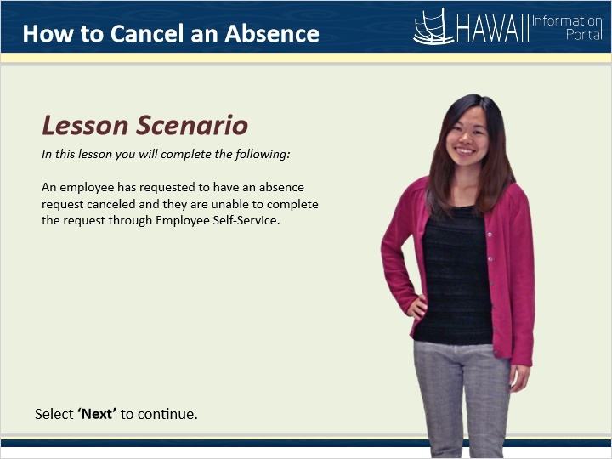

Lesson Scenario

In this lesson you will complete the following:

An employee has requested to have an absence request canceled because they are unable to complete the request through Employee Self-Service.

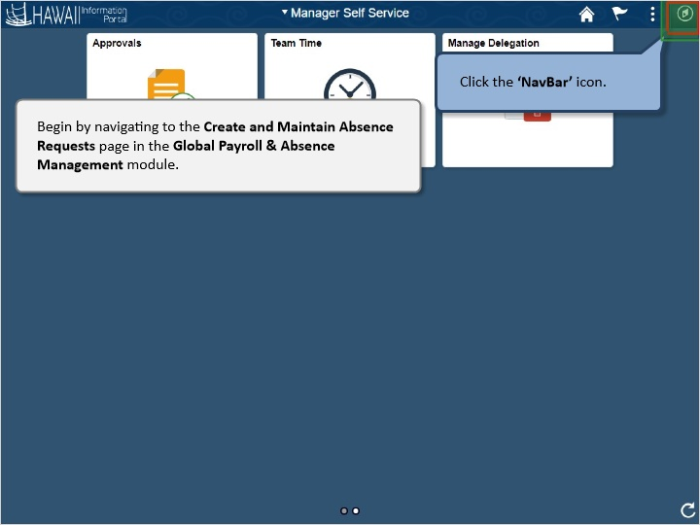

Begin by navigating to the Create and Maintain Absence Requests page in the Global Payroll & Absence Management module.

Click the ‘NavBar’ icon.

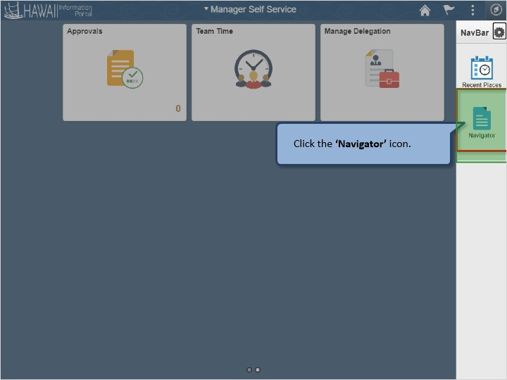

Click the ‘Navigator’ icon.

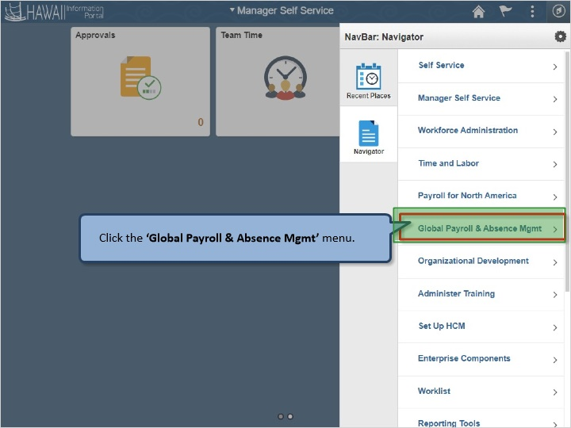

Click the ‘Global Payroll & Absence Mgmt’ menu.

Click the ‘Payee Data’ menu.

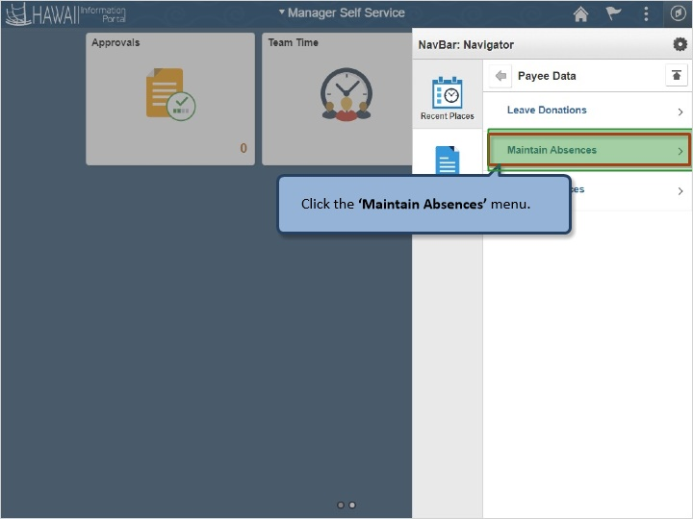

Click the ‘Maintain Absences’ menu.

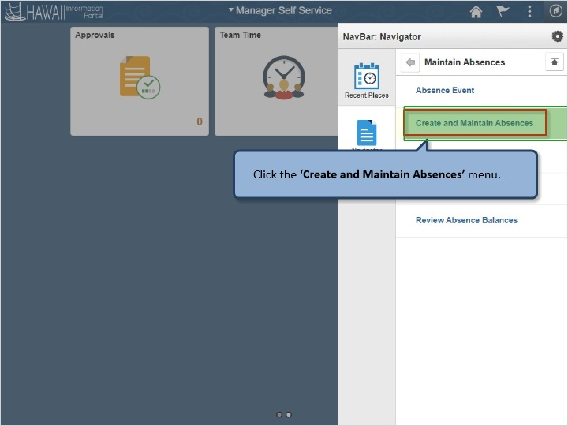

Click the ‘Create and Maintain Absences’ menu.

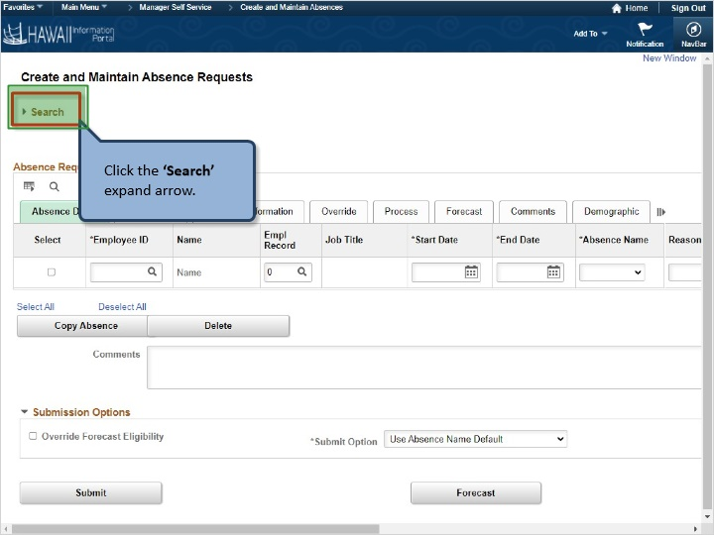

Click the ‘Search’ expand arrow.

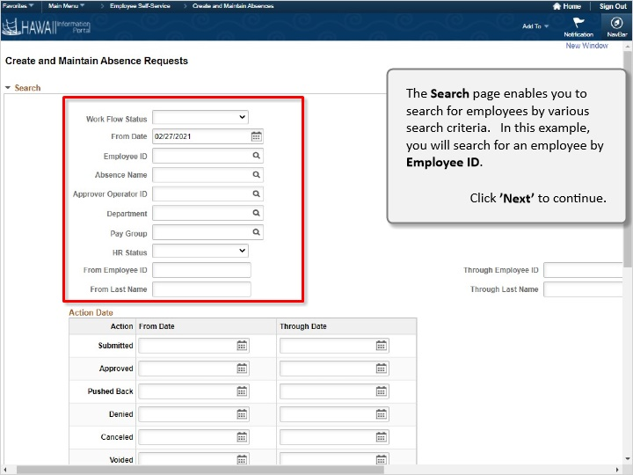

The Search page enables you to search for employees by various search criteria. In this example, you will search for an employee by Employee ID.

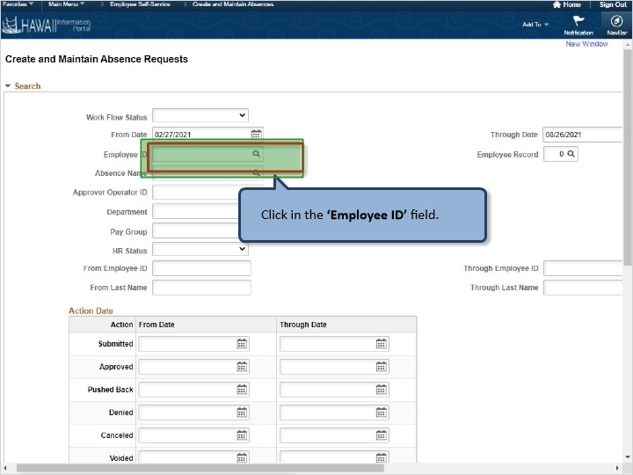

Click in the ‘Employee ID’ field.

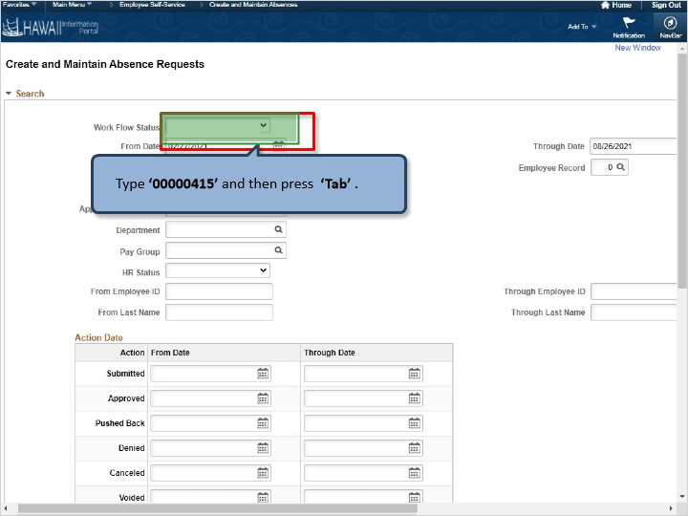

Type ‘00000415’ and then press ‘Tab’ .

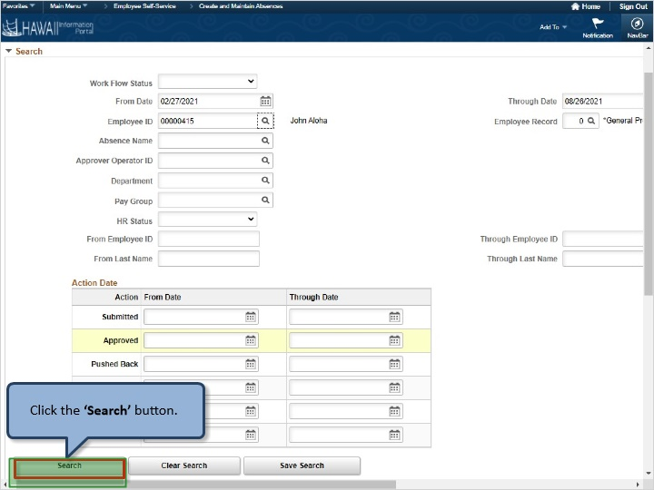

Click the ‘Search’ button.

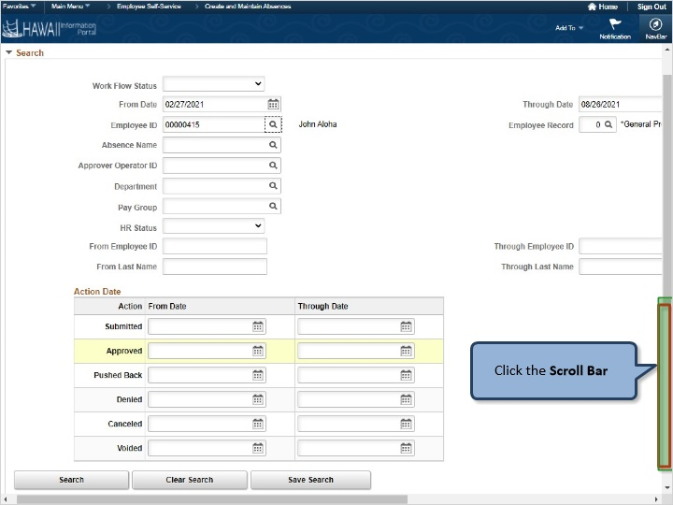

Click the Scroll Bar

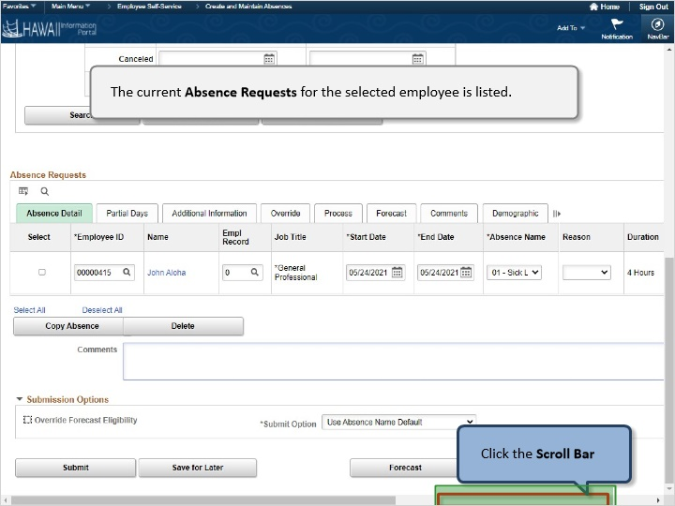

The current Absence Requests for the selected employee is listed.

Click the Scroll Bar

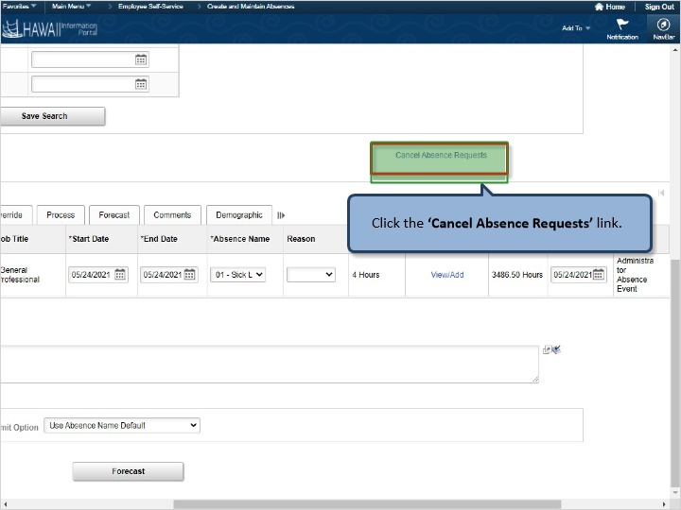

Click the ‘Cancel Absence Requests’ link.

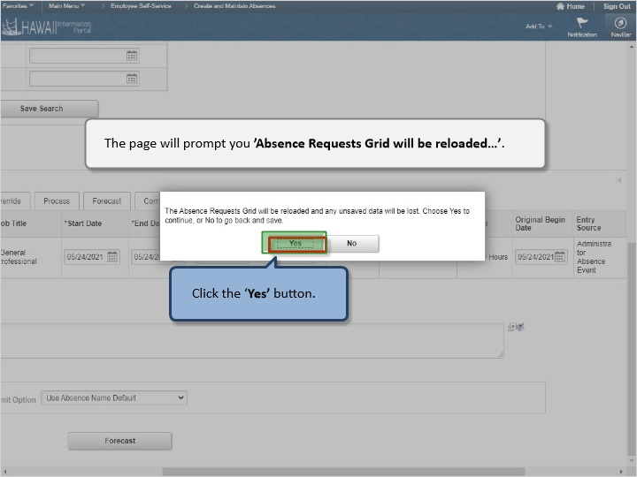

The page will prompt you ’Absence Requests Grid will be reloaded…’.

Click the ‘Yes’ button.

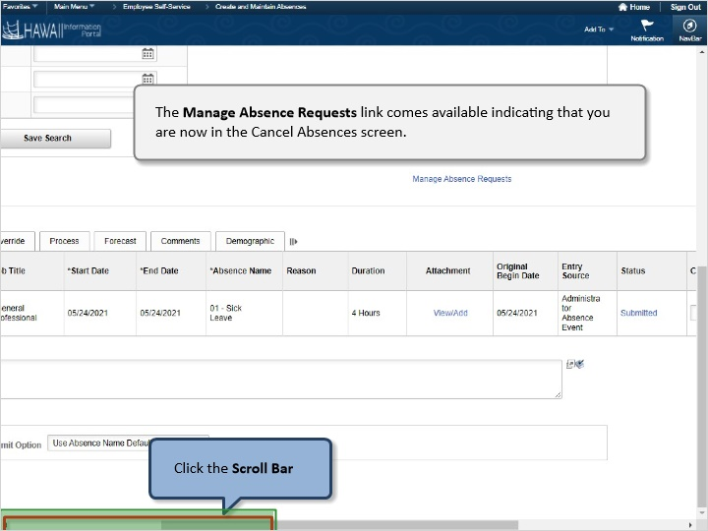

The Manage Absence Requests link comes available indicating that you are now in the Cancel Absences screen.

Click the Scroll Bar

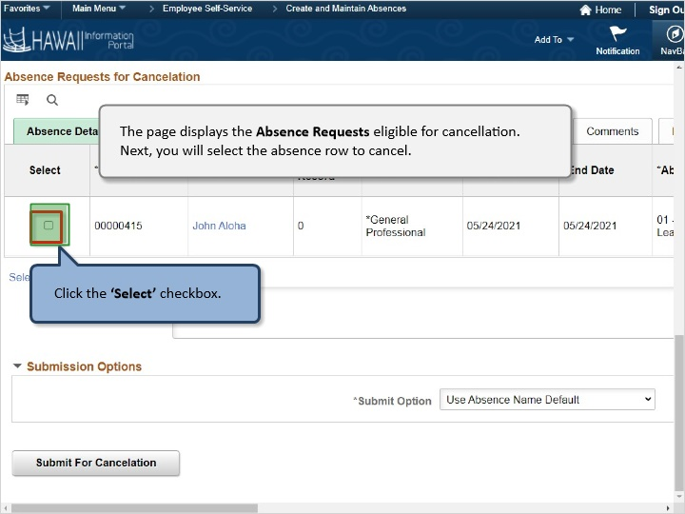

The page displays the Absence Requests eligible for cancellation. Next, you will select the absence row to cancel.

Click the ‘Select’ checkbox.

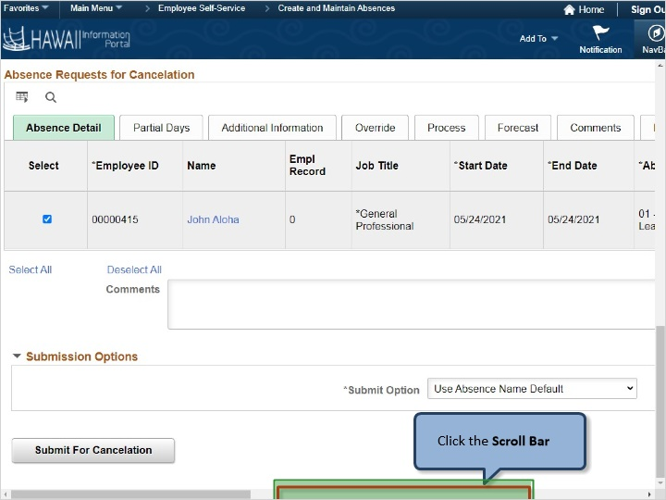

Click the Scroll Bar

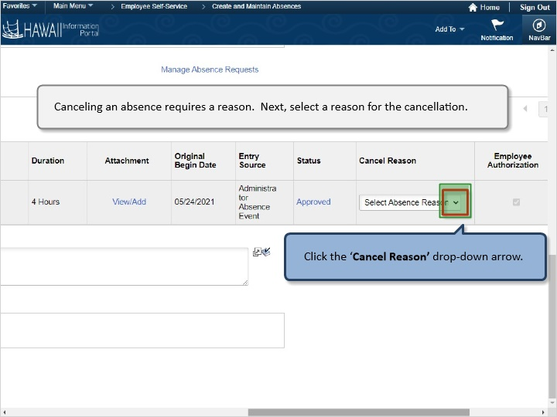

Canceling an absence requires a reason. Next, select a reason for the cancellation.

Click the ‘Cancel Reason’ drop-down arrow.

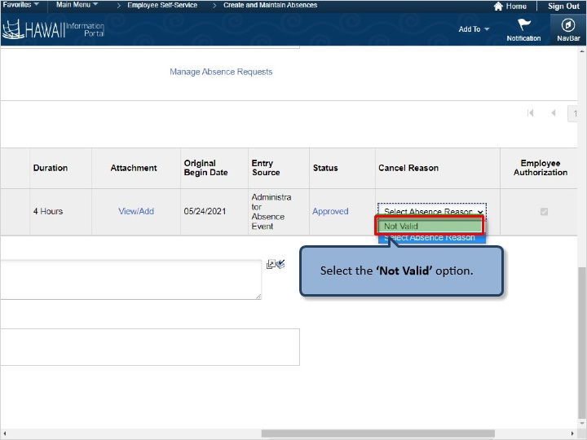

Select the ‘Not Valid’ option.

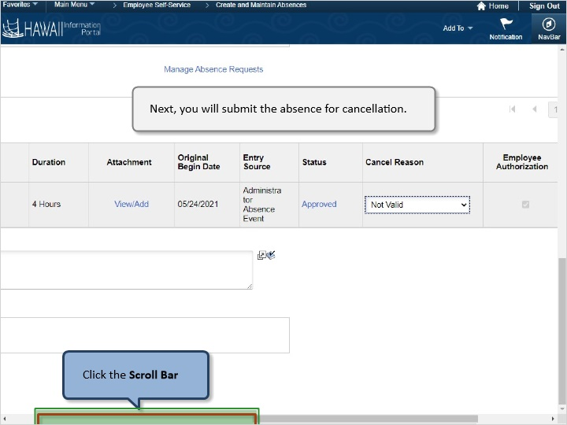

Next, you will submit the absence for cancellation.

Click the Scroll Bar

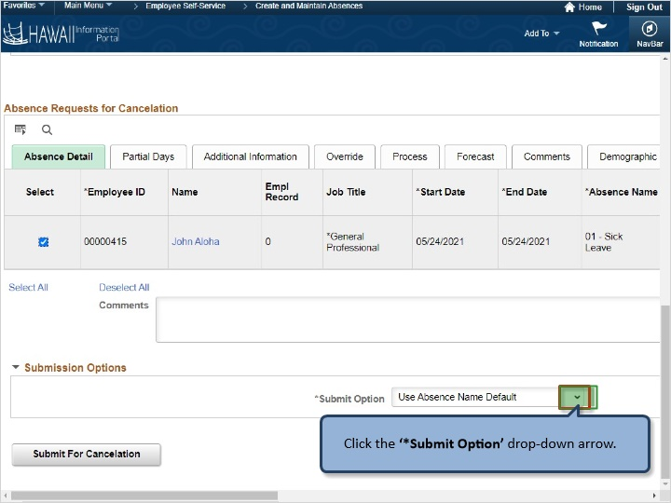

Click the ‘*Submit Option’ drop-down arrow.

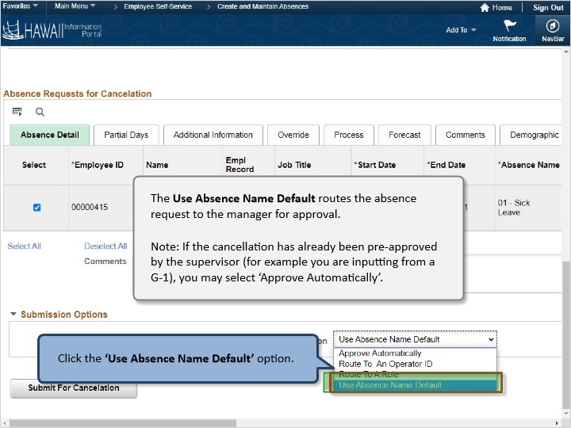

The Use Absence Name Default routes the absence request to the supervisor for approval.

Note: If the cancellation has already been pre-approved by the supervisor (for example you are inputting from a G-1), you may select ‘Approve Automatically’.

Click the ‘Use Absence Name Default’ option.

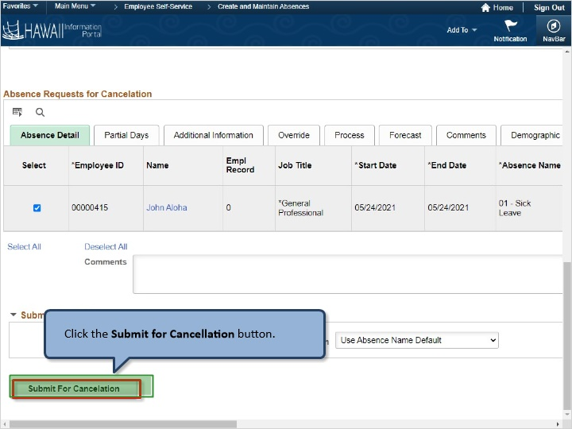

Click the Submit for Cancellation button.

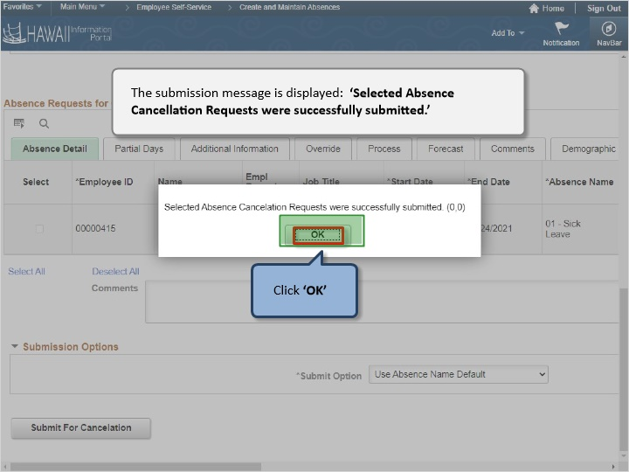

The submission message is displayed: ‘Selected Absence Cancellation Requests were successfully submitted.’

Click ‘OK’

Congratulations!
You’ve successfully completed this lesson.

Reports and Queries
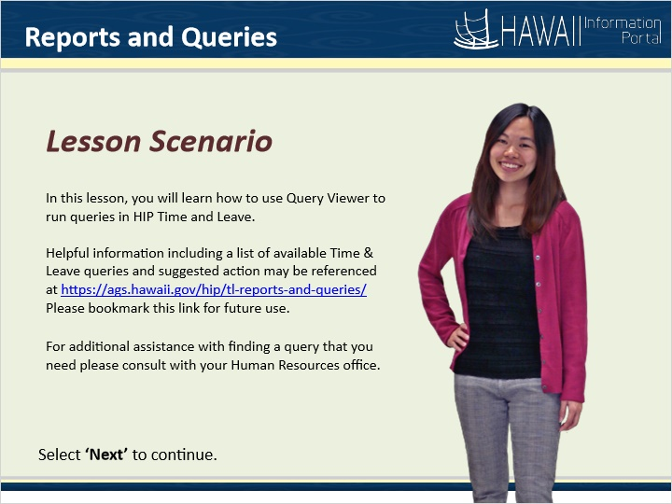

Lesson Scenario

In this lesson, you will learn how to use Query Viewer to run predefined reports in HIP Time and Leave.

Helpful information including a list of available Time & Leave queries and suggested action may be referenced at https://ags.hawaii.gov/hip/tl-reports-and-queries/

For additional assistance with finding a query that you need please consult your Human Resources office.
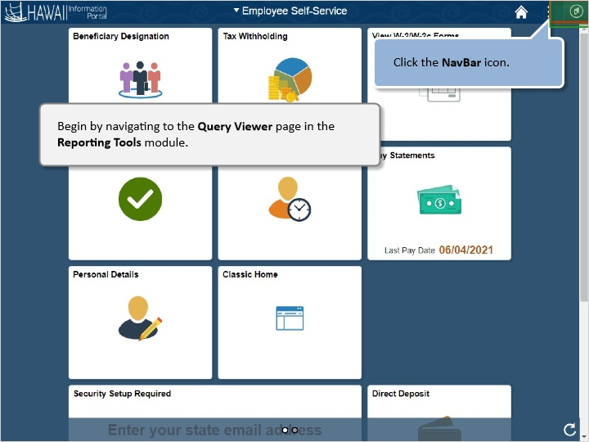

Begin by navigating to the Query Viewer page in the Reporting Tools module.

Click the NavBar icon.

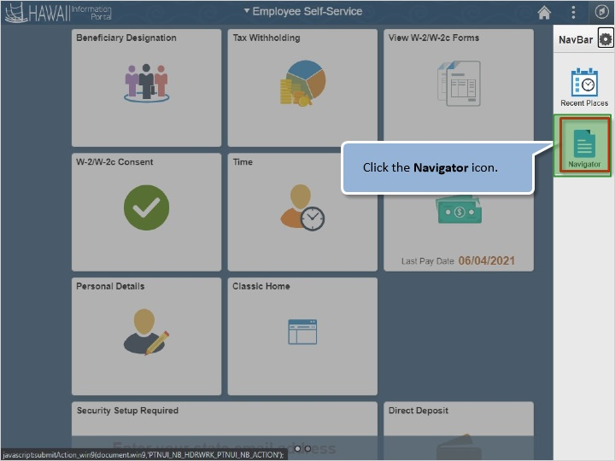

Click the Navigation icon.

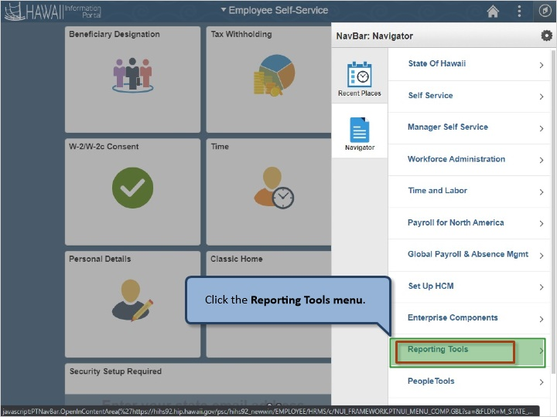

Click the Reporting Tools menu.

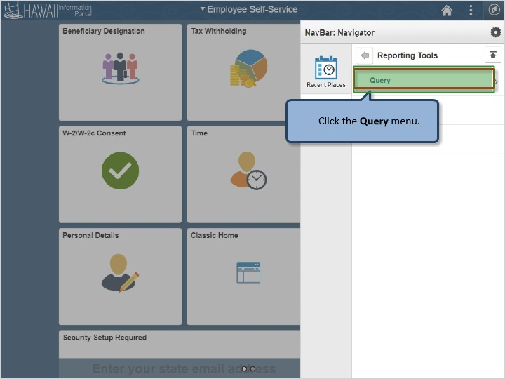

Click the Query menu.

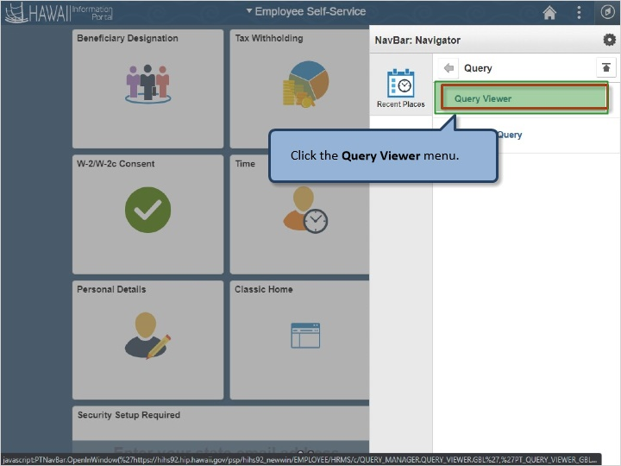

Click the Query Viewer menu.

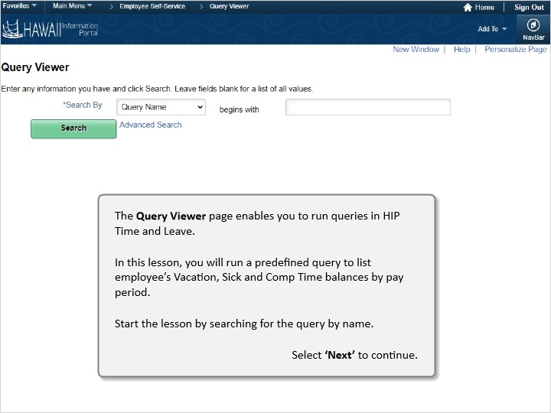

The Query Viewer page enables you to run standard or predefined reports in HIP Time and Leave.

In this lesson, you will run a predefined report to list employees’ leave balances.

Start the lesson by searching for the query by name.

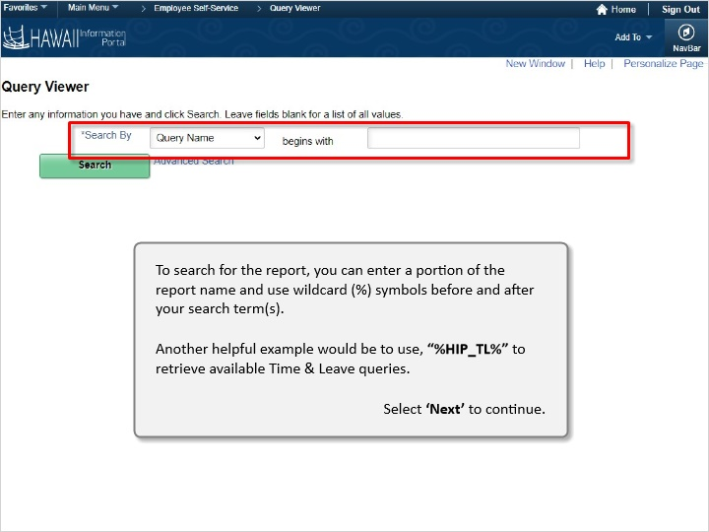

To search for the report, you can enter a portion of the report name and use wildcard (%) symbols before and after your search term(s).

Another helpful example would be to use, “%HIP_TL%” to retrieve available Time & Leave queries.

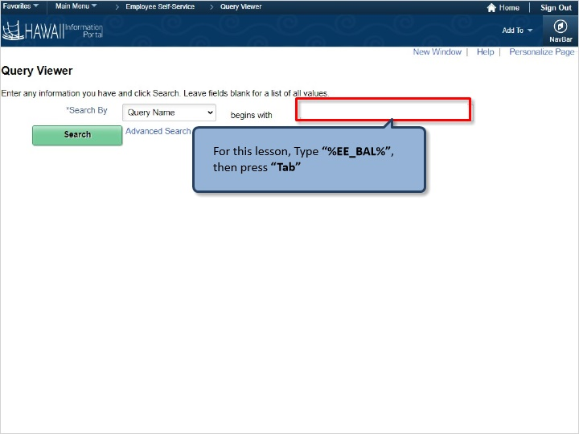

For this lesson, Type “%EE_BAL%”, then press “Tab”

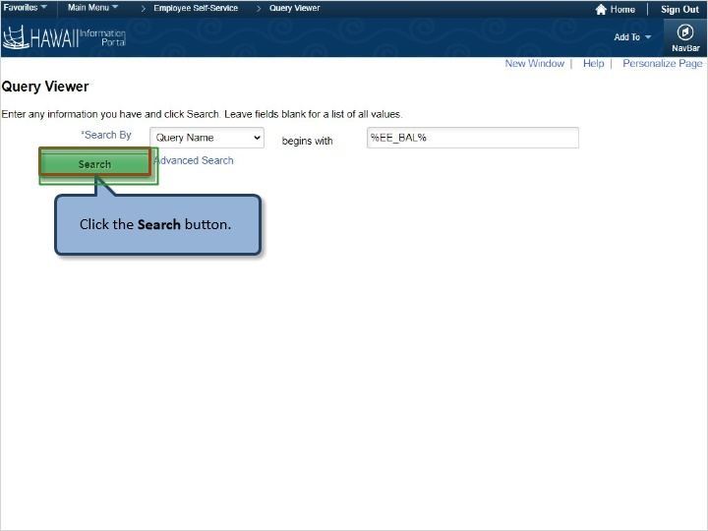

Click the Search button.

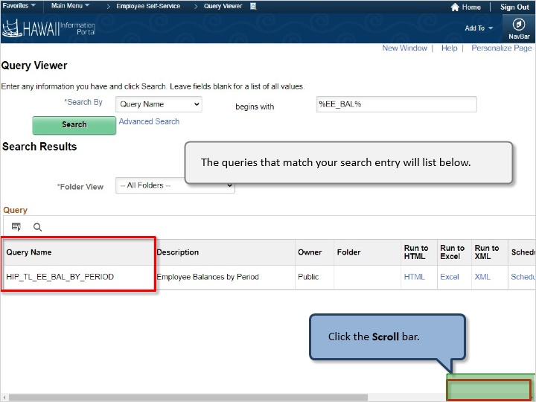

The predefined report(s) that match your search entry will list below.

Click the Scroll bar.

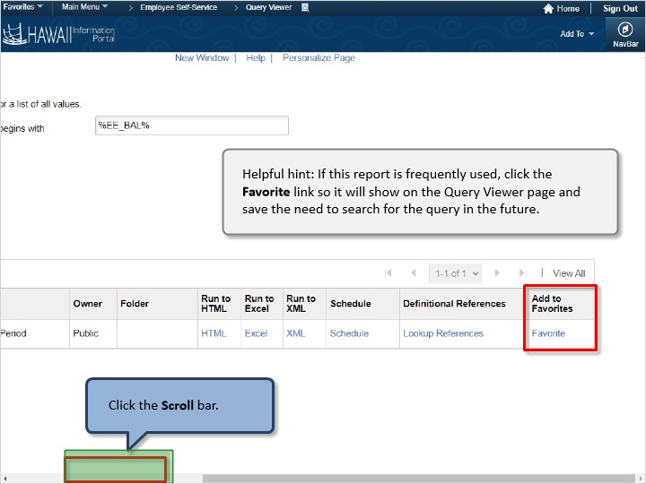

Helpful hint: If this report is frequently used, click the Favorite link so it will show on the Query Viewer page and save the need to search for the query in the future.

Click the Scroll bar

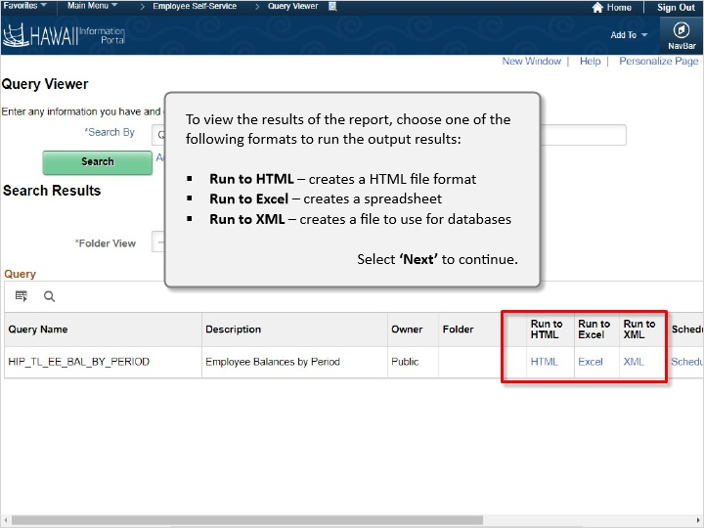

To view the results of the report, choose one of the following formats to run the output results:

- Run to HTML - creates a HTML file format
- Run to Excel - creates a spreadsheet
- Run to XML - creates a file to use for databases

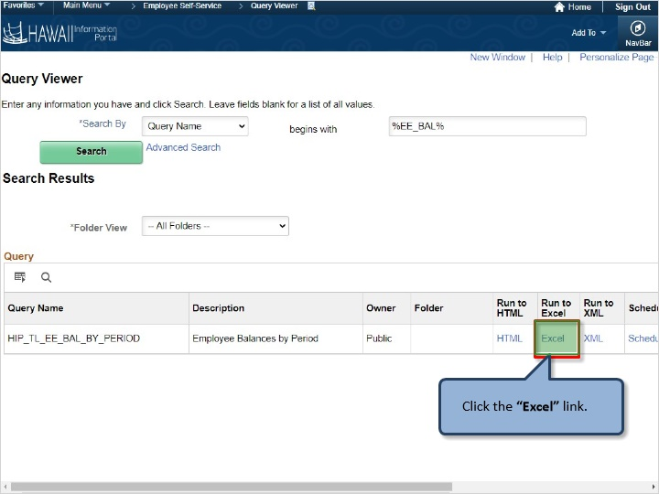

Click the “Excel” link.

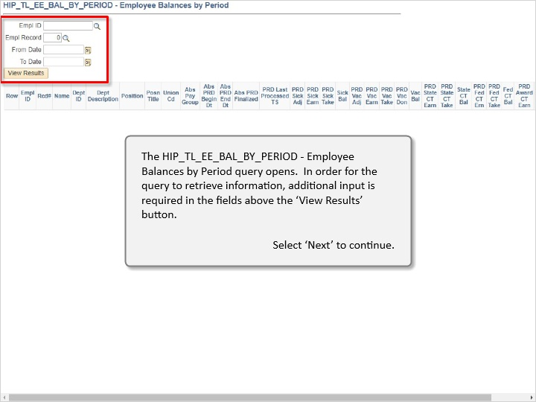

The HIP_TL_EE_BAL_BY_PERIOD – Employee Balances by Period query opens. In order for the query to retrieve information, additional input is required in the fields above the ‘View Results’ button.

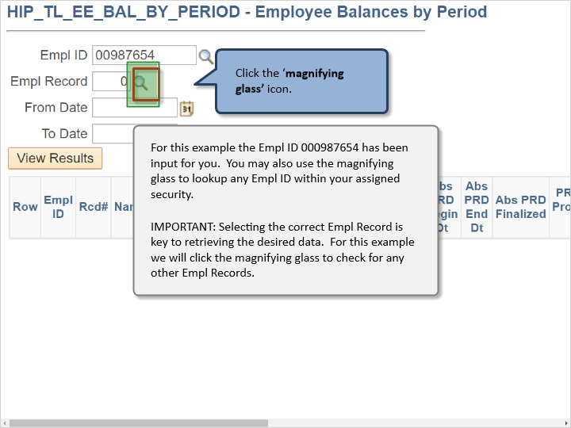

For this example the Empl ID 000987654 has been input for you. You may also use the magnifying glass to look up any Empl ID within your assigned security.

IMPORTANT: Selecting the correct Empl Record is key to retrieving the desired data. For this example, we will click the magnifying glass ot check for any other Empl Records.

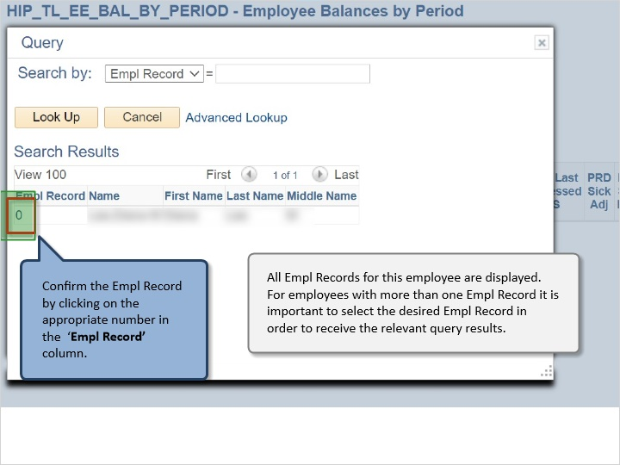

All Empl Records for this employee are displayed. For employees with more than one Empl Record it is important to select the desired Empl Record in order to receive the relevant query results.

Confirm the Empl Record by clicking on the appropriate number in the ‘Empl Record’ column.

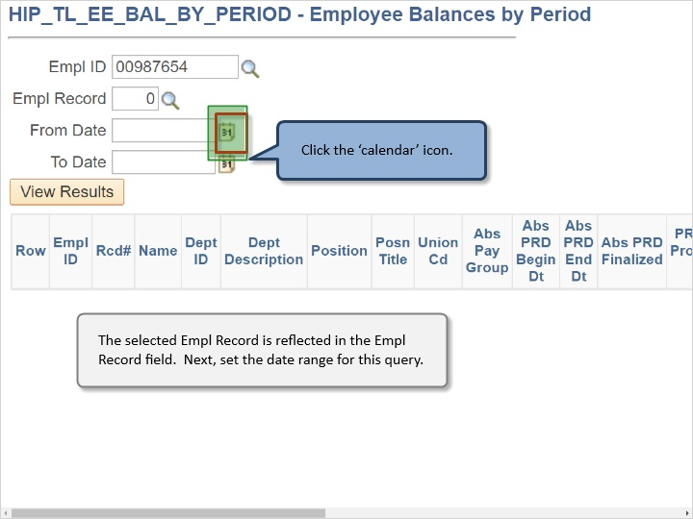

The selected Empl Record is reflected in the Empl Record field. Next, set the date range for this query.

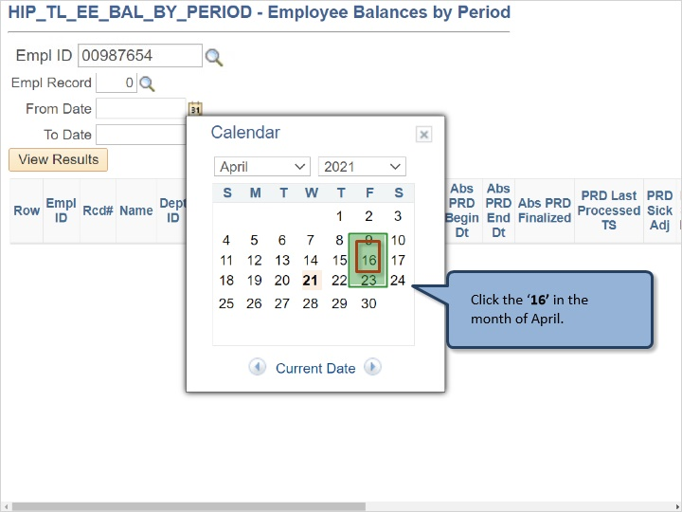

Click the ‘16’ in the month of April.

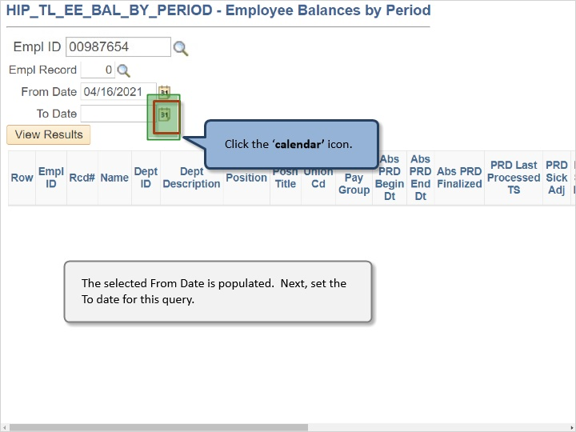

The selected From Date is populated. Next, set the To Date for this query.

Click the ‘Open’ button.

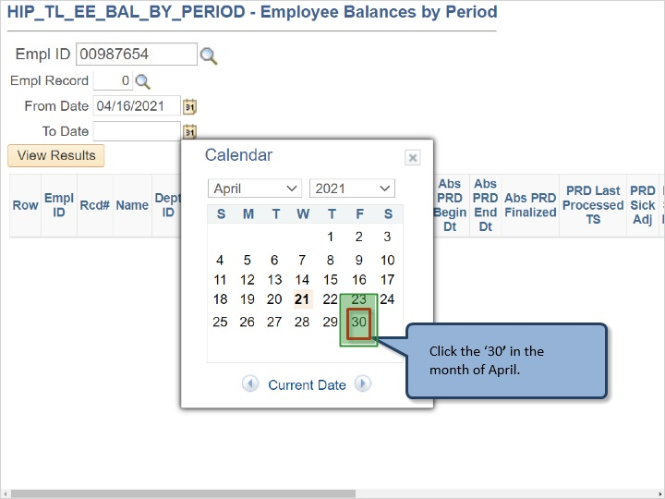

Click the ‘’30’ in the month of April.

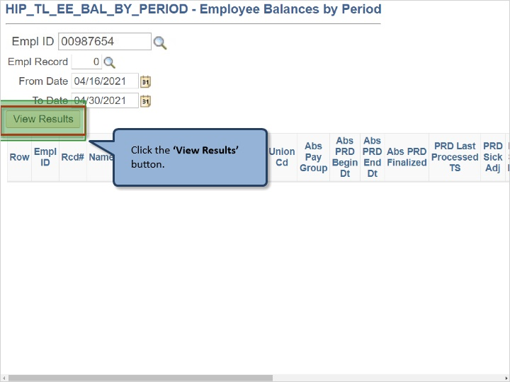

Click the ‘View Results’ button.

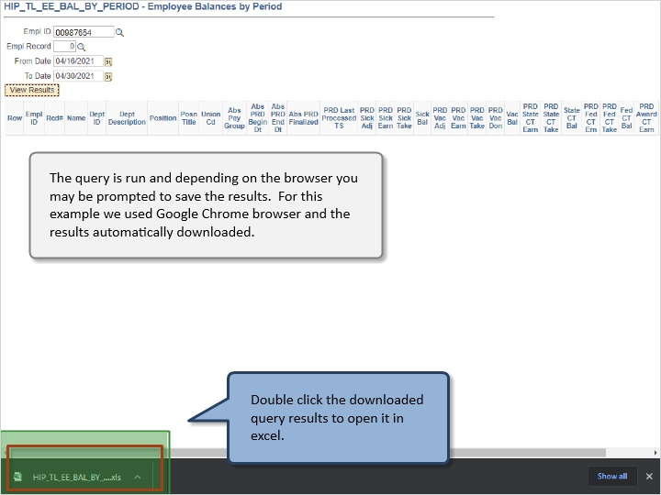

The query is run and depending on the browser you may be prompted to use the results. For this example we used Google Chrome browser and the results automatically downloaded.

Double click the ‘downloaded query results to open it in excel.

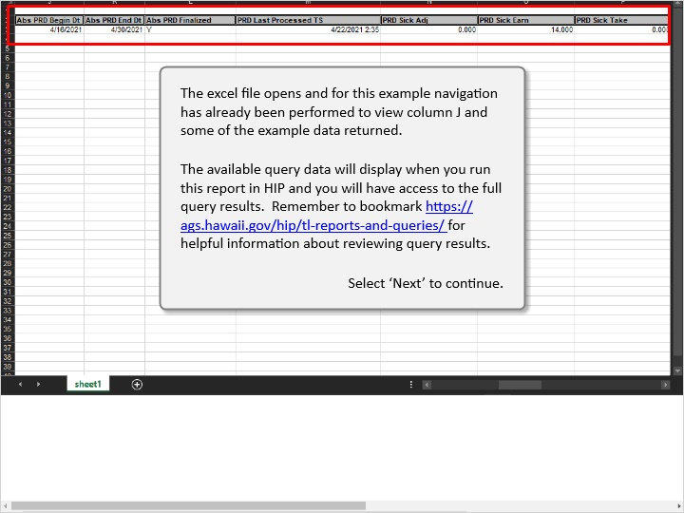

The excel file opens and for this example navigation has already been preformed to view column J and some of the example data returned.

The available query data will display when you run this report in HIP and you will have access to the full query results. Remember to bookmark https://ags.hawaii.gov/hip/tl-reports-nd-queries/ for helpful information about reviewing query results.

Congratulations!
You’ve successfully completed this lesson.

Monthly Calendar
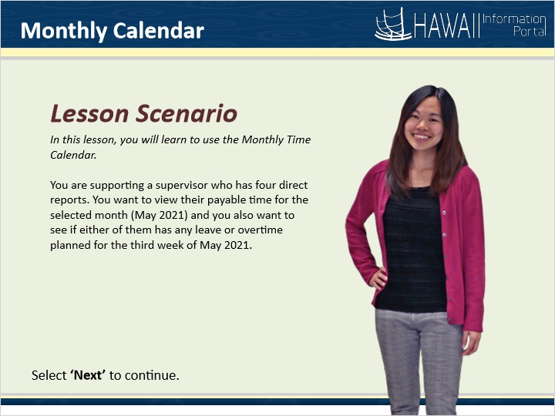

Lesson Scenario

In this lesson, you will learn to use the Monthly Time Calendar.

You are supporting a supervisor who has four direct reports. You want to view their payable time for the current month (May 2021) and you also want to see if either of them has any leave or overtime planned for the third week of May 2021.

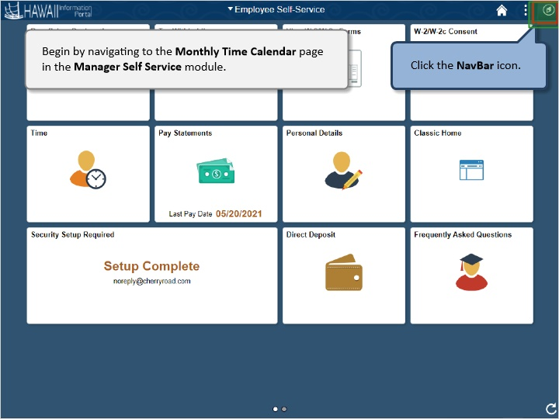

Begin by navigating to the Monthly Time Calendar page in the Manager Self Service module.

Click the NavBar icon.

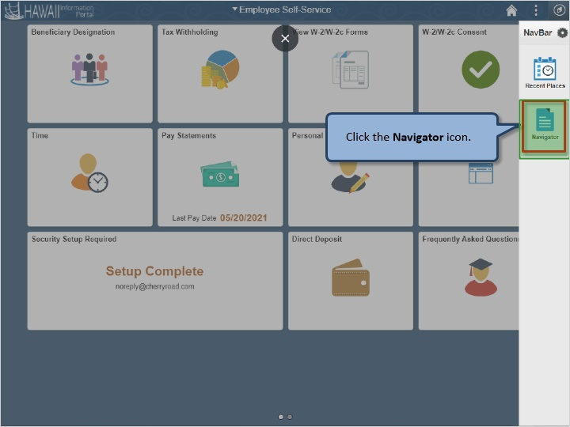

Click the Navigator icon.

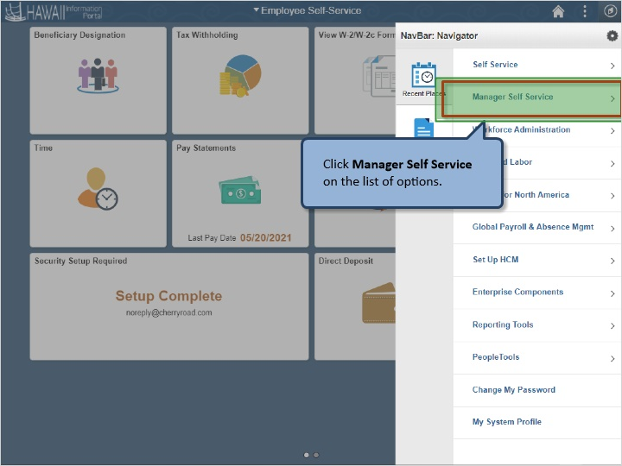

Click Manager Self Service on the list of options.

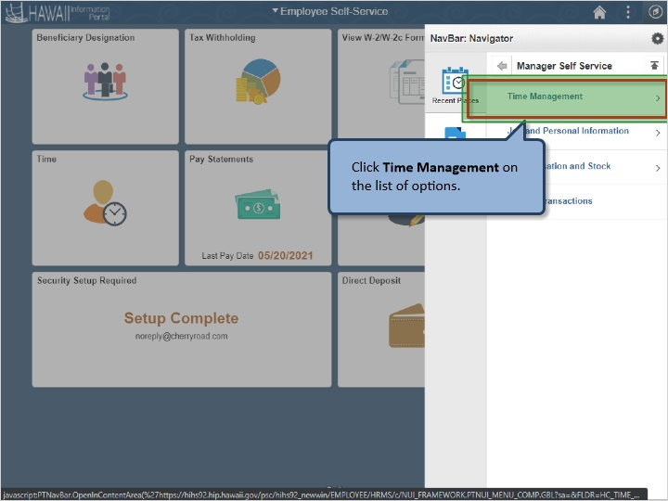

Click Time Management on the list of options.

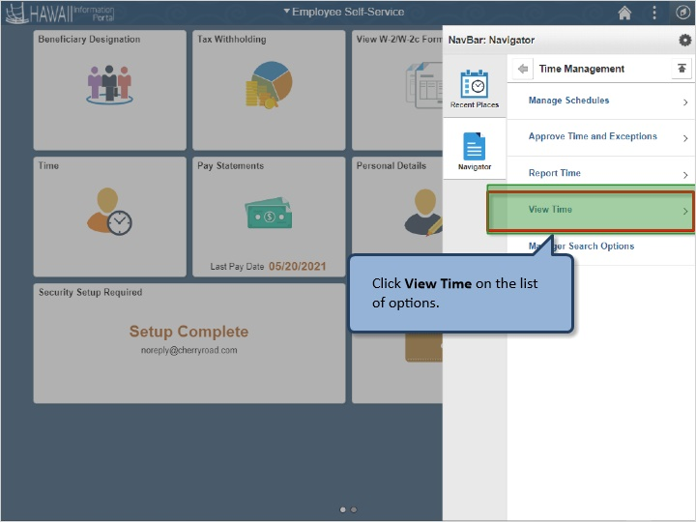

Click View Time on the list of options.

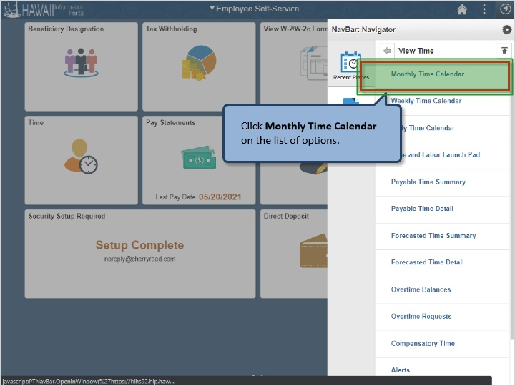

Click Monthly Time Calendar on the list of options.

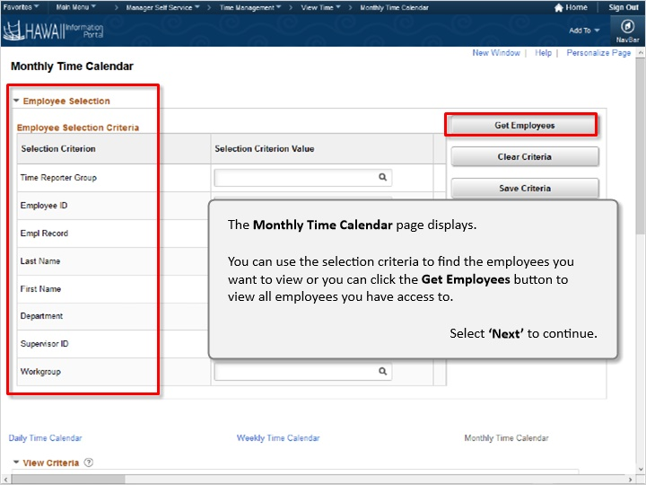

The Monthly Time Calendar page displays.

You can use the selection criteria to find the employees you want to view, or you can click the Get Employees button to view all employees you have access to.

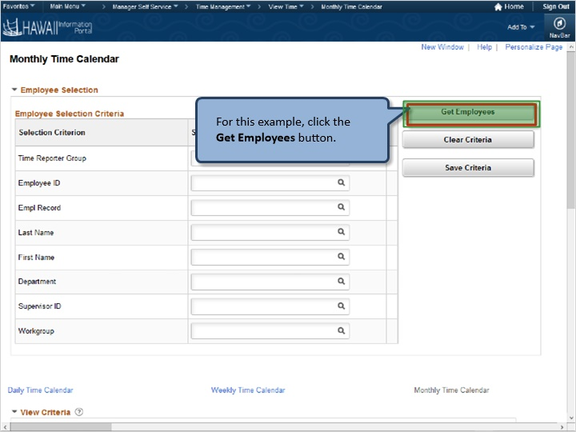

For this example, click the Get Employees button.

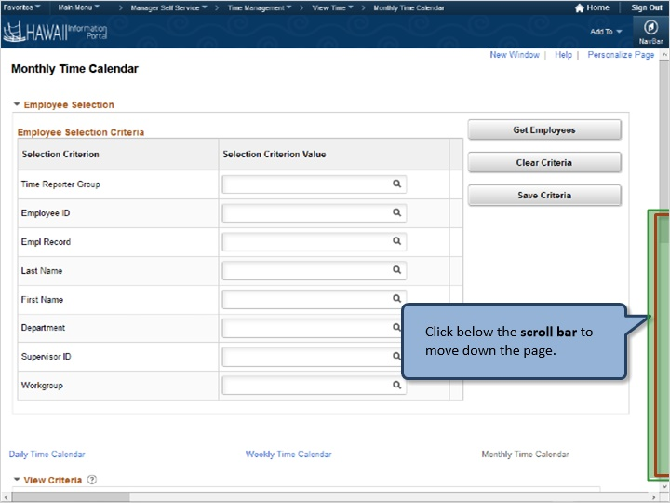

Click below the scroll bar to move down the page.

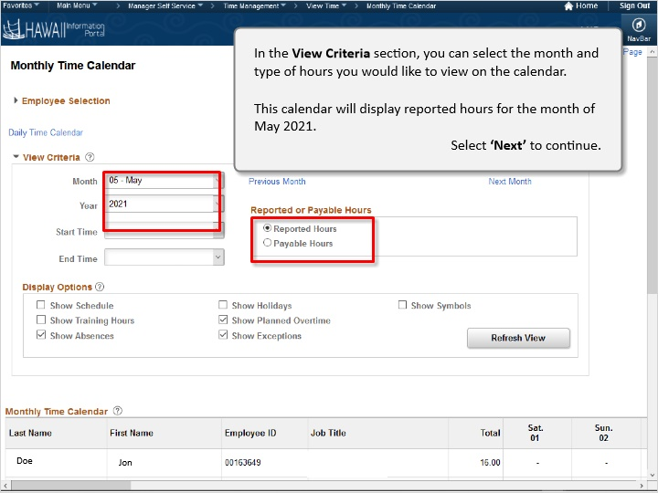

In the View Criteria section, you can select the month and type of hours you would like to view on the calendar.

This calendar will display reported hours for the month of May 2021.

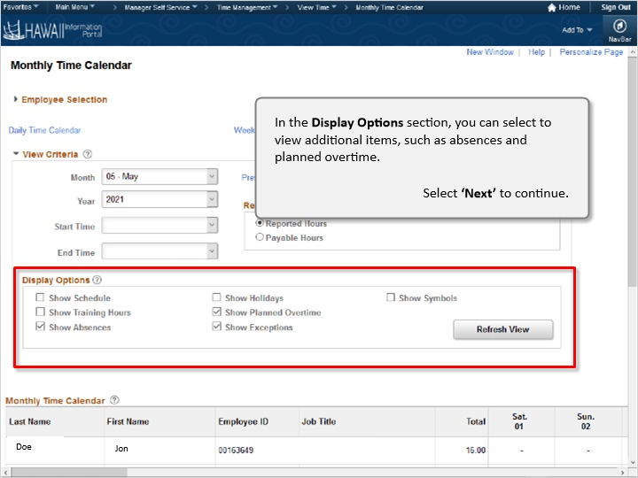

In the Display Options section, you can select to view additional items, such as absences and planned overtime.

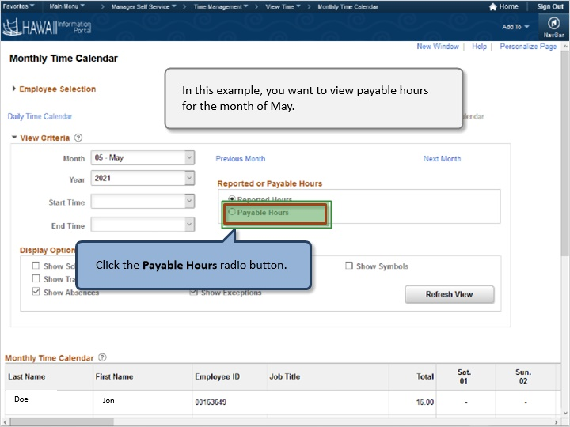

In this example, you want to view payable hours for the month of February.

Click the Payable Hours radio button.

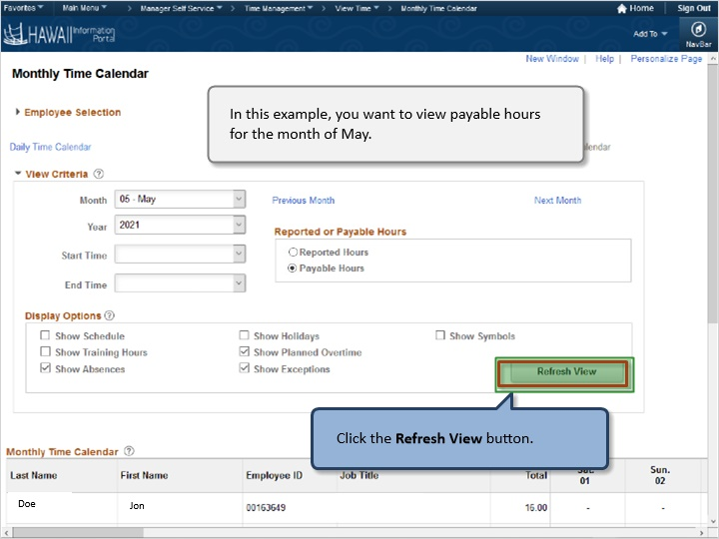

In this example, you want to view payable hours for the month of May

Click the Refresh View button.

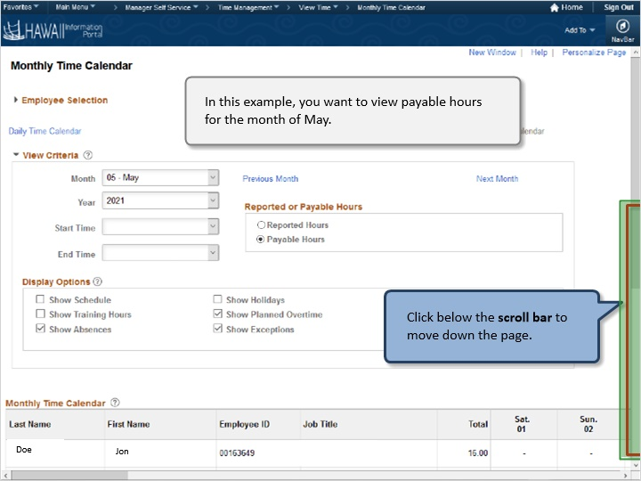

In this example, you want to view payable hours for the month of May.

Click below the scroll bar to move down the page.

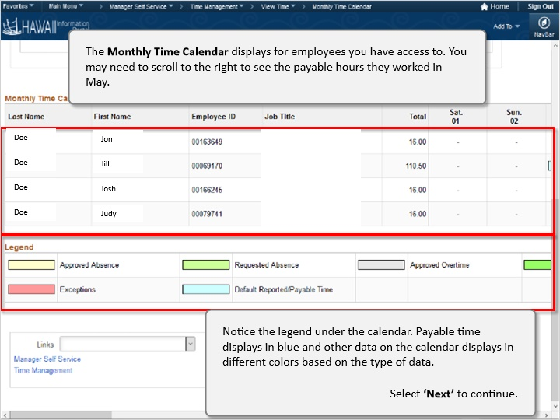

The Monthly Time Calendar displays for employees you have access to. You may need to scroll to the right to see the payable hours they worked in May.

Notice the legend under the calendar. Payable time displays in green and other data on the calendar displays in different colors based on the type of data.

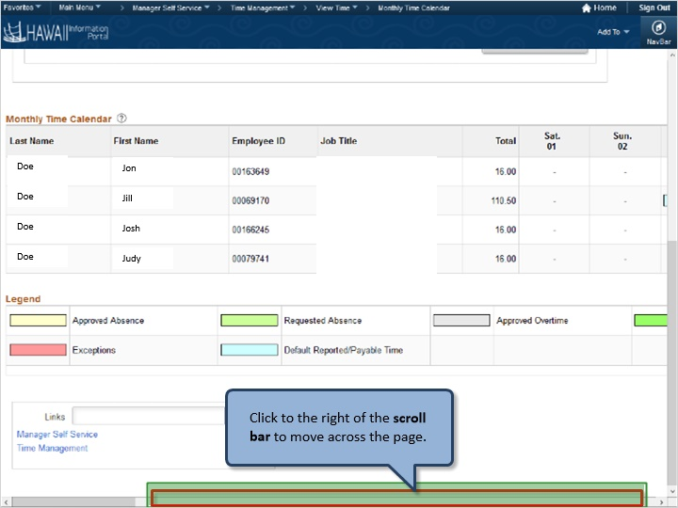

Click the right of the scroll bar to move across the page.

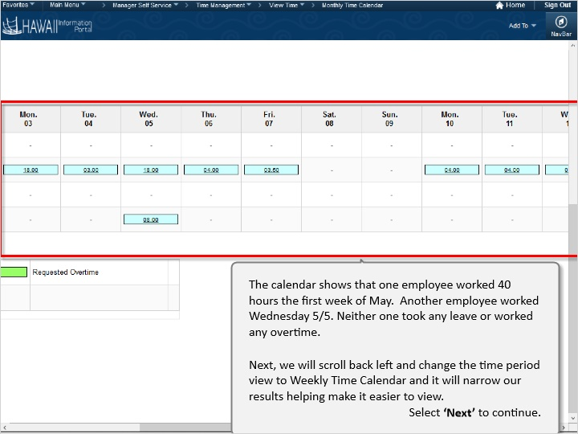

The calendar shows that both employees worked 40 hours the first week of May. Another employee worked Wednesday 5/5. Neither on took any leave or worked any overtime.

Next, we will scroll back left and change the time period view to Weekly Time Calendar and it will narrow our results helping make it easier to view.

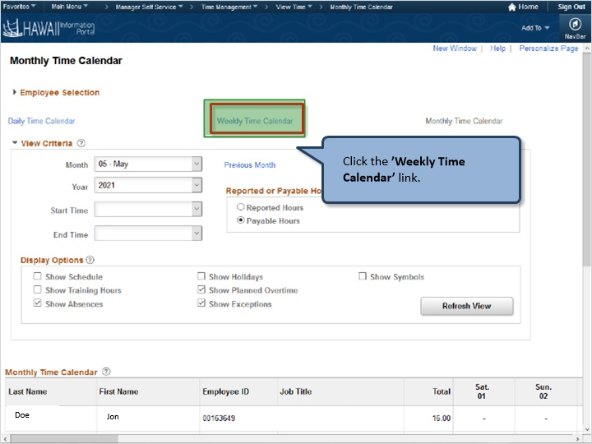

Click the ‘Weekly Time Calendar’ link.

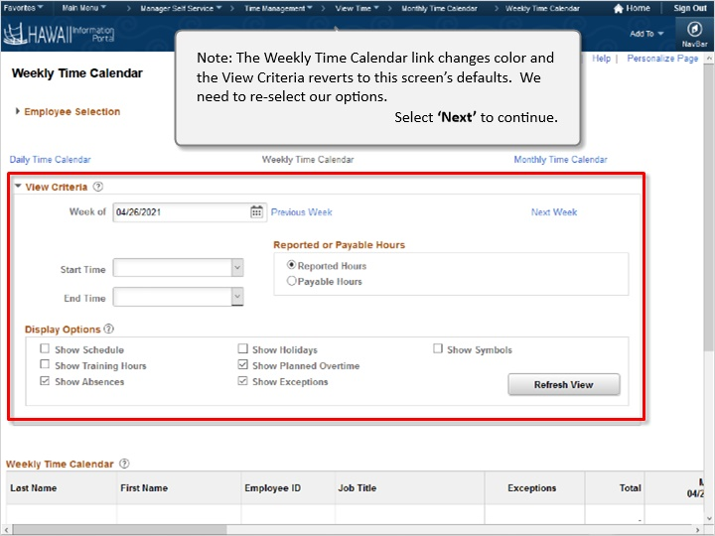

Note: The Weekly Time Calendar link changes color and the View Criteria reverts to the screen’s defaults. We need to reselect our options.

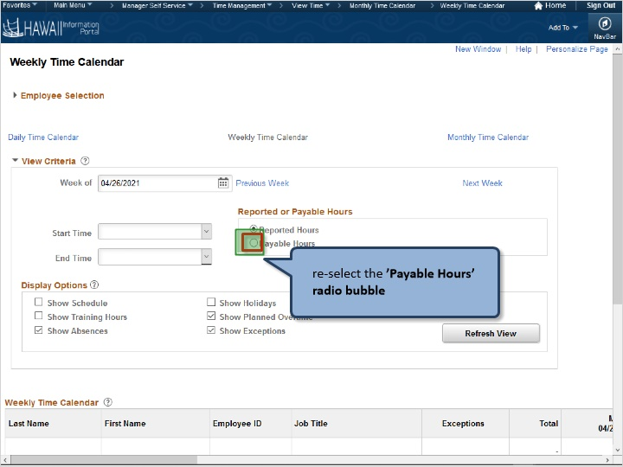

Re-select the ‘Payable Hours’ radio bubble.

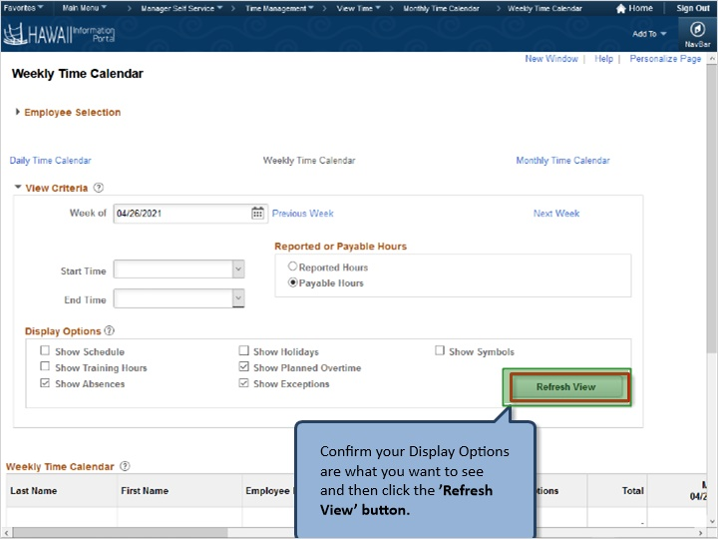

Confirm your Display Options are what you want to see and then click the ‘Refresh View’ button.

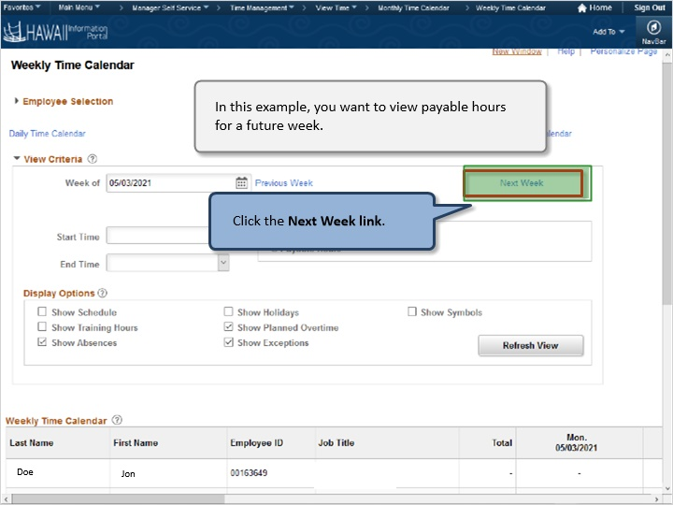

In this example, you want to view payable hours for a future week.

Click the ‘Next Week’ link.

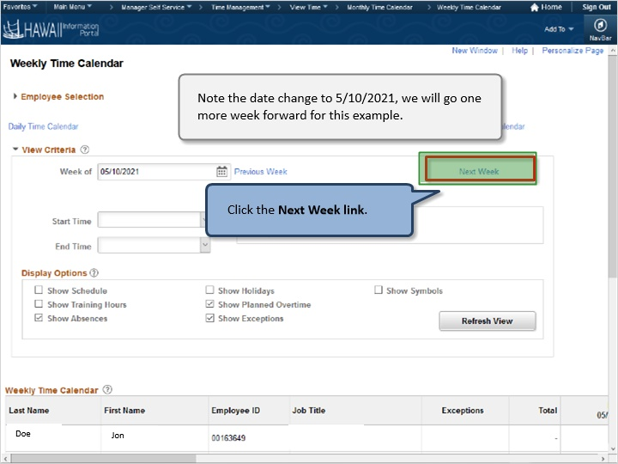

Note the date change to 5/10/2021, we will go one more week forward for this example.

Click the Next Week link.

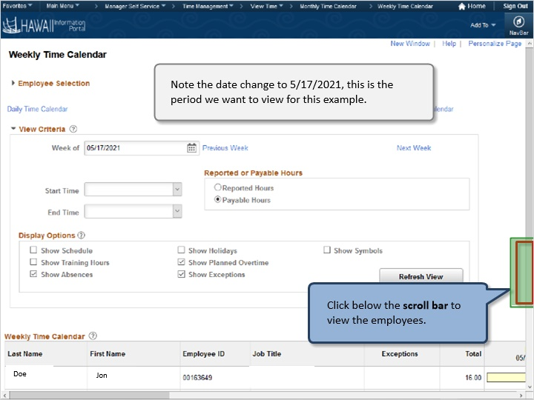

Note the date change to 5/17/2021, this is the period we want to view for this example.

Click below the scroll bar to view the employees.

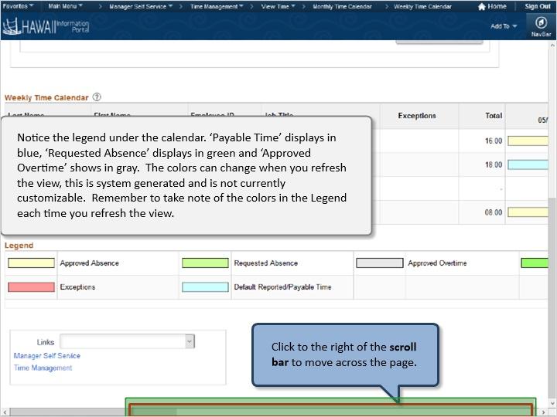

Notice the legend under the calendar. ‘Payable Time’ displays in blue. ‘Requested Absence’ displays in green and ‘Approved Overtime’ show in gray. The colors can change when you refresh the view, this is system generated and is not currently customizable. Remember to take note of the colors in the Legend each time you refresh the view.

Click to the right of the scroll bar to move across the page.

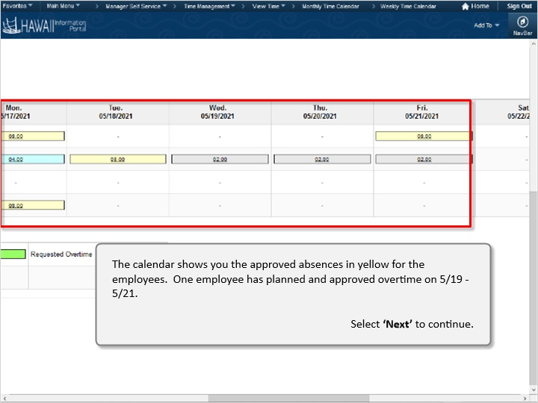

The calendar shows you the approved absences in yellow for the employees. One employee has planned and approved overtime on 5/19 – 5/21.

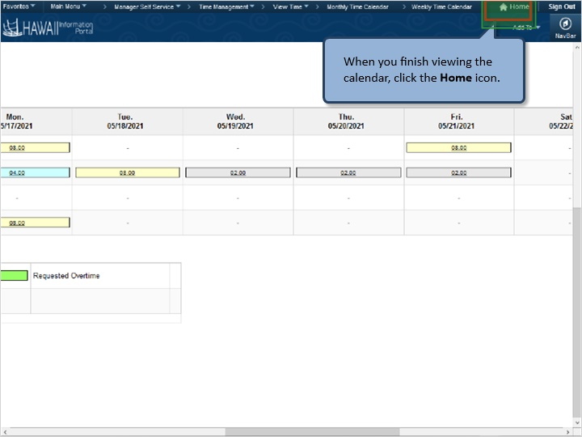

When you finish viewing the calendar, click the Home icon.

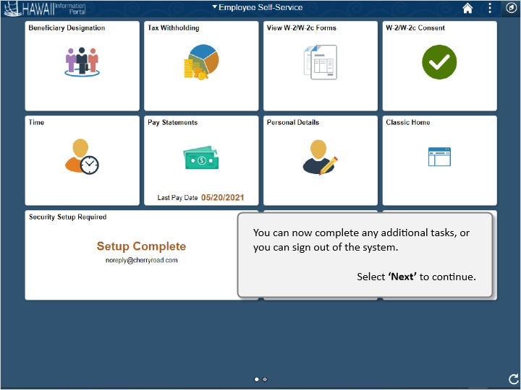

You can now complete any additional tasks, or you can sign out of the system.

Congratulations!
You’ve successfully completed this lesson.

End

